A Cost-Matched Benchmark of Adaptive Modality Acquisition for Alzheimer’s Disease Prognosis on ADNI
Rishi Jayanath A¹, Adwaith Sajikumar¹, G. Naveen Sundar², D. Narmadha³, for the Alzheimer’s Disease Neuroimaging Initiative*
¹Department of Computer Science and Engineering, Karunya Institute of Technology and Sciences, Coimbatore, India
²Division of Computer Science and Engineering, Karunya Institute of Technology and Sciences, Coimbatore, Tamil Nadu, India
³Division of AIML, Karunya Institute of Technology and Sciences, Coimbatore, Tamil Nadu, India
E-mail: ¹rishijayanath@karunya.edu.in, ¹adwaithsajikumar@karunya.edu.in, ²naveensundar@karunya.edu, ³narmadha@karunya.edu
*Data used in preparation of this article were obtained from the Alzheimer’s Disease Neuroimaging Initiative (ADNI) database (adni.loni.usc.edu). As such, the investigators within the ADNI contributed to the design and implementation of ADNI and/or provided data but did not participate in analysis or writing of this report. A complete listing of ADNI investigators can be found at: http://adni.loni.usc.edu/wp-content/uploads/how_to_apply/ADNI_Acknowledgement_List.pdf
Abstract
Adaptive modality-acquisition policies promise to cut the cost of Alzheimer’s disease prognosis by deciding, per patient, which scan to order, but to our knowledge none has been compared with the others or with the trivial baselines that any cost-saving claim must beat. We re-implemented three published policies (an uncertainty-gated cascade, a staged evidential method and a reinforcement-learning test-ordering policy) as nine configurations under one leakage-free protocol, using 1,566 participants with mild cognitive impairment from the Alzheimer’s Disease Neuroimaging Initiative (ADNI) and conversion outcomes at 12, 24 and 36 months. Against random acquisition at the same expected cost, 25 of 27 configuration-horizon pairs showed no significant difference after Holm correction under price-like costs (one better, one worse), and 19 of 27 were dominated by a patient-independent fixed rule costing no more. A fixed rule using expanded structural magnetic resonance imaging (MRI) features and training on partially observed participants (signature-pooled fixed acquisition, SPFA) beat cost-matched random acquisition at its MRI-only operating point (area under the receiver operating characteristic curve, AUC, +0.056 and +0.046 at 24 and 36 months; Holm-adjusted $p=0.010$ and 0.016) and showed no significant AUC difference from acquiring all four modalities at one-third to one-tenth of the cost, except for MRI-only at 36 months in development. The held-out test set, scored on two successive data releases (the second is reported), is small and cannot establish equivalence. Complete-case analysis reduced non-White representation from 14.2% to 5.9%, making race-stratified fairness auditing infeasible.
Keywords: Alzheimer’s disease, modality acquisition, cost-aware machine learning, benchmarking, algorithmic fairness, mild cognitive impairment
- Introduction
Predicting whether a person with mild cognitive impairment (MCI) will progress to Alzheimer’s disease (AD) dementia is usually framed as a prediction problem: assemble as many modalities as possible – structural magnetic resonance imaging (MRI), fluorodeoxyglucose (FDG) and amyloid positron emission tomography (PET), and cerebrospinal fluid (CSF) assays – and maximise discrimination. In a clinic, it is also an economics problem. Amyloid-PET is expensive and exposes the patient to radiation; a lumbar puncture is invasive; MRI is comparatively cheap. Acquiring everything for everyone is neither affordable nor necessary.
This has motivated a line of work on adaptive acquisition policies: models that decide, per patient, which modality to acquire next, typically escalating only the cases the cheaper data leaves uncertain. Published policies of this kind report substantial savings – reductions of 50–90% in imaging use at maintained accuracy are claimed [1, 2, 3].
To our knowledge these claims have not been tested against each other, and, more importantly, they have not been tested against the baselines any cost-saving claim must clear. Two are essential. The first is random acquisition: if escalating a randomly chosen half of patients performs as well, the policy’s decisions carry no information, only its willingness to spend. The second is a fixed rule that acquires the same modalities for everyone: if a rule that never looks at the patient matches the policy at equal or lower cost, personalisation has bought nothing. To our knowledge, neither baseline appears in the original reports.
This paper supplies that audit. The contributions are:
(i) A head-to-head benchmark of three published adaptive acquisition policies, re-implemented under one leakage-free protocol, across three prediction horizons and three acquisition-cost regimes, with paired statistical comparison against random and fixed baselines.
(ii) Random-acquisition baselines swept over acquisition rate and matched to each policy’s expected cost, a cost-domination analysis quantifying how often a learned policy is beaten by a patient-independent rule costing no more, and a robustness sweep over predictor family, cost regime and random seed.
(iii) A quantification of representation attrition: the demographic cost of the complete-case multimodal designs this literature relies on, and its consequence for fairness auditing.
We report a largely negative result, and one constructive consequence of it. We are explicit throughout about which findings are new and which reproduce established results in a new setting.
- Related Work
Adaptive acquisition policies for AD. Three published methods are audited here. Zheng et al. [1] gate amyloid-PET acquisition on the predictive uncertainty of an MRI model, reporting an area under the receiver operating characteristic curve (AUC) of 0.880 while saving 77% of amyloid-PET scans (23% of patients escalated), against 0.905 for acquiring all modalities. A staged evidential method [2] performs Dirichlet-based evidential classification on cheap clinical data and escalates to MRI or PET when uncertainty exceeds a learned threshold, fusing modality opinions by Dempster-Shafer combination and reporting 50–90% reductions in imaging use. A reinforcement-learning (RL) formulation [3] treats diagnosis as sequential decision-making, learning a policy that chooses which test to order next. To our knowledge, none of the three reports a comparison against random acquisition or against a cost-matched fixed rule, and none has been compared against the others.
Active feature acquisition. The broader machine-learning literature on acquiring features under a budget is mature, with a recent survey and benchmark [4, 5], and a formal evaluation framework for the static setting [6]. Our finding is consistent with a known and uncomfortable pattern in that literature: informed acquisition strategies frequently fail to beat random selection. This has been documented for unsupervised feature selection [7] and, in an inflammatory bowel disease cohort, as a “flat-to-negative lift over random” for the leading planner when evaluated against clinical labels [8]. Our contribution is not the discovery of that pattern but its demonstration for these specific, named AD policies under a controlled protocol.
Simple baselines in AD prediction. That simple models are hard to beat in this domain is likewise established. The TADPOLE challenge received 92 submissions from 33 teams and found that for ADAS-Cog13 forecasting no submission was considerably better than the organisers’ benchmark mixed-effects model [9]. Our result extends that lesson from forecasting to acquisition.
Structural features and incomplete data. The constructive part of our result rests on two established findings, and we claim novelty for neither. First, the AD-signature cortical thickness measure predicts progression better than hippocampal volume, and performed best among the MRI and CSF markers compared by Dickerson and Wolk [10]. Second, restricting analysis to complete cases wastes data: the incomplete-multimodal learning literature is founded on precisely this observation [11]. What is new here is the use of these two established techniques as the comparison baseline against which adaptive policies are measured, which has not previously been done.
Methodological rigour. Reported accuracies in this field are known to be inflated by data leakage. A scoping review of 44 AD deep-learning studies found that 68.2% relied on ADNI and only 15.9% performed any external validation [12], and splitting by slice rather than by subject can move reported accuracy by as much as 28 percentage points [12, 13]. Our protocol is designed against these failure modes. Fairness in AD prediction models has been examined for prediction accuracy [14], but not, to our knowledge, for acquisition decisions.
- Proposed Work
Figure 1 summarises the evaluation pipeline; Section 3.5 describes the proposed configuration.
3.1 Cohort
Data were drawn from the Alzheimer’s Disease Neuroimaging Initiative (ADNI) database (adni.loni.usc.edu). Diagnosis, demographics, genotype, cognitive assessments, FreeSurfer morphometry, PET summaries and CSF assays were assembled from the source tables rather than a pre-merged file. All joins use ADNI’s harmonised visit code; the protocol-specific visit code is not comparable across study phases and its use silently corrupts longitudinal merges. Screening visits were coalesced into baseline where no baseline record exists, with a genuine baseline record always taking precedence – without this, 274 MCI participants whose diagnosis is recorded only at screening are dropped, and dropped unevenly by phase.
Inclusion was MCI at the baseline visit, giving 1,566 participants from 3,762. Baseline predictors come only from the baseline-equivalent record (the baseline visit or, where absent, the screening visit; for one FreeSurfer table, a scan coded as month 3 that ADNI treats as baseline-equivalent), and tables are joined on exact visit codes rather than nearest-date matching, so predictors are limited to baseline-equivalent measurements.
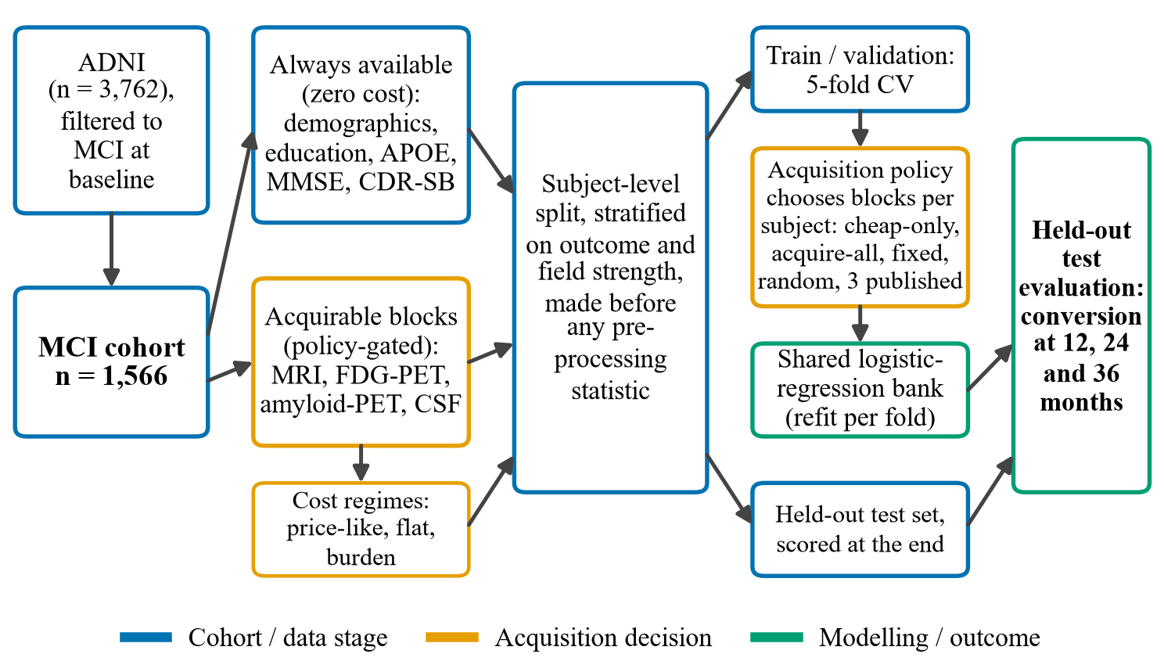
Figure 1. Evaluation pipeline. The subject-level split is made before any preprocessing statistic is computed; every policy uses the same per-fold logistic-regression predictor bank, so differences between policies reflect the acquisition decision; the test set is scored only at the end.
Outcome definition. For a horizon of $h∈\{12,24,36\}$ months, a participant is a converter (label 1) if any recorded visit at or before month $h$ has a diagnosis of dementia, using the month implied by the harmonised visit code; a conversion stays a conversion if the diagnosis later reverts. A participant with no such visit is a non-converter (label 0) if their last recorded visit is at or after month $h$, and is otherwise censored: no label is assigned and they are excluded from that horizon rather than coded as non-converters. No visit-window tolerance is applied. Participants who return to normal cognition at any visit without a prior dementia diagnosis are flagged as reverters; they are labelled 0 for classification but counted separately in cohort reporting rather than merged into “stable”. Converter counts were 134, 252 and 313, and reverter counts 120, 113 and 110, at the three horizons. Table 1 traces the 24-month cohort to the final analysis sets; the same participants can contribute to more than one horizon.
Table 1. Cohort flow at the 24-month horizon.
Stage | n | Converters | Note
ADNI participants | 3762 | – | all phases
MCI at baseline | 1566 | 252 | inclusion criterion
+ 24-month outcome label | 941 | 252 | 625 censored (insufficient follow-up)
+ all four modalities | 458 | 84 | the other 483 labelled subjects form the training pool $P$
Locked test set | 92 | 17 | scored at the end, on two releases (Section 3.2)
Development set | 366 | 67 | five-fold CV; benchmark, ablation and sex-stratified fairness analyses
The development sets at 12 and 36 months contain 402 subjects (36 converters) and 334 subjects (86 converters); the test sets contain 9, 17 and 22 converters at 12, 24 and 36 months.
3.2 Acquirable modality blocks and costs
Demographics, education, apolipoprotein E (APOE) genotype, Mini-Mental State Examination (MMSE) and Clinical Dementia Rating Sum of Boxes (CDR-SB) are treated as always available at zero acquisition cost: they are in hand before any scan is ordered. Four blocks are acquirable in the benchmark: MRI, FDG-PET, amyloid-PET and CSF. FDG, amyloid and tau PET are separate scans with separate tracers and are therefore treated as separate acquisitions rather than one “PET” block; conflating them misstates the decision. Tau-PET and plasma biomarkers are defined in the feature code but excluded from the benchmark: only 153–299 labelled participants hold tau-PET (20–43 converters, depending on horizon), and only 19–122 hold a plasma measurement, too few at any horizon. In the main benchmark every policy, including the fixed rules, uses the same 12-measure structural MRI block described in Section 3.5, and so do the robustness, clinical-utility, fairness and horizon analyses of Sections 4.3 to 4.6. The customary three-feature block (hippocampus, ventricles, intracranial volume) serves only as the ablation reference.
Costs are relative units, not currency, and are deliberately swept across three regimes rather than fixed: price-like (MRI 1.0, FDG 2.0, amyloid 5.0, CSF 1.5, roughly proportional to order-of-magnitude list prices), flat (all 1.0, isolating how many tests from which tests), and burden (MRI 1.0, FDG 3.0, amyloid 4.0, CSF 6.0, penalising the invasive lumbar puncture and radiation-exposing tracers; these weights are judgement-based). Acquiring all four modalities therefore costs 9.5, 4.0 and 14.0 units. Any conclusion that holds under only one regime is reported as regime-dependent.
3.3 Evaluation protocol
Comparisons are made on the complete-case cohort for the four blocks, so that every policy could in principle have acquired anything; otherwise a policy that happens to prefer the most-available modality wins for the wrong reason. Splits are at subject level and made before any preprocessing statistic is computed, stratified jointly on outcome and scanner field strength. Imputation and scaling are fitted inside each cross-validation fold on that fold’s training rows only. Each policy, including every internal threshold, is refitted within each fold.
A test set was held out (a stratified 20% of the complete-case cohort) and left untouched through all development. All development figures come from five-fold cross-validation (CV) on the remaining subjects. Test-set protocol. The analysis was completed and the test set scored once, at the end, on the September 2026 ADNI release. The data were then re-downloaded (October 2026 release, which changed the cohort slightly) and the whole pipeline was re-run with unchanged models, operating points and test procedure, and the test set was scored a second time. We report the October results throughout; the two scorings differ by at most 0.011 AUC for any model and horizon. Because the test set was scored on both releases, it is not untouched with respect to the first, and the test results should be read as two scorings of one fixed procedure, not as an independent replication. The test set was not used to choose anything, and the post hoc checks of Section 4.4 that look at it are descriptive. Labelled subjects who lack at least one of the four modalities (483 at 24 months) are never evaluated: they form a training pool $P$ used only by the proposed configuration (Section 3.5), and are disjoint from every development fold and from the test set by construction. Confidence intervals (CIs) are percentile intervals from 1,000 bootstrap resamples of subjects.
3.4 Policies compared
Reference points are cheap-only (never acquires), acquire-all (always acquires everything), fixed rules acquiring a set prefix for every patient (MRI; MRI then FDG), and a random baseline in which each of the four modalities is acquired independently with a given probability (the acquisition rate). A single rate is not cost-matched, so the rate is swept from 0 to 1 in steps of 0.1 and every rate is repeated over 50 random seeds, with an independent random draw for every patient. The expected cost at rate $r$ is $r$ times the cost of acquiring everything (4.75 price-like units at $r=0.5$); the realised cost is the empirical mean over the simulated draws (4.73, 4.73 and 4.72 at $r=0.5$ at 12, 24 and 36 months). Table 2 reports realised costs at 24 months and Table 3 the three-horizon mean. Each policy is compared with random acquisition at the same expected cost (Section 3.6). No public code exists for any of the three published policies, so each was re-implemented from its description, giving the nine configurations listed in Table 2; results should therefore be read as our implementation of each mechanism rather than a reproduction of the original numbers. Table 3 and Figure 3 show one representative configuration of each policy: the uncertainty cascade at a target escalation of 53.8%, the staged evidential method’s full ladder with the shared predictor, and the RL policy at cost weight 0.01. The calibration, decision-curve and fairness analyses (Figures 7 and 11) use the RL policy at cost weight 0.05.
Table 2. Configurations compared and their mean acquisition cost per patient at 24 months under the price-like, flat and burden regimes. Random acquisition is shown at rate 0.5, at its realised cost (expected costs 4.75, 2.00 and 7.00).
Configuration | Price-like | Flat | Burden
Reference rules
cheap-only | 0.00 | 0.00 | 0.00
fixed MRI | 1.00 | 1.00 | 1.00
fixed MRI+FDG | 3.00 | 2.00 | 4.00
random, rate 0.5 per modality (50 seeds) | 4.73 | 1.99 | 6.98
acquire-all | 9.50 | 4.00 | 14.00
Published policies (nine configurations)
uncertainty cascade [1], 53.8% escalated to amyloid | 3.75 | 1.55 | 3.20
uncertainty cascade [1], 25% escalated to amyloid | 2.19 | 1.24 | 1.95
staged evidential [2], full ladder, own predictor | 4.57 | 1.95 | 6.74
staged evidential [2], full ladder, shared predictor | 4.57 | 1.95 | 6.74
staged evidential [2], MRI then amyloid, own predictor | 2.99 | 1.00 | 2.49
staged evidential [2], MRI then amyloid, shared predictor | 2.99 | 1.00 | 2.49
RL test-ordering [3], cost weight 0.01 | 4.42 | 2.24 | 7.54
RL test-ordering [3], cost weight 0.05 | 1.44 | 0.94 | 2.88
RL test-ordering [3], cost weight 0.2 | 0.24 | 0.21 | 0.42
Prediction is delegated to a shared logistic-regression model bank for all policies, so that differences between policies are differences in the acquisition decision rather than in predictor strength. For the evidential method [2], whose predictor follows evidential deep learning [15], this required an additional variant: its neural predictor is weaker than logistic regression at this sample size, and reporting only the faithful version would penalise its decision rule for its predictor. Both are reported.
3.5 Proposed algorithm: signature-pooled fixed acquisition
The audit motivates a deliberately simple alternative, which we call signature-pooled fixed acquisition (SPFA). SPFA is not a new decision rule. Because learned rules did not beat fixed ones, SPFA keeps the acquisition decision trivial – every patient receives the same pre-specified modality set $A$ – and changes only what the predictor for that set is built on. Two ingredients, both established, are combined:
(i) Signature features. The customary three-feature MRI block (hippocampus, ventricles and intracranial volume, ICV) is replaced by 12 FreeSurfer measures from regions affected early in AD, motivated by the AD-signature literature [10] rather than reproducing its published composite: Hippocampus, Amygdala, Entorhinal (cortical volume and mean thickness), Fusiform, MidTemporal, InfTemporal, ParaHippocampal, Precuneus and PosteriorCingulate (cortical volumes), Ventricles and ICV. Nine regions give ten regional measures, plus the two global ones. Because the main benchmark gives every policy this same block (Section 3.2), SPFA differs from the fixed rules of Table 3 only in ingredient (ii).
(ii) Pooled state training. The model for acquisition state $S=\text{CHEAP}∪A$ needs only the blocks in $S$, so it is fitted on every labelled subject who holds those blocks rather than on the complete-case cohort alone [11].
Algorithm 1 gives the training procedure and the deployment step is described below it; Figure 2 summarises both. Three properties follow from the design. Cost is fixed and known in advance: b∈A​cb for every patient. Acquisition disparity is zero by construction, since the decision never consults the patient. Leakage is excluded by construction: the pool $P$ is disjoint from the complete-case cohort, and hence from every development fold, inner validation fold and the test set, so pooled rows only ever add training data. Imputation and scaling are fitted on $T_{S}$ only, and the regularisation strength $C$ is selected by inner CV on development rows alone. For the held-out test, each operating point is refitted once on all development subjects plus $P_{S}$ and scored (Section 3.2). The operating points $A=\{\text{MRI}\}$ and $A=\{\text{MRI},\text{FDG}\}$ were fixed in advance and were not chosen using the test set.
Algorithm 1. SPFA training for acquisition state $S=\text{CHEAP}∪A$
Require: Training rows $D_{tr}$ (development subjects outside the evaluation fold); pool $P$ (labelled subjects lacking at least one modality, disjoint from all development and test subjects); acquisition set $A$; regularisation grid $C$
Ensure: Fitted risk model $f_{S}$
1: $P_{S}←\{p∈P:p\text{ holds every block in }S\}$
2: $T_{S}←D_{tr}∪P_{S}$ ▷ pooled training rows
3: if $|T_{S}|<n_{min}$ or $T_{S}$ has one class then
4: $T_{S}←D_{tr}$ ▷ fall back to complete cases (in every fit)
5: end if
6: for all $C∈C$ do ▷ inner 3-fold CV on $D_{tr}$ only
7: $\text{AUC}(C)←$ mean AUC over inner folds $V⊂D_{tr}$ of a model fitted with $C$ on $(D_{tr}∖V)∪P_{S}$ and scored on $V$
8: end for
9: $C^{*}←arg\max_{C}\text{AUC}(C)$
10: Fit median imputer and standard scaler on $T_{S}$ (features of $S$ only)
11: Fit $L_{2}$ logistic regression $f_{S}$ on $T_{S}$ with $C^{*}$
12: return $f_{S}$
Deployment is a single step: acquire the fixed set $A$ for every patient and return $\hat{p}=f_{S}(x)$ at cost κ=b∈A​cb. Honest performance estimation uses nested cross-validation: the outer loop measures AUC, and $C^{*}$ is re-selected inside every outer fold, so the reported figure is never one that anything was tuned on. The measured selection optimism of the non-nested estimate was +0.0016 AUC.
3.6 Statistics
Differences between policies are assessed by paired bootstrap on pooled out-of-fold predictions for the same subjects (1,000 resamples of subjects, two-sided 95% percentile intervals; a difference is called significant when the interval excludes zero), which is considerably more sensitive than comparing independent confidence intervals. Each policy is compared with random acquisition at the same expected cost: for a policy whose mean cost is $c$ under a given cost regime, the reference is random acquisition at rate $c$ divided by the cost of acquiring all four modalities, averaged over 50 seeds and scored on the same subjects and the same cross-validation folds. The paired difference carries a 95% percentile interval and a two-sided bootstrap $p$-value from 10,000 subject resamples (the $p$-value is $(k+1)/(B+1)$, so it cannot fall below ${10}^{−4}$). The comparison family is the 13 policies that differ from random acquisition at their own cost, within each horizon and cost regime: the nine published configurations, fixed MRI, fixed MRI+FDG and the two SPFA operating points. Cheap-only and acquire-all are excluded, since random acquisition at rate 0 and 1 is identical to them. Holm adjustment is applied within each family of 13. We report the unadjusted interval and the Holm-adjusted $p$-value separately and call a difference significant after adjustment only when the adjusted $p<0.05$; “significant” without qualification never refers to the unadjusted interval. Comparisons with acquire-all are paired bootstrap intervals without adjustment and are descriptive.
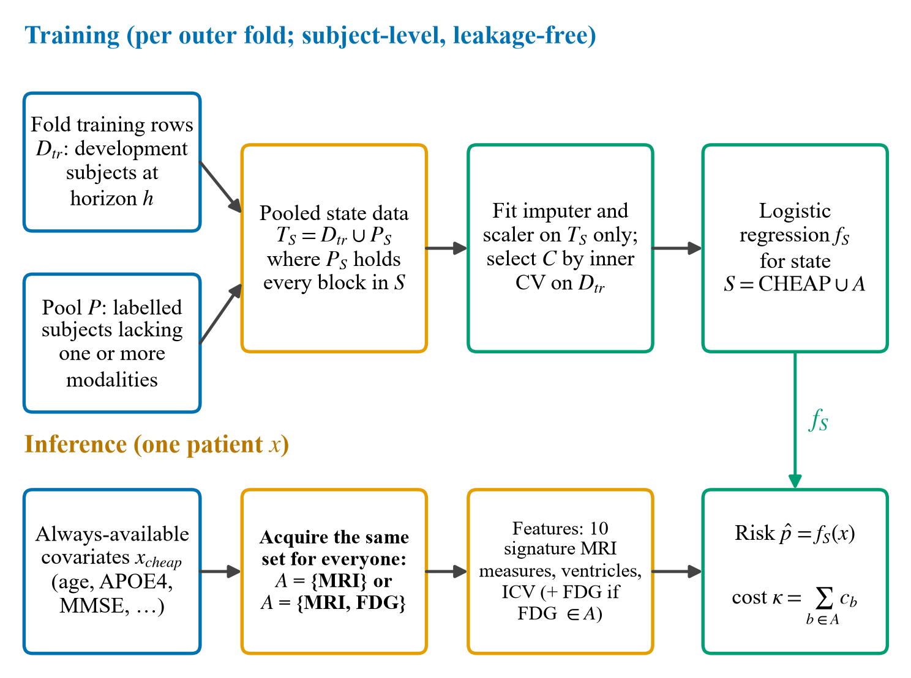
Figure 2. The proposed SPFA procedure: training (top) and inference for one patient (bottom).
The matching is by expected cost, not a strict fixed budget. Random acquisition draws a different cost for every patient, so a policy whose mean cost is $c$ is compared with random acquisition whose mean cost over 50 seeds is within 0.03, 0.01 and 0.05 units of $c$ (price-like, flat, burden; largest deviation over all policies and horizons), and whose seed-to-seed SD of mean cost is at most 0.23 units. Per-patient cost varies: at the matched rate its SD is 0.6 to 2.8 units under price-like costs, against 0.5 to 3.0 for the adaptive policies at their own cost, so the two spend with comparable spread. The same procedure is applied separately under each regime, with that regime’s cost weights and its own matched rate. Acquisition-rate disparities are tested with a bootstrap over subgroups and corrected for multiplicity using the Benjamini-Hochberg procedure [16]; with dozens of (policy, modality) comparisons, uncorrected significance is not evidence. Calibration is reported as slope, intercept and Brier score, and clinical utility as net benefit across threshold probabilities [17].
- Results and Discussion
4.1 Adaptive policies do not outperform cost-matched random acquisition
Table 3 gives cross-validated AUC by policy and horizon on the development set, and Figure 3 plots the same results as a cost-AUC frontier. Differences between policies are small and their ranking changes between horizons. Random acquisition is not a single number, because its AUC depends on how much it spends. Across the rate sweep it rises smoothly from the cheap-only value (0.816, 0.810 and 0.793 at 12, 24 and 36 months) to the acquire-all value (0.862, 0.893 and 0.898), reaching 0.846, 0.870 and 0.868 at rate 0.5 (Figure 4). Its seed-to-seed SD is 0.004–0.019 at intermediate rates, and the subject-bootstrap interval around the seed-averaged AUC has a half-width of 0.03–0.06, which is the real uncertainty in the baseline; the acquire-all AUC lies inside the rate-0.5 interval at every horizon. (A single draw of one random policy can therefore land well above or below the mean, which is why a single-rate, single-seed baseline is not informative.)
Compared with random acquisition at the same expected cost, adaptive selection gave no consistent gain. We report unadjusted and Holm-adjusted results separately (Section 3.6). Of the 27 configuration-horizon pairs for the published policies under price-like costs, unadjusted, 22 had a paired 95% interval including zero, 2 were better and 3 were worse. After Holm adjustment, 25 of 27 showed no significant difference: one was better (the RL policy at cost weight 0.05 at 12 months, AUC +0.040, 95% CI +0.016 to +0.066, adjusted $p=0.014$, which did not recur at 24 or 36 months) and one was worse (the staged evidential method’s full ladder with its own neural predictor at 12 months, −0.169, adjusted $p=0.003$). The other three unadjusted differences did not survive adjustment: losses of the evidential method’s MRI-then-amyloid variant with its own predictor at 12 and 24 months (adjusted $p=0.11$ and 0.10) and a gain of the 25%-escalation uncertainty cascade at 36 months (+0.028, 95% CI +0.002 to +0.053, adjusted $p=0.37$). All three unadjusted losses were evidential variants using that method’s own neural predictor, which is weaker than logistic regression at this sample size (Section 3.4). Under flat costs, 1 pair was better and 3 worse unadjusted, and after adjustment none was better and one worse (the same evidential full ladder); the RL gain at 12 months is not significant after adjustment under flat costs (adjusted $p=0.079$). Under burden costs, 4 were better and 2 worse unadjusted, and after adjustment 2 were better (the same RL gain, adjusted $p=0.026$, and the 25%-escalation cascade at 36 months, adjusted $p=0.035$) and one worse. The gains therefore depend on the cost regime, and neither recurs across horizons.
The reference rules tell a different story. At their own cost, fixed MRI and fixed MRI+FDG exceeded random acquisition at matched cost by +0.009 to +0.036 AUC, with unadjusted intervals excluding zero at 24 and 36 months for both rules (for example fixed MRI+FDG at 24 months, +0.034, 95% CI +0.011 to +0.058; adjusted $p=0.058$); and SPFA, which uses the same fixed acquisition rule with a better predictor, did so, unadjusted, at all horizons for MRI+FDG and, after adjustment, at 24 and 36 months for MRI-only (Section 4.4). Cheap-only and acquire-all coincide with random at rates 0 and 1 by construction. The conclusion that survives is therefore narrower than “nothing beats random”: choosing per patient adds nothing to what the same budget buys at random, whereas a fixed rule with good inputs does beat both. Random acquisition is also a stronger baseline than a single rate suggests: it costs more than most published configurations at its default rate (Table 2), so the matched comparison is the fair test, and the domination analysis in the next section is its complement, asking whether a patient-independent rule matches the policy at no greater cost.
Table 3. Cross-validated AUC by policy and horizon (development set; test set not used), with one representative configuration of each published policy (Section 3.4). Cost in relative price-like units, realised and averaged over the three horizons. The random row is the mean over 50 seeds; its seed-to-seed SD is 0.010–0.015 and its 95% subject-bootstrap CI has a half-width of 0.03–0.06 (Figure 4).
Policy | Cost | 12 mo | 24 mo | 36 mo
cheap-only | 0.00 | 0.817 | 0.810 | 0.793
fixed MRI | 1.00 | 0.836 | 0.863 | 0.849
fixed MRI+FDG | 3.00 | 0.851 | 0.886 | 0.883
uncertainty cascade [1] | 3.68 | 0.852 | 0.883 | 0.862
RL test-ordering [3] | 4.35 | 0.848 | 0.872 | 0.875
staged evidential [2] | 4.73 | 0.852 | 0.877 | 0.862
random, rate 0.5 (mean of 50 seeds) | 4.73 | 0.846 | 0.870 | 0.868
acquire-all | 9.50 | 0.862 | 0.893 | 0.898
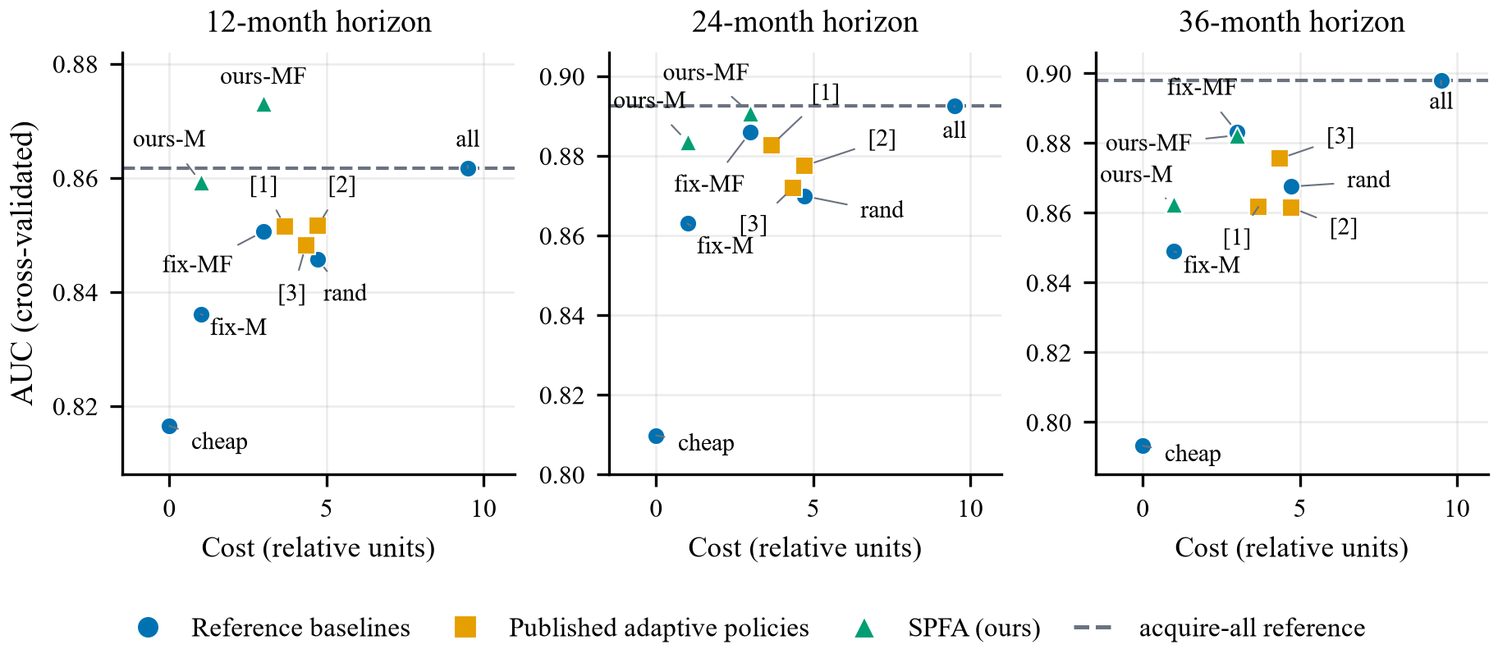
Figure 3. Cost-AUC frontier at each prediction horizon (development set, cross-validated). The dashed line marks the AUC reached by acquiring all four modalities at cost 9.5. Key: cheap = cheap-only; fix-M = fixed MRI; fix-MF = fixed MRI+FDG; rand = random acquisition; all = acquire-all; [1] uncertainty cascade; [2] staged evidential; [3] RL test-ordering (cost weight 0.01); ours-M and ours-MF = SPFA with MRI and with MRI+FDG. Published adaptive policies (squares) rarely sit above the frontier traced by the reference rules (circles); Section 4.2 counts how many are dominated.
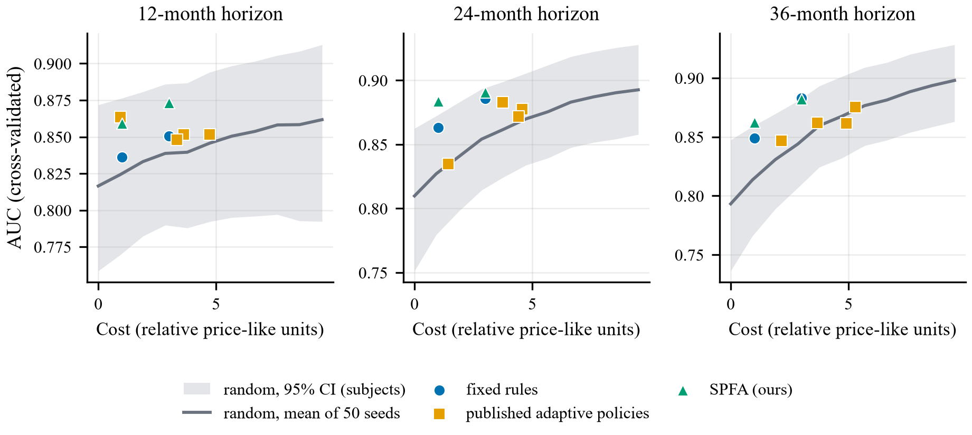
Figure 4. Cost-matched random baseline. The grey line is the AUC of random acquisition (each modality acquired independently with the rate varied from 0 to 1; mean of 50 seeds) against its realised price-like cost, with the 95% subject-bootstrap interval of the seed-averaged AUC shaded. Markers show fixed rules (blue), published adaptive policies (orange; the configurations of Table 3 plus RL at cost weight 0.05) and SPFA (green). Points above the line spend their budget better than random acquisition does.
Figure 5a shows what each policy actually orders. The uncertainty cascade sends every patient to MRI and roughly half (55%) onward to amyloid-PET, so its mean load is about 1.5 modalities. The staged evidential method acquires each of the four modalities for about half of patients (about 1.9 modalities per patient), a profile close to that of random acquisition at rate 0.5 (2.0). At cost weight 0.05 the RL policy orders MRI (40%) and CSF (28%) most often, FDG sometimes (21%) and amyloid-PET rarely (4%); at cost weight 0.01 it orders about 2.2 modalities per patient (MRI 67%, FDG 64%, CSF 62%, amyloid-PET 31%). Policies that spend like random acquisition and perform no better than it have, in effect, learned to spend rather than to select.
4.2 Learned policies are dominated by fixed rules
A stronger test than AUC alone is domination: is a learned policy beaten by a patient-independent rule that costs no more? Under price-like costs, 19 of 27 configuration-horizon pairs were dominated (4, 7 and 8 of the nine configurations at 12, 24 and 36 months), by fixed MRI+FDG (cost 3.00) in 9 cases, by cheap-only in 5 and by fixed MRI in 5. Figure 5b repeats the count under each cost regime.
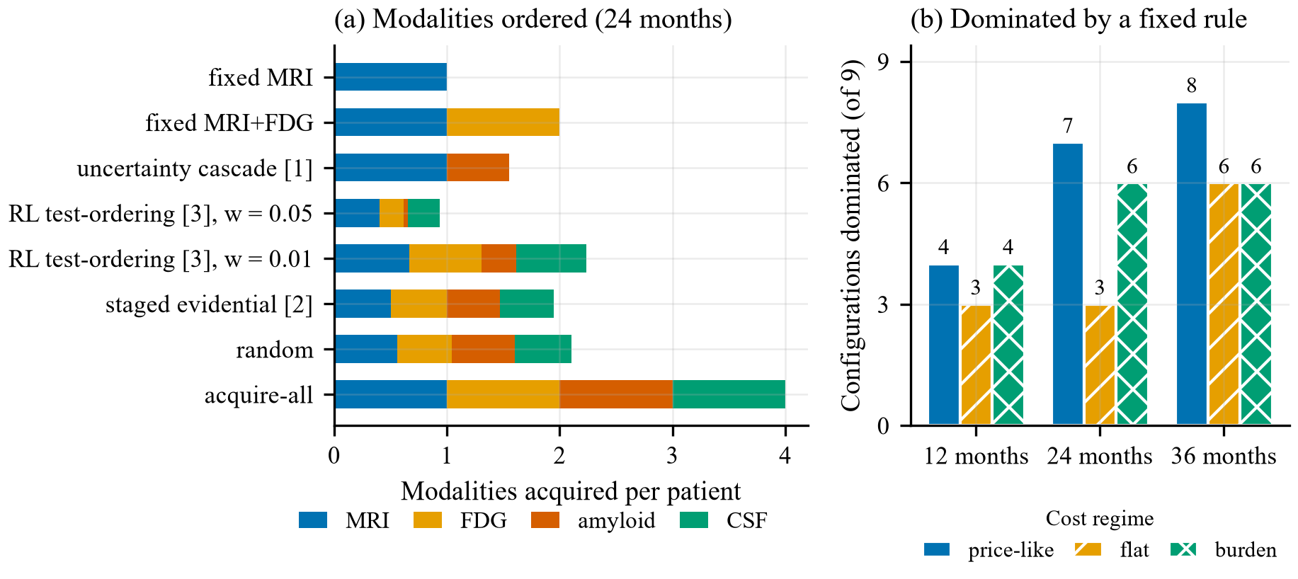
Figure 5. (a) Expected number of modalities acquired per patient by each policy in the 24-month benchmark, split by modality. (b) Number of the nine published configurations dominated by a patient-independent rule at each horizon, under each cost regime.
Domination depends partly on the cost regime, and we report it as such. Under flat costs 12 of the 27 pairs remain dominated (3, 3 and 6 at the three horizons) and under burden costs 16 (4, 6 and 6); the 12 flat-cost pairs are dominated under all three regimes. At 24 months the uncertainty cascade escapes domination under flat and burden costs, and the staged evidential method with the shared predictor under flat costs. The comparison with cost-matched random acquisition in Section 4.1 is made separately under each regime and gives the same qualitative answer under all three.
4.3 Robustness
Two further checks probe the negative result; both give every policy the same 12-measure MRI block as the main benchmark. Replacing the shared logistic regression with gradient boosting did not rescue the published policies: at 24 months two of the three representative configurations (the uncertainty cascade and RL at cost weight 0.05) were dominated, and the staged evidential method was not (0.868 at cost 4.6, against 0.855 for fixed MRI+FDG at 3.0 and 0.881 for acquire-all at 9.5). Gradient boosting lowered AUC for every policy, by 0.010 (evidential) to 0.055 (RL) and by 0.031 for fixed MRI+FDG (Figure 6b), so logistic regression was the stronger predictor at this sample size. Across random seeds 0, 7 and 42, per-policy AUC standard deviations (SDs) were 0.004–0.014 (Figure 6a); the ranking shifted between seeds, but acquire-all ranked first and fixed MRI and cheap-only last at every seed, and the best published policy ranked second at one seed and below fixed MRI+FDG at the other two.
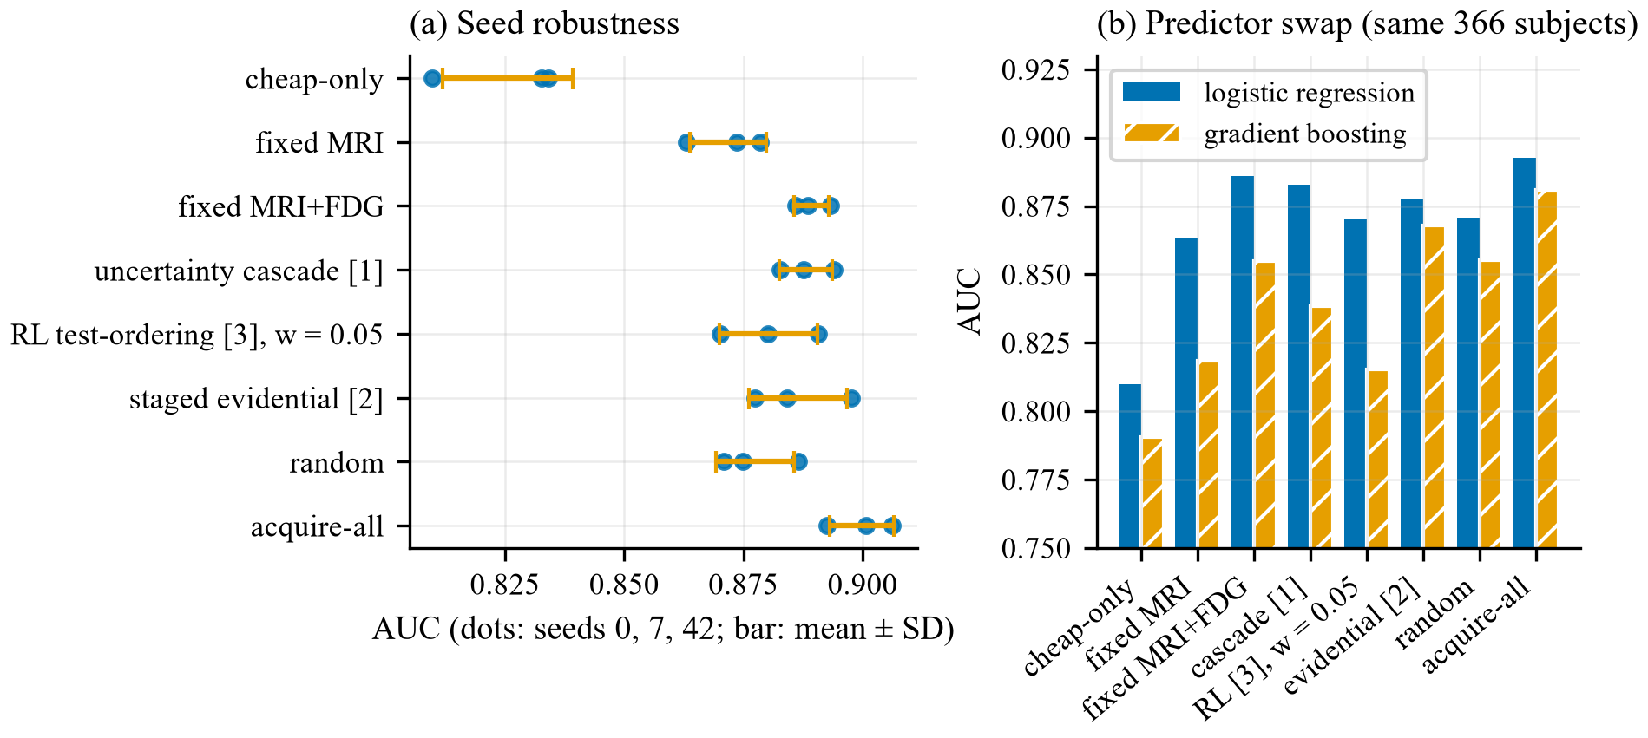
Figure 6. (a) Seed robustness at 24 months: dots are seeds 0, 7 and 42; the bar is mean ± SD. (b) AUC under the shared logistic regression and under gradient boosting on the same 366-subject cohort (seed 42). Both panels use the 12-measure MRI block.
Decision-curve analysis extended the comparison to clinical utility (Figure 7a). Every strategy delivered a clear net benefit over treating everyone at thresholds of 0.10 and above, and no published policy led consistently: the highest net benefit came from acquire-all at four of the ten thresholds (0.05, 0.15, 0.20 and 0.30), fixed MRI+FDG at 0.10, the uncertainty cascade at 0.25, and SPFA with MRI+FDG at 0.35–0.50. Where a published policy exceeded the best reference strategy (thresholds 0.25, 0.35 and 0.40) it did so by at most 0.005. Calibration slopes did not favour the published policies either: cheap-only was the best calibrated reference (slope 0.828), random acquisition scored 0.780, the three published policies ranged from 0.733 to 0.756, and acquire-all was the worst (0.725); SPFA was closest to ideal (1.080 and 1.104). Figure 7b shows reliability curves for the reference strategies and SPFA.
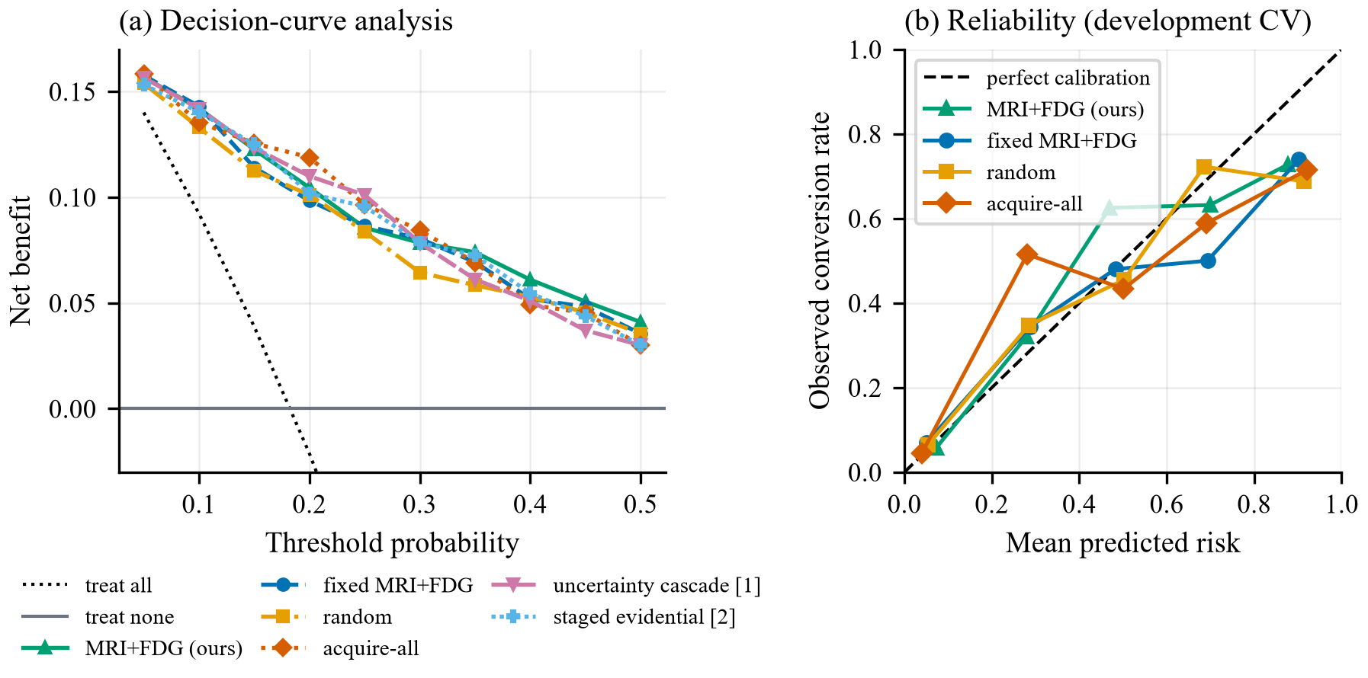
Figure 7. (a) Net benefit across threshold probabilities in the 24-month benchmark, with treat-all and treat-none references (RL policy not shown, for legibility). (b) Reliability diagram: mean predicted risk against observed conversion rate within risk bins.
4.4 The proposed configuration (SPFA)
If the savings these policies chase do not require a policy, they should be obtainable directly. Table 4 gives the nested cross-validated AUC of SPFA, which combines the expanded MRI block [10] with training each acquisition state on every participant who holds it rather than on complete cases only [11]. Neither ingredient is novel; their use as the baseline against which adaptive policies are measured is. Cost ratios refer to acquire-all (9.5 price-like units): 9.5 for MRI-only and 3.2 for MRI+FDG.
Table 4. Nested cross-validated AUC of SPFA. Nested CV re-selects regularisation within each outer fold; measured selection optimism was +0.0016 AUC. Acquire-all has no tuned hyperparameters, so its row repeats the five-fold value from Table 3.
Configuration | Cost | 12 mo | 24 mo | 36 mo
SPFA, MRI-only | 1.00 | 0.872 | 0.883 | 0.860
SPFA, MRI+FDG | 3.00 | 0.885 | 0.897 | 0.885
acquire-all (reference) | 9.50 | 0.862 | 0.893 | 0.898
These nested estimates are point estimates. The paired comparison with acquire-all (Table 5, from the five-fold development benchmark, which is not nested) shows no significant difference for either configuration at 12 or 24 months, and none for MRI+FDG at 36 months; MRI-only was significantly lower than acquire-all at 36 months. Failing to detect a difference is not evidence of equivalence, and no equivalence margin was pre-specified.
Table 5. Paired AUC difference of SPFA from acquire-all (SPFA minus acquire-all; development cross-validation; 95% bootstrap CI).
Configuration | 12 mo | 24 mo | 36 mo
MRI-only (cost 1.0) | −0.002 (−0.055, +0.059) | −0.009 (−0.035, +0.018) | −0.036 (−0.068, −0.004)
MRI+FDG (cost 3.0) | +0.011 (−0.016, +0.037) | −0.002 (−0.026, +0.021) | −0.016 (−0.040, +0.008)
Against random acquisition at the same cost (Section 4.1), SPFA with MRI only was better by +0.032, +0.056 and +0.046 AUC at 12, 24 and 36 months; the 24- and 36-month intervals excluded zero (+0.026 to +0.089 and +0.018 to +0.077) and survived Holm adjustment (adjusted $p=0.010$ and 0.016). SPFA with MRI+FDG was better by +0.040, +0.039 and +0.034, with unadjusted intervals excluding zero at all three horizons (for example +0.010 to +0.068 at 24 months) but adjusted $p$-values of 0.42, 0.097 and 0.067, so none survived adjustment. The adjustment matters: the strongest claim these data support is for the MRI-only operating point, with the MRI+FDG point suggestive.
An ablation separates the two ingredients (Figure 8), relative to the three-feature block trained on complete cases. At the 24-month horizon, the combination improves the MRI-only state by +0.034 AUC (95% CI +0.007 to +0.063). Pooled training alone gives +0.019 (+0.004 to +0.036), whose interval also excludes zero, and the expanded features alone +0.013 (−0.011 to +0.039), whose interval includes zero, so the significant part of the gain at this state is attributable to pooling. At richer acquisition states (MRI+FDG or more) the changes are within noise (at most +0.007) and slightly negative at the amyloid state (−0.009, interval including zero), so the benefit is concentrated at the cheap end of the frontier, which is where it matters for cost. Because the main benchmark already gives every policy the expanded block, the gap between SPFA and the fixed rules in Table 3 reflects pooling alone: +0.021 AUC for MRI-only at 24 months (95% CI +0.001 to +0.042), significant only at the margin.
On the held-out test set (scored at the end on two releases; Section 3.2), SPFA with MRI only reached AUC 0.944, 0.908 and 0.855 at 12, 24 and 36 months against acquire-all’s 0.928, 0.922 and 0.944. Paired against acquire-all, neither SPFA operating point was significantly worse at any horizon. The weakest case is MRI-only at 36 months (−0.089, 95% CI −0.186 to +0.000), where the upper limit sits at zero to three decimals; this weakness was visible in development and is reported rather than rounded away (Figure 9).
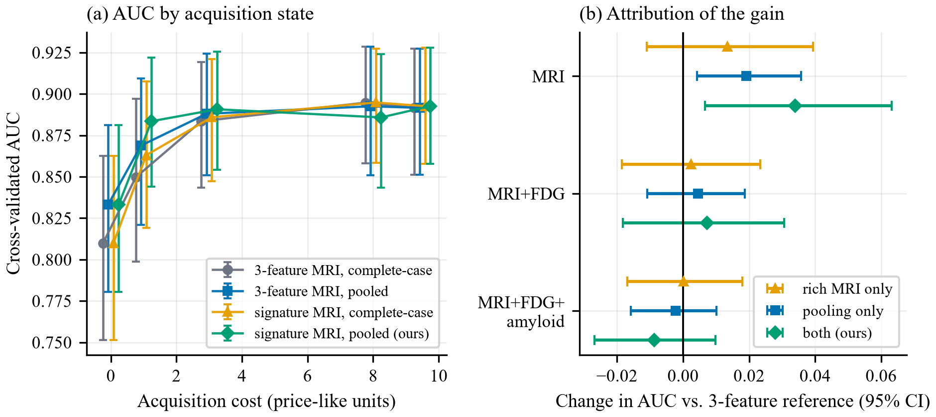
Figure 8. (a) Cross-validated AUC at each acquisition state for the three-feature and the expanded MRI block, each with and without pooled training, at 24 months (95% CI). (b) Paired change in AUC relative to the three-feature, complete-case reference for each ingredient alone and both together (95% bootstrap CI).
Three cautions attach to the test figures. The test sets are small (9, 17 and 22 converters), so “not significantly worse” is weak evidence of equivalence: the intervals are compatible with losses of up to 0.186 AUC for MRI-only at 36 months. For the two SPFA operating points, test AUC differed from the nested development estimate by −0.005 to +0.072 (largest for MRI-only at 12 months: 0.944 against 0.872), and the 12-month test set appears easier overall: all five models scored 0.066 to 0.099 above their development estimates, including cheap-only (+0.099). Two post hoc, descriptive checks (nothing was tuned on them) put this in context. First, we drew 20,000 random subsets of the development out-of-fold predictions with the same size and number of converters as each test set. The standard deviation of AUC across such subsets is 0.04–0.06 at 12 months and 0.03–0.05 at 24 and 36 months, and the observed 12-month test AUCs fall at the 92nd to 99th percentile of that distribution (24 and 36 months: 41st to 95th, with acquire-all at 36 months the highest at 94.5th); the five models share the same test subjects, so these percentiles are not independent. A 12-month gap of this size is therefore unusual but not implausible for nine converters. Second, test and development subjects were similar at baseline: standardised mean differences in age, education, MMSE, CDR-SB, APOE4 and hippocampal and ventricular volume were at most 0.23 in magnitude, and outcome prevalence matched (9.0% against 8.9%, 18.3% against 18.5%, and 25.7% against 26.2% at 12, 24 and 36 months). We therefore attribute the differences to small-sample variation rather than a real gain, but cannot exclude other causes; the nested figures in Table 4 are the ones to quote as expected performance. As a check on leakage, test subjects are excluded from the training pool by construction and the split asserts that no subject appears in two partitions; operating points, feature blocks and the regularisation grid were fixed before the test set was scored, and it was scored at the end on two releases (Section 3.2).
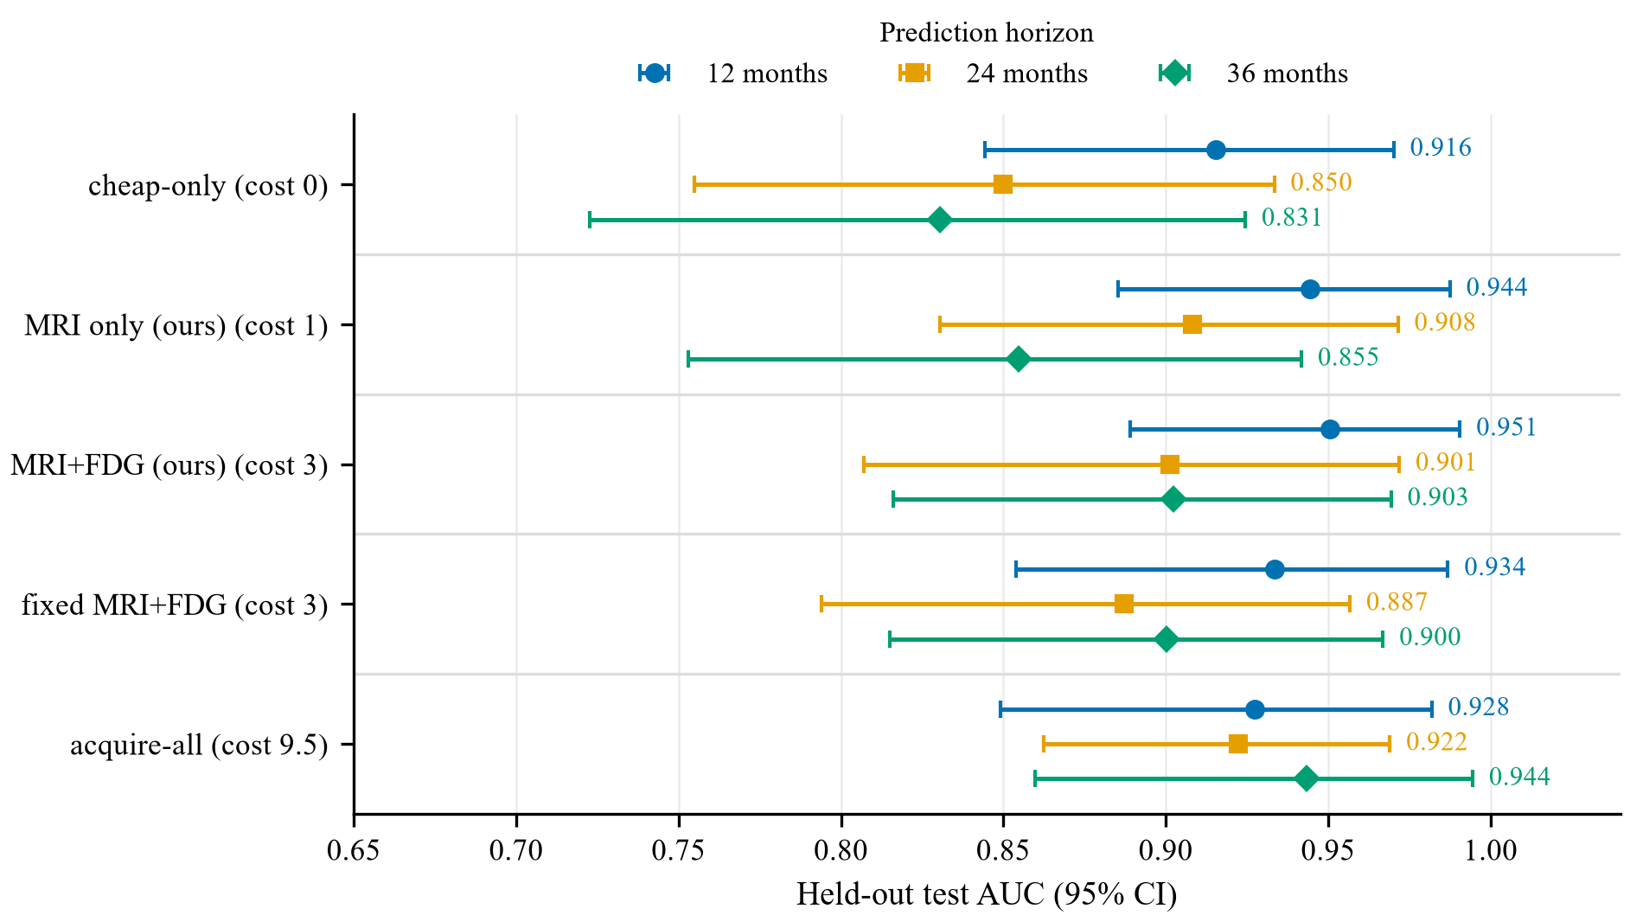
Figure 9. Held-out test AUC with 95% bootstrap CI for the proposed SPFA operating points (“ours”), fixed MRI+FDG (expanded MRI block, complete-case training), cheap-only and acquire-all, at the 12-, 24- and 36-month horizons. Intervals overlap throughout because the test sets contain only 9, 17 and 22 converters.
4.5 Representation attrition and the limits of fairness auditing
The complete-case multimodal design this literature relies on has a demographic cost that is not usually reported. Table 6 traces it, and Figure 10a plots the same attrition alongside cohort size.
Table 6. Representation attrition through cohort construction (24-month horizon). Percentages use each stage’s own $n$ as the denominator.
Stage | n | non-White (n) | non-White (%)
MCI at baseline | 1566 | 222 | 14.2
+ 24-month outcome label | 941 | 86 | 9.1
+ all four modalities | 458 | 27 | 5.9
Requiring an outcome label removes 61% of non-White participants (222 to 86), and requiring complete modalities removes most of the remainder (to 27). The mechanism is identifiable: among MCI participants, ADNI’s most recent phase (ADNI4) is 38.8% non-White, against 6.3–9.4% in ADNI1, ADNI-GO and ADNI2, a substantial recruitment improvement, but only 16.3% of its participants yet have 24-month follow-up (48–87% in earlier phases). ADNI’s diversity gains are therefore structurally invisible to conversion-prediction studies at present. Figure 10b shows how thin the non-White strata are in the audit cohort itself.
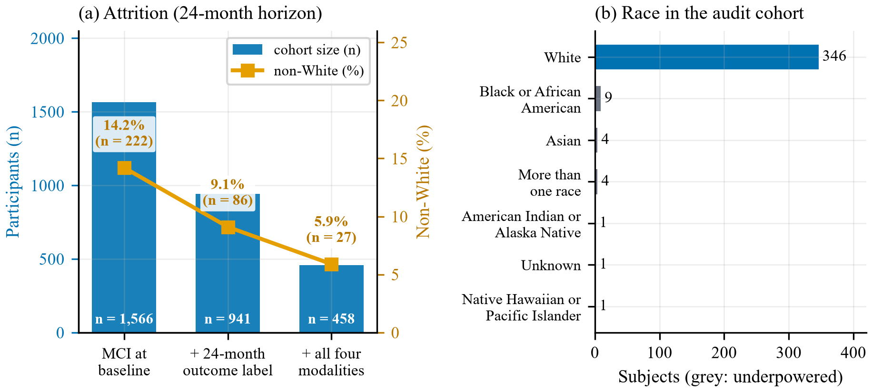
Figure 10. (a) Cohort size (blue bars, left axis) and non-White representation (orange line, right axis) at each stage of complete-case cohort construction, 24 months. (b) Participants by self-reported race in the 24-month audit cohort; grey bars mark groups too small for stratified inference.
The practical consequence is that a race-stratified fairness audit of these policies is not currently feasible: the 366-participant audit cohort contains 9 Black, 9 Hispanic and 4 Asian participants, with no converters in any of these groups, so neither acquisition rates nor error rates can be estimated with any precision. This is a limitation of the data, not a finding about the policies: reduced representation shows that these groups cannot be audited, not that the policies treat them unfairly. On sex, the only adequately powered dimension (213 male and 153 female participants), no acquisition disparity survived multiplicity correction. Two gaps reached $p=0.050$ uncorrected – the evidential method ordering FDG-PET 10.0 percentage points less often for male participants, and the RL policy (cost weight 0.05) ordering 0.23 more modalities per male participant – but neither survived Benjamini-Hochberg across the comparison family, and they are reported as suggestive only (Figure 11). We note that fixed policies cannot exhibit acquisition disparity at all, since they do not consult the patient.
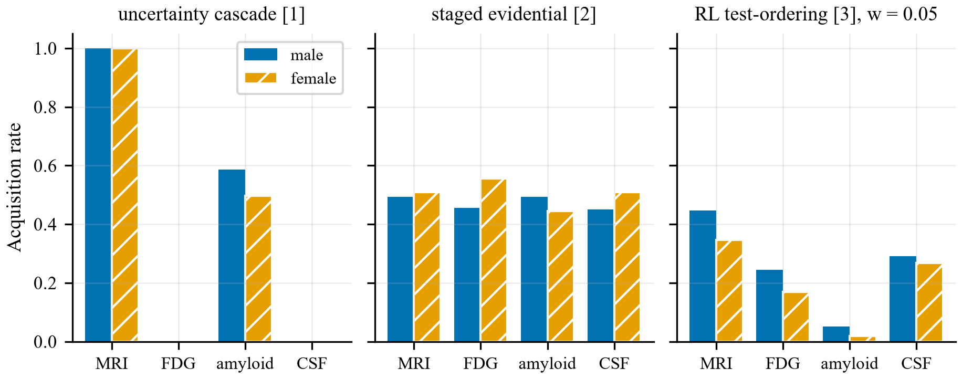
Figure 11. Acquisition rate by modality and sex for the three published policies at 24 months (RL policy at cost weight 0.05; male $n=213$, female $n=153$). No gap survived Benjamini-Hochberg correction.
4.6 Horizon dependence
A secondary analysis asked whether modality value depends on the prediction horizon, which would motivate horizon-conditioned policies. This analysis uses the same 12-measure MRI block as the main benchmark. On a fixed subject set, amyloid-PET and CSF showed a significant increase in incremental value from 12 to 36 months (+0.049, 95% CI +0.021 to +0.080, and +0.040, 95% CI +0.010 to +0.068); MRI and FDG did not (tau-PET, flagged underpowered, also increased). A horizon-conditioned policy built on this effect did not outperform horizon-swapped controls, indicating the effect is real as a measurement but not exploitable as an acquisition rule at this sample size. Figure 12 shows the incremental value of each modality by horizon (a) and on subjects matched to each modality, including all four together (b).
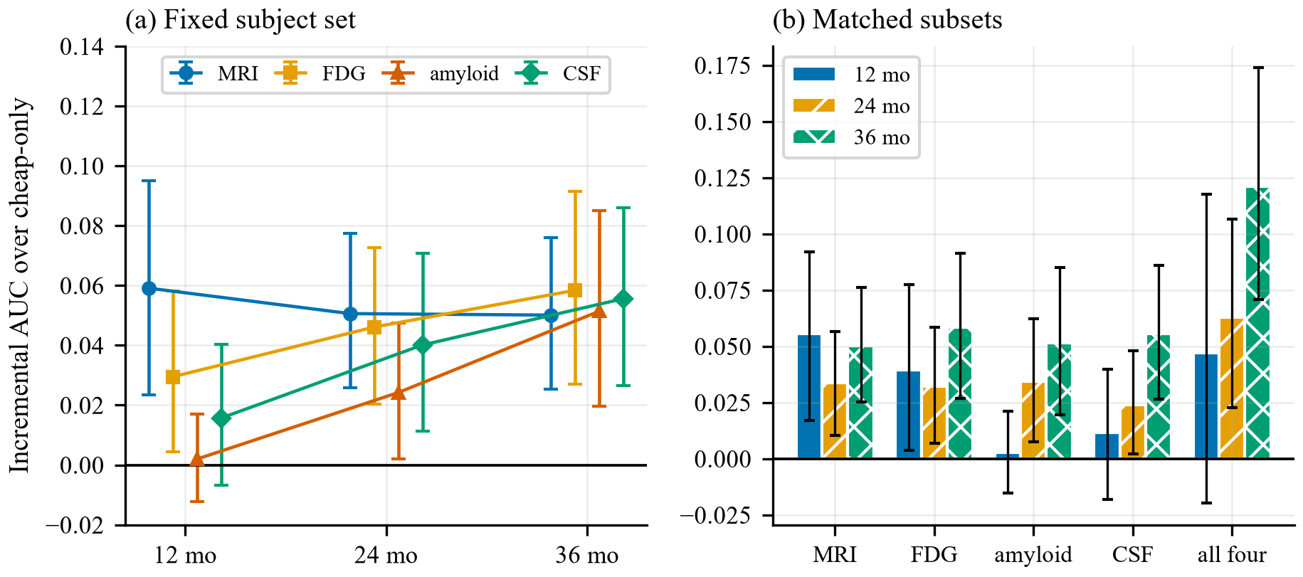
Figure 12. (a) Incremental AUC of each modality over the cheap-only model at 12, 24 and 36 months on a fixed subject set (95% CI); tau-PET omitted as underpowered. (b) The same quantity on subjects matched to each modality; the all-four estimate rises from +0.047 at 12 months to +0.121 at 36 months. Both panels use the 12-measure MRI block.
4.7 Limitations
The three policies are re-implementations from published descriptions, as no public code exists for any of them; a negative result about a re-implementation is weaker evidence than one about original code, and we state this plainly. Sample sizes are modest – 67 converters in the 24-month development cohort and 17 in its test set – so several non-significant comparisons are underpowered, and “not distinguishable” should not be read as “equivalent”. Random acquisition is matched to each policy by expected cost, not as a strict fixed budget: the matched rate is derived from the policy’s mean cost, and a policy’s per-patient cost can differ from random acquisition’s even when the means agree (Section 3.6). Comparisons against cost-matched random are Holm-adjusted within each horizon and cost regime (families of 13), but not across horizons and regimes together, and comparisons against acquire-all are unadjusted. In the proposed configuration, different acquisition states are fitted on different, overlapping subject sets, so part of the gain may reflect which subjects each state was trained on, and one FreeSurfer table treats a month-3 scan as baseline-equivalent. The held-out test set was scored on two ADNI data releases (Section 3.2) with unchanged code, so it cannot be treated as untouched with respect to the first. Acquisition costs are relative units whose absolute values are contestable, which is why every cost-dependent conclusion is reported across three regimes. ADNI’s missingness is protocol-driven rather than random, so any retrospective estimate of what could have been skipped is a simulation and not a prospective guarantee. MRI morphometry pools several FreeSurfer pipeline versions, and the results come from a single cohort without external validation.
- Conclusion
Three published adaptive modality-acquisition policies for Alzheimer’s disease prognosis were re-implemented and audited under a common leakage-free protocol across three prediction horizons and three cost regimes. Against random acquisition at the same expected cost, 25 of 27 configuration-horizon pairs showed no significant difference after Holm correction under price-like costs (one better, one worse), and 19 of 27 were dominated by a patient-independent fixed rule costing no more under price-like costs (12 under every cost regime tested). For most configurations, then, the cost savings these methods report do not appear to derive from personalisation: a rule that ignores the patient captures them as well, and so does spending the same budget at random. The one significant gain, the RL policy at cost weight 0.05 at 12 months, did not recur at 24 or 36 months.
Consistent with this, SPFA, built from two existing ideas – an expanded set of structural MRI features and training on partially observed participants – beat cost-matched random acquisition at its MRI-only operating point at 24 and 36 months, and showed no significant AUC difference from acquiring four modalities at about one-third to one-tenth of the acquisition cost, with the caveats that its cheapest operating point was significantly lower at the 36-month horizon in development and that the small test set cannot establish equivalence.
Finally, complete-case multimodal analysis reduces non-White representation in this cohort from 14.2% to 5.9%, and recent recruitment gains are not yet visible to conversion studies because those participants lack follow-up. Race-stratified fairness auditing of acquisition policies on the current complete-case ADNI cohort is therefore not feasible, a constraint the field should state explicitly rather than rediscover per study.
Future work should test these policies on prospective or more diverse cohorts, and should evaluate acquisition methods against random and cost-matched fixed baselines as a default, since neither appears in the original reports.
Funding Statement
This research received no specific grant from any funding agency in the public, commercial, or not-for-profit sectors.
Ethical Statement
This study is a secondary analysis of de-identified data obtained from the Alzheimer’s Disease Neuroimaging Initiative (ADNI). Ethical approval and participant informed consent were obtained by the ADNI investigators at each participating site. No new human-subject data were collected and no identifiable participant information was accessed. Data were used in accordance with the ADNI Data Use Agreement.
Conflicts of Interest
The authors declare no conflicts of interest.
Acknowledgement
Data collection and sharing for this project was funded by the Alzheimer’s Disease Neuroimaging Initiative (ADNI) (National Institutes of Health Grant U01 AG024904) and DOD ADNI (Department of Defense award number W81XWH-12-2-0012). ADNI is funded by the National Institute on Aging, the National Institute of Biomedical Imaging and Bioengineering, and through generous contributions from the following: AbbVie, Alzheimer’s Association; Alzheimer’s Drug Discovery Foundation; Araclon Biotech; BioClinica, Inc.; Biogen; Bristol-Myers Squibb Company; CereSpir, Inc.; Cogstate; Eisai Inc.; Elan Pharmaceuticals, Inc.; Eli Lilly and Company; EuroImmun; F. Hoffmann-La Roche Ltd and its affiliated company Genentech, Inc.; Fujirebio; GE Healthcare; IXICO Ltd.; Janssen Alzheimer Immunotherapy Research & Development, LLC.; Johnson & Johnson Pharmaceutical Research & Development LLC.; Lumosity; Lundbeck; Merck & Co., Inc.; Meso Scale Diagnostics, LLC.; NeuroRx Research; Neurotrack Technologies; Novartis Pharmaceuticals Corporation; Pfizer Inc.; Piramal Imaging; Servier; Takeda Pharmaceutical Company; and Transition Therapeutics. The Canadian Institutes of Health Research is providing funds to support ADNI clinical sites in Canada. Private sector contributions are facilitated by the Foundation for the National Institutes of Health (www.fnih.org). The grantee organization is the Northern California Institute for Research and Education, and the study is coordinated by the Alzheimer’s Therapeutic Research Institute at the University of Southern California. ADNI data are disseminated by the Laboratory for Neuro Imaging at the University of Southern California.
References
- Zheng, Z., Y. Su, K. Chen, D. Weidman, T. Wu, S. C. Lo, F. Lure, and J. Li, for the Alzheimer’s Disease Neuroimaging Initiative. “Uncertainty-Driven Modality Selection for Data-Efficient Prediction of Alzheimer’s Disease.” IISE Transactions on Healthcare Systems Engineering 14, no. 1 (2024): 18–31. https://doi.org/10.1080/24725579.2023.2227197.
- Doan, L., B. Chen, E. Litton, H. Huang, J. Huang, Y. Xie, W. Zhou, N. Narayanan, and C. Zhao. “ProMUSE: Progressive Multi-Modal Uncertainty-Guided Staged Evidential Alzheimer Disease Classification.” Preprint, arXiv:2606.19371, 2026.
- Drissi, N., N. Khalil, H. El-Kassabi, M. A. Serhani, and R. Dssouli. “Efficient Alzheimer’s Diagnosis through Sequential Decision-Making with Reinforcement Learning.” In Proceedings of the 2025 7th International Conference on Big-Data Service and Intelligent Computation, 108–16. ACM, 2025. https://doi.org/10.1145/3778265.3778280.
- Aronsson, L., A. Rahbar, and M. H. Chehreghani. “A Survey on Active Feature Acquisition Strategies.” In Proceedings of the International Joint Conference on Artificial Intelligence, Survey Track, 7740–48. IJCAI, 2026. https://doi.org/10.24963/ijcai.2026/860.
- Schütz, V., H. Wu, R. Rezvan, L. Aronsson, and M. H. Chehreghani. “AFABench: A Generic Framework for Benchmarking Active Feature Acquisition.” In Proceedings of the 32nd ACM SIGKDD Conference on Knowledge Discovery and Data Mining, 9765–76. ACM, 2026. https://doi.org/10.1145/3770855.3817493.
- von Kleist, H., A. Zamanian, I. Shpitser, and N. Ahmidi. “Evaluation of Active Feature Acquisition Methods for Static Feature Settings.” Preprint, arXiv:2312.03619, 2023.
- Rajabinasab, M., M. E. Houle, O. Chelly, and A. Zimek. “Worse than Random: The Importance of a Baseline for Unsupervised Feature Selection.” Preprint, arXiv:2605.22973, 2026.
- Perets, B., N. Mendelson, S. Vainberg, Y. Chowers, S. Shen-Orr, and S. Mannor. “Zero-Shot Active Feature Acquisition via LLM-Elicitation.” Preprint, arXiv:2606.18933, 2026.
- Marinescu, R. V., N. P. Oxtoby, A. L. Young, E. E. Bron, A. W. Toga, M. W. Weiner, F. Barkhof, et al. “TADPOLE Challenge: Accurate Alzheimer’s Disease Prediction through Crowdsourced Forecasting of Future Data.” In Multimodal Brain Image Analysis Workshop (MICCAI 2019). Springer, 2019. https://doi.org/10.1007/978-3-030-32281-6_1. Preprint, arXiv:2001.09016.
- Dickerson, B. C., and D. A. Wolk, for the Alzheimer’s Disease Neuroimaging Initiative. “Biomarker-Based Prediction of Progression in MCI: Comparison of AD Signature and Hippocampal Volume with Spinal Fluid Amyloid-Beta and Tau.” Frontiers in Aging Neuroscience 5 (2013): 55. https://doi.org/10.3389/fnagi.2013.00055.
- Thung, K.-H., P.-T. Yap, and D. Shen. “Multi-Stage Diagnosis of Alzheimer’s Disease with Incomplete Multimodal Data via Multi-Task Deep Learning.” In Deep Learning in Medical Image Analysis and Multimodal Learning for Clinical Decision Support, 160–68. Springer, 2017. https://doi.org/10.1007/978-3-319-67558-9_19.
- Young, V. M., S. Gates, L. Y. Garcia, and A. Salardini. “Data Leakage in Deep Learning for Alzheimer’s Disease Diagnosis: A Scoping Review of Methodological Rigor and Performance Inflation.” Diagnostics 15, no. 18 (2025): 2348. https://doi.org/10.3390/diagnostics15182348.
- Wen, J., E. Thibeau-Sutre, M. Diaz-Melo, J. Samper-Gonzalez, A. Routier, S. Bottani, D. Dormont, S. Durrleman, N. Burgos, and O. Colliot. “Convolutional Neural Networks for Classification of Alzheimer’s Disease: Overview and Reproducible Evaluation.” Medical Image Analysis 63 (2020): 101694. https://doi.org/10.1016/j.media.2020.101694.
- Yuan, C., K. A. Linn, and R. A. Hubbard. “Algorithmic Fairness of Machine Learning Models for Alzheimer Disease Progression.” JAMA Network Open 6, no. 11 (2023): e2342203. https://doi.org/10.1001/jamanetworkopen.2023.42203.
- Sensoy, M., L. Kaplan, and M. Kandemir. “Evidential Deep Learning to Quantify Classification Uncertainty.” In Advances in Neural Information Processing Systems, vol. 31. 2018.
- Benjamini, Y., and Y. Hochberg. “Controlling the False Discovery Rate: A Practical and Powerful Approach to Multiple Testing.” Journal of the Royal Statistical Society: Series B 57, no. 1 (1995): 289–300. https://doi.org/10.1111/j.2517-6161.1995.tb02031.x.
- Vickers, A. J., and E. B. Elkin. “Decision Curve Analysis: A Novel Method for Evaluating Prediction Models.” Medical Decision Making 26, no. 6 (2006): 565–74. https://doi.org/10.1177/0272989X06295361.
Authors' Biographies
 | Rishi Jayanath A is a final-year undergraduate student pursuing a Bachelor of Technology in Computer Science and Engineering at Karunya Institute of Technology and Sciences, India. His academic and research interests include Artificial Intelligence, Machine Learning, Deep Learning, Computer Vision, and GPU-accelerated computing. His research focuses on intelligent and explainable deep learning frameworks for real-world classification problems, including microscopic fungal species classification on the DeFungi dataset using multi-scale Vision Transformers, confidence-guided model fusion, comparative evaluation of Vision Transformer, Swin Transformer, ResNet and EfficientNet architectures, and attention-based interpretability. His broader interests include medical image analysis and intelligent computing systems, and he is particularly interested in reproducible, computationally efficient and scientifically rigorous research that combines predictive performance with explainability. He aspires to pursue further research in emerging computing technologies and intelligent systems. Email: rishijayanath@karunya.edu.in.

 | Adwaith Sajikumar is a Computer Science and Engineering student at Karunya Institute of Technology and Sciences, passionate about Artificial Intelligence, AI agents, intelligent automation and emerging technologies. His interests include AI agent development, large language models, machine learning, retrieval-augmented generation, AI-powered applications and software engineering. Through his experience at Entarch Solutions and his involvement in research, collaborative development and hackathons, he has gained exposure to software development, system design and testing. His research interests also extend to intelligent computing architectures and the practical application of AI in real-world environments. He contributes to the IEEE Computer Society as a Development Lead, engaging in technical initiatives and collaborative learning. His goal is to deepen his expertise in AI engineering, develop reliable AI-powered products, and pursue postgraduate studies in the United States. Email: adwaithsajikumar@karunya.edu.in.

 | Dr. G. Naveen Sundar is an Associate Professor in the Division of Computer Science and Engineering at Karunya Institute of Technology and Sciences. He holds a Ph.D. in Computer Science and Engineering from Anna University, an M.E. from Karunya University, and a B.E. from Manonmaniam Sundaranar University, and has been associated with Karunya since 2006. His research interests include Computer Vision, Data Science, Medical Image Processing, Machine Learning and Deep Learning. He has published 35 international journal papers and 29 national and international conference papers, with 67 Scopus citations and 102 Google Scholar citations (h-index 6). He has guided 13 postgraduate research scholars and currently supervises seven Ph.D. scholars. His contributions include participation in the HALECOM project funded by Boston Children’s Hospital, Harvard Medical School, USA, a published Indian patent application on Target Protein Prediction for Infectious Diseases, and the book Problem Solving using Python (Charulatha Publisher, 2024). Email: naveensundar@karunya.edu.

 | Dr. D. Narmadha is an Associate Professor in the Division of Artificial Intelligence and Machine Learning at Karunya Institute of Technology and Sciences. She holds a Ph.D. in Computer Science and Engineering from Sathyabama Institute of Science and Technology (2021), an M.Tech. from Karunya Institute of Technology and Sciences (2011), and a B.E. from Francis Xavier Engineering College (2006). Her research interests include Machine Learning, Deep Learning and Computer Vision, and she teaches Machine Learning, Database Management Systems, Soft Computing, Data Visualization and Data Science. She has contributed 21 international journal publications and 28 national and international conference publications, with 71 Scopus citations and 99 Google Scholar citations (h-index 5), and is a patent contributor for Target Protein Prediction for Infectious Diseases (December 2021). She has guided three postgraduate and 18 undergraduate scholars and continues to supervise doctoral and undergraduate research scholars. Email: narmadha@karunya.edu.

