SOC Telemetry & Kafka Integration Design Specification
A Server-Side Engineering Design Document for Multi-Source Telemetry Ingestion, Fault-Tolerant Processing, and Tiered Archival Storage
──────────────────────────────────────────────────────────────────────

System Architecture & Design Questions
This document details the architectural decisions and system design patterns for ingesting high-throughput security event logs from host endpoints into an Enterprise Security Operations Center (SOC). From a server-side engineering perspective, building a pipeline that is resilient, scalable, and highly queryable requires addressing several database, queuing, and data serialization challenges. Below are the design specifications addressing the nine core questions of this integration.

1) Ingesting 10 Different Logs Collected for a Single Endpoint
To successfully collect and push 10 different log types (e.g., DNS Queries, Process Creations, Network Sockets, Registry Changes, Windows Event Logs, File Operations, System Resource Metrics, Active User Sessions, Firewall Violations, and Kernel Audit Records) from a single endpoint, we design a unified host shipper/collector agent on the endpoint (e.g., Filebeat, Vector, or a custom daemon). Instead of transmitting these logs as independent, unstructured events, the agent serializes them into a unified, structured JSON metadata envelope. This envelope acts as a common contract between the endpoint and the backend server, attaching universal metadata to allow cross-log correlation:
- Global Envelope Headers: Contains universal telemetry attributes: `event_id` (UUIDv4), `timestamp` (event_time in UTC), `log_type` (e.g., DNS, PROCESS), and `endpoint_id` / `hostname`.
- Polymorphic Payload Wrapper: Contains an inner `data` object whose schema varies dynamically based on the `log_type` (e.g., process command line for process logs, destination port for firewall logs).
- Sender Buffer & Batching: To minimize network overhead and socket exhaustion, the agent buffers logs in local memory and sends them in compressed batches (micro-batches) to the ingestion server via TCP/TLS sockets.

2) Handling Log Subtypes, Details, and Depths
Each log type has unique subtypes, nested details, and varying depth levels. For example, a Process Log may have subtypes like `CREATION`, `TERMINATION`, or `INJECTION` and contain deep metadata such as code-signing certificates and execution chains. To manage this complexity without schema conflicts, we design a hierarchical polymorphic schema (e.g., JSON Schema, Avro, or Protobuf):
- Nested Objects: The root envelope defines common metadata, while subtype-specific attributes are encapsulated in nested sub-objects. This maintains a stable root structure while supporting deep nested fields (e.g., `data.process.parent_process.hashes.sha256`).
- Taxonomy Standardization: We map fields to a consistent standard like the Elastic Common Schema (ECS). This ensures variables across different operating systems (such as `username`, `login_user`, or `uid`) map to a single consistent database column (e.g., `user.name`).

3) Managing Asynchronous and Out-of-Order Log Arrival
Because of network latency, endpoint buffering, or offline hosts catching up on reconnection, logs may arrive at the ingestion server out of chronological order. To handle this, the server-side pipeline implements a three-timestamp model:
- 1. Event Time (event_time): The UTC timestamp when the event actually occurred on the client endpoint. This is the source of truth for correlation.
- 2. Ingestion Time (ingest_time): The UTC timestamp when the Kafka broker received the record. Used to measure system ingestion latency.
- 3. Processing Time (process_time): The UTC timestamp when the database consumer parsed and wrote the record. Used for ingestion audits.
Handling Strategies:
• Database Ordering: The primary database uses event_time as its sorting and partitioning key, ensuring analyst queries are chronologically correct, regardless of arrival delays.
• Watermarking / Windowing: Stream processing frameworks (like Flink or Kafka Streams) evaluate time-based correlations (e.g., detecting lateral movement within a 1-minute window) using Watermarks. Watermarks allow a predefined 'grace period' for late-arriving logs to ensure correlation logic triggers accurately.

4) Storing Log Data Effectively
Relational databases (OLTP) crash under the massive, sustained write rates of security event logging. To store SOC telemetry effectively, we design a tiered storage model utilizing a Columnar Time-Series Database (e.g., ClickHouse or TimescaleDB):
- Columnar Storage: Columnar engines group data on disk by column rather than row. This is ideal for security logs, which have many fields but are queried on only a few columns at a time (e.g., 'Find all process names for IP 192.168.1.50'). This layout achieves 5x to 10x compression ratios, dramatically reducing hardware costs.
- Composite Indexing: We define a primary composite index: `(event_time, endpoint_id, log_type)`. This optimizes typical security queries, allowing the database engine to skip scanning unrelated files and retrieve data in milliseconds.
- Typed Fields: Raw log strings are parsed into typed columns (e.g., IPv4/IPv6 data types for IPs, Low Cardinality enums for log types), avoiding slow regular expression operations during analytics queries.

5) Offset Management & Crash Recovery (Fault Tolerance)
To ensure that a consumer recovers gracefully from crashes without losing logs or inserting duplicates (Exactly-Once Semantics), we implement manual offset commit management inside Apache Kafka combined with database idempotency constraints:
- Disable Auto-Commit: We set `enable.auto.commit = False` in the Kafka consumer configuration. This prevents Kafka from automatically advancing the partition cursor before the logs are safely stored in the database.
- Post-Write Commit Cycle: The consumer pulls a batch of messages, parses and enriches them, and writes them to the database. Only after the database returns a successful write acknowledgment (ACK) does the consumer synchronously commit the offset back to Kafka (`consumer.commit()`).
- Idempotent Writing: If the consumer crashes after writing the logs to the database but before committing the offset to Kafka, the re-started consumer will re-read and attempt to re-write the same batch. To prevent duplicate records, the database uses the log's unique `event_id` (UUIDv4) as a unique constraint or primary key. On conflict, the database ignores or updates the existing entry, ensuring data integrity.

6) Real-Time Formatting and In-Stream Enrichment (No Raw Storage)
Storing raw, unparsed logs directly in a database is highly inefficient because it requires expensive runtime parsing during searches. Our architecture uses an in-stream parsing and enrichment model inside the consumer application before database ingestion:
- Structured Schema Conversion: Raw string values (e.g., syslog messages) are parsed using regex, grok filters, or schema definitions and converted into structured objects.
- Memory-Cached GeoIP & WHOIS Lookups: To enrich events without slow API calls, the consumer queries local memory-mapped databases (e.g., MaxMind MaxISP cache) and persistent WHOIS cache tables to map IPs to locations/ASNs and domains to registration ages.
- High-Speed Threat Intelligence Matching: Domains and IPs are matched against local blacklists and Threat Intelligence feeds stored in high-performance in-memory databases (e.g., Redis) before ingestion.

7) Retention Policy and Archival Storage (Tiered Storage)
To manage costs while meeting long-term security compliance standards, we implement an Index Lifecycle Management (ILM) flow consisting of three distinct tiers:
Storage Tier | Age Range | Hardware Media | Operational Performance
Hot (Active) | 0 – 15 Days | High-Speed SSDs (Primary DB) | Sub-second analytical queries, active incident investigation.
Warm (Searchable) | 16 – 90 Days | High-Capacity HDDs | Compressed DB tables, slower threat hunting and trend mapping.
Cold (Archival) | 91+ Days | S3 / MinIO Object Storage | Exported as compressed columnar Parquet files. Queryable via S3 Athena/DuckDB.

8) Kafka Topic & Partition Design
To manage high throughput and enable parallel processing while preserving the chronological order of endpoint events, we use the following Kafka Topic and Partition design:
- Topic Allocation: We define exactly two topics to separate typical data from high-priority security findings:
• `dns-events-raw`: Handles high-volume, routine activity logs (benign traffic, typical resolutions) used for historical searches and baseline modeling.
• `dns-alerts`: Dedicated to high-severity findings (DGA, Tunneling, Typosquatting, known malware indicators) requiring immediate ingestion, security analyst alerts, and incident response routing.
- Partition Count: We configure each topic with 3 partitions. This supports horizontal scaling, allowing up to 3 consumer instances per consumer group to read and process events in parallel.
- Partitioning Key Strategy: We use `endpoint_id` (or `hostname`) as the message routing key. Kafka hashes this key using MurmurHash2 and routes it:
Partition = Hash(endpoint_id) % Total Partitions
This guarantees that all logs from a single endpoint map to the same partition and are processed sequentially. This is crucial for timeline reconstruction during incident investigations.

9) Kafka Integration Payload Schema Diagram
The following diagram illustrates the structured Kafka payload schema. It shows how the client endpoint bundles the Message Key (for partition hashing) and the Message Value (structured JSON containing system metadata, telemetry details, host context, and real-time security alerts) for ingestion.
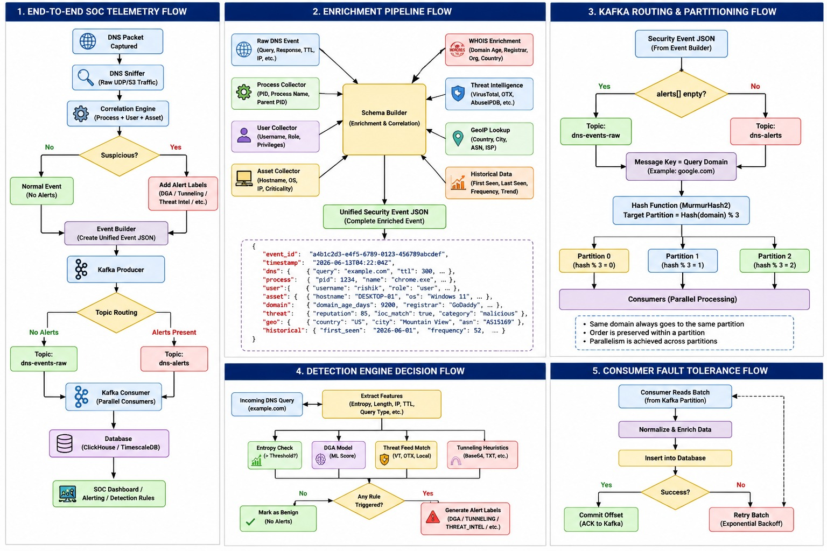
Figure 9.1: Unified Kafka Message Schema Envelope & Partitioning Strategy

