
SHRI VILE PARLE KELAVANI MANDAL’S
SHRI BHAGUBHAI MAFATLAL POLYTECHNIC
& COLLEGE OF ENGINEERING

INFORMATION TECHNOLOGY DEPARTMENT

SELF LEARNING ASSESMENT MINI PROJECT REPORT
Submitted in partial fulfillment of the requirements of the
DIPLOMA course by:

NAME OF THE STUDENT | Rishik Jariwala
ROLL NO | T023
SAP ID | 57508240026
PROJECT TOPIC | KutumbSetu-  https://github.com/rishik-123/Final-Year-Project-Kutumbsetu.git
COURSE | # Development & Operations (DEV230913)
SEMESTER | V
ACADEMIC YEAR | 2026 - 2027
ACADEMIC TERM | 01/07/2026 – 19/10/2026
NAME OF THE DEPARTMENT | INFORMATION TECHNOLOGY

SIGNATURE OF FACULTY

SHRI VILE PARLE KELAVANI MANDAL’S
SHRI BHAGUBHAI MAFATLAL POLYTECHNIC
& COLLEGE OF ENGINEERING

INFORMATION TECHNOLOGY DEPARTMENT

FIFTH SEMESTER

Course: # Development & Operations (DevOps) |  | Course Code: DEV230913

CO No. | COURSE OUTCOME
CO1 | Recognize basic concepts of Development & Operations.
CO2 | Interpret and apply various principles, phases, and activities of Agile methodology.
CO3 | Manage Source Code using Version Control System.
CO4 | Build applications using the process of Continuous Integration.
CO5 | Perform automated testing of DevOps application.
CO6 | Use Configuration Management tools using Containerization.

SHRI VILE PARLE KELAVANI MANDAL’S
SHRI BHAGUBHAI MAFATLAL POLYTECHNIC
& COLLEGE OF ENGINEERING

CERTIFICATE

THIS IS TO CERTIFY THAT
MR. RISHIK JARIWALA
HAS SATISFACTORILY COMPLETED HIS SELF LEARNING ASSIGNMENT IN PARTIAL FULFILMENT OF THE REQUIREMENTS OF THE
DIPLOMA COURSE IN INFORMATION TECHNOLOGY

FACULTY | HEAD OF DEPARTMENT (I.T.) | PRINCIPAL

SHRI VILE PARLE KELAVANI MANDAL’S
SHRI BHAGUBHAI MAFATLAL POLYTECHNIC
& COLLEGE OF ENGINEERING

INFORMATION TECHNOLOGY DEPARTMENT

INDEX

Sr.no | Topics | Page No
1. | Project Overview & Objectives  1.1 Project Description (KutumbSetu Mobile Application)  1.2 Objectives of DevOps SLA Implementation  1.3 System & Software Requirements
2. | Task 1: Version Control Management using Git & GitHub  2.1 Repository Setup & Remote Linking  2.2 Working Tree Shelving: Git Stash Push Operation  2.3 Restoring Shelved State: Git Stash Pop Operation  2.4 Synchronizing Code: Git Remote Push to GitHub  2.5 Verification on GitHub Web Portal
3. | Task 2: Continuous Integration with Jenkins on Windows  3.1 Jenkins Installation & Environment Configuration  3.2 Jenkins Appium Plugin & Tool Setup  3.3 Creating the Automated Build Pipeline  3.4 Build Execution & Console Output Analysis  3.5 Verification: Serving & Launching the KutumbSetu Homepage
4. | Task 3: Automated Functional Testing using Selenium  4.1 Appium WebDriver & uiAutomator2 Setup on Windows  4.2 Test Script Design  4.3 Automated UI Test Cases  4.4 Test Execution Results & Assertion Reports
5. | Task 4: Containerization & Database Connectivity with Docker  5.1 Dockerizing Authentication Service  5.2 Multi-Container Orchestration using Docker Compose  5.3 Establishing Database Connectivity with MongoDB  5.4 Container Build, Deployment & Live Service Verification  5.5 Testing User Registration & Data Persistence in Database
6. | Task 5: Configuration Management & Automation using Ansible  6.1 Ansible Control Node & Inventory Configuration  6.2 Writing the Automation Playbook  6.3 Automated Installation of Required Project Software  6.4 Execution Logs, Idempotency & Version Verification
7. | DevOps Pipeline Integration Summary & Learning Outcomes
8. | Conclusion & Future Scope
9. | References & Documentation Link

1)PROJECT RELATED INFORMATION
1.1)Project Description(KutumbSetu)
KutumbSetu is a secure community management platform designed to digitally transform the administration of community organizations, trusts, and social groups. Many communities still rely on paper registers, spreadsheets, and manual processes to manage donations, member records, receipts, announcements, and family information, resulting in inefficiency, data redundancy, and lack of transparency. The proposed system provides a centralized mobile application where administrators can manage donor records, generate digital receipts, maintain member directories, publish community updates, visualize donation analytics, and represent family relationships through an interactive family tree. The application also includes role-based access control to ensure secure and authorized data management. By digitizing community operations, KutumbSetu aims to improve transparency, simplify administration, strengthen communication, and provide an organized platform for community members. The project uses Flutter and Dart for mobile application development, Node.js and Express.js for backend services, and MongoDB for database management. The DevOps activities include maintaining the project on GitHub, installing Jenkins on Windows, testing the mobile application using an approved automation tool, creating a Docker image for the login/registration component with database connectivity, and automating software installation using Ansible or Chef.These activities demonstrate how version control, continuous integration concepts, automated testing, containerization and configuration management can support a more organized software development process.

1.2)Objectives of Devops SLA Implementation
The main objectives of this DevOps SLA are:
- To maintain the KutumbSetu project source code using Git and GitHub.
- To understand and demonstrate Git operations such as push, pull and pop-related workflows.
- To install Jenkins on Windows and demonstrate the execution of the application's home page or a suitable project build.
- To test the KutumbSetu mobile application using Appium or another faculty-approved testing tool.
- To create a Docker image for the login/registration component and demonstrate database connectivity.
- To automate the installation and configuration of required project software using Ansible or Chef.
- To understand the role of automation, version control, testing and containerization in software development.
- To document the implementation process with commands, configuration files, screenshots and test results.

1.3)System and Software Requirements
The project requires software development tools, source-control utilities, automation tools, a database and suitable computer hardware. The exact requirements depend on the selected testing and configuration-management tools.
Software / Tool | Purpose
Windows 10/11 | Operating system for development and tool installation
Flutter SDK and Dart | Mobile application development
Android Studio / Android SDK | Android build tools and emulator/device support
Visual Studio Code | Source-code editing and project management
Git | Version control and repository operations
GitHub | Remote source-code repository and collaboration
Node.js and npm | Backend runtime and dependency management
Express.js | Backend API development
MongoDB | Database storage
Jenkins | Build and execution automation
Appium or approved alternative | Mobile application testing
Docker Desktop | Container image creation and execution
Ansible or Chef | Software installation and configuration automation
Postman | Optional API testing and verification
Web browser | Accessing Jenkins, GitHub and web-based interfaces

Hardware Requirements
The following are suggested development requirements, not measured specifications of your computer.
Component | Suggested requirement
Processor | Intel Core i3 or equivalent; i5/Ryzen 5 recommended
RAM | 8 GB minimum; 16 GB recommended for emulators and containers
Storage | At least 20–30 GB of free space for project tools and build files; additional space may be required
Display | 1366 × 768 or higher
Internet | Stable connection for downloading dependencies and using GitHub
Android device | Optional, for testing the application on physical hardware
USB cable | Optional, for connecting a physical Android device

TASK1:Version Control Management using Git and Github

4.1 Git and GitHub
Git is a distributed version-control system used to track changes in source code. It allows developers to create commits, compare changes, restore earlier versions and work with branches.
GitHub is a cloud-based platform used to host Git repositories. It allows project code to be stored remotely and shared with other developers.
In KutumbSetu, Git and GitHub can be used to maintain the Flutter source code, backend code, configuration files and documentation. They also provide a way to recover committed code if an accidental deletion occurs.

2.1) Repository setup and remote linking:Here we connected our locl rpeo to the central repo creted of our project on github.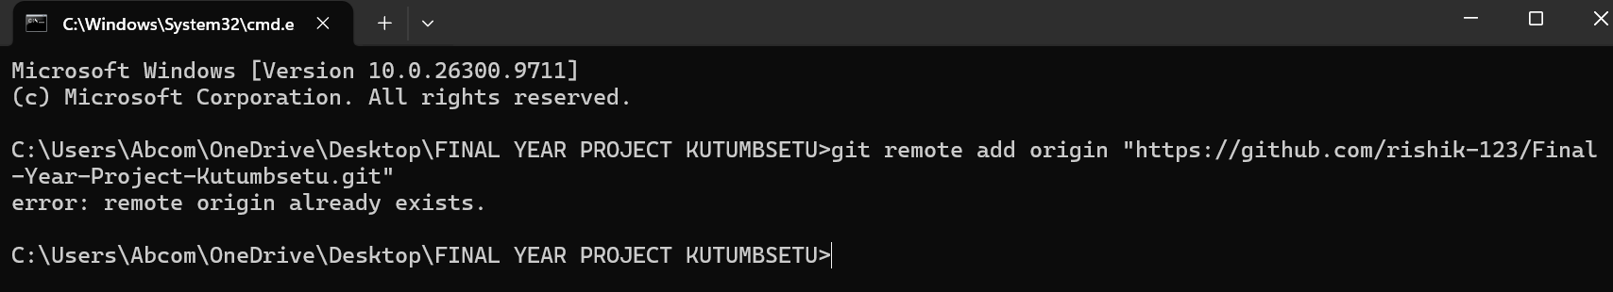
2.2)The github repo long with sample code
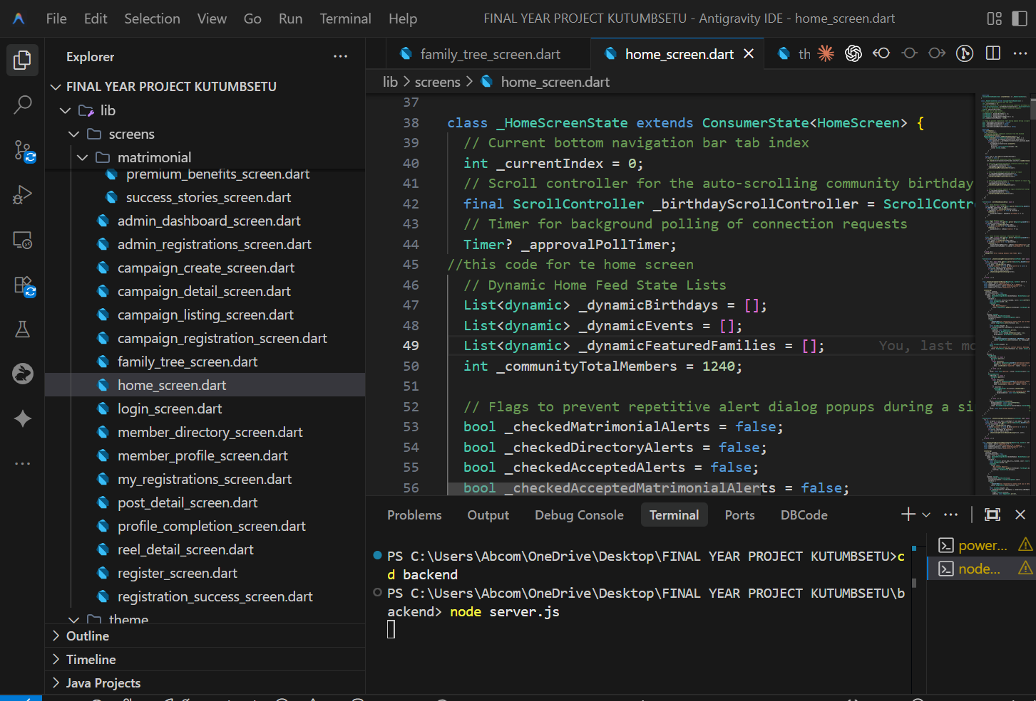
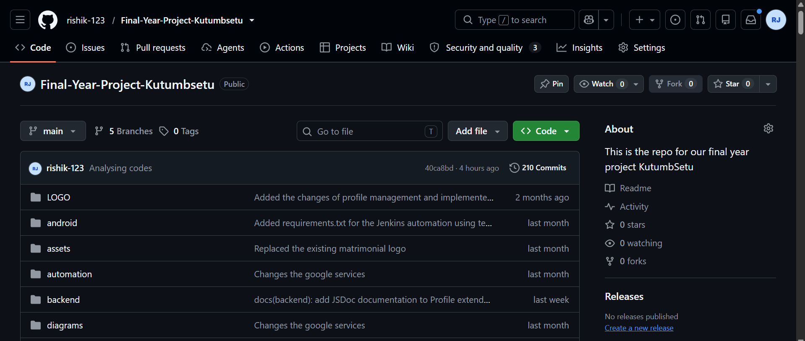
2.3)GIT push operation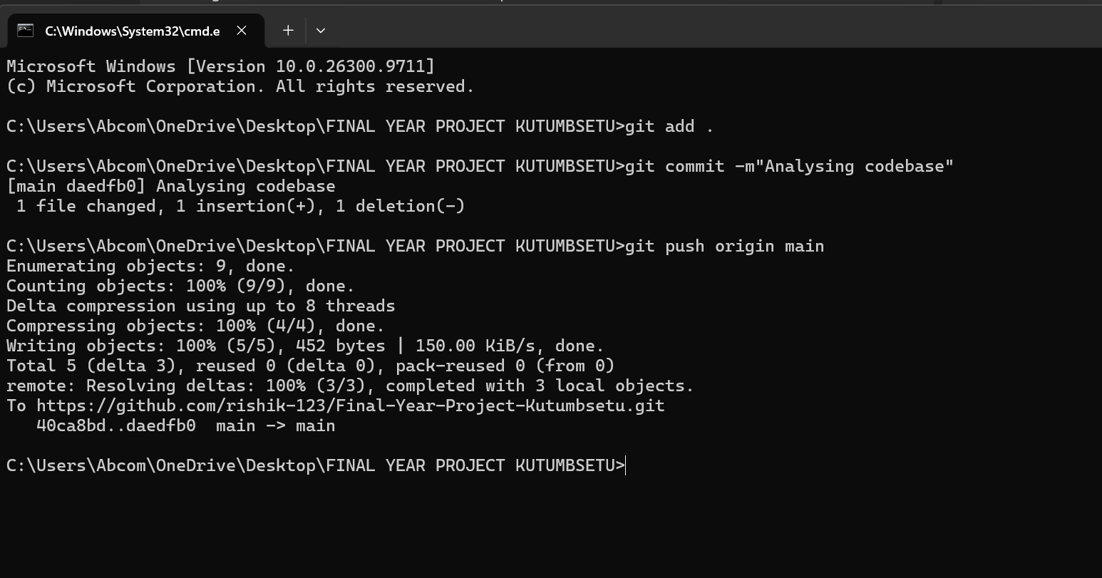
2.4)PULL OPERATION
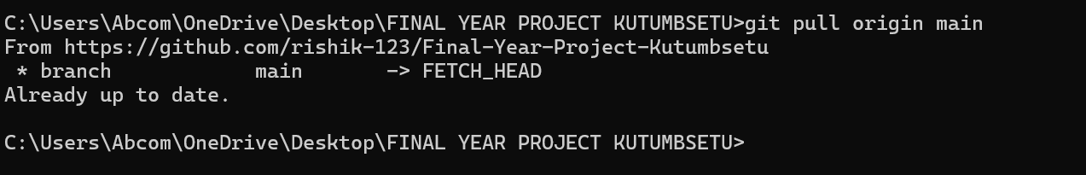

2.5)Synchronizing the git push and verification on portal
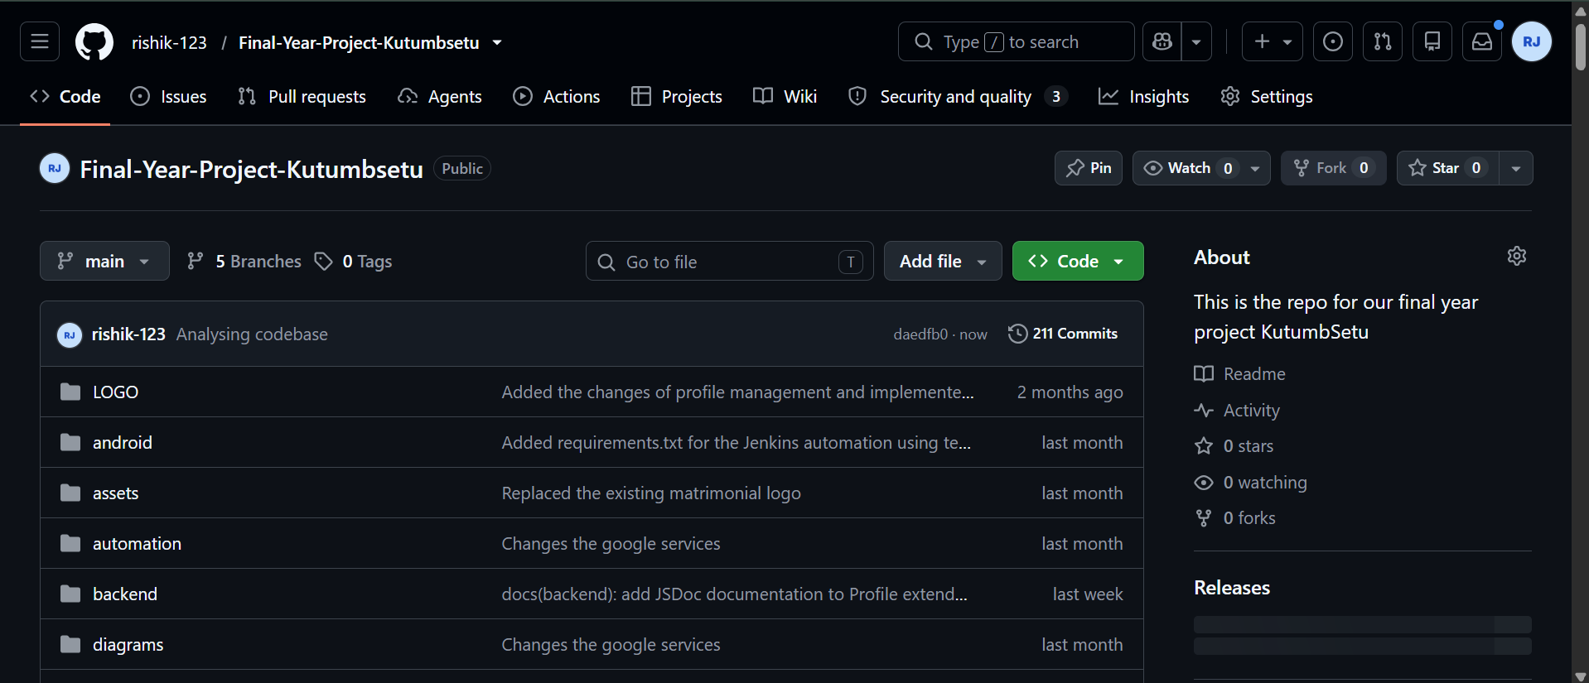

TASK2 :Continuous Integration with Jenkins on Windows

4.2 Jenkins
Jenkins is an automation server used to execute repeatable software-development tasks. It can run build commands, perform tests and execute configured jobs.
For this SLA, Jenkins is installed on Windows. A suitable job can be configured to run a command, build a component or launch a project page, depending on the project's architecture and the task requirements.
Jenkins can later be integrated with GitHub so that source-code changes trigger automated builds.
3.1 Jenkins Installation and Environment Configuration
Since Jenkins was already installed no screnshots have been attached explicitly
3.2 Enviornment Configuration and Jenkins Appium Configuration and Tool Setup
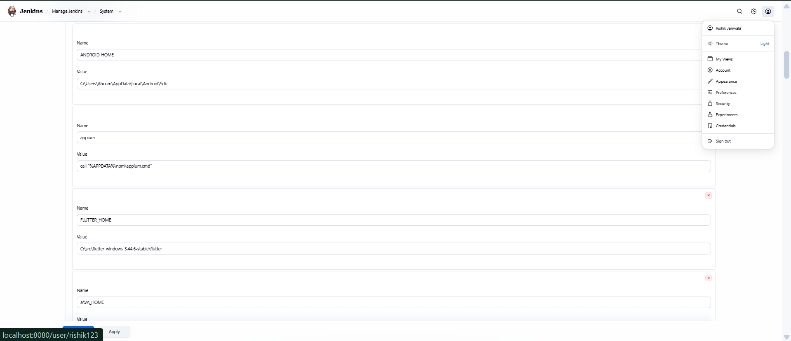
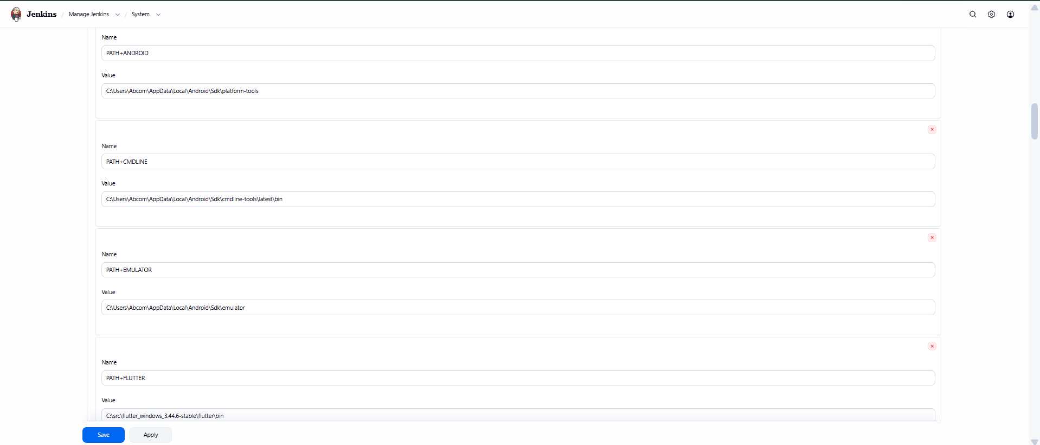
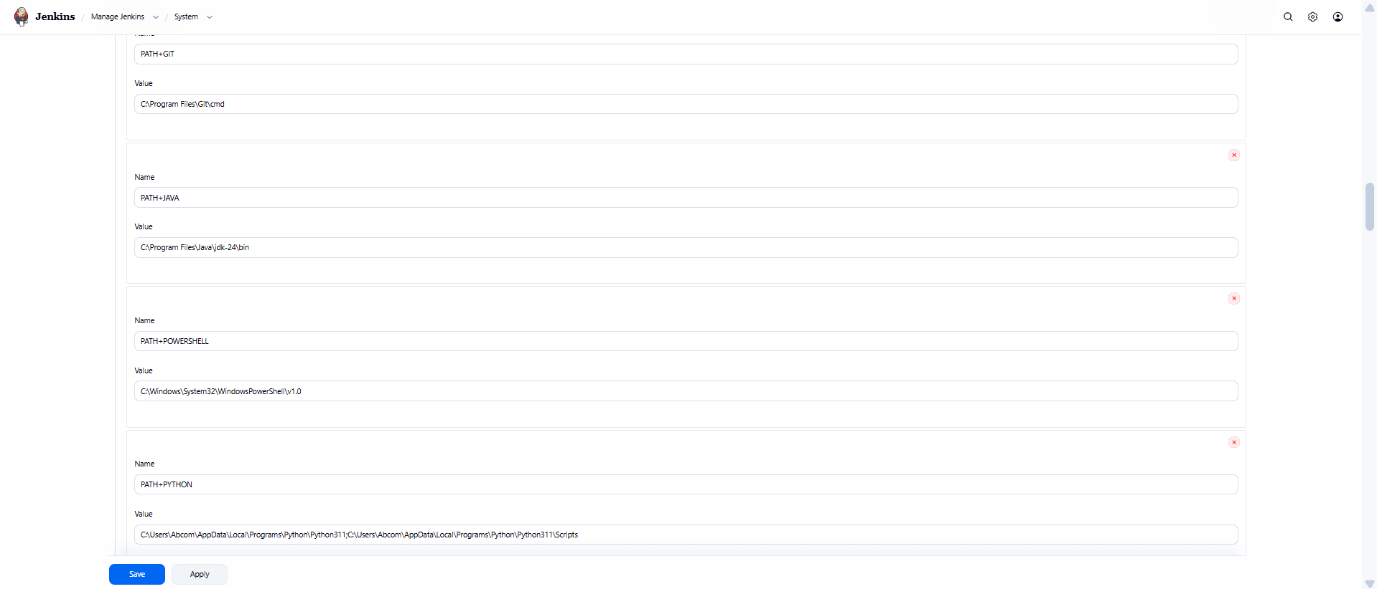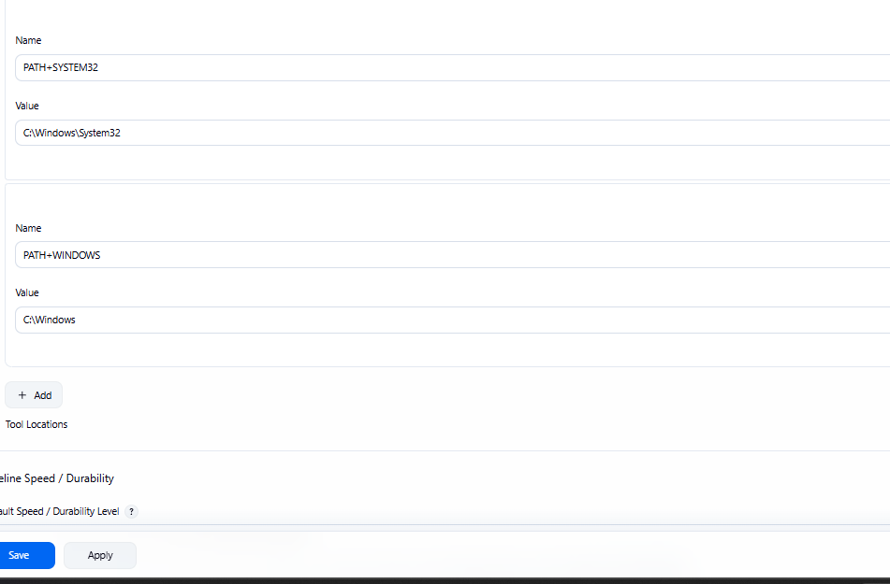
3.3)Created a project automated build pipeline
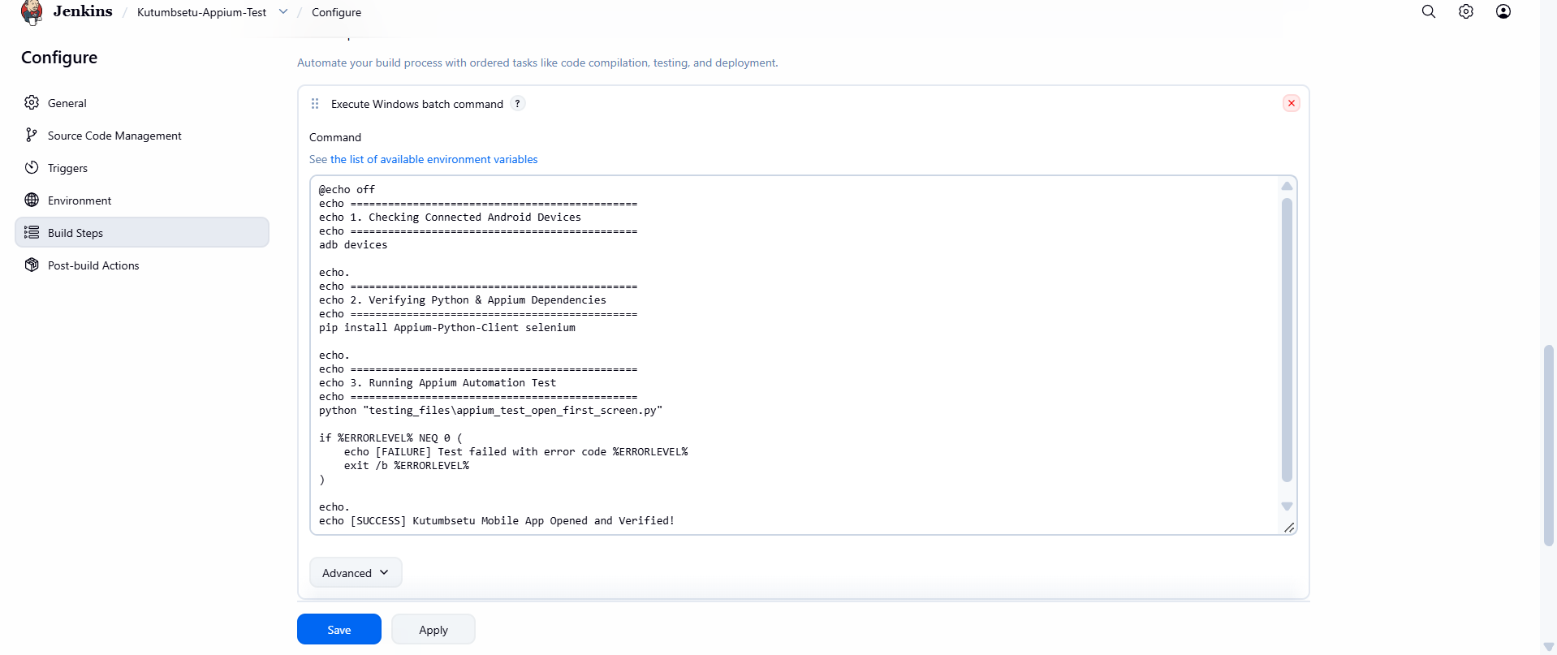
3.4)Build Execution and Console Output Analysis
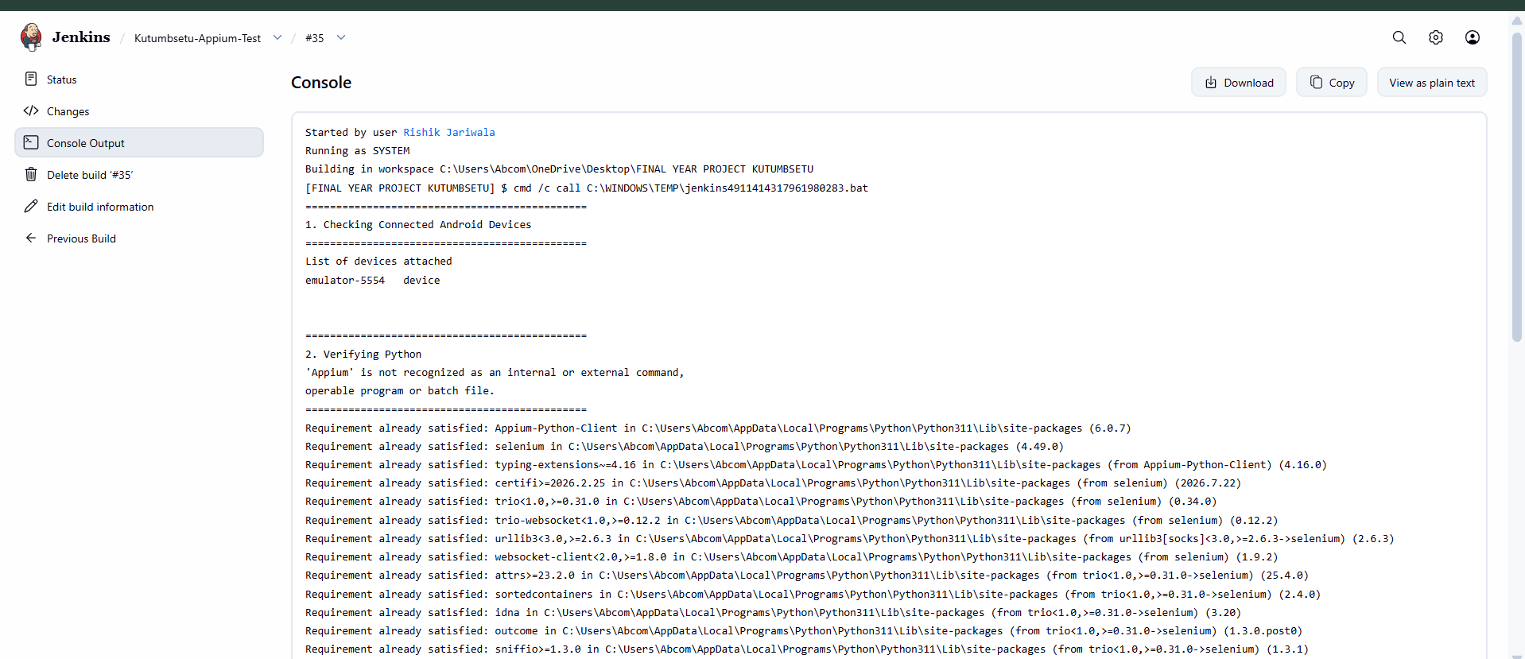
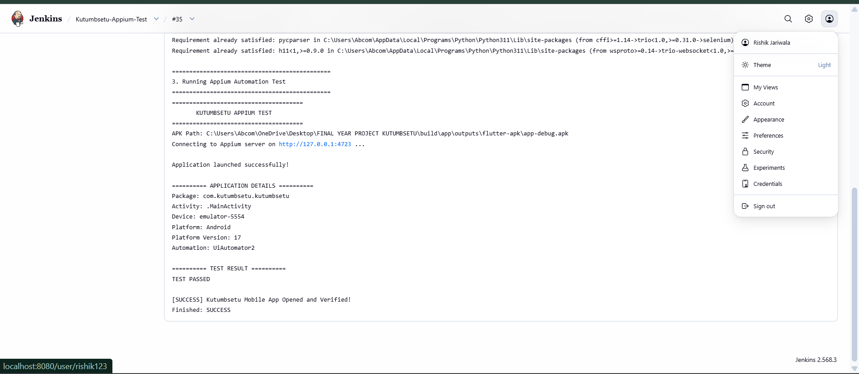
3.5)Verification:Serving and Launching the KutumbSetu Home page
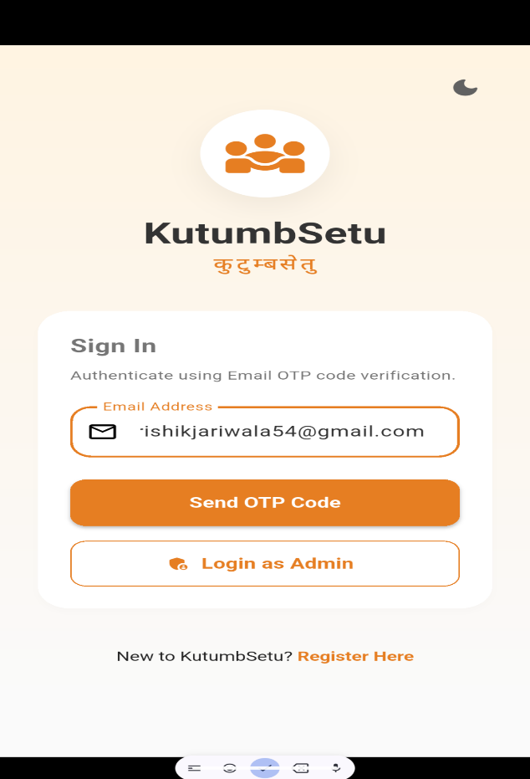

TASK3:Automated Functional Testing using Appium
Appium is an open-source automation framework for testing mobile applications. It allows automated interactions with application elements, including buttons, text fields and navigation controls.
For KutumbSetu, a suitable test can verify that the login screen opens, input fields are available, and navigation behaves as expected. Authentication tests should use a test account and a controlled test environment.
Appium requires a compatible driver, a running application or emulator/device, and suitable test scripts. If another approved tool is selected, document that tool's actual setup and test process instead.

4.1Appium Webdriver and uiAutomator Setup on Windows
Appium Configuration
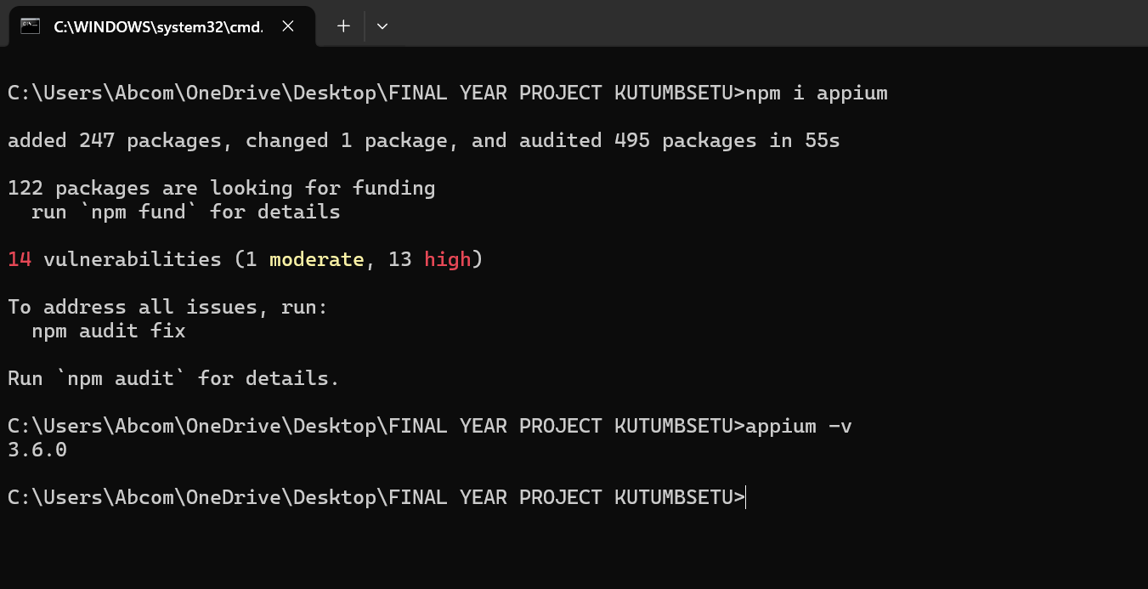
uiAutomator2 configuration
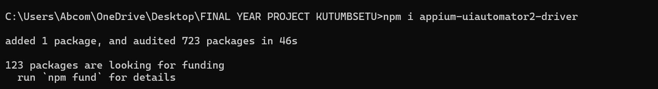
4.2)Test script design
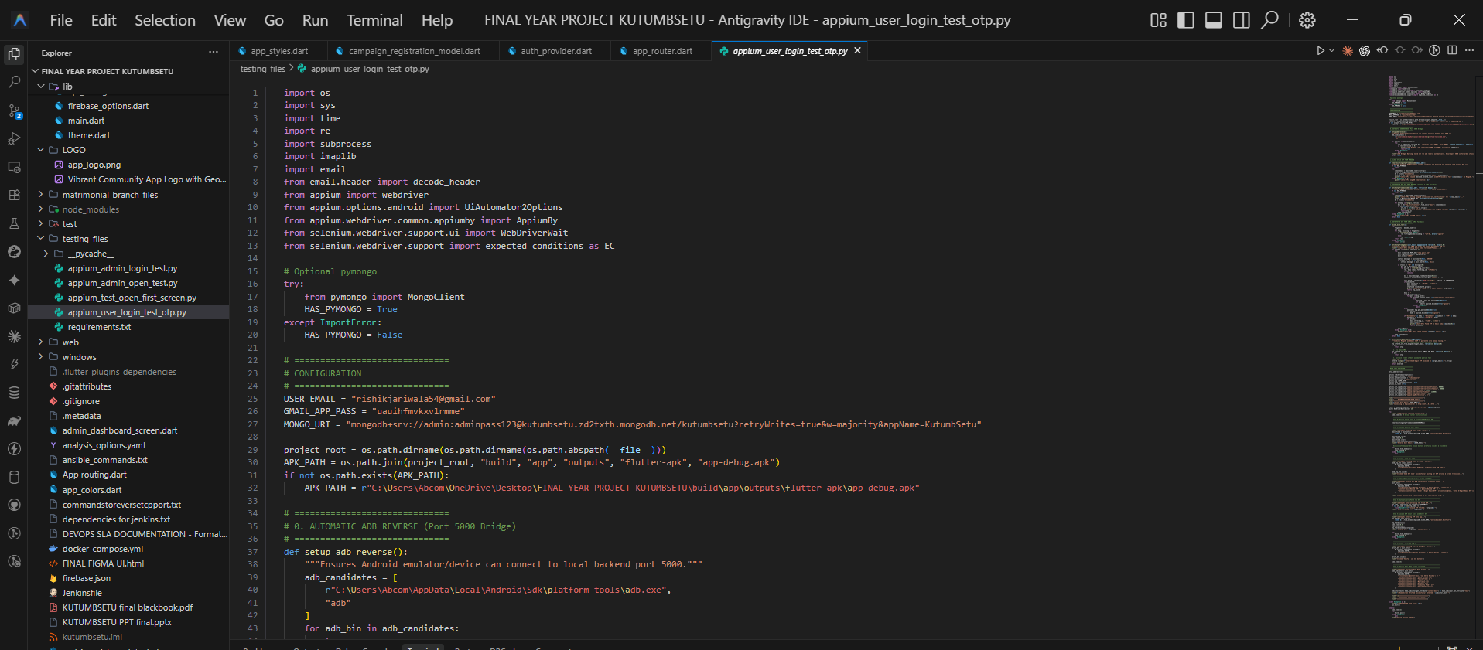
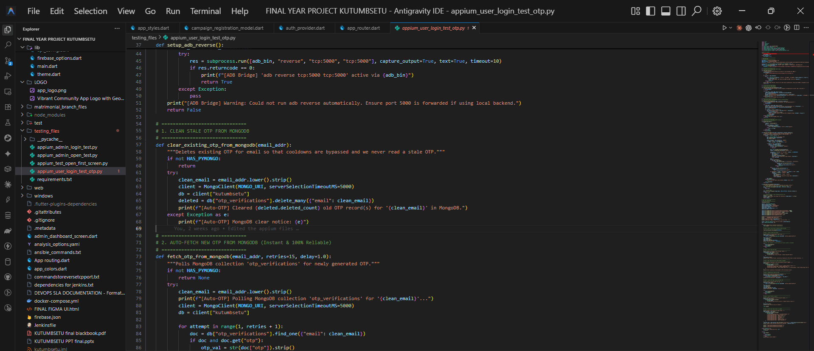
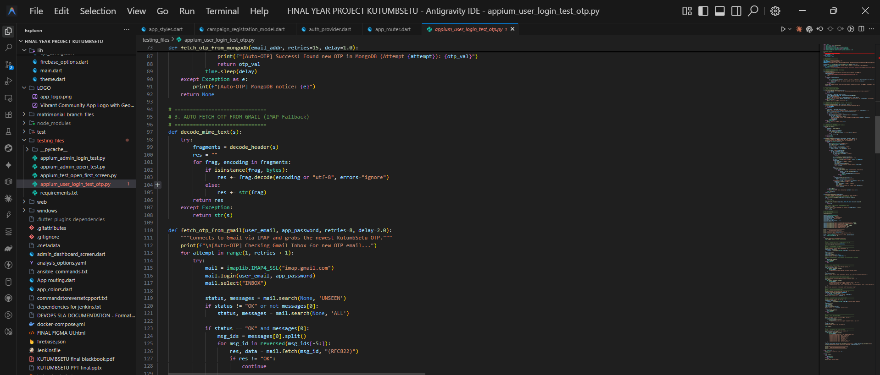
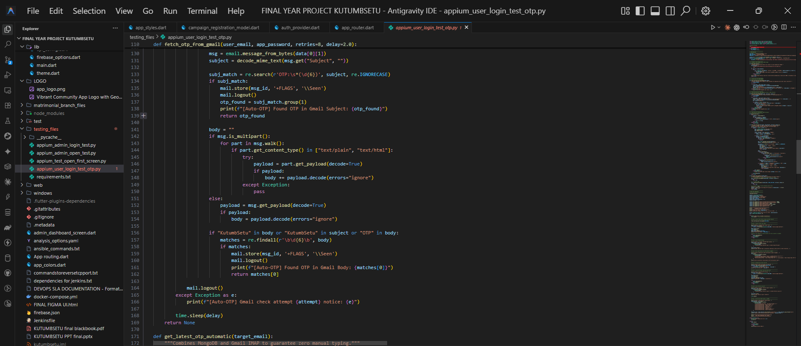
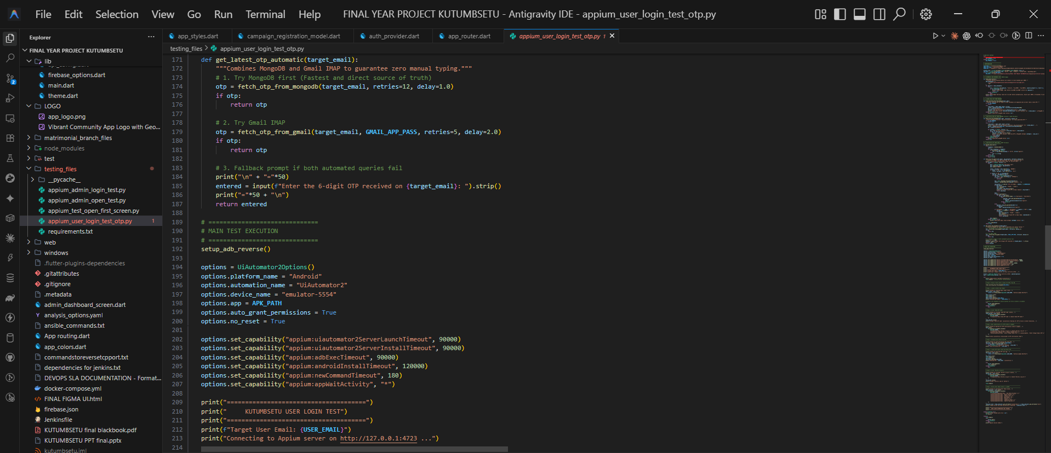
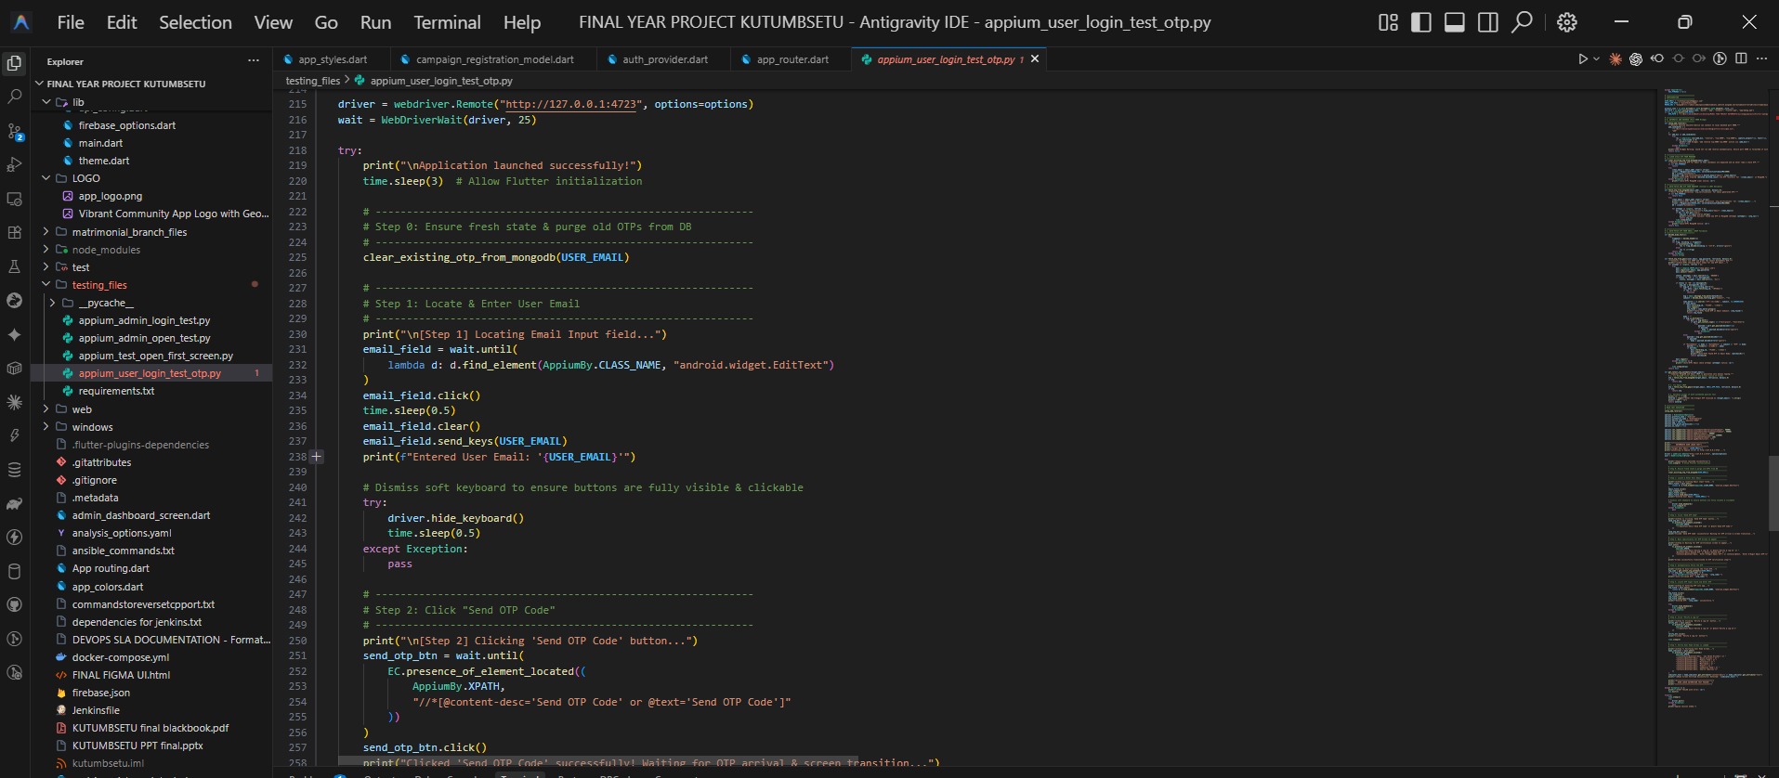
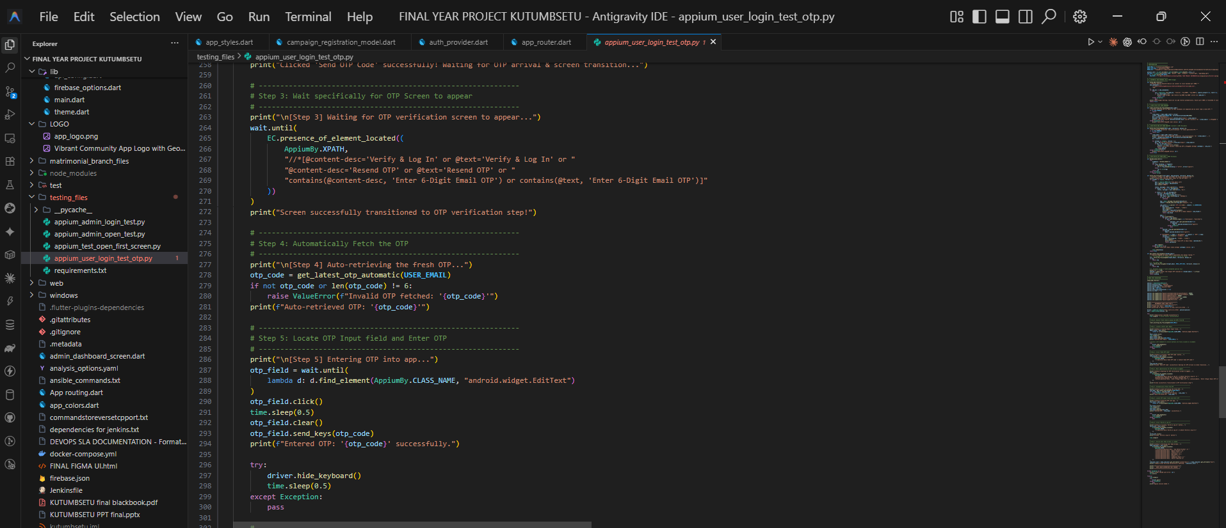
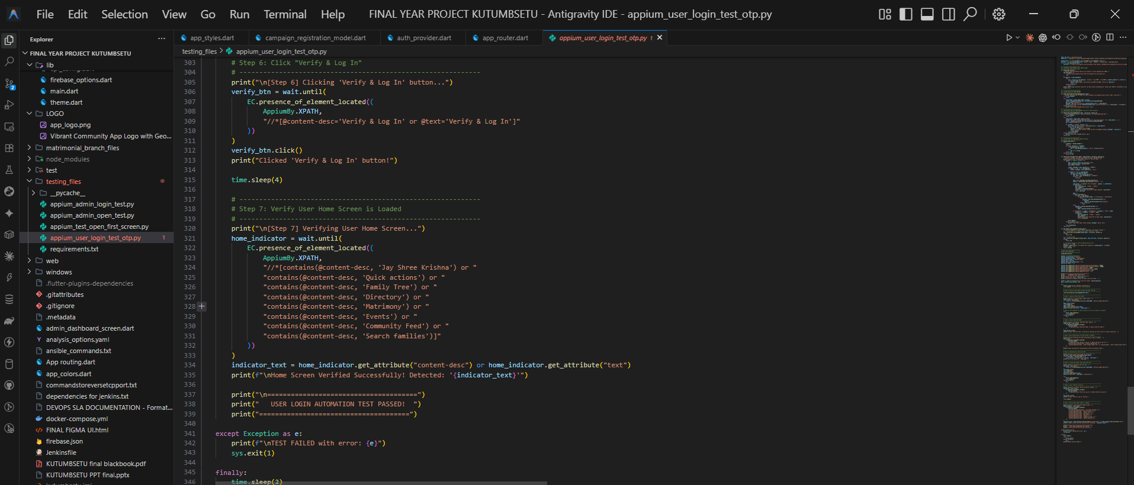
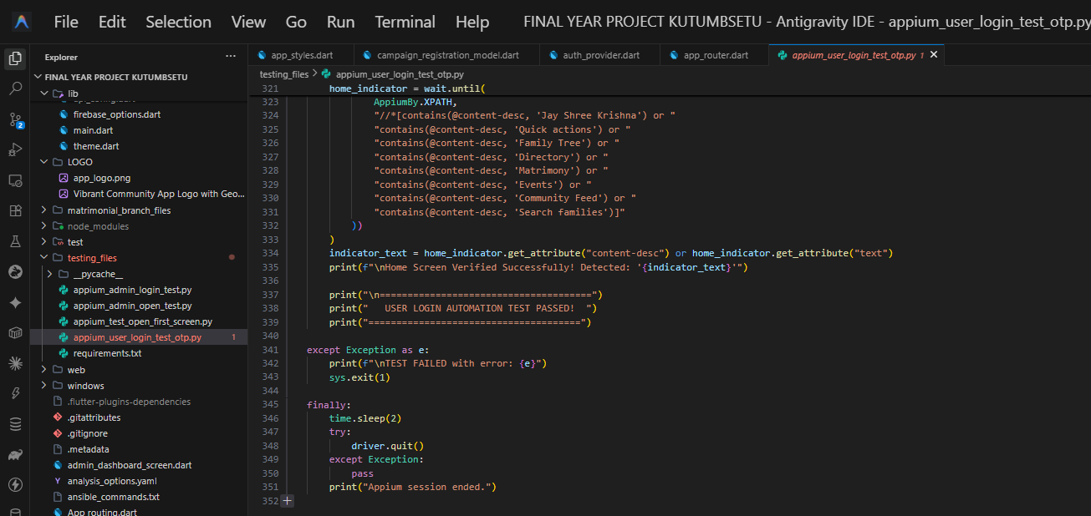
4.3)Automated UI test cases and appium start
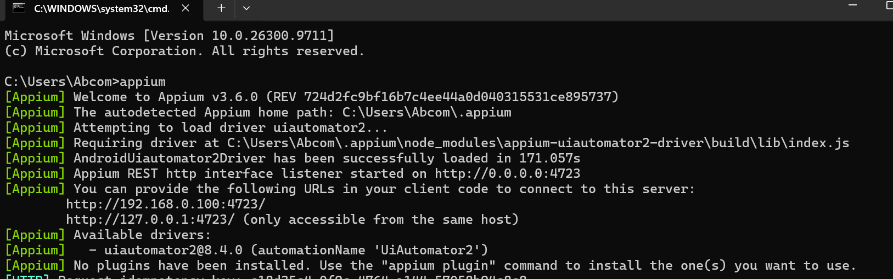
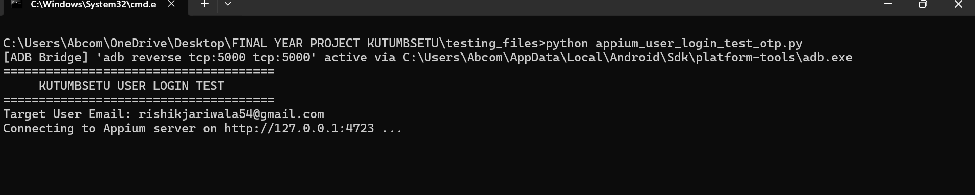
4.4)Test case execution and opening of home screen
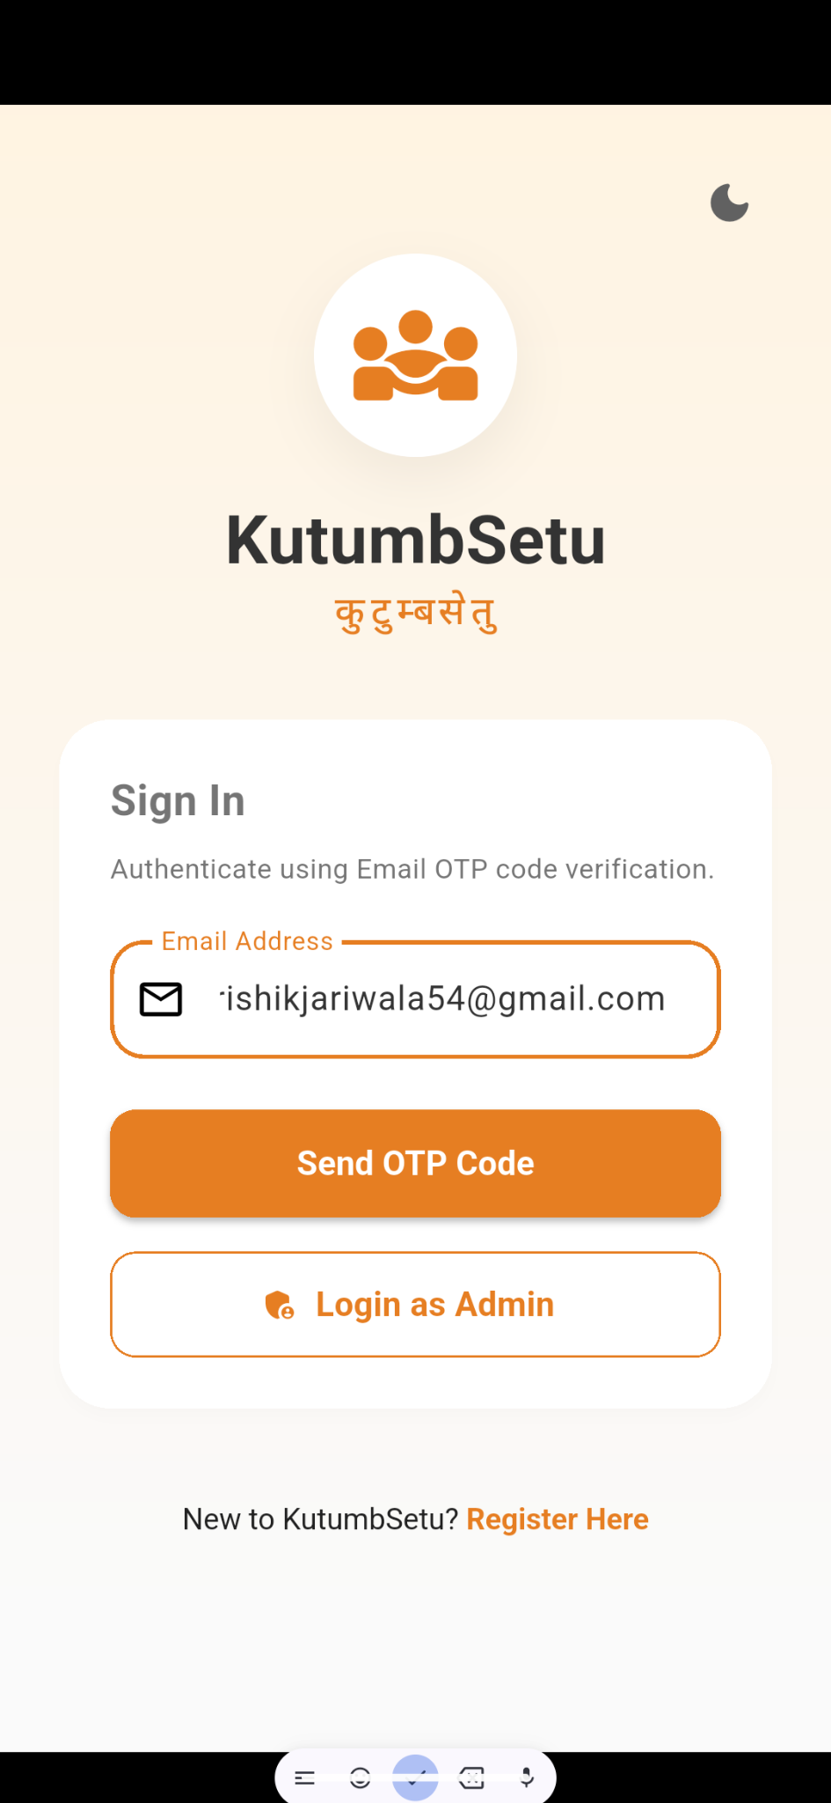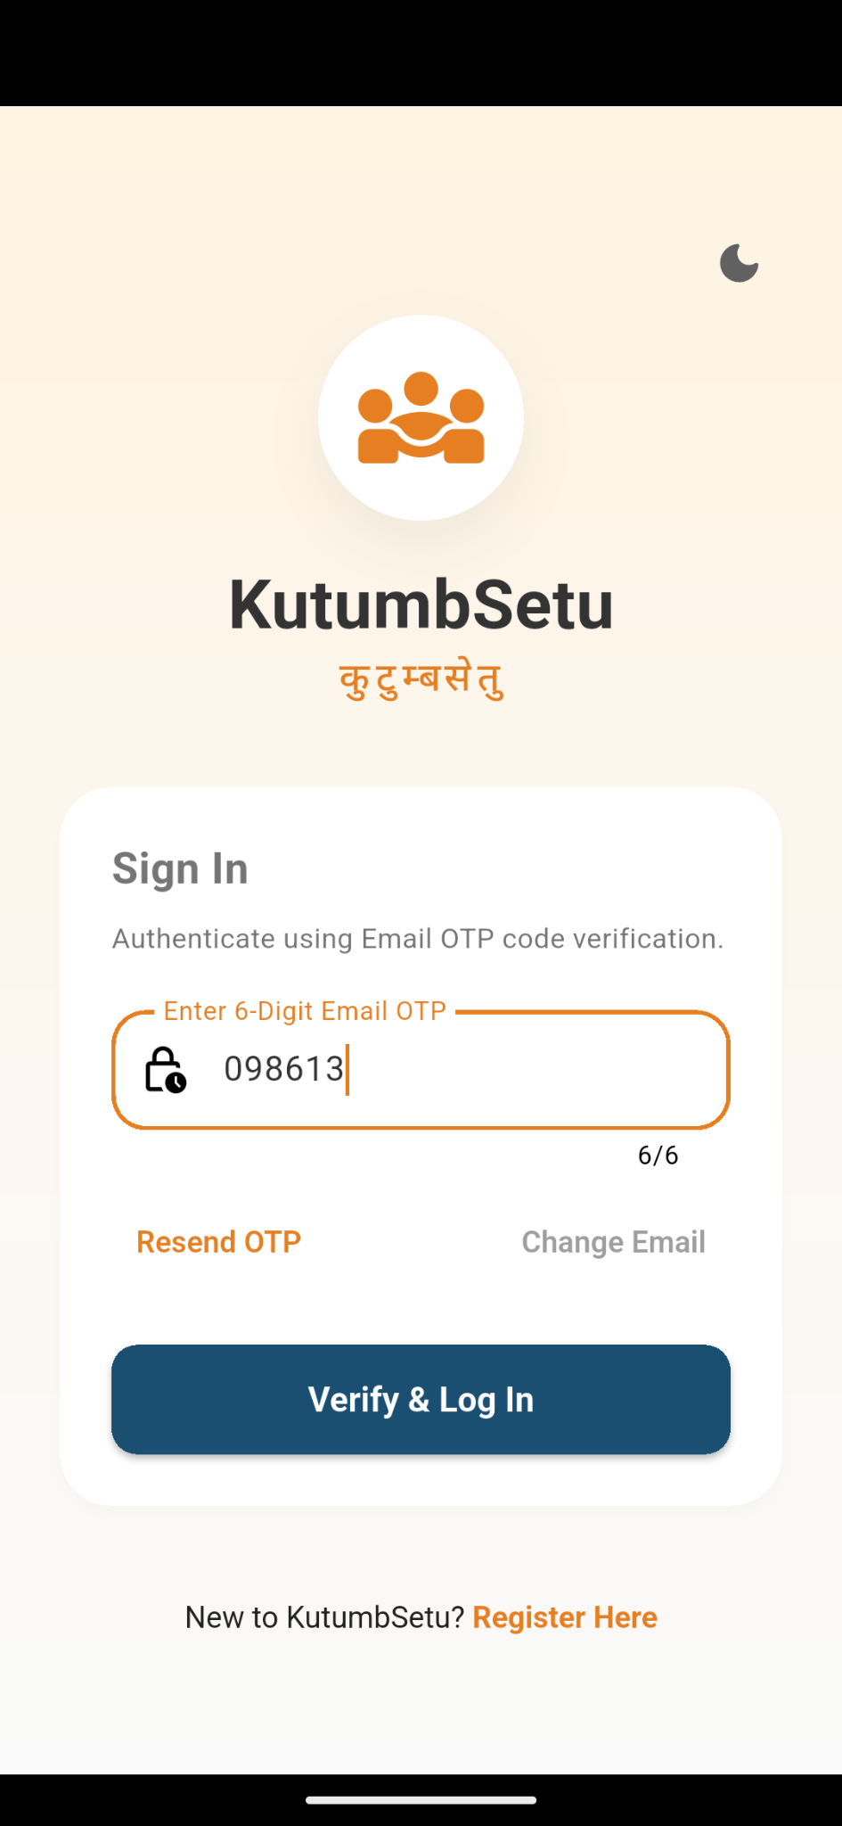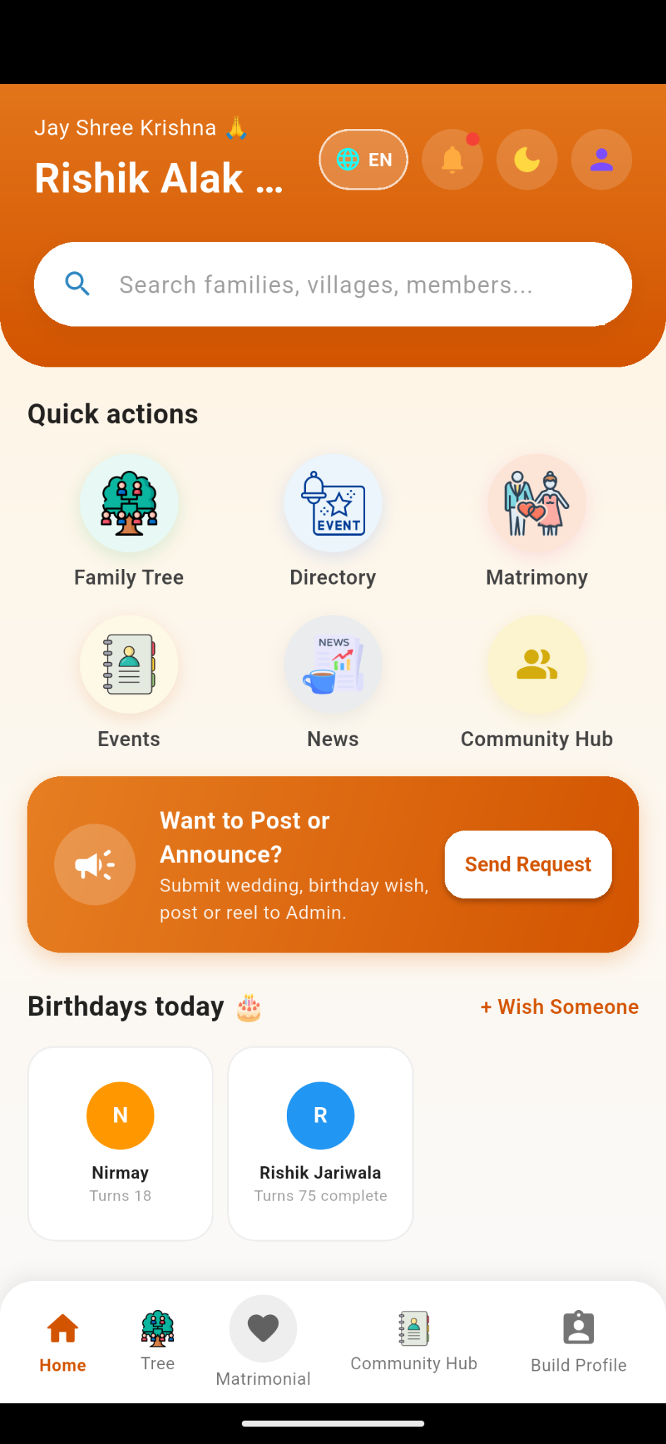

TASK:5 Containerization and Database Connectivity with Docker

4.4 Docker and Containerization
Docker is a containerization platform that packages an application and its required dependencies into a consistent environment.
A Docker image is a template used to create containers. A container is a running instance of an image.
For this SLA, Docker is used to package the login/registration component or the relevant service that supports it. The resulting container should be tested to confirm that it starts correctly and can communicate with the configured database.

4.5 MongoDB and Database Connectivity
MongoDB is a NoSQL document database that stores data in flexible, JSON-like documents. KutumbSetu uses MongoDB to store application data such as member profiles and other supported community records.
The Node.js backend connects to MongoDB using an appropriate driver or ODM, such as the MongoDB Node.js driver or Mongoose.
When a Docker container accesses MongoDB, the connection string must refer to a reachable database host. For example, localhost inside a container refers to that container itself, not automatically to the host computer. Docker networking or a suitable external database address must therefore be configured.

5.1)dockerizing authentication service with multi container orchestration using docker-compose.yml
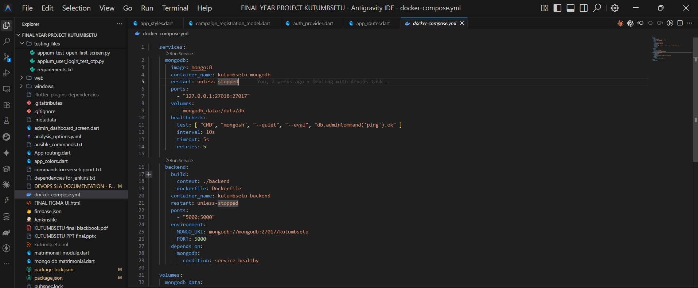
5.2)Building the container
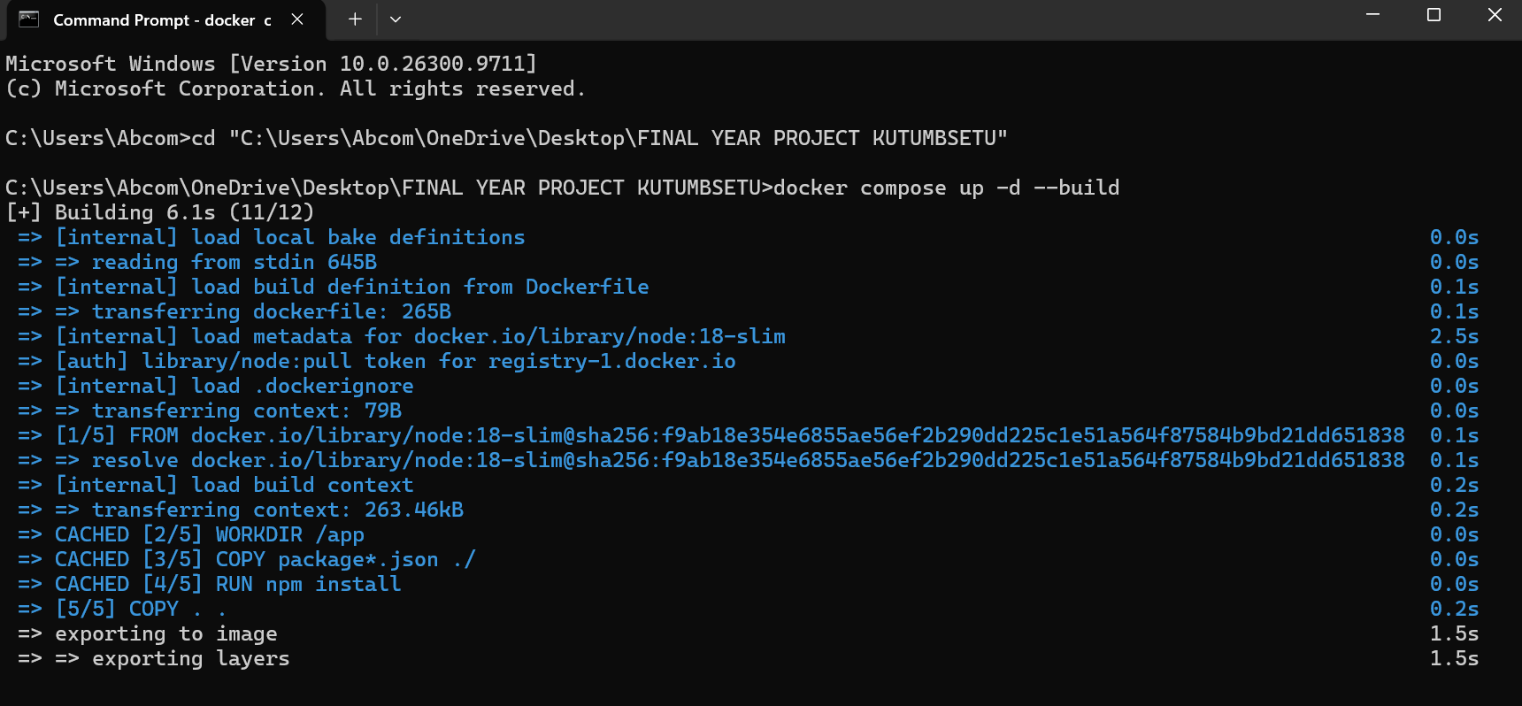
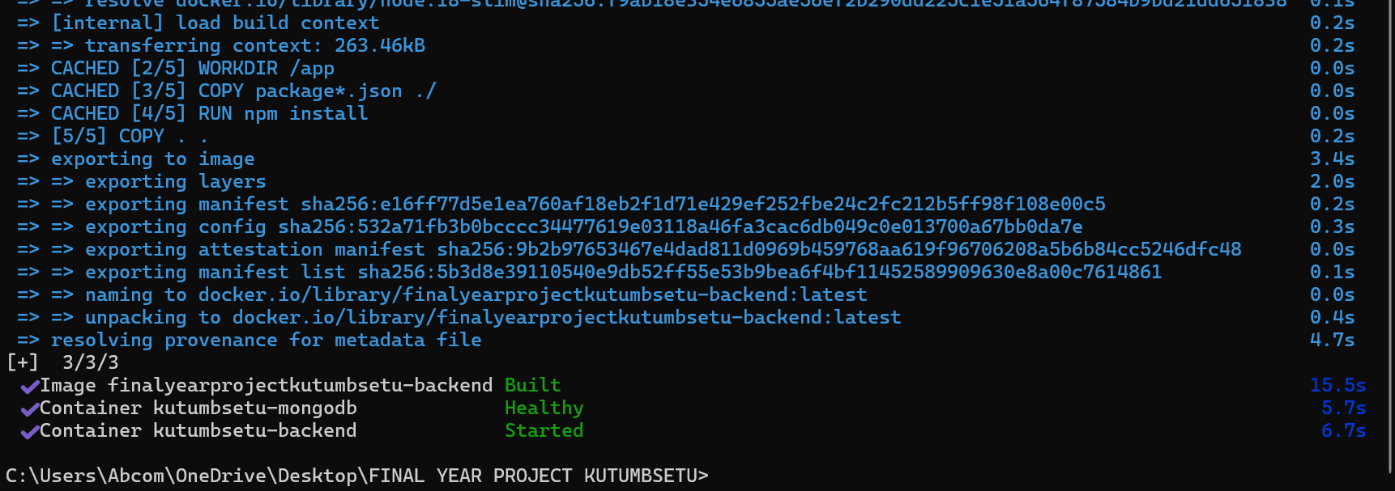
5.3)Executing the Dokcer container on localhost:5000
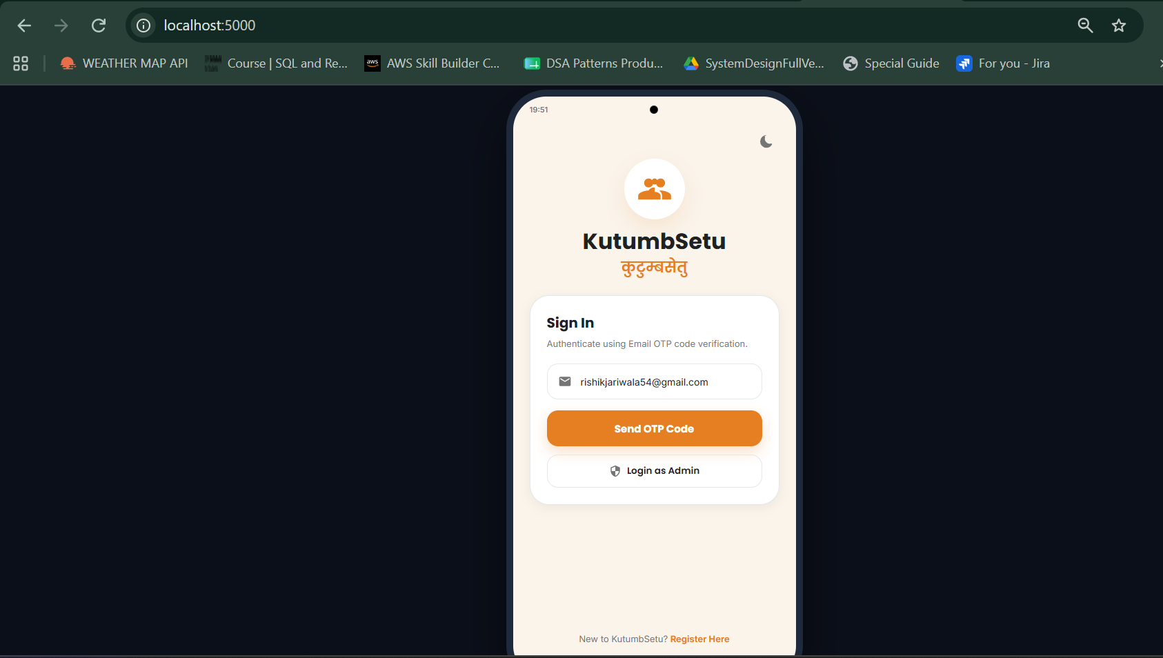
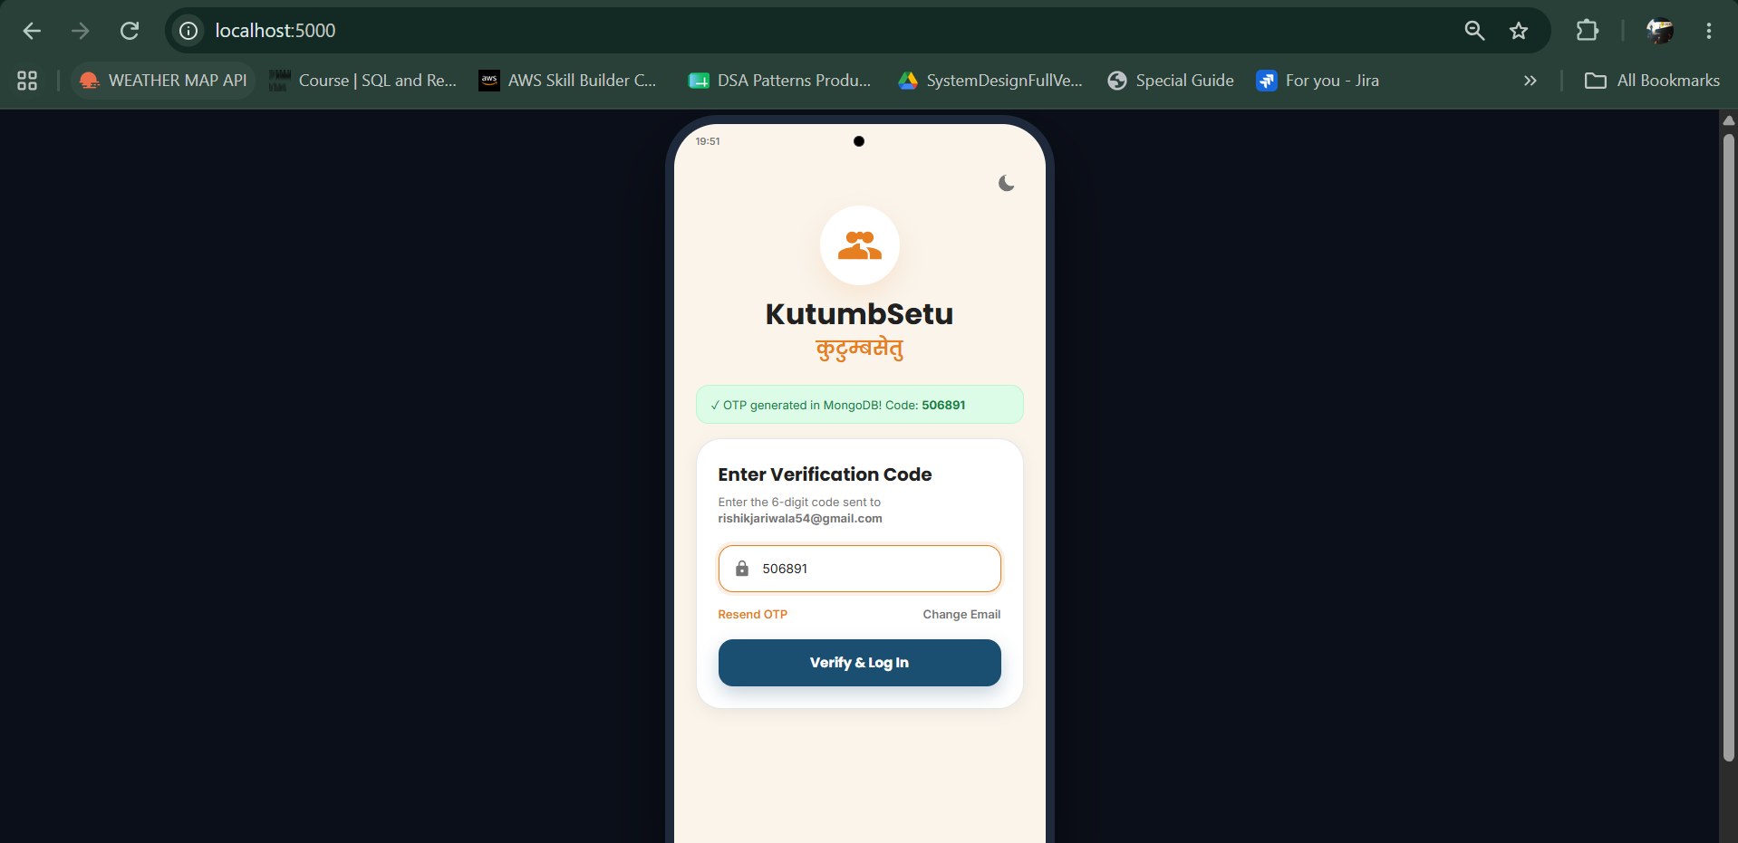
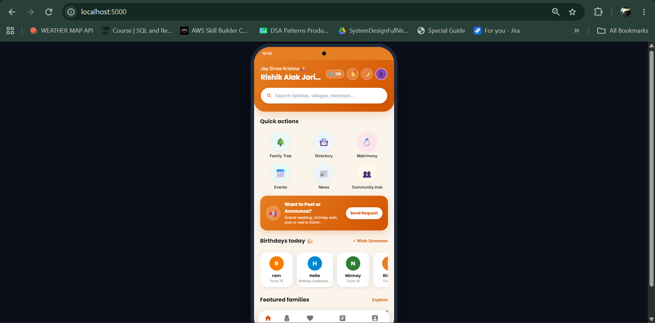
5.4)Pushing the image on Dockerhub
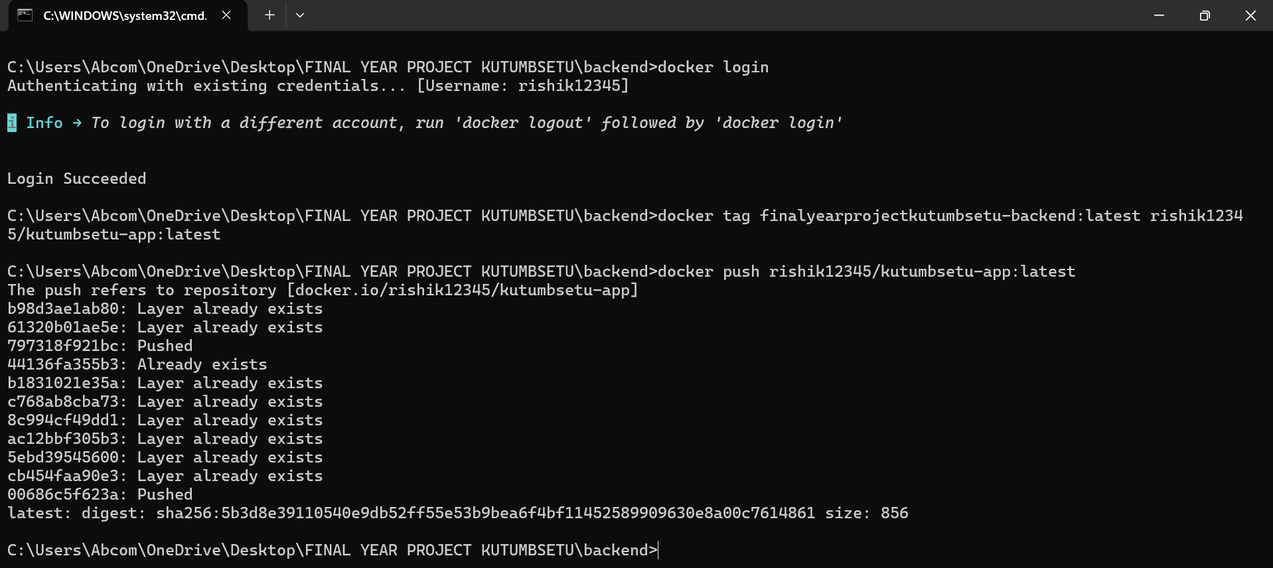

5.5)Verifying on Dockerhub
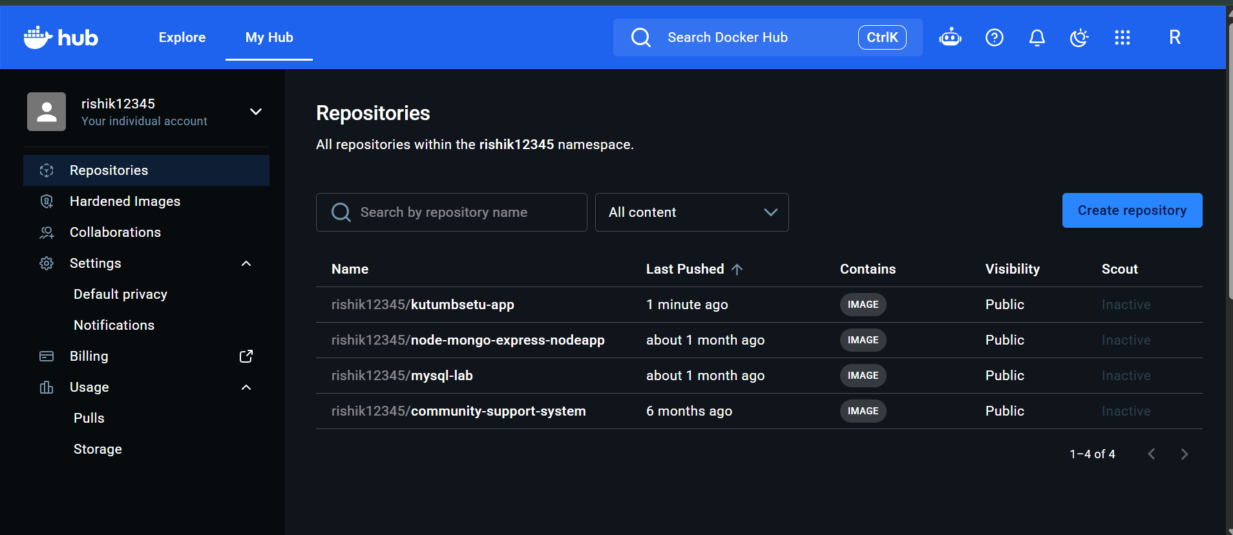

TASK5:Configuration Management and automation using Ansible
For Ansible, the main configuration artifact is the YAML playbook. It specifies the target hosts, connection settings, privilege requirements and tasks.
For Chef, the equivalent documentation may include:
- Cookbook structure.
- Recipe file.
- Resource declarations.
- Target-node configuration.
- Execution command and verification output.
Include the actual file used in your implementation. Explain the purpose of the important fields, such as hosts, tasks, name, state and the selected package/resource.
The configuration should be appropriate for the actual target operating system. Do not claim that Windows software was installed using a Linux-only package module unless the execution environment supports that operation.

6.1)Ansible Configuration on EC2 instances
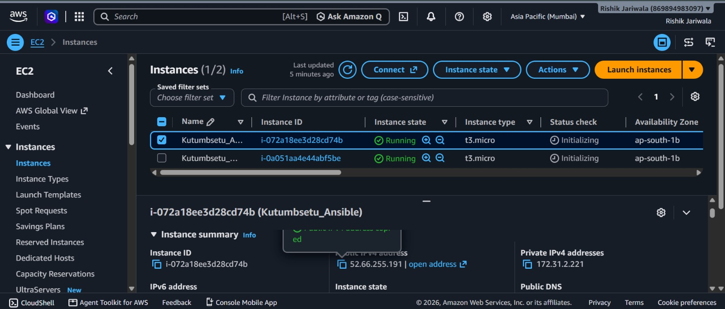
6.2)Copying the pem key and starting the services
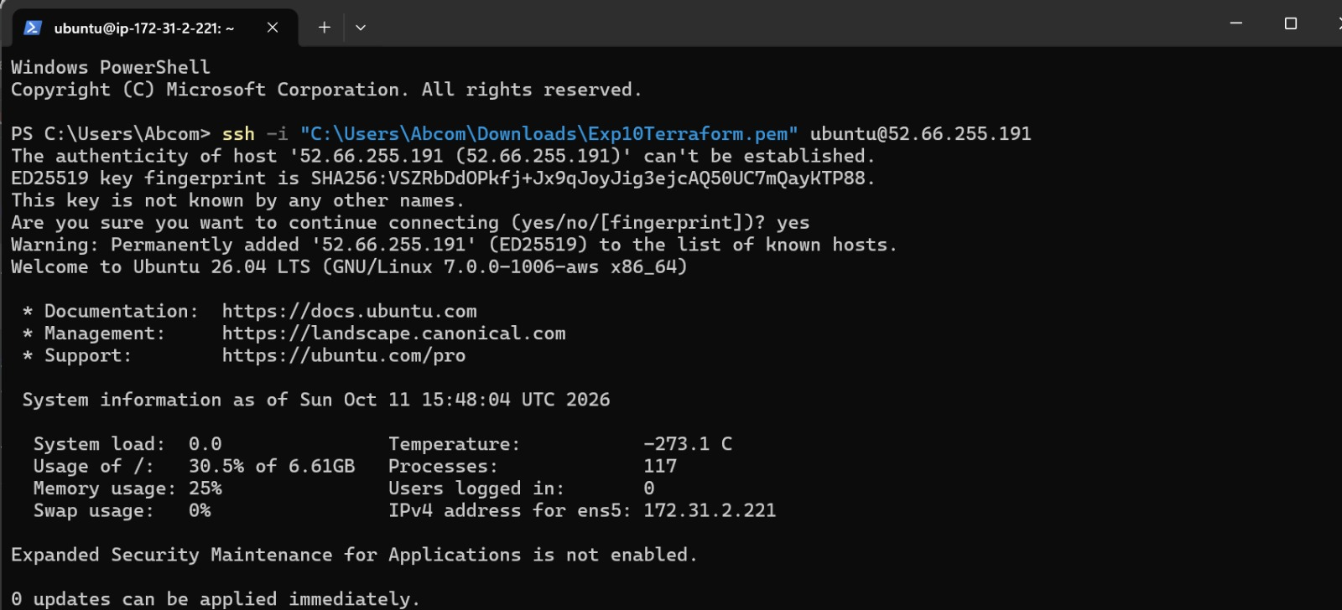
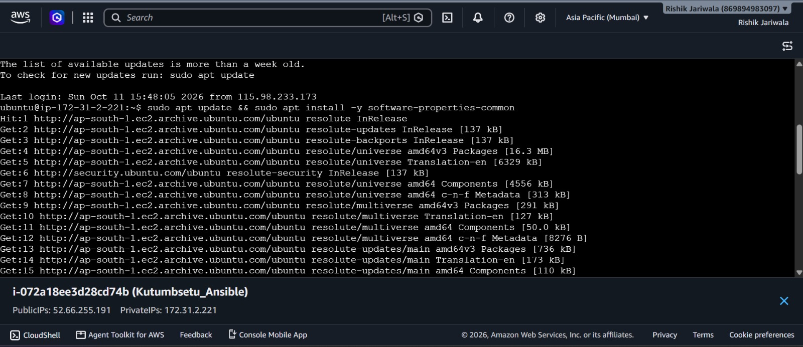
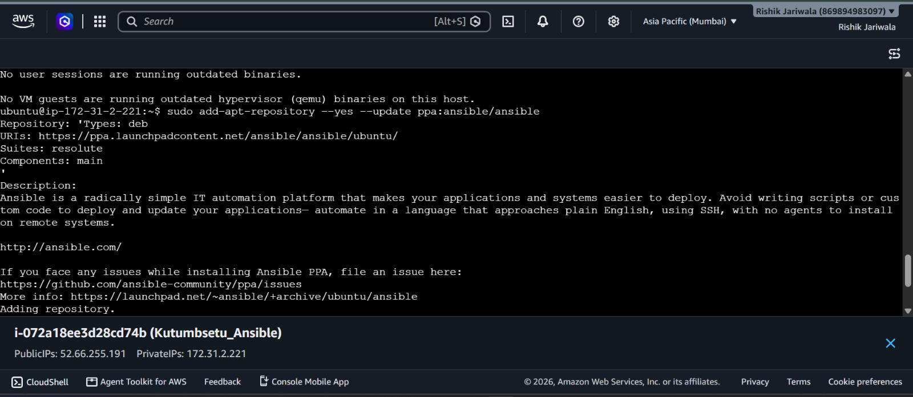
6.3)Installing Dependencies
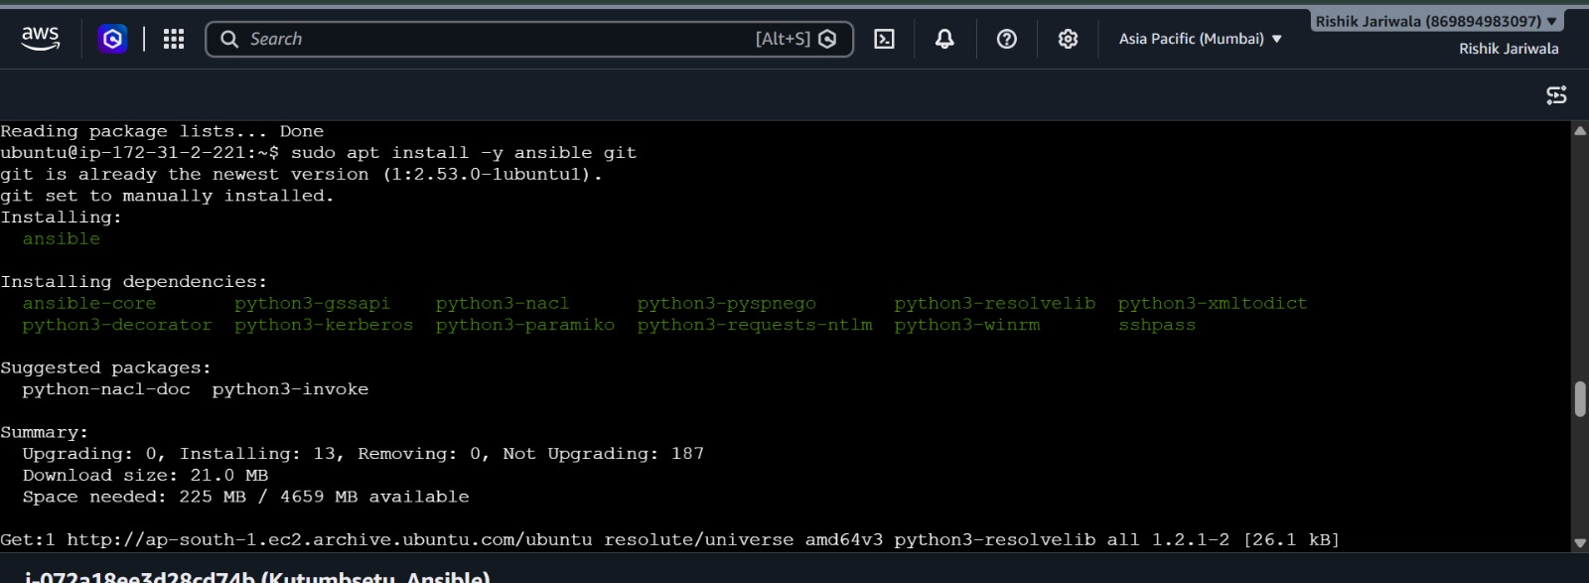
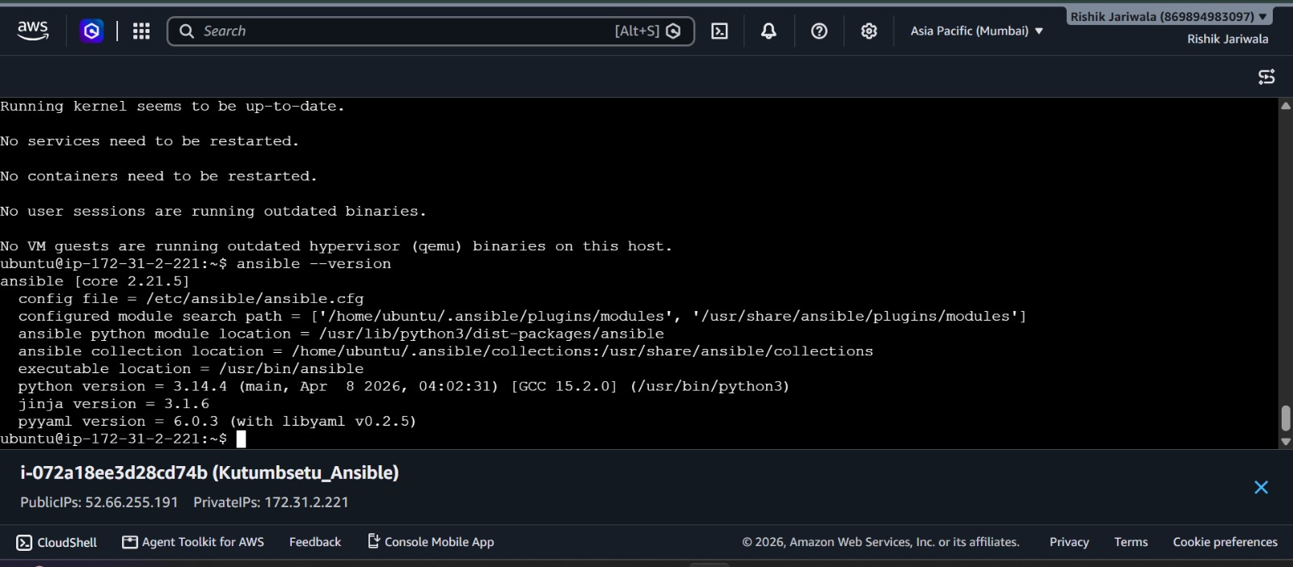
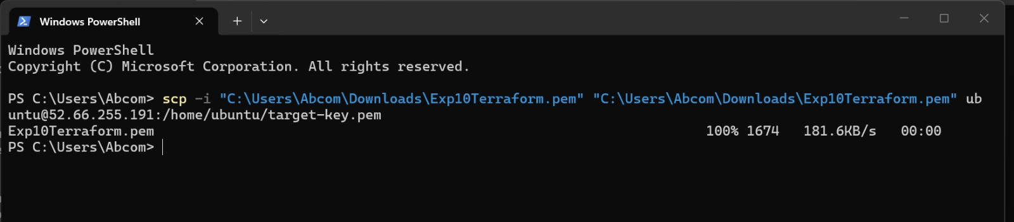
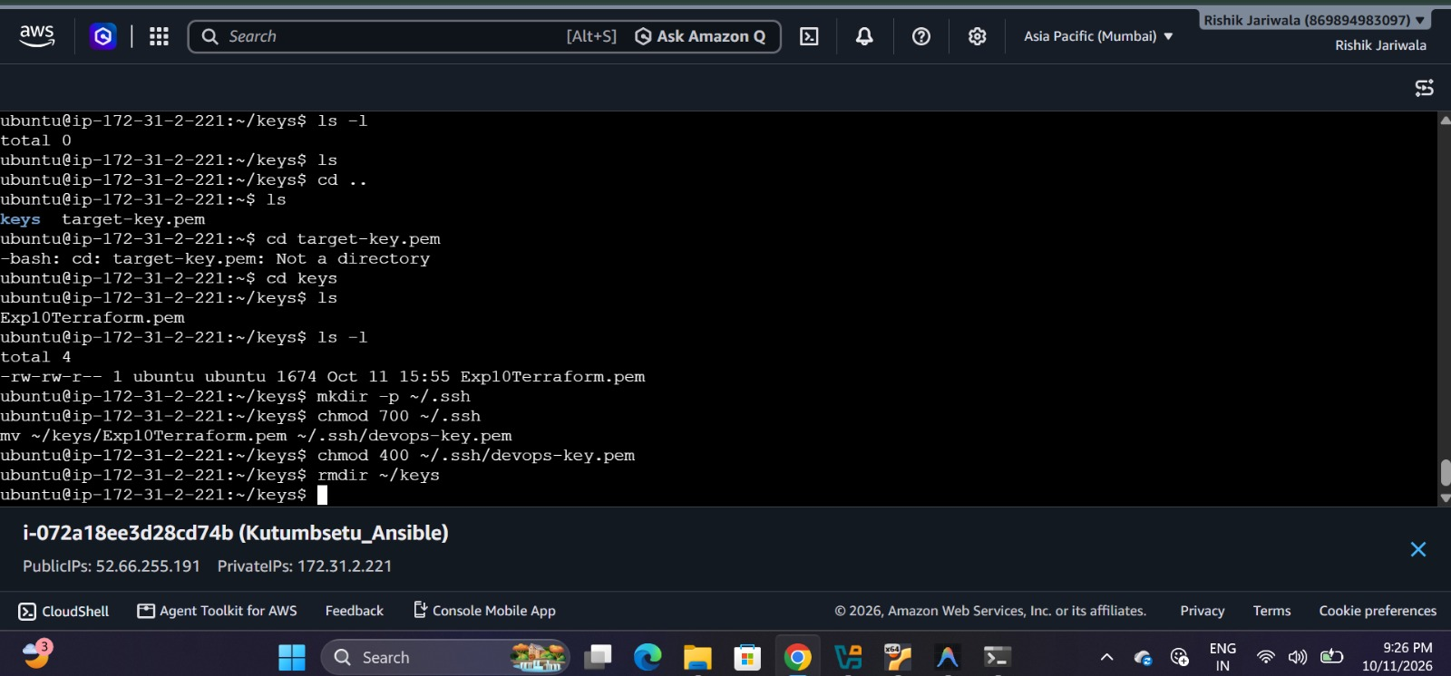
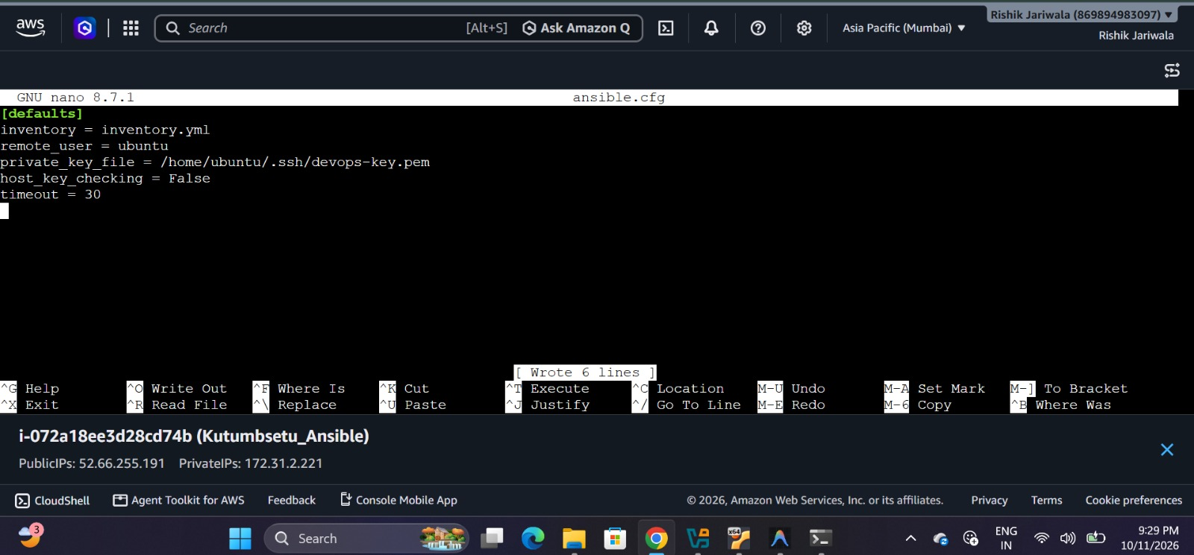
6.4)Generating a ping request and verifying scripts for installation
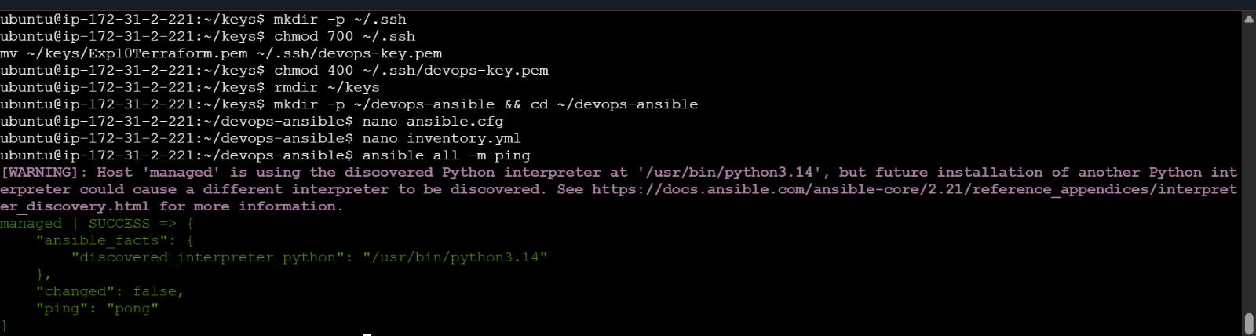
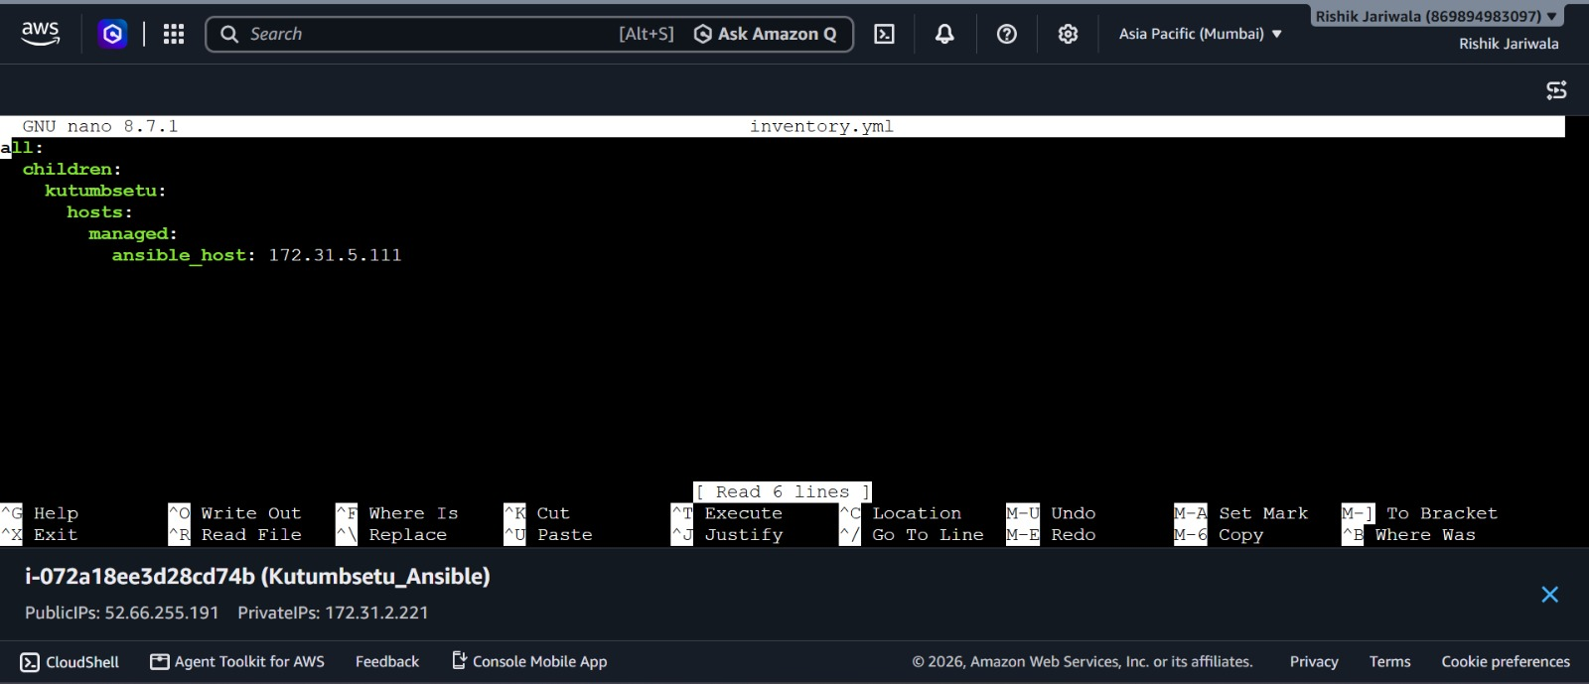
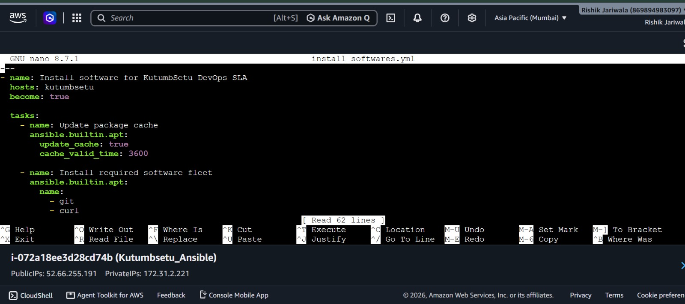
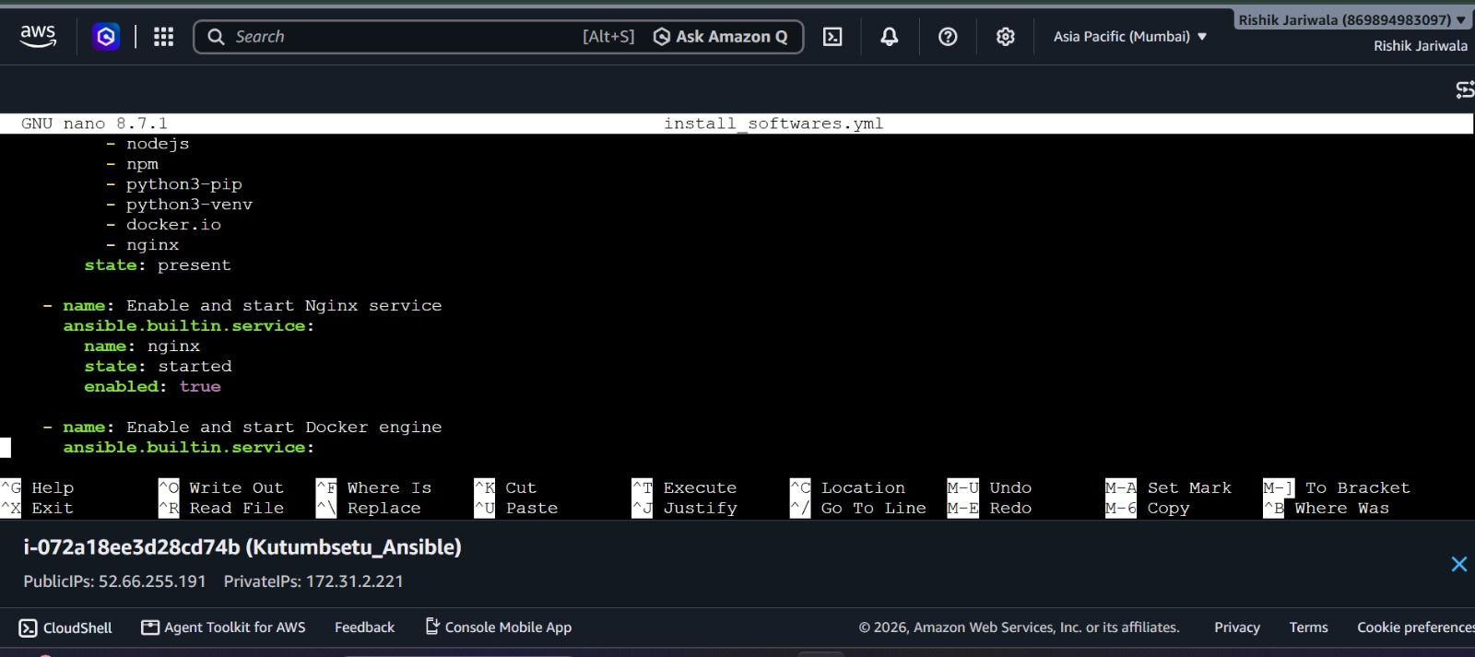
6.5)Verifying the downloaded softwares and their versions
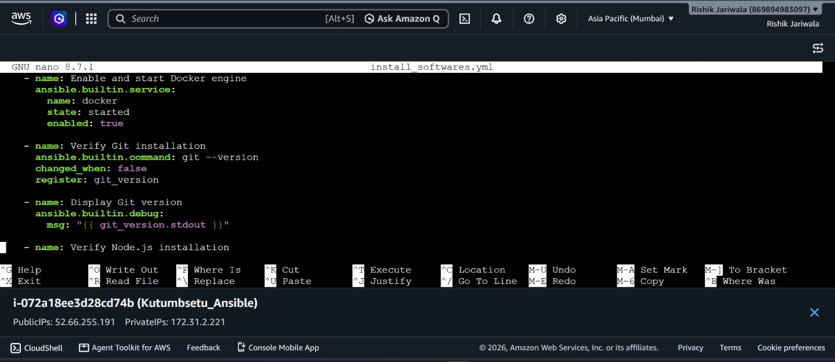
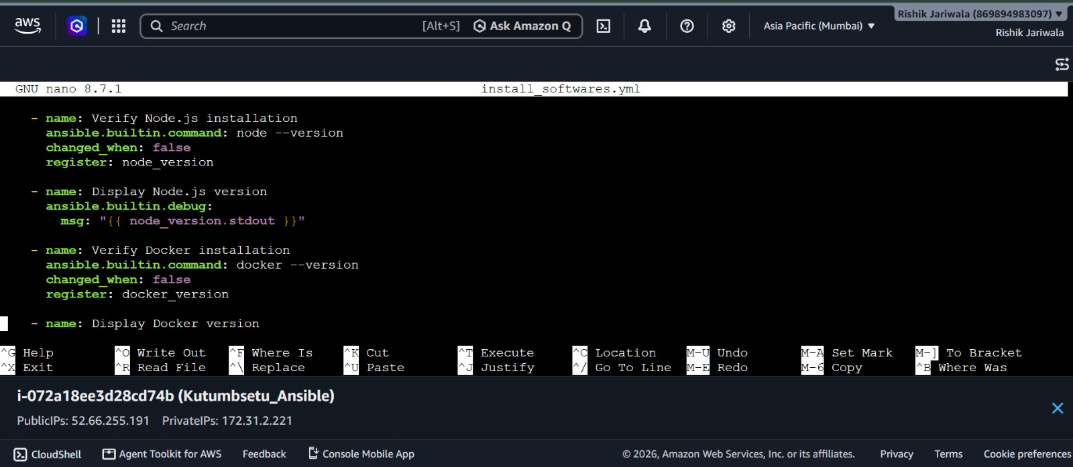
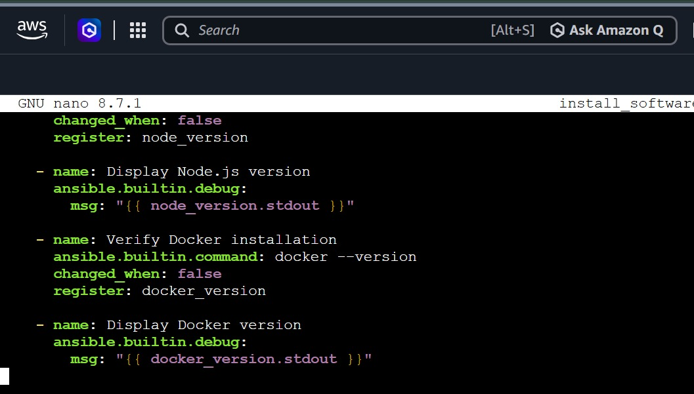

7)Devops integration pipeline summary
- The implementation of DevOps practices for the KutumbSetu project demonstrates how development, testing, deployment, and configuration management can be organized into a more systematic and reliable workflow.
- Git and GitHub support version control and source-code management, while Jenkins helps automate build and execution tasks.
- Mobile application testing helps verify the application's functionality, and Docker provides a consistent environment for running the backend with database connectivity.
- Ansible or Chef can further simplify software installation and environment configuration. These practices improve project maintainability, reduce manual effort, and provide a foundation for future enhancements and deployment.
- The successful completion of each activity is evaluated through the corresponding commands, screenshots, and testing results documented in this report.

Conclusion
The DevOps activities performed for the KutumbSetu project provided practical knowledge of version control, continuous integration, application testing, containerization, database connectivity, and configuration management. The use of Git and GitHub helps maintain code changes, Jenkins introduces automation into the development workflow, and Docker supports consistent application execution. Mobile application testing and automated software configuration further contribute to improving the reliability and maintainability of the project. Overall, this work strengthened the understanding of how DevOps tools can be integrated into a real-world software development project and established a foundation for more efficient development and deployment in the future.

14. References
- Git Documentation — https://git-scm.com/doc
- GitHub Documentation — https://docs.github.com/
- Jenkins Documentation — https://www.jenkins.io/doc/
- Flutter Documentation — https://docs.flutter.dev/
- Appium Documentation — https://appium.io/docs/en/latest/
- Docker Documentation — https://docs.docker.com/
- MongoDB Documentation — https://www.mongodb.com/docs/
- Ansible Documentation — https://docs.ansible.com/
- Chef Documentation — https://docs.chef.io/
- Node.js Documentation — https://nodejs.org/docs/

