Client-Server Based Course Registration System (Academia portal)

Problem Statement
The goal is to develop a client-server based academic course registration portal that supports three user roles: Admin, Faculty, and Student. The system facilitates user authentication, course management, and enrollment functionality through networked communication between clients and a centralized server.

Sockets Usage

The system uses socket programming for client-server communication.

The server initializes a socket, binds it to port 8080, listens for incoming connections, and spawns a new thread for each client.

Clients interact with the server by sending and receiving structured messages via sockets

Locks (pthread_mutex_t) Usage
Three mutexes are used to ensure thread-safe operations on shared files:
- Student Mutex – Protects students.dat during access/modification.
- Faculty Mutex – Ensures synchronized access to faculty.dat.
- Course Mutex – Used during course enrollment, unenrollment, or updates.
These locks prevent race conditions and maintain data consistency under concurrent access.

Semaphores Usage

The <semaphore.h> header is included, though semaphores are not currently active in the implementation. They may be integrated in the future to manage resource access limits or control concurrency.

Threading
Each client is assigned a new thread upon connection. Threads are detached so they clean up automatically when done. This allows handling multiple concurrent clients efficiently.

File Operations

Persistent data is maintained using simple binary files:

admin.dat — Stores admin credentials.

students.dat — Holds student records.

faculty.dat — Contains faculty information and their offered courses.

Low-level system calls (open, read, write, lseek) handle file operations, with mutexes providing logical locking.

Signal Handling

A signal handler is implemented for SIGINT (Ctrl+C) to release mutex resources gracefully during server shutdown, preventing resource leaks and ensuring clean exit.

User Roles
- Admin: Add/Update Students and Faculty, Activate/Deactivate students.
- Faculty: Add/Remove offered courses, View enrollments.
- Student: Enroll or unenroll in courses, View enrolled courses, Change password.

Role-Based Functionalities

Admin:
- Add New Student
- Add Faculty
- Activate Student
- Deactivate Student
- Update student / Faculty details
- Exit

Student:
- Enroll New Course
- Unenroll Courses
- View Enrolled Courses
- Password Change
- Exit

Faculty:
- Add New Courses
- Remove Offered Courses
- View Enrollments
- Password Change
- Exit

Structures Used
Three main structures are used in the system:
1. Student:
- ID
- Username
- Password
- Active Status
- List of Enrolled Courses
- Course Count
2. Faculty:
- ID
- Username
- Password
- List of Offered Courses
- Seats per Course
- Course Count
3. Admin:
- Username
- Password

Server Code Functionality
The server initializes by setting up a socket, binds to a port, and listens for incoming client connections. When a client connects, a new thread is created to handle the client independently.
Each client goes through a login interface to select their role (Admin, Student, or Faculty), provide credentials, and get authenticated. Post-authentication, each role is presented with a unique menu and capabilities.
The server handles all core logic like reading/writing to files, validating credentials, updating student/faculty details, enrolling and unenrolling in courses, and changing passwords. Mutex locks ensure that no two threads corrupt shared data.

Client Code Functionality
The client connects to the server via sockets and interacts through text-based prompts. It displays menus for each role and takes user input which it sends to the server. It also displays messages and feedback received from the server such as successful operations, errors, or prompts.

Output Screenshots:
1. Server terminal showing connections.
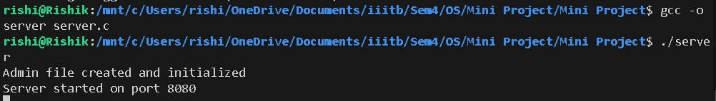
2. Admin menu interface.
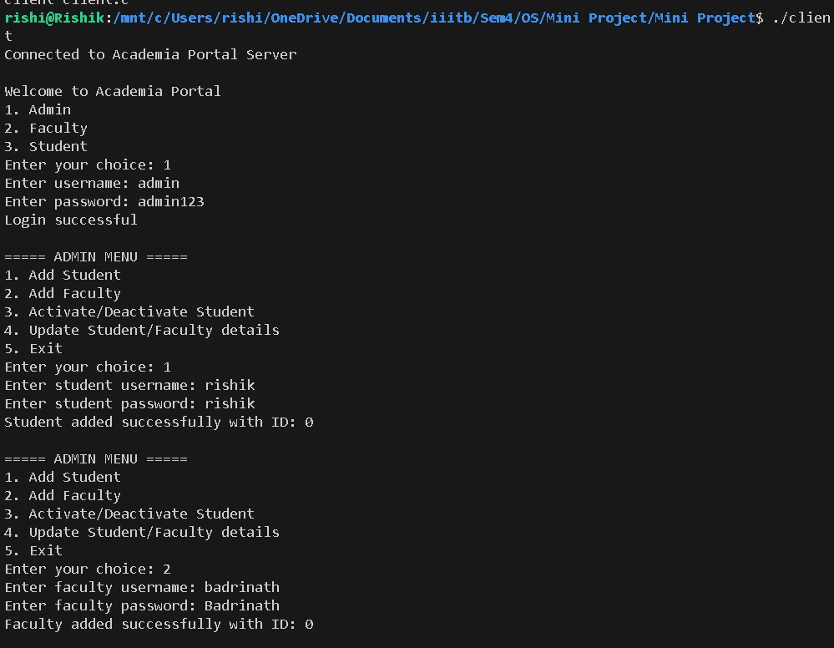
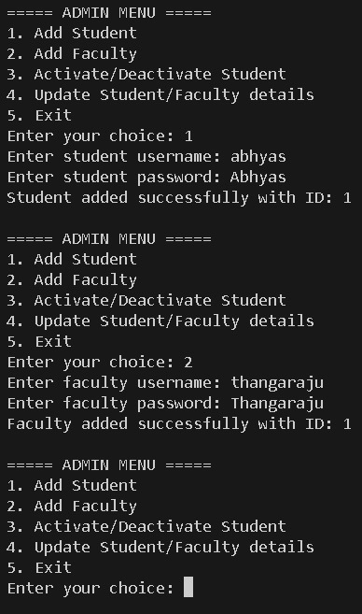
3. Faculty adding a course.
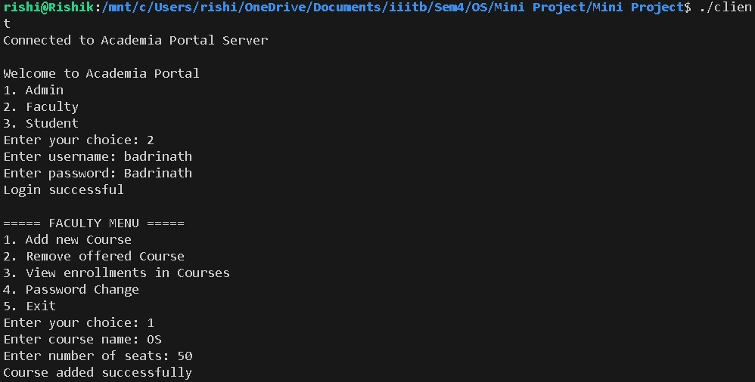
4. Student enrolling in a course.
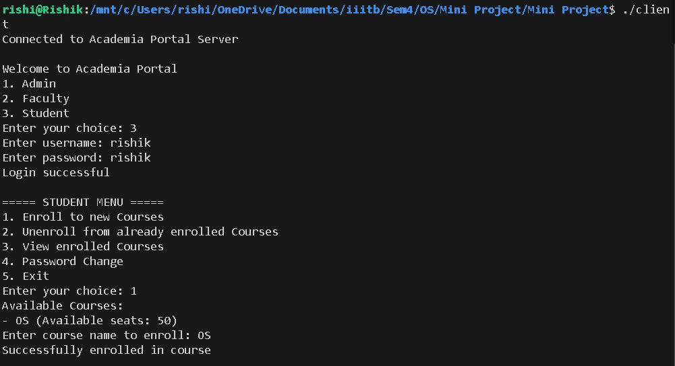
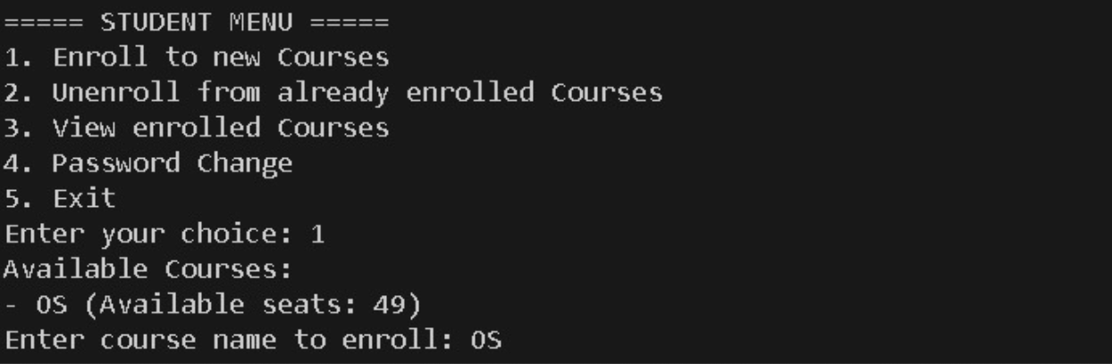
5. Student viewing enrolled courses.
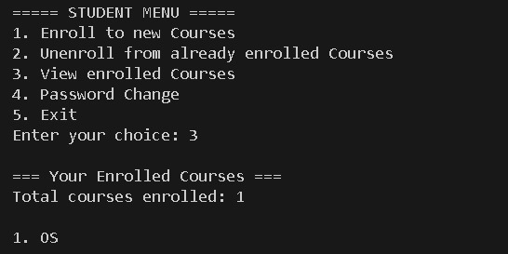
6. Faculty viewing course enrollments.
