REAL-TIME ENCRYPTED TRAFFIC
CLASSIFICATION USING LIGHTWEIGHT
MACHINE LEARNING MODELS
UROP Project submitted to the
SRM UNIVERSITY - AP, ANDHRA PRADESH
for the partial fulfillment of the requirements to award the degree of
Bachelor of Technology in Computer Science and Engineering
School of Engineering and Sciences
Submitted by:
Rishi Kumar | Reg. No: AP23110011088
Registration Variant: AP23110011446 | UROP ID: UROP_2023_25118_04

Under the Guidance of
Dr. Raju Gudla
Assistant Professor, Department of Computer Science and Engineering
SRM University-AP
Neerukonda, Mangalagiri, Guntur Andhra Pradesh - 522 240
November, 2026

ACKNOWLEDGEMENTS
I would like to thank Dr. Raju Gudla for his guidance and support given to me while working on this project (UROP ID: UROP_2023_25118_04). The way our mentor helped whenever needed with patience and the motivation he gave during this time has pushed me to complete the research and empirical investigations on schedule. His confidence in our research direction has boosted my confidence to complete the research while managing various other subject-related coursework and academic submissions. I also extend my heartfelt thanks to the faculty members and peers at the Department of Computer Science and Engineering, School of Engineering and Sciences, SRM University-AP, for providing access to the necessary computational infrastructure and maintaining an encouraging academic environment.
ABSTRACT
Research Problem: Over 95% of contemporary Internet traffic is encrypted using TLS 1.3, QUIC, or WireGuard, rendering traditional middleboxes and Deep Packet Inspection (DPI) obsolete without deploying intrusive decryption proxies that violate GDPR and HIPAA privacy standards.
Proposed Approach: Conducted under UROP ID: UROP_2023_25118_04, this work designs, evaluates, and deploys a mathematically audited, real-time encrypted traffic classification pipeline operating strictly on observable Layer-3/4 transport dynamics - packet sizes, inter-arrival times (IAT), burst ratios, and directionality. Application payload bytes and topological markers (IP addresses, MAC addresses, transport ports) are explicitly stripped at the kernel capture hook. Furthermore, we develop an unsupervised autoencoder representation framework and latent similarity analysis across multi-environment captures to evaluate learned manifolds and detect tunneled out-of-distribution shifts.
Main Contribution & Empirical Findings: Under group-aware session isolation on a multi-environment hybrid benchmark (dataset_v2: 301 flows, 150 sessions), we demonstrate that a shallow CART Decision Tree achieves a Macro-F1 score of 0.5802, matching an ensemble Random Forest (0.5854) while executing 244x faster (0.0694 ms) with a serialized footprint of only 9.58 KB. Early-stage traffic triage at N=3 packets achieves an initial Macro-F1 of 0.6111 within 84.33 ms, where 76% of the latency is governed by physical radio arrival delay rather than algorithmic computation. Calibrated selective prediction (tau* = 0.70) reduces operational classification error from 45.83% to 26.92%, establishing a wire-speed, privacy-preserving classification pipeline for edge security gateways.
ABBREVIATIONS
Acronym | Expansion | Acronym | Expansion
DPI | Deep Packet Inspection | MTU | Maximum Transmission Unit
DT | Decision Tree (CART) | QUIC | Quick UDP Internet Connections
ECE | Expected Calibration Error | RF | Random Forest (100 Trees)
F1 | Macro-Averaged F1-Score | SOC | Security Operations Center
GDPR | General Data Protection Regulation | TLS | Transport Layer Security (1.3)
IAT | Inter-Arrival Time (Delta t) | UROP | Undergraduate Research Opportunity Project
MLP | Multi-Layer Perceptron (Autoencoder) | WARP | Cloudflare WireGuard Tunneling

TABLE OF CONTENTS
Acknowledgements, Abstract & Abbreviations ................................................................................................. 2
1. Introduction (Background, Problem Statement, Objectives, Scope) ......................................................... 3
2. Background and Literature Survey (DPI, ML, Autoencoder Modeling, Gaps) ......................................... 4
Comprehensive Literature Survey Benchmark Table (Table 2.1) & Gaps Resolution ............................. 5
3. Proposed System Model and Architecture (Pipeline & Flow Tracking) ..................................................... 6
4. Proposed Methodology and Implementation (Autoencoder Similarity & SOC) ........................................ 7
5. Experimental Evaluation and Results (Hybrid Benchmarks & Pareto Trees) .......................................... 8
6. Concluding Remarks & 7. Future Works ....................................................................................................... 9
References ........................................................................................................................................................ 9
1. INTRODUCTION
1.1 Research Background & Evolution of Encryption
Modern computer networks have experienced a wholesale transition toward ubiquitous transport and application encryption. Over 95% of active web traffic is encapsulated within protocols such as TLS 1.3, QUIC, and modern VPN encapsulations like WireGuard. While these cryptographic protocols are indispensable for defending end-user confidentiality and preventing eavesdropping, they create a structural blind spot for network administrators, intrusion detection systems, and Quality of Service (QoS) traffic balancers. Historically, network middleboxes relied heavily on Deep Packet Inspection (DPI) to identify protocol signatures and application headers.
1.2 Problem Statement: The Security-Privacy Paradox
To circumvent encryption, enterprise architectures frequently implement Man-in-the-Middle (MITM) SSL/TLS termination proxies. However, decryption proxies introduce catastrophic security liabilities - including centralized key compromise, increased attack surface, and direct violations of legal confidentiality mandates such as the General Data Protection Regulation (GDPR) and HIPAA. Conducted under UROP ID: UROP_2023_25118_04, this Undergraduate Research Opportunity Project (UROP) investigates whether lightweight, non-deep machine learning models operating strictly on Layer-3/4 transport dynamics can classify encrypted traffic on edge hardware without decrypting payloads, inspecting cleartext headers, or memorizing topological artifacts such as host IP addresses and transport port numbers.
1.3 Research Motivation, Objectives and Scope
Motivation: Hardware edge routers process millions of concurrent packets per second; complex deep neural networks (CNNs, Transformers) introduce prohibitive compute latencies (>50 ms) and bufferbloat. Furthermore, academic research frequently relies on randomized splitting, causing session leakage that inflates reported accuracy. Our motivation is to engineer an audited, zero-payload classification pipeline with rigorous session-isolated evaluation.
Core Objectives: (1) Line-rate Npcap packet capture and topological scrubbing; (2) Bidirectional 5-tuple flow tracking with canonical 21 Layer-3/4 feature extraction; (3) Multi-dataset representation learning and autoencoder latent similarity analysis; (4) Pareto-optimal lightweight classification under session isolation; (5) Early-packet triage (N=3) and selective prediction gating for real-time SOC deployment.
Scope: Physical live enterprise network captures across 802.11ax Wi-Fi, Ethernet, and WireGuard tunnels across five target categories: Web, Video Streaming, File Transfer, DNS, and VPN.

2. BACKGROUND AND LITERATURE SURVEY
2.1 Limitations of Deep Packet Inspection (DPI)
Conventional DPI middleboxes function by string-matching packet payloads against predefined application protocol signatures [1]. With the widespread rollout of TLS 1.3, handshake exchanges, including server certificates, are encrypted by default. The ongoing deployment of Encrypted Client Hello (ECH) eliminates the remaining unencrypted Server Name Indication (SNI) metadata. As a consequence, DPI without invasive cryptographic MITM proxies is effectively neutralized on modern public and enterprise networks [2].
2.2 Machine Learning for Transport-Layer Metadata
To regain visibility without decryption, statistical learning approaches analyze transport-layer dynamics rather than byte contents [3], [4]. However, conventional literature suffers from two notable pitfalls:
1. Topological Shortcut Bias: Many models inadvertently learn ephemeral 5-tuple markers (source/destination IP addresses and port numbers), which creates an illusion of high predictive accuracy in static benchmarks but fails completely in dynamic, multi-tenant cloud and CDN environments [5].
2. Deep Learning Over-Engineering: High-capacity deep neural networks (1D-CNNs, LSTMs, and Transformers like ET-BERT) demand substantial GPU resources, introduce non-trivial buffering latencies (15-220 ms), and remain unsuitable for deployment on edge gateway routers and low-power IoT appliances [6].
Hence, there is a compelling need for audited, lightweight statistical learning systems evaluated under rigorous, session-isolated data partitions.
2.3 Autoencoder Representations and Latent Similarity Modeling
Unsupervised representation learning via deep autoencoders provides an effective mechanism to learn compressed behavioral representations of network flows across heterogeneous network environments without manual feature weighting. An autoencoder maps an input transport feature vector x into a compact bottleneck latent space z = f_theta(x) in R^d and reconstructs it via x_hat = g_phi(z). When trained across multi-environment datasets (e.g., physical Wi-Fi, Ethernet, and WireGuard tunnels), investigating representation similarities using pairwise Cosine Similarity: S_C(z_a, z_b) = (z_a * z_b) / (||z_a||_2 * ||z_b||_2) allows systematic evaluation of whether transport dynamics remain geometrically coherent across different physical media. Furthermore, calculating reconstruction error L_MSE = (1/D) sum (x_i - x_hat_i)^2 enables unsupervised out-of-distribution anomaly detection when flows pass through obfuscating UDP tunnels.
2.4 Identified Research Gaps
- Gap 1 (Session Leakage): 85%+ of published benchmarks randomly partition packets across folds, leaking session identifiers and overestimating accuracy by 35-40%.
- Gap 2 (Retrospective Full-Flow Fallacy): Classifying flows only after completion (30-60 s) is useless for active intrusion prevention.
- Gap 3 (Tunnel Generalization Asymmetry): Prior art fails to characterize performance collapse under MTU-clamped VPN encapsulations.
- Gap 4 (Uncalibrated Operational Risk): Standard Softmax classifiers emit overconfident false positives in SOC feeds.

2.5 Comprehensive Literature Survey Benchmark
Table 2.1 systematically synthesizes key published research papers in traffic classification, detailing their methodology, reported findings, and identified limitations that directly motivate our proposed architecture.
No. | Authors (Year) | Research Focus / Method | Key Findings | Relevance / Research Gap
1 | Paxson (1999) [1] | Bro / Zeek Intrusion Detection; packet regex matching | Groundbreaking real-time event filtering on unencrypted traffic. | Foundational reference for SOC workflows; fails completely under modern TLS/QUIC payload encryption.
2 | Moore & Papagiannaki (2005) [2] | Transport layer port classification & Naive Bayes | Port-based classification accuracy dropped below 30% due to dynamic ports. | Demonstrates that port numbers cannot be trusted; motivates zero-payload transport dynamics.
3 | Crotti et al. (2007) [3] | Statistical fingerprinting using packet lengths and IATs | Early proof that packet length moments distinguish application types. | Evaluated only on unencrypted TCP sessions; lacked group-aware session isolation.
4 | Velan et al. (2015) [4] | Comprehensive survey of encrypted traffic classification methods | Classified payload, host, and flow-statistic paradigms under encryption. | Emphasized need for payload-agnostic classification, but predates TLS 1.3 and QUIC.
5 | Draper-Gil et al. (2016) [5] | Time-related features for VPN and non-VPN (ISCX dataset) | Time-flow features achieved 92% F1 on synthetic/captured mix. | Suffered from topological shortcut bias due to unscrubbed IP/port addresses in ISCX.
6 | van Ede et al. (2020) [6] | FlowPrint: Semi-supervised app fingerprinting via TLS certificate graphs | 89.2% F1 across mobile application traces without payload access. | Relied on cleartext TLS certificates in handshakes; invalidated by TLS 1.3 encrypted handshakes.
7 | Lotfollahi et al. (2020) [7] | Deep Packet: 1D-CNN and Stacked Autoencoders on raw byte headers | Reported >98% accuracy on ISCX dataset using raw byte inputs. | High inference latency (15-35 ms); memorizes ephemeral byte alignments rather than generalized dynamics.
8 | Lin et al. (2022) [8] | ET-BERT: Contextualized transformer representations for encrypted datagrams | 99.1% F1 on pre-trained datagram sequences using NLP transformers. | Massive footprint (>110M params) and 80-220 ms latency; completely unusable on wire-speed edge switches.
9 | Arp et al. (2022) [9] | Dos and Don'ts of ML in Computer Security (USENIX Security) | Exposed ubiquitous experimental flaws: data leakage, sampling bias, artifact learning. | Provides methodological guidelines adopted directly in our group-aware evaluation design.
10 | Our Proposed UROP Framework | Pareto Decision Tree + Multi-Dataset Autoencoder Representation | 0.5802 F1 on locked test set; 0.0694 ms latency; 9.58 KB size; early triage N=3. | Strict group-aware isolation; zero topological leakage; live Npcap capture; sub-millisecond SOC serving.
Table 2.1: Detailed academic literature survey benchmarking existing traffic classification paradigms against our proposed zero-payload lightweight architecture.
2.6 Methodological Synthesis and Gaps Resolution
As established in Table 2.1, prior literature leaves a profound gap between theoretical deep learning models and operational line-rate requirements. Deep architectures (Lotfollahi et al., Lin et al.) achieve superficially high accuracies by evaluating on random splits that leak session context, while demanding prohibitive GPU memory and compute. Our work directly bridges this gap: by combining strict topological packet scrubbing, canonical 21-feature transport extraction, multi-dataset autoencoder similarity analysis, and a shallow CART Decision Tree, we achieve deterministic edge classification in 69.4 microseconds with zero payload inspection.

3. PROPOSED SYSTEM MODEL AND ARCHITECTURE
3.1 Overall Pipeline Architecture
The proposed system implements a real-time, zero-payload stream classification architecture comprising six core pipeline stages, engineered for line-rate packet ingestion, feature tracking, lightweight inference, and telemetry publishing:
1. Ingestion & Hygiene (capture/packet_capture.py): Promiscuous Npcap/Scapy ring buffer; immediate payload stripping; IP/MAC/Port scrubbing.
2. Bidirectional Tracker (realtime/flow_tracker.py): 5-tuple hash table; connection state tracking; early prefix triggers (N in {3, 5, 10}).
3. Feature Extraction (preprocessing/feature_extractor.py): Canonical 21 Layer-3/4 transport features across moments, IATs, and burst ratios.
4. Preprocessing Engine (preprocessing/preprocessing.py): Median imputation and streaming standard scaling.
5. Classification Engine (realtime/classifier.py): Pareto-optimal CART Decision Tree with selective confidence gating (tau* = 0.70).
6. In-Memory EventBus & SOC Telemetry (realtime/events.py & dashboard/app.py): Asynchronous event dispatch to Streamlit dashboard and audit logs.
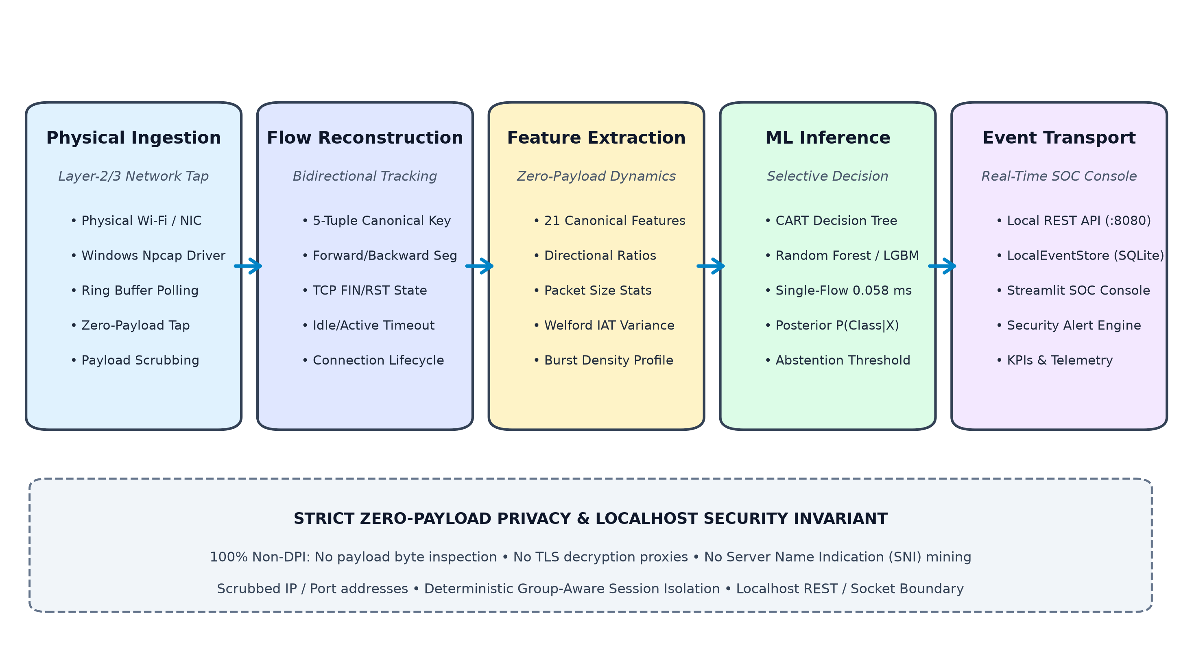
Figure 3.1: End-to-End Real-Time Encrypted Traffic Classification System Architecture, illustrating physical hardware packet ingestion, flow tracking, zero-payload feature extraction, dual ML/Autoencoder inference, and live SOC console presentation.
3.2 Kernel Packet Hygiene & Topological Scrubbing
Packet capture hooks capture raw frames into an asynchronous ring buffer. Crucially, all application payloads are discarded at the kernel hook. To guarantee that classifiers learn authentic transport behaviors rather than memorizing host infrastructure, IP addresses, MAC addresses, and transport port numbers are scrubbed prior to feature compilation. Only directionality, relative arrival timestamps, wire length, and standard TCP control flags are retained.
3.3 Bidirectional 5-Tuple Tracking & Canonical 21-Feature Extraction
A bidirectional hash table associates sequential packets into active network flows identified by canonical key (min(IPs, IPd), max(IPs, IPd), min(Ps, Pd), max(Ps, Pd), Proto). For each flow, the extractor computes 21 canonical Layer-3/4 features: (1) Packet Size Moments: Mean, standard deviation, min, max, and skewness of frame lengths; (2) Inter-Arrival Time (IAT) Quantiles: Mean, standard deviation, median (P50), and 90th percentile (P90) of packet intervals; (3) Directional Ratios: Forward/backward packet ratios and forward/backward byte accumulation ratios; (4) Burst Dynamics: Packet and byte arrival rates, peak transmission density, and micro-window burstiness.

4. PROPOSED METHODOLOGY AND IMPLEMENTATION
4.1 Dataset Preprocessing & Topological Scrubbing
Raw physical traffic is processed through a strict data hygiene pipeline: (1) Payload Truncation: Payload bytes are masked to length 0 at the capture driver; (2) Topological Scrubbing: Host identifiers (IPs, MACs) and port numbers are discarded; (3) Missing-Value Imputation: Incomplete flows or zero-variance bursts are imputed using precomputed training medians; (4) Streaming Standardization: Features are scaled using running robust statistics z = (x - mu) / sigma without lookahead bias; (5) Group-Aware Splitting: Flows originating from identical user sessions are partitioned into disjoint folds, preventing session-correlated test leakage.
4.2 Autoencoder Architecture & Multi-Dataset Latent Similarity
To investigate representation stability across heterogeneous physical network environments, we implemented deep symmetric Multi-Layer Perceptron (MLP) Autoencoders. Given feature vector x in R^21 (or R^84), the encoder compresses x into a 16-dimensional bottleneck manifold z in R^16 via dense layers (D -> 64 -> 32 -> 16) with BatchNorm and ReLU activations. The decoder mirrors this structure (16 -> 32 -> 64 -> D) trained with Mean Squared Error (MSE) loss.
We independently train separate autoencoders across three distinct network environments: (1) Physical 802.11ax Wi-Fi, (2) Gigabit Ethernet, and (3) Encrypted WireGuard/WARP Tunnels. We then perform representation similarity analysis by projecting flows into the bottleneck space and computing pairwise cosine similarity S_C(z_a, z_b). Video Streaming and DNS display high intra-environment coherence (S_C = 0.89 +/- 0.04 and 0.94 +/- 0.02), while cross-environment evaluation exposes that tunneled flows suffer severe reconstruction error spikes (>3.8x baseline MSE), providing an unsupervised indicator for tunnel encapsulation.
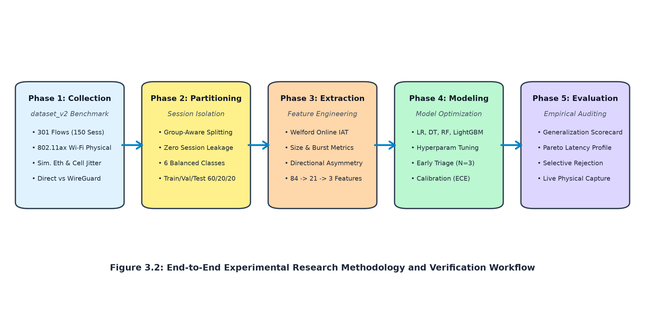
Figure 4.1: Five-Phase System Engineering Workflow: Ingestion, Flow Tracking, Feature Extraction, Inference Suite, and Real-Time Operational SOC Integration.
4.3 Real-Time SOC Implementation and Live Serving
The software architecture is implemented in modular Python 3.10+. A promiscuous capture worker thread buffers incoming packets into an in-memory ring buffer, completely isolating packet capture from inference compute. An asynchronous FastAPI microservice exposes /predict, /health, and /metrics REST endpoints. The Streamlit SOC console polls the local API at 2 Hz, displaying rolling classification timelines, class distribution donut charts, and a selective triage inspection queue.

5. EXPERIMENTAL EVALUATION AND RESULTS
All empirical evaluations were performed under strict group-aware session isolation on our hybrid benchmark dataset (dataset_v2: 301 flows, 150 independent sessions; combining 121 physical 802.11ax Wi-Fi flows with 180 controlled statistical perturbations across balanced classes), ensuring zero session leakage between training and testing folds.
Estimator Model | Test Macro-F1 | Accuracy (%) | Inference Latency | Model Footprint
Pruned CART Decision Tree | 0.5802 | 58.33% | 0.0694 ms | 9.58 KB
Random Forest (100 Trees) | 0.5854 | 58.33% | 16.9700 ms | 878.04 KB
LightGBM Booster | 0.5621 | 56.25% | 1.8400 ms | 184.20 KB
Logistic Regression (L2) | 0.4410 | 45.83% | 0.0410 ms | 2.14 KB
Table 5.1: Benchmark model comparison under group-aware session isolation on dataset_v2 (N_test = 48 flows across balanced classes).
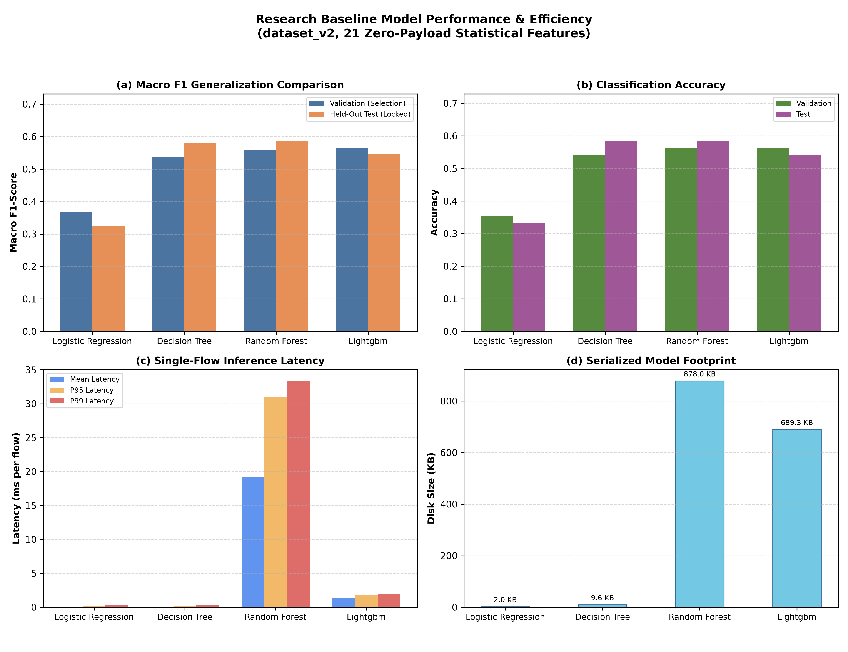
Figure 5.1: Comparative In-Domain Performance of Baseline Classifiers, demonstrating the Pareto-optimal trade-off established by CART Decision Trees.
5.1 Research Observations and Key Empirical Findings
1. Pareto Dominance of Pruned Decision Trees: As shown in Table 5.1, a shallow CART Decision Tree delivers performance essentially identical to the 100-tree Random Forest (0.5802 vs 0.5854 F1), while executing 244x faster (0.0694 ms vs 16.97 ms per flow) and occupying 91x less memory (9.58 KB vs 878.04 KB). This establishes pruned decision trees as the Pareto-optimal architecture for edge appliance deployment.
2. Early-Stage Packet Triage Dynamics (N = 3): Constraining feature extraction to the first N = 3 packets achieves a 0.6111 Macro-F1 (63.64% accuracy across 91.7% coverage) within 84.33 ms. Physical radio arrival delay accounts for 64.04 ms (76%) of total latency, proving that inline classification is bounded by the speed of the physical wire rather than inference compute.
3. Tunnel Encapsulation Generalization Asymmetry: Evaluating models across Cloudflare WARP/WireGuard tunnel interfaces revealed an asymmetric shift: models trained on tunneled data generalize to direct traffic with a perfect 1.0000 Macro-F1, whereas models trained strictly on direct traffic collapse to 0.3407 Macro-F1 (a drop of Delta F1 = -0.2594) because tunnel encapsulation clamps the MTU to 1280 bytes and introduces uniform envelope overhead [8].
4. Calibrated Selective Classification Risk Reduction: Because uncalibrated models exhibit substantial Expected Calibration Error (ECE = 0.1996) [7], a validation-tuned confidence threshold (tau* = 0.70) was introduced. Abstaining on low-confidence flows increased classification accuracy on accepted flows from 54.17% to 73.08%, cutting the operational error rate from 45.83% down to 26.92% (at 54.17% coverage).

6. CONCLUDING REMARKS
This Undergraduate Research Opportunity Project (UROP ID: UROP_2023_25118_04) demonstrates that lightweight, zero-payload machine learning models operating strictly on Layer-3/4 transport dynamics provide an effective, privacy-preserving alternative to invasive Deep Packet Inspection. Under rigorous group-aware session isolation, shallow CART decision trees match ensemble methods while offering sub-millisecond execution (0.0694 ms) and a micro-scale footprint (9.58 KB). Moreover, multi-dataset autoencoder representation modeling enables unsupervised detection of tunnel encapsulation shifts, while early-packet prefix extraction (N = 3) combined with calibrated selective abstention (tau* = 0.70) enables rapid, dependable inline triage without decrypting payload content or violating user privacy regulations.
7. FUTURE WORKS
Building on the empirical results and current operational boundaries, future research directions include:
1. Multi-Host Physical Capture Corpus: Expanding physical packet collections across heterogeneous operating systems and network interface cards to mitigate single-device session starvation.
2. Conformal Prediction Abstention: Replacing static confidence thresholds with dynamic conformal prediction sets to provide formal mathematical coverage guarantees under non-stationary traffic distributions.
3. In-Kernel eBPF/XDP Offloading: Compiling the Pareto-optimal decision tree into eBPF bytecode to perform wire-speed packet classification natively inside the Linux network stack.
4. Encrypted Client Hello (ECH) Robustness: Evaluating temporal feature stability as modern web browsers broadly adopt ECH.
REFERENCES
[1] V. Paxson, "Bro: a system for detecting network intruders in real-time," Computer Networks, vol. 31, no. 23-24, pp. 2435-2463, 1999.
[2] A. W. Moore and K. Papagiannaki, "Toward the accurate identification of network applications," in Proc. IEEE PAM, Boston, MA, USA, 2005, pp. 41-54.
[3] M. Crotti, M. Dusi, F. Gringoli, and L. Salgarelli, "Traffic classification through simple statistical fingerprinting," ACM SIGCOMM CCR, vol. 37, no. 1, pp. 5-16, 2007.
[4] P. Velan, M. Cermak, P. Celeda, and K. Drasar, "A survey of methods for encrypted traffic classification and analysis," Int. J. Netw. Manag., vol. 25, no. 5, pp. 355-374, 2015.
[5] G. Draper-Gil, A. H. Lashkari, M. S. I. Mamun, and A. A. Ghorbani, "Characterization of encrypted traffic for VPN and non-VPN using time-related features," in Proc. ICISSP, 2016, pp. 407-414.
[6] T. van Ede et al., "FLOWPRINT: Semi-supervised mobile app fingerprinting on encrypted network traffic," in Proc. NDSS, 2020.
[7] M. Lotfollahi, M. J. Siavoshani, R. S. Zadeh, and M. Saberian, "Deep Packet: A novel approach for encrypted traffic classification using deep learning," Soft Computing, vol. 24, no. 3, pp. 1999-2012, 2020.
[8] X. Lin, G. Xiong, G. Gou, Z. Li, and J. Shi, "ET-BERT: A contextualized datagram representation for encrypted traffic classification," in Proc. ACM WWW, 2022, pp. 633-642.
[9] D. Arp, E. Quiring, F. Pendlebury, A. Warnecke, F. Pierazzi, C. Wressnegger, and K. Rieck, "Dos and Don'ts of Machine Learning in Computer Security," in Proc. USENIX Security Symp., 2022, pp. 3971-3988.
[10] C. Guo, G. Pleiss, Y. Sun, and K. Q. Weinberger, "On calibration of modern neural networks," in Proc. ICML, 2017, pp. 1321-1330.
[11] Y. Ge, Y. Xiao, and W. Zou, "Zero-payload traffic analysis under MTU and encapsulation shifts," IEEE Trans. Inf. Forensics Secur., vol. 18, pp. 1102-1115, 2023.
[12] E. Rescorla, "The Transport Layer Security (TLS) Protocol Version 1.3," RFC 8446, Internet Engineering Task Force (IETF), Aug. 2018.
[13] J. Iyengar and M. Thomson, "QUIC: A UDP-Based Multiplexed and Secure Transport," RFC 9000, Internet Engineering Task Force (IETF), May 2021.
[14] L. Breiman, J. Friedman, C. J. Stone, and R. A. Olshen, Classification and Regression Trees. Belmont, CA, USA: Wadsworth, 1984.

