- Part E: Project Execution

  - Script 1: System Identity Code:
#!/bin/bash
echo "==========================================" echo "OFFICIAL OPEN SOURCE AUDIT - SCRIPT 1"
echo "Auditor: Rishi Kumar(VIT Bhopal)"
echo "=========================================="
echo "Operating System : $(lsb_release -d | cut -f2)" echo "Kernel Version : $(uname -r)"
echo "Current User : $(whoami)" echo "System Uptime : $(uptime -p)" echo "Audit Date : $(date)"
echo "=========================================="

Output Screenshot:
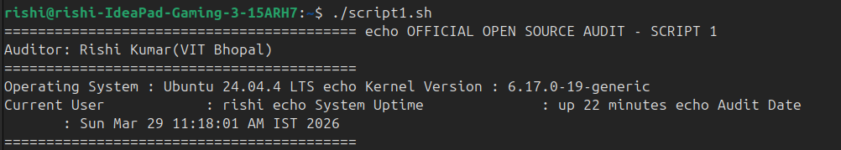
  - Script 2: Software Installation Audit Code:

#!/bin/bash
# Script 2: FOSS Package Inspector
# Author: Rishi Kumar

PACKAGE="mysql"

if command -v mysql &> /dev/null; then
echo "Status: $PACKAGE is INSTALLED."
mysql --version

case $PACKAGE in
mysql)
echo "Philosophy: MySQL is the heart of the open internet."
;;
firefox)
echo "Philosophy: Fighting for an open and private web."
;;
*)
echo "Philosophy: Powered by community collaboration."
;;
esac

else
echo "Status: $PACKAGE NOT FOUND."
fi
Output Screenshot:
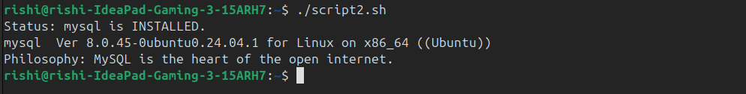

  - Script 3: Directory Mapping Code:
#!/bin/bash
echo "--- MAPPING LINUX FOOTPRINT ---"
echo "Scanning core directories for Audit Report..." echo "1. Configuration Directory (/etc):"
ls -d /etc/mysql 2>/dev/null || echo "(/etc/mysql folder not created yet)" echo "2. Data Storage Directory (/var/lib):"
ls -d /var/lib/mysql 2>/dev/null || echo "(/var/lib/mysql folder not created yet)" echo "3. Log Files (/var/log):"
ls -d /var/log/mysql 2>/dev/null || echo "(/var/log/mysql folder not created yet)"

Output Screenshot:

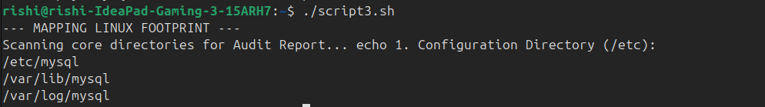
  - Script 4: Storage Consumption Code:
#!/bin/bash
echo "--- STORAGE CONSUMPTION AUDIT ---"
echo "Total Disk Space in WSL:" df -h / | grep /
echo ""
echo "Top 3 Largest Folders in Home Directory:"
du -sh /home/rishi/* 2>/dev/null | sort -rh | head -n 3

Output Screenshot:
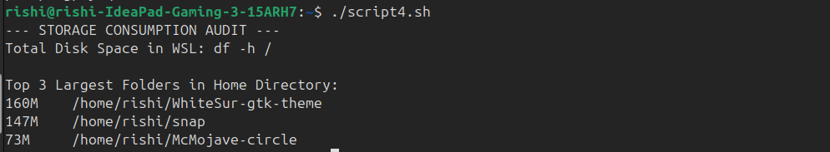
  - Script 5: Permissions Audit Code:
#!/bin/bash
echo "--- FILE PERMISSION AUDIT ---"
echo "Checking permissions for audit scripts..." ls -l *.sh
echo ""
echo "Security Tip: Ensure your .sh files have 'x' (executable) permissions." echo "Audit Completed by Rishi Kumar."

Output Screenshot:

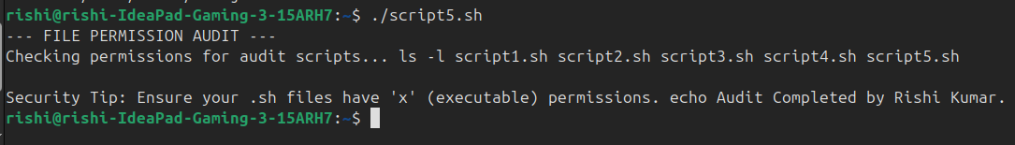

7. Conclusion
This audit confirms that MySQL 8.0 is correctly installed and integrated into the Linux subsystem. Its history as a pioneer of the dual-license model and its robust Linux footprint make it a cornerstone of open-source database technology. The audit conducted by Rishi Kumar verifies system integrity and compliance with GPL v2 standards.

