Next Up

Movie Recommendation System

# Overview

Next up is a movie recommendation system that offers generalized recommendations to every user based on movie popularity, genre, and year. The model also gives personalized recommendations based on the user's choice of genre and cast.

Finally, the system suggests similar movies have a higher probability of being liked based on the movie selected by the user.

## Use Case Diagram

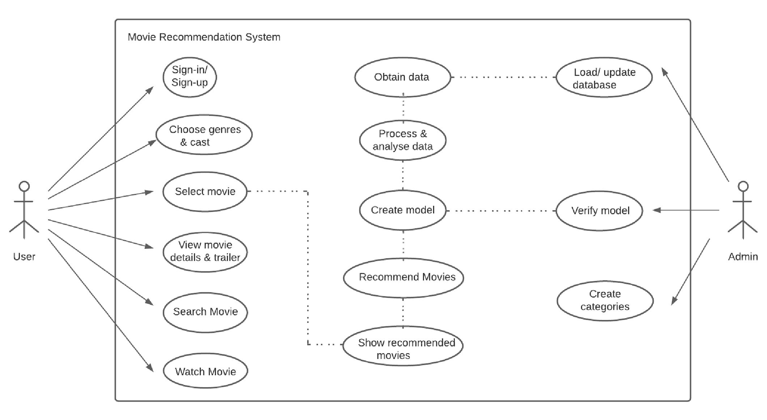

## Features

1. Sign-up and Sign-in functionality.
2. Forgot password (resetting password) functionality.
3. OTP validation.

The user receives a mail containing OTP for validation before resetting the password.

1. The User’s credentials are stored in the database.
2. Completely responsive front end.
3. A total of 4 types of recommendations:

* Recommended movies based on the user's chosen genres and casts.
* Most popular movies based on different genres.
* Most popular movies based on different years.
* Recommended movies similar to the user's selected movie.

1. Movie details and trailer linked for each movie.
2. Watch a movie option.
3. Option to like or dislike a movie.
4. Client-side session tracking.
5. Continuous deployment.

## Recommendation Algorithms

* Based on chosen genres and cast:

First, the movies which have the cast chosen by the user are filtered out by using a search algorithm. Then out of those, movies that have the genres chosen by the user are filtered out using a search algorithm. The resultant movies are sorted based on the frequency of chosen cast appearing in a movie and secondly based on popularity. The top 3 movies are recommended to the user.

* Popular movies based on the genre

First, the movies which have the genre chosen by the user are filtered out by using a search algorithm. Then movies are sorted based on their popularity. The top movies are recommended to the user for that genre.

* Popular movies based on the year

First, the movies which are released in the year chosen by the user are filtered out by using a search algorithm. Then movies are sorted based on their popularity. The top movies are recommended to the user for that genre.

* Similar movie recommendation

For recommendations of similar movies, a content-based recommendation system. For recommendation, the system takes into account movie titles, genres, starring cast, keywords, overview, and the director. I have implemented Cosine Algorithm after the vectorization of movies.

It is achieved by using Annoy (Approximate Nearest Neighbors) mechanism.

Resource for Annoy: <https://github.com/spotify/annoy>

## Web Flow

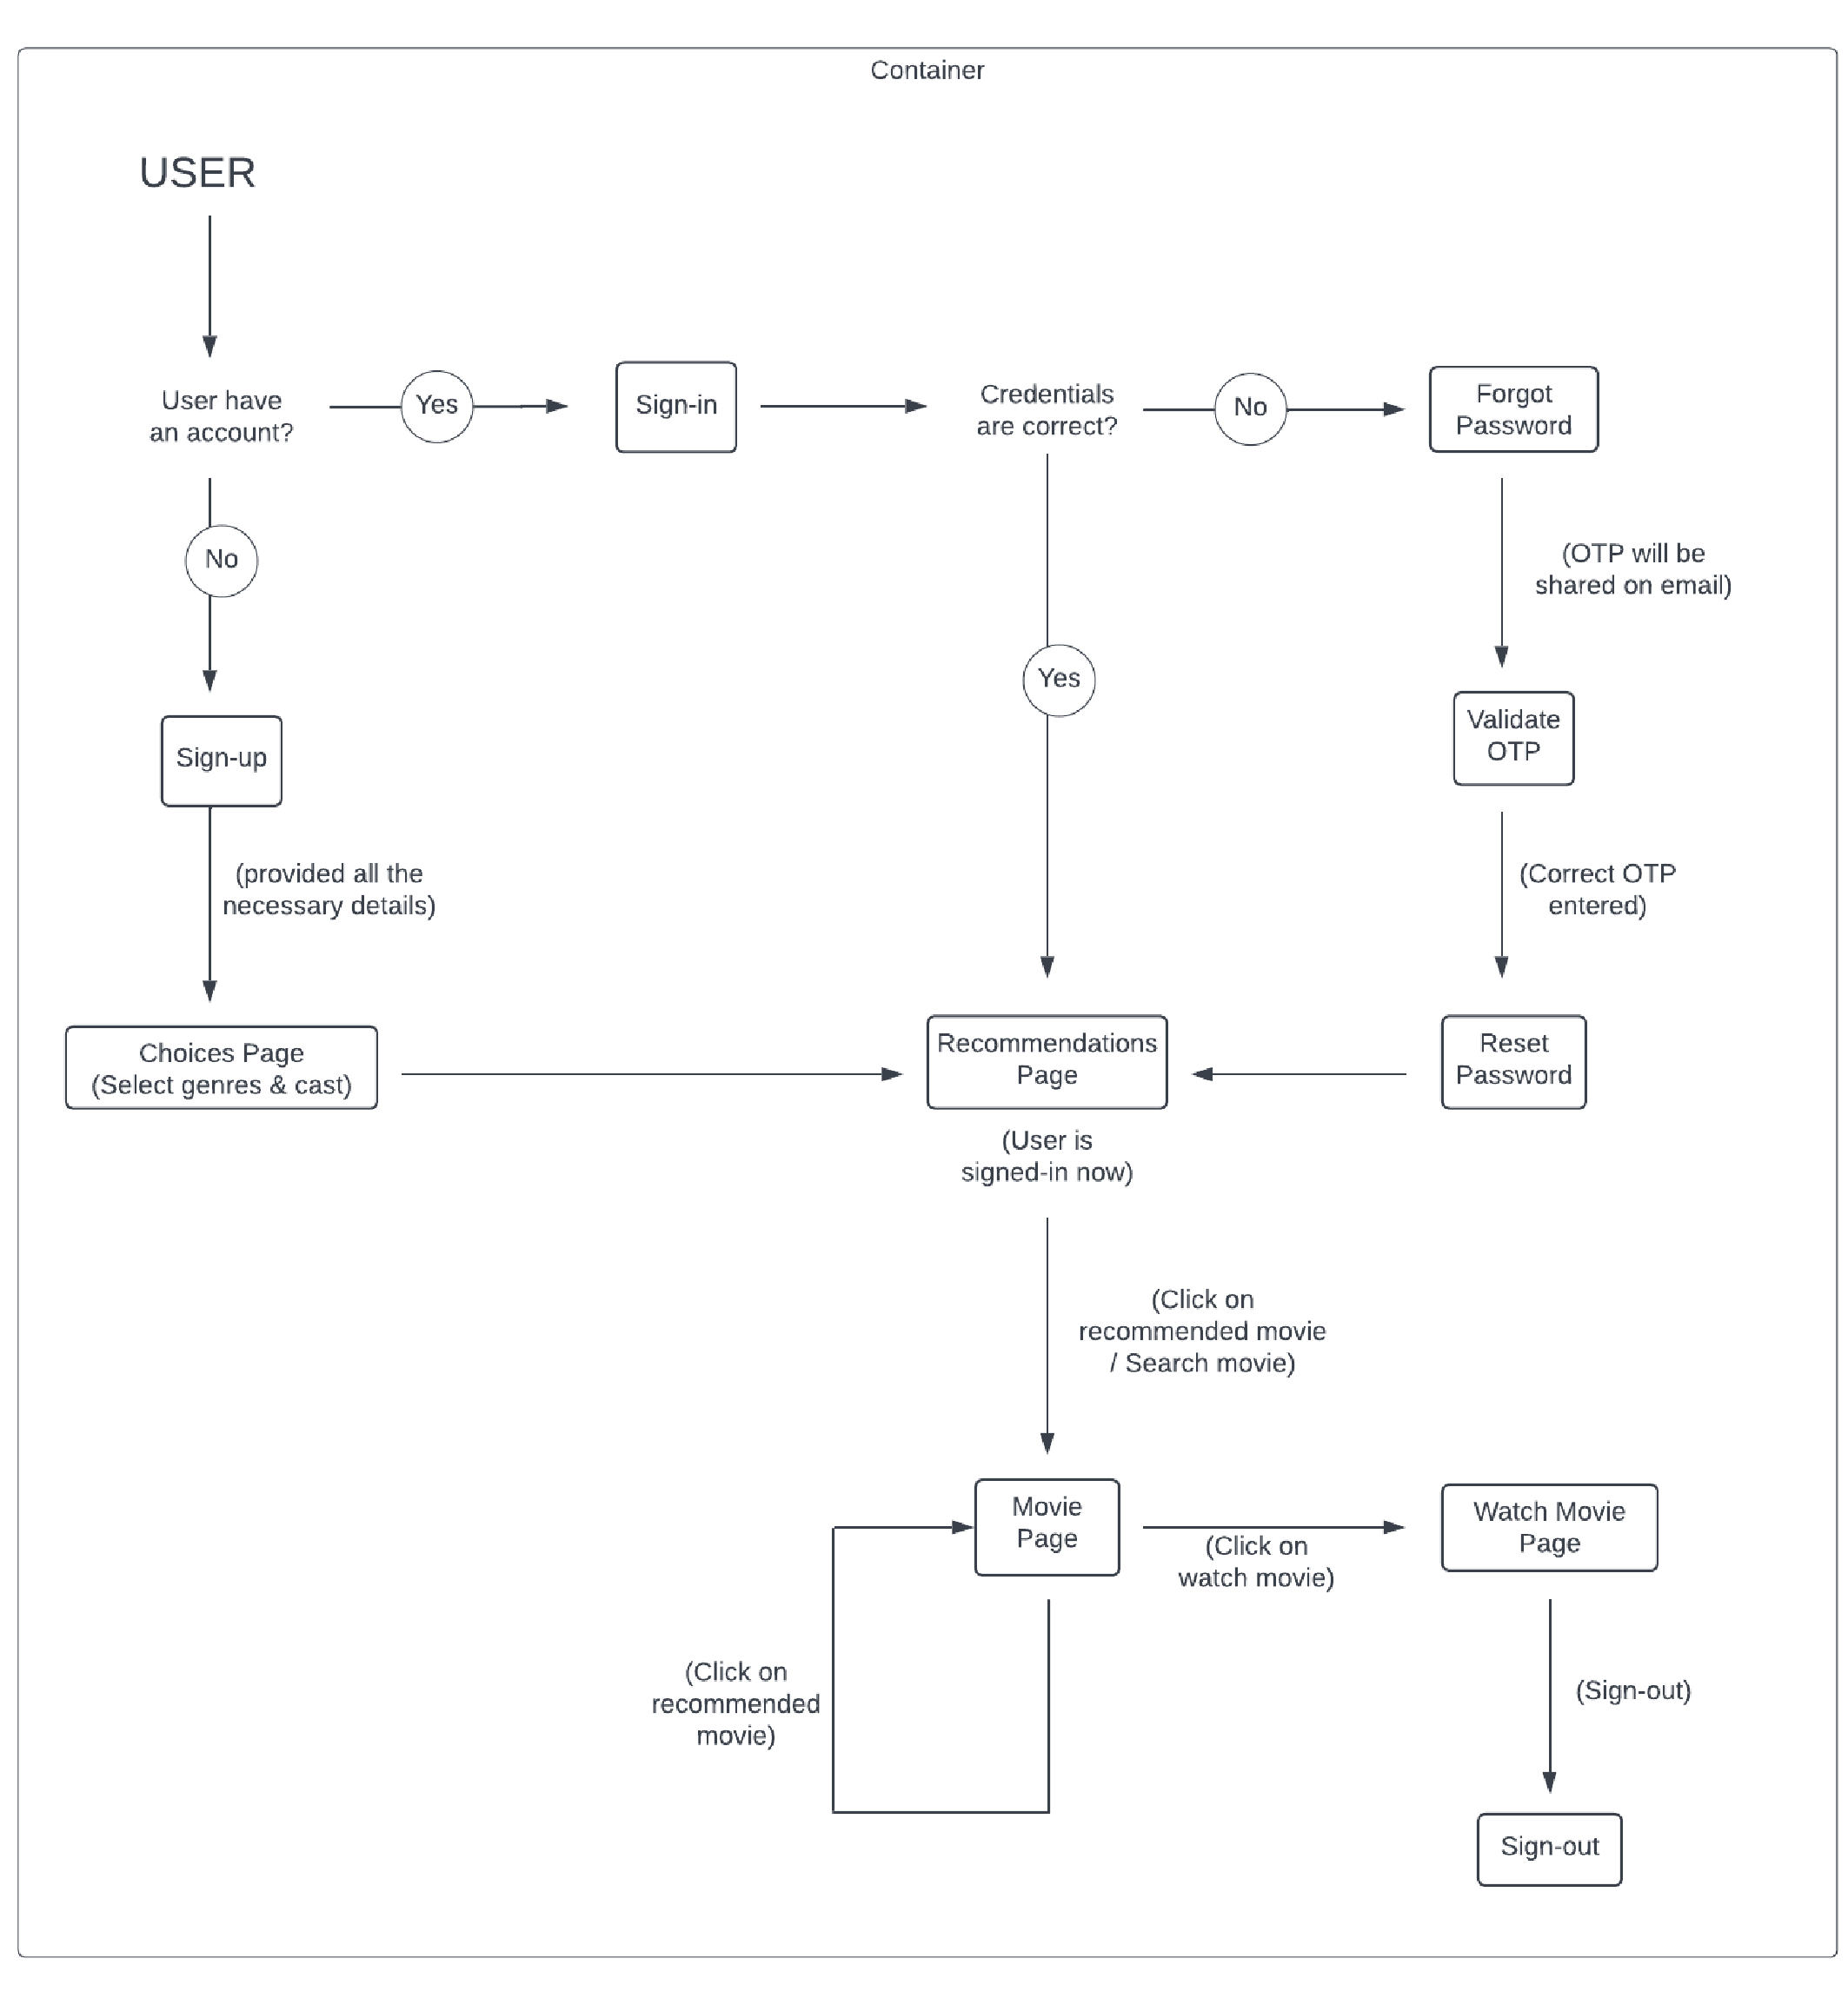

## Work Flow

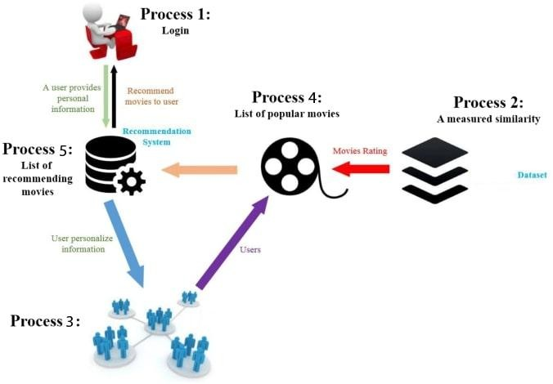

________________________________________________________________

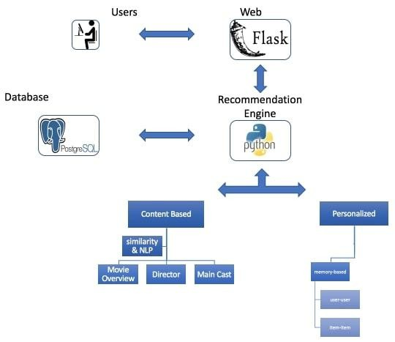

## Requirements

**Tech Stack and Software requirements:**

1. Frontend: HTML5, CSS3, JavaScript, BootStrap, jQuery
2. Backend: Python flask
3. Database: PostgreSQL, SQLite3
4. ML model : Jupyter Notebook
5. IDE: PyCharm
6. Version Control: Git
7. Deployment: Heroku

**Libraries and toolkit requirements:**

1. Python: NumPy, Pandas, ast (Abstract Syntax Trees), pickle
2. ML: ntlk (Natural Language Toolkit), sklearn (scikit-learn)
3. SQLite: sqlite3, SQLAlchemy

**Interfaces** ● Landing Page

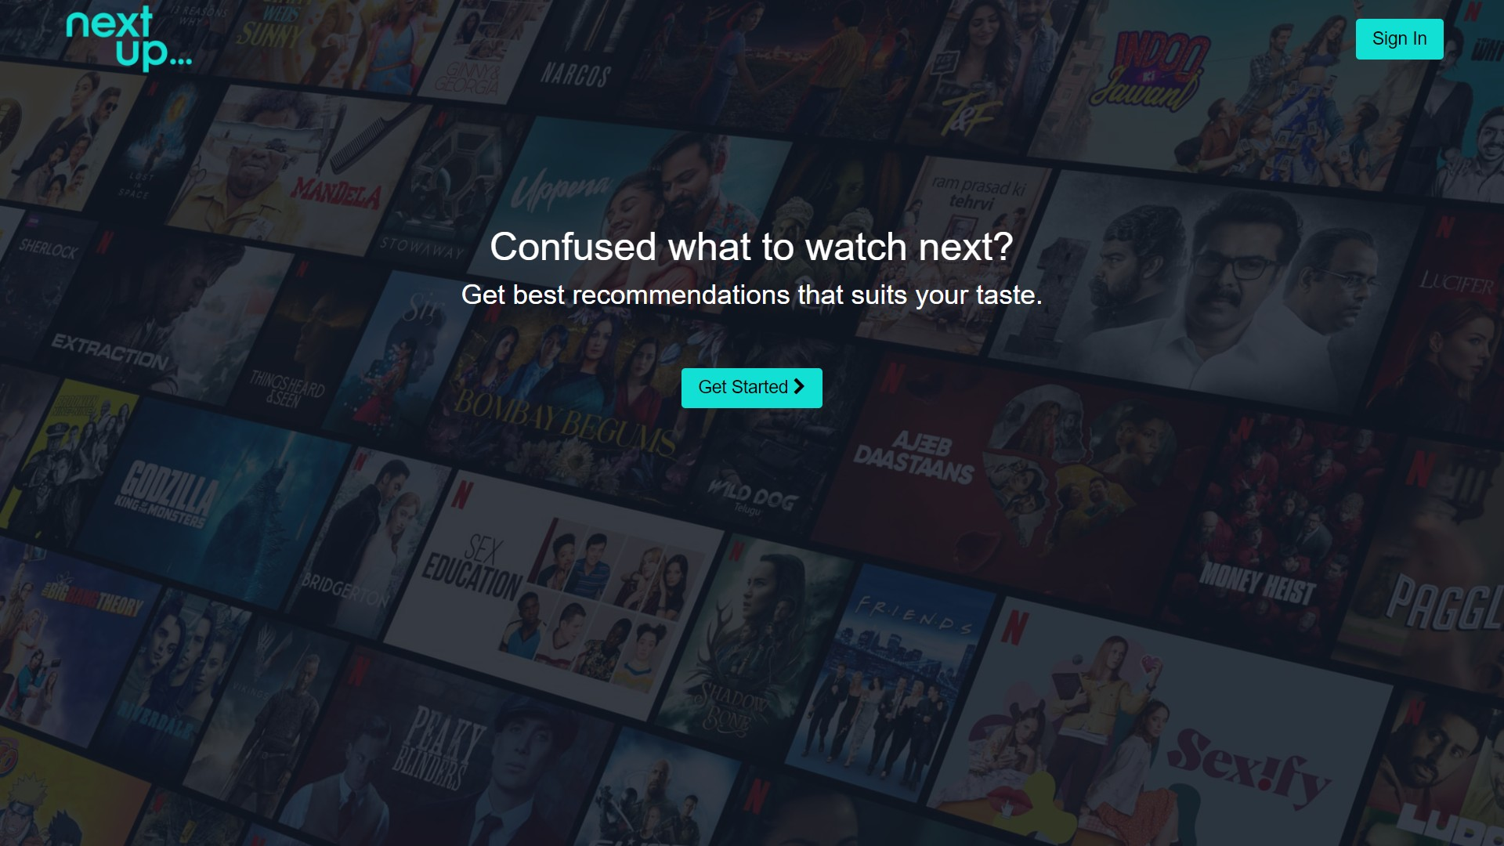

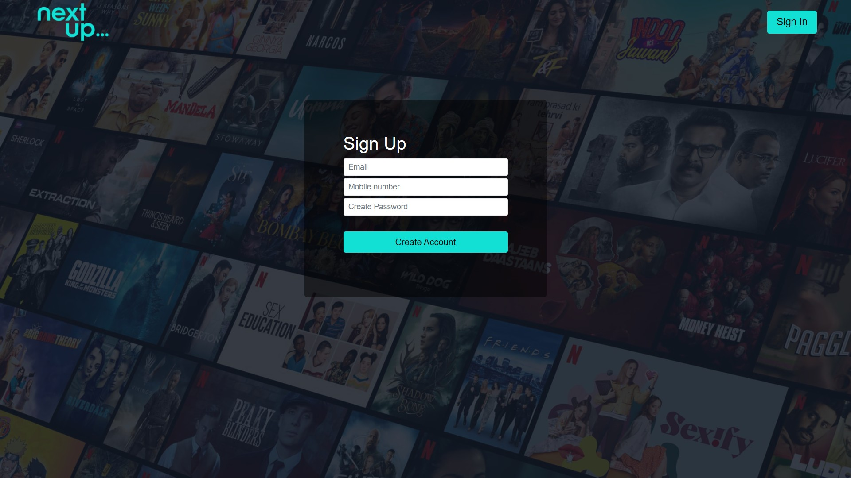

* Sign-in Page

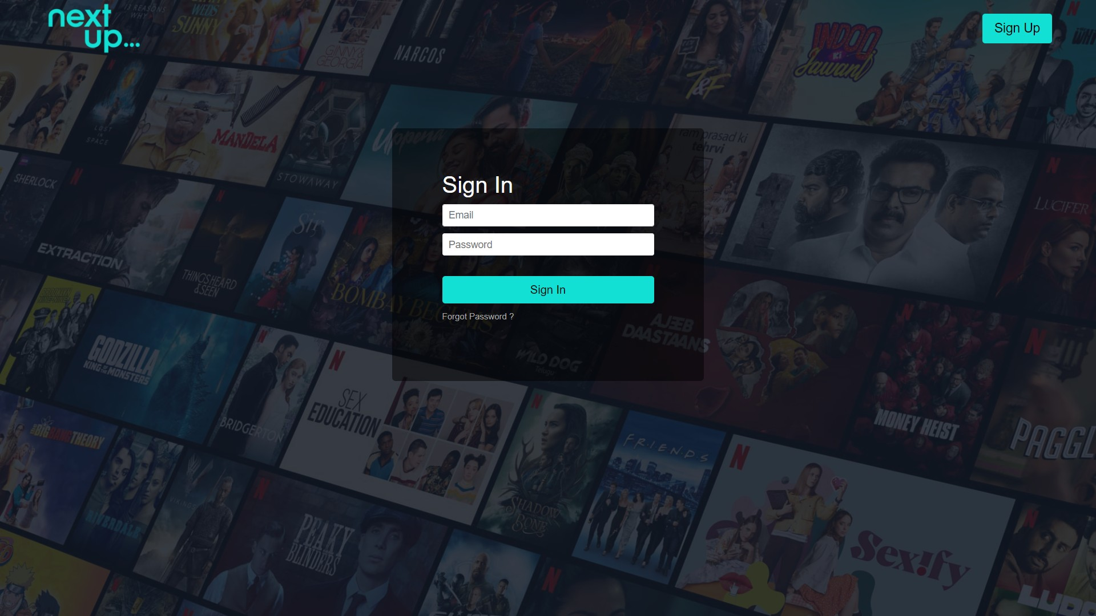

* OTP Validation Page

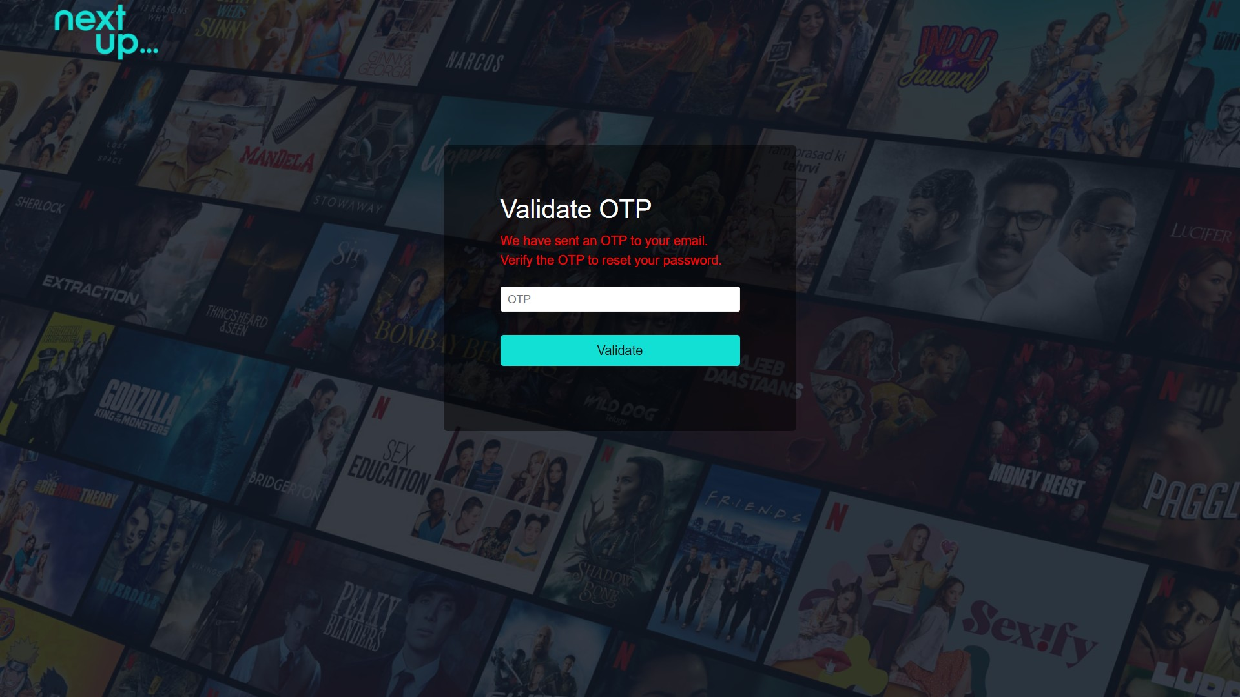

* Reset Password Page

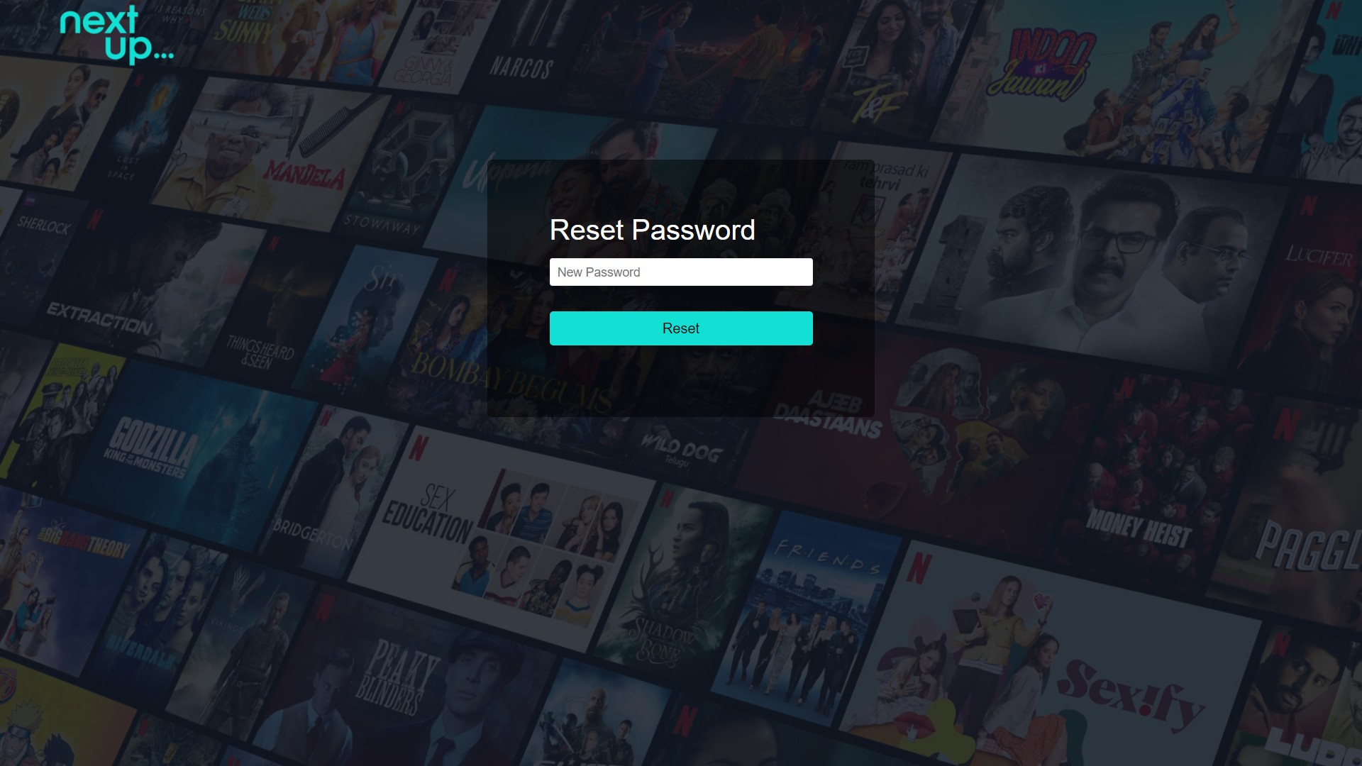

* Restrictions and validations on the sign-up page, sign-in page, forgot password functionality, OTP validation page, and reset password page
  1. All fields not filled
  2. Email account already registered (sign-up), Email account not registered (sign-in)
  3. Incorrect password, OTP incorrect
  4. Email address not entered, OTP not entered, new password not entered

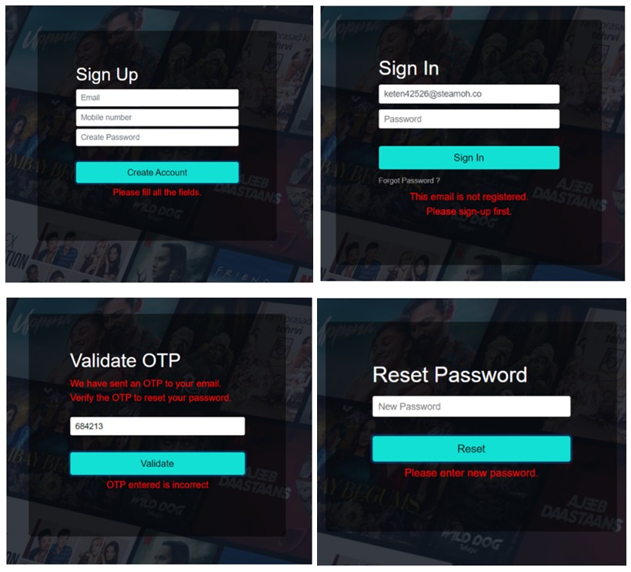

Choices Page

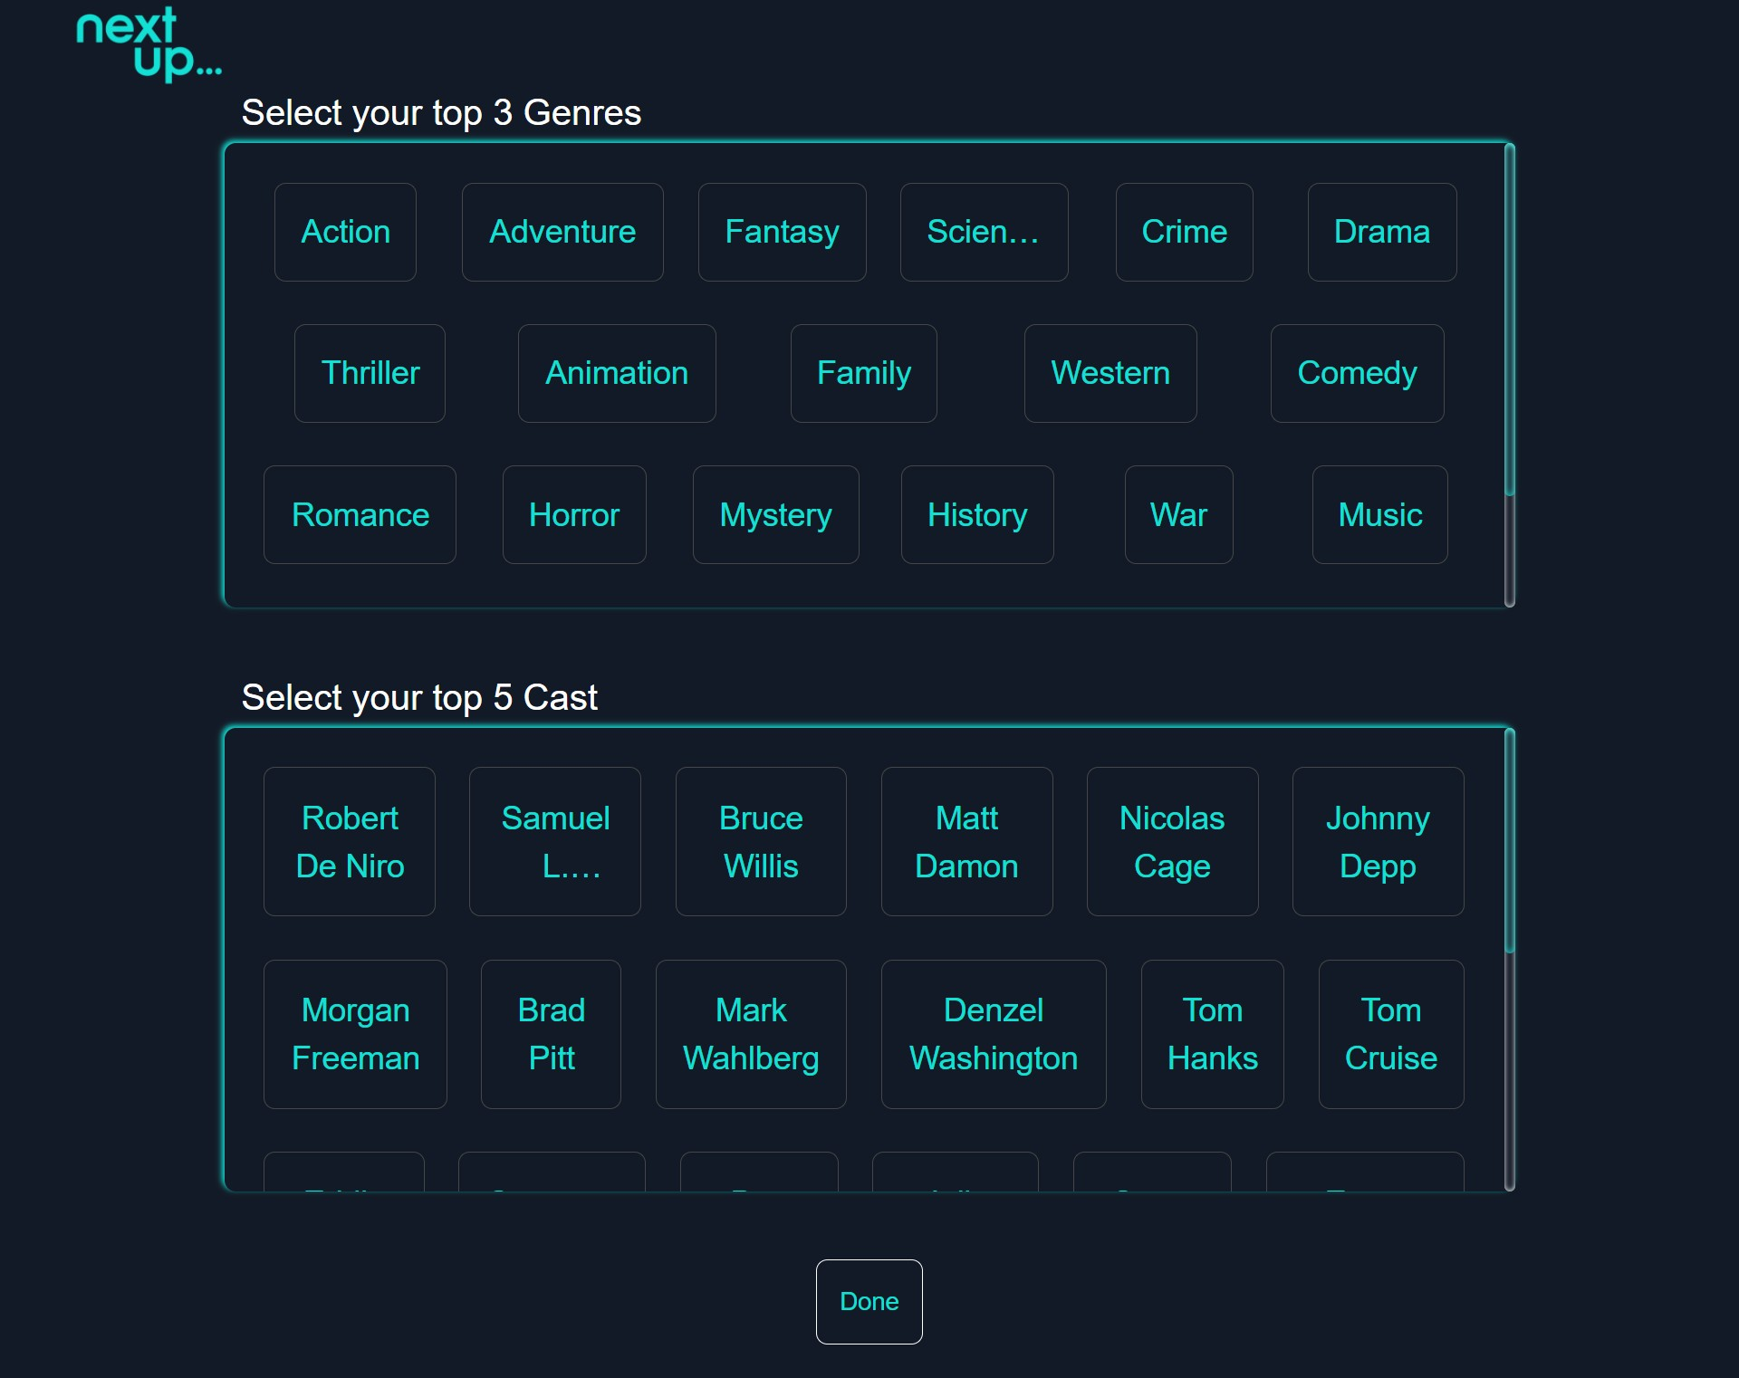

Recommendations Page

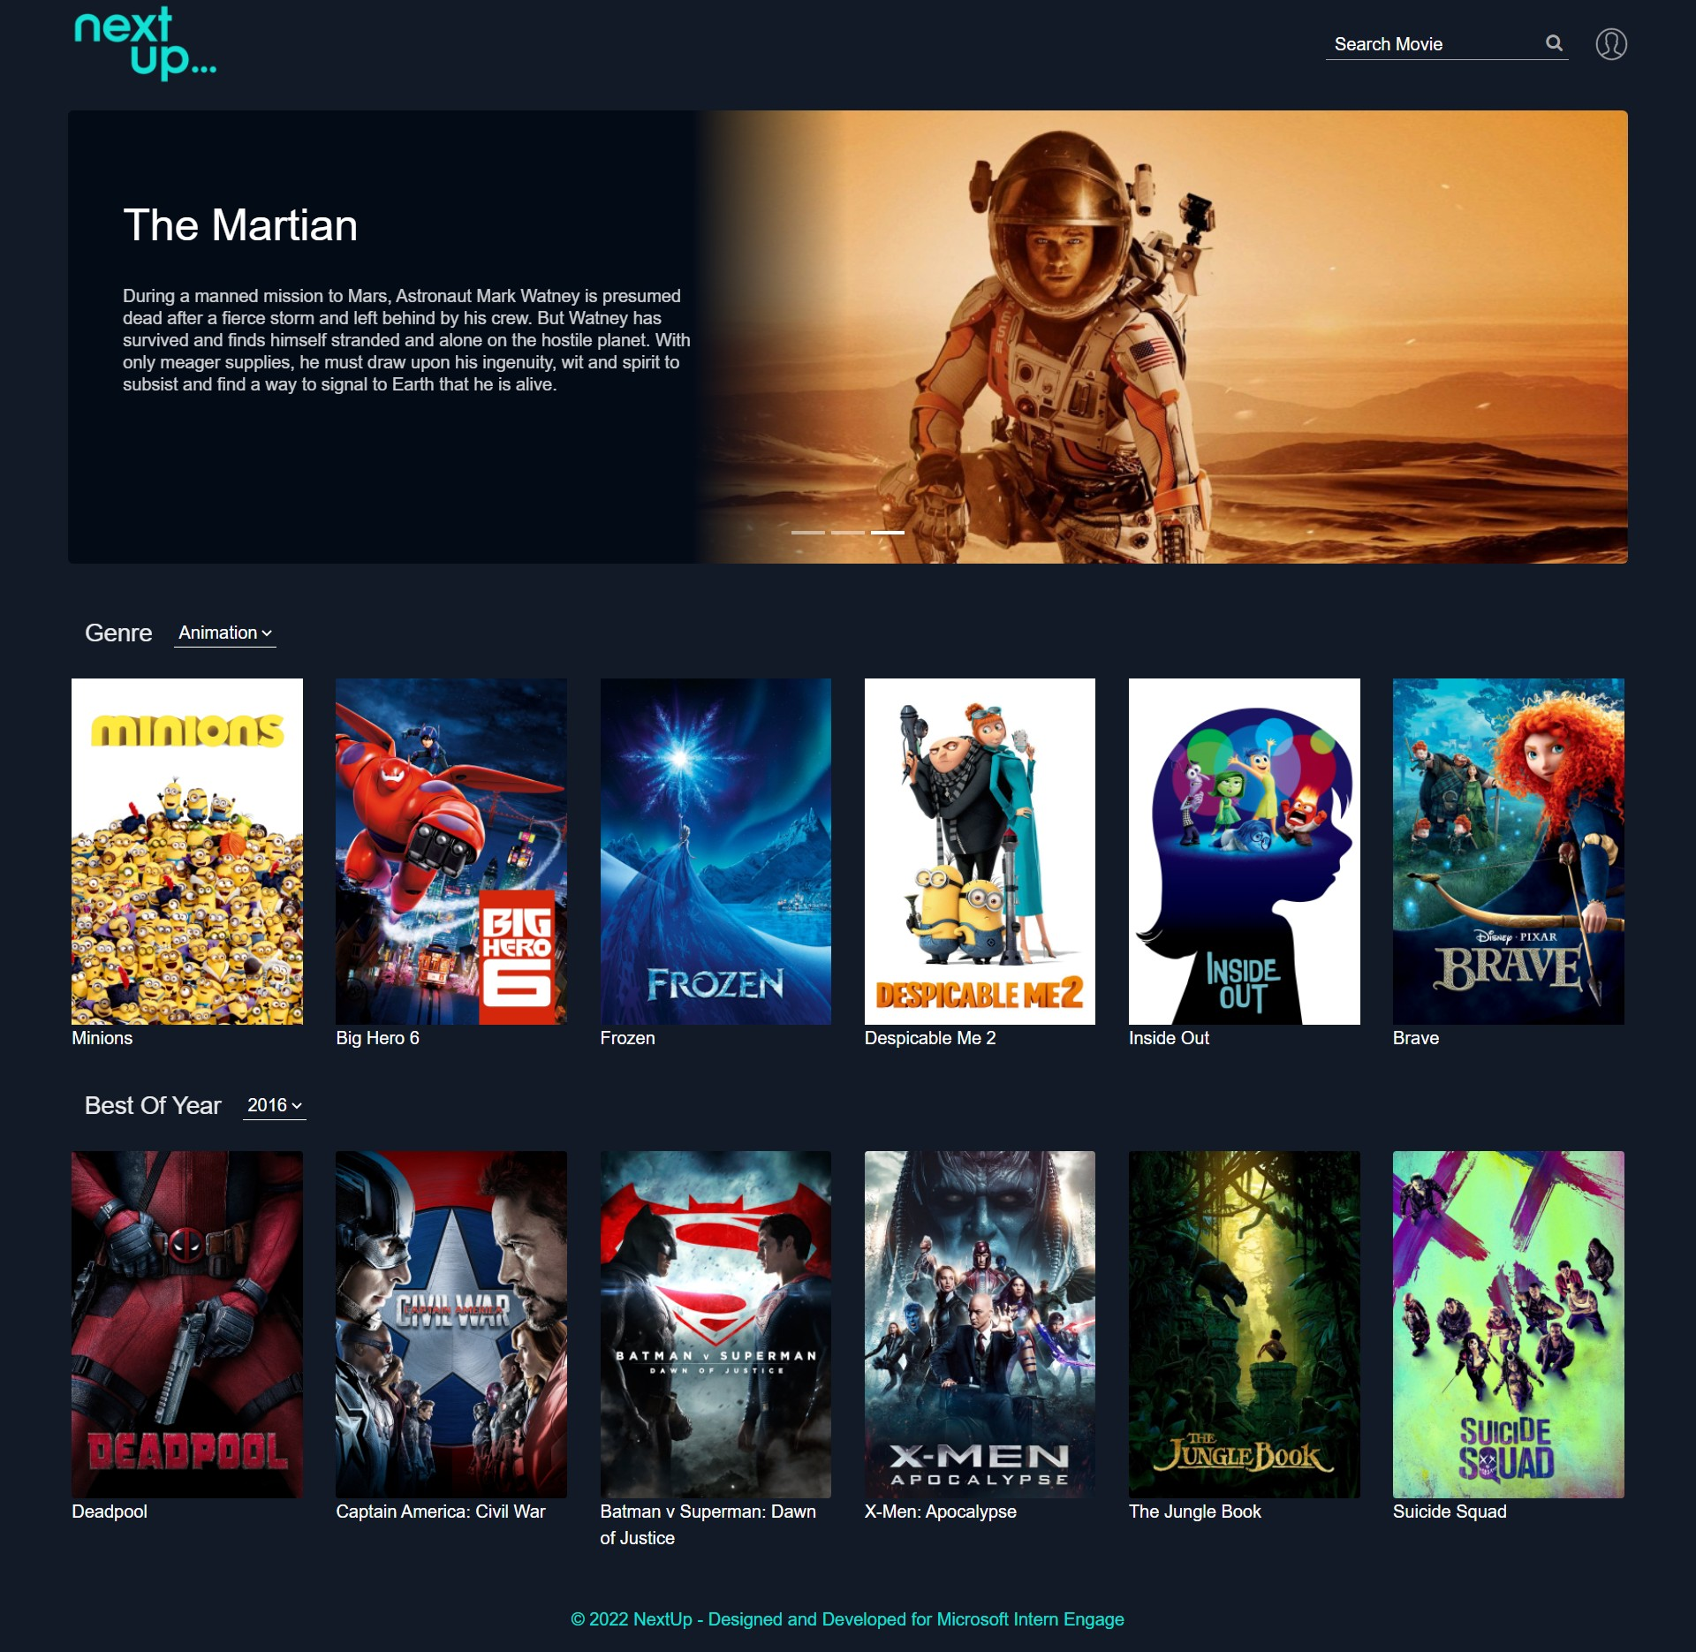

Movie Page

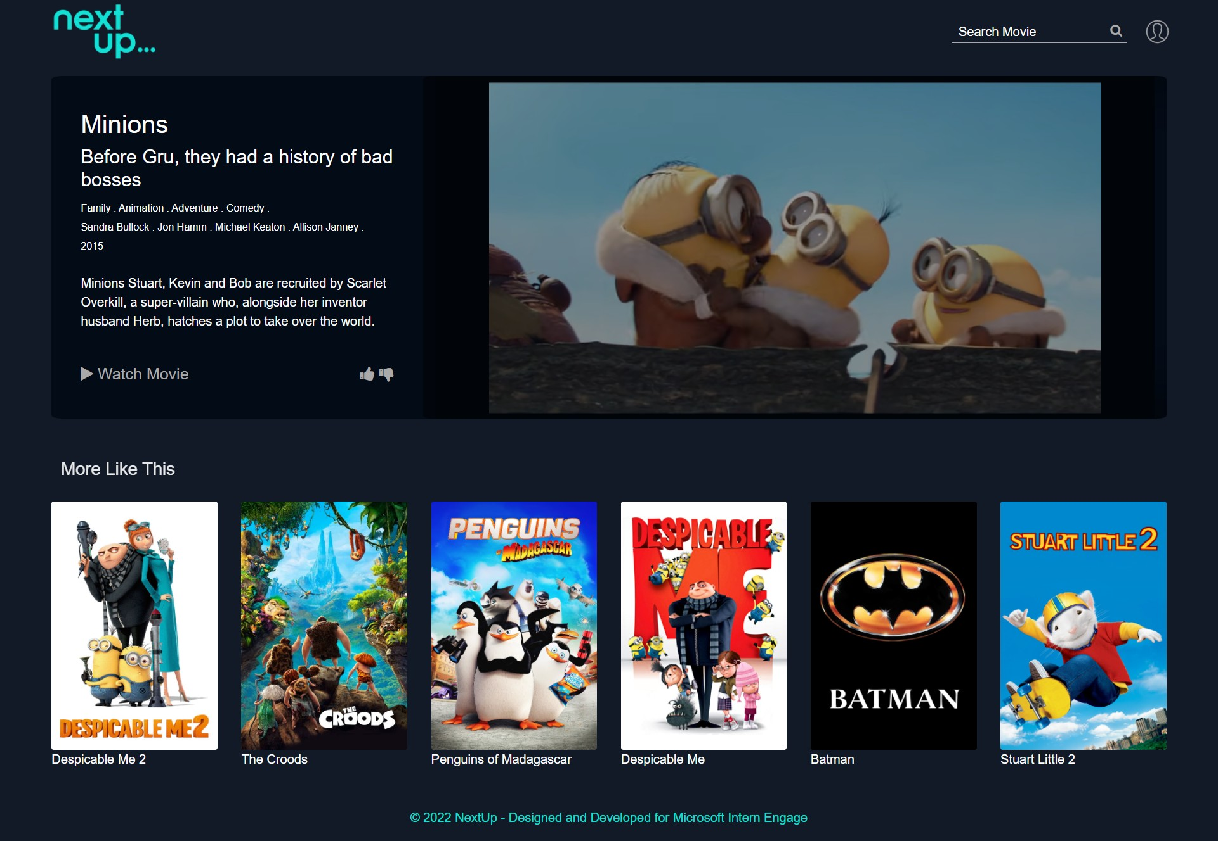

* Watch Movie Page

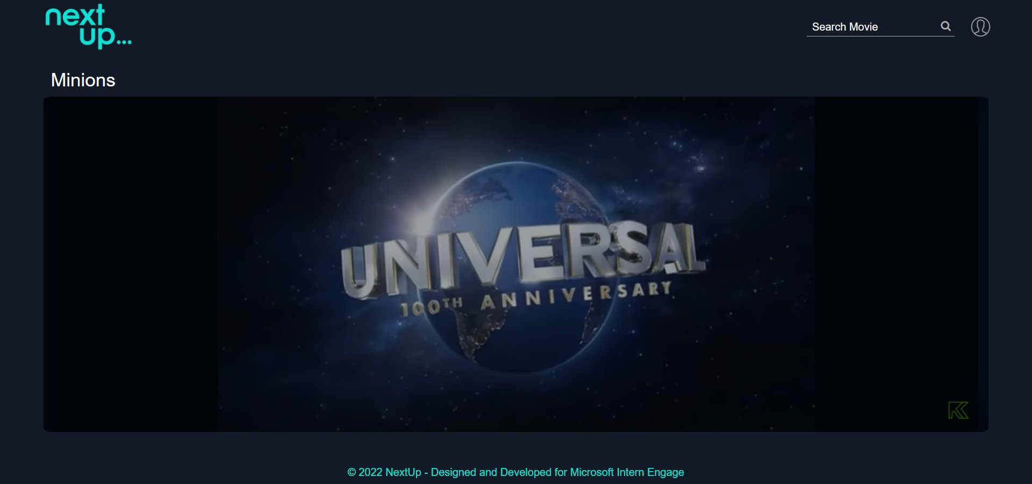

## Future Scope

* Like/Dislike: The option to like or dislike a movie adds the movie to the user's like/dislike list. As of now, I am just accumulating the data. This can be further extended by using the like/dislike list to recommend movies to the user.
* Watch Movie: The watch movie option currently displays the same movie intro for all the movies. In the future, it can be customized according to the movie selected.
* Collaborative Filtering: The model currently uses a content-based recommendation system. It can be converted into a hybrid system by adding a collaborative filtering mechanism.