1.what are diffrent buzzword in java?

ANS:- Simple, Secure, Portable, Object-oriented, Robust, Multithreaded, Architecture-neutral, Interpreted, High Performance, Distributed and Dynamic are the Java buzzwords.

2.Simple hello world program in java and use java javac javap command.

ANS.

class Simple{

public static void main(String args[]){

System.out.println("Hello World...");

}

} 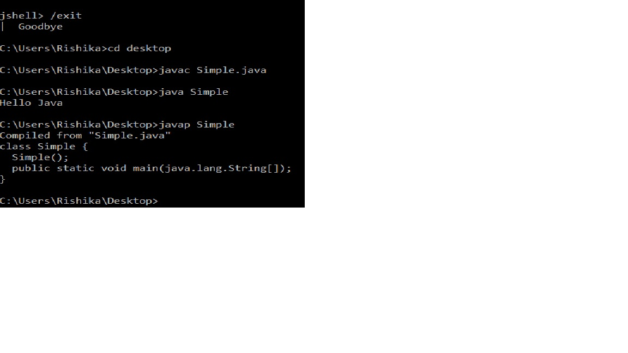

3. Use “jshell” and try following:

* + “core java”.length()
  + Arithmetic operations like “int answer = 6\*7”

Use references like this in arithmetic operations “$1”, which got generated in previous operations

