LIBRARY MANAGEMENT SYSTEM
A DBMS Capstone Project Report submitted in partial fulfillment of the requirements for the award of the degree of

BACHELOR OF TECHNOLOGY
in

ARTIFICIAL INTELLIGENCE AND MACHINE LEARNING

Submitted By

THUTA RISHIKA – 25B11AID25

VANTAPATI DEEPIKA – 25B11AIC44

UNGARALA DHARANI TEJASWINI –25B11AIC23

MEKALA CHANDRA SEKHAR REDDY –25B11AID28

Under the esteemed guidance of
G L NARASAMBA VANGURI
M.Tech(Ph.D)
Assistant Professor
Department of AI&ML
ADITYA UNIVERSIT


DEPARTMENT OF ARTIFICIAL INTELLIGENCE AND MACHINE LEARNING

ADITYA UNIVERSITY
(Formerly Aditya Engineering College (A))
Aditya Nagar, ADB Road, Surampalem, Andhra Pradesh, India

2026 – 2027


Aditya Nagar, ADB Road, Surampalem, Andhra Pradesh, India
DEPARTMENT OF ARTIFICIAL INTELLIGENCE AND MACHINE LEARNING

CERTIFICATE

This is to certify that the DBMS Capstone Project report entitled “library Management System” is being submitted by T Rishika (Roll No. 25B11AID25), V Deepika (Roll No. 25B11AIC44), U Dharani (Roll No. 25B11AIC23) and G Chandra Sekhar Reddy (Roll No. 25B11AID28) in
partial fulfillment of the requirements for the award of the B.Tech. degree in Artificial Intelligence and Machine Learning. The work documented in this report was carried out as part of the Capstone Project for the course Database Management Systems (2501IT05) during the academic year 2026–2027, and records the database design, implementation, and documentation undertaken by the team.

Project Guide Head of the Department
G.L.Narasamba.v, M. Tech, (Ph.D.) Dr. K. Naga Bhargavi, M. Tech, Ph.D.
Associate professor Associate Professor & HOD

External Examiner

DECLARATION
We hereby declare that the DBMS Capstone Project entitled “ LIBRARY MANAGEMENT SYSTEM” is a genuine work carried out by us. The database design, SQL implementation, queries and documentation presented in this report are our own work, completed under the guidance of Mr. T. Srinivasulu, M. Tech, (Ph.D.), Department of Artificial Intelligence and Machine Learning, Aditya University, Surampalem. We further declare that this work has not been submitted, in full or in part, for the award of any degree of this or any other educational institution.

Project Associates

T.Rishika(25B11AID25)
V.Deepika (25B11AIC44)
U.Dharani (25B11AIC23)
M.Chandra sekhar reddy (25B11AID28)

Date: 14 September 2026 Place: Surampalem

ACKNOWLEDGEMENT

It is with immense pleasure that we express our indebted gratitude to our project guide G.L.Narasamba.v, M. Tech, (Ph.D.), Department of Artificial Intelligence and Machine Learning, who guided us throughout the capstone project. We are thankful for the constant encouragement and valuable suggestions received at every review stage.
We are grateful to Head of the Department of the Artificial Intelligence and Machine Learning for inspiring us and for arranging the facilities and resources needed for this project.
We extend our sincere thanks to the Management, Dr. M. Sreenivasa Reddy, Deputy Pro-Chancellor, Dr. M. B. Srinivas, Vice-Chancellor, and Dr. A. Ramesh, Pro Vice-Chancellor (Engineering & Sciences), for providing an excellent academic environment.
Not to forget, we thank the Teaching and Non-Teaching Staff, our parents and our friends, who have directly or indirectly supported us in completing this project on time.

Project Associates

T.RISHKA 25B11AID25
V.DEEPIKA 25B11AIC44
U.DHARANI 25B11AIC23
M.CHANDRA SEKHAR REDDY 25B11AID28

ADITYA UNIVERSITY
Surampalem
Department of Computer Science and Engineering

DBMS CAPSTONE PROJECT


Project Documentation Report
Project Title: Bank Account Management System
Submitted by:
Course: Database Management System (DBMS) Course Code: DBMS
Faculty Coordinator:
Academic Year: 2026–27
Date of Submission: 14 September 2026
GitHub Repository Link: https://github.com/rishika1527-stack/Library-management-system-dbms.

S.No | Student Name | Roll Number
1 | T RISHIKA | 25B11AID25
2 | V DEEPIKA | 25B11AIC44
3 | U DHARANI | 25B11AIC23
4 | M CHANDRA SEKHAR REDDY | 25B11AID28

ABSTRACT

The Library Management System is a database project designed to manage and organize library information in a structured and efficient manner. The system focuses on maintaining details of books, authors, publishers, members, loans, and fines. The database addresses common problems such as data redundancy, difficulty in retrieving information, inconsistent records, and improper
management of borrowing and fine details.

The main purpose of the project is to provide a normalized relational database that stores library information accurately and maintains relationships between different records. The system consists of six main entities: Book, Author, Publisher, Member, Loan, and Fine, along with the Book_Author junction table for managing the relationship between books and authors. SQL is used for database creation, data insertion, retrieval, updating, and deletion, along with primary keys, foreign keys, unique constraints, and other integrity rules.

SQL operations such as CREATE, INSERT, UPDATE, DELETE, SELECT, joins, aggregate functions, GROUP BY, HAVING, subqueries, views, and set operations are implemented. The database design is normalized up to Third Normal Form (3NF) to reduce redundancy and improve data consistency. The project provides a structured foundation for managing library operations and retrieving required information efficiently.

TABLE OF CONTENTS

Chapter | Title | Page No.
 | Certificate | i
 | Declaration | ii
 | Acknowledgement | iii
 | Project Documentation Report | iv
1 | ABSTRACT | v
 | List of Figures | vii
 | List of Tables | vii
2 | INTRODUCTION | 1
 | 2.1 Background | 1
 | 2.2 Purpose of the Database | 1
3 | PROBLEM STATEMENT | 1
4 | OBJECTIVES | 1
5 | TOOLS & TECHNOLOGIES USED | 2
6 | DATABASE DESIGN | 2
 | 6.1 Identified Entities | 2
 | 6.2 Entity Attributes | 2
 | 6.3 ER Diagram | 4
 | 6.4 Relationships & Cardinality | 4
 | 6.5 Relational Database Schema | 4
 | 6.6 Normalization | 6
7 | DATABASE IMPLEMENTATION | 8
 | 7.1 DDL — Database and Table Creation | 8
 | 7.2 Sample Data — DML. | 10
 | 7.3 Constraints & Data Integrity | 10
 | 7.4 SQL Operations & Queries | 10
 | 7.5 Sample Outputs / Screenshots | 12
8 | MODULES & FUNCTIONALITIES | 14
9 | GITHUB REPOSITORY & TEAM RESPONSIBILITIES | 14
10 | ENHANCEMENTS & FUTURE IMPROVEMENTS | 15
11 | CONCLUSION | 15
12 | REFERENCES | 15
 | APPENDIX | 16
 | A. Complete SQL Script | 16
 | B. Additional Screenshots / Outputs | 16

LIST OF FIGURES
LIST OF TABLES

Figure No. | Title of the Figure | Page No.
6.3 | ER Diagram | 4
Figure 1 | Customer records / basic SELECT output | 12
Figure 2 | Active savings accounts / filtering output | 12
Figure 3 | Aggregate or GROUP BY output | 13
Figure 4 | Join or subquery output | 13

Table No. | Title of the Table | Page No.
5 | TOOLS & TECHNOLOGIES USED | 2
6.1 | Identified Entities | 2
6.2 | Entity Attributes | 2
6.4 | Relationships & Cardinality | 4
6.5 | Relational Database Schema | 4
7.2 | Sample Data — DML. | 10
7.3 | Constraints & Data Integrity | 10
7.4 | SQL Operations & Queries | 10
8 | MODULES & FUNCTIONALITIES | 14
9 | GITHUB REPOSITORY & TEAM RESPONSIBILITIES | 14

INTRODUCTION

Background

The Library Management System is a database project designed to manage the day-to-day operations of a library in an organized and efficient manner. A library handles different types of information, including publishers, authors, books, members, book borrowing records, and fines. Managing this information manually can make it difficult to maintain accurate records and retrieve information quickly.
The proposed database uses PostgreSQL to store and manage the library's data. The database is organized into related tables such as Publisher, Author, Book, Book_Author, Member, Loan, and Fine. Primary keys and foreign keys are used to establish relationships between the tables and maintain data consistency.
The project also demonstrates important DBMS concepts such as DDL, DML, DQL, CRUD operations, primary keys, foreign keys, constraints, joins, aggregate functions, and views

Purpose of the Database
The main purpose of the Library Management System database is to provide a structured system for storing, managing, and retrieving library information.
The database is designed to:
- Store information about books, authors, and publishers.
- Maintain member details.
- Record book loans and returns.
- Manage fine information related to loans.
- Establish relationships between books and authors using the Book_Author table.
- Reduce data duplication through proper database organization.
- Maintain data consistency using primary keys, foreign keys, and constraints.
- Retrieve useful information using SQL queries, joins, and aggregate functions.
- Demonstrate practical implementation of DBMS concepts using PostgreSQL.

PROBLEM STATEMENT
In a library, information about books, authors, publishers, members, loans, and fines may become difficult to manage when records are maintained manually or in separate files. Such an approach can lead to data redundancy, inconsistent information, difficulty in retrieving records, and lack of proper integrity checks. Managing book availability, member borrowing details, loan dates, return dates, and fine information manually can also make it difficult to maintain accurate and updated records.

The proposed Library Management System addresses these limitations by using a structured relational database. The database stores related information in separate tables and connects them using primary keys and foreign keys. Constraints such as UNIQUE, NOT NULL, and referential integrity help maintain accurate and consistent records. SQL operations can be used to efficiently insert, update, delete, and retrieve information. This provides a systematic way to manage library records and reduces redundancy and data inconsistencies.

OBJECTIVES

- To design a normalized relational database for the selected domain with at least six entities.
- To implement the database with appropriate primary keys, foreign keys and integrity constraints.
- To efficiently store, retrieve, update, and manage library information using SQL operations.
- To establish proper relationships between books, authors, publishers, members, loans, and fines.

- To reduce data redundancy and maintain data consistency through normalization up to Third Normal Form (3NF).

TOOLS & TECHNOLOGIES USED
Category | Tool / Technology Used | Version / Remarks
Database Platform | dbfiddle.dev | Used to create and execute SQL queries
Query / Admin Tool | SQL | Used for DDL, DML and query operations
ER Diagram Tool | Diagrams.net (draw.io) | Used to create the ER diagram
Documentation | Microsoft Word | Used to prepare the project report
Version Control | GitHub | Used to store and manage project files
Database Design | Relational Database Model | Used for designing tables and relationships

DATABASE DESIGN

Identified Entities
S.No | Entity Name | Description
1 |  | Stores information about books available in the library, such as title, ISBN, genre, and number of copies.
  Book
2 |  | Stores details of authors who have written the books, including their name and nationality.
  Author
3 | Publisher | Stores information about publishers, including publisher name, country, and website.
4 | Member | Stores details of registered library members, including their name, email, membership type, and dates.
5 |  | Stores information about books borrowed by members, including loan date, due date, and return date.
  Loan
6 | Fine | Stores fine details related to loans, including fine amount, fine date, and payment status.


Entity Attributes

Entity | Attribute | Data Type | Key (PK / FK / —) | Attribute Type
BOOK | Book_id | INT | PK | simple
Book | title | VARCHAR(200) | — | simple
Book | isbn | VARCHAR(20) | — | simple
Book | Publication_year | YEAR | — | simple
Book | Authors | TEXT | — | Multi-valued
Book | Total_copies | INT | — | Simple
Book | Available_copies | INT | — | Derived
Book | genre | VARCHAR(20) | — | simple
AUTHOR | Author_id | INT | pk | simple
Author | First_name | VARCHAR(20) | — | Composite part
Author | Last_name | VARCHAR(20) | — | Composite part
Author | nationality | VARCHAR(20) | — | simple
PUBLISHER | Publisher_id | INT | PK | Simple
Publisher | Publisher_name | VARCHAR(20) | — | simple
Publisher | Country | VARCHAR(20) | — | Simple
Publisher | website | VARCHAR(20) | — | Simple
MEMBER | Member_id | INT | PK | Simple
Member | First_name | VARCHAR(20) |  | Composite part
Member | Last_name | VARCHAR(20) |  | Composite part
Member | Email | VARCHAR(20) | — | simple
Member | Membership_type | VARCHAR(20) | — | Simple
Member | Membership_date | DATE | — | Simple
Member | Membership_expiry | DATE | — | Simple
Member | phone | INT | — | simple
LOAN | Loan_id | INT | PK | Simple
Loan | Book_id | INT | FK | Simple
Loan | Member_id | INT | FK | Simple
Loan | Loan_date | DATE | — | Simple
Loan | Due_date | DATE | — | Simple
Loan | Return_date | DATE | — | Simple
Loan | Days_overdue | INT | — | simple
Loan | status | VARCHAR(20) | — | Simple
FINE | Fine_id | INT | PK | Simple
Fine | Loan_id | INT | FK | Simple
Fine | Member_id | INT | FK | Simple
Fine | Fine_amount | DECIMAL(8,2) | — | Simple
Fine | Fine_date | DATE | — | Simple

ER Diagram

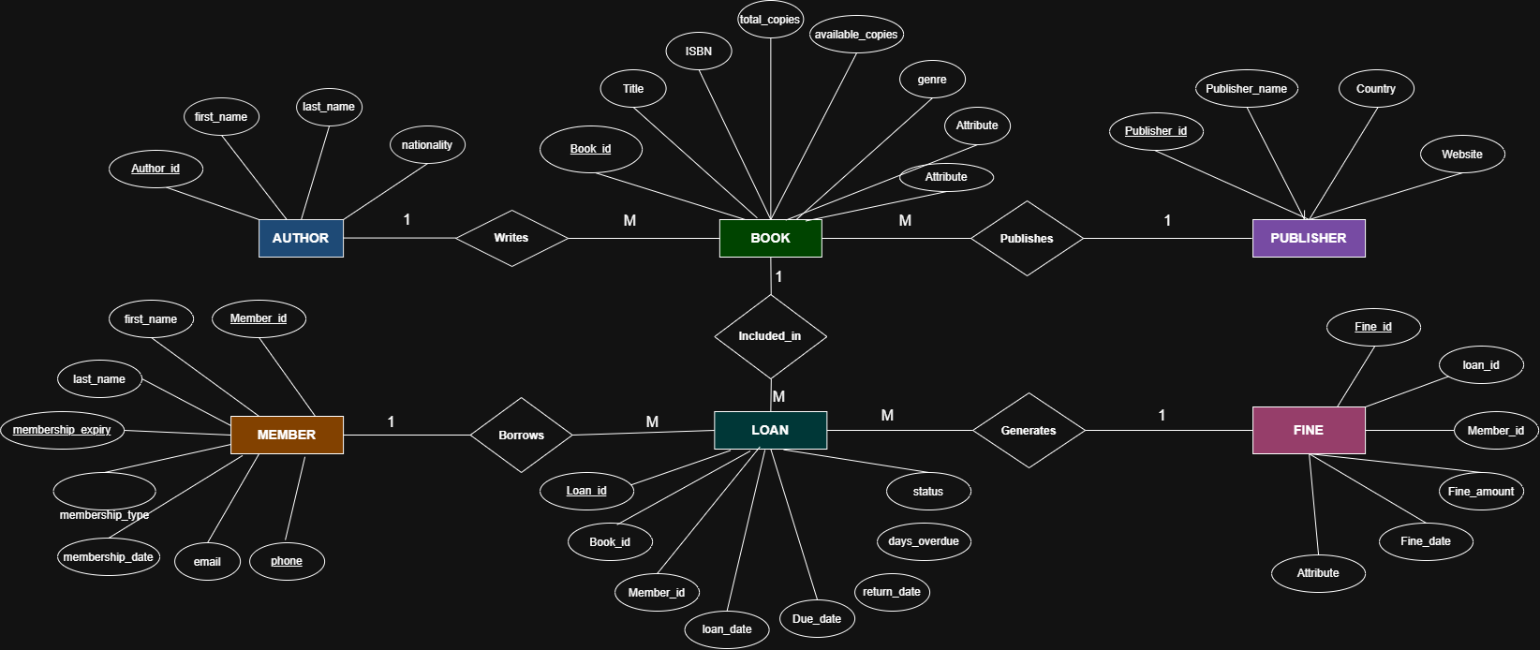

Relationships & Cardinality

Entity 1 | Relationship | Entity 2 | Cardinality (1:1 / 1:N / M:N) | Participation
Book | Written by | Author | M:N | partial
Book | Published by | Publisher | N:1 | Partial
Member | Borrows | Book | M:N | Partial
Member | Pays | Fine | 1:1 | Partial
Loan | has | fine | 1:N | partial

Relational Database Schema

Table Name | Column Name | Data Type | Key (PK / FK / —) | Constraints
Book | book_id | INT | PK | PRIMARY KEY
Book | title | VARCHAR(200) | — | NOT NULL
Book | isbn | VARCHAR(20) | — | UNIQUE, NOT NULL
Book | total_copies | INT | — | —
Book | available_copies | INT | — | Derived
Book | genre | VARCHAR(50) | — | —
Book | publication_year | YEAR | — | —
Book | authors | TEXT | — | Multi-valued
Author | author_id | INT | PK | PRIMARY KEY
Author | first_name | VARCHAR(50) | — | —
Author | last_name | VARCHAR(50) | — | —
Author | nationality | VARCHAR(50) | — | —
Publisher | publisher_id | INT | PK | PRIMARY KEY
Publisher | publisher_name | VARCHAR(100) | — | NOT NULL
Publisher | country | VARCHAR(50) | — | —
Publisher | website | VARCHAR(200) | — | —
Member | member_id | INT | PK | PRIMARY KEY
Member | first_name | VARCHAR(50) | — | —
Member | last_name | VARCHAR(50) | — | —
Member | email | VARCHAR(100) | — | UNIQUE
Member | membership_type | VARCHAR(30) | — | —
Member | membership_date | DATE | — | —
Member | membership_expiry | DATE | — | —
Member | phone_numbers | TEXT | — | Multi-valued
Loan | loan_id | INT | PK | PRIMARY KEY
Loan | book_id | INT | FK | FK → Book
Loan | member_id | INT | FK | FK → Member
Loan | loan_date | DATE | — | NOT NULL
Loan | due_date | DATE | — | —
Loan | return_date | DATE | — | —
Loan | days_overdue | INT | — | Derived
Loan | status | VARCHAR(20) | — | —
Fine | fine_id | INT | PK | PRIMARY KEY
Fine | loan_id | INT | FK | FK → Loan
Fine | member_id | INT | FK | FK → Member
Fine | fine_amount | DECIMAL(8,2) | — | —
Fine | fine_date | DATE | — | —
Fine | payment_status | VARCHAR(20) | — | —

Schema Diagram

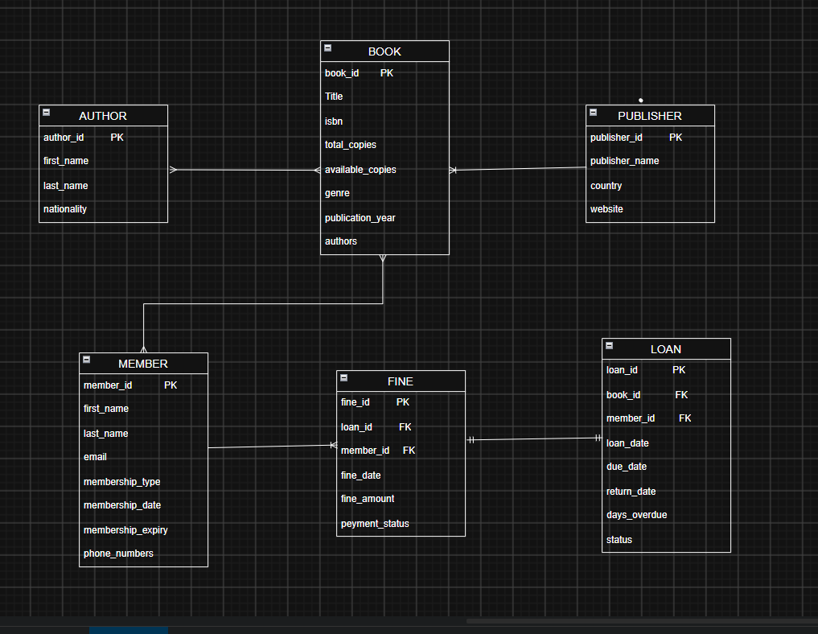

Normalization

UNF → 1NF → 2NF → 3NF
Normal Form | Condition Satisfied | Anomaly Removed | Resulting Tables
UNF | Data may contain repeating groups and multiple values in a single record. | Repeating-group and insertion problems identified. | Library_Records
1NF | All attributes contain atomic values and repeating groups are removed. | Removes repeating groups and non-atomic values. | Book, Author, Publisher, Member, Loan, Fine, Book_Author
2NF | Relation is in 1NF and all non-key attributes are fully dependent on the complete primary key. | Removes partial dependency and associated update anomalies. | Book, Author, Publisher, Member, Loan, Fine, Book_Author
3NF | Relation is in 2NF and non-key attributes depend only on the primary key, with no transitive dependency. | Removes transitive dependency and reduces redundancy. | Book, Author, Publisher, Member, Loan, Fine, Book_Author


DATABASE IMPLEMENTATION

DDL — Database and Table Creation

CREATE TABLE Publisher (
publisher_id INT GENERATED ALWAYS AS IDENTITY PRIMARY KEY,
publisher_name VARCHAR(100) NOT NULL,
country VARCHAR(50),
website VARCHAR(200)
);

CREATE TABLE Author (
author_id INT GENERATED ALWAYS AS IDENTITY PRIMARY KEY,
first_name VARCHAR(50) NOT NULL,
last_name VARCHAR(50),
nationality VARCHAR(50)
);

CREATE TABLE Book (
book_id INT GENERATED ALWAYS AS IDENTITY PRIMARY KEY,
title VARCHAR(200) NOT NULL,
isbn VARCHAR(20) UNIQUE NOT NULL,
publication_year INT,
total_copies INT NOT NULL CHECK (total_copies >= 0),
available_copies INT NOT NULL CHECK (available_copies >= 0),
genre VARCHAR(50),
publisher_id INT,

CONSTRAINT fk_book_publisher
FOREIGN KEY (publisher_id)
REFERENCES Publisher(publisher_id),

CONSTRAINT chk_available_copies
CHECK (available_copies <= total_copies)
);

CREATE TABLE Member (
member_id INT GENERATED ALWAYS AS IDENTITY PRIMARY KEY,
first_name VARCHAR(50) NOT NULL,
last_name VARCHAR(50),
email VARCHAR(100) UNIQUE NOT NULL,
membership_type VARCHAR(30),
membership_date DATE,
membership_expiry DATE,
phone_numbers VARCHAR(20)
);

CREATE TABLE Book_Author (
book_id INT,
author_id INT,

PRIMARY KEY (book_id, author_id),

CONSTRAINT fk_book_author_book
FOREIGN KEY (book_id)
REFERENCES Book(book_id),

CONSTRAINT fk_book_author_author
FOREIGN KEY (author_id)
REFERENCES Author(author_id)
);

CREATE TABLE Loan (
loan_id INT GENERATED ALWAYS AS IDENTITY PRIMARY KEY,
book_id INT NOT NULL,
member_id INT NOT NULL,
loan_date DATE NOT NULL,
due_date DATE NOT NULL,
return_date DATE,
days_overdue INT DEFAULT 0,
status VARCHAR(20) DEFAULT 'Borrowed',

CONSTRAINT fk_loan_book
FOREIGN KEY (book_id)
REFERENCES Book(book_id),

CONSTRAINT fk_loan_member
FOREIGN KEY (member_id)
REFERENCES Member(member_id),

CONSTRAINT chk_loan_dates
CHECK (due_date >= loan_date)
);

CREATE TABLE Fine (
fine_id INT GENERATED ALWAYS AS IDENTITY PRIMARY KEY,
loan_id INT NOT NULL,
member_id INT NOT NULL,
fine_amount DECIMAL(8,2) CHECK (fine_amount >= 0),
fine_date DATE,
payment_status VARCHAR(20) DEFAULT 'Pending',

CONSTRAINT fk_fine_loan
FOREIGN KEY (loan_id)
REFERENCES Loan(loan_id),

CONSTRAINT fk_fine_member
FOREIGN KEY (member_id)
REFERENCES Member(member_id)
);

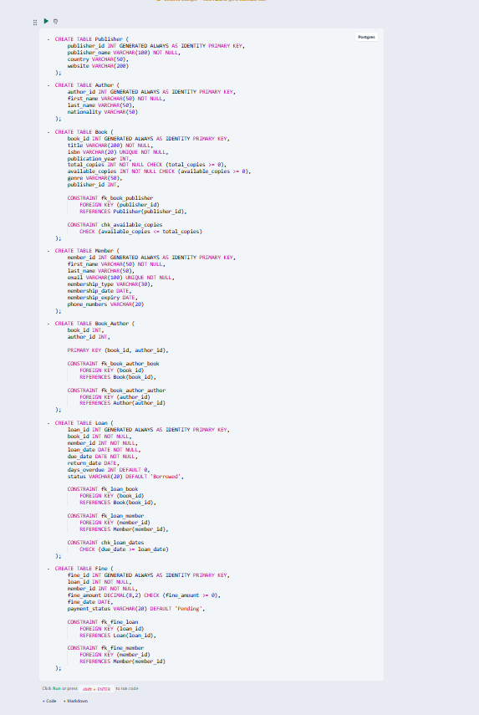

Sample Data — DML.

S.No | Table Name | No. of Records Inserted | Screenshot Reference
1 | Publisher | 4
  Fig. 4.2
2 | Author | 5
  Fig. 4.2
3 | Book | 5 | Fig.4.2
4 | Book_Author | 5 | Fig.4.2
5 | Member | 4 | Fig.4.2
6 | Loan | 4 | Fig.4.2
7 | Fine | 1 | Fig.4.2
--publisher
INSERT INTO Publisher
(publisher_name, country, website)
VALUES
('person', 'USA', 'https://www.pearson.com'),
('McGraw Hill', 'USA', 'https://www.mheducation.com'),
('OReilly Media', 'USA', 'https://www.oreilly.com'),
('Wiley', 'USA', 'https://www.wiley.com');
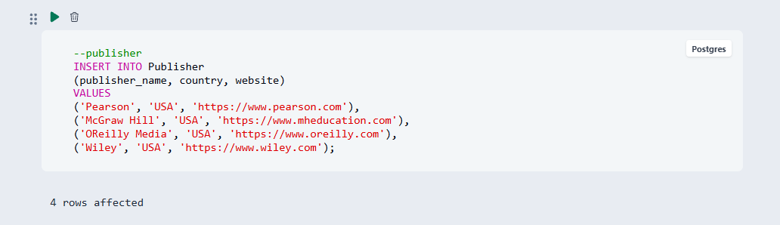

--Author
INSERT INTO Author
(first_name, last_name, nationality)
VALUES
--publisher
INSERT INTO Publisher
(publisher_name, country, website)
VALUES
('Pearson', 'USA', 'https://www.pearson.com'),
('McGraw Hill', 'USA', 'https://www.mheducation.com'),
('OReilly Media', 'USA', 'https://www.oreilly.com'),
('Wiley', 'USA', 'https://www.wiley.com');

--Author
INSERT INTO Author
(first_name, last_name, nationality)
VALUES
('Robert', 'Martin', 'American'),
('Thomas', 'Cormen', 'American'),
('Abraham', 'Silberschatz', 'American'),
('Ramez', 'Elmasri', 'American'),
('James', 'Kurose', 'American');
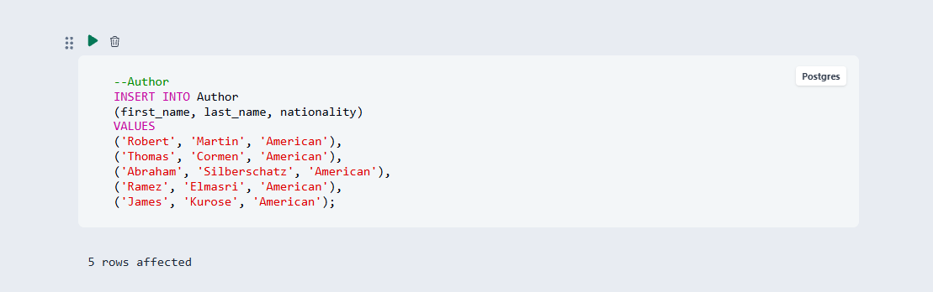

--Book
INSERT INTO Book
(title, isbn, publication_year, total_copies,
available_copies, genre, publisher_id)
VALUES
('Clean Code', '9780132350884', 2008, 5, 4, 'Programming', 1),
('Introduction to Algorithms', '9780262046305', 2022, 4, 3, 'Algorithms', 2),
('Database System Concepts', '9781260084504', 2019, 6, 5, 'Database', 2),
('Fundamentals of Database Systems', '9780137502523', 2020, 5, 5, 'Database', 1),
('Computer Networking', '9780136681557', 2021, 4, 4, 'Networking', 1);
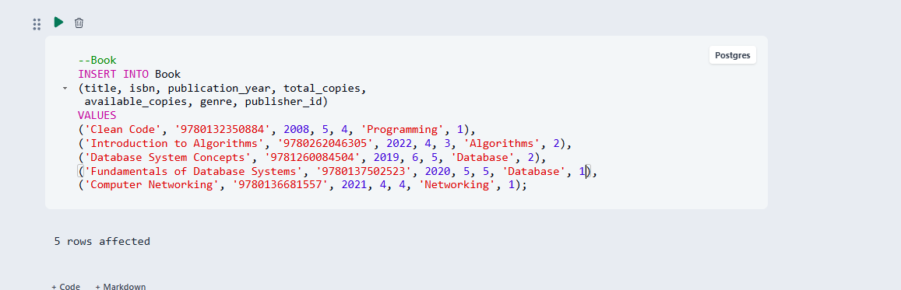

INSERT INTO Book_Author
(book_id, author_id)
VALUES
(1, 1),
(2, 2),
(3, 3),
(4, 4),
(5, 5);
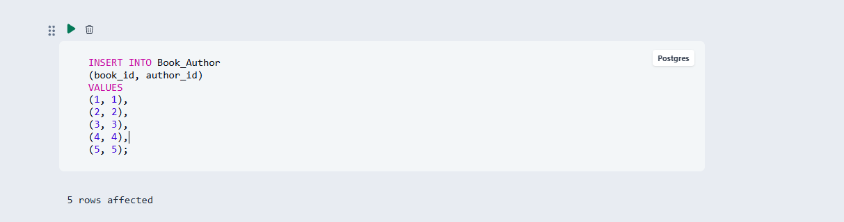
INSERT INTO Member
(first_name, last_name, email, membership_type,
membership_date, membership_expiry, phone_numbers)
VALUES
('Rahul', 'Kumar', 'rahul@gmail.com',
'Student', '2026-06-01', '2027-06-01', '9876543210'),

('Priya', 'Sharma', 'priya@gmail.com',
'Student', '2026-06-05', '2027-06-05', '9876543211'),

('Arjun', 'Reddy', 'arjun@gmail.com',
'Faculty', '2026-06-10', '2027-06-10', '9876543212'),

('Sneha', 'Patel', 'sneha@gmail.com',
'Student', '2026-06-15', '2027-06-15', '9876543213');
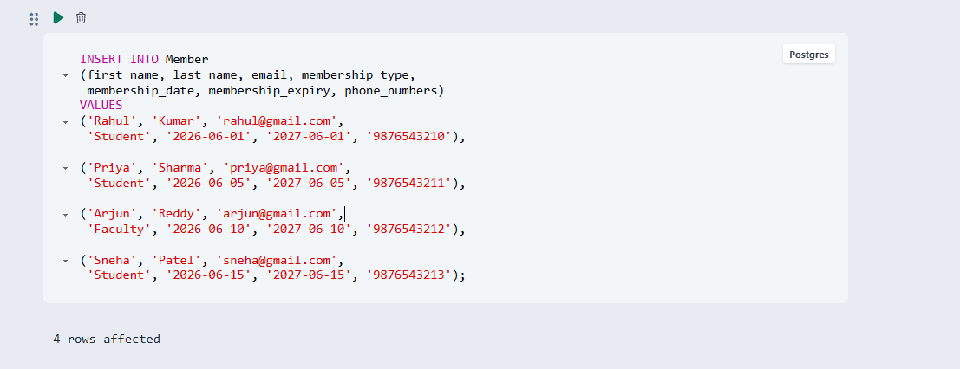
INSERT INTO Loan
(book_id, member_id, loan_date, due_date,
return_date, days_overdue, status)
VALUES
(1, 1, '2026-09-01', '2026-09-15',
'2026-09-14', 0, 'Returned'),

(2, 2, '2026-09-05', '2026-09-19',
NULL, 0, 'Borrowed'),

(3, 3, '2026-09-10', '2026-09-24',
'2026-09-26', 2, 'Returned'),

(4, 4, '2026-09-12', '2026-09-26',
NULL, 0, 'Borrowed');
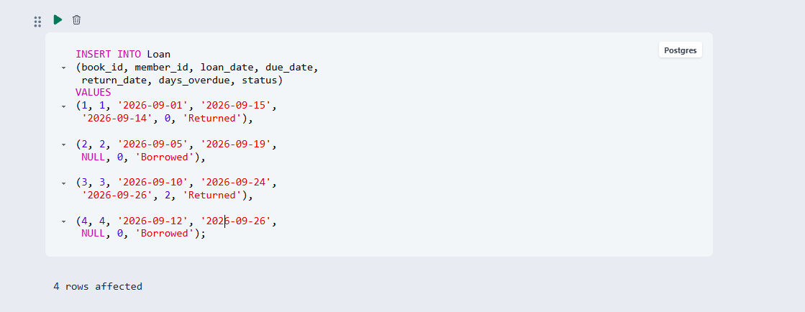
INSERT INTO Fine
(loan_id, member_id, fine_amount,
fine_date, payment_status)
VALUES
(3, 3, 20.00, '2026-09-26', 'Pending');
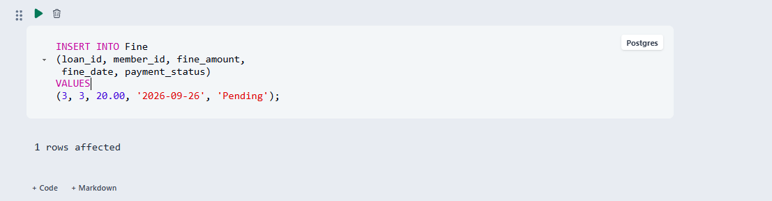

Constraints & Data Integrity

Constraint / Validation | Applied On | Purpose | Evidence / Screenshot Ref.
PRIMARY KEY | All entity tables | Uniquely identifies each record | Fig. 4.1
FOREIGN KEY | Loan.book_id | Maintains relationship with Book | Fig. 4.1
FOREIGN KEY | Loan.member_id | Maintains relationship with Member | Fig. 4.1
FOREIGN KEY | Fine.loan_id | Maintains relationship with Loan | Fig. 4.1
FOREIGN KEY | Fine.member_id | Maintains relationship with Member | Fig. 4.1
UNIQUE | Book.isbn | Prevents duplicate ISBN values | Fig. 4.1
UNIQUE | Member.email | Prevents duplicate member email addresses | Fig. 4.1
NOT NULL | Book.title | Ensures every book has a title | Fig. 4.1
NOT NULL | Loan.loan_date | Ensures every loan has a loan date | Fig. 4.1
CHECK | Book.available_copies | Prevents invalid copy counts | Fig. 4.1
CHECK | Fine.fine_amount | Prevents negative fine amounts | Fig. 4.1
DEFAULT | Loan.status | Automatically assigns a default loan status | Fig. 4.1

SQL Operations & Queries
.

DQL – Basic Retrieval Queries
Purpose of the Query | SQL Statement
Display all books available in the library | SELECT * FROM Book;
Display books belonging to the Database genre | SELECT book_id, title, genre FROM Book WHERE genre = 'Database';
Display books published after 2020 | SELECT book_id, title, publication_year FROM Book WHERE publication_year > 2020;
Display all members in alphabetical order | SELECT member_id, first_name, last_name, email FROM Member ORDER BY first_name ASC;

Join Operations
Type of Join | SQL Statement
Natural Join | SELECT book_id, title, publisher_name FROM Book NATURAL JOIN Publisher;
  Equi Join | SELECT b.book_id, b.title, p.publisher_name FROM Book b, Publisher p WHERE b.publisher_id = p.publisher_id;
Inner Join | SELECT l.loan_id, m.member_id, m.first_name, m.last_name, l.loan_date, l.due_date FROM Loan l INNER JOIN Member m ON l.member_id = m.member_id;
Left Outer Join | SELECT p.publisher_id, p.publisher_name, b.book_id, b.title FROM Publisher p LEFT OUTER JOIN Book b ON p.publisher_id = b.publisher_id;
Right Outer Join | SELECT b.book_id, b.title, p.publisher_id, p.publisher_name FROM Book b RIGHT OUTER JOIN Publisher p ON b.publisher_id = p.publisher_id;
Full Outer Join | SELECT b.book_id, b.title, p.publisher_id, p.publisher_name FROM Book b FULL OUTER JOIN Publisher p ON b.publisher_id = p.publisher_id;

Aggregate Functions, GROUP BY and HAVING

Function Used | SQL Statement
COUNT | SELECT COUNT(*) AS total_books FROM Book;
SUM | SELECT SUM(total_copies) AS total_copies FROM Book;
AVG | SELECT AVG(fine_amount) AS average_fine FROM Fine;
MIN and MAX | SELECT MIN(fine_amount) AS minimum_fine, MAX(fine_amount) AS maximum_fine FROM Fine;
GROUP BY + HAVING | SELECT member_id, COUNT(*) AS total_loans FROM Loan GROUP BY member_id HAVING COUNT(*) > 1;
Nested and Correlated Subqueries

Type (Nested / Correlated) | SQL Statement
Nested | SELECT book_id, title, publication_year FROM Book WHERE publication_year > (SELECT AVG(publication_year) FROM Book);
Nested | SELECT member_id, first_name, last_name FROM Member WHERE member_id IN (SELECT member_id FROM Loan);
Nested | SELECT book_id, title FROM Book WHERE publisher_id IN (SELECT publisher_id FROM Publisher);
Correlated | SELECT m.member_id, m.first_name, m.last_name FROM Member m WHERE EXISTS (SELECT 1 FROM Loan l WHERE l.member_id = m.member_id);
Correlated | SELECT b.book_id, b.title FROM Book b WHERE EXISTS (SELECT 1 FROM Book_Author ba WHERE ba.book_id = b.book_id);
Views and Relational Set Operations
View / Set Operation | SQL Statement
Updatable View – CREATE | CREATE VIEW Book_View AS SELECT book_id, title, isbn, genre, publication_year FROM Book;
Non-updatable View – CREATE | CREATE VIEW Loan_Details_View AS SELECT l.loan_id, b.title, m.first_name, m.last_name, l.loan_date, l.due_date, l.status FROM Loan l JOIN Book b ON l.book_id = b.book_id JOIN Member m ON l.member_id = m.member_id;
UNION | SELECT first_name, last_name FROM Member UNION SELECT first_name, last_name FROM Author;
INTERSECT | SELECT first_name, last_name FROM Member INTERSECT SELECT first_name, last_name FROM Author;
EXCEPT | SELECT first_name, last_name FROM Member EXCEPT SELECT first_name, last_name FROM Author;
DCL and TCL Operations
Command | Purpose | SQL Statement
GRANT | Give SELECT privilege on the Book table | GRANT SELECT ON Book TO library_user;
REVOKE | Remove SELECT privilege from the Book table | REVOKE SELECT ON Book FROM library_user;
COMMIT | Permanently save transaction changes | BEGIN; UPDATE Book SET available_copies = available_copies - 1 WHERE book_id = 1; COMMIT;
SAVEPOINT | Create an intermediate point in a transaction | BEGIN; SAVEPOINT book_update;
ROLLBACK TO SAVEPOINT | Undo changes made after the savepoint | ROLLBACK TO SAVEPOINT book_update; COMMIT;
ROLLBACK | Cancel all changes in the current transaction | BEGIN; UPDATE Book SET available_copies = available_copies - 1 WHERE book_id = 1; ROLLBACK;

Sample Outputs / Screenshots
Figure 1: Book records / basic SELECT output
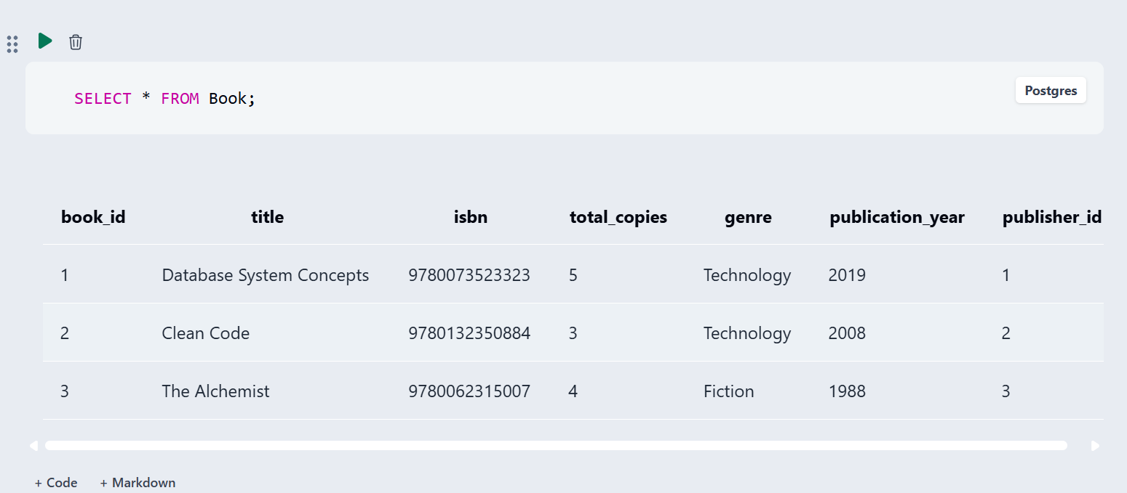

Figure 2: Filtered book records / WHERE clause output

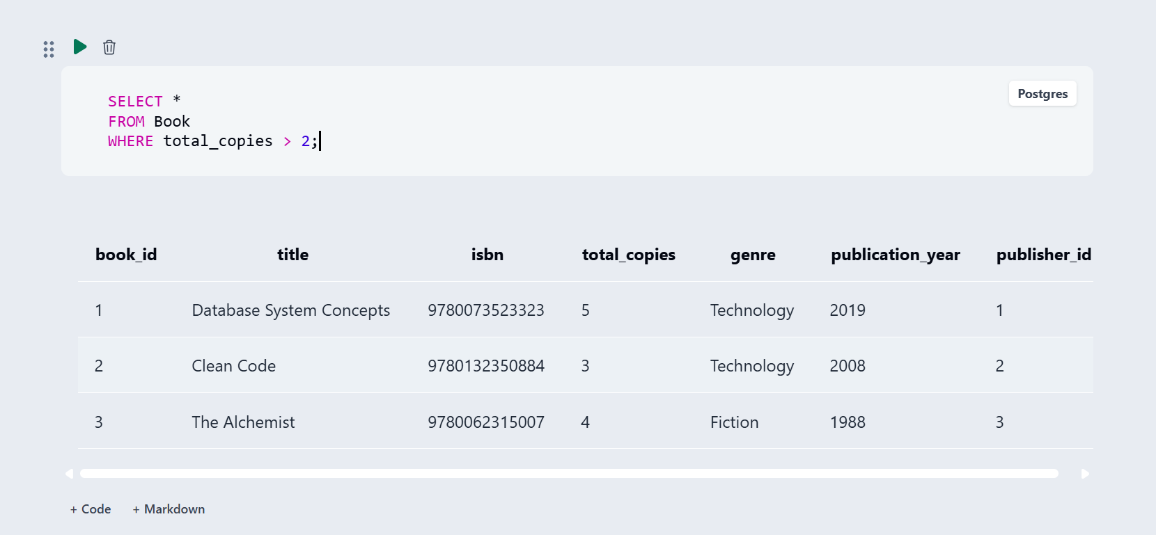

Figure 3: Aggregate functions output

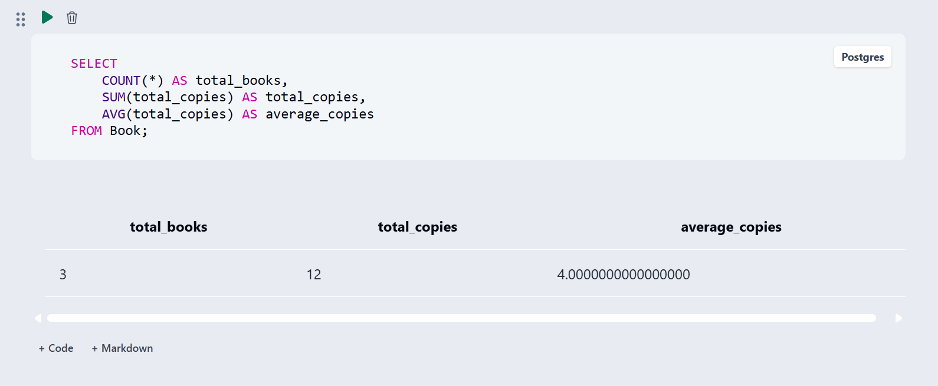

Figure 4 Member–Loan–Book JOIN output

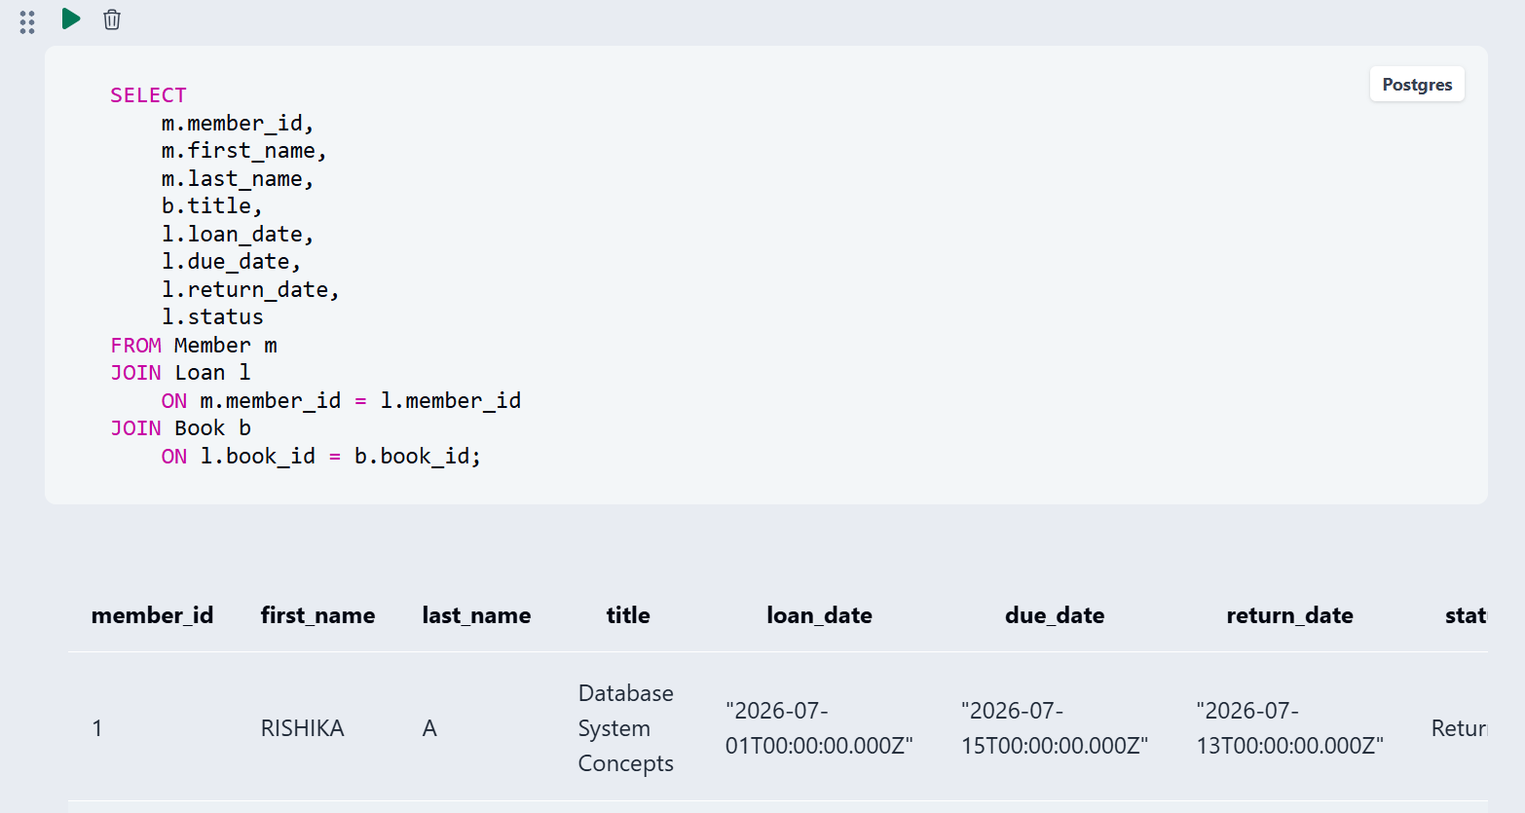

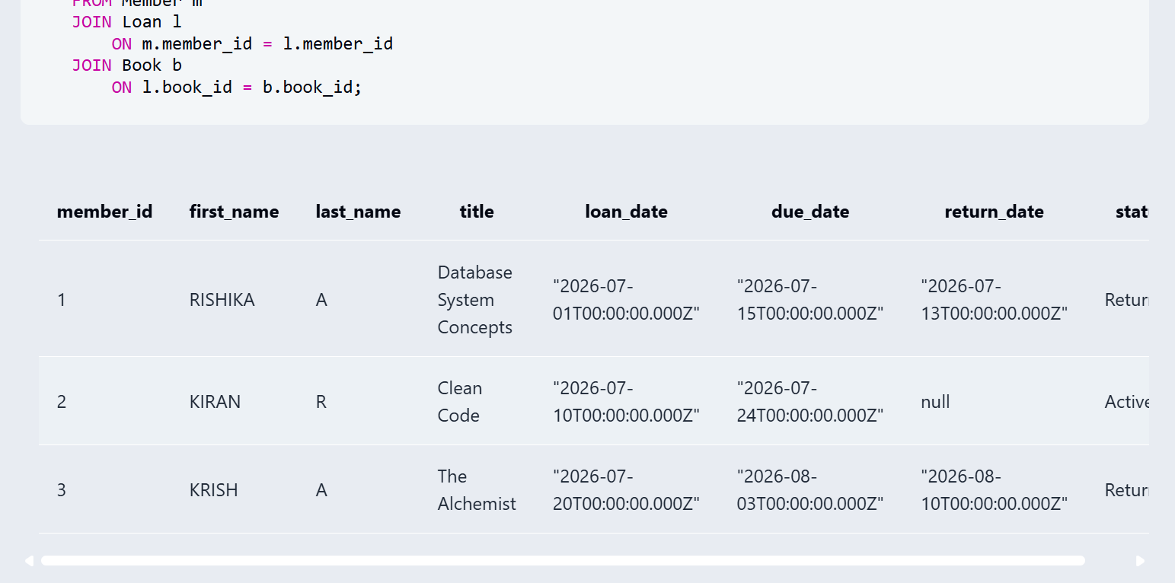


MODULES & FUNCTIONALITIES
S.No | Module Name | Functionality | Tables Involved
1 | Book Management Module | Stores and manages book details such as title, ISBN, genre, publication year, total copies and available copies. | Book, Publisher, Book_Author
2 | Author Management Module | Stores author information such as author name and nationality and maintains the relationship between authors and books. | Author, Book_Author, Book
3 | Publisher Management Module | Maintains publisher details such as publisher name, country and website and connects publishers with books. | Publisher, Book
4 | Member Management Module | Stores and manages registered member details including name, email, membership type, membership dates and phone number. | Member
5 | Loan Management Module | Manages book borrowing and returning information, including loan date, due date, return date, overdue days and loan status. | Loan, Book, Member
6 | Fine Management Module | Maintains fine information associated with loans and members, including fine amount, fine date and payment status. | Fine, Loan, Member
7 | Book–Author Relationship Module | Maintains the many-to-many relationship between books and authors using a junction table. | Book_Author, Book, Author
8 | Database Query and Reporting Module | Retrieves and analyzes library information using SELECT queries, joins, aggregate functions, subqueries, views and set operations. | Book, Author, Publisher, Member, Loan, Fine, Book_Author

GITHUB REPOSITORY & TEAM RESPONSIBILITIES
Repository Link:
https://github.com/rishika1527-stack/Library-management-system-dbms..git

Student Name | Roll Number | Role / Responsibility | Contribution Status
T RISHIKA | 25B11AI924 | ER Diagram and Database Schema | Completed
V DEEPIKA | 25B11AIC44 | DDL – Table Creation and ConstraintS | Completed
U DHARANI | 25B11AIC23 | DML, CRUD Operations, Joins and Aggregate Functions | Completed
M CHANDRA SEKHAR REDDY | 25B11AID28 | Documentation and Screenshots | Completed

ENHANCEMENTS & FUTURE IMPROVEMENTS

1. Front-End Application
A web or desktop-based front-end application can be developed so that librarians and members can interact with the database through forms and user-friendly screens instead of directly executing SQL queries.

2. Stored Procedures and Triggers
Stored procedures and triggers can be introduced to automate operations such as loan processing, fine calculation, book availability updates and validation of database changes.

3. Indexing for Performance
Indexes can be created on frequently searched columns such as book title, ISBN, member ID and loan ID to improve query performance when the database grows.

4. Security and Access Control
User authentication and role-based access control can be added so that administrators, librarians and members receive different levels of database access.

5. Backup and Recovery
A systematic backup and recovery mechanism can be implemented to protect library records from accidental data loss and support restoration of the database when required.

6. Reporting and Analytics
Additional reports and dashboards can be developed to analyze popular books, borrowing trends, overdue loans, fines collected and member activity.

7. Additional Library Modules
Future versions can include modules for book reservations, notifications, inventory management, barcode or QR-code scanning and automated overdue reminders.

These enhancements would extend the current database-focused system into a more complete and automated Library Management System. The report itself identifies future improvements including additional modules, a front-end application, stored procedures and triggers, indexing, security and access control, backup and recovery, and reporting and analytics.

CONCLUSION
The Library Management System was successfully designed and implemented as a relational database for managing library information in a structured manner. The database manages information related to books, authors, publishers, members, loans and fines, along with the Book_Author junction table for maintaining the relationship between books and authors.

The project achieved the objective of designing a normalized relational database with appropriate primary keys, foreign keys and integrity constraints. The database was normalized up to Third Normal Form (3NF) to reduce data redundancy and maintain consistency.
SQL operations were implemented for CREATE, INSERT, UPDATE, DELETE and SELECT, along with joins, aggregate functions, GROUP BY, HAVING, nested and correlated subqueries, views and set operations. These operations allow library records to be efficiently stored, modified and retrieved.
The database also establishes relationships between books, authors, publishers, members, loans and fines using relational keys. Constraints such as UNIQUE, NOT NULL, primary keys and foreign keys help maintain data integrity.
Overall, the project provides a structured database foundation for managing library records and demonstrates the practical application of DBMS concepts, relational database design, normalization and SQL operations.

REFERENCES
• Uploaded project DDL script: ddl.sql.
• Uploaded project DML/sample-data script: dml.sql.
• Uploaded SQL query script: queries.sql.
• Aditya University — DBMS Capstone Project documentation template.
• GitHub repository: Library Management System – DBMS (project repository).
• Uploaded ER diagram: er-diagram.png.
• Uploaded SQL query output screenshots: query1_output.png and query2_output.png.
- • Uploaded project documentation: Project_Documentation.docx.

APPENDIX

Complete SQL Script

The final SQL implementation is supplied through the uploaded project files:
- ddl.sql — database table definitions, primary keys, foreign keys, and constraints.
- dml.sql — sample data and data manipulation operations for the library database.
- queries.sql — representative SQL operations, joins, aggregate functions, filtering, sorting, and view-related queries.
- library_management.sql — complete SQL script containing the Library Management System database implementation.
Repository: https://github.com/rishika1527-stack/Library-management-system-dbms..git

Additional Screenshots / Outputs
Additional evidence is provided through SQL execution screenshots showing:
- Book records / basic SELECT output.
- Filtered book records using the WHERE clause.
- Aggregate functions such as COUNT(), SUM(), and AVG().
- Member–Loan–Book JOIN output.
- Active loan records using filtering and JOIN operations.
The screenshots are included in the project repository as:
- query1_output.png
- query2_output.png
These outputs provide evidence of the SQL queries and database operations implemented in the Library Management System.

APPENDIX A – COMPLETE SQL SCRIPT
/* ============================================================
1. DROP EXISTING TABLES
============================================================ */

DROP TABLE IF EXISTS Fine CASCADE;
DROP TABLE IF EXISTS Loan CASCADE;
DROP TABLE IF EXISTS Book_Author CASCADE;
DROP TABLE IF EXISTS Book CASCADE;
DROP TABLE IF EXISTS Author CASCADE;
DROP TABLE IF EXISTS Publisher CASCADE;
DROP TABLE IF EXISTS Member CASCADE;

/* ============================================================
2. CREATE TABLES
============================================================ */

/* ---------- AUTHOR TABLE ---------- */

CREATE TABLE Author (
Author_ID INT PRIMARY KEY,
First_Name VARCHAR(50) NOT NULL,
Last_Name VARCHAR(50) NOT NULL,
Nationality VARCHAR(50)
);

/* ---------- PUBLISHER TABLE ---------- */

CREATE TABLE Publisher (
Publisher_ID INT PRIMARY KEY,
Publisher_Name VARCHAR(100) NOT NULL,
Country VARCHAR(50),
Website VARCHAR(150)
);

/* ---------- BOOK TABLE ---------- */

CREATE TABLE Book (
Book_ID INT PRIMARY KEY,
Title VARCHAR(150) NOT NULL,
ISBN VARCHAR(20) UNIQUE NOT NULL,
Total_Copies INT NOT NULL CHECK (Total_Copies >= 0),
Genre VARCHAR(50),
Publication_Year INT,
Publisher_ID INT,
CONSTRAINT fk_book_publisher
FOREIGN KEY (Publisher_ID)
REFERENCES Publisher(Publisher_ID)
);

/* ---------- MEMBER TABLE ---------- */

CREATE TABLE Member (
Member_ID INT PRIMARY KEY,
First_Name VARCHAR(50) NOT NULL,
Last_Name VARCHAR(50) NOT NULL,
Email VARCHAR(100) UNIQUE NOT NULL,
Membership_Type VARCHAR(30),
Membership_Date DATE,
Membership_Expiry DATE,
Phone VARCHAR(20)
);

/* ---------- BOOK_AUTHOR TABLE ---------- */

CREATE TABLE Book_Author (
Book_ID INT,
Author_ID INT,
PRIMARY KEY (Book_ID, Author_ID),
CONSTRAINT fk_book_author_book
FOREIGN KEY (Book_ID)
REFERENCES Book(Book_ID),
CONSTRAINT fk_book_author_author
FOREIGN KEY (Author_ID)
REFERENCES Author(Author_ID)
);

/* ---------- LOAN TABLE ---------- */

CREATE TABLE Loan (
Loan_ID INT PRIMARY KEY,
Book_ID INT NOT NULL,
Member_ID INT NOT NULL,
Loan_Date DATE NOT NULL,
Due_Date DATE NOT NULL,
Return_Date DATE,
Status VARCHAR(20) NOT NULL,
CONSTRAINT fk_loan_book
FOREIGN KEY (Book_ID)
REFERENCES Book(Book_ID),
CONSTRAINT fk_loan_member
FOREIGN KEY (Member_ID)
REFERENCES Member(Member_ID)
);

/* ---------- FINE TABLE ---------- */

CREATE TABLE Fine (
Fine_ID INT PRIMARY KEY,
Loan_ID INT NOT NULL,
Member_ID INT NOT NULL,
Fine_Amount DECIMAL(10,2) NOT NULL CHECK (Fine_Amount >= 0),
Fine_Date DATE,
Payment_Status VARCHAR(20),
CONSTRAINT fk_fine_loan
FOREIGN KEY (Loan_ID)
REFERENCES Loan(Loan_ID),
CONSTRAINT fk_fine_member
FOREIGN KEY (Member_ID)
REFERENCES Member(Member_ID)
);

/* ============================================================
3. INSERT DATA
============================================================ */

/* ---------- AUTHORS ---------- */

INSERT INTO Author
(Author_ID, First_Name, Last_Name, Nationality)
VALUES
(1, 'Ravi', 'Kumar', 'Indian'),
(2, 'Anita', 'Sharma', 'Indian'),
(3, 'Robert', 'Martin', 'American'),
(4, 'Andrew', 'Tanenbaum', 'American'),
(5, 'Thomas', 'Connolly', 'British'),
(6, 'Abraham', 'Silberschatz', 'American'),
(7, 'Henry', 'Korth', 'American'),
(8, 'S. Sudarshan', 'Sudarshan', 'Indian');

/* ---------- PUBLISHERS ---------- */

INSERT INTO Publisher
(Publisher_ID, Publisher_Name, Country, Website)
VALUES
(1, 'Pearson', 'United Kingdom', 'www.pearson.com'),
(2, 'McGraw Hill', 'United States', 'www.mheducation.com'),
(3, 'O''Reilly Media', 'United States', 'www.oreilly.com'),
(4, 'Wiley', 'United States', 'www.wiley.com'),
(5, 'Oxford University Press', 'United Kingdom', 'www.oup.com');

/* ---------- BOOKS ---------- */

INSERT INTO Book
(Book_ID, Title, ISBN, Total_Copies, Genre, Publication_Year, Publisher_ID)
VALUES
(1, 'Database System Concepts', '9780078022159', 5, 'Database', 2019, 2),
(2, 'Database Systems', '9780321980577', 4, 'Database', 2015, 1),
(3, 'Computer Networks', '9780132126953', 6, 'Networking', 2017, 1),
(4, 'Operating System Concepts', '9781119456339', 5, 'Operating System', 2018, 4),
(5, 'Clean Code', '9780132350884', 3, 'Programming', 2008, 3),
(6, 'Design Patterns', '9780201633610', 4, 'Programming', 1994, 3),
(7, 'Introduction to Algorithms', '9780262046305', 7, 'Algorithms', 2022, 5),
(8, 'Data Structures and Algorithms', '9780132576277', 5, 'Algorithms', 2021, 1),
(9, 'Artificial Intelligence', '9780136042594', 3, 'Artificial Intelligence', 2020, 2),
(10, 'Web Technologies', '9781292025631', 4, 'Web Development', 2023, 1);

/* ---------- MEMBERS ---------- */

INSERT INTO Member
(Member_ID, First_Name, Last_Name, Email, Membership_Type,
Membership_Date, Membership_Expiry, Phone)
VALUES
(1, 'Arun', 'Kumar', 'arun@example.com', 'Student',
'2025-01-10', '2026-01-10', '9876543210'),
(2, 'Priya', 'Sharma', 'priya@example.com', 'Student',
'2025-02-15', '2026-02-15', '9876543211'),
(3, 'Rahul', 'Verma', 'rahul@example.com', 'Faculty',
'2025-03-05', '2026-03-05', '9876543212'),
(4, 'Sneha', 'Patel', 'sneha@example.com', 'Student',
'2025-04-12', '2026-04-12', '9876543213'),
(5, 'Vikram', 'Singh', 'vikram@example.com', 'Faculty',
'2025-05-20', '2026-05-20', '9876543214'),
(6, 'Neha', 'Rao', 'neha@example.com', 'Student',
'2025-06-18', '2026-06-18', '9876543215');

/* ---------- BOOK_AUTHOR ---------- */

INSERT INTO Book_Author
(Book_ID, Author_ID)
VALUES
(1, 6),
(1, 7),
(2, 5),
(3, 4),
(4, 6),
(5, 3),
(6, 3),
(7, 1),
(8, 2),
(9, 6),
(10, 8);

/* ---------- LOANS ---------- */

INSERT INTO Loan
(Loan_ID, Book_ID, Member_ID, Loan_Date, Due_Date, Return_Date, Status)
VALUES
(1, 1, 1, '2026-01-05', '2026-01-19', '2026-01-18', 'Returned'),
(2, 2, 1, '2026-02-01', '2026-02-15', NULL, 'Issued'),
(3, 3, 2, '2026-02-05', '2026-02-19', '2026-02-20', 'Returned'),
(4, 4, 3, '2026-02-10', '2026-02-24', NULL, 'Issued'),
(5, 5, 4, '2026-03-01', '2026-03-15', '2026-03-14', 'Returned'),
(6, 6, 1, '2026-03-05', '2026-03-19', NULL, 'Issued'),
(7, 7, 5, '2026-03-10', '2026-03-24', '2026-03-23', 'Returned'),
(8, 8, 6, '2026-03-15', '2026-03-29', NULL, 'Issued');

/* ---------- FINES ---------- */

INSERT INTO Fine
(Fine_ID, Loan_ID, Member_ID, Fine_Amount, Fine_Date, Payment_Status)
VALUES
(1, 3, 2, 10.00, '2026-02-20', 'Paid'),
(2, 7, 5, 5.00, '2026-03-23', 'Paid');

/* ============================================================
4. BASIC RETRIEVAL QUERIES – DQL
============================================================ */

/* Q1 – Display all books */

SELECT *
FROM Book;

/* Q2 – Display books belonging to Database genre */

SELECT Book_ID, Title, Genre
FROM Book
WHERE Genre = 'Database';

/* Q3 – Display books published after 2020 */

SELECT Book_ID, Title, Publication_Year
FROM Book
WHERE Publication_Year > 2020;

/* Q4 – Display all members alphabetically */

SELECT Member_ID, First_Name, Last_Name, Email
FROM Member
ORDER BY First_Name ASC;

/* ============================================================
5. JOIN OPERATIONS
============================================================ */

/* Q5 – NATURAL JOIN */

SELECT Book_ID, Title, Publisher_Name
FROM Book
NATURAL JOIN Publisher;

/* Q6 – EQUI JOIN */

SELECT
b.Book_ID,
b.Title,
p.Publisher_Name
FROM Book b, Publisher p
WHERE b.Publisher_ID = p.Publisher_ID;

/* Q7 – INNER JOIN */

SELECT
l.Loan_ID,
m.Member_ID,
m.First_Name,
m.Last_Name,
l.Loan_Date,
l.Due_Date
FROM Loan l
INNER JOIN Member m
ON l.Member_ID = m.Member_ID;

/* Q8 – LEFT OUTER JOIN */

SELECT
p.Publisher_ID,
p.Publisher_Name,
b.Book_ID,
b.Title
FROM Publisher p
LEFT OUTER JOIN Book b
ON p.Publisher_ID = b.Publisher_ID;

/* Q9 – RIGHT OUTER JOIN */

SELECT
b.Book_ID,
b.Title,
p.Publisher_ID,
p.Publisher_Name
FROM Book b
RIGHT OUTER JOIN Publisher p
ON b.Publisher_ID = p.Publisher_ID;

/* Q10 – FULL OUTER JOIN */

SELECT
b.Book_ID,
b.Title,
p.Publisher_ID,
p.Publisher_Name
FROM Book b
FULL OUTER JOIN Publisher p
ON b.Publisher_ID = p.Publisher_ID;

/* ============================================================
6. AGGREGATE FUNCTIONS, GROUP BY AND HAVING
============================================================ */

/* Q11 – COUNT */

SELECT COUNT(*) AS Total_Books
FROM Book;

/* Q12 – SUM */

SELECT SUM(Total_Copies) AS Total_Copies
FROM Book;

/* Q13 – AVG */

SELECT AVG(Fine_Amount) AS Average_Fine
FROM Fine;

/* Q14 – MIN and MAX */

SELECT
MIN(Fine_Amount) AS Minimum_Fine,
MAX(Fine_Amount) AS Maximum_Fine
FROM Fine;

/* Q15 – GROUP BY */

SELECT
Genre,
COUNT(*) AS Number_Of_Books
FROM Book
GROUP BY Genre
ORDER BY Genre;

/* Q16 – GROUP BY with HAVING */

SELECT
Member_ID,
COUNT(*) AS Total_Loans
FROM Loan
GROUP BY Member_ID
HAVING COUNT(*) > 1;

/* ============================================================
7. NESTED AND CORRELATED SUBQUERIES
============================================================ */

/* Q17 – Nested subquery:
Books published after the average publication year */

SELECT
Book_ID,
Title,
Publication_Year
FROM Book
WHERE Publication_Year >
(SELECT AVG(Publication_Year)
FROM Book);

/* Q18 – Nested subquery:
Members who have borrowed at least one book */

SELECT
Member_ID,
First_Name,
Last_Name
FROM Member
WHERE Member_ID IN
(SELECT Member_ID
FROM Loan);

/* Q19 – Correlated subquery */

SELECT
m.Member_ID,
m.First_Name,
m.Last_Name
FROM Member m
WHERE EXISTS
(
SELECT 1
FROM Loan l
WHERE l.Member_ID = m.Member_ID
);

/* ============================================================
8. VIEWS
============================================================ */

/* Q20 – Create an updatable view */

CREATE OR REPLACE VIEW Book_View AS
SELECT
Book_ID,
Title,
ISBN,
Genre,
Publication_Year,
Total_Copies,
Publisher_ID
FROM Book;

/* Q21 – Update through the updatable view */

UPDATE Book_View
SET Genre = 'Computer Science'
WHERE Book_ID = 1;

/* Q22 – Create a non-updatable view */

CREATE OR REPLACE VIEW Loan_Details_View AS
SELECT
l.Loan_ID,
b.Title,
m.First_Name,
m.Last_Name,
l.Loan_Date,
l.Due_Date,
l.Status
FROM Loan l
JOIN Book b
ON l.Book_ID = b.Book_ID
JOIN Member m
ON l.Member_ID = m.Member_ID;

/* Q23 – Display the non-updatable view */

SELECT *
FROM Loan_Details_View;

/* ============================================================
9. RELATIONAL SET OPERATIONS
============================================================ */

/* Q24 – UNION */

SELECT First_Name, Last_Name
FROM Member

UNION

SELECT First_Name, Last_Name
FROM Author;

/* Q25 – INTERSECT */

SELECT First_Name, Last_Name
FROM Member

INTERSECT

SELECT First_Name, Last_Name
FROM Author;

/* Q26 – EXCEPT */

SELECT First_Name, Last_Name
FROM Member

EXCEPT

SELECT First_Name, Last_Name
FROM Author;

/* ============================================================
10. DCL OPERATIONS
============================================================ */

/*
Q27 – GRANT

The following commands assume that a database role named
library_user already exists.
*/

GRANT SELECT
ON Book
TO library_user;

/* Q28 – REVOKE */

REVOKE SELECT
ON Book
FROM library_user;

/* ============================================================
11. TCL OPERATIONS
============================================================ */

/* Q29 – COMMIT */

BEGIN;

UPDATE Book
SET Total_Copies = Total_Copies + 1
WHERE Book_ID = 1;

COMMIT;

/* Q30 – SAVEPOINT */

BEGIN;

UPDATE Book
SET Total_Copies = Total_Copies + 1
WHERE Book_ID = 1;

SAVEPOINT book_update;

/* Q31 – ROLLBACK TO SAVEPOINT */

ROLLBACK TO SAVEPOINT book_update;

COMMIT;

/* Q32 – ROLLBACK */

BEGIN;

UPDATE Book
SET Total_Copies = Total_Copies + 1
WHERE Book_ID = 1;

ROLLBACK;

/* ============================================================
12. ADDITIONAL USEFUL QUERIES
============================================================ */

/* Display all authors */

SELECT *
FROM Author;

/* Display all publishers */

SELECT *
FROM Publisher;

/* Display all members */

SELECT *
FROM Member;

/* Display all loans */

SELECT *
FROM Loan;

/* Display all fines */

SELECT *
FROM Fine;

/* Display books with their authors */

SELECT
b.Book_ID,
b.Title,
a.First_Name,
a.Last_Name
FROM Book b
JOIN Book_Author ba
ON b.Book_ID = ba.Book_ID
JOIN Author a
ON ba.Author_ID = a.Author_ID;

/* Display books with publisher information */

SELECT
b.Book_ID,
b.Title,
p.Publisher_Name,
p.Country
FROM Book b
JOIN Publisher p
ON b.Publisher_ID = p.Publisher_ID;

/* Display loan details with fine information */

SELECT
l.Loan_ID,
m.First_Name,
m.Last_Name,
b.Title,
f.Fine_Amount,
f.Payment_Status
FROM Loan l
JOIN Member m
ON l.Member_ID = m.Member_ID
JOIN Book b
ON l.Book_ID = b.Book_ID
LEFT JOIN Fine f
ON l.Loan_ID = f.Loan_ID;

/* Display members with unpaid fines */

SELECT
m.Member_ID,
m.First_Name,
m.Last_Name,
f.Fine_Amount,
f.Payment_Status
FROM Member m
JOIN Fine f
ON m.Member_ID = f.Member_ID
WHERE f.Payment_Status = 'Unpaid';

