Assignment:3

Objective
The objective of this assignment is to analyze the Superstore sales dataset using advanced SQL concepts such as Subqueries, Common Table Expressions (CTEs), and Window Functions. The dataset is organized into separate tables to improve data management and query efficiency. Various analytical queries are then performed to gain meaningful business insights from customer and sales data.

Step 1: Data Preparation and Table Creation
The Superstore dataset is initially imported into a raw table named superstore_raw. To achieve better database normalization and organization, the data is divided into three separate tables:
- Customers Table – Stores customer-related information such as customer ID, customer name, and segment.
- Products Table – Contains product details including product ID, product name, category, and sub-category.
- Orders Table – Stores order-specific information such as order dates, shipping details, sales, quantity, discount, and profit.
Distinct records are extracted from the raw dataset to ensure data consistency and eliminate duplicate entries.

Step 2: Query Analysis

1. Orders with Sales Greater Than Average
A subquery is used to calculate the average sales value across all orders. The main query then identified orders whose sales exceeded this average. This analysis helps highlight high-value transactions and provides insight into above-average sales performance.
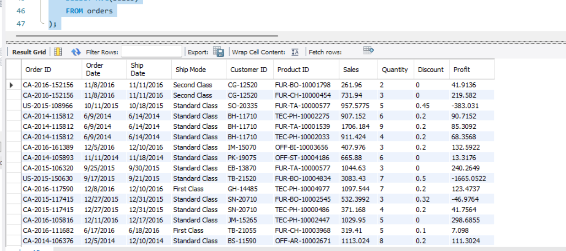

2. Highest Sales Order for Each Customer
A correlated subquery is utilized to determine the maximum sales amount for every customer. The query returned the highest-value order placed by each customer, making it easier to identify significant purchasing behavior and top transactions.
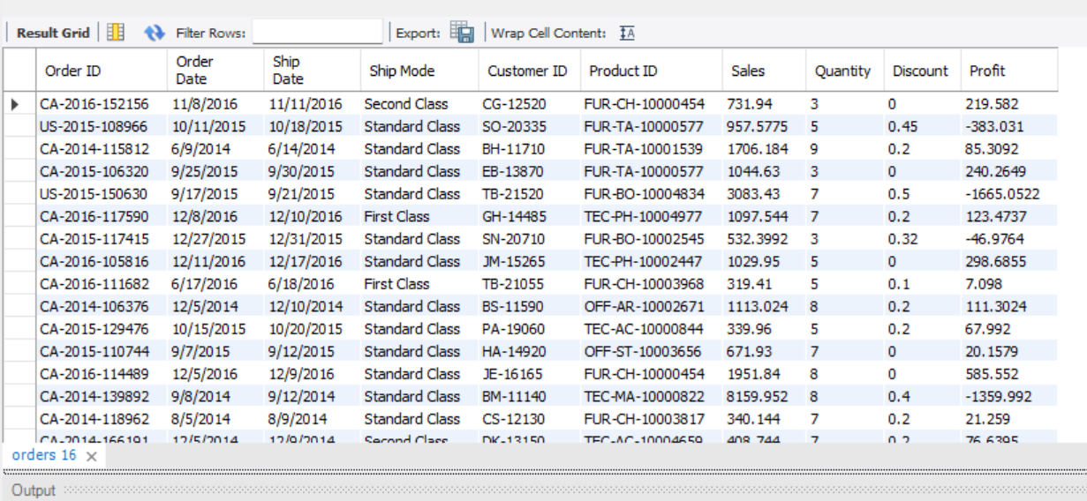

3. Total Sales for Each Customer
A Common Table Expression (CTE) is used to calculate the cumulative sales generated by each customer. This provided a clear overview of customer contribution to overall business revenue and simplified further analysis.
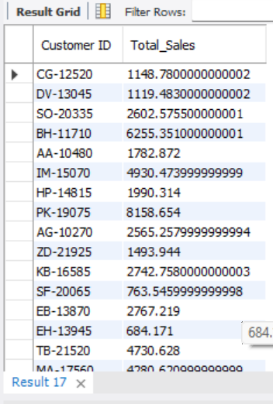

4. Customers with Above-Average Total Sales
Using a combination of a CTE and a subquery, customers whose total sales exceeded the average customer sales are identified. This helped distinguish high-performing customers who contribute more revenue than the average customer base.
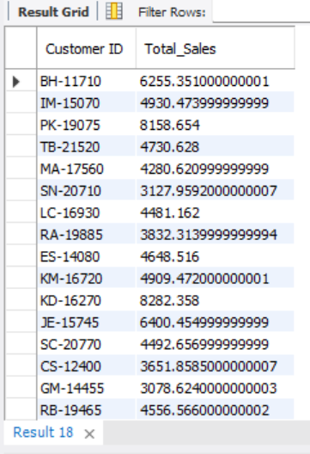

5. Ranking Customers Based on Total Sales
A window function is applied to rank customers according to their total sales. Customers generating higher revenue received higher rankings. This ranking mechanism is useful for customer segmentation and business decision-making.
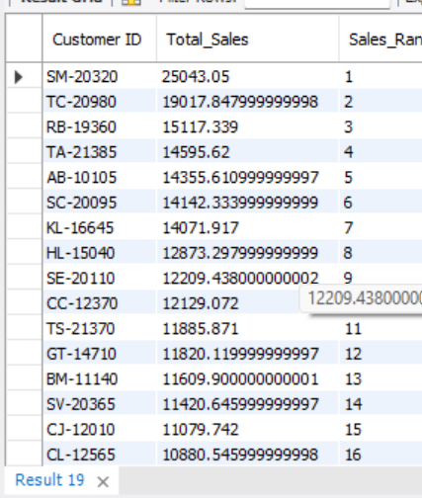

6. Row Number Assignment Within Each Customer
The ROW_NUMBER() window function is used with PARTITION BY to assign sequential numbers to orders belonging to the same customer. This made it possible to analyze customer order history and identify the order sequence for each customer.
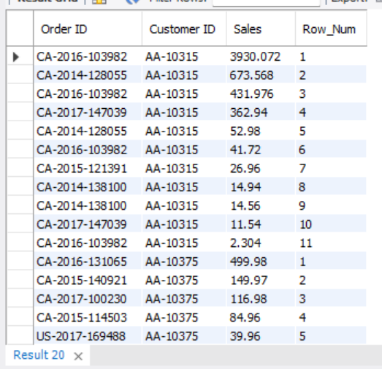

7. Top Three Customers by Total Sales
Customers are ranked according to their total sales, and the top three performers are selected. This analysis helps identify the most valuable customers and supports targeted customer relationship strategies.
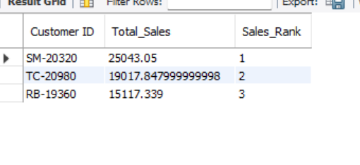

Step 3: Final Combined Analysis
The final query combined multiple SQL concepts, including JOIN operations, CTEs, and Window Functions. The query displayed:
- Customer Name
- Total Sales
- Sales Rank
The CTE first calculated total sales for each customer. The results are then joined with the customer information table to retrieve customer names. Finally, a ranking function is applied to rank customers based on their overall sales contribution.
This combined analysis provides a comprehensive overview of customer performance and enables businesses to quickly identify their most valuable customers.
