Customer Segmentation, Retention & Revenue Analysis for an Online Retailer
AICTE | IBM SkillsBuild Data Analytics with AI Internship 2026 - BharatCares
Submitted by: Rishika Garg
Date: 24 September 2026

Contents
1. Executive Summary
2. Problem Statement & Objectives
3. Dataset Description
4. Tools & Technologies
5. Data Cleaning & Data Scope
6. Methodology
7. Executive KPI Overview
8. Analysis & Results
9. Customer Segmentation Results
10. Predictive Model
11. Business Insights & Recommendations
12. Conclusion, Limitations, Future Scope
13. References

1. Executive Summary
The project analyses 4,334 customers and 18,402 positive product-sale invoices, producing net revenue of £8,737,227.64. Customer value is highly concentrated: Champions generate 64.8% of revenue, while the top 20% of customers generate 74.6%. Corrected month-1 retention is 19.7%, and the 90-day lapse model achieves 0.759 ROC-AUC versus 0.686 for continuous recency. Immediate actions are to protect Champion and Loyal accounts, test a 30-day second-purchase offer, contact 993 High-risk customers with win-back actions, manage concentrated overseas wholesale accounts, and prepare Q4 capacity early.

2. Problem Statement & Objectives
Problem statement: an online retailer needs to identify valuable customers, detect drifting relationships, understand revenue drivers, and direct marketing spend. Objectives are to define a consistent sales scope, analyse sales and products, build RFM segments, measure monthly cohort retention, train a leakage-safe lapse classifier, and turn results into targeted marketing actions.

3. Dataset Description
Source file: Kaggle E-commerce data, https://www.kaggle.com/datasets/carrie1/ecommerce-data, credited to the original UCI Online Retail dataset: https://archive.ics.uci.edu/dataset/352/online+retail. The file contains 541,909 transaction rows covering December 2010 to December 2011. Key fields are InvoiceNo, StockCode, Description, Quantity, InvoiceDate, UnitPrice, CustomerID, and Country. Revenue is calculated as Quantity × UnitPrice. The data file is excluded from version control because of its size and must be saved in this folder as data.csv.
Field | Meaning
InvoiceNo | Invoice identifier
StockCode | Product/service code
Description | Product description
Quantity | Units sold or returned
InvoiceDate | Transaction timestamp
UnitPrice | Price per unit
CustomerID | Customer identifier
Country | Customer country

4. Tools & Technologies
Python 3.12, pandas, NumPy, matplotlib, seaborn, scikit-learn, Jupyter, nbconvert, openpyxl, and python-docx.

5. Data Cleaning & Data Scope
Cohort boundary: December 2010 is left-censored because the data begins there, so the corrected retention figures exclude that cohort and cohorts too recent to observe month 1 or month 3. Retention here is the share of a cohort buying in that specific month, not a running total. Many customers skip a month or two and return later, so the share buying in month 3 can be higher than in month 1; the pattern varies by cohort. Rows with missing CustomerID are excluded from customer-level analysis. Cancellations are identified by InvoiceNo starting with C or negative Quantity and are reported separately, then excluded from sales analysis. Non-positive UnitPrice, administrative StockCodes, and exact duplicates are excluded. The final month is excluded from the complete-month trend when its order count is materially lower than the previous month. All KPIs, segments, retention results, and model results use the same final sales scope.

6. Methodology
The workflow is cleaning → exploratory sales analysis → RFM segmentation → monthly acquisition-cohort retention → leakage-safe lapse modelling → business insights and marketing recommendations.

7. Executive KPI Overview
KPI | Value
Net revenue | £8,737,227.64
Orders | 18,402
Customers | 4,334
Average order value | £474.80
Average orders per customer | 4.25
Repeat-customer rate | 65.3%
Cancellation rate (cancelled invoices / known-CustomerID invoices) | 15.5%
Cancellation line-item rate | 2.1%
Cancelled revenue / gross revenue | 5.1%
UK revenue share | 82.9%
Cancellation definitions: cancelled invoices divided by invoices with known CustomerID; cancelled line items divided by line items with known CustomerID; absolute cancelled revenue divided by positive sales plus absolute cancelled revenue.

8. Analysis & Results
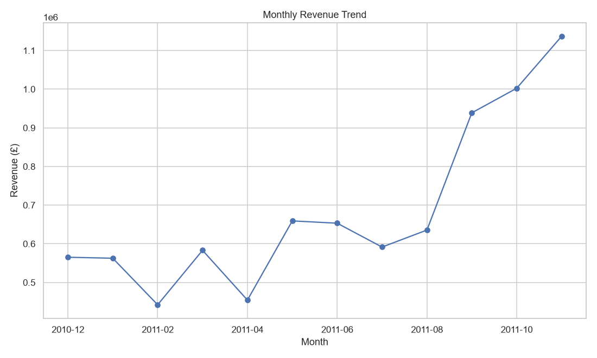
Figure 1. Monthly revenue trend — complete months only
The monthly trend uses complete months only, so the partial final month does not distort seasonality. Revenue peaks in November 2011.
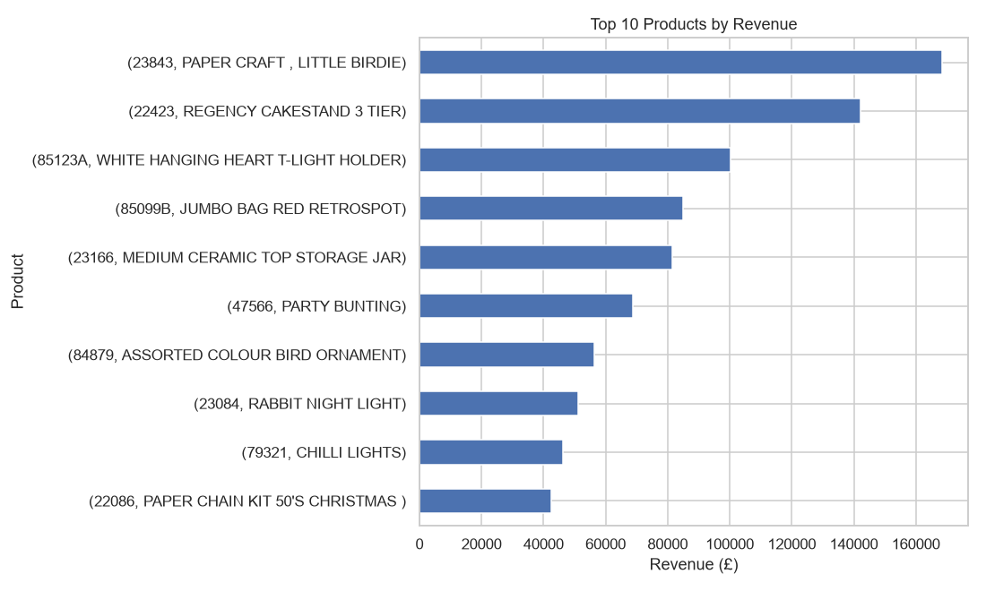
Figure 2. Top 10 products by positive revenue
The product view identifies the leading product lines by positive sales revenue.
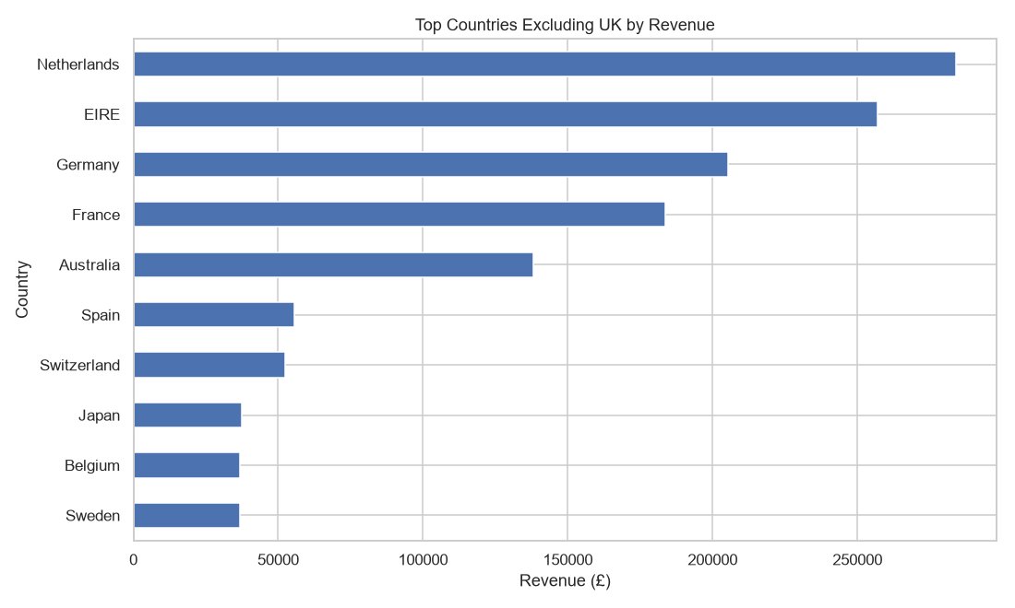
Figure 3. Top countries excluding the UK by revenue
Non-UK country revenue shows market size outside the home market, but concentration must be considered before interpreting demand.
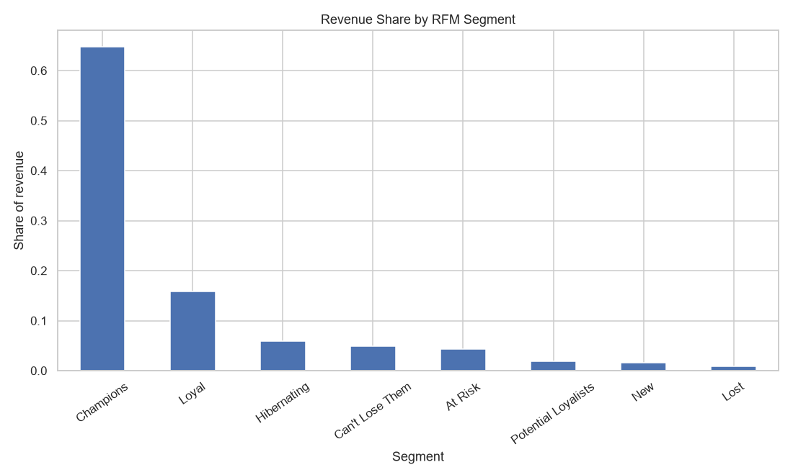
Figure 4. Revenue share by RFM segment
Revenue concentration across RFM segments supports differentiated retention investment.
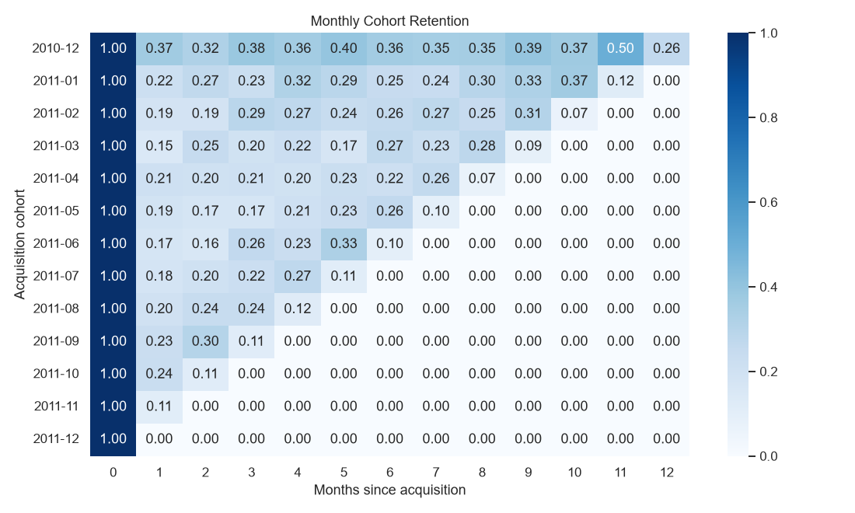
Figure 5. Monthly acquisition-cohort retention
The heatmap measures repeat purchase by acquisition cohort and month since first purchase. Cells beyond a cohort’s observed horizon are not retention evidence.

Country concentration table
Country | Customers | Revenue | Largest customer share
Netherlands | 9 | £283,889.34 | 98.3%
EIRE | 3 | £257,013.12 | 53.0%
Germany | 94 | £205,381.15 | 8.5%
France | 87 | £183,801.94 | 10.2%
Australia | 9 | £138,103.81 | 90.2%
Spain | 30 | £55,706.56 | 21.5%
Switzerland | 21 | £52,441.95 | 21.1%
Japan | 8 | £37,416.37 | 57.3%
Belgium | 25 | £36,927.34 | 12.8%
Sweden | 8 | £36,828.83 | 86.3%
The table shows why country revenue should not automatically be read as broad market demand.

Retention comparison
Retention measure | Uncorrected | Corrected | Rule
Month-1 average | 18.9% | 19.7% | Exclude Dec 2010 and cohorts without an observed month 1
Month-3 average | 17.9% | 22.9% | Exclude Dec 2010 and cohorts without an observed month 3

Customer concentration
Concentration | Share
Top 10 customers' revenue | 17.4%
Top 50 customers' revenue | 33.4%
Top 10 Champions' share of Champions revenue | 24.6%

9. Customer Segmentation Results
Segment | Customers | Revenue | Revenue share | Avg monetary
Champions | 941 | £5,660,267.34 | 64.8% | £6,015.16
Loyal | 770 | £1,379,043.58 | 15.8% | £1,790.97
Hibernating | 1,077 | £515,665.77 | 5.9% | £478.80
Can't Lose Them | 179 | £430,884.31 | 4.9% | £2,407.17
At Risk | 478 | £381,755.17 | 4.4% | £798.65
Potential Loyalists | 347 | £162,988.77 | 1.9% | £469.71
New | 310 | £133,025.33 | 1.5% | £429.11
Lost | 232 | £73,597.37 | 0.8% | £317.23
Wholesale customers and repeat trade can make monetary values high. The top 20% of customers account for 74.6% of revenue.

10. Predictive Model
The model was evaluated on the held-out test set. Risk tiers were assigned by scoring all eligible pre-cutoff customers; the 993 High-risk count is not a test-set count. The cutoff is three months before the final complete month. Features are calculated only before the cutoff. The label is no purchase in the following 90 days. The model uses scaled Logistic Regression with an 80/20 stratified split, random_state=42.
Model | Accuracy | Precision | Recall | F1 | ROC-AUC
Logistic Regression | 0.696 | 0.670 | 0.749 | 0.707 | 0.759
Majority baseline | 0.509 | 0.000 | 0.000 | 0.000 | 0.500
Recency >= 90 days | 0.663 | 0.688 | 0.572 | 0.625 | 0.686
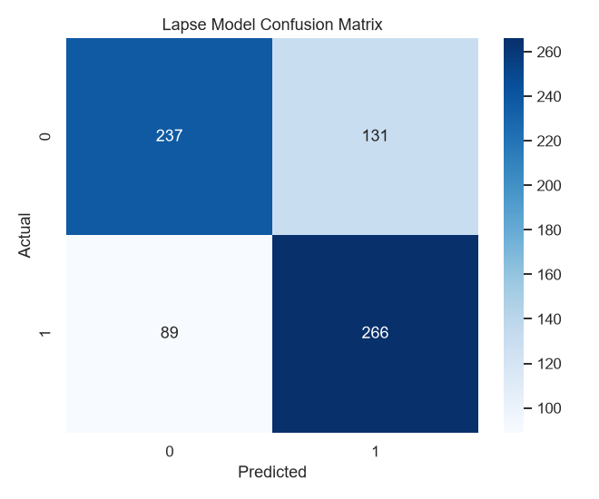
Figure 6. Confusion matrix for the 90-day lapse classifier
Rows are actual classes and columns are predicted classes; counts support the reported classification metrics.
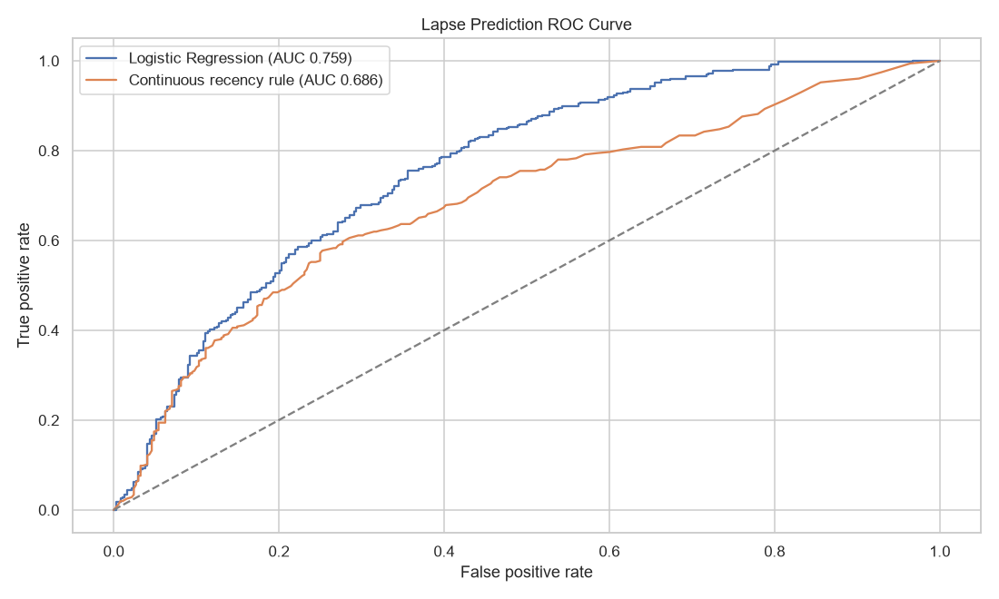
Figure 7. ROC comparison of Logistic Regression and the recency rule
The model ranks lapse risk better than continuous recency across thresholds; this is predictive association, not causation.
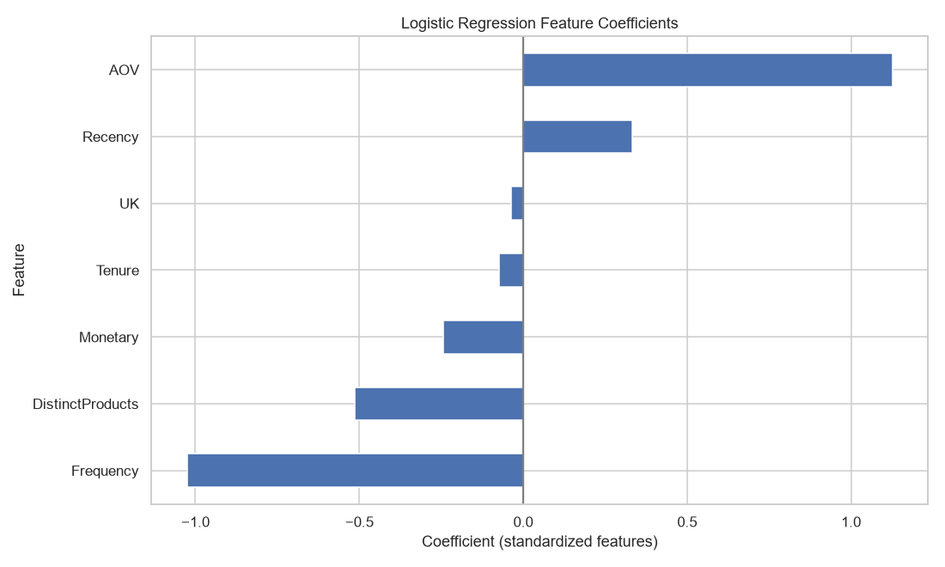
Figure 8. Standardized Logistic Regression coefficients
Positive coefficients increase predicted lapse score and negative coefficients reduce it after feature standardization.
Risk tier | Customers | Historical revenue | Revenue share
Low | 1,106 | £4,607,640.08 | 75.7%
Medium | 1,514 | £1,006,746.05 | 16.5%
High | 993 | £471,752.87 | 7.8%
The recency rule uses a >=90-day threshold for classification metrics and raw recency days for ROC-AUC. Continuous recency ROC-AUC is 0.686; Logistic Regression adds 0.073 ROC-AUC. This is a modest, real gain; use the simple recency rule when simplicity matters. The model estimates association, not causation.

11. Business Insights & Recommendations
Observation | Insight | Risk/Opportunity | Recommended action
941 Champions customers are 21.7% of all customers and bring in 64.8% of revenue. Top 10 customers contribute 17.4% of revenue, top 50 contribute 33.4%, and the top 10 Champions contribute 24.6% of Champions revenue. | A small number of customers drive most sales. | Losing a few large customers would reduce revenue. | Manage the top wholesale accounts separately with key-account service, and use mass-market loyalty offers for the broader customer base.
After excluding Dec 2010 and immature cohorts, 19.7% of acquired customers buy again in month 1; month 3 is 22.9%. Retention here is the share of a cohort buying in that specific month, not a running total. Many customers skip a month or two and return later, so the share buying in month 3 can be higher than in month 1; the pattern varies by cohort. | Most customers do not return soon after their first purchase. | The retailer is losing early repeat-purchase opportunities. | Send a second-purchase offer within 30 days and time reminder campaigns to customers' typical reorder gap (months 2-3), not only a 30-day offer.
993 High-risk customers account for 7.8% of historical revenue. | Some customers at risk of lapsing have already spent significantly. | A win-back campaign can protect revenue at risk. | Contact High-risk customers with a relevant offer and a service check.
Most non-UK revenue depends on a few wholesale accounts: Netherlands: 9 customers, largest customer 98.3%, EIRE: 3 customers, largest customer 53.0%, Australia: 9 customers, largest customer 90.2%, Sweden: 8 customers, largest customer 86.3%, Germany: 94 customers, largest customer 8.5%, France: 87 customers, largest customer 10.2%. | Germany and France are the only broad-based overseas markets in this table because their largest customers contribute only 8.5% and 10.2% of country revenue. | Country totals can overstate broad demand when a few wholesale buyers dominate. | Manage the large overseas buyers as key accounts, and target Germany and France for customer acquisition.
Revenue peaks in 2011-11 at £1,136,534.00, 65.8% above the complete-month average; complete-month Q4 revenue is 32.9% of annual revenue. | Demand is strongest in the final quarter. | Campaigns started too late will miss the highest-revenue period. | Plan and launch Q4 campaigns early, with inventory and delivery capacity prepared in advance.

12. Conclusion, Limitations, Future Scope
The analysis identifies where customer value, repeat purchase, and lapse risk are concentrated. Limitations include the absence of gross margin, marketing cost, product cost, and campaign exposure; the partial final month; and the observational nature of the model. Future work can add profitability, campaign response, seasonal variables, calibrated risk thresholds, and controlled marketing tests.

13. References
Kaggle. E-commerce data. https://www.kaggle.com/datasets/carrie1/ecommerce-data
Original source: UCI Machine Learning Repository. Online Retail. https://archive.ics.uci.edu/dataset/352/online+retail
Scikit-learn documentation. https://scikit-learn.org/stable/documentation.html
pandas documentation. https://pandas.pydata.org/docs/

