**Image processing using openCV: Translation**

Translation refers to shifting of object from one point to another.

|  |  |  |
| --- | --- | --- |
| 1 | 0 | tx |
| 0 | 1 | ty |

Translation matrix for translation is given by, T =

where tx and ty are the amount of translation in x and y axis respectively.

cv2.warpAffine():

To perform translation, we can use cv2.warpAffine(image, transformation_matrix, shape) function which takes a 2x3 transformation matrix and convert the image based on the passed transformation matrix. It has three arguments:

1. image: the image which we want to transform.
2. transformation_matrix: it is a 2x3 matrix which is used to transform the input image. We can perform rotation, translation and other transformations by changing the transformation matrix.
3. shape: it defines the shape(width, height) of the resultant matrix.

Python code:

import cv2

import numpy as np

img = cv2.imread('birds.jpg',1);

rows = img.shape[0];

cols = img.shape[1];

T = np.float32([[1,0,50],[0,1,25]]); #translation matrix

output_img = cv2.warpAffine(img, T, (cols,rows));

cv2.imshow('Original', img);

cv2.imshow('Output Image',output_img);

#wait for 10 seconds

cv2.waitKey(10000);

cv2.destroyAllWindows();

Output:

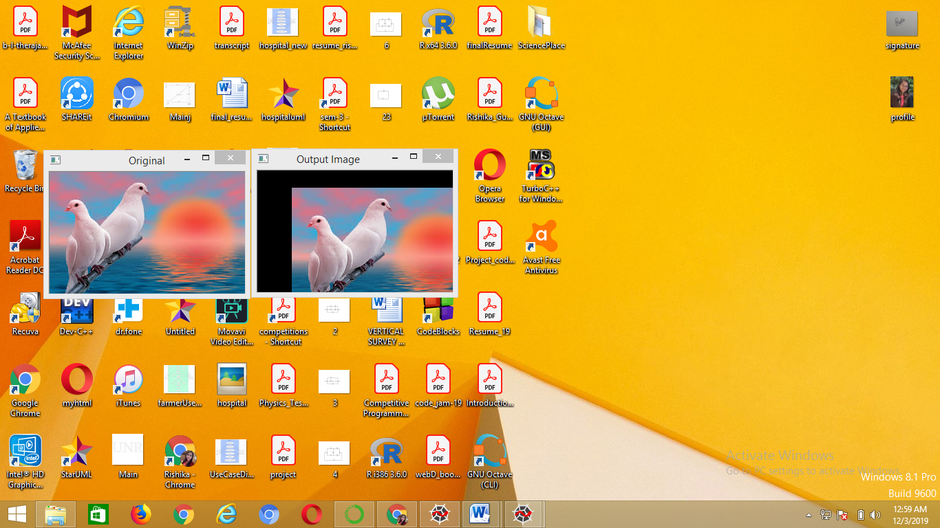

Change window size in translation:

Python code:

import cv2

import numpy as np

img = cv2.imread('birds.jpg',1);

rows = 100;

cols = 350;

T = np.float32([[1,0,50],[0,1,25]]); #translation matrix

output_img = cv2.warpAffine(img, T, (cols,rows));

cv2.imshow('Original', img);

cv2.imshow('Output Image',output_img);

#wait for 10 seconds

cv2.waitKey(10000);

cv2.destroyAllWindows();

Output:

