**Assignment 1 :**

Question :

Draw the tree corresponding to the id[ ] depicted at below. Can this be the result of running weighted quick - union? If not explain why this is impossible or give a sequence of operations that the results in the array.

Solution :

Tree :

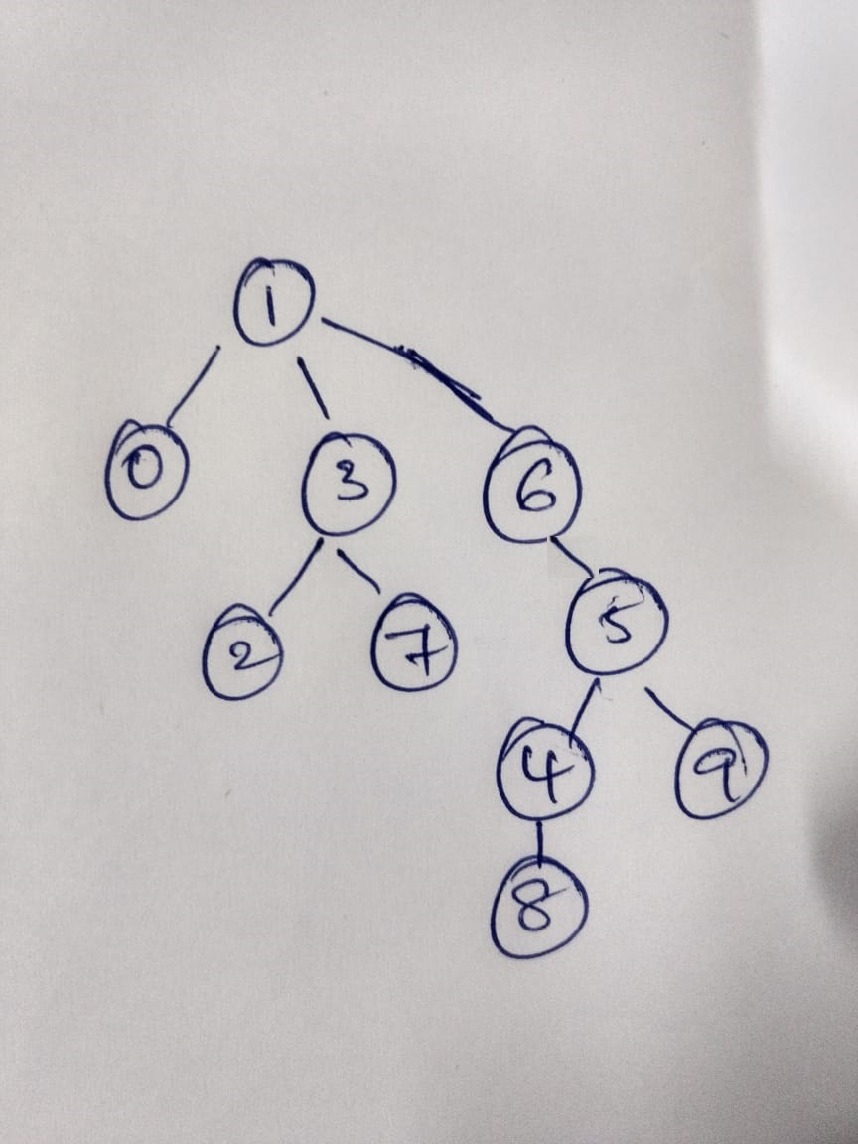

No this cannot be a weighted quick union because when 5 is added as child to 6, it should be added to 1 because the 1 root tree is bigger than 5.