MODULE 5 - ACTIVITY 5

QUESTION :

What does the following code fragment do to the queue q?

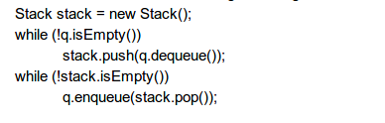

SOLUTION :

* The elements from queue are pushed into a stack and pushed into queue again. In this program, we are reversing the order of elements.
* q.dequeue pops the elements from queue and q.enqueue pushes the elements into queue
* First while loops till queue is empty and second till stack is empty