**Overview:**

Using the ecosystem model the project was implemented to smoothen the flow of vaccine.

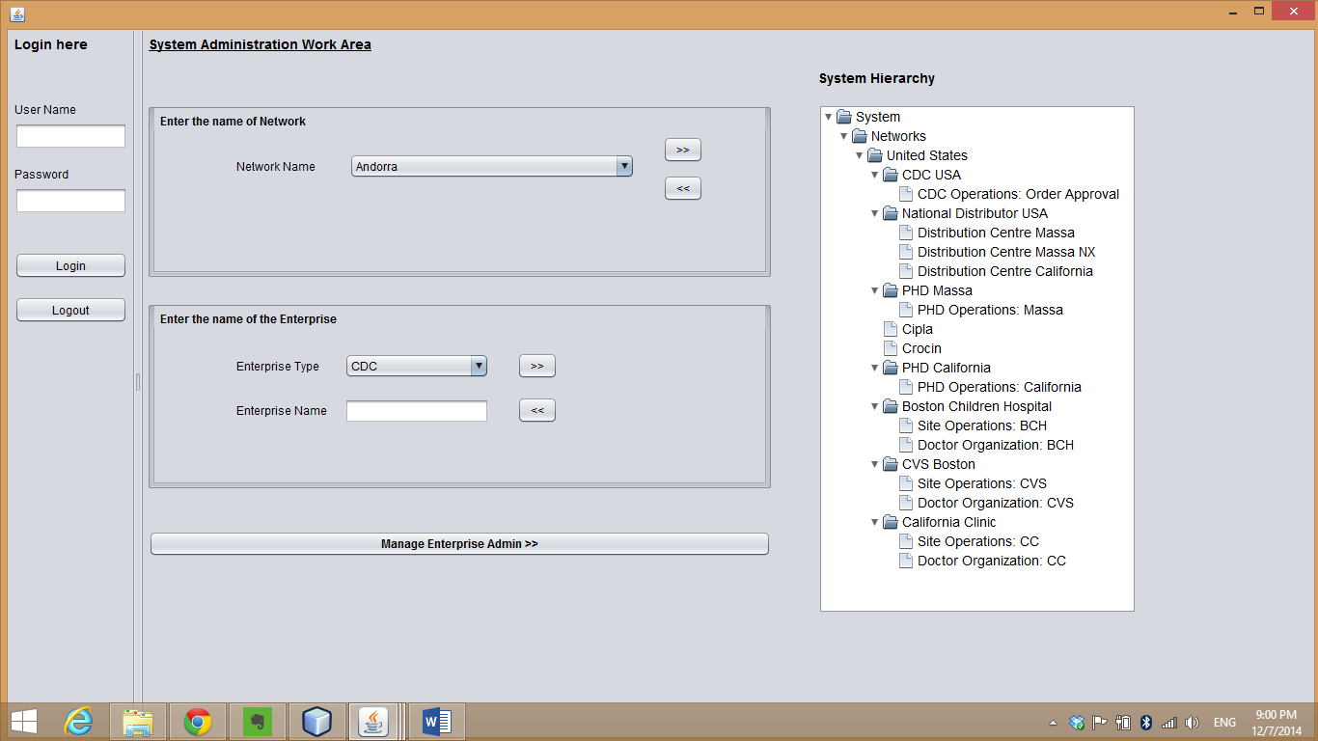

**Problem:**

1. **Vaccine Safety** – If a batch of vaccine is detected bad by one of the provider then the provider places a work request to CDC and CDC using the manufacturing batch of the vaccine look up at all the sites where the manufacturing batch has reached and places a request to those providers using that batch informing about not to use that batch

**Provider Informing CDC**

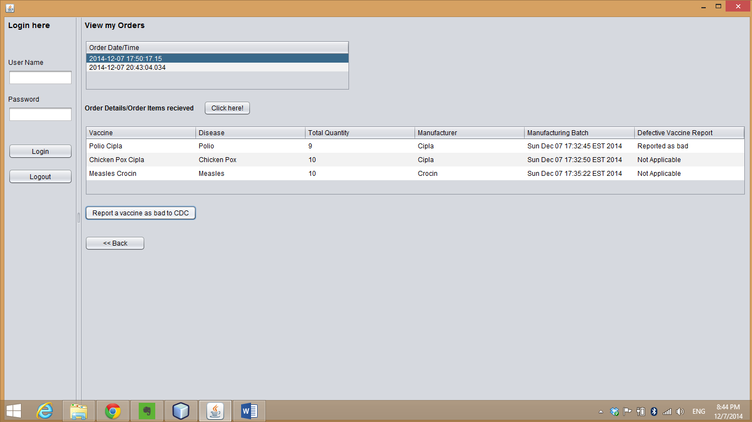

**CDC broadcasting the bad vaccine**

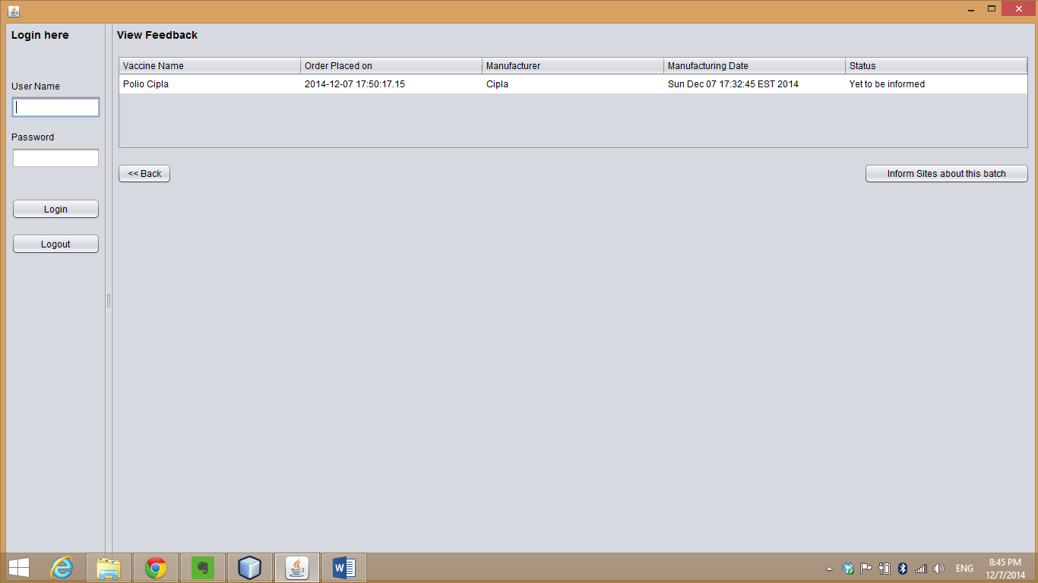

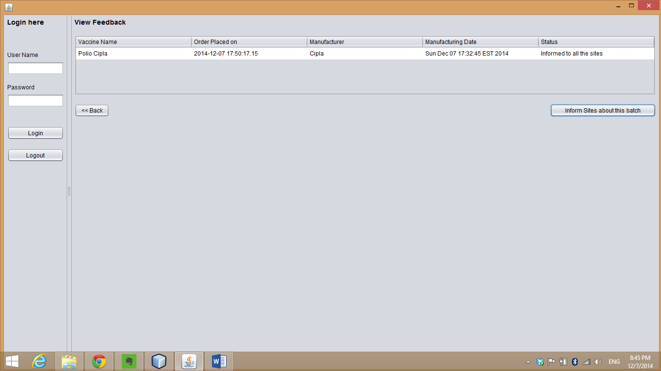

1. **Inventory wastage** – An algorithm is used to ensure the oldest batch is sold first and then the new batch is sold to avoid wastage

Also, track of inventory wastage is kept with the manufacturer

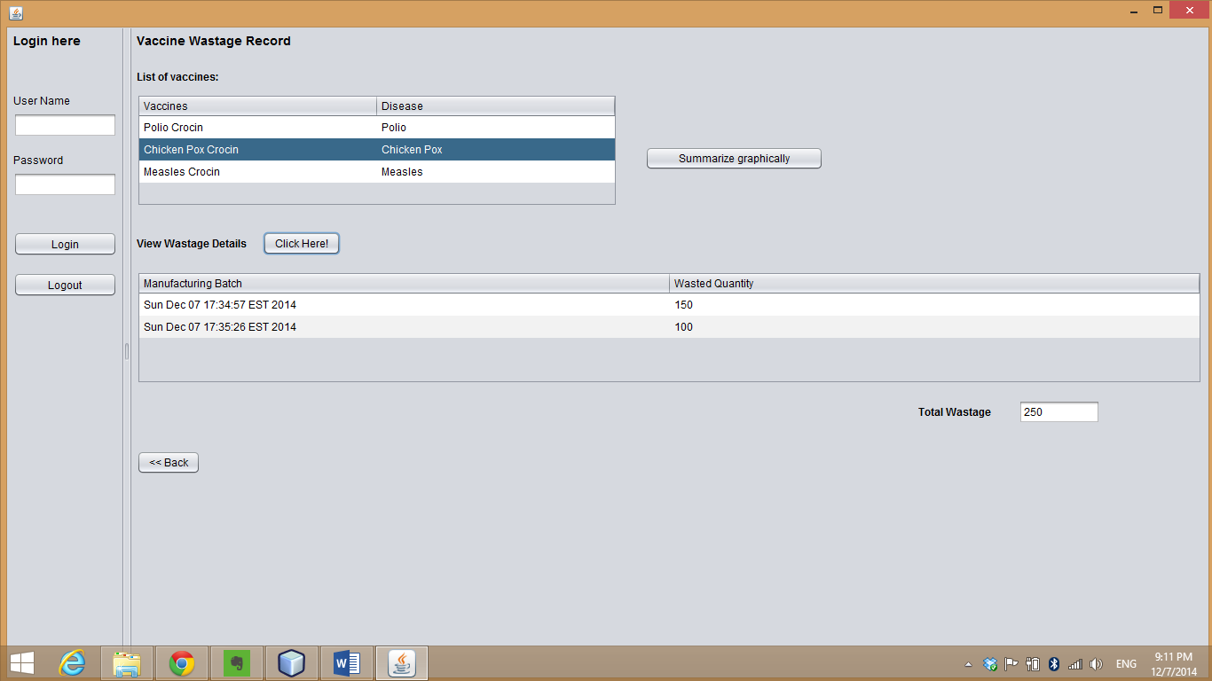

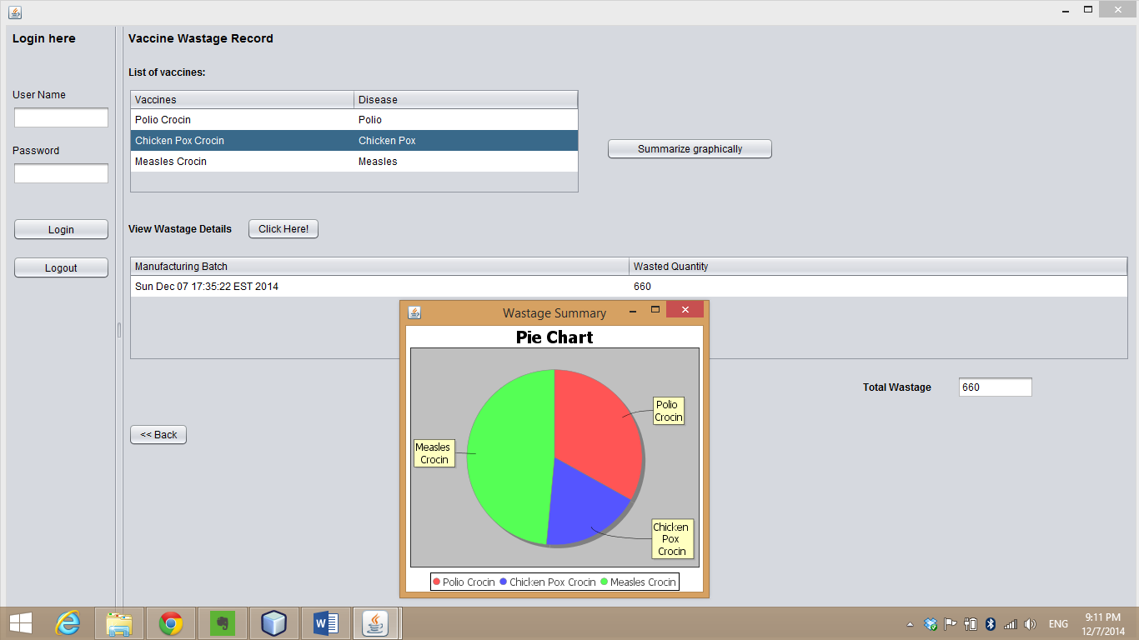

1. **CDC Vaccine Allocation**

As per the population percentile, the vaccine of each manufacturer is allocated to the to that particular state using the formula

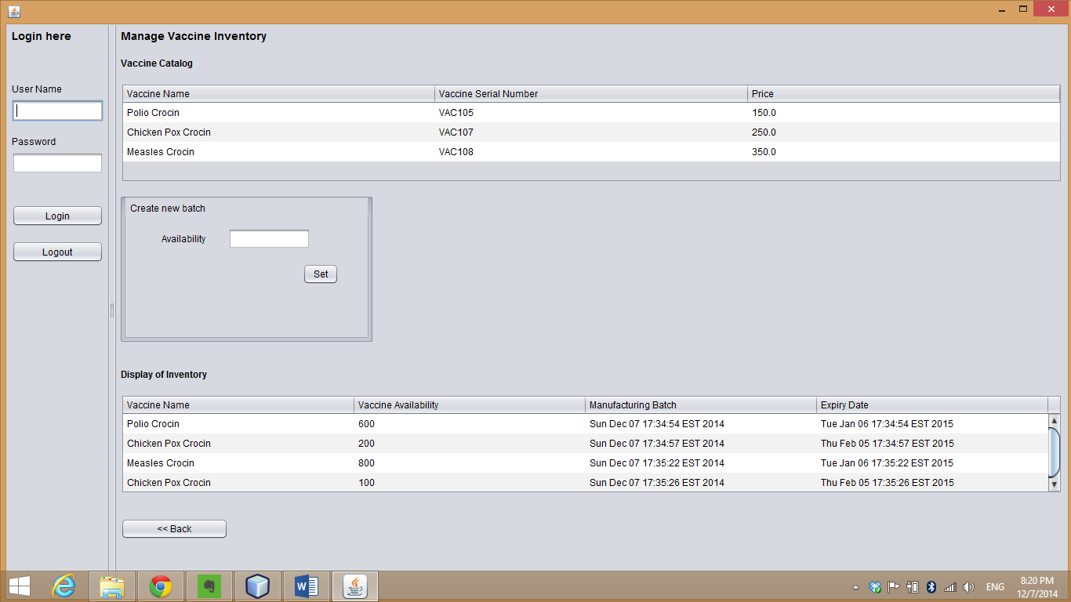

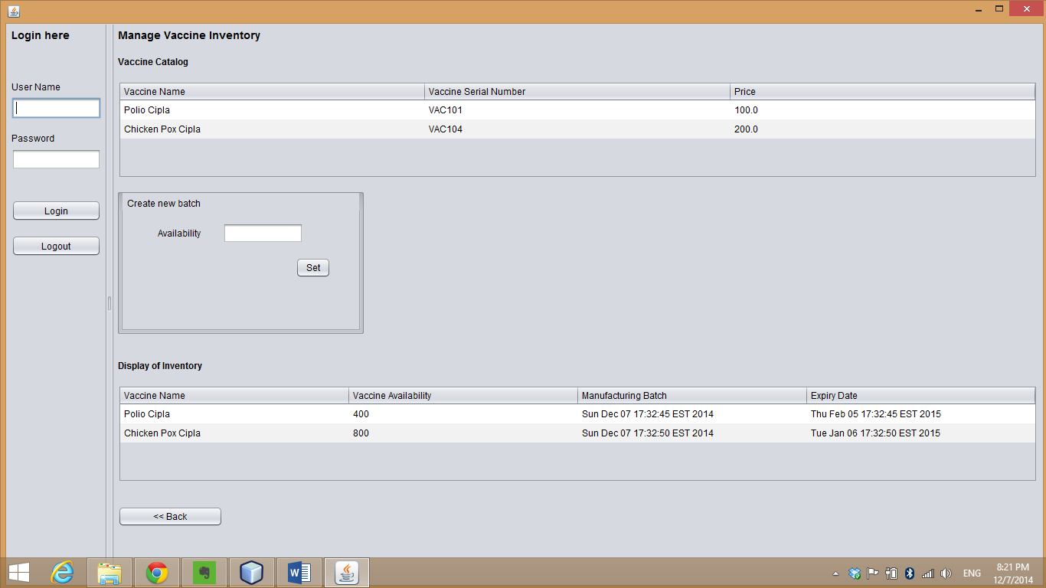

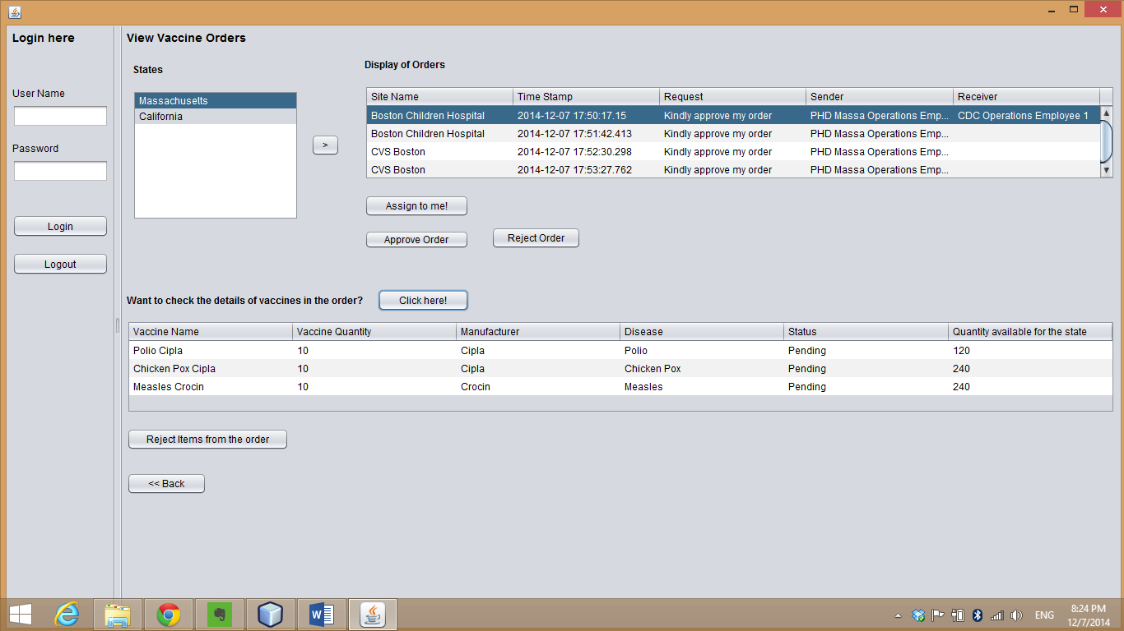

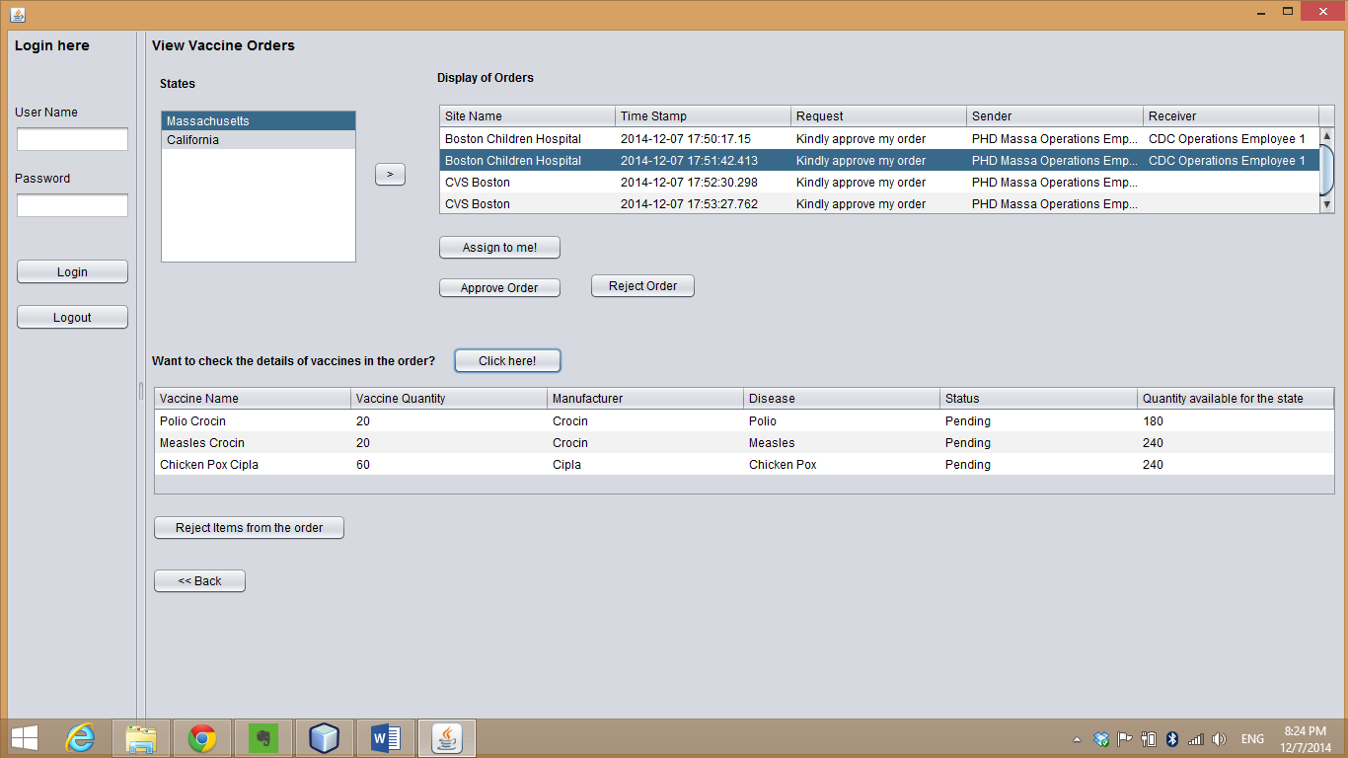

1. **Insurance Modelling**

CDC is billed as per the patient information which is modelled. Automatic order generation when the inventory volume goes below 20

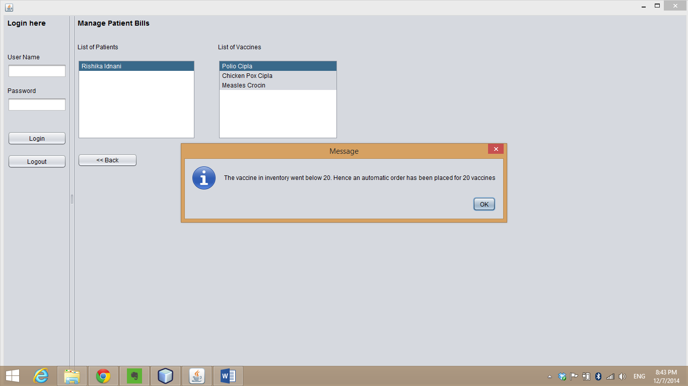



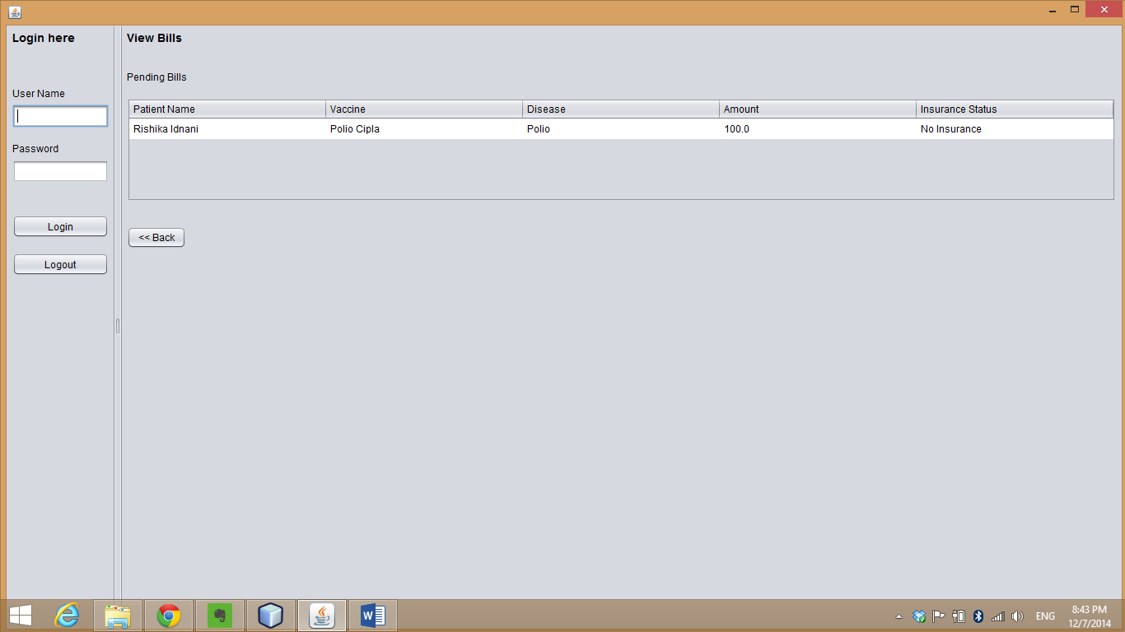

1. **Business Solutions**

**Sale overview of Manufacturer**

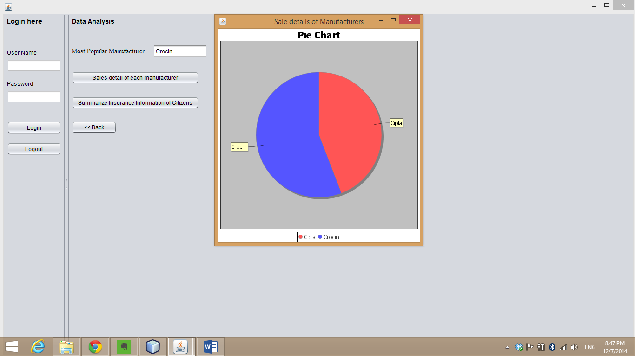

**Disease prevalent in the state**

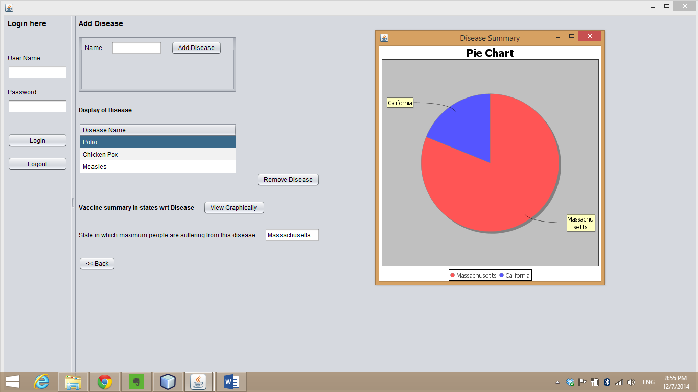

**Insurance information about the citizens**

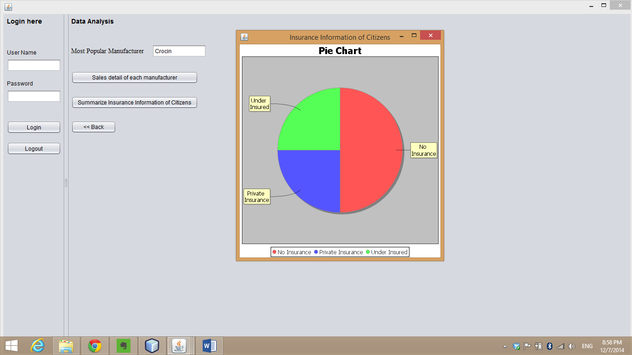

1. **Nearest distribution centre**

**Boston Children having centre with different pin code and CVS having DCM with different pin code**

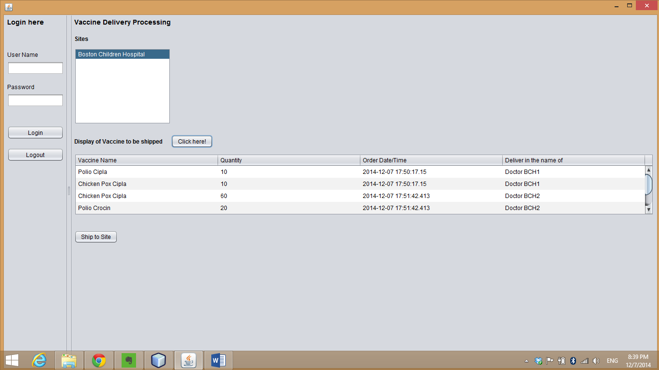

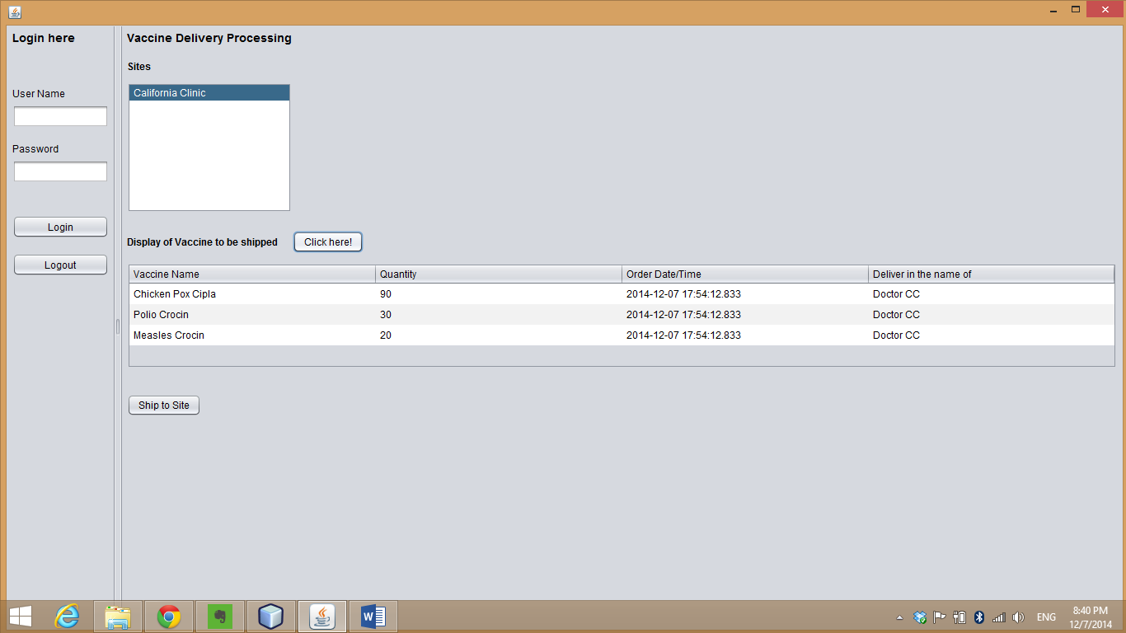

1. **National Distributor tracking the order**

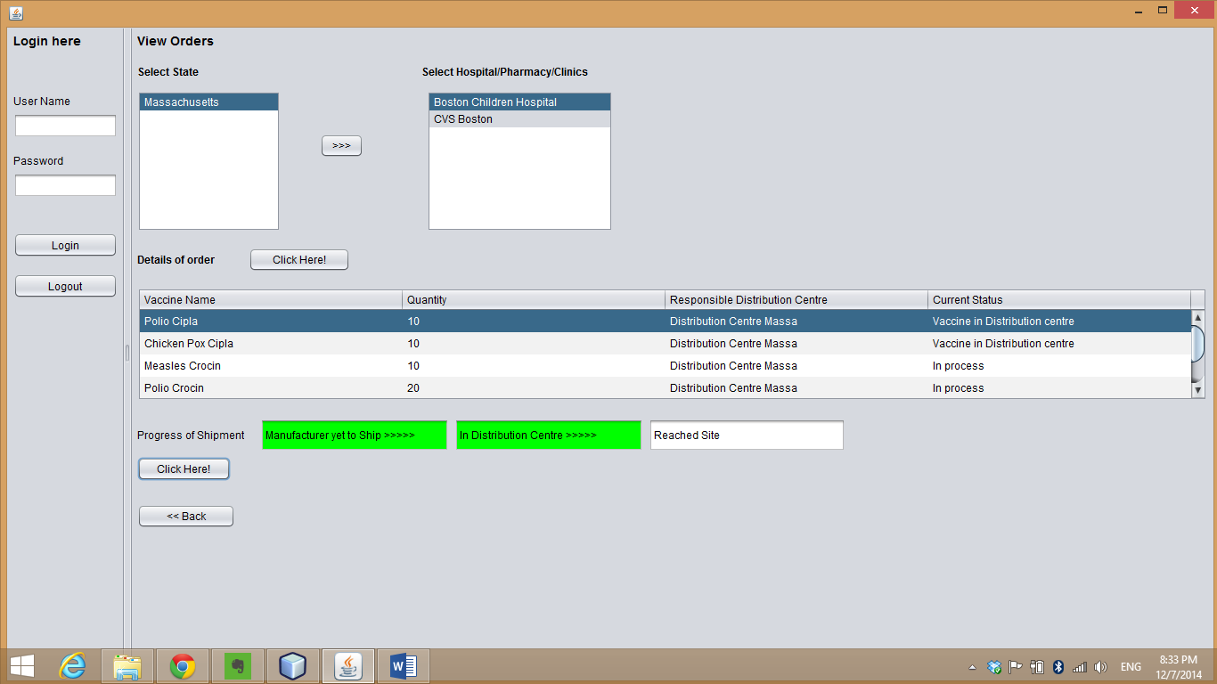

**Assumptions**

1. PHD adds registered sites
2. There are multiple vaccine manufacturers in different region of the country
3. Distribution centre ships the vaccine that it gets from the manufacturer
4. National Distributor tracks the orders of all the distribution centre