RISHIKA JAIN 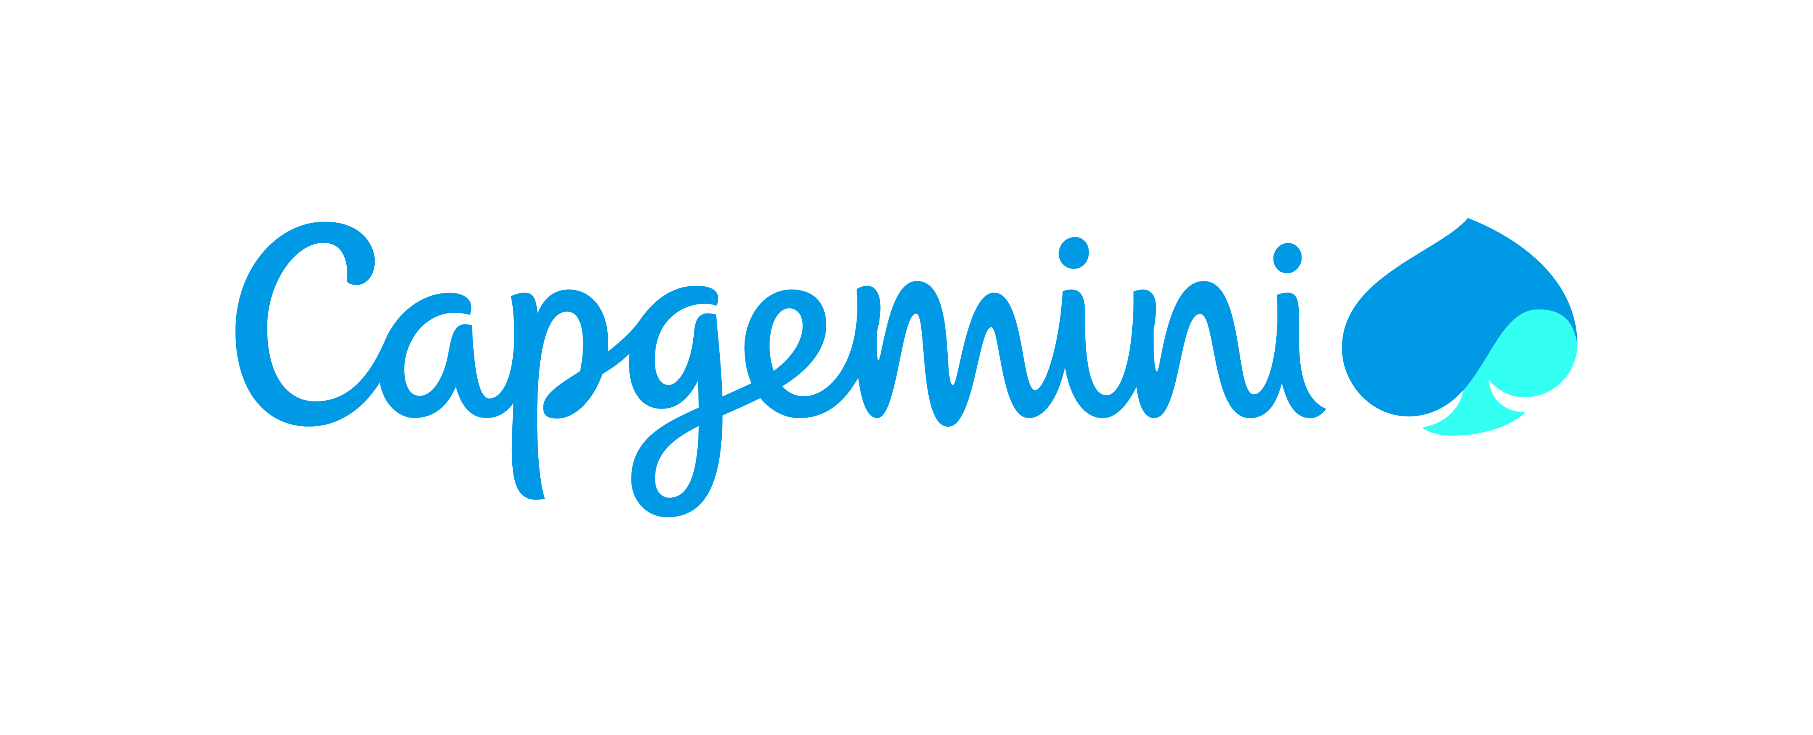
Professional Summary
Enthusiastic and results-driven Software Engineer with a strong foundation in Big Data technologies, gained through intensive training at Capgemini. Led a team project to build a personalized recommendation engine using Hadoop, PySpark, and AWS services on an e-commerce dataset. I am skilled in data processing, distributed computing, and front-end development with React. Proficient in Java, SQL, and data structures, with a passion for solving real-world problems using scalable solutions.

Skills Profile
Technical
Operating System | Windows 10/11, Amazon Linux (EC2)
Environment | Client/Server, Cloud-based Data Processing (AWS), Distributed Computing (Apache Spark),Big Data Analytics
Database | Hive, Amazon Athena, AWS Glue Data Catalog, MySQL, Amazon S3 (as data lake storage)
Cloud | Jupyter Notebook, DataBricks, AWS, Google Collab
Languages | PySpark, Java, C, Scala, SQL (HiveQL, Athena SQL)
Other | Git/GitHub, Data Cleaning & Transformation (Pandas, PySpark), Bucketing), Cloud Services (AWS EC2, S3, Glue, Athena, IAM), Workflow Orchestration (Apache Airflow), Big Data Processing (Spark Core,Hadoop), Performance Optimization, Agile/Scrum Methodologies

Functional
Management and Leadership Skills | - Led a team during Capgemini Big Data training using Agile methodology, managing sprint planning, task delegation, and progress tracking  - Experienced in planning and task allocation to maintain balanced workloads across teams  - Strong focus on clear communication, accountability, and timely progress updates for effective coordination  - Capable of mentoring team members, resolving blockers, and fostering a collaborative work environment  - Served as Class Representative (CR) during Capgemini’s training program, facilitating communication between mentors and trainees and ensuring smooth coordination
Training & Development | - Trained in Big Data and Cloud technologies during Capgemini’s intensive program  - Mentored over 500 students in C and Java programming, focusing on foundational concepts and problem-solving techniques  - Provided peer assistance during hands-on sessions involving data cleaning, query solving, and distributed computing  - Skilled at knowledge sharing to enhance team learning and technical competence  - Proficient in explaining complex technical concepts in a clear and accessible manner

Professional Experience
Capgemini Training Project – E-commerce Recommendation Engine | May 2025 – July 2025
Role: Team Lead – Big Data Engineer
Led a team to develop a personalized book recommendation engine using collaborative filtering techniques on an e-commerce dataset. The project aimed to address the challenge of data overload by suggesting relevant products to users based on their past behavior and similar user preferences.
- Worked with a raw dataset containing 5,80,000 records, which was cleaned and reduced to 3,20,000 records using Pandas
- Solved 20 complex queries using PySpark, Spark SQL, Scala, Hive QL, and DataFrames
- Implemented item-based and user-based recommendations using Apache Mahout
- Used Cloudera for Hive queries and developed solutions on Jupyter, Google Colab, and Databricks platforms
- Followed Agile methodology for sprint planning, task execution, and team collaboration
- Visualized insights and recommendation results using Tableau
Environment: HDFS, PySpark, Hive QL, Scala, Sqoop, Databricks, Tableau, Cloudera, Jupyter, Google Colab
Bharat Bhraman – AI Trip Planner | Feb 2025 – Mar 2025
Role: Frontend Developer & Team Lead
Led the frontend development of an intelligent travel planning web application that uses Generative AI to recommend personalized destinations and itineraries based on user preferences.
- Designed and implemented a responsive, user-friendly interface using HTML, CSS, and JavaScript, ensuring seamless navigation and accessibility across devices
- Integrated dynamic content modules that adapt travel plans based on real-time data and user inputs, enhancing personalization and flexibility
- Collaborated with backend developers to connect APIs for flight, train, and hotel data, enabling real-time itinerary generation
- Developed an interactive final results page that showcases personalized destination ideas, curated using Generative AI based on user preferences and travel history
- Focused on delivering a visually engaging and informative experience to help users make confident travel decisions
Environment: HTML, CSS, JavaScript, Flask (backend), REST APIs, Generative AI, Responsive Design

RailVaani – Train Info Web App | Aug 2024 – Sep 2024
Frontend Developer
Designed and developed a responsive web interface using HTML, CSS, and JavaScript to provide real-time train information. Focused on intuitive user experience, accessibility, and seamless interaction for scheduling and updates
- Integrated a language conversion feature that allows users to view train status, PNR status, and other travel details in their preferred regional language, making the platform inclusive and user-friendly
- Developed an admin mode where administrators can input and manage train information in multiple regional languages, ensuring localized updates and broader accessibility
- Ensured cross-browser compatibility and optimized performance for smooth access on both desktop and mobile devices
Environment: HTML, CSS, JavaScript, Flask (backend), REST APIs

Redesign Omega Watch Website & Cadbury Chocolate Website | Nov 2024 – Dec 2024
Role: Team lead & Frontend Developer
Revamped the Omega watch website to enhance brand engagement and modernize the UI/Ux
- Implemented interactive animations and smooth scrolling using GSAP, ScrollTrigger, and Locomotive JS
- Focused on creating a visually rich and responsive design that aligns with brand aesthetics and enhances user experience
Environment: HTML, CSS, JavaScript, GSAP, ScrollTrigger, Locomotive JS, VS Code, GitHub, Responsive Design Principles

Summary of Projects

E-commerce Recommendation Engine – Capgemini Training Project Jun 2025 – Aug 2025

Team Lead – Big Data Engineer

Built a recommendation system using collaborative filtering on a large e-commerce dataset. Cleaned over 5.8 lakh records down to 3.2 lakh using Pandas and solved 20 queries using PySpark, Hive, and Scala. Managed the project using Agile methodology and visualized results with Tableau.

Bharat Bhraman – AI Trip Planner Feb 2025 – Mar 2025

Frontend Developer & Team Lead

Led the frontend development of an AI-powered travel planner that recommends personalized destinations using real-time data and Generative AI. Designed a responsive interface and integrated APIs for flights, trains, and hotels, with a final results page showcasing curated travel ideas.

Omega Watch Website Redesign Nov 2024 – Dec 2024

Frontend Developer & Team Lead

Revamped the Omega watch website to deliver a modern, engaging user experience. Used animation libraries like GSAP, ScrollTrigger, and Locomotive JS to create smooth, interactive transitions and elevate brand presentation. Focused on responsive design, cross-browser compatibility, and performance optimization.

RailVaani – Train Info Web App Aug 2024 – Sep 2024

Frontend Developer

Built a responsive web app to provide real-time train and PNR status updates. Integrated regional language support for users and admins, enabling multilingual access and management of train information across India. Designed for accessibility, intuitive navigation, and seamless scheduling interaction.

Training and Seminars
- Completed Capgemini Big Data Training Program, covering Hadoop, Hive, HBase, Spark, Scala, PySpark, Oracle SQL, MySQL, and Unix OS
- Participated in hands-on sessions involving real-world datasets and recommendation engine development
- Learned AWS fundamentals including S3 data transfer and permission management
- Conducted peer mentoring sessions during training, sharing knowledge on PySpark and Hive query optimization

Education
Lakshmi Narain College of Technology and Science Bhopal Madhya Pradesh 2021-2025

