**Final Update**

Business Questions

**Q1.) How does availability and rental prices of listings change over time?**

The below chart uses dual axis to show the inverse relation between number of available listings and the average price per guest.

The first chart shows that the summer is the busiest time for visiting Seattle as there are less number of listings available during these months and the average price per guest is also the highest during these months.

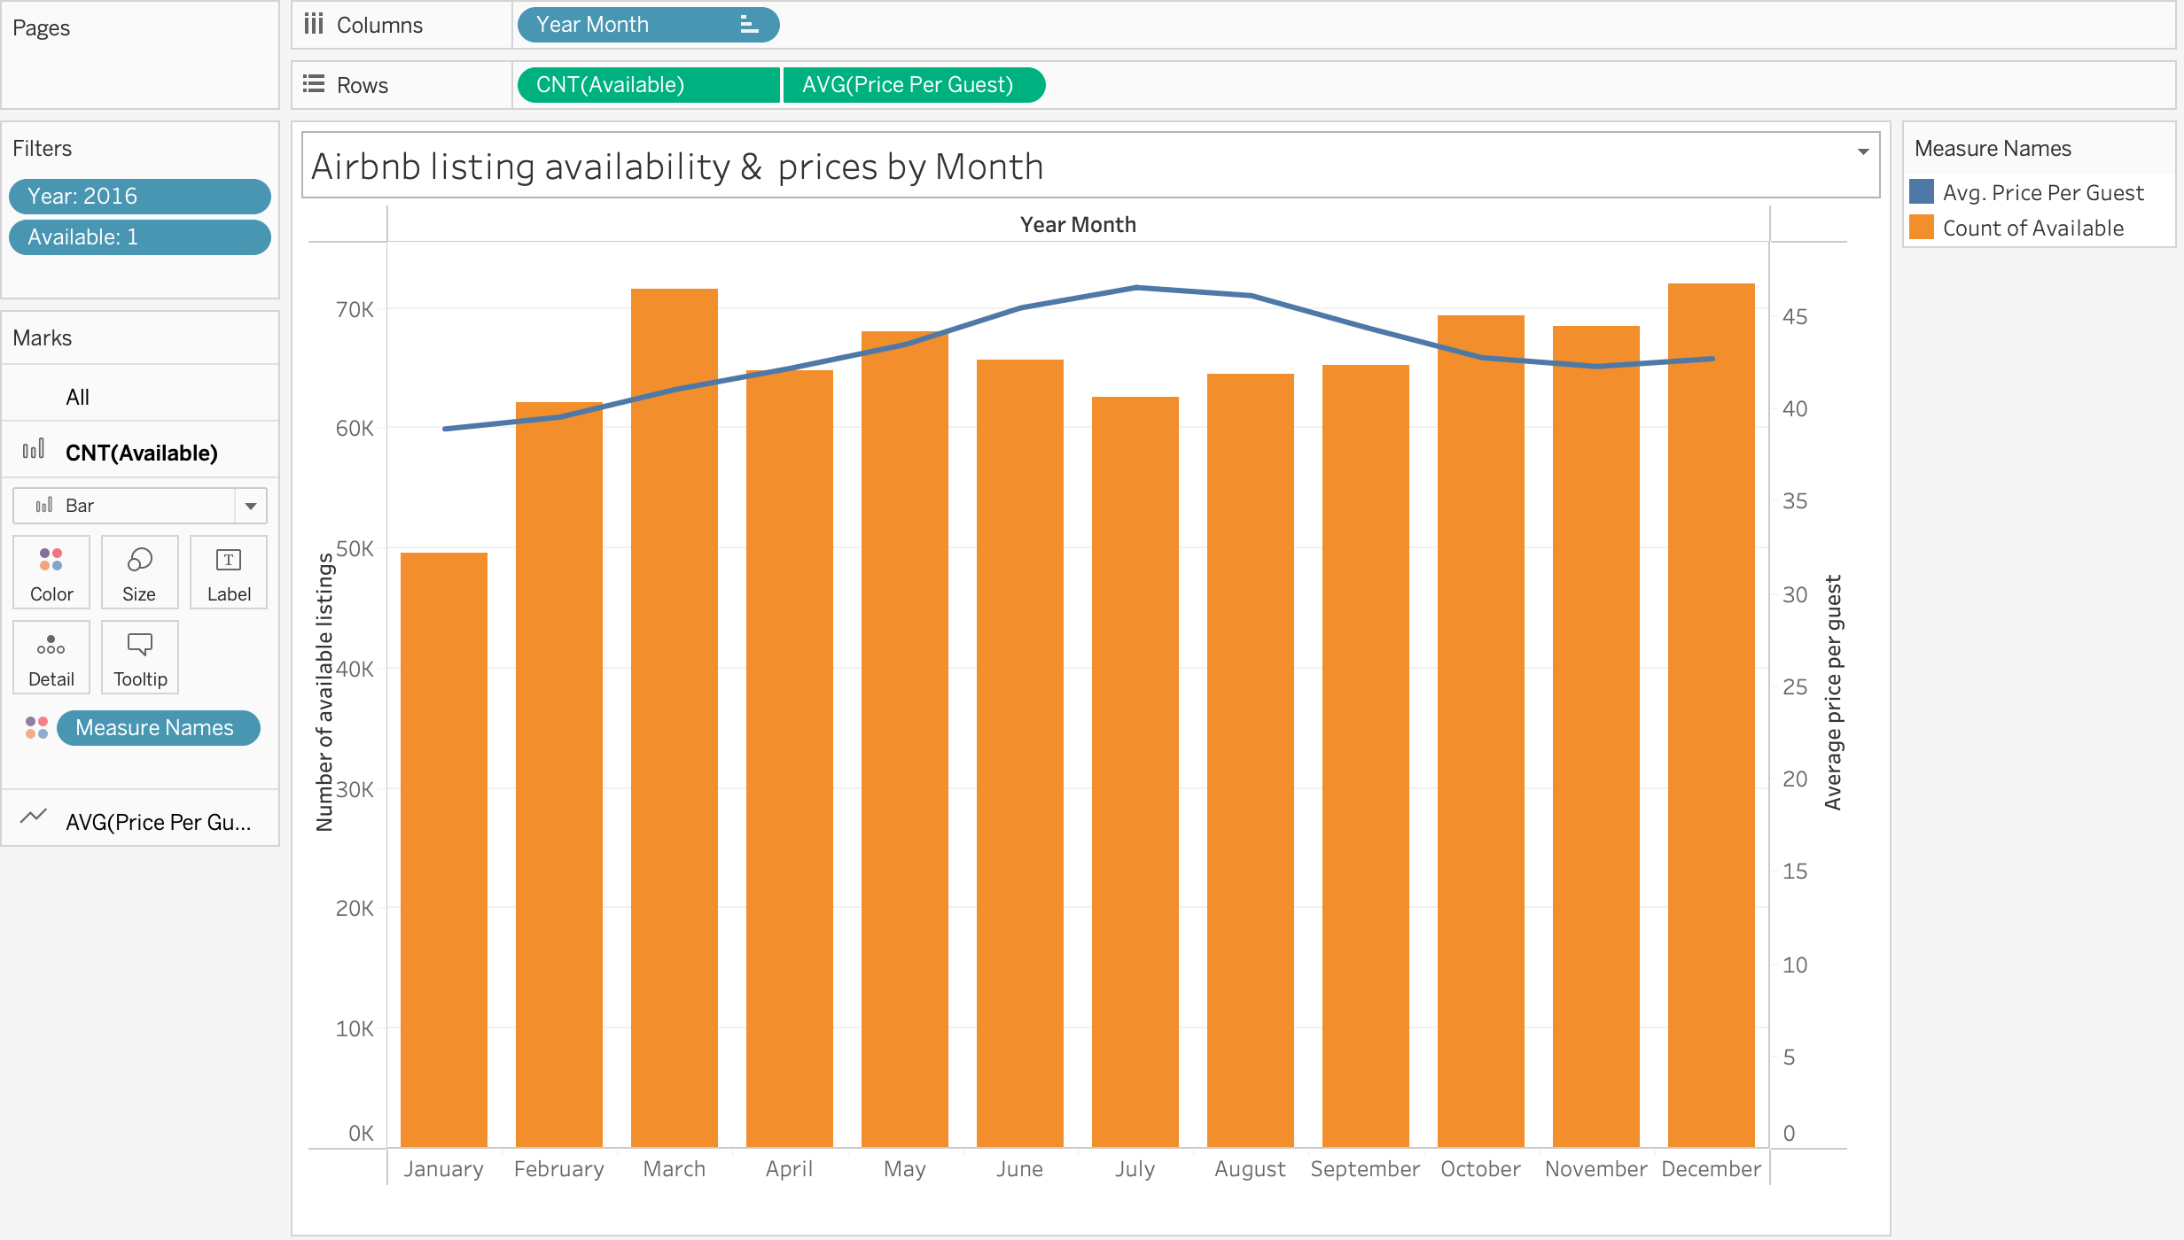

The next chart looks at the availability and prices by day of the week. Weekends are the busiest days, with the least availability and highest prices per guest.

**Q2) For different property types, what is the average price per guest in every quarter of 2016?**

The SQL query uses pivot command to show the average prices per guest by property type for every quarter of 2016. The prices have been rounded to decimal places and formatted with dollar signs.

**Q3) How did a hosts ‘super host’ tag affect their listings occupancy rate, prices and review scores in 2016?**

**Q4) How does crime rate vary by district and neighborhoods?**

Crime is visualized on the map. The first chart shows the crime by district.

The second chart drills down to show number of crimes in every neighborhood.

**Q5) How does crime rate influence the average annual revenue earned by listings in a neighborhood?**

Here, Average revenue of listings in a month is calculated as follows:

The chart shows the number of crimes on the Y axis, and the total annual revenue is represented by the size and colour of the circles. The chart demonstrates that a listings revenue is not affected by the number of crimes in the neighbourhood in which the listing is located as some of the listings located in neighbourhoods with high crime earn more than listings located in low crime neighbourhoods( eg. Central Business District vs Roxhill).

However, crime is correlated to the number of listings in a neighbourhood(X- axis). Crime is the highest in neighbourhoods with highest number of listings and lowest in neighbourhoods with the least number of listings.

