DOCUMENTATION FOR WORLD EXPLORER

World Explorer is a system to search for country, show list of matching countries, show details of a selected country and bookmark favorite country.

​The application fetches country details by using the API link **https://restcountries.eu/.**

World Explorer is a frontend web app where the user can register/login to the application, search for country, view details about selected country and add country to favorite list. Users should be able to view the favorite countries for user.

1. LOGIN PAGE:

It is the landing page of the application. If users are not registered, they can click on register button to navigate to register page.

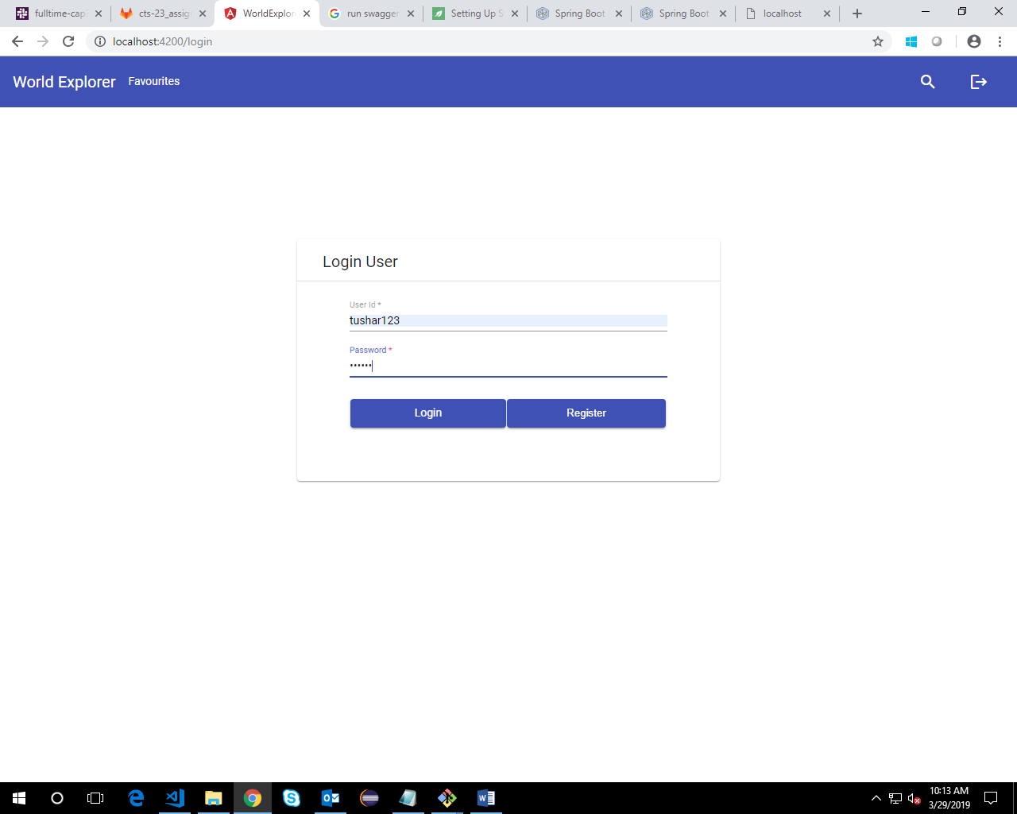

1. REGISTER PAGE:

Users need to provide first name, last name, user id and password to register themselves into the system.

After successful register, a user will be navigated to the login page.

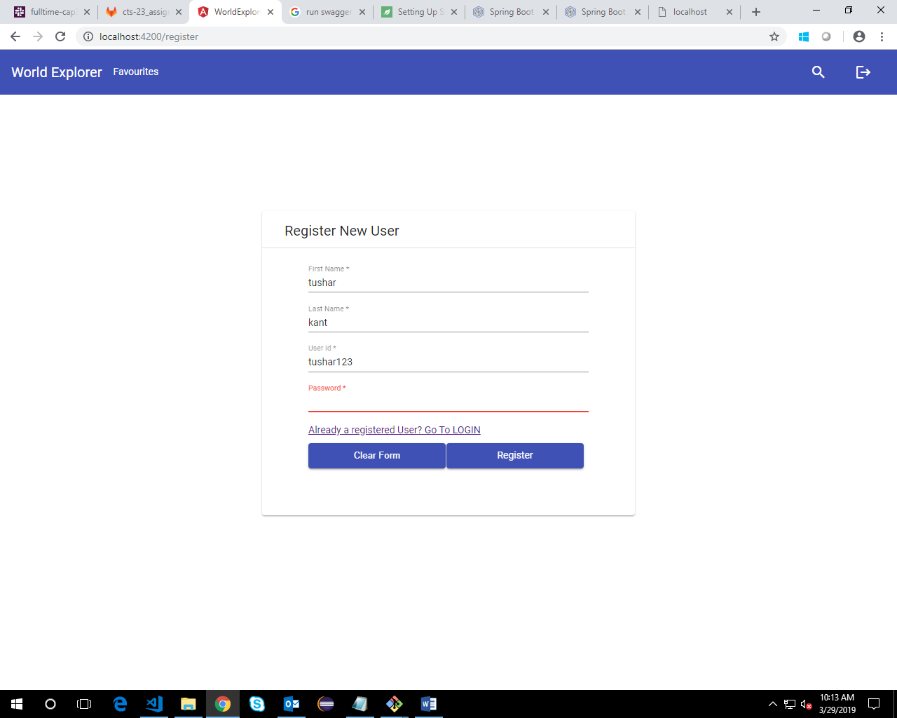

1. SEARCH PAGE:

The main dashboard of a user will have a search box. User needs to provide the search key and press enter on initiate the search.

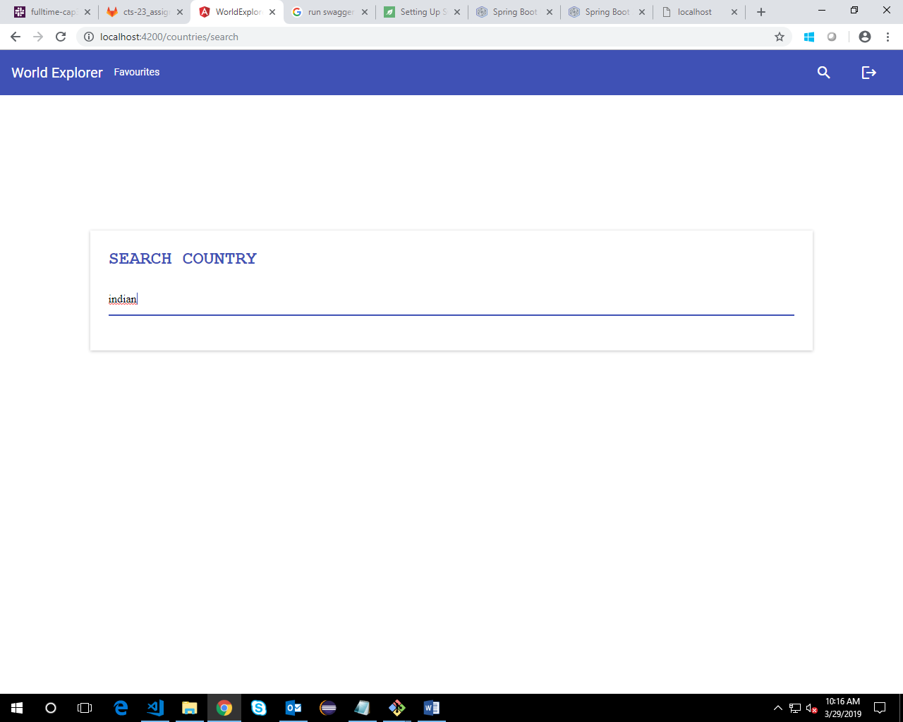

1. SEARCH RESULTS:

After pressing enter. The search results are displayed on the same page. The search box shifts to the top so that a user can search again if he wants. The results are displayed using a flex layout so as to maintain the responsiveness in different screen sizes.

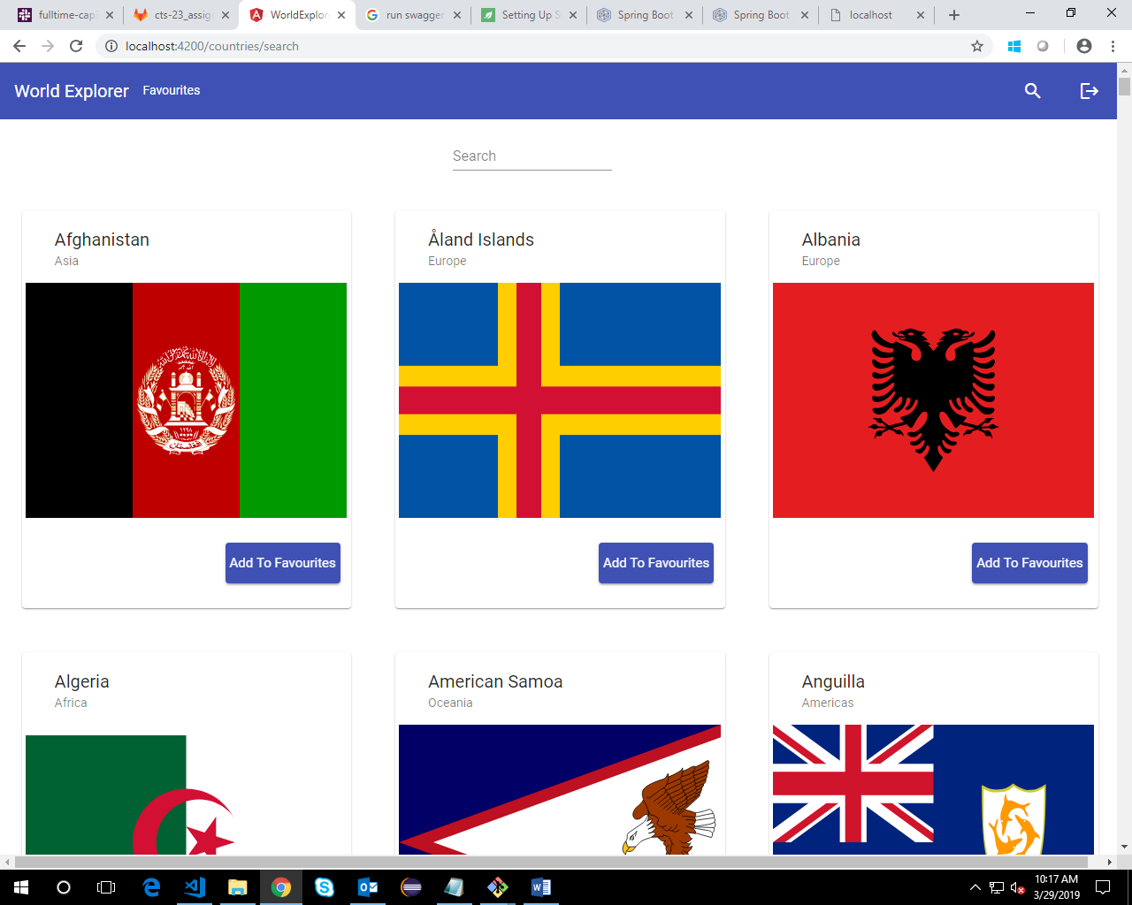

1. ADD TO FAVORITES:

A user can add any country to his favorite list of countries. After successfully adding the country to the favorites, a snack bar is displayed at the bottom of the page.

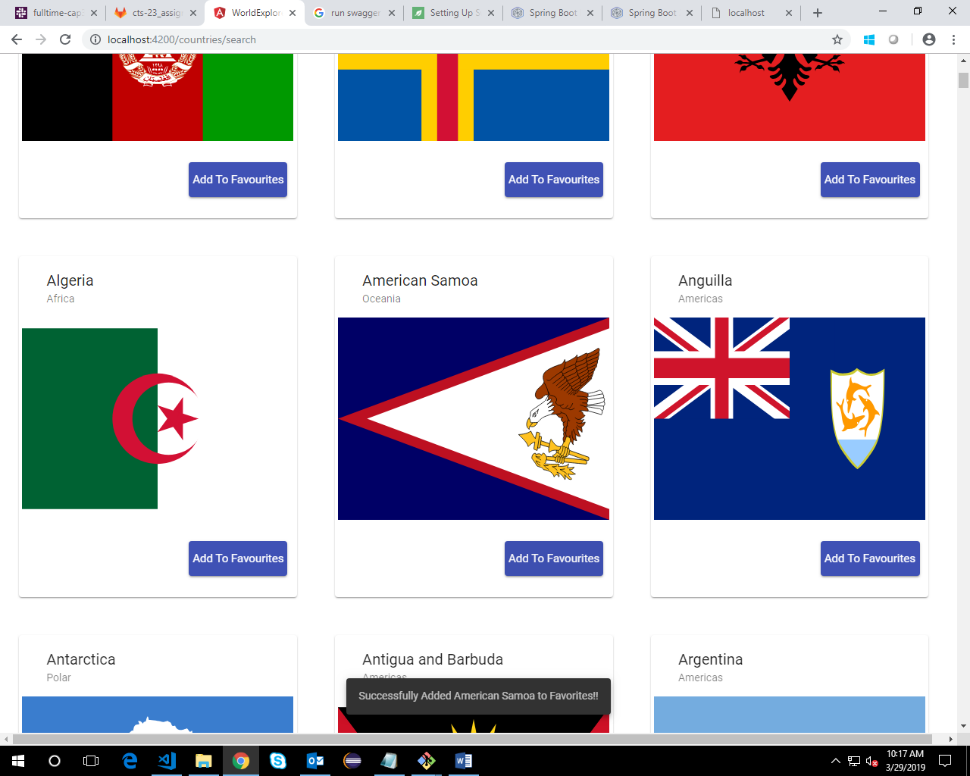

1. CHECK YOUR FAVORITE’S LIST:

By clicking on the favorites tab at the toolbar, a user can see his favorite list of countries. He can add comments to the country or remove a country from the list.

On removing a country from the list, the page doesn’t need to be refreshed.

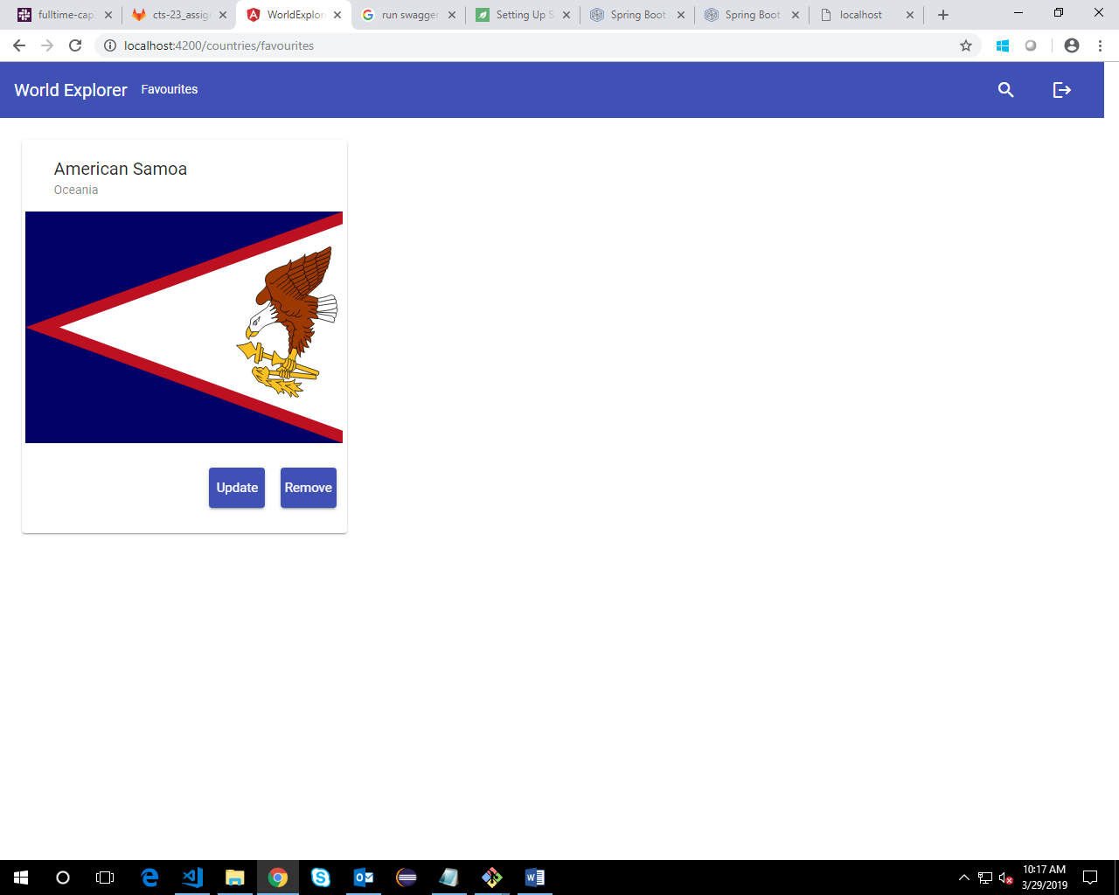

1. VIEW DETAILS OF A COUNTRY:

By clicking on the flag of the country, a user can see the details of the country in a dialog.

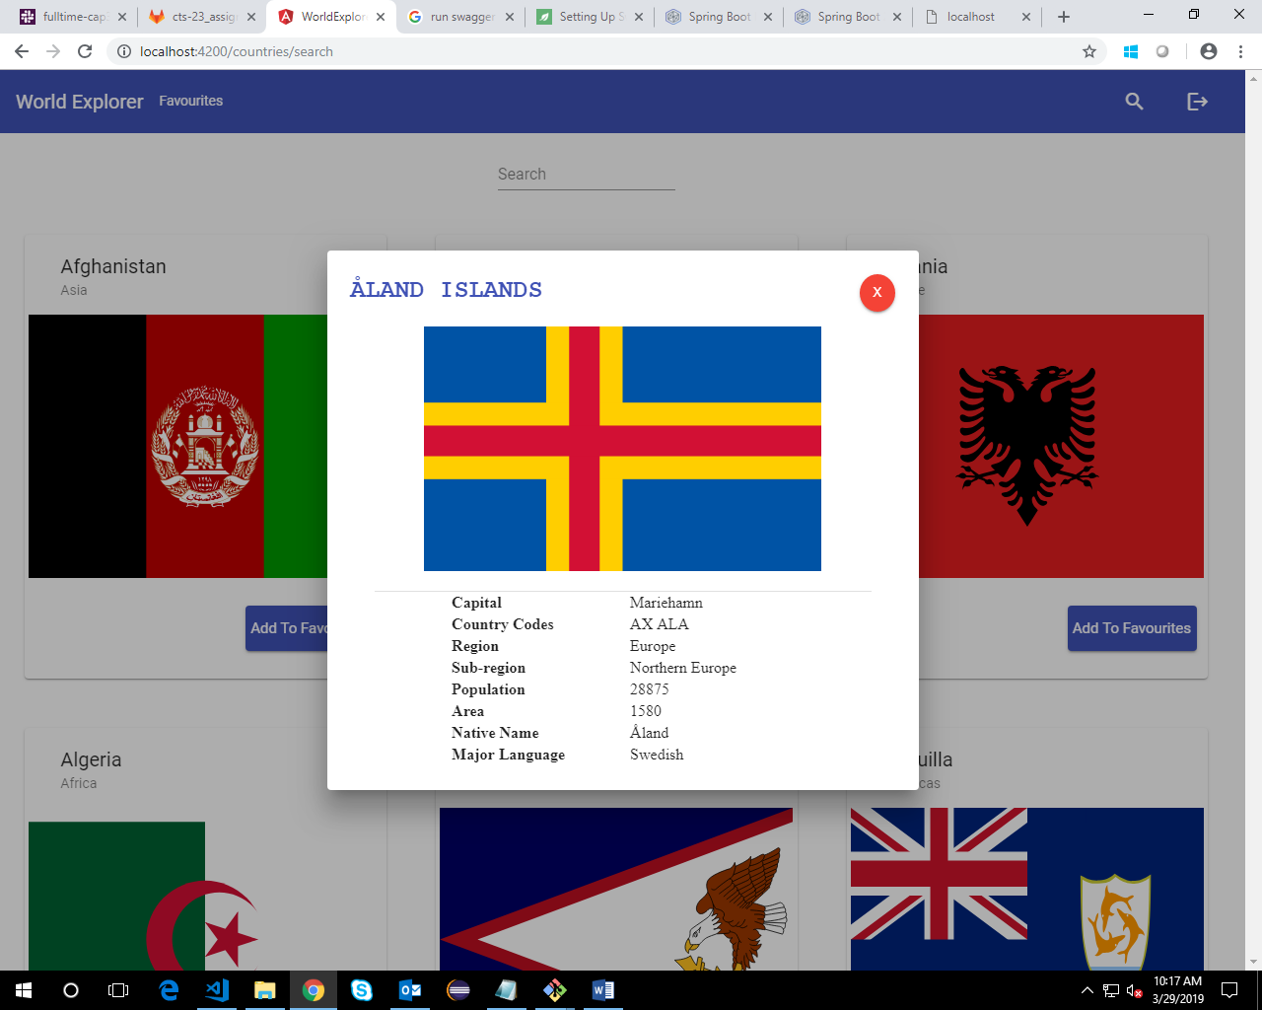

1. UPDATE A COUNTRY:

Inside his favorites list a user can click on update to update the comments. If the country already has an added comment by the same user, it will be pre fetched into the text area.

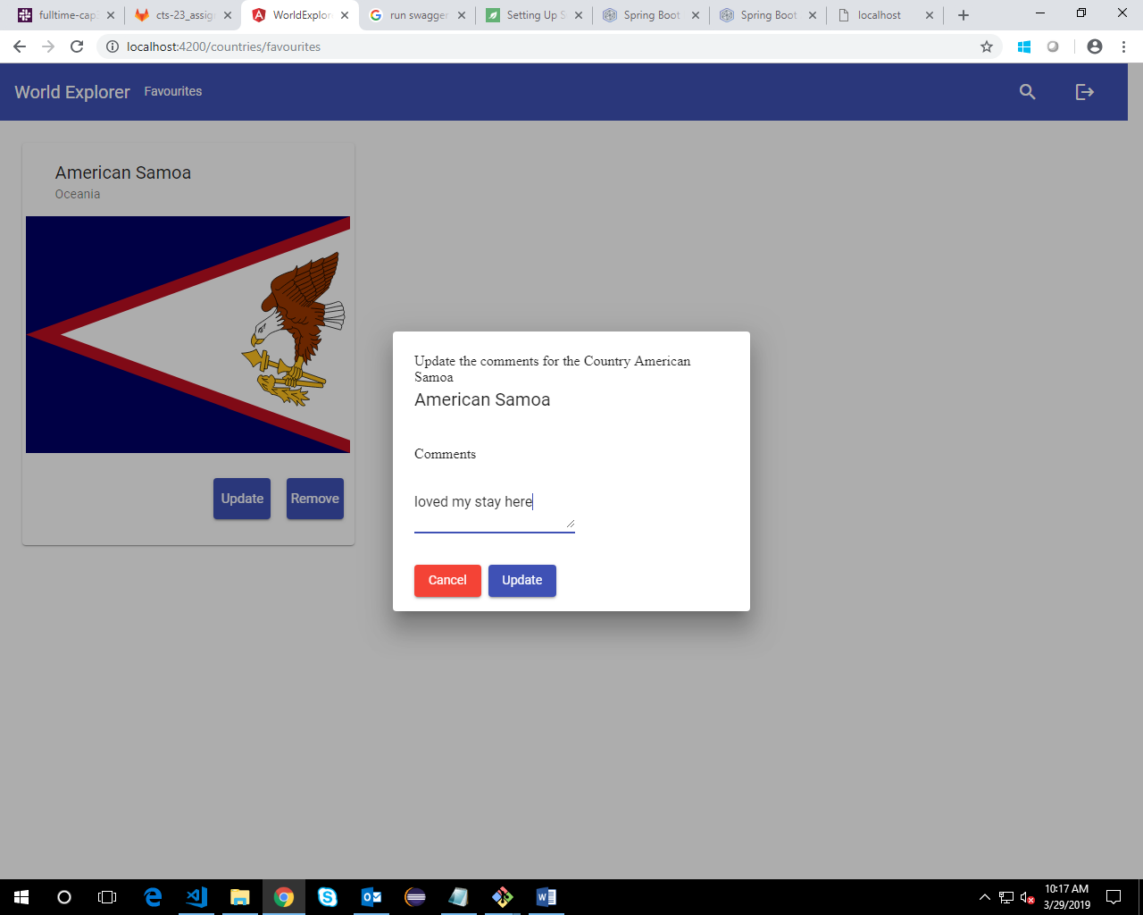

1. LOGOUT:

User can logout from the application anytime, by clicking on the logout icon at the top right corner of his tool bar.