**SMART SURVILLEANCE SYSTEM**

*A*

*Theme Based Project Report*

*Submitted in partial fulfilment of the*

*Requirements for the award of the Degree of*

**BACHELOR OF ENGINEERING**

IN

**INFORMATION TECHNOLOGY**

By

**SURYA TEJASWI 1602-20-737-117**

**RISHIKA 1602-20-737-097**

**VISHWAVARDHAN 1602-20-737-120**



**Department of Information Technology**

**Vasavi College of Engineering (Autonomous)**

**(Affiliated to Osmania University)**

**Ibrahimbagh, Hyderabad-31**

**Vasavi College of Engineering (Autonomous)**

**(Affiliated to Osmania University)**

**Hyderabad-500 031**

**Department of Information Technology**



**DECLARATION BY THE CANDIDATE**

We, **SURYA TEJASWI, RISHIKA,** and **VISHWAVARDHAN,** bearing hall ticket numbers, **1602-20-737-117, 1602-20-737-097, 1602-20-737-120**, hereby declare that the project report entitled **“Text summarizer “** is submitted in partial fulfilment of the requirement for the award of the degree of **Bachelor of Engineering** in **Information Technology**

This is a record of bonafide work carried out by us and the results embodied in this project report have not been submitted to any other university or institute for the award of any other degree or diploma.

**SURYA TEJASWI**

**1602-20-737-117**

**RISHIKA**

**1602-20-737-097**

**VISHWAVARDHAN**

**1602-20-737-120**

(Faculty In-Charge) (Head, Dept of IT)

**ACKNOWLEDGEMENT**

We extend our sincere thanks to Dr. S. V. Ramana, Principal, Vasavi College of Engineering for his encouragement.

We express our sincere gratitude to Dr. K. Ram Mohan Rao, Professor & Head, Department of Information Technology, Vasavi College of Engineering, for introducing the Mini-Project module in our curriculum, and also for his suggestions, motivation, and co-operation for the successful completion of our Mini Project.

We also want to thank and convey our gratitude towards our mini project coordinators Dharma Reddy sir for guiding us in understanding the process of project development & giving us timely suggestions at every phase.

We would also like to sincerely thank the project reviewers for their valuable inputs and suggestions.

PROBLEM STATEMENT

The abstractive based NLP react based application that we are going to develop helps facilitate our daily lives by summarising the painfully long sentences, articles, PDF files, newspapers, magazines, formal texts, academic papers or even their emails and a lot more in short, crisp and concise sentences for our users to understand. It helps almost everyone in summarising their work and making it easier for them to read instead of having them to read long paragraphs and texts. You can also summarise PDF files using this project, wherein, the text from the PDF is extracted and the desired page number can be summarized. We can also recognise texts from images using optimal character resolution, we can obtain text from an article with the URL using web scraping and also recognise voice and convert it into text and further summarise it.

**ABSTRACT**

The project basically involves summarising a block of text which is either directly provided by the user, extracted from a PDF, extracted from an image or recognised from voice. This makes it very easy for the readers who are in a hurry to read a long block of text. We use the concepts of natural language processing and NLTK library to summarise the text. We would develop an application using react native. Voice recognition and Image recognition can be done using deep learning algorithms such as Optimal character resolution etc. Users who want their emails, texts concise and to the point can also use the application to shorten their texts and the interface provided will also be very user friendly and aesthetic.

**INTRODUCTION**

In today's information-driven world, people are constantly inundated with information from various sources such as social media, news, books, and other written materials. While this influx of information has its benefits, it also poses a significant challenge: how to digest and comprehend all the information that is presented.

One solution to this problem is the development of an abstractive based NLP react-based application. This application utilises natural language processing (NLP) to summarise lengthy sentences, articles, and texts into shorter, more concise sentences. By summarising text in this manner, the application can provide a quick and efficient means of understanding the key points of a given text, making it easier for individuals to manage their daily tasks.

The proposed application is highly versatile and can be used to summarise a wide variety of texts. For instance, it can be used to summarise articles from newspapers, magazines, and academic papers. It can also be used to summarise emails, which can be especially useful for professionals who receive a high volume of messages each day. Additionally, the application can summarise PDF files, making it easier for individuals to review and understand the content contained within these files.

One of the most significant benefits of the proposed application is that it can recognise texts from images. This is accomplished through the use of optimal character resolution, which enables the application to extract text from images and summarise it accordingly. This feature can be especially useful for individuals who need to summarise information contained within images, such as charts or graphs.

Another valuable feature of the proposed application is web scraping. Web scraping is the process of automatically extracting information from websites. By utilising this feature, the application can extract text from articles with a URL, making it easier for users to summarise and comprehend the content contained within these articles.

The proposed application also incorporates voice recognition and conversion. This feature allows users to summarise spoken words and convert them into written text, which can then be summarised using the application's other features. This can be especially useful for individuals who prefer to consume information through spoken rather than written language.

Overall, the proposed abstractive based NLP react-based application has the potential to revolutionise the way individuals consume and comprehend information. By providing a quick and efficient means of summarising text, the application can help individuals manage their daily tasks more effectively and efficiently. Additionally, the application's versatile feature set enables it to be used to summarise a wide variety of texts, from articles and emails to PDF files and images. As such, the application has the potential to benefit individuals across a broad range of industries and professions.

**RELATED WORK**

IEEE paper referred –

"Automatic Image Captioning Using Deep Learning and Natural Language Processing" by N. Nandhini, S. Jemina Priyadharshini, and P. Tamizharasi. This work proposes an automatic image captioning system that combines deep learning techniques with natural language processing to generate captions for images.

Similar systems –

* Statistical-based summarisation system
* Extractive summarisation system
* Abstractive summarisation system
* Graph-based summarisation system
* Neural network-based summarisation system

Algorithm

* Step 1:  Install the Transformers Library
* Step 2:  Import Library
* Step 3: Setting GPU (Optional)
* Step 4: Setting the Model to Use, which is BART or t5 which are pre-trained CNN models
* Step 5: Input the Text to Summarize
* Step 6: Summarize using one of the above model

**PROPOSED WORK**

**(a)Use cases –**

* Gives a normal text as input
* Gives a PDF file as input
* Gives a URL as input
* Gives an image as input & Gives Speech as input

**(b)Use Case Diagram-**

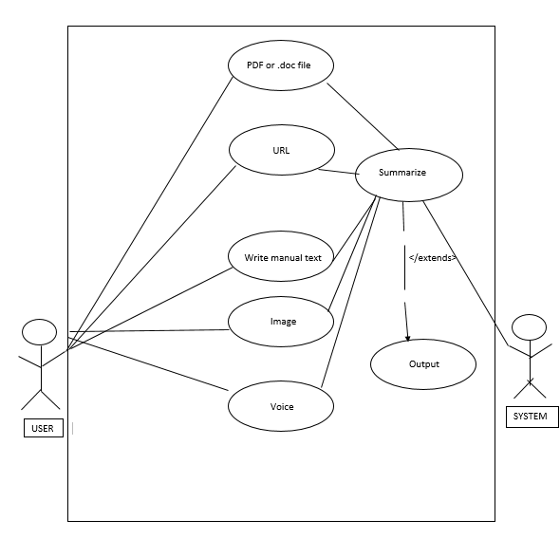

**(c) Code:-**

**app.py:-**

from flask import Flask, render_template, request

import string

import operator

import PyPDF2

from transformers import pipeline

import easyocr

import requests

from bs4 import BeautifulSoup

import speech_recognition as sr

c=0

summarizer = pipeline("summarization", model="t5-base", tokenizer="t5-base", framework="tf")

num_sent=100

#------------Flask Application---------------#

app = Flask(_name_)

@app.route('/speech', methods=['GET','POST'])

def original_speech_form():

text=""

if request.method=="POST":

print("FORM DATA RECEIVED")

# if file not in request.files:

# return redirect(request.url)

file=request.files["file"]

# if file.filename=="":

# return redirect(request.url)

if file:

recognizer=sr.Recognizer()

audiofile=sr.AudioFile(file)

with audiofile as source:

data=recognizer.record(source)

text=recognizer.recognize_google(data, key=None)

summary = summarizer(text, max_length=1000, min_length=0, do_sample=False)[0]['summary_text']

return render_template("speech.html", original_text = text, output_summary = summary)

@app.route('/url', methods=['GET','POST'])

def original_url_form():

global num_sent

title = "Url Summarizer"

if 'url-open' in request.form:

page=request.form['url-open']

r = requests.get(page)

soup = BeautifulSoup(r.content, 'html.parser')

s = soup.find('div', class_='entry-content')

lines = soup('p')

t=[]

for line in lines:

t.append(line.text)

x=''.join(t)

num_sent = int(request.form['num_sentences']) #Get number of sentence required in summary

summary = summarizer(x, max_length=num_sent, min_length=0, do_sample=False)[0]['summary_text']

if c==1:

summary=""

else:

x=""

summary=""

return render_template("url.html", title = title, original_text = x, output_summary = summary, num_sentences = num_sent)

@app.route('/image', methods=['GET','POST'])

def original_image_form():

global num_sent

title = "Image Summarizer"

if 'file-open' in request.form:

path=request.form['file-open']

reader=easyocr.Reader(['en'])

result=reader.readtext(path,paragraph=True)

text=''

for r in result:

text+=r[1]+''

num_sent = int(request.form['num_sentences']) #Get number of sentence required in summary

summary_text = summarizer(text, max_length=num_sent, min_length=0, do_sample=False)[0]['summary_text']

if c==1:

summary_text=""

else:

text=""

summary_text=""

return render_template("image.html", title = title, original_text = text, output_summary = summary_text, num_sentences = num_sent)

@app.route('/file', methods=['GET','POST'])

def original_file_form():

global num_sent

title = "File Summarizer"

if 'file-open' in request.form:

pdf=request.form['file-open']

pdfFileObj = open(pdf, 'rb')

pdfReader = PyPDF2.PdfFileReader(pdfFileObj)

pgno=int(request.form['page'])

pageObj = pdfReader.getPage(pgno-1)

text=pageObj.extractText()

num_sent = int(request.form['num_sentences']) #Get number of sentence required in summary

summary_text = summarizer(text, max_length=num_sent, min_length=0, do_sample=False)[0]['summary_text']

if c==1:

summary_text=""

else:

text=""

summary_text=""

return render_template("index1.html", title = title, original_text = text, output_summary = summary_text, num_sentences = num_sent)

@app.route('/text', methods=['GET','POST'])

def original_text_form():

global num_sent

title = "Text Summarizer"

if 'input_text' in request.form:

text = request.form['input_text'] #Get text from html

num_sent = int(request.form['num_sentences']) #Get number of sentence required in summary

summary_text = summarizer(text, max_length=num_sent, min_length=0, do_sample=False)[0]['summary_text']

print(summary_text)

if c==1:

summary_text=""

else:

text=""

summary_text=""

return render_template("index.html", title = title, original_text = text, output_summary = summary_text, num_sentences = num_sent)

@app.route('/')

def homepage():

title = "Text Summarizer"

return render_template("index.html", title = title)

if _name_ == "_main_":

app.debug = True

app.run()

**image.html:**

<!DOCTYPE html>

<head>

<title>

Image Summarizer

</title>

<link rel="stylesheet" href="https://maxcdn.bootstrapcdn.com/bootstrap/3.3.7/css/bootstrap.min.css">

<script src="https://ajax.googleapis.com/ajax/libs/jquery/3.2.1/jquery.min.js"></script>

<script src="https://maxcdn.bootstrapcdn.com/bootstrap/3.3.7/js/bootstrap.min.js"></script>

<link href="https://maxcdn.bootstrapcdn.com/font-awesome/4.4.0/css/font-awesome.min.css" rel="stylesheet"/>

<link rel="stylesheet" href="css/style.css" />

</head>

<style>

*{

margin: 0;

padding: 0;

}

a{

text-decoration:solid;

color: black;

}

html, header, body{

height: 100%;

width: 100%;

}

footer{

display: block;

}

div{

display: block;

}

nav ul li a{

text-decoration: none;

}

h1, h2, h3, h4, h5, h6{

font-family: Montserrat,"Helvetica Neue",Helvetica,Arial,sans-serif;

font-weight: 700;

}

p{

font-size: 50px;

}

ul{

display: block;

}

.container{

position: relative;

margin-left: auto;

margin-right: auto;

}

.footer{

padding: 12px 0 12px 0;

}

.gray-bg{

background-color: #f6f6f6;

}

.text-center{

text-align: center !important;

}

.footer .social li a{

border: 1px solid #222;

display: block;

font-size: 14px;

height: 30px;

line-height: 28px;

text-align: center;

width: 30px;

transform: rotate(45deg);

}

.transition{

color: gray;

background: 0 0 ;

transition: all .3s ease-in-out;

}

.footer .weblinks-inline{

list-style: none;

padding-left: 0;

}

.marg_bot{

margin-bottom: 30px !important;

}

.weblinks-inline li{

display: inline;

font-size: 200%;

margin: 1%;

padding: 1% 1% 1% 1%;

border-radius: 8px;

}

.copyright{

font-size: 15px;

}

</style>

<body>

<nav class="navbar navbar-inverse">

<div class="container-fluid">

<div class="navbar-header">

<button type="button" class="navbar-toggle" data-toggle="collapse" data-target="#myNavbar">

<span class="icon-bar"></span>

<span class="icon-bar"></span>

<span class="icon-bar"></span>

</button>

<a class="navbar-brand" href="#input">Summarizer</a>

</div>

<div class="collapse navbar-collapse" id="myNavbar">

<ul class="nav navbar-nav">

<li class="active"><a href="/text">Text</a></li>

<li class="active"><a href="/file">File</a></li>

<li class="active"><a href="/image">Image</a></li>

<li class="active"><a href="/url">url</a></li>

<li class="active"><a href="/speech">speech</a></li>

</ul>

<ul class="nav navbar-nav navbar-right">

</ul>

</div>

</div>

</nav>

<section class = "input container" id = "input">

<div class="intro jumbotron">

<h2>Image Summarizer</h2>

<p> You can summarize any text from an article, journal, story

and more by simply copying and pasting that text below. The algorithm for

the summarazier will display the output summary based on keywords extracted from the text.

</p>

</div>

<div class="form-container jumbotron" id="sum-section">

<form action = "/image" id="sumform" method = "POST">

<h2> Upload your Image: </h2>

<p>

<input name="file-open" type="text">

</p>

<p>Enter the summarized number of characters you like to be outputed: </p>

<p>

<input type="number" name = "num_sentences" pattern =

"[0-9]+" min = "1" max = "10000" required >

</p>

<p>

<input type="submit" class="btn btn-success btn-md" value="Submit">

</p>

<h2>Summarized Text: </h2>

<textbox name="output_text" id="output_text" maxlength="50000" style="width:600px;

height:250px">

<p>{{ output_summary }} </p>

</textbox>

<br>

<h2>Original Text:</h2>

<p>{{ original_text }}</p>

</form>

</div>

</section>

</body>

</html>

**index.html:-**

<!DOCTYPE html>

<head>

<title>

Text Summarizer

</title>

<link rel="stylesheet" href="https://maxcdn.bootstrapcdn.com/bootstrap/3.3.7/css/bootstrap.min.css">

<script src="https://ajax.googleapis.com/ajax/libs/jquery/3.2.1/jquery.min.js"></script>

<script src="https://maxcdn.bootstrapcdn.com/bootstrap/3.3.7/js/bootstrap.min.js"></script>

<link href="https://maxcdn.bootstrapcdn.com/font-awesome/4.4.0/css/font-awesome.min.css" rel="stylesheet"/>

<link rel="stylesheet" href="css/style.css" />

</head>

<style>

*{

margin: 0;

padding: 0;

}

a{

text-decoration:solid;

color: black;

}

a:hover{

color: black;

}

html, header, body{

height: 100%;

width: 100%;

}

footer{

display: block;

}

div{

display: block;

}

nav ul li a{

text-decoration: none;

}

h1, h2, h3, h4, h5, h6{

font-family: Montserrat,"Helvetica Neue",Helvetica,Arial,sans-serif;

font-weight: 700;

}

p{

font-size: 50px;

}

ul{

display: block;

}

.container{

position: relative;

margin-left: auto;

margin-right: auto;

}

.footer{

padding: 12px 0 12px 0;

}

.gray-bg{

background-color: #f6f6f6;

}

.text-center{

text-align: center !important;

}

.footer .social li a{

border: 1px solid #222;

display: block;

font-size: 14px;

height: 30px;

line-height: 28px;

text-align: center;

width: 30px;

transform: rotate(45deg);

}

.transition{

color: gray;

background: 0 0 ;

transition: all .3s ease-in-out;

}

.footer .weblinks-inline{

list-style: none;

padding-left: 0;

}

.marg_bot{

margin-bottom: 30px !important;

}

.weblinks-inline li{

display: inline;

font-size: 200%;

margin: 1%;

padding: 1% 1% 1% 1%;

border-radius: 8px;

}

.copyright{

font-size: 15px;

}

</style>

<body>

<nav class="navbar navbar-inverse">

<div class="container-fluid">

<div class="navbar-header">

<button type="button" class="navbar-toggle" data-toggle="collapse" data-target="#myNavbar">

<span class="icon-bar"></span>

<span class="icon-bar"></span>

<span class="icon-bar"></span>

</button>

<a class="navbar-brand" href="#input">Summarizer</a>

</div>

<div class="collapse navbar-collapse" id="myNavbar">

<ul class="nav navbar-nav">

<li class="active"><a href="/text">Text</a></li>

<li class="active"><a href="/file">File</a></li>

<li class="active"><a href="/image">Image</a></li>

<li class="active"><a href="/url">url</a></li>

<li class="active"><a href="/speech">speech</a></li>

</ul>

<ul class="nav navbar-nav navbar-right">

</ul>

</div>

</div>

</nav>

<section class = "input container" id = "input">

<div class="intro jumbotron">

<h2>Text Summarizer</h2>

<p> You can summarize any text from an article, journal, story

and more by simply copying and pasting that text below. The algorithm for

the summarazier will display the output summary based on keywords extracted from the text.

</p>

</div>

<div class="form-container jumbotron" id="sum-section">

<form action = "/text" id="sumform" method = "POST">

<p>Enter the text you wish to summarize:</p>

<textarea maxlength = "50000" name = "input_text" id = "input_text" style="width:600px;

height:250px" value = "{{request.form['input_text']}}" ></textarea>

<p>Enter the summarized number of characters you like to be outputted: </p>

<p>

<input type="number" name = "num_sentences" pattern =

"[0-9]+" min = "1" max = "10000" required >

</p>

<p>

<input type="submit" class="btn btn-success btn-md" value="Submit">

</p>

<h2>Summarized Text: </h2>

<textbox name="output_text" id="output_text" maxlength="50000" style="width:600px;

height:250px">

<p>{{ output_summary }} </p>

</textbox>

<br>

<h2>Original Text:</h2>

<p>{{ original_text }}</p>

</form>

</div>

</section>

</body>

</html>

**index1.html:-**

<!DOCTYPE html>

<head>

<title>

File Summarizer

</title>

<link rel="stylesheet" href="https://maxcdn.bootstrapcdn.com/bootstrap/3.3.7/css/bootstrap.min.css">

<script src="https://ajax.googleapis.com/ajax/libs/jquery/3.2.1/jquery.min.js"></script>

<script src="https://maxcdn.bootstrapcdn.com/bootstrap/3.3.7/js/bootstrap.min.js"></script>

<link href="https://maxcdn.bootstrapcdn.com/font-awesome/4.4.0/css/font-awesome.min.css" rel="stylesheet"/>

<link rel="stylesheet" href="css/style.css" />

</head>

<style>

*{

margin: 0;

padding: 0;

}

a{

text-decoration:solid;

color: black;

}

html, header, body{

height: 100%;

width: 100%;

}

footer{

display: block;

}

div{

display: block;

}

nav ul li a{

text-decoration: none;

}

h1, h2, h3, h4, h5, h6{

font-family: Montserrat,"Helvetica Neue",Helvetica,Arial,sans-serif;

font-weight: 700;

}

p{

font-size: 50px;

}

ul{

display: block;

}

.container{

position: relative;

margin-left: auto;

margin-right: auto;

}

.footer{

padding: 12px 0 12px 0;

}

.gray-bg{

background-color: #f6f6f6;

}

.text-center{

text-align: center !important;

}

.footer .social li a{

border: 1px solid #222;

display: block;

font-size: 14px;

height: 30px;

line-height: 28px;

text-align: center;

width: 30px;

transform: rotate(45deg);

}

.transition{

color: gray;

background: 0 0 ;

transition: all .3s ease-in-out;

}

.footer .weblinks-inline{

list-style: none;

padding-left: 0;

}

.marg_bot{

margin-bottom: 30px !important;

}

.weblinks-inline li{

display: inline;

font-size: 200%;

margin: 1%;

padding: 1% 1% 1% 1%;

border-radius: 8px;

}

.copyright{

font-size: 15px;

}

</style>

<body>

<nav class="navbar navbar-inverse">

<div class="container-fluid">

<div class="navbar-header">

<button type="button" class="navbar-toggle" data-toggle="collapse" data-target="#myNavbar">

<span class="icon-bar"></span>

<span class="icon-bar"></span>

<span class="icon-bar"></span>

</button>

<a class="navbar-brand" href="#input">Summarizer</a>

</div>

<div class="collapse navbar-collapse" id="myNavbar">

<ul class="nav navbar-nav">

<li class="active"><a href="/text">Text</a></li>

<li class="active"><a href="/file">File</a></li>

<li class="active"><a href="/image">Image</a></li>

<li class="active"><a href="/url">url</a></li>

<li class="active"><a href="/speech">speech</a></li>

</ul>

<ul class="nav navbar-nav navbar-right">

</ul>

</div>

</div>

</nav>

<section class = "input container" id = "input">

<div class="intro jumbotron">

<h2>File Summarizer</h2>

<p> You can summarize any text from an article, journal, story

and more by simply copying and pasting that text below. The algorithm for

the summarazier will display the output summary based on keywords extracted from the text.

</p>

</div>

<div class="form-container jumbotron" id="sum-section">

<form action = "/file" id="sumform" method = "POST">

<!-- <form action="/file" method = "POST">

<h2> Upload your file: </h2>

<p>

<input type="file" accept="image/jpeg,image/gif,image/png,application/pdf,image/x-eps" name="file-open">

</p>

<p>

<input type="submit">

</p>

</form> -->

<h2> Upload your file: </h2>

<p>

<input name="file-open" type="text">

</p>

<p>

Enter the page number of the file:

</p>

<p>

<input type="number" name = "page" pattern =

"[0-9]+" min = "0" max = "10000" required >

</p>

<p>Enter the summarized number of characters you like to be outputed: </p>

<p>

<input type="number" name = "num_sentences" pattern =

"[0-9]+" min = "1" max = "10000" required >

</p>

<p>

<input type="submit" class="btn btn-success btn-md" value="Submit">

</p>

<h2>Summarized Text: </h2>

<textbox name="output_text" id="output_text" maxlength="50000" style="width:600px;

height:250px">

<p>{{ output_summary }} </p>

</textbox>

<br>

<h2>Original Text:</h2>

<p>{{ original_text }}</p>

</form>

</div>

</section>

</body>

</html>

**speech.html:-**

<!DOCTYPE html>

<head>

<title>

Speech Summarizer

</title>

<link rel="stylesheet" href="https://maxcdn.bootstrapcdn.com/bootstrap/3.3.7/css/bootstrap.min.css">

<script src="https://ajax.googleapis.com/ajax/libs/jquery/3.2.1/jquery.min.js"></script>

<script src="https://maxcdn.bootstrapcdn.com/bootstrap/3.3.7/js/bootstrap.min.js"></script>

<link href="https://maxcdn.bootstrapcdn.com/font-awesome/4.4.0/css/font-awesome.min.css" rel="stylesheet"/>

<link rel="stylesheet" href="css/style.css" />

</head>

<style>

*{

margin: 0;

padding: 0;

}

a{

text-decoration:solid;

color: black;

}

html, header, body{

height: 100%;

width: 100%;

}

footer{

display: block;

}

div{

display: block;

}

nav ul li a{

text-decoration: none;

}

h1, h2, h3, h4, h5, h6{

font-family: Montserrat,"Helvetica Neue",Helvetica,Arial,sans-serif;

font-weight: 700;

}

p{

font-size: 50px;

}

ul{

display: block;

}

.container{

position: relative;

margin-left: auto;

margin-right: auto;

}

.footer{

padding: 12px 0 12px 0;

}

.gray-bg{

background-color: #f6f6f6;

}

.text-center{

text-align: center !important;

}

.footer .social li a{

border: 1px solid #222;

display: block;

font-size: 14px;

height: 30px;

line-height: 28px;

text-align: center;

width: 30px;

transform: rotate(45deg);

}

.transition{

color: gray;

background: 0 0 ;

transition: all .3s ease-in-out;

}

.footer .weblinks-inline{

list-style: none;

padding-left: 0;

}

.marg_bot{

margin-bottom: 30px !important;

}

.weblinks-inline li{

display: inline;

font-size: 200%;

margin: 1%;

padding: 1% 1% 1% 1%;

border-radius: 8px;

}

.copyright{

font-size: 15px;

}

</style>

<body>

<nav class="navbar navbar-inverse">

<div class="container-fluid">

<div class="navbar-header">

<button type="button" class="navbar-toggle" data-toggle="collapse" data-target="#myNavbar">

<span class="icon-bar"></span>

<span class="icon-bar"></span>

<span class="icon-bar"></span>

</button>

<a class="navbar-brand" href="#input">Summarizer</a>

</div>

<div class="collapse navbar-collapse" id="myNavbar">

<ul class="nav navbar-nav">

<li class="active"><a href="/text">Text</a></li>

<li class="active"><a href="/file">File</a></li>

<li class="active"><a href="/image">Image</a></li>

<li class="active"><a href="/url">url</a></li>

<li class="active"><a href="/speech">speech</a></li>

</ul>

<ul class="nav navbar-nav navbar-right">

</ul>

</div>

</div>

</nav>

<section class = "input container" id = "input">

<div class="intro jumbotron">

<h2>Speech Summarizer</h2>

<p> You can summarize any text from an article, journal, story

and more by simply copying and pasting that text below. The algorithm for

the summarazier will display the output summary based on keywords extracted from the text.

</p>

</div>

<div class="form-container jumbotron" id="sum-section">

<form method="post" enctype="multipart/form-data">

<h2> Upload your file: </h2>

<input type="file" name="file"/>

<br>

<input type="submit" id="submitButton" value="Transcribe"/>

<h2>Summarized Text: </h2>

<textbox name="output_text" id="output_text" maxlength="50000" style="width:600px;

height:250px">

<p>{{ output_summary }} </p>

</textbox>

<br>

<h2>Original Text:</h2>

<p>{{ original_text }}</p>

</form>

</div>

</section>

</body>

</html>

**url.html:-**

<!DOCTYPE html>

<head>

<title>

URL Summarizer

</title>

<link rel="stylesheet" href="https://maxcdn.bootstrapcdn.com/bootstrap/3.3.7/css/bootstrap.min.css">

<script src="https://ajax.googleapis.com/ajax/libs/jquery/3.2.1/jquery.min.js"></script>

<script src="https://maxcdn.bootstrapcdn.com/bootstrap/3.3.7/js/bootstrap.min.js"></script>

<link href="https://maxcdn.bootstrapcdn.com/font-awesome/4.4.0/css/font-awesome.min.css" rel="stylesheet"/>

<link rel="stylesheet" href="css/style.css" />

</head>

<style>

*{

margin: 0;

padding: 0;

}

a{

text-decoration:solid;

color: black;

}

html, header, body{

height: 100%;

width: 100%;

}

footer{

display: block;

}

div{

display: block;

}

nav ul li a{

text-decoration: none;

}

h1, h2, h3, h4, h5, h6{

font-family: Montserrat,"Helvetica Neue",Helvetica,Arial,sans-serif;

font-weight: 700;

}

p{

font-size: 50px;

}

ul{

display: block;

}

.container{

position: relative;

margin-left: auto;

margin-right: auto;

}

.footer{

padding: 12px 0 12px 0;

}

.gray-bg{

background-color: #f6f6f6;

}

.text-center{

text-align: center !important;

}

.footer .social li a{

border: 1px solid #222;

display: block;

font-size: 14px;

height: 30px;

line-height: 28px;

text-align: center;

width: 30px;

transform: rotate(45deg);

}

.transition{

color: gray;

background: 0 0 ;

transition: all .3s ease-in-out;

}

.footer .weblinks-inline{

list-style: none;

padding-left: 0;

}

.marg_bot{

margin-bottom: 30px !important;

}

.weblinks-inline li{

display: inline;

font-size: 200%;

margin: 1%;

padding: 1% 1% 1% 1%;

border-radius: 8px;

}

.copyright{

font-size: 15px;

}

</style>

<body>

<nav class="navbar navbar-inverse">

<div class="container-fluid">

<div class="navbar-header">

<button type="button" class="navbar-toggle" data-toggle="collapse" data-target="#myNavbar">

<span class="icon-bar"></span>

<span class="icon-bar"></span>

<span class="icon-bar"></span>

</button>

<a class="navbar-brand" href="#input">Summarizer</a>

</div>

<div class="collapse navbar-collapse" id="myNavbar">

<ul class="nav navbar-nav">

<li class="active"><a href="/text">Text</a></li>

<li class="active"><a href="/file">File</a></li>

<li class="active"><a href="/image">Image</a></li>

<li class="active"><a href="/url">url</a></li>

<li class="active"><a href="/speech">speech</a></li>

</ul>

<ul class="nav navbar-nav navbar-right">

</ul>

</div>

</div>

</nav>

<section class = "input container" id = "input">

<div class="intro jumbotron">

<h2>URL Summarizer</h2>

<p> You can summarize any text from an article, journal, story

and more by simply copying and pasting that text below. The algorithm for

the summarazier will display the output summary based on keywords extracted from the text.

</p>

</div>

<div class="form-container jumbotron" id="sum-section">

<form action = "/url" id="sumform" method = "POST">

<h2> Upload Url: </h2>

<p>

<input name="url-open" type="text">

</p>

<p>Enter the summarized number of characters you like to be outputed: </p>

<p>

<input type="number" name = "num_sentences" pattern =

"[0-9]+" min = "1" max = "100000" required >

</p>

<p>

<input type="submit" class="btn btn-success btn-md" value="Submit">

</p>

<h2>Summarized Text: </h2>

<textbox name="output_text" id="output_text" maxlength="50000" style="width:600px;

height:250px">

<p>{{ output_summary }} </p>

</textbox>

<br>

<h2>Original Text:</h2>

<p>{{ original_text }}</p>

</form>

</div>

</section>

</body>

</html>

**(d) UI prototypes & Outputs–**

* Gives a normal text as input
* Gives a PDF file as input
* Gives a URL as input
* Gives an image as input
* Gives Speech as input

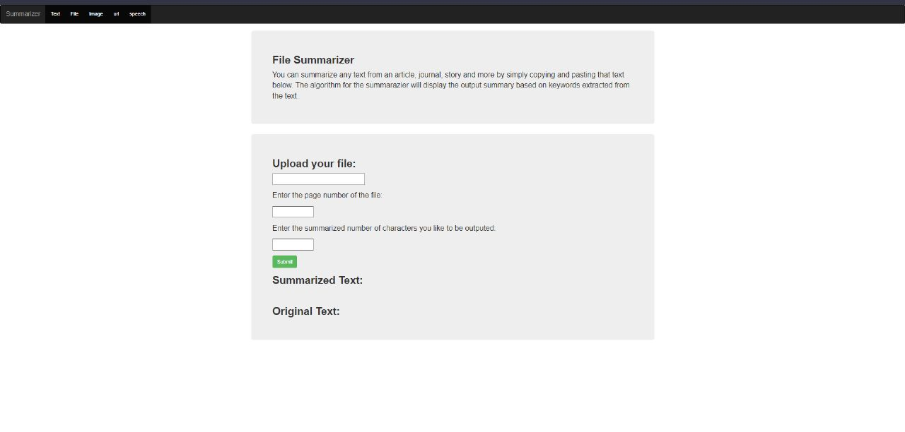

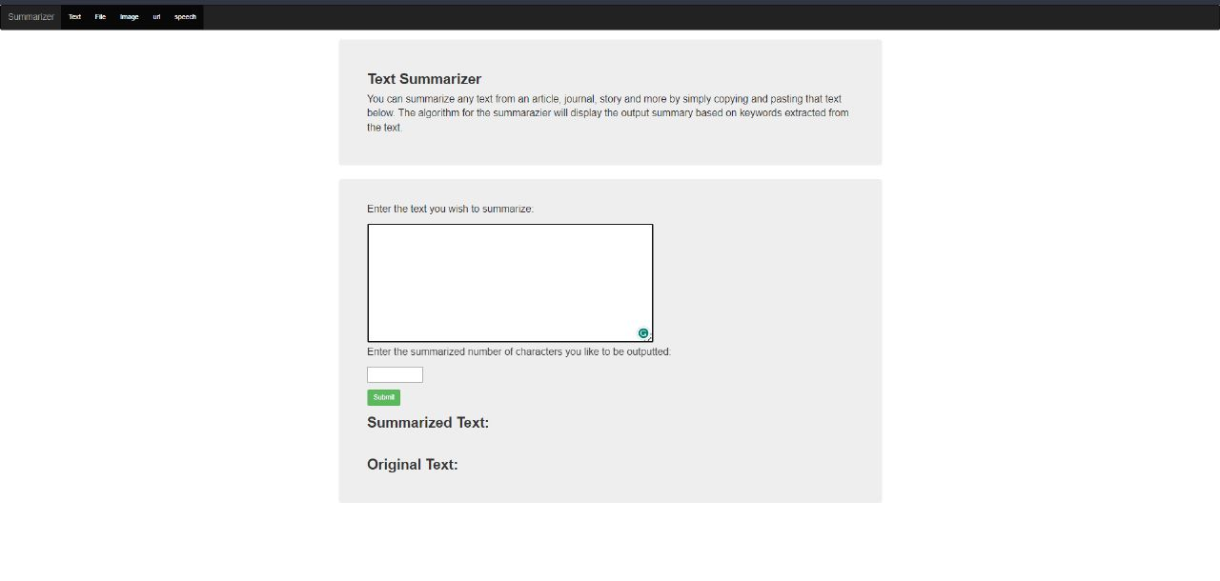

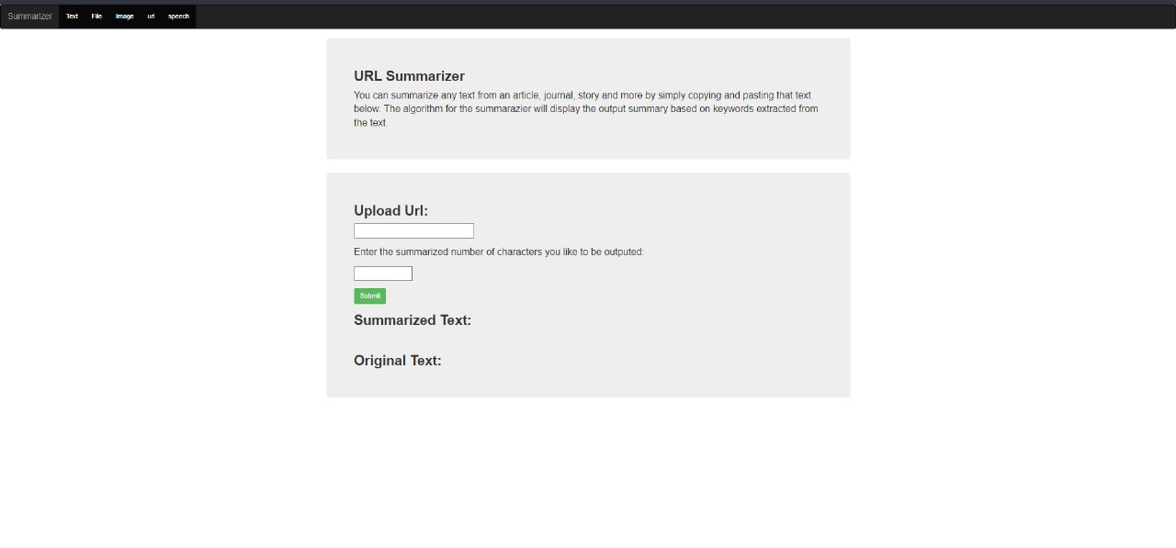

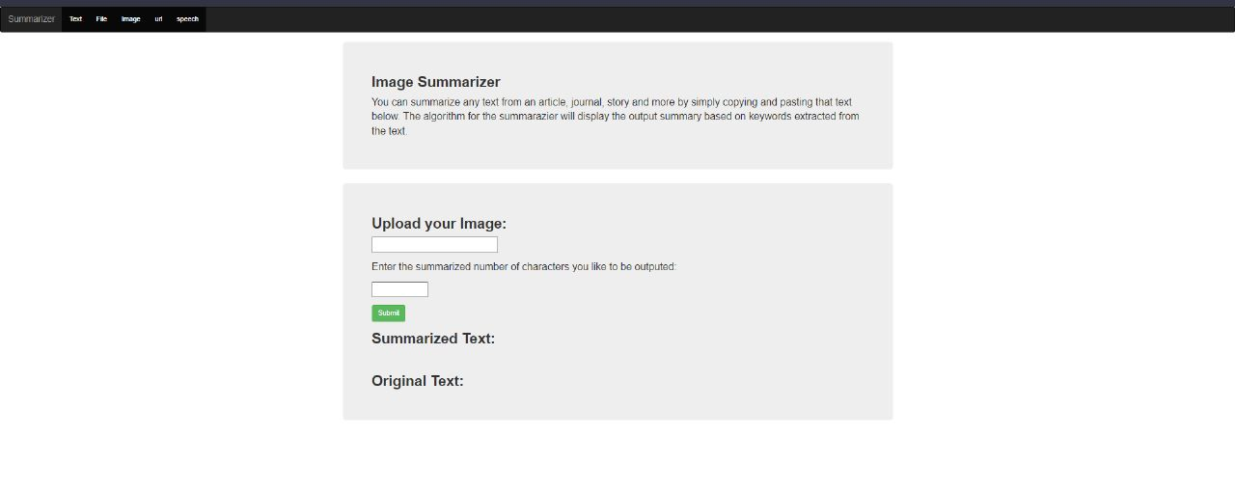

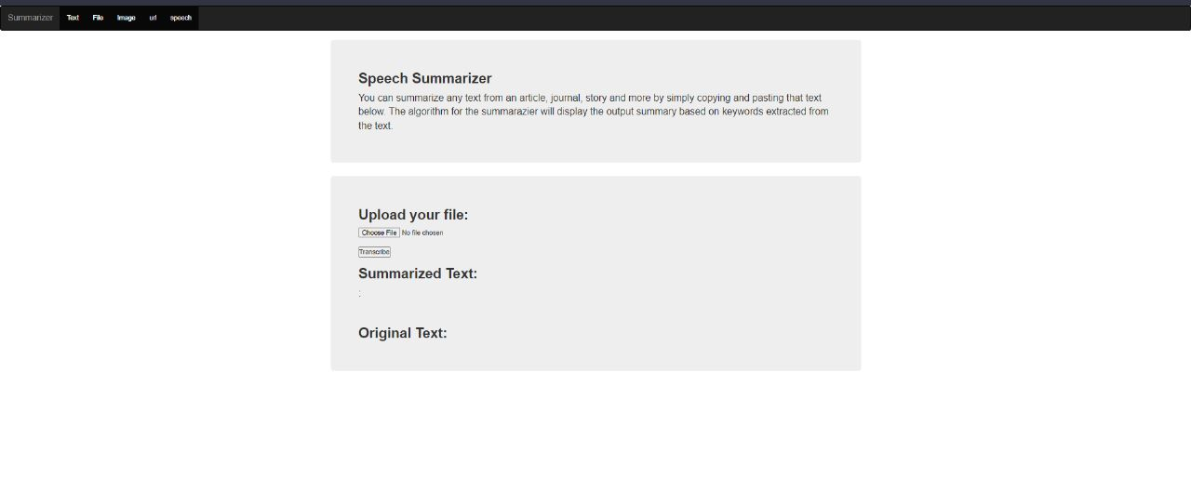

**(e) Architecture :-**

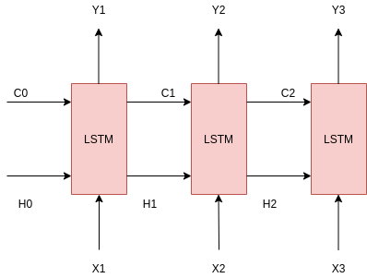

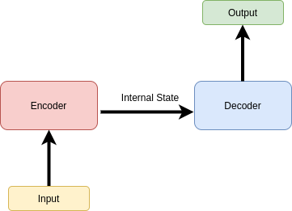

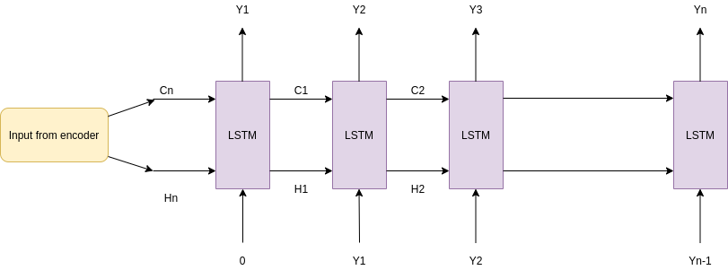

**(e)Implementation –**

GitHub links and folder structure.

<https://github.com/Skyurge/Text-summariser/tree/main/MiniProject>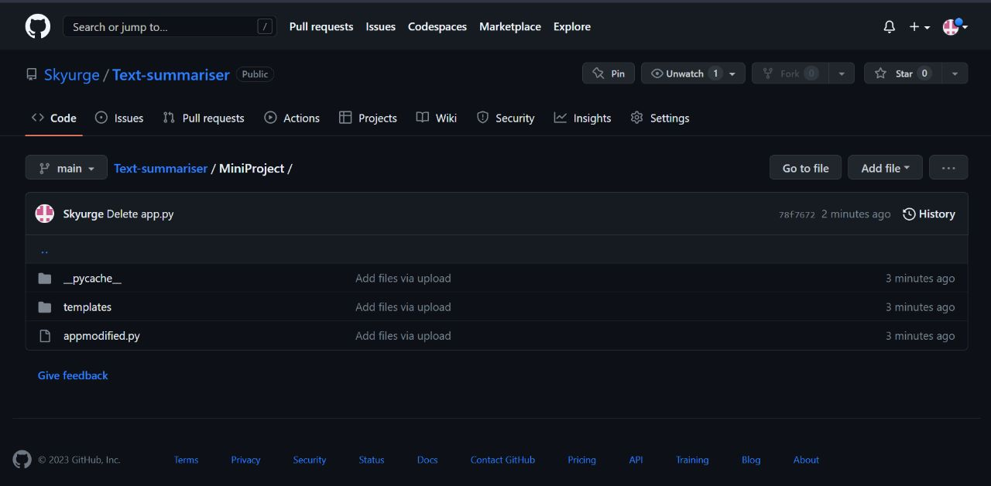

**DISCUSSION AND FUTURE WORK**

1. Multi-lingual summarisation: The current system is designed to work with English texts, but there is potential to extend it to other languages. Future work could involve training the system on multilingual datasets and developing models that can summarise texts in different languages.

2. Fine-tuning summarisation models: The summarisation models can be further fine-tuned to specific domains, such as medical or legal texts. This can improve the accuracy and relevance of the generated summaries.

3. Enhancing summarisation quality: The quality of the summarisation can be enhanced by incorporating more advanced natural language processing techniques such as sentiment analysis, entity recognition, and topic modeling.

4. Incorporating feedback: Future work could involve incorporating user feedback to improve the summarisation quality. This could be done by allowing users to rate the quality of the summaries or by incorporating user corrections to improve the accuracy of the system.

5. Improving text recognition accuracy: The accuracy of text recognition can be improved by using more advanced techniques such as optical character recognition (OCR) and deep learning models. This can help the system accurately identify text from images and other non-textual sources.

6. Integrating with third-party applications: The summarisation system can be integrated with third-party applications, such as email clients, news readers, or content management systems, to provide users with summarised content on-the-fly.

7. Enhancing summarisation output: The summarisation output can be enhanced by providing users with additional features such as summarised keywords, summaries in different formats, and audio summaries.

These are just a few possible future work for the summarisation project. As the field of natural language processing continues to advance, there will likely be many more opportunities for improving and expanding the capabilities of the system.