TRANSMITTAL COVERSHEET

Document Information
Project No | PF221546 | Plant Code | SASREF - 010 | Project Name |  |  | FUSION
Project Doc No | PF221546-010-CSI-PCS-SPEC-00001 |  |  |  |  |  | Rev | 02
Vendor Doc No | PF221546-010-PMP-001 |  |  |  |  |  | Rev | 02
Off Taker Doc No | NA |  |  | DATE |  | 29-Nov-2025 | Rev | -
Document Title | Functional Design Specification
Release Purpose | Issued for Information |  |  | Doc Type | Vendor Document
Vendor Name | CSI Computech India Pvt.Ltd |  |  | Discipline | Process
PO Number | XXXXXXX |  |  | Package Name

Review Status
STATUS |  | SIGN
 |  | DATE

Status Code Legend
A | APPROVED – No Further submittal required
B | APPROVED WITH COMMENTS - Incorporate the comments and resubmit with new revision
C | REVIEWED WITH COMMENTS - Incorporate the comments and resubmit with new revision
D | REVIEWED - No Further submittal required
E | REJECTED - Resubmit for Review
F | INFORMATION – Information only

Comments

Functional Design Specification

For
Project: Fusion
Project No: PF-22-1546
Vendor: CSI Computech India Pvt Ltd
Plant Code: SASREF - 010
Discipline: Process

REVISION HISTORY
Rev | Pages | Date | Description | Prepared | Checked | Approved
01 | 22 | 27-Oct- 25 | Initial Issue Functional Design Specification | CSI | xxxxxxx | xxxxxx
02 | 23 | 24-Nov-25 | Revised issue Functional Design Specification | CSI | xxxxxxx | xxxxxxx

TABLE OF CONTENTS
Executive Summary 4
1.1. Project Overview 4
1.2. Key Business Benefits 4
2. Project Scope & Objectives 5
2.1 Functional Scope 5
2.1.1. In Scope: 5
2.1.2. Out of Scope: 5
2.2. Business Objectives 5
3. System Architecture Overview 6
4. Process & Business Context 7
4.1. Hydrogen Production Process 7
4.1.1. Process Stages: 7
4.2. Contractual Framework (PAP Events) 8
5. Functional Modules Specification 9
5.1. Data Acquisition Module 9
5.1.1. Key Features: 9
5.2. PAP Event Detection Module 9
6. Application Design Overview 11
6.1. Purpose 11
6.2. The Application Will Be Organized into Five Major Menu Groups, Each Representing a Functional Area Within The DFTPC Solution: 11
6.3. Form & Screen Design 12
6.4. Reports Design 13
6.4.1. Daily Operations Report 13
6.4.2. Monthly KPI Report 14
6.4.3. PAP Event Summary Report 14
6.5. Dashboard Wireframe Overview 17
6.5.1. Dashboard Layout 17
6.6. Navigation Wireframe 18
6.7. Role-Based Access Matrix 19
7. User Access & Security 20
7.1. Role-Based Access Control 20
7.2. Security Implementation 21
7.2.1. Audit Logging: 21

Executive Summary

Project Overview
This Functional Design Specification (FDS) defines the complete requirements and solution architecture for the DFTPC (Data For Total Payment Calculations) system. The solution automates data collection, KPI calculations, PAP (Performance Adjustment Payment) event detection, and comprehensive reporting for the SASREF hydrogen production facility.

Key Business Benefits
Automated Compliance: Real-time PAP event detection and contractual reporting
Operational Excellence: Live KPI monitoring and performance optimization
Cost Reduction: 35% savings compared to traditional PI System implementations
Audit Transparency: Complete calculation traceability and event logging
Scalable Platform: Future-ready architecture for plant expansions

Project Scope & Objectives

Functional Scope

In Scope:
- Automated KPI calculations (as per provided Report Format)
- PAP event detection and penalty calculations (DSQm, FEPPm, PEPPm, ROGPPm, PACm)
- User access control and audit logging

Out of Scope:
- Modifications to existing DCS or IP.21 configuration
- Plant process optimization consulting
- Integration with ERP or financial systems

Business Objectives
Objective | Success Criteria | Measurement Method
Automated Reporting | 100% automated daily report generation | Report delivery log analysis
Real-time Monitoring | <5 minute data refresh cycles | Dashboard performance metrics
Calculation Accuracy | 99.9% accuracy vs manual calculations | UAT validation results
System Reliability | 99.5% uptime during production hours | System monitoring dashboards
User Adoption | 90% user satisfaction in UAT | User feedback surveys

System Architecture Overview
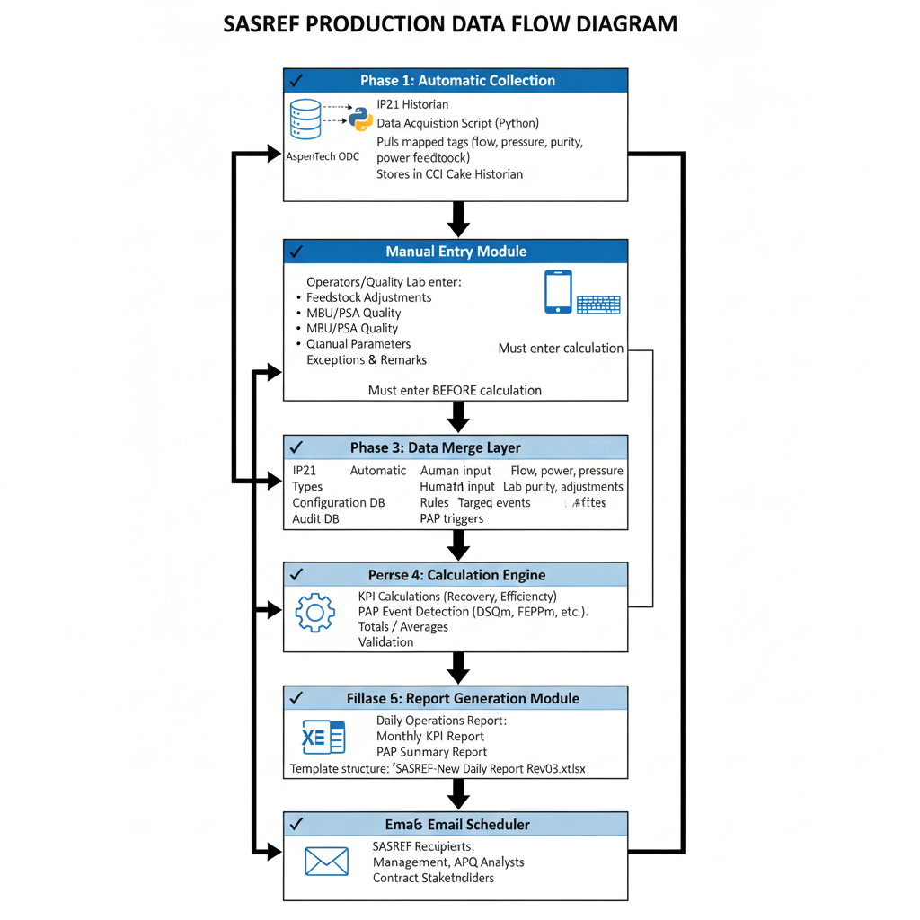
Note: System architecture diagram showing complete data flow is included in the visual appendix.

Process & Business Context

Hydrogen Production Process
The SASREF facility produces high-purity hydrogen through Steam Methane Reforming (SMR) technology:

Process Stages:
- SMR Unit: Natural gas + steam → H₂ + CO (at 700-1000°C)
- Water-Gas Shift: CO + steam → additional H₂ + CO₂
- Methanation: Trace CO/CO₂ → CH₄ (easier separation)
- PSA Purification: Molecular sieves achieve 99.9% H₂ purity
- MBU Recovery: Membrane separation recovers H₂ from waste streams
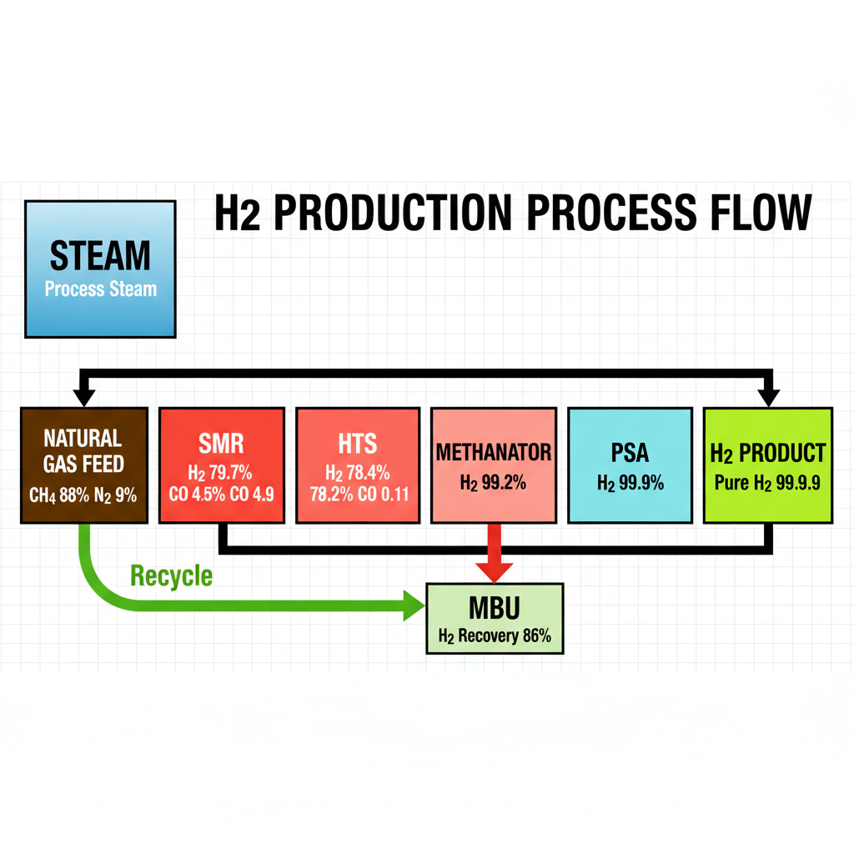

Contractual Framework (PAP Events)
Performance Adjustment Payments (PAP) are contractual mechanisms that impose financial penalties for operational underperformance:
- DSQm: Monthly deductions for H₂ shortfall quantity
- FEPPm: Feedstock efficiency performance penalties
- PEPPm: Power efficiency performance penalties
- ROGPPm: Refinery off-gas recovery efficiency penalties
- PACm: Power adjustment deductions

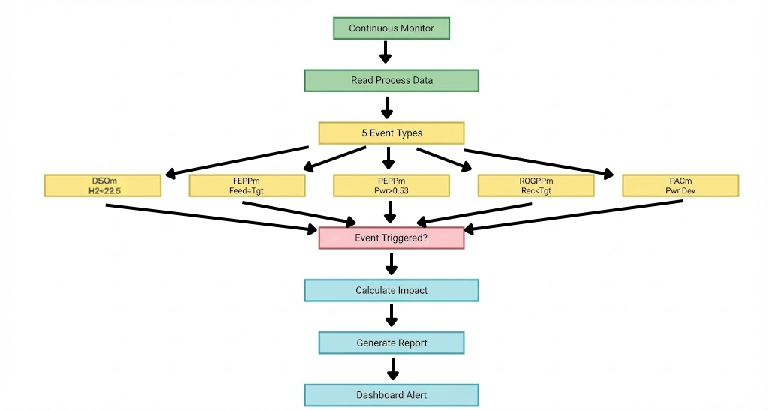

Functional Modules Specification

Data Acquisition Module
Purpose: Extract real-time and historical data from IP.21 historian

Key Features:
Tag-based Data Collection: Automated querying of mapped IP.21 tags
Historical Backfill: Recovery of missed data during downtime
Data Quality Validation: Bad data detection and filtering
Time Synchronization: Timestamp alignment across data sources
Python Implementation: ip21_collector.py script uses python library for IP2 connectivity, implements tag mapping from configuration file, writes data to CCI Cake using Historian API, and includes comprehensive error handling and logging.

PAP Event Detection Module

Purpose: Monitor contractual performance thresholds and detect penalty events
DSQm Event Detection:
• Trigger: H₂ pressure <22.5 barg AND Available H₂ < Required H₂
• Duration: >15 consecutive minutes
• 1-minute intervals with 15-minute moving average
FEPPm Event Detection:
• Trigger: Actual feedstock > Target × (1 + 2.5%)
• Evaluation: Monthly aggregated consumption
• Penalty based on excess above allowable band
PEPPm Event Detection:
• Trigger: Actual power > Target × (1 + 5%)
• Target: 0.53 MWh/MT Net H₂ Output
• Allowable Deviation: 5% band above target

Application Design Overview

Purpose
This section defines the user interface design, menu hierarchy, forms, reports, and dashboards that will be developed in the CCI Cake platform for the Fusion – DFTPC (Data For Total Payment Calculations) system.
It illustrates how end-users will interact with the system through structured menus, data entry forms, and visual dashboards

overview:
The Application Will Be Organized into Five Major Menu Groups, Each Representing a Functional Area Within the DFTPC Solution:

Main Menu | Submenus | Purpose / Description
Dashboard | - Real-Time KPIs & Efficiency Trends | Displays live process metrics, PAP events, and performance visualizations from the IP.21 historian.
Manual Entry | -Manual Forms  - Quality Data Upload | Allows authorized users to enter manual/analysis data through graphics-based forms in CCI Cake.
Reports | - Daily Operations Report  - Finance Monthly Report  - PAP Event Summary  - Analysis Report  - Shortfall Report | Provides preformatted operational and performance reports with export and auto-email capabilities.
Administration | - User & Role Management  - Menu Access Control  - Settings & Maintenance | Handles user authorization, role-based menu access, and overall system configuration.

Form & Screen Design
Each form or screen has been designed to provide intuitive, role-based interaction while ensuring operational integrity and data validation.
Form/Screen Name | Purpose | Key Fields / Controls | User Roles
Manual Entry (Lab Analysis) | Record manually measured quality data | Date, Parameter, Measured Value | Operator
Report Viewer | Display generated reports (as per given format) | Date Selectable, Report Type, Export (Excel/PDF), Email Option | All Roles
KPIs & Trends | View user and system metrics | Date Selectable, Measured Value | All Roles
User & Role Management | Configure user accounts and privileges | Username, Role Assignment, Status | Engineer

Reports Design

Daily Report
Header:
- Title: Daily Report
- Month and Year selection (dropdown) with “SHOW” button
- Export options: Excel, PDF
Body Sections:
- Parameter Overview:
Displays daily operational and production parameters for the selected month. Each parameter shows daily values and a monthly total.
- Daily Records:
  - Data displayed for each day of the selected month (1st to 31st).
  - Each row shows the daily trend for the corresponding tag name and unit.
  - Monthly total or average is displayed in the last column.
- Tags and Units:
  - Each parameter is linked to a corresponding tag name (e.g., 60FG00105, avg_HHV_Q927191Q).
  - Units are standardized (e.g., %, Hrs, T/Day, MW, MMBTU/Day).
Footer:
- Prepared by / Verified by / Approved by
- Remarks section for noting operational highlights or deviations
Purpose:
Provides a day-wise summary of plant performance, energy use, and gas production. Supports daily monitoring, trend tracking, and monthly performance verification.

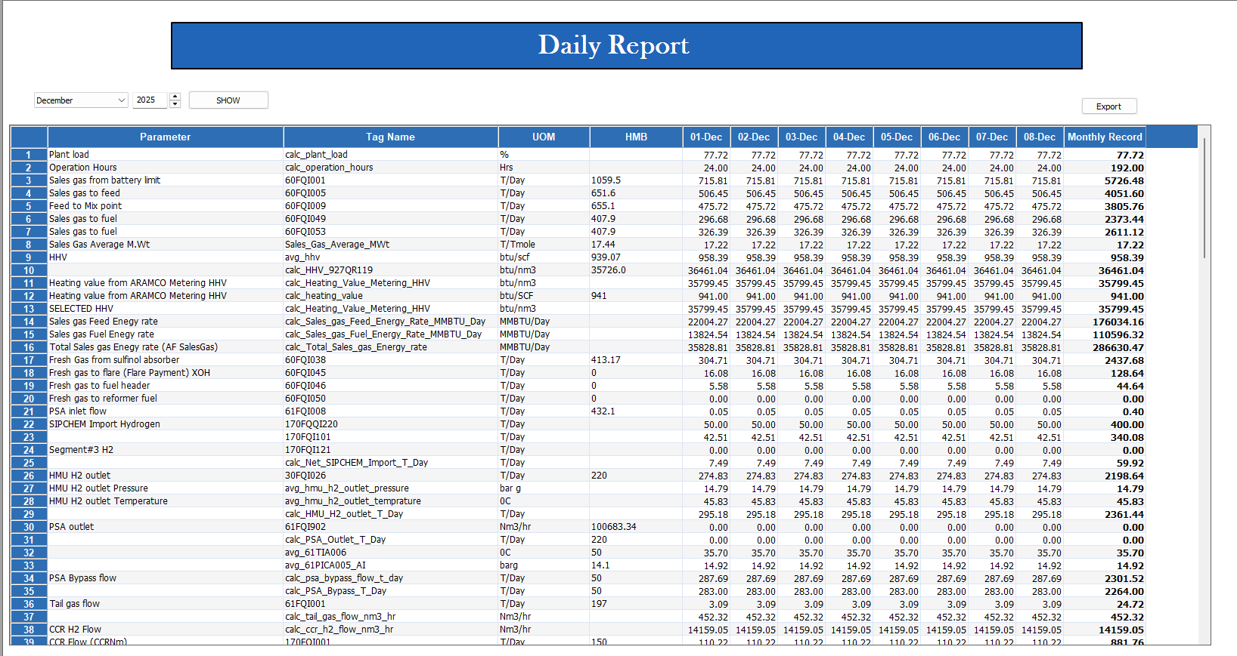

Analysis Report
Header:
- Title: LAB ANALYSIS DATA
- Date selection option with “View Report” button
- Export options: Excel, PDF
Body Sections:
- Component Analysis:
Shows gas composition and other lab parameters for different process points as provided in Report format
- Parameters Covered:
  - Gaseous Components: H₂, N₂, CO, CO₂, CH₄, C₁–C₅, iC₄, nC₄
  - Chemical & Physical Data: Moisture, CO₂ Concentration, RFB, TSS, Water, Oxazolidinone, ATB, ATB-RFB
- Detailed Entry Window:
  - Opens when a section (e.g., Sales Gas Analysis) is selected
  - Shows daily values for each component
  - Supports data view and update with Save / Cancel options, including modification of past dated records as requested
- Report View:
  - Displays all component data for a selected date
  - Allows export to Excel or PDF
Footer:
- Prepared by / Verified by / Approved by
- Optional remarks section
Purpose:
Summarizes lab results for key gas streams and process parameters. Helps track purity, composition, and process efficiency across different units.
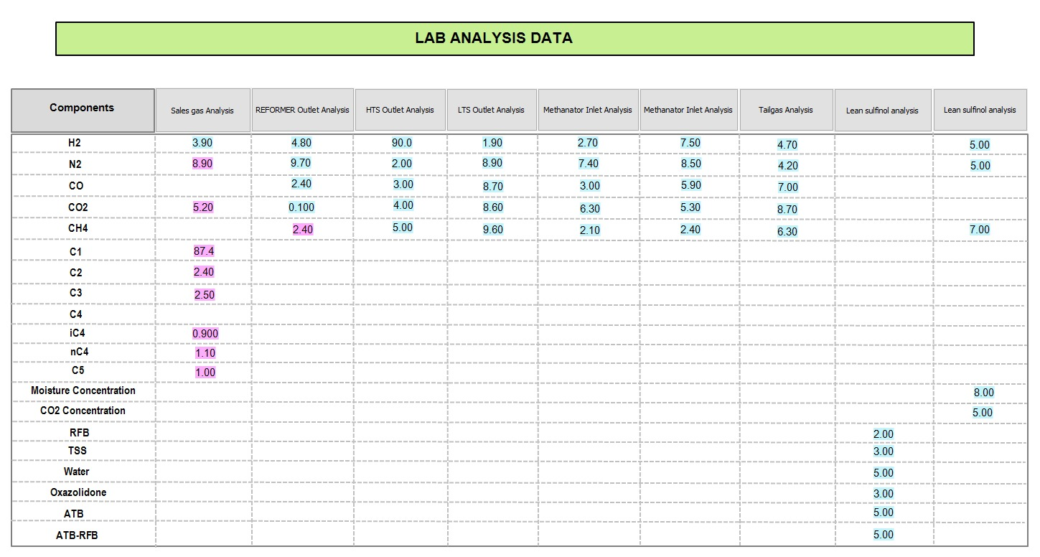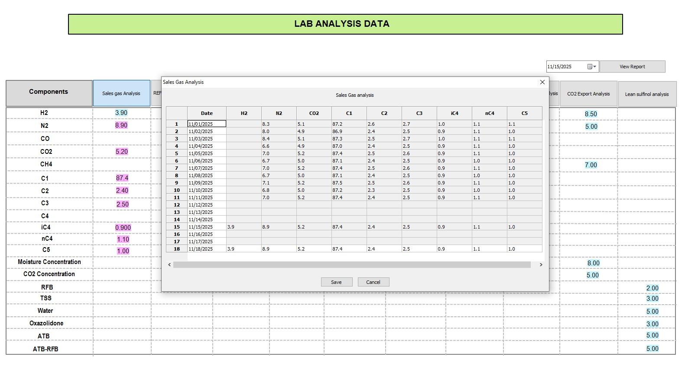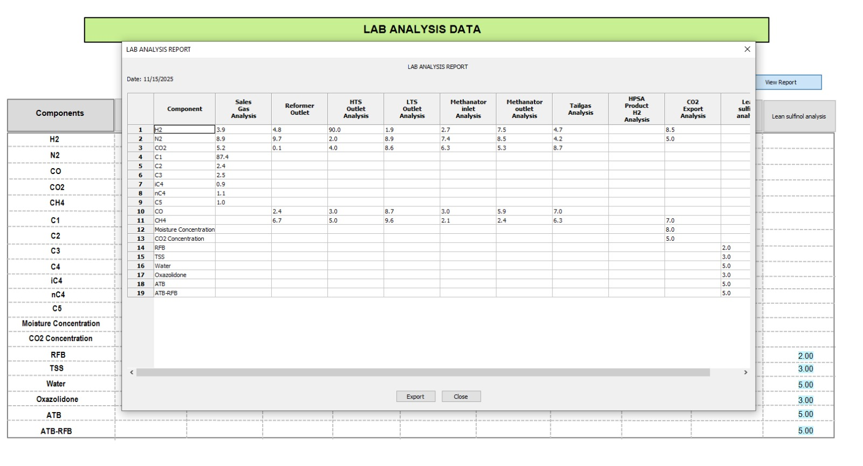

Monthly Finance Report
Header:
- Report Title: BHIG/SASREF FINANCE REPORT
- Month & Year (Selectable via dropdown)
- Export Options: Excel / PDF
- Display Controls: Month and Year selection with “SHOW” button
Body Sections:
- Summary of Operational Metrics:
  - Plant Load (%)
  - Total Operation Hours (Hrs)
  - Average Sales Gas Molecular Weight (T/Tmole)
  - Selected HHV (btu/nm³)
  - Total Sales Gas Energy Rate (MMBTU/Day)
- Process & Production Parameters:
  - CCR, GRH, MBUR, and MBU Gas Flows (T/Day)
  - Pure H₂ Product and Recovery (T/Day)
  - Fuel Gas Consumption and HP Steam Export (T/Day)
  - Total BFW Flow and Power Generation (MW)
- Energy & Utility Consumption:
  - Natural Gas (NG) Consumption (MMBTU)
  - RFG Consumption (MMBTU)
  - Total Power Consumption (MW)
- Special Conditions and Events:
  - Force Majeure Status (Yes/No)
  - Startup/Shutdown Hours without Production
Footer:
- Prepared by / Verified by / Approved by
- Notes or remarks section (if applicable)
Export & Distribution:
- Export options: Excel / PDF
- Automated storage on file server
- Auto-email distribution to configured stakeholders (Finance, Production, and Management teams)
Purpose:
Provides a consolidated monthly summary of plant performance, energy utilization, production efficiency, and key operational parameters for financial and management analysis.
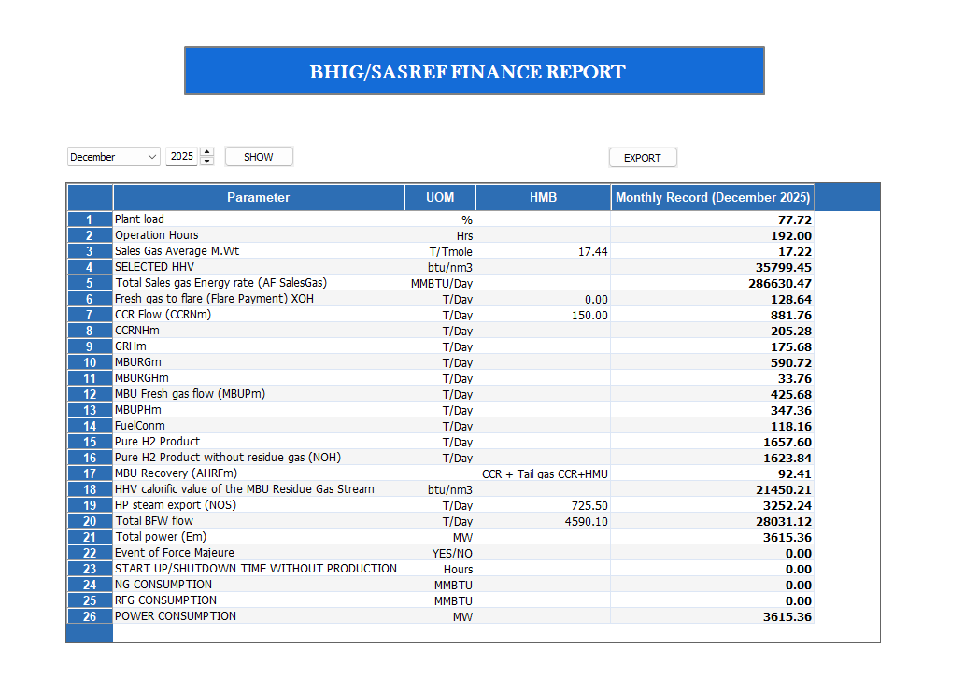

Monthly Totalizer Report
Header:
- Report Title: Monthly Totalizer Report
- Month & Year: Selectable via dropdown menus
- Display Control: “SHOW” button to view selected period data

Body Sections:
- Hydrogen Section
- Steam Section
- Flared Gas Section
- Feedstock Section
- Power Section
- CCR Net Gases Section
- Refinery Fuel Gas Section
- Third-Party Hydrogen Section
- Purchase / Procurement of Hydrogen Section

Footer:
- Prepared by / Verified by / Approved by
- Remarks or special observations section (optional)

Export & Distribution:
- Export options: Excel / PDF
- Auto-email to configured recipients (Plant Management, Finance, and Operations teams)
- Stored automatically on file server for recordkeeping
Purpose:
Provides a comprehensive monthly summary of all plant totalizers including hydrogen production, feedstock and energy usage, flared gas losses, and efficiency indicators. This report acts as a performance and audit record, supporting financial reconciliation and operational benchmarking.
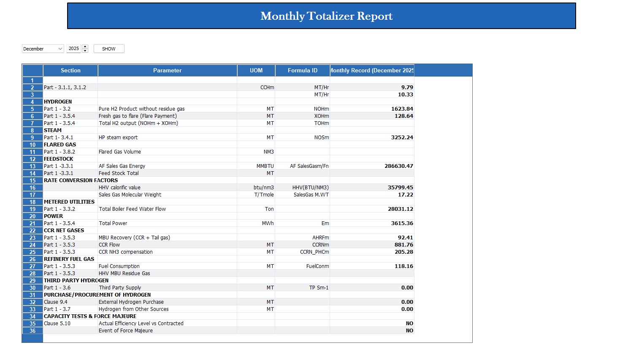

Dashboard Wireframe Overview

Dashboard Layout
The dashboard consists of four primary panels:
- KPI Gauges: Hydrogen purity, feedstock efficiency, PSA/MBU recovery.
- Trends Graphs: Time-series plots for H₂ production, power, and gas flow.
- Alerts Panel: List of current and past PAP events.
- Summary Tiles: Real-time efficiency and deviation indicators.
Design Characteristics:
- Color-coded thresholds (Green/Yellow/Red)
- Drill-down from plant overview → unit → tag level
- Compatible with both desktop and tablet viewports

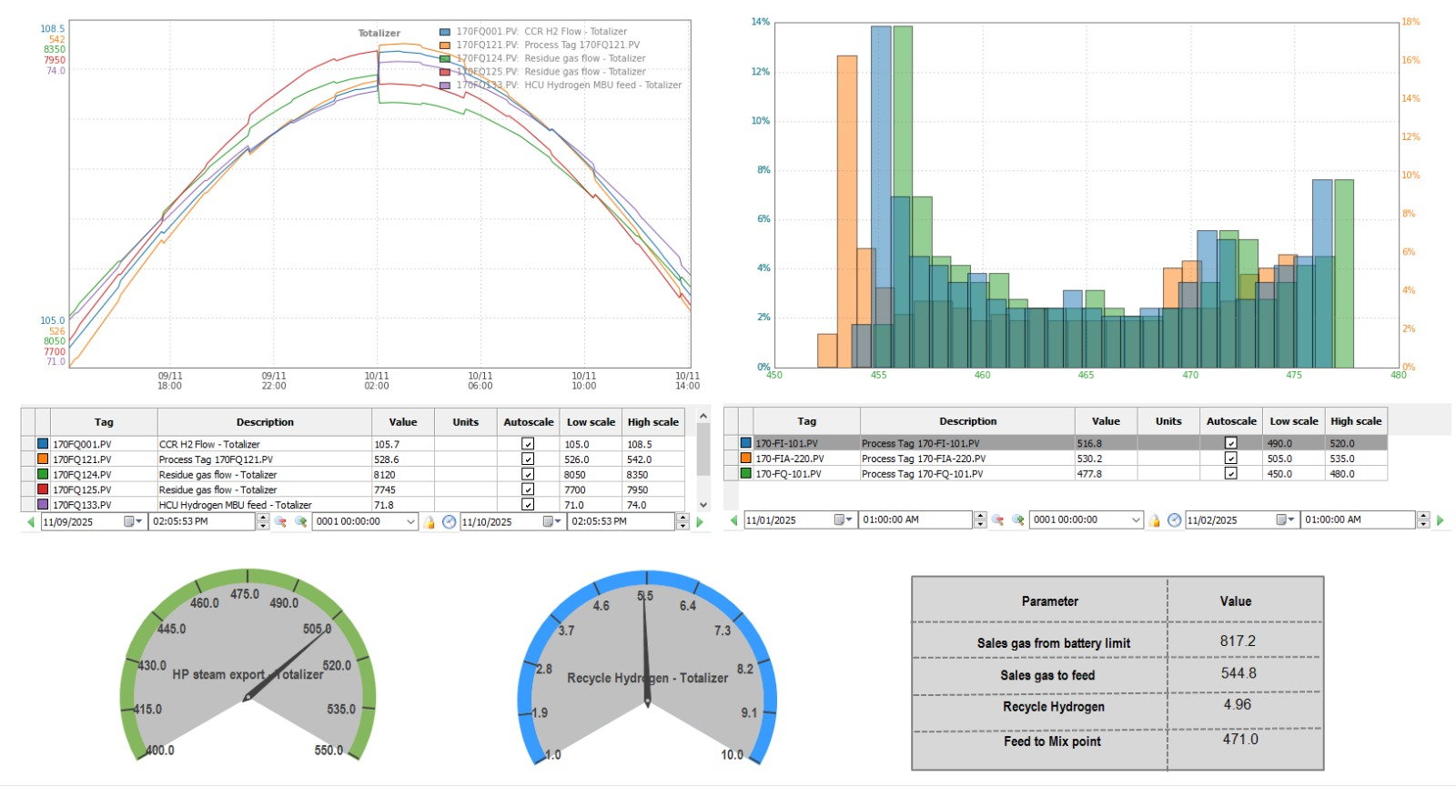

Role-Based Access Matrix
Role | Accessible Menus | Permissions
Operator | Dashboard, Reports (Daily), Manual Entry | Read/Write data entry, view dashboards
Engineer | Dashboard, Data Management, Reports | Configure tags, view all reports

User Access & Security

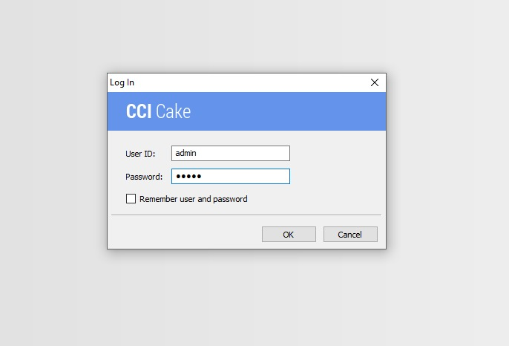
Role-Based Access Control

Role | Dashboard Access | Report Access | Configuration Rights
Operator | Operations dashboard (read-only) | Daily reports | Manual data entry
Engineer | All dashboards + configuration | All reports | User and Role confurigation

Security Implementation
Primary Authentication: Windows Active Directory integration
Fallback Authentication: Local CCI Cake user accounts
Session Management: Automatic timeout after inactivity
Password Policy: Corporate security standards compliance

Audit Logging:
- User Activities: Login/logout, configuration changes, data overrides
- System Events: Service starts/stops, connection failures, calculation errors
- Data Changes: Manual entries, corrections, approved modifications
- Report Access: Generation timestamps, recipient confirmations

