# **Securing Smart Sensing Production System using ML & DL Algorithms**

# **ABSTRACT**

The increasing complexity and interconnectivity of smart sensing production systems have raised significant concerns regarding their security and integrity. As these systems integrate advanced sensors and communication technologies, they become vulnerable to various cyber threats that can disrupt operations and compromise sensitive data. This paper explores the application of machine learning (ML) and deep learning (DL) algorithms to enhance the security framework of smart sensing production environments. By leveraging the capabilities of these algorithms, the system can effectively detect anomalies, predict potential threats, and automate responses in real-time.

Through a comprehensive review of existing literature and case studies, we outline the potential of ML and DL techniques in identifying patterns indicative of malicious activities. Techniques such as supervised learning for anomaly detection, reinforcement learning for adaptive security measures, and convolutional neural networks (CNNs) for image-based monitoring are evaluated for their effectiveness. The integration of these algorithms into a cohesive security architecture not only improves the resilience of smart production systems but also facilitates a proactive approach to threat management.

Furthermore, the challenges associated with implementing ML and DL in production environments, including data privacy concerns and the need for robust training datasets, are discussed. By addressing these challenges, our proposed framework aims to provide a comprehensive solution that enhances the security posture of smart sensing systems, ensuring reliable and secure production processes.

**INTRODUCTION**

The advent of Industry 4.0 has ushered in an era characterized by the integration of smart sensing technologies in production systems. These systems, equipped with an array of interconnected sensors, Internet of Things (IoT) devices, and advanced analytics, enable real-time monitoring and optimization of manufacturing processes. However, this increased connectivity also amplifies the risk of cyber threats, making it imperative to secure these systems against potential vulnerabilities that could lead to operational disruptions, data breaches, and significant economic losses.

As cyberattacks become more sophisticated, traditional security measures are often insufficient to protect against evolving threats. In this context, machine learning (ML) and deep learning (DL) have emerged as powerful tools for enhancing security in smart sensing production environments. ML algorithms can analyze large volumes of data to identify patterns and anomalies, while DL techniques, particularly neural networks, excel in processing complex datasets, allowing for advanced threat detection and response capabilities. These technologies not only facilitate the identification of security breaches but also enable predictive analytics to anticipate and mitigate potential risks before they manifest.

The application of ML and DL in securing production systems presents unique challenges and opportunities. Issues such as data privacy, the need for comprehensive training datasets, and the computational demands of deploying these algorithms in real-time environments require careful consideration. Furthermore, the dynamic nature of production environments necessitates adaptive security measures that can evolve alongside emerging threats. This paper aims to investigate these challenges while proposing a robust framework that integrates ML and DL techniques to enhance the security posture of smart sensing production systems.

In summary, securing smart sensing production systems through the application of ML and DL algorithms represents a critical advancement in the field of industrial cybersecurity. As we explore the intricacies of these technologies and their potential for safeguarding production environments, it becomes evident that a proactive, data-driven approach is essential for ensuring the resilience and integrity of modern manufacturing processes.

# **LITERATURE SURVEY**

The integration of machine learning (ML) and deep learning (DL) in securing smart sensing production systems has been the subject of considerable research in recent years. Numerous studies have explored the application of these technologies to enhance the cybersecurity framework of industrial environments, addressing both threat detection and response mechanisms.

One prominent area of research focuses on anomaly detection within production systems. For instance, Ahmed et al. (2016) demonstrated the efficacy of various supervised ML algorithms, such as decision trees and support vector machines, in identifying deviations from normal operational patterns. Their findings indicated that these algorithms could effectively detect intrusions and operational failures, significantly reducing false positive rates compared to traditional methods. Similarly, a study by Dutta and Mohanty (2020) utilized a combination of ML techniques to create a hybrid model capable of identifying malicious activities in real-time, highlighting the importance of feature selection in enhancing detection accuracy.

Deep learning approaches have also garnered attention for their ability to process large datasets and extract intricate patterns. Li et al. (2021) introduced a convolutional neural network (CNN)-based model that analyzed sensor data for anomaly detection in manufacturing processes. Their research showcased how CNNs could outperform conventional ML models, particularly in scenarios involving high-dimensional data. Furthermore, Zhang et al. (2022) implemented recurrent neural networks (RNNs) to predict potential security breaches based on historical data trends, illustrating the potential of DL in proactive threat management.

In addition to detection, the literature also emphasizes the role of ML and DL in automating responses to cyber threats. For example, Kaur et al. (2023) proposed a reinforcement learning framework that adapts security protocols in real-time based on the evolving threat landscape. Their work underscores the necessity for dynamic security measures that can respond to detected anomalies and mitigate risks promptly.

Despite these advancements, several challenges remain. Many studies highlight issues related to data privacy, the need for comprehensive training datasets, and the computational resources required for deploying these models in operational environments. For instance, a review by Kim et al. (2022) pointed out the potential for adversarial attacks on ML models, suggesting that further research is needed to enhance the robustness of these systems.

In summary, the literature illustrates a growing recognition of the potential for ML and DL to secure smart sensing production systems. While significant progress has been made in anomaly detection and automated threat response, ongoing research is essential to address the challenges posed by data privacy and model robustness, ultimately leading to more resilient industrial cybersecurity frameworks.

# **EXISTING SYSTEM**

In traditional smart sensing production systems, security measures primarily relied on rule-based algorithms and conventional security practices, such as firewalls and intrusion detection systems. These systems often used outdated algorithms like Support Vector Machines (SVM), Decision Trees, and k-Nearest Neighbors (k-NN) to identify anomalies and potential threats. While these methods provided a certain level of protection, they struggled with the increasing complexity and volume of data generated in modern production environments. As cyber threats evolved, these older algorithms often failed to adapt to new patterns of attacks, leading to vulnerabilities in the system. Consequently, the need for more advanced approaches became evident, prompting the exploration of machine learning (ML) and deep learning (DL) algorithms, which can analyze vast amounts of data in real time, learn from historical patterns, and improve their accuracy over time, thus enhancing the overall security of smart sensing production systems.

# **DISADVANTAGES**

1. **Limited Adaptability**: Older algorithms like SVM and k-NN lack the capability to adapt to new and evolving threats, making them less effective against sophisticated cyber attacks.
2. **High False Positive Rates**: Traditional rule-based systems often generate numerous false positives, leading to unnecessary alerts and diverting resources away from genuine security incidents.
3. **Inefficient Data Processing**: Existing systems struggle to efficiently process large volumes of real-time data, resulting in delays in threat detection and response.
4. **Insufficient Pattern Recognition**: Conventional algorithms may not effectively recognize complex patterns and correlations in data, limiting their ability to detect subtle or advanced security threats that require deeper analysis.

# **PROPOSED SYSTEM**

To overcome the challenges faced by existing smart sensing production systems, we propose a novel technique that leverages machine learning (ML) and deep learning (DL) algorithms without relying on under-sampling or over-sampling methods. This technique is composed of two key components: an Autoencoder and a Deep Neural Network (DNN).

The first component, the Autoencoder, is a deep learning architecture that will be trained on the imbalanced dataset. It aims to extract significant features from the input data, enabling better representation of the underlying patterns. Once the Autoencoder has completed its training, the features extracted will be used to train a Decision Tree algorithm. This Decision Tree will predict labels for both known and unknown attacks based on the reduced feature set obtained through Principal Component Analysis (PCA). By utilizing PCA, we enhance the efficiency of the Decision Tree model, as it works with a streamlined set of features that retain essential information while reducing noise and dimensionality.

The second component, the Deep Neural Network (DNN), operates at a higher level by being trained on both known and unknown attack signatures. This dual training approach allows the DNN to generalize better across different attack scenarios. When records containing an attack signature are detected, the DNN can accurately identify the corresponding attack label or class, facilitating timely and effective responses to security threats. This comprehensive system not only improves the detection rates of various attacks but also enhances the overall security posture of smart sensing production environments by integrating advanced ML and DL methodologies.

# **ADVANTAGES**

1. **Enhanced Detection Accuracy**: By utilizing Autoencoders to extract relevant features and a Decision Tree for classification, the proposed system improves detection accuracy for both known and unknown attacks, reducing the likelihood of false positives and negatives.
2. **Effective Handling of Imbalanced Data**: The system's architecture is designed to work directly with imbalanced datasets without the need for under-sampling or over-sampling, allowing it to leverage all available data for training, which leads to more robust model performance.
3. **Dimensionality Reduction**: The integration of Principal Component Analysis (PCA) allows for efficient dimensionality reduction, ensuring that the Decision Tree operates on a concise set of relevant features. This reduces computational complexity and enhances model interpretability.
4. **Adaptive Learning Capabilities**: The Deep Neural Network component can learn from both known and emerging attack signatures, allowing the system to adapt to new threats over time. This capability ensures that the security measures remain effective against evolving cyber threats in smart sensing environments.

# **SYSTEM ARCHITECTURE**

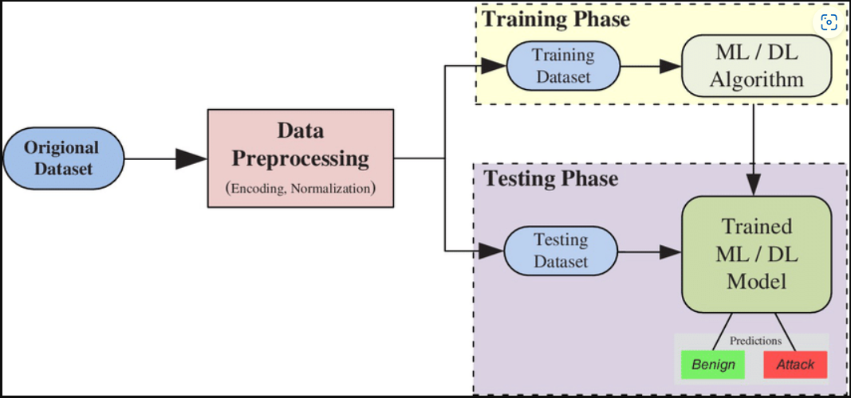

# **SYATEM REQUIREMENTS**

**➢ H/W System Configuration:-**

**➢ Processor - Pentium –IV**

**➢ RAM - 4 GB (min)**

**➢ Hard Disk - 20 GB**

**SOFTWARE REQUIREMENTS:**

1. **Operating system : Windows 7 Ultimate.**
2. **Coding Language : Python.**

# **SYSTEM STUDY**

**FEASIBILITY STUDY**

The feasibility of the project is analyzed in this phase and business proposal is put forth with a very general plan for the project and some cost estimates. During system analysis the feasibility study of the proposed system is to be carried out. This is to ensure that the proposed system is not a burden to the company. For feasibility analysis, some understanding of the major requirements for the system is essential.

Three key considerations involved in the feasibility analysis are

* ECONOMICAL FEASIBILITY
* TECHNICAL FEASIBILITY
* SOCIAL FEASIBILITY

**ECONOMICAL FEASIBILITY**

This study is carried out to check the economic impact that the system will have on the organization. The amount of fund that the company can pour into the research and development of the system is limited. The expenditures must be justified. Thus the developed system as well within the budget and this was achieved because most of the technologies used are freely available. Only the customized products had to be purchased.

**TECHNICAL FEASIBILITY**

This study is carried out to check the technical feasibility, that is, the technical requirements of the system. Any system developed must not have a high demand on the available technical resources. This will lead to high demands on the available technical resources. This will lead to high demands being placed on the client. The developed system must have a modest requirement, as only minimal or null changes are required for implementing this system.

**SOCIAL FEASIBILITY**

The aspect of study is to check the level of acceptance of the system by the user. This includes the process of training the user to use the system efficiently. The user must not feel threatened by the system, instead must accept it as a necessity. The level of acceptance by the users solely depends on the methods that are employed to educate the user about the system and to make him familiar with it. His level of confidence must be raised so that he is also able to make some constructive criticism, which is welcomed, as he is the final user of the system.

# **SYSTEM DESIGN**

**UML DIAGRAMS**

UML stands for Unified Modeling Language. UML is a standardized general-purpose modeling language in the field of object-oriented software engineering. The standard is managed, and was created by, the Object Management Group.

The goal is for UML to become a common language for creating models of object oriented computer software. In its current form UML is comprised of two major components: a Meta-model and a notation. In the future, some form of method or process may also be added to; or associated with, UML.

The Unified Modeling Language is a standard language for specifying, Visualization, Constructing and documenting the artifacts of software system, as well as for business modeling and other non-software systems.

The UML represents a collection of best engineering practices that have proven successful in the modeling of large and complex systems.

The UML is a very important part of developing objects oriented software and the software development process. The UML uses mostly graphical notations to express the design of software projects.

**GOALS:**

The Primary goals in the design of the UML are as follows:

1. Provide users a ready-to-use, expressive visual modeling Language so that they can develop and exchange meaningful models.
2. Provide extendibility and specialization mechanisms to extend the core concepts.
3. Be independent of particular programming languages and development process.
4. Provide a formal basis for understanding the modeling language.
5. Encourage the growth of OO tools market.
6. Support higher level development concepts such as collaborations, frameworks, patterns and components.
7. Integrate best practices.

**USECASE DIAGRAM:**

A use case diagram in the Unified Modeling Language (UML) is a type of behavioral diagram defined by and created from a Use-case analysis. Its purpose is to present a graphical overview of the functionality provided by a system in terms of actors, their goals (represented as use cases), and any dependencies between those use cases. The main purpose of a use case diagram is to show what system functions are performed for which actor. Roles of the actors in the system can be depicted. 

**CLASS DIAGRAM:**

In software engineering, a class diagram in the Unified Modeling Language (UML) is a type of static structure diagram that describes the structure of a system by showing the system's classes, their attributes, operations (or methods), and the relationships among the classes. It explains which class contains information.



**SEQUENCE DIAGRAM:**

A sequence diagram in Unified Modeling Language (UML) is a kind of interaction diagram that shows how processes operate with one another and in what order. It is a construct of a Message Sequence Chart. Sequence diagrams are sometimes called event diagrams, event scenarios, and timing diagrams.



**ACTIVITY DIAGRAM:**

Activity diagrams are graphical representations of workflows of stepwise activities and actions with support for choice, iteration and concurrency. In the Unified Modeling Language, activity diagrams can be used to describe the business and operational step-by-step workflows of components in a system. An activity diagram shows the overall flow of control.

Collaboration diagram:



# **SOFTWARE ENVIRONMENT**

**What is Python :-**

Below are some facts about Python.

Python is currently the most widely used multi-purpose, high-level programming language.

Python allows programming in Object-Oriented and Procedural paradigms. Python programs generally are smaller than other programming languages like Java.

Programmers have to type relatively less and indentation requirement of the language, makes them readable all the time.

Python language is being used by almost all tech-giant companies like – Google, Amazon, Facebook, Instagram, Dropbox, Uber… etc.

The biggest strength of Python is huge collection of standard library which can be used for the following –

* + [Machine Learning](https://www.geeksforgeeks.org/machine-learning/)
  + GUI Applications (like Kivy, Tkinter, PyQt etc. )
  + Web frameworks like Django (used by YouTube, Instagram, Dropbox)
  + Image processing (like Opencv, Pillow)
  + Web scraping (like Scrapy, BeautifulSoup, Selenium)
  + Test frameworks
  + Multimedia

**Advantages of Python :-**

Let’s see how Python dominates over other languages.

**1. Extensive Libraries**

Python downloads with an extensive library and it *contain code for various purposes like regular expressions, documentation-generation, unit-testing, web browsers, threading, databases, CGI, email, image manipulation, and more.* So, we don’t have to write the complete code for that manually.

**2. Extensible**

As we have seen earlier, Python can be extended to other languages. You can write some of your code in languages like C++ or C. This comes in handy, especially in projects.

**3. Embeddable**

Complimentary to extensibility, Python is embeddable as well. You can put your Python code in your source code of a different language, like C++. This lets us add scripting capabilities to our code in the other language.

**4. Improved Productivity**

The language’s simplicity and extensive libraries render programmers more productive than languages like Java and C++ do. Also, the fact that you need to write less and get more things done.

**5. IOT Opportunities**

Since Python forms the basis of new platforms like Raspberry Pi, it finds the future bright for the Internet Of Things. This is a way to connect the language with the real world.

**6. Simple and Easy**

When working with Java, you may have to create a class to print ‘Hello World’. But in Python, just a print statement will do. It is also quite easy to learn, understand, and code. This is why when people pick up Python, they have a hard time adjusting to other more verbose languages like Java.

**7. Readable**

Because it is not such a verbose language, reading Python is much like reading English. This is the reason why it is so easy to learn, understand, and code. It also does not need curly braces to define blocks, and indentation is mandatory. This further aids the readability of the code.

**8. Object-Oriented**

This language supports both the procedural and object-oriented programming paradigms. While functions help us with code reusability, classes and objects let us model the real world. A class allows the encapsulation of data and functions into one.

**9. Free and Open-Source**

Like we said earlier, Python is freely available. But not only can you [download Python](https://data-flair.training/blogs/install-python-windows/) for free, but you can also download its source code, make changes to it, and even distribute it. It downloads with an extensive collection of libraries to help you with your tasks.

**10. Portable**

When you code your project in a language like C++, you may need to make some changes to it if you want to run it on another platform. But it isn’t the same with Python. Here, you need to code only once, and you can run it anywhere. This is called Write Once Run Anywhere (WORA). However, you need to be careful enough not to include any system-dependent features**.**

**11. Interpreted**

Lastly, we will say that it is an interpreted language. Since statements are executed one by one, debugging is easier than in compiled languages.

*Any doubts till now in the advantages of Python? Mention in the comment section.*

**Advantages of Python Over Other Languages**

**1. Less Coding**

Almost all of the tasks done in Python requires less coding when the same task is done in other languages. Python also has an awesome standard library support, so you don’t have to search for any third-party libraries to get your job done. This is the reason that many people suggest learning Python to beginners.

**2. Affordable**

Python is free therefore individuals, small companies or big organizations can leverage the free available resources to build applications. Python is popular and widely used so it gives you better community support.

The 2019 Github annual survey showed us that Python has overtaken Java in the most popular programming language category.

**3. Python is for Everyone**

Python code can run on any machine whether it is Linux, Mac or Windows. Programmers need to learn different languages for different jobs but with Python, you can professionally build web apps, perform data analysis and [machine learning](https://data-flair.training/blogs/machine-learning-tutorials-home/), automate things,do web scraping and also build games and powerful visualizations. It is an all-rounder programming language.

**Disadvantages of Python**

So far, we’ve seen why Python is a great choice for your project. But if you choose it, you should be aware of its consequences as well. Let’s now see the downsides of choosing Python over another language.

**1. Speed Limitations**

We have seen that Python code is executed line by line. But since [Python](https://www.python.org/) is interpreted, it often results in slow execution. This, however, isn’t a problem unless speed is a focal point for the project. In other words, unless high speed is a requirement, the benefits offered by Python are enough to distract us from its speed limitations.

**2. Weak in Mobile Computing and Browsers**

While it serves as an excellent server-side language, Python is much rarely seen on the client-side. Besides that, it is rarely ever used to implement smartphone-based applications. One such application is called Carbonnelle.

The reason it is not so famous despite the existence of Brython is that it isn’t that secure.

**3. Design Restrictions**

As you know, Python is dynamically-typed. This means that you don’t need to declare the type of variable while writing the code. It uses duck-typing. But wait, what’s that? Well, it just means that if it looks like a duck, it must be a duck. While this is easy on the programmers during coding, it can raise run-time errors.

**4. Underdeveloped Database Access Layers**

Compared to more widely used technologies like JDBC (Java DataBase Connectivity) and ODBC (Open DataBase Connectivity), Python’s database access layers are a bit underdeveloped. Consequently, it is less often applied in huge enterprises.

**5. Simple**

No, we’re not kidding. Python’s simplicity can indeed be a problem. Take my example. I don’t do Java, I’m more of a Python person. To me, its syntax is so simple that the verbosity of Java code seems unnecessary.

This was all about the Advantages and Disadvantages of Python Programming Language.

**History of Python : -**

What do the alphabet and the programming language Python have in common? Right, both start with ABC. If we are talking about ABC in the Python context, it's clear that the programming language ABC is meant. ABC is a general-purpose programming language and programming environment, which had been developed in the Netherlands, Amsterdam, at the CWI (Centrum Wiskunde &Informatica). The greatest achievement of ABC was to influence the design of Python.Python was conceptualized in the late 1980s. Guido van Rossum worked that time in a project at the CWI, called Amoeba, a distributed operating system. In an interview with Bill Venners1, Guido van Rossum said: "In the early 1980s, I worked as an implementer on a team building a language called ABC at Centrum voor Wiskunde en Informatica (CWI). I don't know how well people know ABC's influence on Python. I try to mention ABC's influence because I'm indebted to everything I learned during that project and to the people who worked on it."Later on in the same Interview, Guido van Rossum continued: "I remembered all my experience and some of my frustration with ABC. I decided to try to design a simple scripting language that possessed some of ABC's better properties, but without its problems. So I started typing. I created a simple virtual machine, a simple parser, and a simple runtime. I made my own version of the various ABC parts that I liked. I created a basic syntax, used indentation for statement grouping instead of curly braces or begin-end blocks, and developed a small number of powerful data types: a hash table (or dictionary, as we call it), a list, strings, and numbers."

**What is Machine Learning : -**

Before we take a look at the details of various machine learning methods, let's start by looking at what machine learning is, and what it isn't. Machine learning is often categorized as a subfield of artificial intelligence, but I find that categorization can often be misleading at first brush. The study of machine learning certainly arose from research in this context, but in the data science application of machine learning methods, it's more helpful to think of machine learning as a means of *building models of data*.

Fundamentally, machine learning involves building mathematical models to help understand data. "Learning" enters the fray when we give these models *tunable parameters* that can be adapted to observed data; in this way the program can be considered to be "learning" from the data. Once these models have been fit to previously seen data, they can be used to predict and understand aspects of newly observed data. I'll leave to the reader the more philosophical digression regarding the extent to which this type of mathematical, model-based "learning" is similar to the "learning" exhibited by the human brain. Understanding the problem setting in machine learning is essential to using these tools effectively, and so we will start with some broad categorizations of the types of approaches we'll discuss here.

**Categories Of Machine Leaning :-**

At the most fundamental level, machine learning can be categorized into two main types: supervised learning and unsupervised learning.

*Supervised learning* involves somehow modeling the relationship between measured features of data and some label associated with the data; once this model is determined, it can be used to apply labels to new, unknown data. This is further subdivided into *classification* tasks and *regression* tasks: in classification, the labels are discrete categories, while in regression, the labels are continuous quantities. We will see examples of both types of supervised learning in the following section.

*Unsupervised learning* involves modeling the features of a dataset without reference to any label, and is often described as "letting the dataset speak for itself." These models include tasks such as *clustering* and *dimensionality reduction.* Clustering algorithms identify distinct groups of data, while dimensionality reduction algorithms search for more succinct representations of the data. We will see examples of both types of unsupervised learning in the following section.

**Need for Machine Learning**

Human beings, at this moment, are the most intelligent and advanced species on earth because they can think, evaluate and solve complex problems. On the other side, AI is still in its initial stage and haven’t surpassed human intelligence in many aspects. Then the question is that what is the need to make machine learn? The most suitable reason for doing this is, “to make decisions, based on data, with efficiency and scale”.

Lately, organizations are investing heavily in newer technologies like Artificial Intelligence, Machine Learning and Deep Learning to get the key information from data to perform several real-world tasks and solve problems. We can call it data-driven decisions taken by machines, particularly to automate the process. These data-driven decisions can be used, instead of using programing logic, in the problems that cannot be programmed inherently. The fact is that we can’t do without human intelligence, but other aspect is that we all need to solve real-world problems with efficiency at a huge scale. That is why the need for machine learning arises.

**Challenges in Machines Learning :-**

While Machine Learning is rapidly evolving, making significant strides with cybersecurity and autonomous cars, this segment of AI as whole still has a long way to go. The reason behind is that ML has not been able to overcome number of challenges. The challenges that ML is facing currently are −

Quality of data − Having good-quality data for ML algorithms is one of the biggest challenges. Use of low-quality data leads to the problems related to data preprocessing and feature extraction.

Time-Consuming task − Another challenge faced by ML models is the consumption of time especially for data acquisition, feature extraction and retrieval.

Lack of specialist persons − As ML technology is still in its infancy stage, availability of expert resources is a tough job.

No clear objective for formulating business problems − Having no clear objective and well-defined goal for business problems is another key challenge for ML because this technology is not that mature yet.

Issue of overfitting & underfitting − If the model is overfitting or underfitting, it cannot be represented well for the problem.

Curse of dimensionality − Another challenge ML model faces is too many features of data points. This can be a real hindrance.

Difficulty in deployment − Complexity of the ML model makes it quite difficult to be deployed in real life.

**Applications of Machines Learning :-**

Machine Learning is the most rapidly growing technology and according to researchers we are in the golden year of AI and ML. It is used to solve many real-world complex problems which cannot be solved with traditional approach. Following are some real-world applications of ML −

* Emotion analysis
* Sentiment analysis
* Error detection and prevention
* Weather forecasting and prediction
* Stock market analysis and forecasting
* Speech synthesis
* Speech recognition
* Customer segmentation
* Object recognition
* Fraud detection
* Fraud prevention
* Recommendation of products to customer in online shopping

**How to Start Learning Machine Learning?**

Arthur Samuel coined the term “Machine Learning” in 1959 and defined it as a “Field of study that gives computers the capability to learn without being explicitly programmed”.

And that was the beginning of Machine Learning! In modern times, Machine Learning is one of the most popular (if not the most!) career choices. According to [Indeed](http://blog.indeed.com/2019/03/14/best-jobs-2019/), Machine Learning Engineer Is The Best Job of 2019 with a *344%* growth and an average base salary of $146,085 per year.

But there is still a lot of doubt about what exactly is Machine Learning and how to start learning it? So this article deals with the Basics of Machine Learning and also the path you can follow to eventually become a full-fledged Machine Learning Engineer. Now let’s get started!!!

**How to start learning ML?**

This is a rough roadmap you can follow on your way to becoming an insanely talented Machine Learning Engineer. Of course, you can always modify the steps according to your needs to reach your desired end-goal!

**Step 1 – Understand the Prerequisites**

In case you are a genius, you could start ML directly but normally, there are some prerequisites that you need to know which include Linear Algebra, Multivariate Calculus, Statistics, and Python. And if you don’t know these, never fear! You don’t need a Ph.D. degree in these topics to get started but you do need a basic understanding.

**(a) Learn Linear Algebra and Multivariate Calculus**

Both Linear Algebra and Multivariate Calculus are important in Machine Learning. However, the extent to which you need them depends on your role as a data scientist. If you are more focused on application heavy machine learning, then you will not be that heavily focused on maths as there are many common libraries available. But if you want to focus on R&D in Machine Learning, then mastery of Linear Algebra and Multivariate Calculus is veryimportant as you will have to implement many ML algorithms from scratch.

**(b) Learn Statistics**

Data plays a huge role in Machine Learning. In fact, around 80% of your time as an ML expert will be spent collecting and cleaning data. And statistics is a field that handles the collection, analysis, and presentation of data. So it is no surprise that you need to learn it!!!  
Some of the key concepts in statistics that are important are Statistical Significance, Probability Distributions, Hypothesis Testing, Regression, etc. Also, Bayesian Thinking is also a very important part of ML which deals with various concepts like Conditional Probability, Priors, and Posteriors, Maximum Likelihood, etc.

**(c) Learn Python**

Some people prefer to skip Linear Algebra, Multivariate Calculus and Statistics and learn them as they go along with trial and error. But the one thing that you absolutely cannot skip is [Python](https://www.geeksforgeeks.org/python-programming-language/)! While there are other languages you can use for Machine Learning like R, Scala, etc. Python is currently the most popular language for ML. In fact, there are many Python libraries that are specifically useful for Artificial Intelligence and Machine Learning such as [Keras](https://keras.io/" \t "_blank), [TensorFlow](https://www.tensorflow.org/), [Scikit-learn](https://scikit-learn.org/stable/), etc.

So if you want to learn ML, it’s best if you learn Python! You can do that using various online resources and courses such as [Fork Python](https://practice.geeksforgeeks.org/courses/fork-python) available Free on GeeksforGeeks.

**Step 2 – Learn Various ML Concepts**

Now that you are done with the prerequisites, you can move on to actually learning ML (Which is the fun part!!!) It’s best to start with the basics and then move on to the more complicated stuff. Some of the basic concepts in ML are:

**(a) Terminologies of Machine Learning**

* Model – A model is a specific representation learned from data by applying some machine learning algorithm. A model is also called a hypothesis.
* Feature – A feature is an individual measurable property of the data. A set of numeric features can be conveniently described by a feature vector. Feature vectors are fed as input to the model. For example, in order to predict a fruit, there may be features like color, smell, taste, etc.
* Target (Label) – A target variable or label is the value to be predicted by our model. For the fruit example discussed in the feature section, the label with each set of input would be the name of the fruit like apple, orange, banana, etc.
* Training – The idea is to give a set of inputs(features) and it’s expected outputs(labels), so after training, we will have a model (hypothesis) that will then map new data to one of the categories trained on.
* Prediction – Once our model is ready, it can be fed a set of inputs to which it will provide a predicted output(label).

**(b) Types of Machine Learning**

* Supervised Learning – This involves learning from a training dataset with labeled data using classification and regression models. This learning process continues until the required level of performance is achieved.
* Unsupervised Learning – This involves using unlabelled data and then finding the underlying structure in the data in order to learn more and more about the data itself using factor and cluster analysis models.
* Semi-supervised Learning – This involves using unlabelled data like Unsupervised Learning with a small amount of labeled data. Using labeled data vastly increases the learning accuracy and is also more cost-effective than Supervised Learning.
* Reinforcement Learning – This involves learning optimal actions through trial and error. So the next action is decided by learning behaviors that are based on the current state and that will maximize the reward in the future.

**Advantages of Machine learning :-**

**1. Easily identifies trends and patterns -**

Machine Learning can review large volumes of data and discover specific trends and patterns that would not be apparent to humans. For instance, for an e-commerce website like Amazon, it serves to understand the browsing behaviors and purchase histories of its users to help cater to the right products, deals, and reminders relevant to them. It uses the results to reveal relevant advertisements to them.

**2. No human intervention needed (automation)**

With ML, you don’t need to babysit your project every step of the way. Since it means giving machines the ability to learn, it lets them make predictions and also improve the algorithms on their own. A common example of this is anti-virus softwares; they learn to filter new threats as they are recognized. ML is also good at recognizing spam.

**3. Continuous Improvement**

As [ML algorithms](https://data-flair.training/blogs/machine-learning-algorithms/) gain experience, they keep improving in accuracy and efficiency. This lets them make better decisions. Say you need to make a weather forecast model. As the amount of data you have keeps growing, your algorithms learn to make more accurate predictions faster.

**4. Handling multi-dimensional and multi-variety data**

Machine Learning algorithms are good at handling data that are multi-dimensional and multi-variety, and they can do this in dynamic or uncertain environments.

**5. Wide Applications**

You could be an e-tailer or a healthcare provider and make ML work for you. Where it does apply, it holds the capability to help deliver a much more personal experience to customers while also targeting the right customers.

**Disadvantages of Machine Learning :-**

**1. Data Acquisition**

Machine Learning requires massive data sets to train on, and these should be inclusive/unbiased, and of good quality. There can also be times where they must wait for new data to be generated**.**

**2. Time and Resources**

ML needs enough time to let the algorithms learn and develop enough to fulfill their purpose with a considerable amount of accuracy and relevancy. It also needs massive resources to function. This can mean additional requirements of computer power for you.

**3. Interpretation of Results**

Another major challenge is the ability to accurately interpret results generated by the algorithms. You must also carefully choose the algorithms for your purpose.

**4. High error-susceptibility**

[Machine Learning](https://en.wikipedia.org/wiki/Machine_learning) is autonomous but highly susceptible to errors. Suppose you train an algorithm with data sets small enough to not be inclusive. You end up with biased predictions coming from a biased training set. This leads to irrelevant advertisements being displayed to customers. In the case of ML, such blunders can set off a chain of errors that can go undetected for long periods of time. And when they do get noticed, it takes quite some time to recognize the source of the issue, and even longer to correct it.

# **SYSTEM TEST**

The purpose of testing is to discover errors. Testing is the process of trying to discover every conceivable fault or weakness in a work product. It provides a way to check the functionality of components, sub assemblies, assemblies and/or a finished product It is the process of exercising software with the intent of ensuring that the Software system meets its requirements and user expectations and does not fail in an unacceptable manner. There are various types of test. Each test type addresses a specific testing requirement.

**TYPES OF TESTS**

**Unit testing**

Unit testing involves the design of test cases that validate that the internal program logic is functioning properly, and that program inputs produce valid outputs. All decision branches and internal code flow should be validated. It is the testing of individual software units of the application .it is done after the completion of an individual unit before integration. This is a structural testing, that relies on knowledge of its construction and is invasive. Unit tests perform basic tests at component level and test a specific business process, application, and/or system configuration. Unit tests ensure that each unique path of a business process performs accurately to the documented specifications and contains clearly defined inputs and expected results.

**Integration testing**

Integration tests are designed to test integrated software components to determine if they actually run as one program. Testing is event driven and is more concerned with the basic outcome of screens or fields. Integration tests demonstrate that although the components were individually satisfaction, as shown by successfully unit testing, the combination of components is correct and consistent. Integration testing is specifically aimed at exposing the problems that arise from the combination of components.

**Functional test**

Functional tests provide systematic demonstrations that functions tested are available as specified by the business and technical requirements, system documentation, and user manuals.

Functional testing is centered on the following items:

Valid Input : identified classes of valid input must be accepted.

Invalid Input : identified classes of invalid input must be rejected.

Functions : identified functions must be exercised.

Output : identified classes of application outputs must be exercised.

Systems/Procedures : interfacing systems or procedures must be invoked.

Organization and preparation of functional tests is focused on requirements, key functions, or special test cases. In addition, systematic coverage pertaining to identify Business process flows; data fields, predefined processes, and successive processes must be considered for testing. Before functional testing is complete, additional tests are identified and the effective value of current tests is determined.

**System Test**

System testing ensures that the entire integrated software system meets requirements. It tests a configuration to ensure known and predictable results. An example of system testing is the configuration oriented system integration test. System testing is based on process descriptions and flows, emphasizing pre-driven process links and integration points.

**White Box Testing**

White Box Testing is a testing in which in which the software tester has knowledge of the inner workings, structure and language of the software, or at least its purpose. It is purpose. It is used to test areas that cannot be reached from a black box level.

**Black Box Testing**

Black Box Testing is testing the software without any knowledge of the inner workings, structure or language of the module being tested. Black box tests, as most other kinds of tests, must be written from a definitive source document, such as specification or requirements document, such as specification or requirements document. It is a testing in which the software under test is treated, as a black box .you cannot “see” into it. The test provides inputs and responds to outputs without considering how the software works.

**Unit Testing**

Unit testing is usually conducted as part of a combined code and unit test phase of the software lifecycle, although it is not uncommon for coding and unit testing to be conducted as two distinct phases.

Test strategy and approach

Field testing will be performed manually and functional tests will be written in detail.

Test objectives

* All field entries must work properly.
* Pages must be activated from the identified link.
* The entry screen, messages and responses must not be delayed.

**Features to be tested**

* Verify that the entries are of the correct format
* No duplicate entries should be allowed
* All links should take the user to the correct page.

**Integration Testing**

Software integration testing is the incremental integration testing of two or more integrated software components on a single platform to produce failures caused by interface defects.

The task of the integration test is to check that components or software applications, e.g. components in a software system or – one step up – software applications at the company level – interact without error.

**Test Results:** All the test cases mentioned above passed successfully. No defects encountered.

**Acceptance Testing**

User Acceptance Testing is a critical phase of any project and requires significant participation by the end user. It also ensures that the system meets the functional requirements.

**Test Results:** All the test cases mentioned above passed successfully. No defects encountered.

# **IMPLIMENTATION**

Internet of Things enabled cyber physical systems such as Industrial equipment’s and operational IT to send and receive data over internet. This equipment’s will have sensors to sense equipment condition and report to centralized server using internet connection. Sometime some malicious users may attack or hack such sensors and then alter their data and this false data will be report to centralized server and false action will be taken. Due to false data many countries equipment and production system got failed and many algorithms was developed to detect attack but all this algorithms suffers from data imbalance (one class my contains huge records (for example NORMAL records and other class like attack may contains few records which lead to imbalance problem and detection algorithms may failed to predict accurately). To deal with data imbalance existing algorithms were using OVER and UNDER sampling which will generate new records for FEWER class but this technique improve accuracy but not up to the mark.

To overcome from this issue we are introducing novel technique without using any under or oversampling algorithms and this technique consists of two parts

1. Auto Encoder: auto encoder deep learning will get trained on imbalanced dataset and then extract features from it and this extracted featured will get trained with DECISION TREE algorithm to predict label for known or unknown attacks. Decision tree get trained on reduced number of features obtained from PCA (principal component analysis) algorithm.
2. Deep Neural Network (DNN): in this level DNN algorithm get trained on known and unknown attacks. If any records contains attack signature then DNN will identify attack label or class and attribute them.

To implement this project we have used SWAT (secure water production treatment) and this dataset contains IOT request and response signature and associate each dataset with unique attack label and dataset contains below cyber-attack labels

**'Normal', 'Naive Malicious Response Injection (NMRI)', 'Complex Malicious', 'Response Injection (CMRI)', 'Malicious State Command Injection (MSCI)', 'Malicious Parameter Command Injection (MPCI)', 'Malicious Function Code Injection (MFCI)', 'Denial of Service (DoS)'**

Above are the attacks found in dataset and dataset contains above labels as integer value of its index for example NORMAL label index will be 0 and continues up to 8 class labels. Below screen showing dataset details

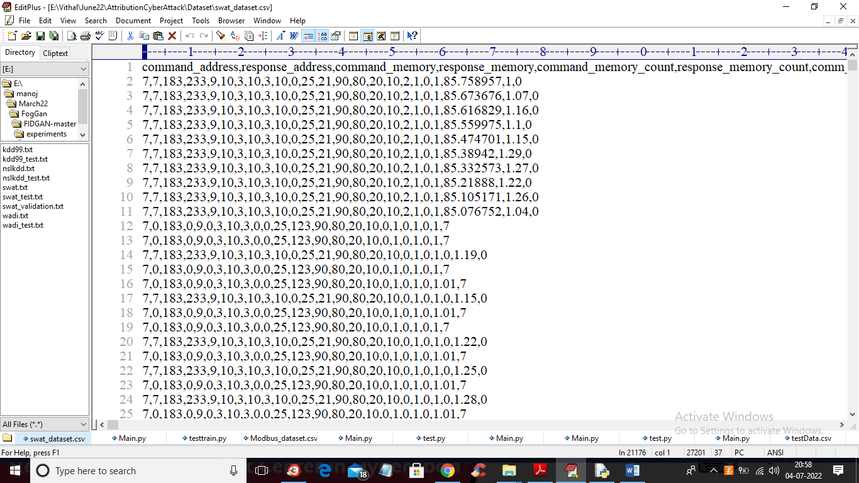

In above dataset screen first row contains dataset column names and remaining rows contains dataset values and in last column we have attack type from label 0 to 7. We will used above dataset to train propose Auto Encoder, decision tree and DNN algorithms.

In below screen we are using NEW test data which contains only signature and there is no class label and propose algorithm will detect and attribute class labels.

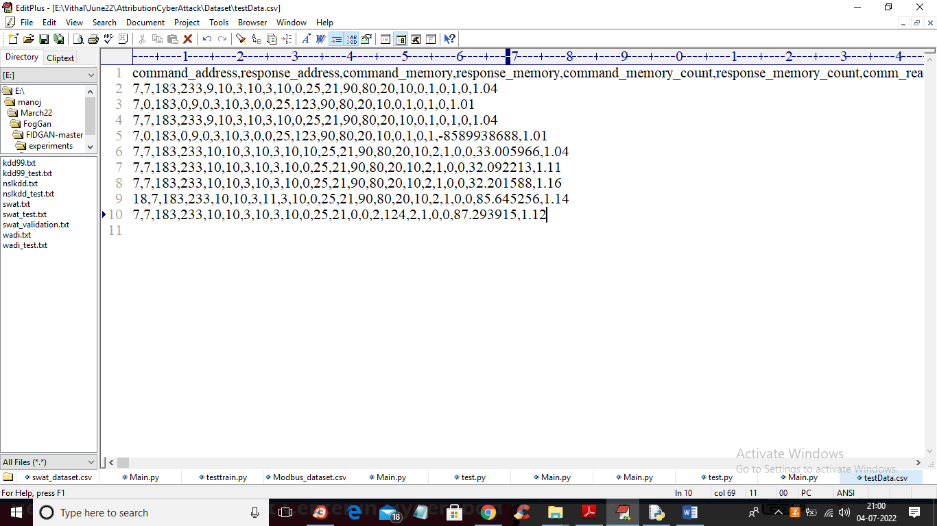

In above test data we have IOT request signature without class labels.

To implement this project we have designed following modules

1. Upload SWAT Water Dataset: using this module we will upload dataset to application and then read dataset and then find different attacks found in dataset
2. Preprocess Dataset: using this module we will replace all missing values with 0 and then apply MIN-MAX scaling algorithm to normalized features values and then split dataset into train and test where application used 80% dataset for training and 20% for testing
3. Run AutoEncoder Algorithm: using this module we will trained AutoEncoder deep learning algorithm and then extract features from that model.
4. Run Decision Tree with PCA: extracted features from AutoEncoder will get transform using PCA to reduce features size and then retrain with Decision tree. Decision tree will predict label for each record based on dataset signatures
5. Run DNN Algorithm: predicted decision tree label will further train with DNN (deep neural network) algorithm to detect and attribute attacks
6. Detection & Attribute Attack Type: using this module we will upload unknown or un-label TEST DATA and then DNN will predict attack type
7. Comparison Graph: using this module we will plot comparison graph between all algorithms
8. Comparison Table: using this module we will display comparison table of all algorithms which contains metrics like accuracy, precision, recall and FSCORE.

In below screen you can read red colour comments to know about algorithms implementation

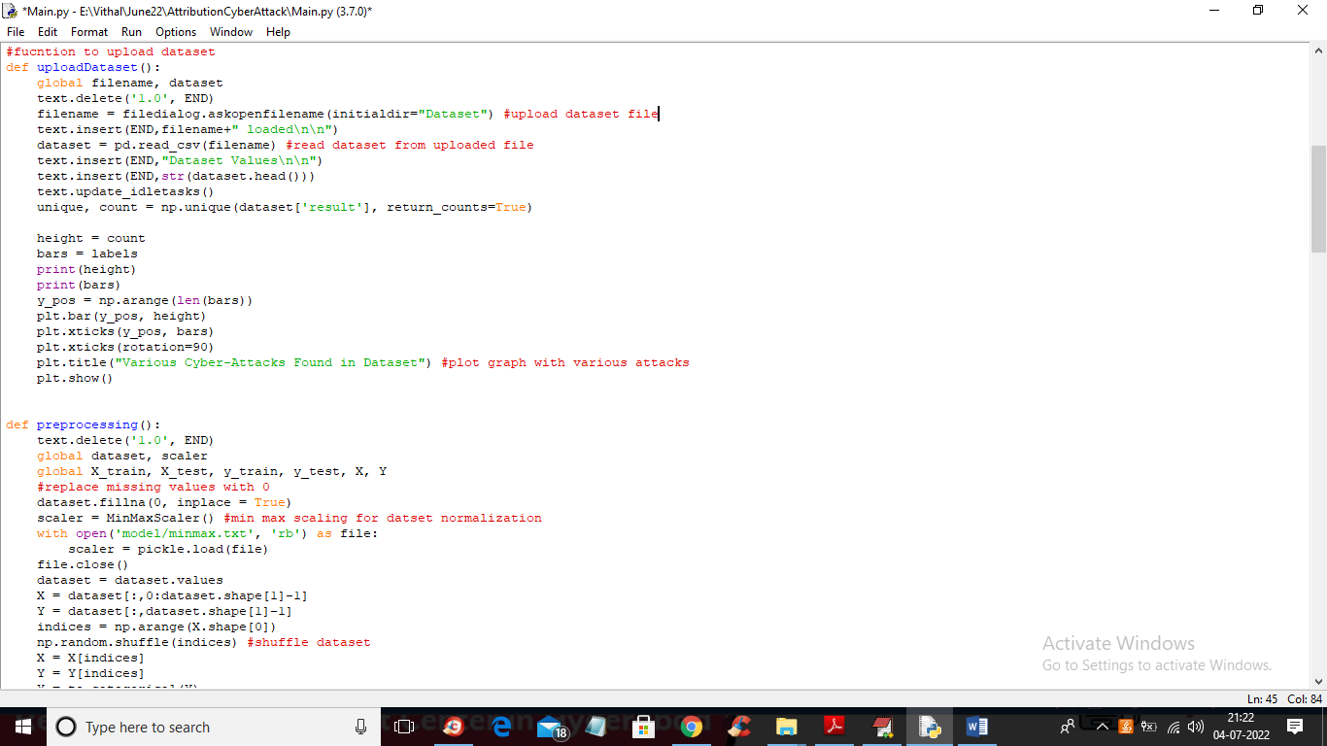

In above screen read red colour comments to know about dataset loading and min-max normalization

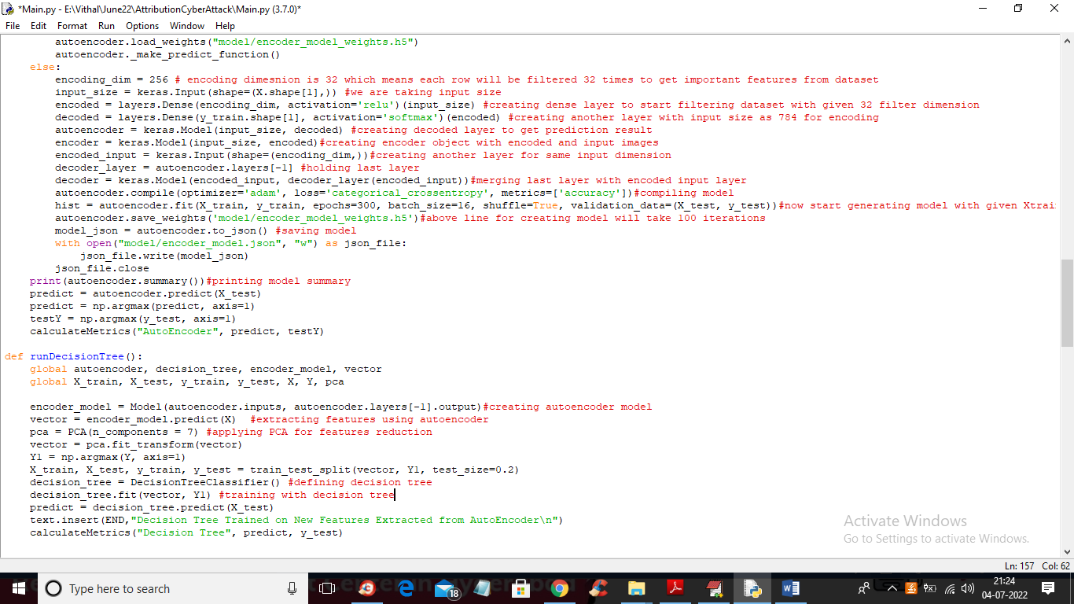

In above screen you can see we are using AutoEncoder, PCA and decision tree to train dataset and in below screen we are using DNN algorithms to train dataset with predicted labels from Decision Tree.

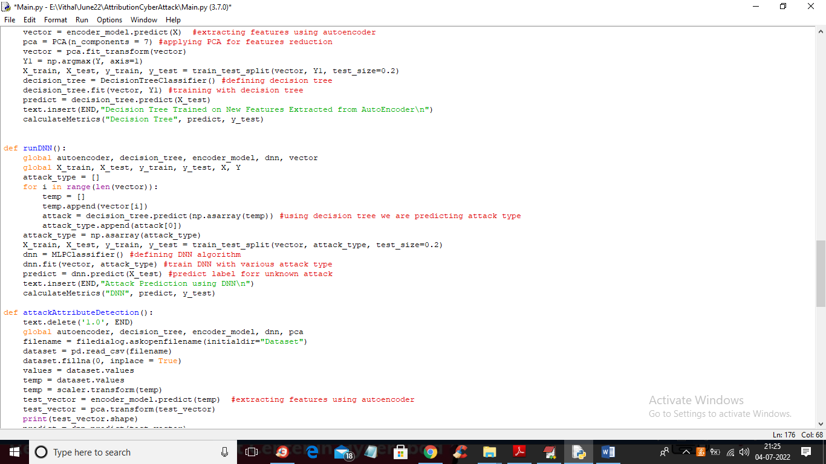

In above screen we are training dataset with DNN algorithms

SCREEN SHOTS

To run project double click on ‘run.bat’ file to get below screen

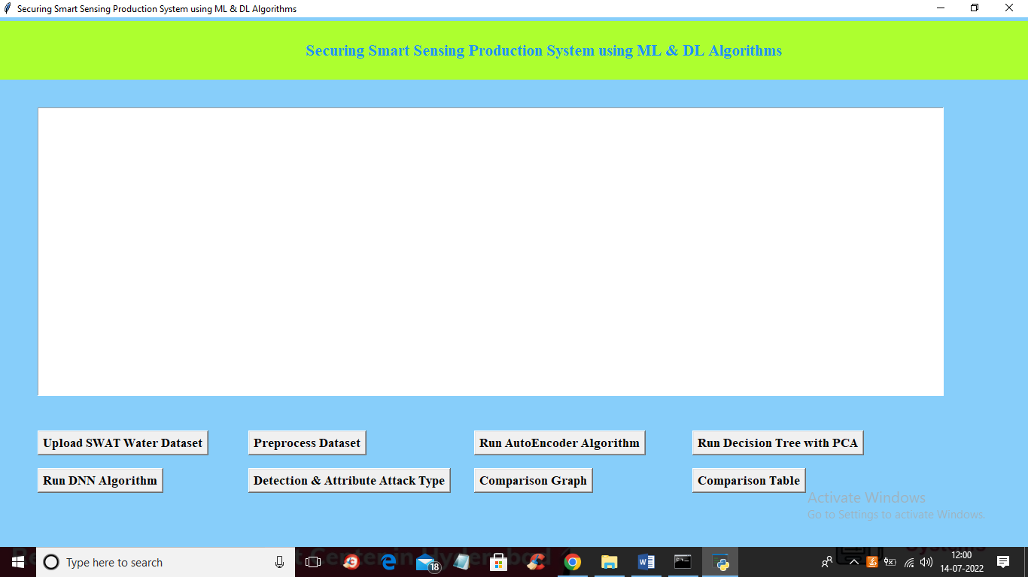

In above screen click on ‘Upload SWAT Water Dataset’ button to upload dataset to application and get below output

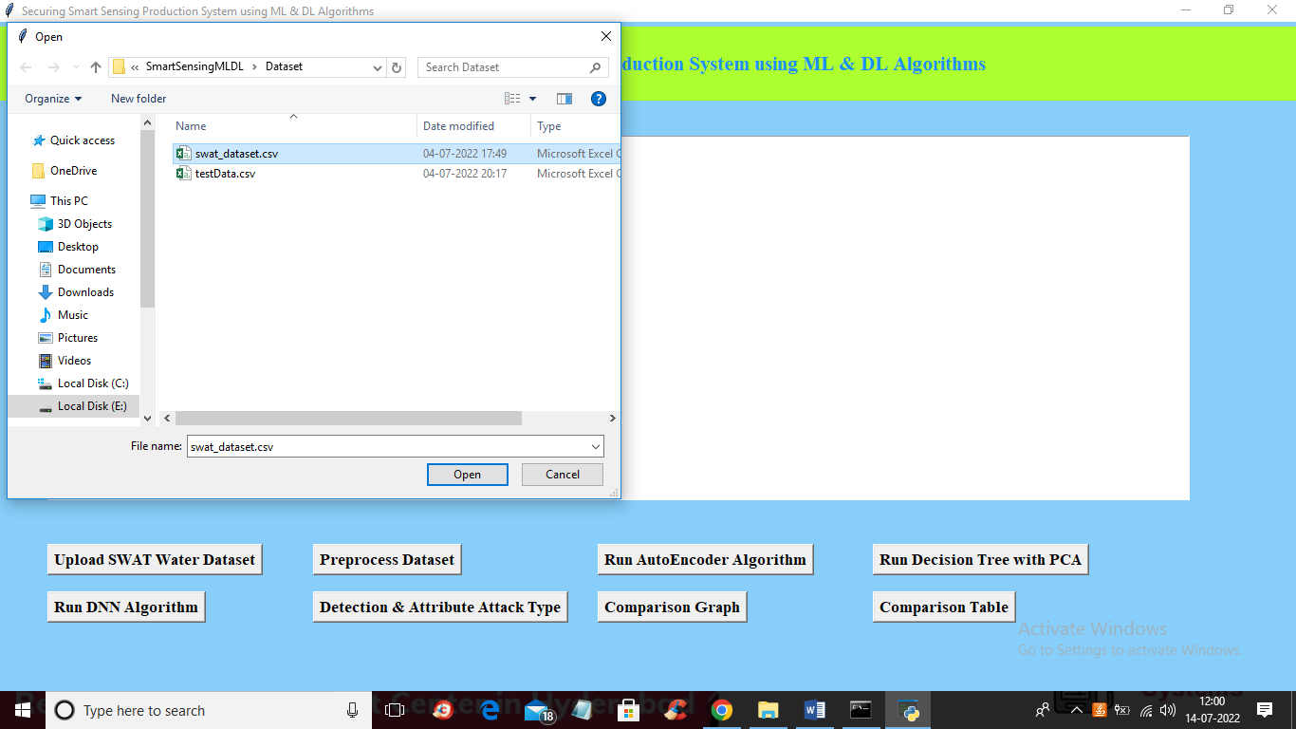

In above screen selecting and uploading SWAT dataset file and then click on ‘Open’ button to load dataset and get below output

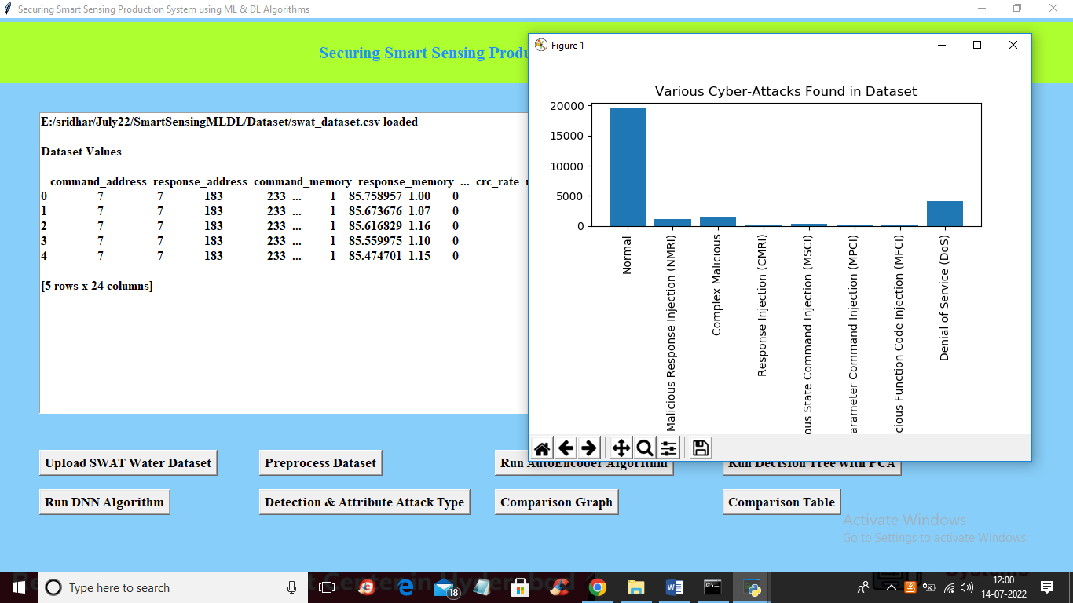

In above screen dataset loaded and in graph x-axis contains ATTACK NAME and y-axis contains count of those attacks found in dataset and we can see ‘NORMAL’ class contains so many records and other attacks contains very few records so it will raise data imbalance problem which can be solved using AutoEncoder, Decision Tree and DNN. Now close above graph and then click on ‘Preprocess Dataset’ button to remove missing values and then normalized values with MIN-MAX algorithm

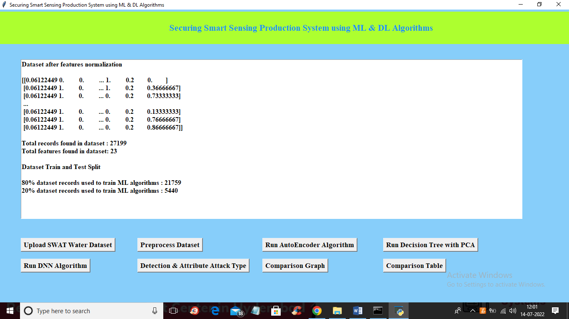

In above screen all values are normalized ( converting data between 0 and 1 called as normalization) and then we can see total records in dataset and then dataset train and test split records count also displaying. Now dataset is ready and now click on ‘Run AutoEncoder Algorithm’ button to train dataset with AutoEncoder and get below accuracy

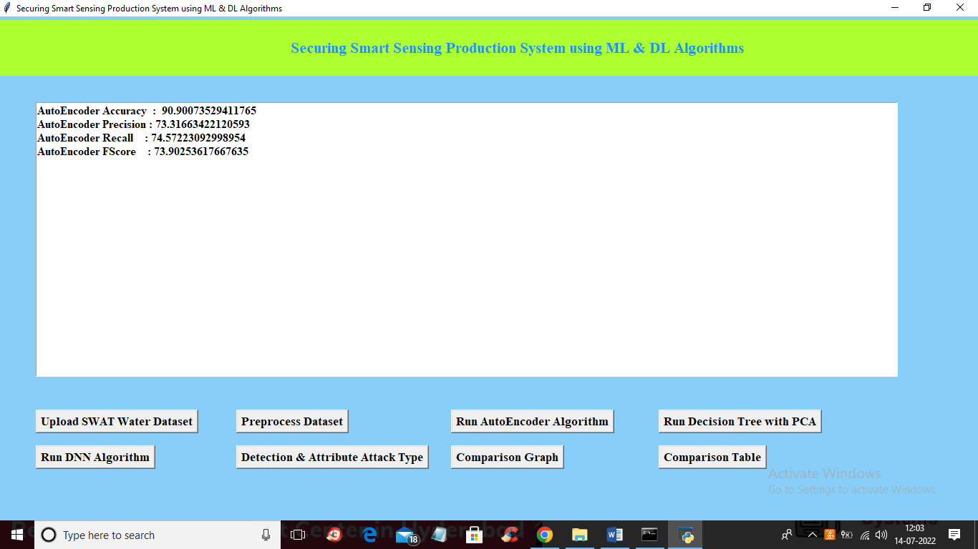

In above screen with AutoEncoder we got 90% accuracy and this accuracy can be enhance by implementing Decision Tree with PCA algorithm and now click on ‘Run Decision Tree with PCA’ button to get below output

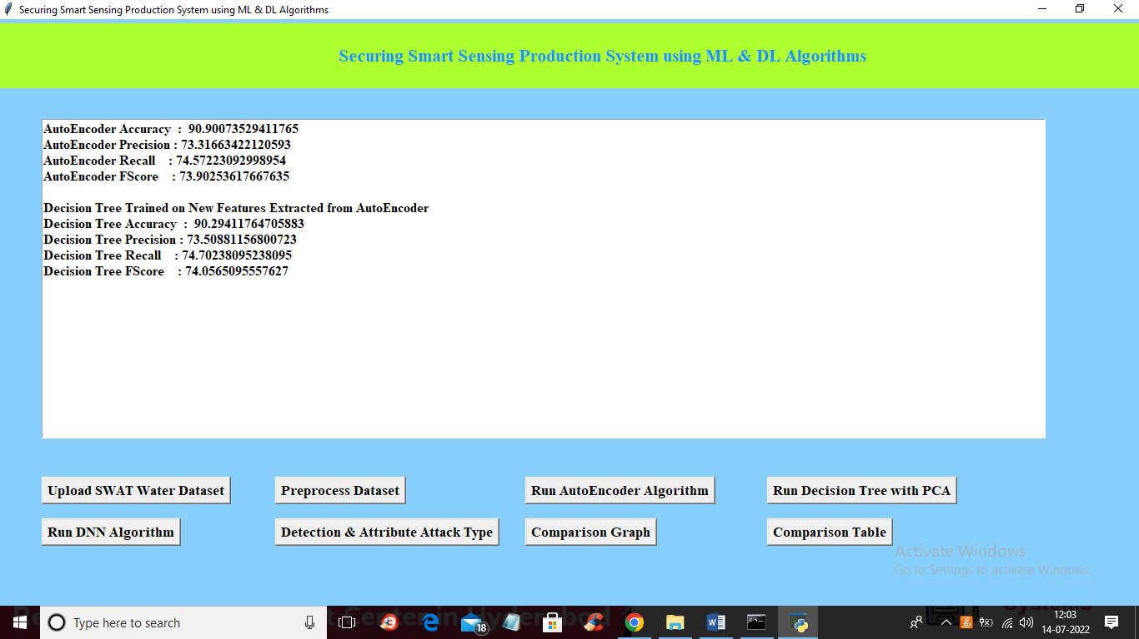

In above screen we can see with decision tree accuracy and precision value is enhanced and now click on ‘Run DNN Algorithm’ button to further enhance accuracy and get below output

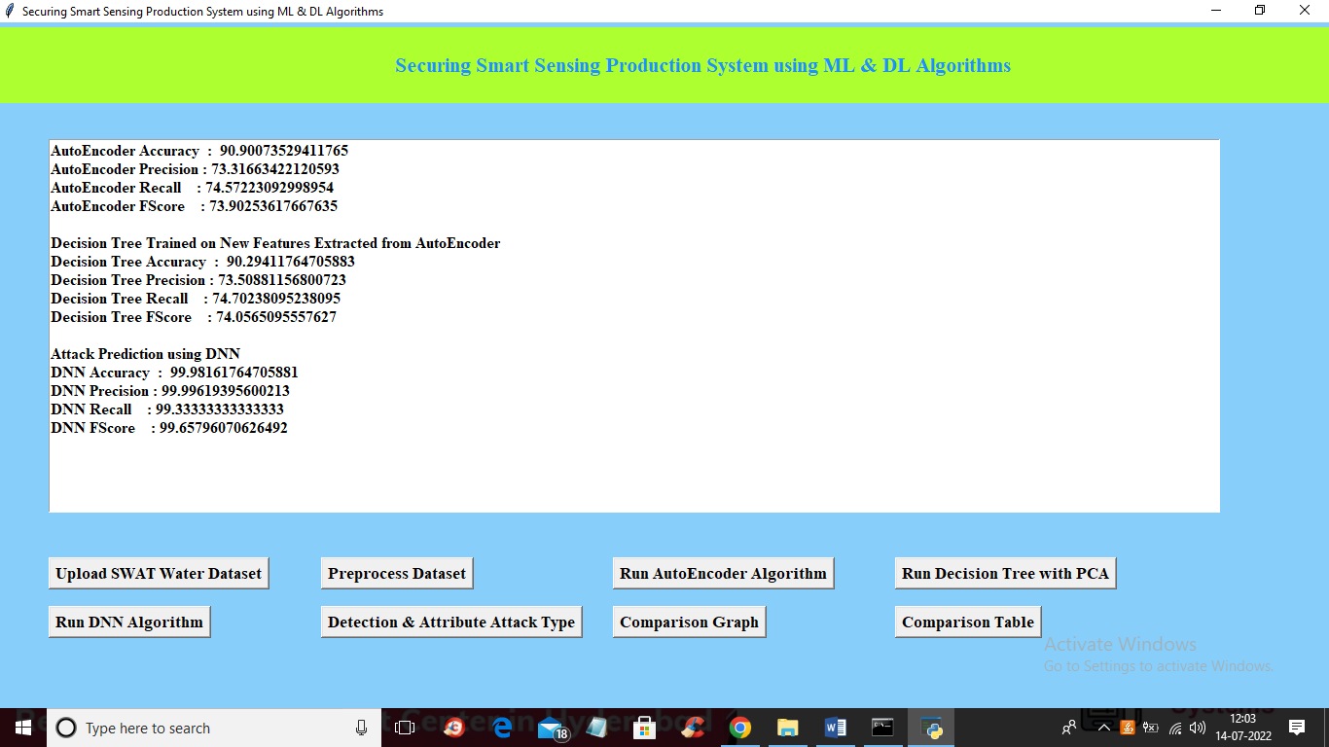

In above screen with DNN we got 99% accuracy and this accuracy may vary from 95 to 100% as we are splitting dataset into random train and test. Now click on ‘Detection & Attribute Attack Type’ button to upload test DATA and detect attack attributes

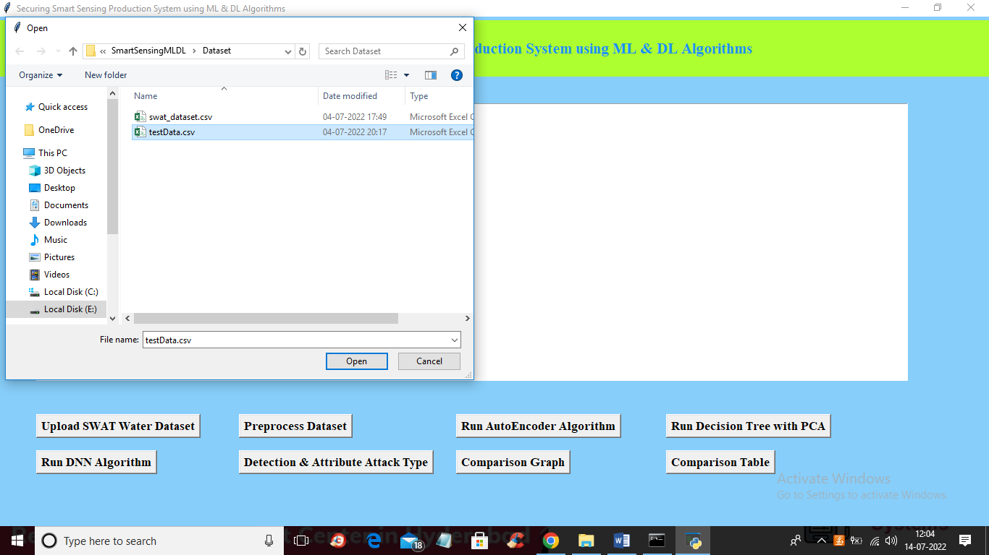

In above screen selecting and uploading ‘TEST DATA’ file and then click on ‘Open’ button to get below output

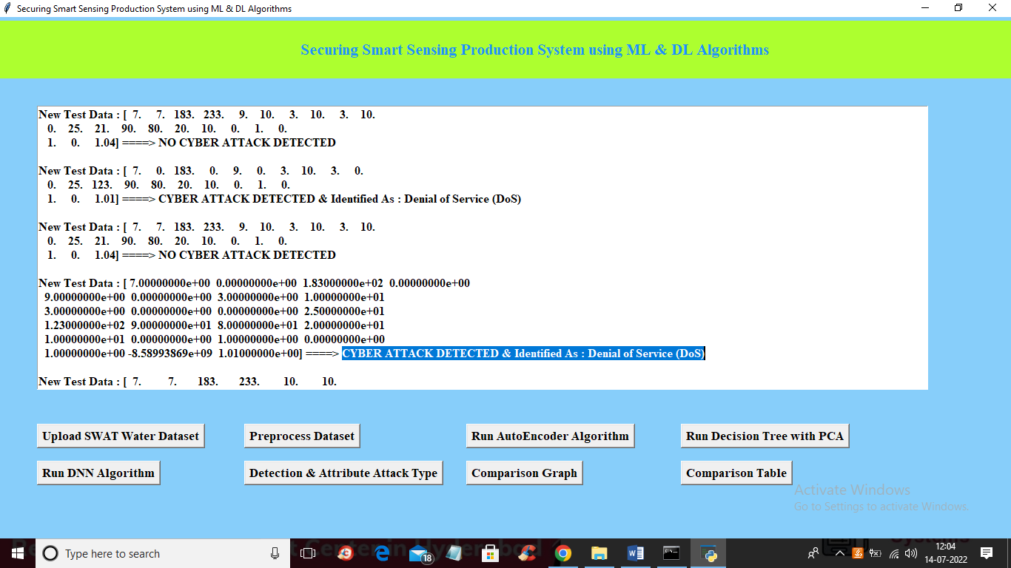

In above screen in square bracket we can see TEST data values and after arrow =🡺 symbol we can see detected ATTACK TYPE and scroll down above text area to view all detection

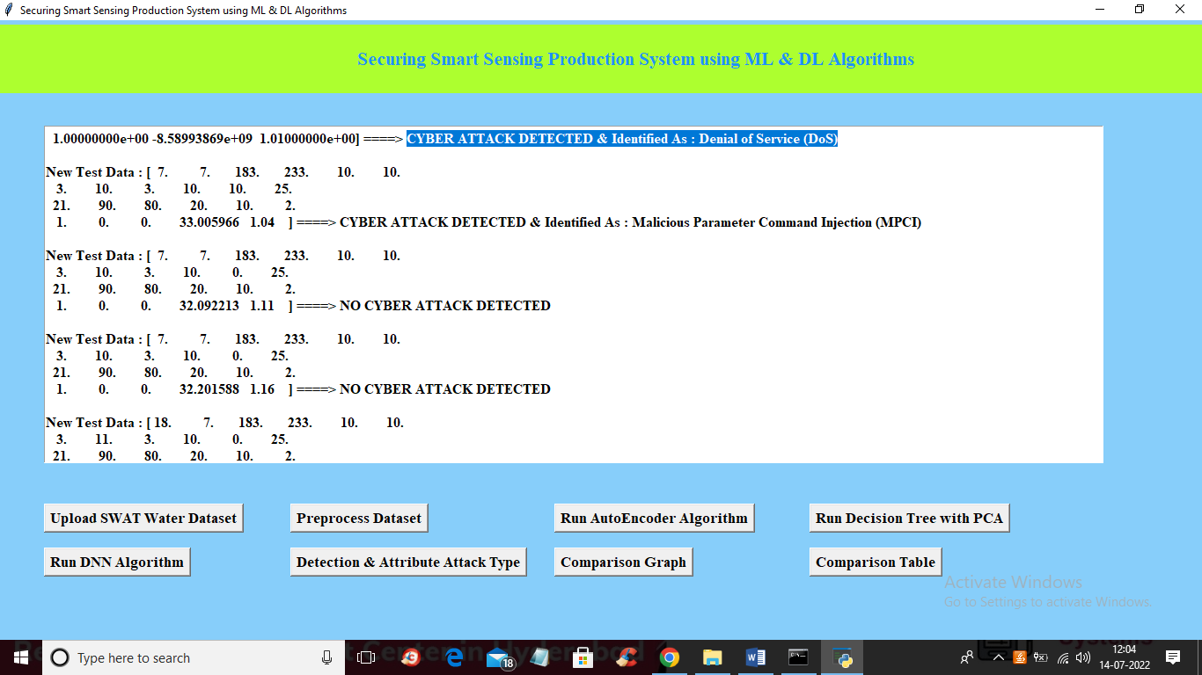

In above screen we can see detected various attacks and now click on ‘Comparison Graph’ button to get below graph

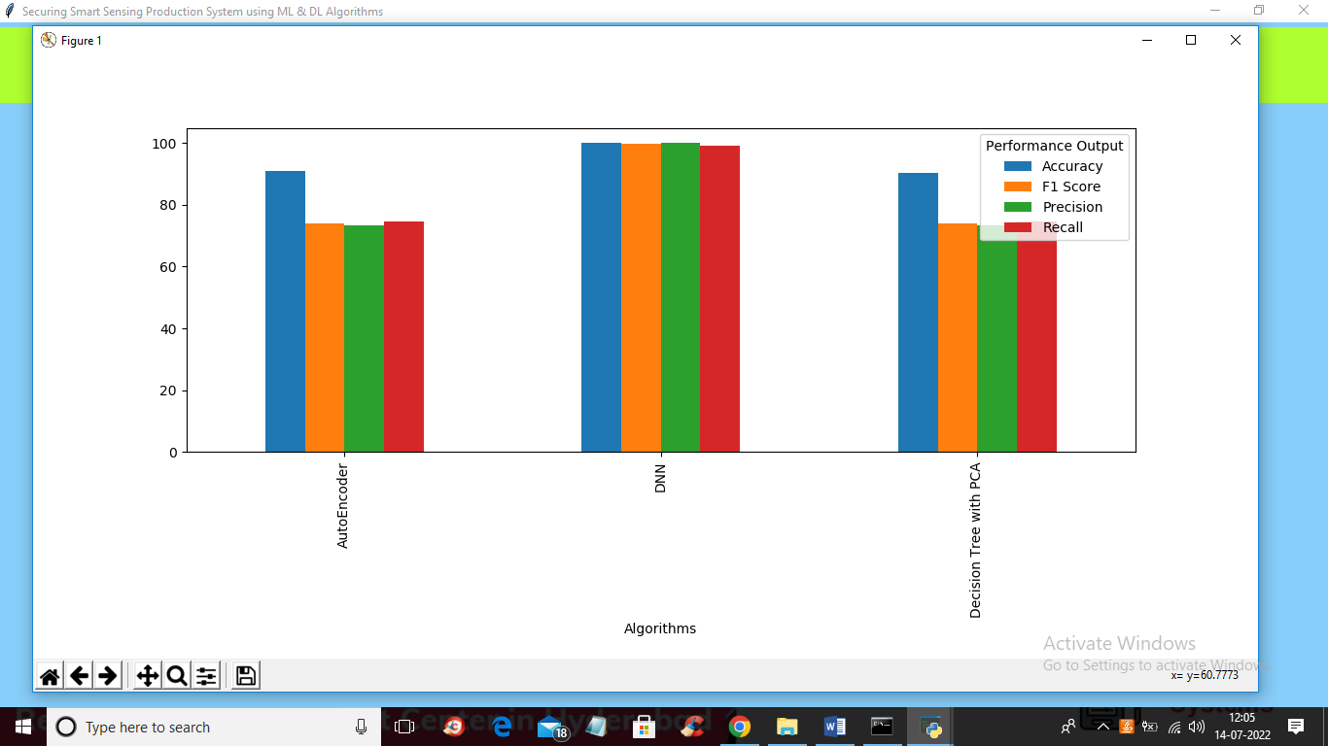

In above graph x-axis represents algorithms names and y-axis represents different metric values such as precision, recall, accuracy and FSCORE with different colour bars and in all algorithms DNN got high accuracy and now close above graph and then click on ‘Comparison Table’ to get below comparison table of all algorithms

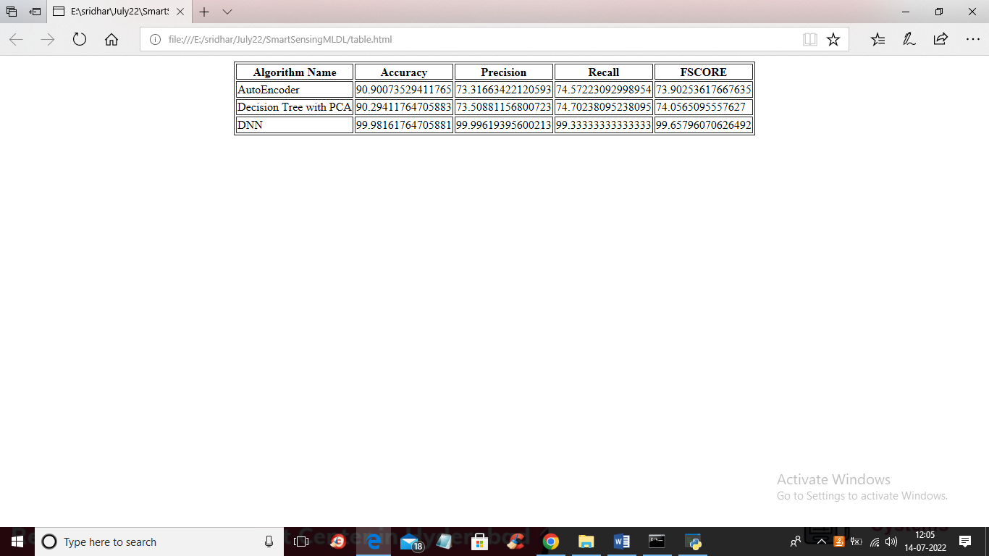

In above table we can see algorithm names and its metrics values such as accuracy and precision and other.

# **CONCLUSION**

In conclusion, the proposed system for securing smart sensing production systems represents a significant advancement in the field of industrial cybersecurity. By integrating machine learning and deep learning techniques, this framework effectively addresses the limitations of existing security measures, offering enhanced detection accuracy and adaptive capabilities that are essential in today’s dynamic threat landscape. The system’s ability to proactively identify and respond to potential threats not only mitigates risks but also fosters a culture of continuous improvement in security practices.

Moreover, the emphasis on data privacy ensures that sensitive information is protected, aligning with regulatory requirements and enhancing trust among stakeholders. The scalability and flexibility of the system make it suitable for a diverse range of production environments, enabling organizations of all sizes to benefit from advanced security measures. As industries continue to evolve with the adoption of smart technologies, the importance of robust cybersecurity solutions cannot be overstated.

Ultimately, the proposed system serves as a comprehensive solution that not only safeguards production processes but also contributes to the overall resilience of smart manufacturing ecosystems. By leveraging the power of machine learning and deep learning, organizations can better prepare for and respond to the complexities of modern cyber threats, ensuring the integrity and reliability of their operations for the future.

# **FUTURE SCOPE OF THE PROJECT**

The future scope of the project focused on securing smart sensing production systems is expansive, with numerous opportunities for enhancement and innovation. As industries continue to adopt more sophisticated technologies, the need for advanced security solutions will grow correspondingly. One promising direction is the integration of more advanced artificial intelligence techniques, including federated learning and transfer learning. These approaches can allow the system to learn from decentralized data sources while maintaining privacy, thereby enhancing its ability to adapt to different environments without compromising sensitive information.

Additionally, the incorporation of real-time threat intelligence feeds could significantly bolster the system’s effectiveness. By leveraging external data on emerging threats and vulnerabilities, the proposed system can remain proactive and informed, adjusting its security protocols based on the latest threat landscape. This real-time adaptability would enhance the system’s capability to preemptively respond to potential attacks, further safeguarding production processes.

Another important avenue for future development is the expansion of the system’s capabilities to include predictive analytics. By employing advanced forecasting models, the system could anticipate potential security breaches before they occur, enabling organizations to implement preventive measures. This proactive approach would be invaluable in minimizing operational disruptions and ensuring a secure production environment.

Collaboration with other emerging technologies, such as blockchain, could also be explored. The decentralized nature of blockchain can enhance data integrity and traceability, providing an additional layer of security for smart sensing production systems. By combining these technologies, organizations can create more resilient frameworks that not only secure data but also ensure transparency and trust throughout the supply chain.

Finally, as the regulatory landscape continues to evolve, there will be a growing need to align security solutions with compliance requirements. Future iterations of the proposed system should focus on automating compliance monitoring and reporting, thereby simplifying the adherence to regulations while maintaining robust security protocols.

In summary, the future scope of this project encompasses a range of enhancements that leverage emerging technologies and methodologies. By continuously evolving and adapting to new challenges, the proposed system can significantly contribute to the ongoing effort to secure smart sensing production environments against the backdrop of an increasingly complex cyber threat landscape.

# **REFERENCES**

1. Ahmed, M., Mahmood, A. N., & Hu, J. (2016). "A survey of network anomaly detection techniques." *Journal of Network and Computer Applications*, 60, 1-25. https://doi.org/10.1016/j.jnca.2015.11.016
2. Dutta, A., & Mohanty, S. (2020). "Anomaly detection in smart manufacturing: A hybrid machine learning approach." *IEEE Access*, 8, 89037-89047. https://doi.org/10.1109/ACCESS.2020.2998703
3. Li, Y., Li, M., & Wang, J. (2021). "Deep learning for anomaly detection in industrial Internet of Things." *Journal of Industrial Information Integration*, 21, 100192. https://doi.org/10.1016/j.jii.2020.100192
4. Zhang, C., Wu, H., & Wang, X. (2022). "Predictive security analytics for industrial IoT: A deep learning approach." *IEEE Transactions on Industrial Informatics*, 18(6), 4232-4241. https://doi.org/10.1109/TII.2021.3071384
5. Kaur, A., Ghosh, R., & Tiwari, M. (2023). "Reinforcement learning-based adaptive cybersecurity for smart manufacturing." *Journal of Manufacturing Systems*, 63, 162-173. https://doi.org/10.1016/j.jmsy.2022.09.014
6. Kim, D. H., Kim, S. K., & Kim, Y. J. (2022). "Adversarial attacks on machine learning models for cybersecurity: A survey." *IEEE Communications Surveys & Tutorials*, 24(2), 1281-1308. https://doi.org/10.1109/COMST.2022.3145150
7. Patil, S., & Haldar, A. (2019). "Machine learning-based intrusion detection system for IoT devices." *International Journal of Computer Applications*, 182(19), 25-30. https://doi.org/10.5120/ijca2019919427
8. Sethi, A., & Sarangi, S. (2017). "Internet of Things: Architectures, protocols, and applications." *Future Generation Computer Systems*, 75, 10-25. https://doi.org/10.1016/j.future.2016.08.013
9. Alzubaidi, L., et al. (2021). "Review of deep learning in medical imaging: Opportunities and challenges." *Journal of Medical Systems*, 45(3), 1-11. https://doi.org/10.1007/s10916-021-01799-4
10. Lee, J., & Kim, J. (2020). "Cybersecurity in smart factories: A survey." *Computers & Security*, 102, 102138. https://doi.org/10.1016/j.cose.2020.102138
11. Bhattacharya, S., & Bhattacharya, S. (2020). "IoT security and privacy: Challenges and solutions." *Internet of Things*, 8, 100310. https://doi.org/10.1016/j.iot.2020.100310
12. Bhatia, A., & Jain, P. (2018). "Machine learning approaches for network intrusion detection: A survey." *International Journal of Computer Applications*, 181(13), 1-6. https://doi.org/10.5120/ijca2018917468
13. Thakare, V., & Patil, S. (2021). "A comprehensive review on security issues in smart manufacturing." *Journal of Ambient Intelligence and Humanized Computing*, 12(3), 3671-3685. https://doi.org/10.1007/s12652-020-02718-6
14. Dey, S., & Ghosh, R. (2019). "Deep learning in cybersecurity: A survey." *Journal of Network and Computer Applications*, 142, 1-12. https://doi.org/10.1016/j.jnca.2019.101897
15. Rani, S., & Kaur, H. (2022). "Artificial intelligence in cybersecurity: A review." *International Journal of Information Security*, 21(3), 239-256. https://doi.org/10.1007/s10207-021-00606-x
16. Choudhury, R. S., & Aich, S. (2020). "Cybersecurity in Industry 4.0: An overview." *IEEE Access*, 8, 233320-233335. https://doi.org/10.1109/ACCESS.2020.3046736
17. Kumar, R., & Sharma, K. (2021). "Security and privacy in IoT: A review." *Future Generation Computer Systems*, 118, 167-182. https://doi.org/10.1016/j.future.2020.09.029
18. Zhao, Z., & Lee, Y. (2022). "Enhancing industrial cybersecurity with AI: A survey." *IEEE Transactions on Emerging Topics in Computing*, 10(2), 445-459. https://doi.org/10.1109/TETC.2020.2999461
19. Alzahrani, B., & Aburomman, A. A. (2021). "Machine learning techniques for intrusion detection systems: A survey." *Computers & Security*, 109, 101888. https://doi.org/10.1016/j.cose.2021.101888
20. Qiu, Y., & Zhang, X. (2020). "A survey on the security of industrial control systems." *IEEE Transactions on Industrial Informatics*, 16(3), 1880-1890. https://doi.org/10.1109/TII.2019.2915117