AI for Smart Manufacturing and Industry 4.0

Predicting Machine Failures, Inspecting Quality and Planning Production

Group | Group 06
Name | Rishika Yaduvanshi
Enrolment Number | 20261030
Programme | PGDM in Big Data Analytics
Course Faculty | Chintan Patel (Introduction to AI)
Date | 18th October 2026

Introduction and Problem
Looking at a typical manufacturing plant in India. The machine breaks down in the middle of a shift, a batch of products turns out defective, the production team has to reschedule the whole shift by hand. These problems may look different but they are closely related. When a machine breaks down production is held up. Then the workers will try to finish the pending orders as fast as they can. This may lead to more mistakes and product defects at times. Many factories still do repairs only after machine breakdown, products are inspected manually, and production schedules are developed using spreadsheets or experience. These techniques may be time consuming and not always produce the best results.
Here we propose a system powered by AI that can help factories to tackle these three problems simultaneously. The system has three major elements. First, predictive maintenance leverages machine data to detect early signs of failure and enables the maintenance team to be proactive before breakdowns occur. Second, computer vision utilizes cameras and AI to detect defects and enhance product quality control. Third, smart scheduling helps in deciding which job should be performed on which machine at what time so that production runs more smoothly and delays are minimized. Together with these characteristics we also speak of the responsible use of AI in manufacturing. AI is able to forecast and recommend solutions, but human workers and managers should remain involved in the big decisions. These practical applications are linked to relevant topics from our course, such as intelligent agents, search and optimization, reasoning under uncertainty, and machine learning. The goal is to demonstrate how these concepts can be applied in a real factory to save time, reduce waste and increase overall productivity.
1.1 What is AI? Agents and the three kinds of AI
Artificial Intelligence (AI) is a term for computer systems that can do things that usually need human intelligence, like recognizing images, making predictions, planning, and learning from data. An intelligent agent is a system that perceives its environment, processes information and acts to achieve a specific goal (Russell & Norvig, 2021). The AI system in our factory example works on the same idea. Sensors and cameras gather data from machines and products and AI models analyze the data to help detect potential problems. The system can issue alerts, recommend maintenance or suggest changes to the production schedule based on the results. Table 1 describes the functioning of this system using the PEAS method (Performance, Environment, Actuators and Sensors).
Artificial intelligence can also be classified into three levels based on its capabilities. Narrow AI is designed to do one specific thing, such as detecting scratches on metal sheets or predicting when a machine might fail. General AI is a system that can understand and perform a wide range of tasks like human intelligence. Super AI is the hypothetical AI that would be more intelligent than humans in many ways. General AI . We haven't achieved Super AI . This report is talking about a system which is using Narrow AI because its functions are well defined and can be applied to the real manufacturing problems today. By concentrating on specific tasks, factories may improve the quality of their products, minimize machine breakdowns, and make improved production decisions.

2. A Brief History of AI and Why It Matters Now
Back in 1950 Alan Turing asked whether a machine could actually think. He proposed the test later called the Turing Test, which said that if it was impossible to distinguish between a conversation with a computer and with humans, then the machine could be considered to be intelligent (Turing, 1950). The promises were too much, and AI used rule-based programming. Funding has been cut twice, once in the 1970s and again at the end of the 1980s. These times when the development of artificial intelligence had frozen are called AI Winters. The resurgence of AI came with the development of data-driven AI. Behind it all were cheaper sensors, faster computers, and the Internet. Modern factories produce a lot of data every second, making the idea of Industry 4.0 possible.

- AI in the Modern Business & Types of Artificial Intelligence Systems
AI is used in almost every business function. Table 2 shows some common uses and how each one relates to a manufacturing firm.
Artificial intelligence systems can also be divided into three categories and our design makes use of all three:
• Rule-based systems use fixed if-then rules, written by experts, e.g. if motor temperature is above 90°C, send an alert. They are easy to explain, simple, but they are not able to learn.
• Learning-based systems learn patterns from data, e.g. learning what a normal vibration looks like or what a cracked part looks like.
• Generative AI creates new text or images, e.g. a chat assistant that summarizes a machine manual for a technician or writes a maintenance report.
4. AI Strategy: The System Proposed
Most business organizations follow a three-step process to adopt AI. First they do an experiment with a pilot project. Then they scale that success to larger teams and locations. Lastly, they reinvent themselves so that data drives all decisions. Most of the manufacturing firms in India are in the early stages of implementation of AI from first to second step. We therefore suggest a step-by-step approach (Section 9).
Our strategy is to move from fixing problems after they happen to fixing problems before they happen in the factory. The flow is shown in Fig. 1. Data capture and analysis is handled by three AI modules. Then the analysis becomes choices. The biggest decisions are finally signed off by people.
4.1 Data and knowledge in the plant
The factory has two sorts of information. Structured data can be organized in the form of tables (e.g. sensor data, orders, records of stock and maintenance). There are unstructured data that can not be structured this way (camera data, sounds produced by machinery and notes of technicians). All of them are needed, so all data will be entered in one unified platform, where duplicate and wrong readings will be excluded. Two methods of information storage facilitate the AI reasoning process. In expert systems or trees of decisions, the experience of the engineers are stored as rules. knowledge graph linking machines, their parts, jobs and customer orders so you can ask questions like: "If Machine 4 is down, which orders will be delayed?
Example of expert rules for pumps
• If vibration level is high AND temperature is high then service within 24 hours.
•If the vibration level is high, but the temperature is normal, check at the next scheduled machine shutdown.
If both values are normal, run normally.
The decision tree can also generate these rules itself, from failure data. This is much easier than having engineers design all the rules.
5. Relation of all
5.1 Dealing with uncertainty
There can never be absolute certainty about any sensory input. The system will determine this based on probabilities. Bayes’ theorem allows us to update the posterior probability as new data comes in. For example, you might say the probability of a failure next week is 2%. 80% of the malfunctioning machines have high vibration as compared to 10% in normal cases. Thus, the new probability of failure is (0.80 * 0.02)/(0.80 * 0.02+0.10*0.98), that is 14%. In 70% of faulty machines and in 15% of healthy ones, when the high temperature assumption in addition, the probability is 43% and the service is scheduled.
Fuzzy logic is useful for describing linguistic qualifiers like "somewhat" or "quiet". Instead of one threshold at 90°C, each measurement has a value in the range [0;1] (Zadeh, 1965). If vibration is “high” (value=0.7) and temperature is “warm” (value=0.6), the rule “high vibration AND warm temperature → medium-high risk” is applied with strength of minimum of values, min (0.7; 0.6)=0.6. The output would be schedule a maintenance.
6. Computer Vision for Quality Control
For each product on the line one image is taken and the AI predicts if the item is of an acceptable quality or if there are some defects. This is done using supervised learning . We show the model thousands of already classified images and the algorithm learns the differences. The most suitable architecture for images is CNN - Convolutional Neural Network. CNN is deep learning and consists of detecting small features such as edges first and then joining these features to form more complex shapes (LeCun et al., 2015). It will pick up any scratches, cracks, wrong dimensions or any assembly defects. If there is insufficient evidence for the model, then the decision is taken by a human inspector. The inspection process consists of the following stages:
Capture: the camera captures the image of each object moving on the belt;
• Preparation: the image is prepared so that the model gets clear information;
• Decision: CNN gives a score e.g. “96% sure that this one has a crack”
• Action: a clear defect is removed from the line; in doubt the item goes to
7. Smart Production Planning
7.1 Problem formulation
The first step is to properly define a production planning problem, so the AI system knows what it is to achieve. A state is an incomplete production plan, i.e., which jobs are already assigned to machines and which jobs are remaining. Action will be a distribution of one more job to the available machines according to their load and productivity requirements. The final state will be the optimal production plan, where all jobs have been assigned and done in the minimal time satisfying the requirements in terms of their deadlines. The cost function will be used to estimate different production plan considering total production time, delivery delays and useless idle time of machines. So the main goal is to find an optimal plan to minimize costs and utilize resources efficiently to perform the tasks. The state space of our problem will be the set of all possible plans of production. Unfortunately, as the number of jobs and machines used for production grows, the number of possible states grows very quickly. For example, if there are 20 jobs that can be assigned to any of 5 machines, there could be $5^{20}$ possible combinations, or roughly 95 trillion. So, it is not possible
7.2 Search and optimization methods
There are two ways that artificial intelligence can use to find suitable solutions to a problem: informed search and uninformed search. Uninformed search methods (e.g. Breadth-First Search (BFS) and Depth-First Search (DFS)) search for possible options without using extra information about which option is likely to be the best. BFS explores option by option. DFS explores a path as far as it can, then backtracks and explores another. These methods may be useful for smaller problems, but they may require a lot of time and memory when the number of possible production schedules becomes very large.
Informed search methods use extra information, called a heuristic, to estimate which options are most promising.

Greedy Best-First Search chooses the path that seems to be closest to the goal according to the estimated distance remaining. It can find a solution quickly, but not always the best one. A search* takes into account the cost so far and the estimated cost to the goal. It uses these two values to determine which option to explore next. Under appropriate search conditions, A* can find an optimal solution if the heuristic does not overestimate the actual remaining cost (Hart et al., 1968). This enables the system to compare various production schedules in manufacturing considering completion time, delays and machine availability. Local search methods can also be useful when a factory has a very large number of possible schedules. Local search does not consider all possible plans but begins with an initial schedule and then makes small changes to improve. It may, for example, move a job from one machine to another, change the sequence of jobs, or reduce the idle time of a machine. The system improves the schedule until it finds a satisfactory solution or hits a stopping condition. The three commonly used local search algorithms are Hill Climbing, Simulated Annealing and Genetic Algorithms. Hill Climbing changes the current solution to make it better. Simulated Annealing sometimes accepts a change which makes the solution worse in an attempt to escape from a poor solution. Genetic Algorithms combine and modify different candidate solutions in an attempt to search for better solutions. Table 4 summarizes these three methods.
Example: Scheduling Four Jobs on Two Machines
Now imagine a factory with 4 jobs; A, B, C and D. Their processing times are 4, 3, 2, 3 hours respectively. The factory has two machines and each job has to be assigned to one of the machines. The primary goal is to minimize the total completion time for all four jobs. In Plan 1, all the four jobs are assigned to Machine 1. Total processing time is 4 + 3 + 2 + 3 = 12 hours and Machine 2 is not used. This is not an efficient schedule because one machine does all the work while the other does nothing. In Plan 2 the jobs are more evenly spread between the two machines. Machine 1 has Jobs A and D and takes 4 + 3 = 7 hours while Machine 2 has Jobs B and C and takes 3 + 2 = 5 hours. If both machines are available at start, the factory finishes all the jobs in 7 hours. This is the makespan, that is, the time to finish all jobs on the machines.
Now let’s assume that Machine 2 requires service during the first two hours. If Jobs B and C are assigned to it, they can start only when servicing is performed. 2+3+2 = 7 hours for me to get done working . It would also take 7 hours to get done working for machine 1 . So, if servicing is finished within the planned two hours, and there are no other delays, the whole schedule needs seven hours. A poorly scheduled schedule that ignores the service requirement may lead to further delays or reassign jobs later. The smart scheduler takes into account machine availability before job assignment. It can schedule Jobs A and D on Machine 1 and then process Jobs B and C on Machine 2 while Machine 2 is being serviced. In this example both machines are completed at the end of the seventh hour. This shows how search and optimization can help a factory make better use of available machines, take into account maintenance needs and avoid unnecessary delays. The example also shows why production scheduling should not be based solely on the processing time of each job. Besides machine availability, maintenance, deadlines and changes in production requirements need to be taken into account. An AI system that combines search algorithms with real-time factory data can update schedules as conditions change, then recommend a practical plan to keep production flowing smoothly.
8. Business Case and Examples from the Industry
For our group presentation we talked about various companies that use AI in manufacturing or could use AI in manufacturing. These are just a few examples of how standard artificial intelligence can help make factory work easier, faster and more efficient. However, if you want to include any specific information about these companies or their results it must be checked before it is included in a formal report. A measure called Overall Equipment Effectiveness (OEE) can be used to measure how well a factory is doing. It says how good we are in using machines and production lines. OEE is calculated by multiplying three factors; Availability, Performance and Quality (Nakajima, 1988). This provides the percentage of planned production time that a machine is actually operational and ready to produce. Availability Performance is whether the machine is running at the speed we expect. Quality is the measure of the number of products that are up to the standards without defects. Together these three factors give a better picture of the overall performance of the factory. For instance, think of a factory with 70% availability, 90% performance and 95% quality. The OEE would be 0.70 x 0.90 x 0.95, or about 60%. This means that the effectiveness of the factory’s use of machines to produce good quality products could be improved.
Now, imagine the factory uses AI to predict when a machine might break down and detect faulty products earlier. This results in availability rising to 85%, performance remaining at 90% and quality increasing to 98%. So the new OEE would be 0.85 * 0.90 * 0.98, or roughly 75%. This example illustrates how increasing machine availability and product quality can make a visible difference to the factory performance. These numbers, however, are only examples used to demonstrate our group presentation. These are not guarantyd results, as the actual improvement will depend on the factory and how well the AI system works. There are many advantages to AI, however it does require an investment to set up the system. The factory could require sensors to collect data from machines, edge hardware to process data near the production line, and software to analyze the information. There will also be costs for installation, maintenance, software updates and training of employee. Workers must know how the system works and how to use its advice in their day-to-day operations. But in the long run, standard artificial intelligence can help the factory save money. Take, for example, predicting machine failures – this can avoid sudden breakdowns and expensive emergency repairs. Early detection of faulty products can help to prevent material waste and reduce the need to repair or remake products. AI-driven production planning can also help to cut delays and make better use of machines, workers and raw materials. Furthermore, the prediction of maintenance needs enables the factory to plan its spare-part purchases rather than ordering parts in a hurry when a machine fails.
The payback period is expected to be approximately 14 to 22 months based on the estimate used in our group presentation. Simply put, the payback period is the time it takes for the savings from the AI system to pay back the money you spent on it. But this time can be different in different factories. It is contingent upon the price of the installation of the system, how often machines break down, the waste of product, and the savings after implementation. A factory should not be entirely dependent upon estimated figures. It should first analyze its current costs and production performance, pilot the AI system on a small scale and benchmark the results, before considering broader deployment. In general, artificial intelligence can help factories become more efficient, cut unnecessary expenses, improve the quality of products and minimize production delays. Managers can also monitor OEE and compare the actual savings to the cost of setting it up to see if the system is providing the benefits they anticipate. The goal is to ensure that AI enhances factory operations and offers sufficient real-world and financial value to support the investment.
9. Roadmap and Risk of Implementation
Key Risks and Mitigation
Although standard artificial intelligence can provide many advantages to a factory, there are a few challenges that must be taken into account. It is common to find that older machines lack the technology needed to gather useful data. In such cases, factories can start with cheap sensors and work on improving the quality of data they collect. This gives the AI system better information to work with. Another issue is cybersecurity and the possibility that AI will make false predictions. The system is connected to the machines and factory data, so it is very important to protect the system from the unauthorized access. AI models should be tested regularly, access limited to authorized personnel and critical decisions should always be overseen by a human. New artificial intelligence systems can also make workers uncomfortable, particularly if they fear the technology might take their jobs. The factory should take a phased approach to adopting AI and start by using it to offer suggestions instead of making decisions on its own. Good training can help employees understand the system and feel more confident in using it. It is about making their work easier, improving safety and helping them make better decisions.
Responsible AI Use
AI should enhance the workers and managers, not replace their judgment altogether. AI is able to spot problems and recommend actions, but people still have to be responsible for important decisions. In cases where the system advises to halt a production line or reject a complete batch of products, this information should be looked at by a qualified person before proceeding. It is also important that the AI system explain how and why it raised an alert. Or instead of saying a machine might fail, it could say its vibration level is 40% above normal. It gives engineers a good reason to investigate the problem, and helps them know if the recommendation is trustworthy. Privacy is another important part of responsible use of AI. The collected data, such as camera footage and employee information, should only be used for the reasons explained to the concerned people. The factory should also store this information securely and restrict access to it to authorized users. Its data collection and handling practices must comply with India’s Digital Personal Data Protection Act, 2023, where applicable. These steps can help build trust between workers and ensure that AI is used in a fair and responsible way.

10. Summary
When machines break down suddenly, when products that do not meet the required standards pass through the production line and when the production plan fails to work correctly, industrial companies can suffer serious financial losses. All these problems affect the operations adversely resulting in delay, increase in operating expenses, wastage of raw materials, decrease in the quality of produced products. In the competition, the factories must make the products of good quality in time, and use the resources efficiently. To find out these problems traditional techniques for production management may not be sufficient. So, Artificial Intelligence can make the work of the factory much easier. An integrated AI system can address these problems by predicting machine failures, detecting product defects and improving production planning. It can gather and analyze data from machines, sensors and production processes to help managers make decisions.

For example, sensors gather data on the temperature, vibrations, speed and pressure of the machine. The AI system can evaluate these data and discover abnormal patterns which may indicate the possible machine failure based on this information. Then the maintenance workers can do the necessary checks or repairs.” That is called predictive maintenance. Unexpected machine breakdowns, delays in production and extended Another important application of AI is production planning and scheduling. Factories have to manage machines, workers, raw materials, delivery deadlines and customer orders at the same time. poor planning means wasted resources, longer waiting times and delayed deliveries. Search techniques and optimization methods can be used to compare different possible solutions and find better production schedules. An AI system can suggest which product should be manufactured first, which machine should be used and how to distribute available resources. The system can help reschedule to minimize disruption should a machine stop working unexpectedly or an urgent order come in. This gives the production more flexibility and helps the factory to react on unexpected changes.
These applications link many important topics of our course. Intelligent agents allow the system to monitor the factory environment, analyze the information and recommend appropriate actions. Search and optimization for efficient production schedules and resource allocations. The system can reason under uncertainty to make decisions when it does not have complete information or a machine failure might occur, but it does not have to. Machine learning enables the system to learn patterns from past data and improve its predictions as it goes. Deep learning techniques such as CNNs can also be used to analyze product images and detect defects. These concepts together show how the different fields of standard artificial intelligence can be put together to solve real-world problems in manufacturing.

Key Takeaways

• Concentrate on the core issues: Begin with solving the issues associated with machine malfunctions, defective products, and poor production planning.

• Prediction of failures in advance: Use anomaly detection and probabilistic methods to detect anomalous behavior of machines and to predict their failure in advance.

• Increase product quality: Implement computer vision based on CNNs for product inspection and defect detection; leave the verification of doubtful cases to human employees.

• Optimize production planning: Apply search and optimization methods for the creation of effective schedules of production to minimize delays and be able to react flexibly to unexpected situations.

• Better decision-making based on data: Collect relevant information from machines and sensors to analyze production problems and to implement appropriate solutions.

• Do not replace human judgment: The role of AI must be to assist people in making decisions; critical cases should be handled by humans.

• Begin small-scale implementation: Start with the pilot project in one area of the plant, evaluate its effectiveness, calculate potential savings and implement the system further.

Appendix: Tables and Figures
PEAS element | Factory AI agent
Performance | Less downtime; fewer defects; fewer idle machines; on-time delivery; lower repair and scrap cost.
Environment | Shop floor with machines, products on the line, workers, orders and raw materials. It keeps changing and cannot be fully seen.
Actuators | Maintenance alerts; reject or flag a product; new job schedule; message to supervisor.
Sensors | Temperature, vibration, pressure and motor-current sensors; cameras; order, stock and worker data.
Table 1: PEAS description of the factory AI agent
Area | Common use in business | Link to manufacturing
Marketing | Guess customer demand; suggest products. | Forecast orders so production matches demand.
Finance | Detect fraud; predict costs and risk. | Predict repair cost and calculate savings.
HR | Plan shifts; find training needs. | Match skilled workers to the right machine and shift.
Healthcare | Read scans; monitor health. | Similar image AI checks that workers wear safety helmets.
Supply chain and operations | Track stock; plan routes and delivery. | Order spare parts and raw material at the right time.
Table 2: AI across business functions and the manufacturing link
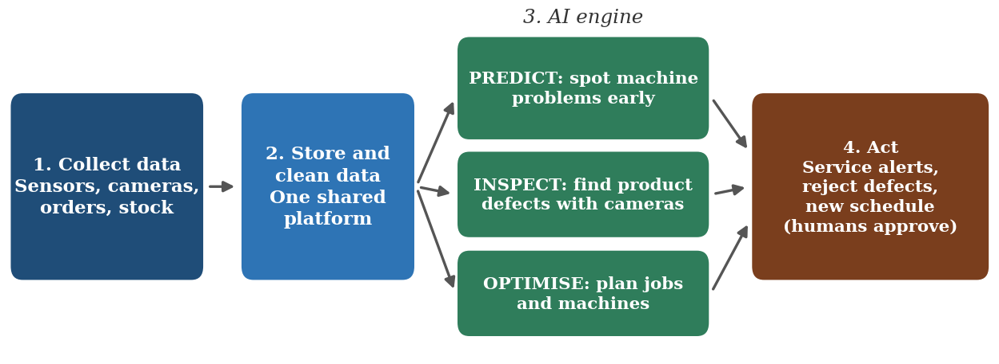
Figure 1: Flow of the proposed smart manufacturing AI system
Problem | AI idea used | Course topic | How we measure success
Machine breakdowns | Anomaly detection; Bayes and fuzzy logic; edge AI | Unsupervised learning; reasoning under uncertainty | Less unplanned downtime; higher availability
Quality issues | CNN image inspection | Supervised learning; classification | Fewer defects reaching customers; high recall
Poor planning | A*, hill climbing, simulated annealing, genetic algorithm | Search and optimisation | Less idle time; orders on time
Trust and safety | Human review; clear alerts | Responsible AI | No unchecked AI decisions
Table 3: Mapping problems to AI ideas and success measures
Method | How it works (simple) | Good / weak point
Hill Climbing | Swap jobs; keep the change only if the plan gets better. | Fast, but can get stuck on a “good enough” plan.
Simulated Annealing | Like hill climbing, but sometimes accepts a worse plan early on to escape traps (Kirkpatrick et al., 1983). | Finds better plans; needs tuning.
Genetic Algorithm | Keeps many plans, mixes the best ones and makes small random changes, generation after generation. | Good for large, complex plans; slower.
Table 4: Local search methods for scheduling
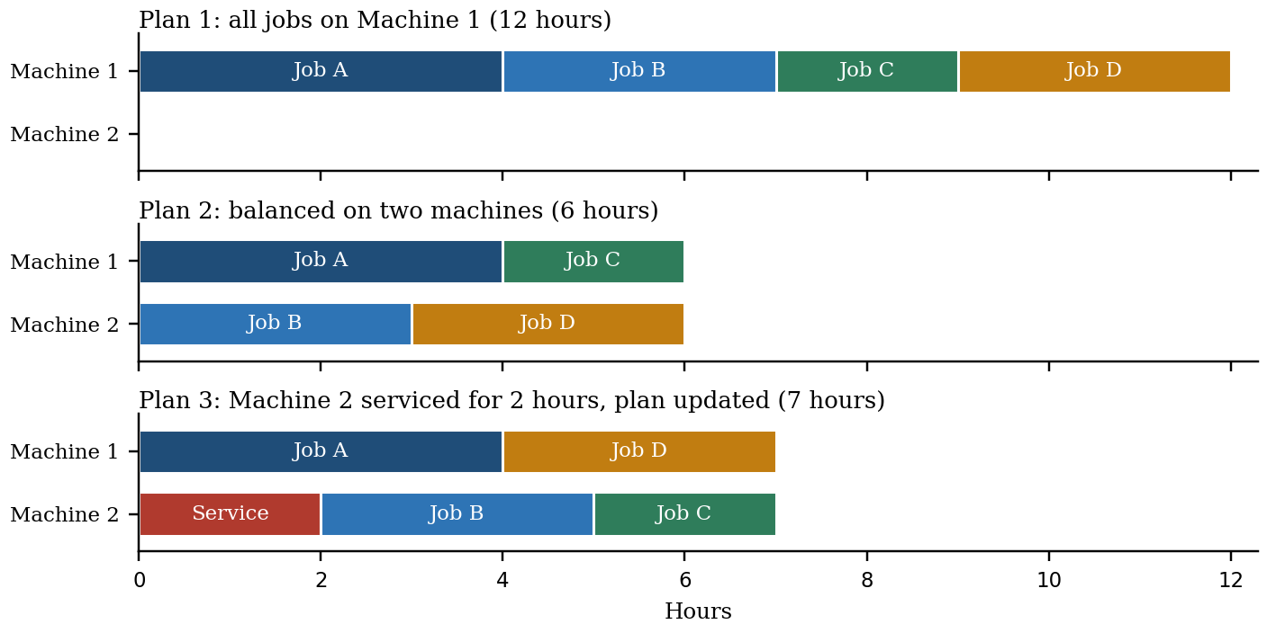
Figure 2: Three schedules for the same four jobs
Company | Related use of AI
Tata Steel (India) | Condition-based monitoring of plant equipment and digital twins (a virtual copy of a machine used for testing).
Mahindra & Mahindra (India) | Vision-based inspection of vehicle parts and predictive alerts for equipment.
Siemens (Global) | Industry 4.0 platforms that connect machines, software and digital twins.
Table 5: Industry examples referenced in the group presentation
Phase | Key activities | Exit check
1. Assess | Study machines, data quality and current downtime, defect and delay levels. | Baseline numbers recorded.
2. Pilot | Try on one line or machine in advisory mode. | Alerts are useful and not too many.
3. Validate | Compare AI results with the old method. | Better results are proven.
4. Integrate | Link with maintenance, quality and planning systems. | Teams use it daily.
5. Scale | Roll out to all plants; keep monitoring and retraining. | Stable results.
Table 6: Phased roadmap
Measure | Starting point (illustrative) | Target (illustrative)
Machine availability | About 65–70% | Above 85%
First-pass quality yield | Not stated; to be measured | Toward 98% or more
Payback of investment | Not applicable | 14 to 22 months
Table 7: Illustrative targets from the group presentation
Term | Meaning in simple words
Industry 4.0 | Factories that connect machines, sensors and software and use data to take decisions.
Anomaly | A reading that is very different from normal, possibly a sign of trouble.
Edge AI | AI that runs near the machine instead of in a faraway cloud.
CNN | A deep learning model that is very good at understanding images.
State space | The list of all possible plans or situations a problem can have.
Heuristic | A smart guess that helps the search move in the right direction.
Digital twin | A virtual copy of a machine or plant used to test ideas safely.
OEE | A single score of how well a machine is used: availability × performance × quality.
Table 8: Simple glossary of terms used in this report

References
1. Alaoui, A. H., Meddaoui, A., & Hain, M. (2026). AI-driven predictive maintenance for Industry 4.0: A systematic review of models, methods, and challenges. The International Journal of Advanced Manufacturing Technology, 143, 4861–4876. https://doi.org/10.1007/s00170-026-17531-w
2. He, B., & Bai, K.-J. (2021). Digital twin-based sustainable intelligent manufacturing: A review. Advances in Manufacturing, 9, 1–21. https://doi.org/10.1007/s40436-020-00302-5
3. Yang, J., Li, S., Wang, Z., Dong, H., Wang, J., & Tang, S. (2020). Using deep learning to detect defects in manufacturing: A comprehensive survey and current challenges. Materials, 13(24), 5755. https://doi.org/10.3390/ma13245755
4. Zhong, R. Y., Xu, X., Klotz, E., & Newman, S. T. (2017). Intelligent manufacturing in the context of Industry 4.0: A review. Engineering, 3(5), 616–630. https://doi.org/10.1016/j.eng.2017.05.015
5. Soori, M., Arezoo, B., & Dastres, R. (2023). Digital twin for smart manufacturing: A review. Sustainable Manufacturing and Service Economics, 2, Article 100017. https://doi.org/10.1016/j.smse.2023.100017
6. Cimino, C., Negri, E., & Fumagalli, L. (2019). Review of digital twin applications in manufacturing. Computers in Industry, 113, Article 103130. https://doi.org/10.1016/j.compind.2019.103130
7. Lu, Y., Liu, C., Wang, K. I.-K., Huang, H., & Xu, X. (2020). Digital twin-driven smart manufacturing: Connotation, reference model, applications and research issues. Robotics and Computer-Integrated Manufacturing, 61, Article 101837. https://doi.org/10.1016/j.rcim.2019.101837
8. Yang, J., et al. (2023). Deep CNN-based visual defect detection: Survey of current literature. Computers in Industry, 148, Article 103911. https://doi.org/10.1016/j.compind.2023.103911

