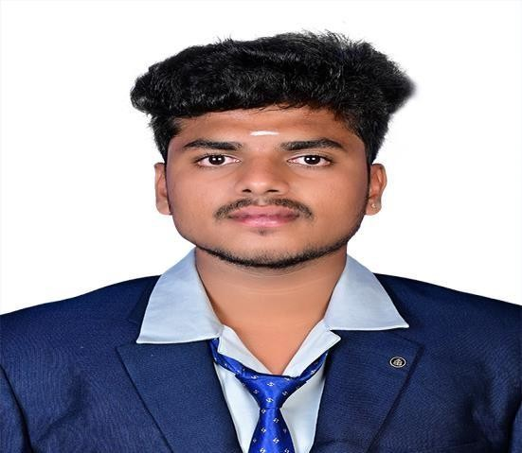RISHIKESAVAN R

## CONTACT PHONE

+91 – 9865111266

## EMAIL

[rishirk3118@gmail.com](mailto:rishirk3118@gmail.com)

## PERSONAL DETAILS

Father’s Name : Rajendran M Father Contact : +91 - 9488344944 Date of Birth : 31.08.2003

Address : 275/20A, Mariyamman Kovil Back Side, Sivadhapuram, Salem 07

Languages Knows: Tamil & English

# CAREER OBJECTIVE

To seek a position in a company that can launch my career and help me to build a stronger skill and expanding my knowledge.

# EDUCATION

* Knowledge Institute of Technology,UG,2024,CGPA-74%
* PV Matriculation Higher Secondary School, HSE, 2020
* Salem Sri Sowdeswari Matriculation Higher Secondary School. SSLC, 2018

# TECHNICAL SKILLS

### Software Known

* + AutoCAD
  + Revit
  + SketchUp
  + Tekla
  + Lumion
  + V-ray Render

## CERTIFICATIONS

### Interior designer

[View certificate](https://drive.google.com/file/d/1GtR6ZZzIbBHHOzWdiX1wS3-DWIZhnVMg/view?usp=drivesdk).

## WORK EXPERIENCE

### Moongil Home Construction, Erode

Site Supervisor Internship: 7 June 2023 - 27 July 2023

### C3d Studio, Bangalore

Interior Designer Internship: 28 March 2023 - 11 May 2023

### Hexascons, Edappadi

Elevation Designer Internship: 31 January 2023 - 06 February 2023

### Anjanasri Archinfra, Attayampatti

Site Supervisor Internship: 26 February 2022 - 26 March 2022

* + - **Om Sakthi builders,salem**

Site Supervisor :August 2023 – August 2024

* + - **DEEJOS Architects, Chennai**

Site Engineer: October 2024 – till now

## ACHIEVEMENTS

* Certified has “**NSS**” On the National Service Scheme in **Ministry of Youth Affairs & Sports**.
* Certified as a “**Entrepreneurship Development Programme**” Declared by **Coir Board**.
* Got Certified for “**Best Student in Extra Curricular Activities**” in The Department Of KIOT.
* Medaled For **State Chess Player.**
* Participated In Various Inter-College Competitions.

## EXTRA-CURRICULAR ACTIVITIES

* Active member of NSS
* Active member of Rotaract
* Member of academic Teams and Clubs
* Organized Conference and Symposium

## PROJECTS MINI PROJECTS

### Temporary Conference Hall View.

Created a 3D model of a temporary conference hall in SketchUp and enhanced the rendering using V-Ray, focusing on space use and design.

### Modular Kitchen.

Developed a 3D view of a modular kitchen in SketchUp and used V-Ray for realistic rendering, with a focus on modern design and functionality.

### Seminar Hall

Designed a 3D model of a seminar hall in SketchUp, considering seating and sound quality,

and rendered it with V-Ray for a detailed finish.

## MAIN PROJECTS

### Bedroom Interior Design

Developed a 3D model of a bedroom interior using SketchUp, focusing on creating a stylish and functional living space with modern design elements and practical layout.

[View project.](https://drive.google.com/file/d/1EjTPluEgnDc6vBNaNhE8kMtr_nu8Gapz/view?usp=share_link)

### Elevation Design

Created a detailed 3D elevation view using SketchUp, emphasizing architectural style and design aesthetics.

[View project.](https://drive.google.com/file/d/17Ab0DW-KVVtmReTAuKRpIk4ibhoCVKVF/view?usp=share_link)

### Planning, Analysis and Designing of Shopping Complex

Developed a commercial building of shopping mall based on all Indian Standard Codes of practice using revit. Detailing drawings pertaining to the structural design of shopping complex are presented.