---

- name: something

hosts: localhost

var_files:

- key.yml

tasks:

- name: provision of ec2 instance on AWS.

ec2:

key_name: "ansiblekey"

aws_access_key: "{{ myuser }}"

aws_secret_key: "{{ mypass }}"

instance_type: "t2.micro"

image: ""

wait: yes

instance_tags:

Name: webserver

count: 3

vpc_subnet_id: ""

assign_public_ip: yes

region: ""

state: present

group_id: ""

- name: provision of ec2 instance on AWS.

ec2:

key_name: "ansiblekey"

aws_access_key: "{{ myuser }}"

aws_secret_key: "{{ mypass }}"

instance_type: "t2.micro"

image: ""

wait: yes

instance_tags:

Name: webserver

count: 3

vpc_subnet_id: ""

assign_public_ip: yes

region: ""

state: present

group_id: ""

- name: provision of ec2 instance on AWS.

ec2:

key_name: "ansiblekey"

aws_access_key: "{{ myuser }}"

aws_secret_key: "{{ mypass }}"

instance_type: "t2.micro"

image: ""

wait: yes

instance_tags:

Name: loadbalancer

count: 1

vpc_subnet_id: ""

assign_public_ip: yes

region: ""

state: present

group_id: ""

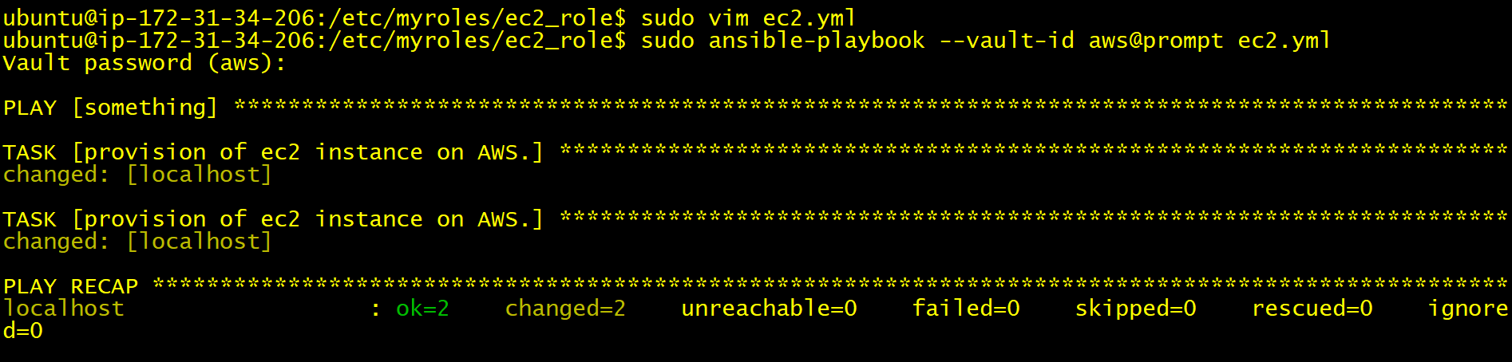

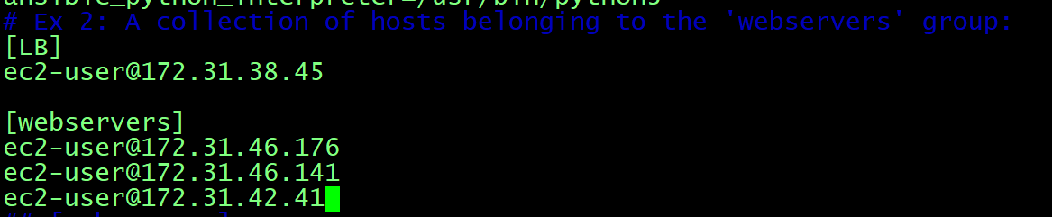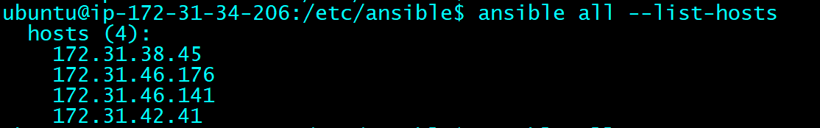

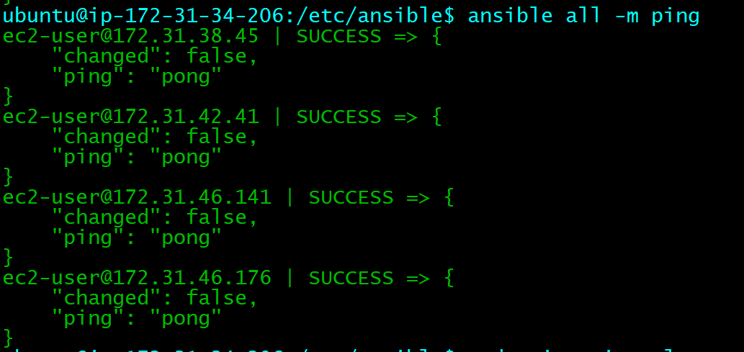

---

- name: webserver setup

hosts: webservers

tasks:

- name: "Installing httpd software"

package:

name: "httpd"

state: present

- name: "Installing php software"

package:

name: "php"

state: present

- name: "Copying the web pages"

copy:

src: "index.php"

dest: "/var/www/html/index.php"

- name: "starting httpd service"

service:

name: "httpd"

state: restarted

- name: LB-setup

hosts: LB

tasks:

- name: "Installing haproxy"

package:

name: haproxy

state: present

- name: "Copying configuration file"

template:

src: "haproxy.cfg.j2"

dest: "/etc/haproxy/haproxy.cfg"

- name: "Start service of haproxy"

service:

name: "haproxy"

state: started

