**Report on fact data from remote hosts**

---

- name: Task is to create a csv file from the fact data of remote machines

hosts: demo

become: yes

connection: ssh

gather_facts: yes

vars:

filename: "device_report_{{ date }}.csv"

tasks:

- name: CSV - Get device facts

set_fact:

csv_tmp: >

{{ansible_distribution}},{{ansible_nodename}},{{ansible_os_family}},{{ansible_pkg_mgr}},{{ansible_user_shell}},{{ansible_machine_id}}

register: data

- debug: var=data

- name: CSV - Generate output filename

set_fact: date="{{lookup('pipe','date +%Y_%m_%d')}}"

run_once: true

register: name

- debug: var=name

- name: CSV - Create file and set the header

lineinfile:

dest: /home/ansible/{{ filename }}

line:

ansible_distribution,ansible_nodename,ansible_os_family,ansible_pkg_mgr,ansible_user_shell,ansible_machine_id

create: yes

state: present

delegate_to: localhost

- name: CSV - Write information into .csv file

lineinfile:

insertafter: EOF

dest: /home/ansible/{{ filename }}

line: "{{ hostvars[item]['csv_tmp'] }}"

loop: "{{ groups['demo'] }}"

delegate_to: localhost

**OUTPUT:**

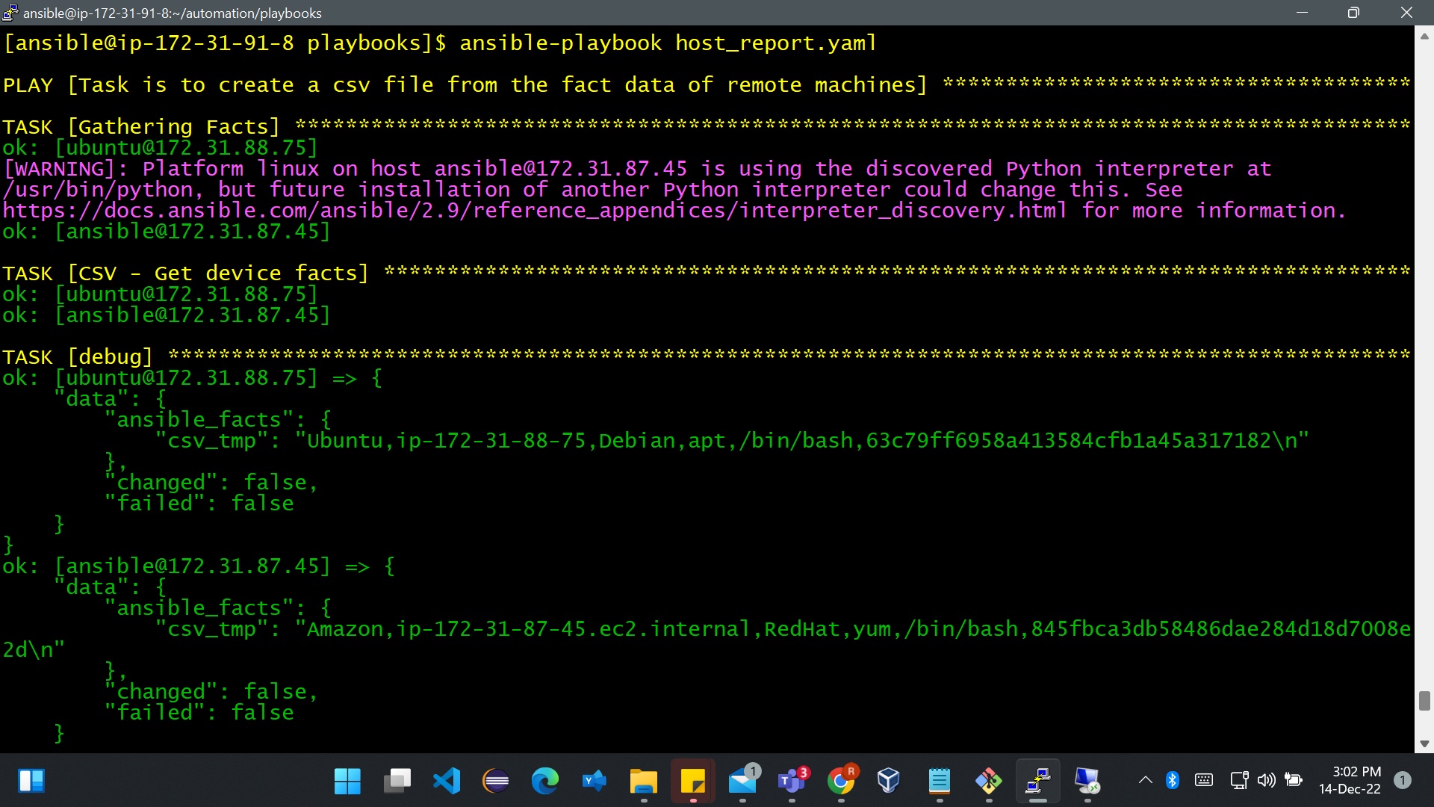

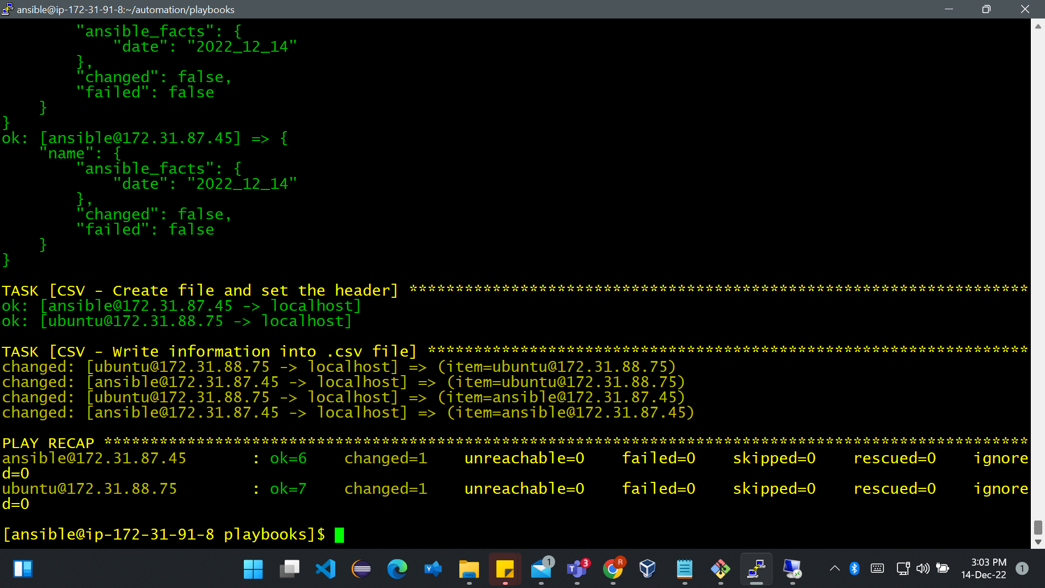

**REPORT CREATED:**

