IMAGE PROCESSING LAB
Lab Record: Questions, Theory, Python Code and Outputs
Programs 1 – 15
Tools: Python, OpenCV, NumPy, Matplotlib, Pillow, SciPy, PyWavelets

Index
1. Acquire an image, store it in different formats and display its properties
2. Intensity slicing for image enhancement
3. Interchange the RED and BLUE planes of a picture
4. Histogram equalization
5. Analysing images using different colour models
6. Image bitwise operations using OpenCV
7. Noise removal using Mean, Median, Gaussian filters and Otsu thresholding
8. Edge detection using Canny and Sobel filters
9. Frequency-domain filtering: HPF and LPF
10. Detecting an electrical line using the Hough Transform
11. Image restoration techniques
12. Image compression: DCT, DPCM, Huffman coding and Haar wavelets
13. Erosion, dilation and skeleton extraction
14. Adaptive filters for noise removal
15. Face detection using feature matching

Program 1
Question: Write a program to acquire an image, store in different formats and display the properties of the images?
Aim
To read an image, perform basic operations (resize, crop, rotate, flip, convert) and display its properties such as size, mode, format and pixel values.
Theory
A digital image is a 2-D array of pixels. Each pixel of an RGB image holds three intensity values (Red, Green, Blue), while a grayscale image holds one value (0–255) and a binary image holds only 0 or 1 (black/white).
Image acquisition means reading an image from a source (file, camera, scanner) into memory. Common storage formats are JPEG (lossy, small), PNG (lossless), BMP (uncompressed), TIFF and WEBP. Format conversion is done by saving the same image object with a different extension.
Important properties are: size (width × height), mode (RGB, L = grayscale, 1 = binary), format and pixel value at a coordinate. The Python Imaging Library (PIL / Pillow) provides Image.open(), resize(), crop(), convert(), rotate(), getpixel() and putpixel() for these tasks.
Code
from PIL import Image, ImageOps

# Read image
img = Image.open("antman.jpg")
img.show()

# Resize image
resizing = img.resize((61, 40))
resizing.show()

# Crop image
cropped = img.crop((200, 300, 400, 500))
cropped.show()

# Display image properties
print("Size:", img.size)
print("Width:", img.width)
print("Height:", img.height)
print("Mode:", img.mode)
print("Format:", img.format)

# Convert to grayscale
gray = img.convert("L")
gray.show()

# Convert to binary
binary = img.convert("1")
binary.show()

# Rotate image
rot = img.rotate(45)
rot.show()

# Flip image horizontally
flip = ImageOps.flip(img)
flip.show()

# Mirror image horizontally
mirror = ImageOps.mirror(img)
mirror.show()

# Invert grayscale image
neg = ImageOps.invert(gray)
neg.show()

# Display pixel values
print("RGB Pixel:", img.getpixel((20, 20)))
print("Gray Pixel:", gray.getpixel((20, 20)))
print("Binary Pixel:", binary.getpixel((20, 20)))

# Change a pixel to red
img.putpixel((20, 20), (255, 0, 0))
img.show()
Output
Size: (1600, 900)
Width: 1600
Height: 900
Mode: RGB
Format: JPEG
RGB Pixel: (239, 243, 244)
Gray Pixel: 242
Binary Pixel: 255

(The image windows opened by show() are not captured; the printed properties are shown above.)

Program 2
Question: Implementation of Image Intensity slicing technique for image enhancement
Aim
To highlight a specific range of gray levels in an image using the intensity (gray-level) slicing technique.
Theory
Intensity slicing is a point-processing enhancement technique that highlights a chosen band of gray levels [A, B] in an image. It is useful for emphasising features such as masses of water in satellite images or flaws in X-ray images.
Two approaches exist: (1) without background – pixels inside the range are set to a high value and all others to a low value; (2) with background – pixels in the range are brightened while all other pixels keep their original intensity.
Mathematically, s = L−1 (or a higher value) if A ≤ r ≤ B, otherwise s = r (or 0). Here the range 100–200 is set to 255 while the remaining pixels are preserved.
Code
import cv2
import matplotlib.pyplot as plt

# Read image in grayscale
img = cv2.imread("antman.jpg", 0)

# Apply intensity slicing
sliced = img.copy()
sliced[(img >= 100) & (img <= 200)] = 255

# Display images
plt.figure(figsize=(10, 5))

plt.subplot(1, 2, 1)
plt.imshow(img, cmap="gray")
plt.title("Original Image")
plt.axis("off")

plt.subplot(1, 2, 2)
plt.imshow(sliced, cmap="gray")
plt.title("Intensity Slicing")
plt.axis("off")

plt.tight_layout()
plt.show()
Output
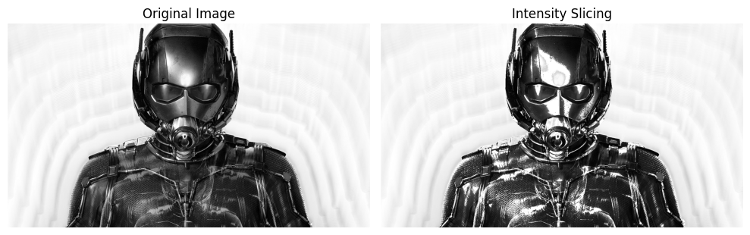

Program 3
Question: Write a python program using matplotlib to interchange RED and BLUE planes in each picture.
Aim
To split a colour image into its R, G and B planes and interchange the red and blue planes.
Theory
An RGB image is made of three 2-D matrices (planes or channels), one each for red, green and blue. Every colour is produced by mixing the three intensities.
split() separates the planes and merge() recombines them in any order. Swapping the order (B, G, R) exchanges the red and blue planes, so objects that were reddish look bluish and vice-versa while green stays unchanged.
Matplotlib is used to display each plane with a colour map (Reds, Greens, Blues) and the final swapped image.
Code
from PIL import Image
import matplotlib.pyplot as plt

# Read image
img = Image.open("antman.jpg")

# Split RGB channels
R, G, B = img.split()

# Interchange Red and Blue
RB = Image.merge("RGB", (B, G, R))

# Display images
plt.figure(figsize=(10, 8))

plt.subplot(2, 2, 1)
plt.imshow(R, cmap="Reds")
plt.title("Red Plane")
plt.axis("off")

plt.subplot(2, 2, 2)
plt.imshow(G, cmap="Greens")
plt.title("Green Plane")
plt.axis("off")

plt.subplot(2, 2, 3)
plt.imshow(B, cmap="Blues")
plt.title("Blue Plane")
plt.axis("off")

plt.subplot(2, 2, 4)
plt.imshow(RB)
plt.title("Red and Blue Interchanged")
plt.axis("off")

plt.tight_layout()
plt.savefig("RGB_channel.jpg")
plt.show()
Output
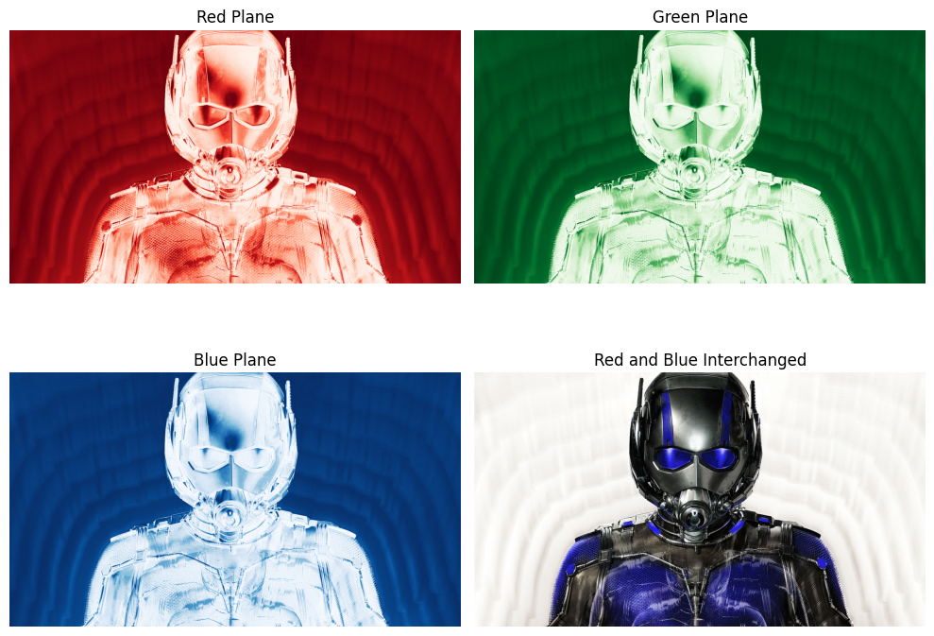

Program 4
Question: Write a python program to implement a histogram equalization to obtain the histogram of the given image and to enhance the input image by equalizing its histogram.
Aim
To obtain the histogram of an image and enhance its contrast by equalizing the histogram.
Theory
The histogram of a digital image is a plot of gray level r_k versus the number of pixels n_k having that level. A narrow histogram indicates low contrast.
Histogram equalization spreads the gray levels uniformly over the whole range. It uses the cumulative distribution function (CDF): s_k = (L−1) · Σ p_r(r_j) for j = 0…k, where p_r(r_j) = n_j / N.
The transformed image has a flatter histogram, better contrast and improved visibility of details. In OpenCV this is done with cv2.equalizeHist().
Code
import cv2
import matplotlib.pyplot as plt

# Read image in grayscale
img = cv2.imread("antman.jpg", 0)

# Apply histogram equalization
equalized = cv2.equalizeHist(img)

# Display images
plt.figure(figsize=(10, 8))

plt.subplot(2, 2, 1)
plt.imshow(img, cmap="gray")
plt.title("Original Image")
plt.axis("off")

plt.subplot(2, 2, 2)
plt.imshow(equalized, cmap="gray")
plt.title("Equalized Image")
plt.axis("off")

# Original histogram
plt.subplot(2, 2, 3)
plt.hist(img.ravel(), bins=256, range=(0, 256), color="blue")
plt.title("Original Image Histogram")
plt.xlim(0, 255)

# Equalized histogram
plt.subplot(2, 2, 4)
plt.hist(equalized.ravel(), bins=256, range=(0, 256), color="orange")
plt.title("Equalized Histogram")
plt.xlim(0, 255)

plt.tight_layout()
plt.show()

# Save equalized image
cv2.imwrite("equalized_image.jpg", equalized)
Output
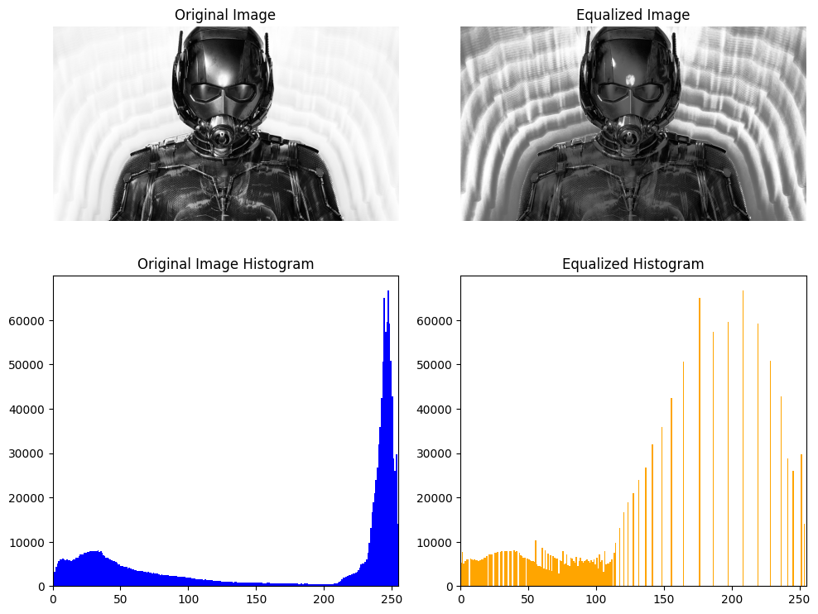

Program 5
Question: Write a python program in analysing the images using different color models.
Aim
To convert an image into different colour models (RGB, Grayscale, HSV, YCrCb) and compare them.
Theory
A colour model is a mathematical way of representing colours. RGB is additive and used by displays; Grayscale keeps only intensity; HSV separates Hue, Saturation and Value (brightness) and is close to human perception; YCrCb separates luminance (Y) from chrominance (Cr, Cb) and is used in JPEG and video compression.
OpenCV reads images in BGR order, so cv2.cvtColor() is used with flags such as COLOR_BGR2RGB, COLOR_BGR2GRAY, COLOR_BGR2HSV and COLOR_BGR2YCrCb to move between models.
Code
import cv2
import matplotlib.pyplot as plt

# Read image
img = cv2.imread("antman.jpg")

# Convert into different color models
rgb = cv2.cvtColor(img, cv2.COLOR_BGR2RGB)
gray = cv2.cvtColor(img, cv2.COLOR_BGR2GRAY)
hsv = cv2.cvtColor(img, cv2.COLOR_BGR2HSV)
ycrcb = cv2.cvtColor(img, cv2.COLOR_BGR2YCrCb)

# Display images
plt.figure(figsize=(10, 8))

plt.subplot(2, 2, 1)
plt.imshow(rgb)
plt.title("RGB Image")
plt.axis("off")

plt.subplot(2, 2, 2)
plt.imshow(gray, cmap="gray")
plt.title("Grayscale Image")
plt.axis("off")

plt.subplot(2, 2, 3)
plt.imshow(hsv)
plt.title("HSV Image")
plt.axis("off")

plt.subplot(2, 2, 4)
plt.imshow(ycrcb)
plt.title("YCrCb Image")
plt.axis("off")

plt.tight_layout()
plt.show()
Output
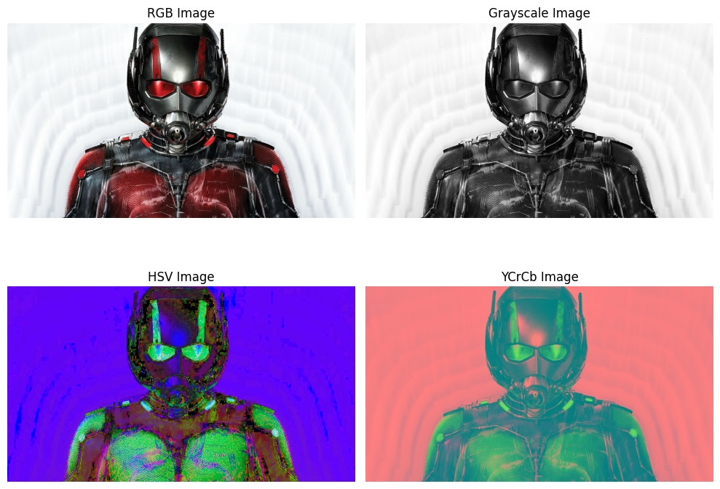

Program 6
Question: Write a python program using OpenCV function demonstrate the image bitwise operations.
Aim
To demonstrate the bitwise AND, OR, XOR and NOT operations on images.
Theory
Bitwise operations work on each pixel bit-by-bit and are mainly used on binary images and for masking and region-of-interest extraction.
AND keeps only the region common to both images; OR gives the union of both; XOR gives the region present in either image but not both; NOT inverts the image (black becomes white and vice-versa).
Here a white rectangle and a white circle are created on black backgrounds and the four operations are applied with cv2.bitwise_and(), bitwise_or(), bitwise_xor() and bitwise_not().
Code
import matplotlib.pyplot as plt
import cv2
import numpy as np

img1 = np.zeros((300, 300), dtype="uint8")
img2 = np.zeros((300, 300), dtype="uint8")

cv2.rectangle(img1, (30, 30), (250, 250), 255, -1)
cv2.circle(img2, (150, 150), 80, 255, -1)

bit_and = cv2.bitwise_and(img1, img2)
bit_or = cv2.bitwise_or(img1, img2)
bit_xor = cv2.bitwise_xor(img1, img2)
bit_not = cv2.bitwise_not(img1)

plt.figure(figsize=(12, 8))

plt.subplot(2, 3, 1)
plt.imshow(img1, cmap="gray")
plt.title("Rectangle")
plt.axis("off")

plt.subplot(2, 3, 2)
plt.imshow(img2, cmap="gray")
plt.title("Circle")
plt.axis("off")

plt.subplot(2, 3, 3)
plt.imshow(bit_and, cmap="gray")
plt.title("AND")
plt.axis("off")

plt.subplot(2, 3, 4)
plt.imshow(bit_or, cmap="gray")
plt.title("OR")
plt.axis("off")

plt.subplot(2, 3, 5)
plt.imshow(bit_xor, cmap="gray")
plt.title("XOR")
plt.axis("off")

plt.subplot(2, 3, 6)
plt.imshow(bit_not, cmap="gray")
plt.title("NOT")
plt.axis("off")

plt.tight_layout()
plt.show()
Output
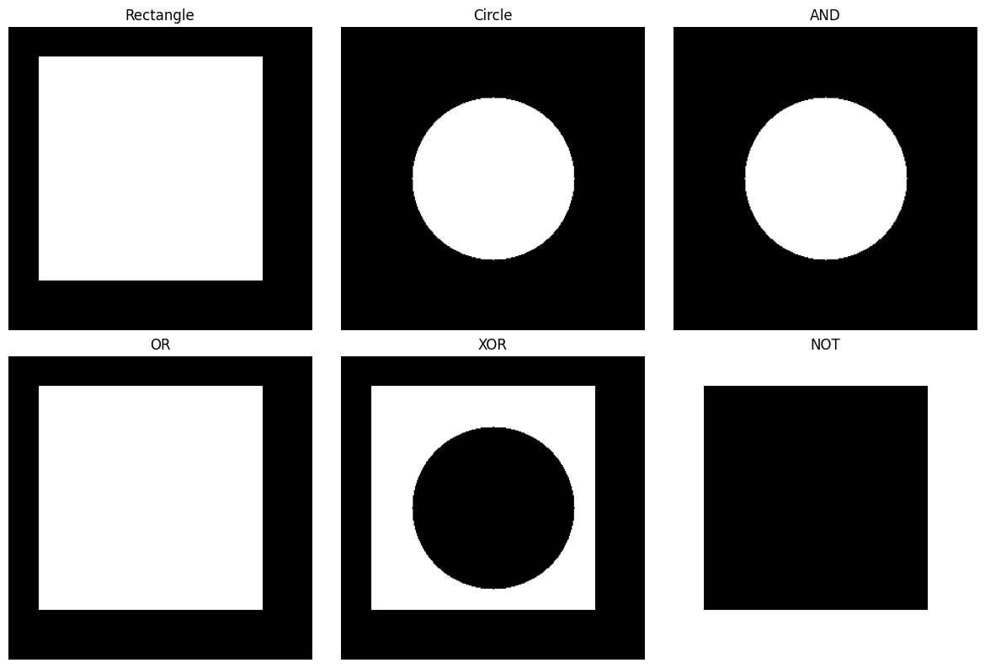

Program 7
Question: Write a python program to implement noise removal using mean filer, median filter, Gaussian filter, and Otsue Thresholding methods to display the output images with histograms.
Aim
To remove noise using spatial filters and Otsu's thresholding and compare the results with histograms.
Theory
Mean (averaging) filter replaces each pixel by the average of its neighbourhood; it smooths noise but blurs edges. Median filter replaces each pixel by the median of its neighbourhood; it is very effective for salt-and-pepper noise and preserves edges. Gaussian filter uses a Gaussian-weighted kernel, giving smoother blurring that removes Gaussian noise.
Otsu's method automatically finds the threshold that minimises the intra-class variance (equivalently maximises the between-class variance) of the foreground and background pixels, converting the image to binary.
Histograms of the output images show how each method changes the distribution of gray levels.
Code
import cv2
import matplotlib.pyplot as plt

# Read image in grayscale
img = cv2.imread("antman.jpg", 0)

# Apply filters
mean = cv2.blur(img, (3, 3))
median = cv2.medianBlur(img, 3)
gaussian = cv2.GaussianBlur(img, (3, 3), 0)

# Otsu thresholding
_, otsu = cv2.threshold(
img, 0, 255, cv2.THRESH_BINARY + cv2.THRESH_OTSU
)

# Store images and titles
images = [img, mean, median, gaussian, otsu]
titles = ["Original", "Mean Filter", "Median Filter",
"Gaussian Filter", "Otsu Thresholding"]

# Display images and histograms
plt.figure(figsize=(12, 10))

for i in range(5):
plt.subplot(5, 2, 2*i + 1)
plt.imshow(images[i], cmap="gray")
plt.title(titles[i])
plt.axis("off")

plt.subplot(5, 2, 2*i + 2)
plt.hist(images[i].ravel(), bins=256, range=(0, 256))
plt.title(titles[i] + " Histogram")
plt.xlim(0, 255)

plt.tight_layout()
plt.show()
Output
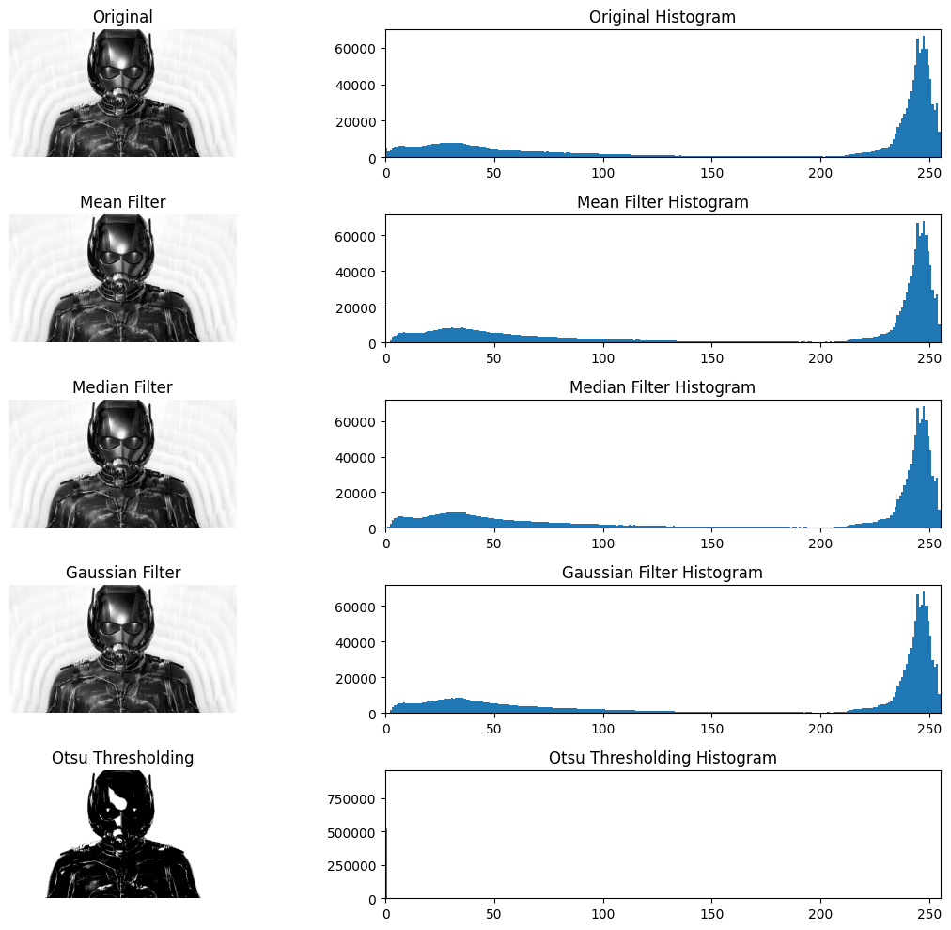

Program 8
Question: Write a python program to implement edge detection using canny filter, sobel filter.
Aim
To detect edges in an image using the Sobel and Canny operators.
Theory
Edges are sudden changes in intensity and correspond to object boundaries. Sobel is a first-derivative operator that uses two 3×3 kernels (Gx and Gy) to compute the gradient magnitude G = √(Gx² + Gy²).
The Canny detector is a multi-stage algorithm: (1) Gaussian smoothing, (2) gradient computation, (3) non-maximum suppression, (4) double thresholding and (5) edge tracking by hysteresis. It gives thin, well-localised edges with less noise than Sobel.
In OpenCV: cv2.Sobel(img, ddepth, dx, dy, ksize) and cv2.Canny(img, low_threshold, high_threshold).
Code
import cv2
import matplotlib.pyplot as plt

# Read image
img = cv2.imread("antman.jpg", 0)

# Sobel filter
sobel = cv2.Sobel(img, cv2.CV_8U, 1, 1, ksize=3)

# Canny filter
canny = cv2.Canny(img, 100,200)

# Display images
plt.figure(figsize=(12, 6))

plt.subplot(1, 3, 1)
plt.imshow(img, cmap="gray")
plt.title("Original")
plt.axis("off")

plt.subplot(1, 3, 2)
plt.imshow(sobel, cmap="gray")
plt.title("Sobel")
plt.axis("off")

plt.subplot(1, 3, 3)
plt.imshow(canny, cmap="gray")
plt.title("Canny")
plt.axis("off")

plt.tight_layout()
plt.savefig("sobel_canny.jpg")
plt.show()
Output
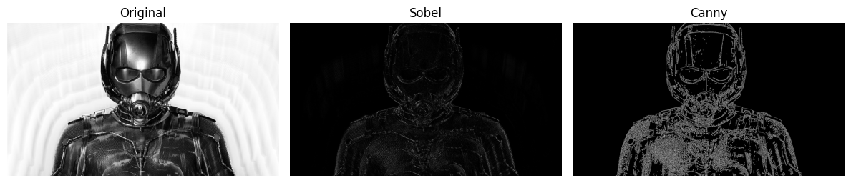

Program 9
Question: Write a python program to implement an image enhancement using frequency domain filtering to perform HPF and LPF over the given noisy images.
Aim
To enhance an image in the frequency domain by applying a High Pass Filter (HPF) and a Low Pass Filter (LPF).
Theory
The 2-D Fourier transform converts an image from the spatial domain to the frequency domain. Low frequencies represent smooth regions and overall brightness; high frequencies represent edges, details and noise.
Low Pass Filter (LPF) keeps frequencies near the centre of the shifted spectrum and removes the rest, producing a blurred, smoothed image. High Pass Filter (HPF) removes the low frequencies and keeps the rest, producing an edge-enhanced image.
Steps: FFT (np.fft.fft2) → shift zero-frequency to centre (fftshift) → multiply with mask → inverse shift → inverse FFT (ifft2) → take absolute value.
Code
import cv2
import numpy as np
import matplotlib.pyplot as plt

# Read noisy image
img = cv2.imread("antman.jpg", 0)

# Apply Fourier Transform
f = np.fft.fft2(img)
fshift = np.fft.fftshift(f)

# Create frequency mask
rows, cols = img.shape
crow, ccol = rows // 2, cols // 2

mask = np.zeros((rows, cols), np.uint8)
mask[crow-30:crow+30, ccol-30:ccol+30] = 1

# Low Pass Filter (LPF)
lpf = fshift * mask
img_lpf = np.abs(np.fft.ifft2(np.fft.ifftshift(lpf)))

# High Pass Filter (HPF)
hpf = fshift * (1 - mask)
img_hpf = np.abs(np.fft.ifft2(np.fft.ifftshift(hpf)))

# Display results
plt.figure(figsize=(10, 7))

plt.subplot(2, 2, 1)
plt.imshow(img, cmap="gray")
plt.title("Original Image")
plt.axis("off")

plt.subplot(2, 2, 2)
plt.imshow(np.log1p(np.abs(fshift)), cmap="gray")
plt.title("Frequency Spectrum")
plt.axis("off")

plt.subplot(2, 2, 3)
plt.imshow(img_lpf, cmap="gray")
plt.title("Low Pass Filter (LPF)")
plt.axis("off")

plt.subplot(2, 2, 4)
plt.imshow(img_hpf, cmap="gray")
plt.title("High Pass Filter (HPF)")
plt.axis("off")

plt.tight_layout()
plt.show()
Output
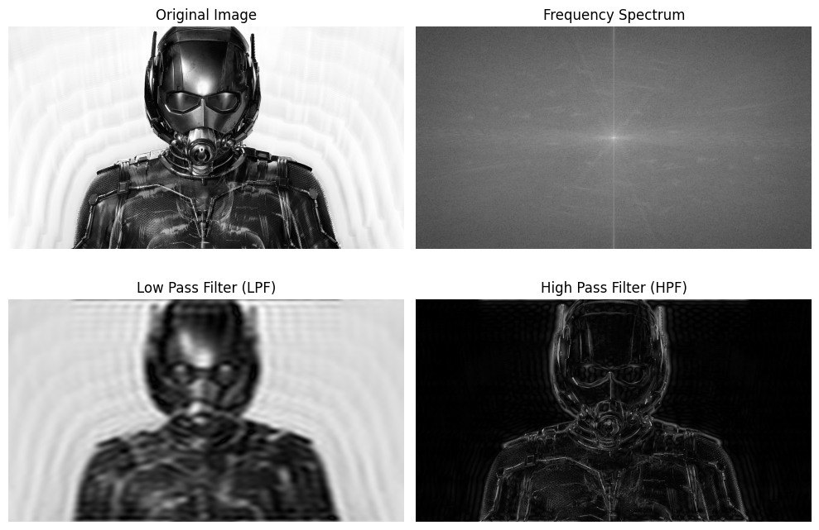

Program 10
Question: Write a python program to detect an electrical line in an image using Hough Transform.
Aim
To detect straight (electrical/transmission) lines in an image using the Hough Transform.
Theory
The Hough Transform detects shapes by voting in a parameter space. A line is represented as ρ = x·cosθ + y·sinθ; every edge pixel votes for all (ρ, θ) pairs passing through it, and peaks in the accumulator indicate lines.
The Probabilistic Hough Transform (cv2.HoughLinesP) returns end-points of line segments and is faster. Parameters include the distance and angle resolution, the accumulator threshold, the minimum line length and the maximum gap between segments.
Procedure: convert to grayscale → detect edges with Canny → apply HoughLinesP → draw the detected lines on the original image.
Code
import cv2
import numpy as np
import matplotlib.pyplot as plt

img = cv2.imread("transmission-line-post.jpg")

gray = cv2.imread("transmission-line-post.jpg",0)

edges = cv2.Canny(gray, 200, 300)

lines = cv2.HoughLinesP(edges, 1, np.pi/180, 130,
minLineLength=100, maxLineGap=40)

if lines is not None:
for line in lines:
x1, y1, x2, y2 = line
cv2.line(img, (int(x1), int(y1)),
(int(x2), int(y2)), (0, 0, 255), 2)

plt.imshow(cv2.cvtColor(img, cv2.COLOR_BGR2RGB))
plt.title("Detected Transmission Lines")
plt.axis("off")
plt.show()
Output
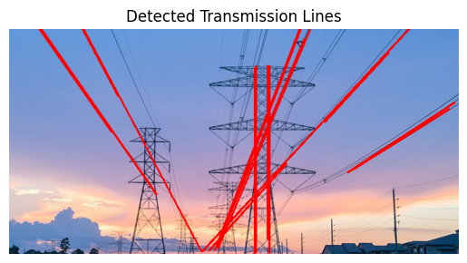

Program 11
Question: Implementation of image restoring techniques
Aim
To restore an image degraded by noise using a restoration filter.
Theory
Image restoration tries to recover the original image from a degraded one using knowledge of the degradation, g(x,y) = h(x,y) * f(x,y) + n(x,y), where f is the original, h the degradation function and n the noise.
Common techniques: spatial filters (mean, median, order-statistic filters), inverse filtering, Wiener (minimum mean square error) filtering and constrained least squares filtering.
Here salt noise is added to 8% of pixels and then removed with a 5×5 median filter, which is the best choice for impulse (salt-and-pepper) noise.
Code
import cv2
import numpy as np
import matplotlib.pyplot as plt

# Read image in grayscale
img = cv2.imread("trump2.png", 0)

# Check whether image loaded
if img is None:
print("Image not found!")
else:
# Add salt noise
noise = np.random.rand(*img.shape) < 0.08
noisy = img.copy()
noisy[noise] = 255

# Restore image using median filter
restored = cv2.medianBlur(noisy, 5)

# Display images
plt.figure(figsize=(12, 4))

plt.subplot(1, 3, 1)
plt.imshow(img, cmap="gray")
plt.title("Original Image")
plt.axis("off")

plt.subplot(1, 3, 2)
plt.imshow(noisy, cmap="gray")
plt.title("Noisy Image")
plt.axis("off")

plt.subplot(1, 3, 3)
plt.imshow(restored, cmap="gray")
plt.title("Restored Image")
plt.axis("off")

plt.tight_layout()
plt.show()
Output
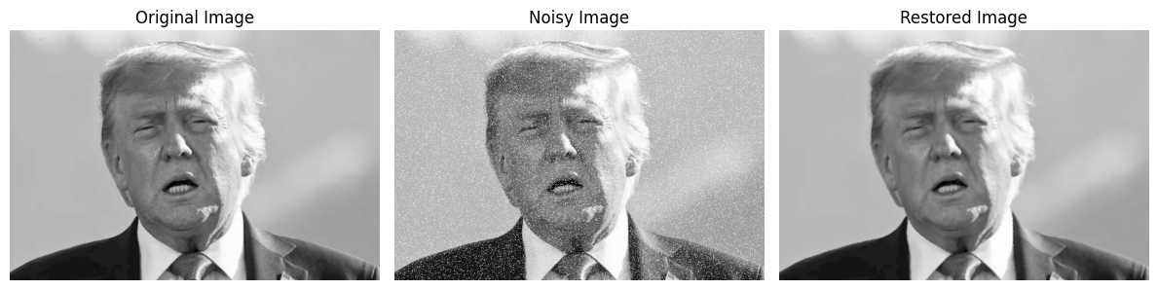

Program 12
Question: Image Compression by DCT, DPCM, HUFFMAN coding and Haar Wavelets.
Aim
To compress an image using DCT, DPCM, Huffman coding and Haar wavelet transform and compare the sizes.
Theory
Image compression reduces the number of bits needed to represent an image by removing redundancy (coding, inter-pixel and psycho-visual).
DCT (Discrete Cosine Transform): converts the image to frequency coefficients; most energy lies in a few low-frequency coefficients, so high-frequency ones can be discarded (used in JPEG). DPCM (Differential PCM): encodes the difference between neighbouring pixels, which has a smaller range than the pixels themselves. Huffman coding: lossless variable-length coding that gives shorter codes to more frequent gray levels. Haar wavelet: decomposes the image into approximation (LL) and detail (LH, HL, HH) sub-bands; keeping only LL gives compression.
The program prints the size obtained with each technique.
Code
import cv2
import numpy as np
import matplotlib.pyplot as plt
import pywt
from dahuffman import HuffmanCodec

# Read image
img = cv2.imread("trump2.png", 0)
img = cv2.resize(img, (256, 256))

# Original size
print("Original Size:", round(img.nbytes / 1024, 2), "KB")

# 1. DCT
dct = cv2.dct(np.float32(img))
dct[50:, :] = 0
dct[:, 50:] = 0
dct_img = cv2.idct(dct)
print("DCT Size:", round(50 * 50 * 2 / 1024, 2), "KB")

# 2. DPCM
dpcm = np.diff(img.astype(int), axis=1)

# 3. Huffman Coding
pixels = img.flatten()
codec = HuffmanCodec.from_data(pixels)
encoded = codec.encode(pixels)
print("Huffman Size:", round(len(encoded) / 1024, 2), "KB")

# 4. Haar Wavelet
LL, (LH, HL, HH) = pywt.dwt2(img, "haar")
print("Haar LL Size:", round(LL.size * 2 / 1024, 2), "KB")

# Display results
plt.subplot(2, 2, 1)
plt.imshow(dct_img, cmap="gray")
plt.title("DCT")
plt.axis("off")

plt.subplot(2, 2, 2)
plt.imshow(dpcm, cmap="gray")
plt.title("DPCM")
plt.axis("off")

plt.subplot(2, 2, 3)
plt.imshow(img, cmap="gray")
plt.title("Huffman - Original")
plt.axis("off")

plt.subplot(2, 2, 4)
plt.imshow(LL, cmap="gray")
plt.title("Haar Wavelet")
plt.axis("off")

plt.tight_layout()
plt.show()
Output
Original Size: 64.0 KB
DCT Size: 4.88 KB
Huffman Size: 53.44 KB
Haar LL Size: 32.0 KB

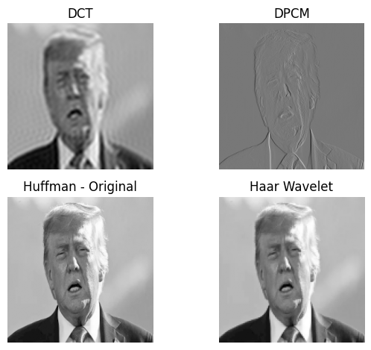

Program 13
Question: Implement erosion and dilation based morphology and 4 extract skeletal from an image.
Aim
To implement erosion and dilation based morphology and extract the skeleton of a binary image.
Theory
Morphological operations process shapes using a structuring element. Erosion removes pixels at object boundaries (shrinks objects, removes small noise); dilation adds pixels to object boundaries (expands objects, fills small holes).
Opening = erosion followed by dilation; closing = dilation followed by erosion.
Skeletonization reduces an object to a thin line (one pixel wide) preserving its shape. It is computed iteratively: skeleton = ∪ (Aₖ − open(Aₖ)), where Aₖ is the k-times eroded image, until the image becomes empty.
Code
import cv2
import numpy as np
import matplotlib.pyplot as plt

# Create a binary image
img = np.array([
[0, 0, 0, 0, 0, 0, 0],
[0, 1, 1, 1, 1, 0, 0],
[0, 1, 1, 1, 1, 0, 0],
[0, 1, 1, 1, 1, 0, 0],
[0, 1, 1, 1, 1, 0, 0],
[0, 0, 0, 0, 0, 0, 0],
[0, 0, 0, 0, 0, 0, 0]
], dtype=np.uint8)

img = img * 255

# Structuring element
kernel = np.ones((3, 3), np.uint8)

# Erosion and dilation
erosion = cv2.erode(img, kernel, iterations=1)
dilation = cv2.dilate(img, kernel, iterations=1)

# Skeleton extraction
skeleton = np.zeros(img.shape, np.uint8)
temp = img.copy()

while cv2.countNonZero(temp) > 0:
eroded = cv2.erode(temp, kernel)
opened = cv2.dilate(eroded, kernel)
difference = cv2.subtract(temp, opened)
skeleton = cv2.bitwise_or(skeleton, difference)
temp = eroded

# Display results
images = [img, erosion, dilation, skeleton]
titles = ["Original", "Erosion", "Dilation", "Skeleton"]

for i in range(4):
plt.subplot(2, 2, i + 1)
plt.imshow(images[i], cmap="gray")
plt.title(titles[i])
plt.axis("off")

plt.tight_layout()
plt.show()
Output
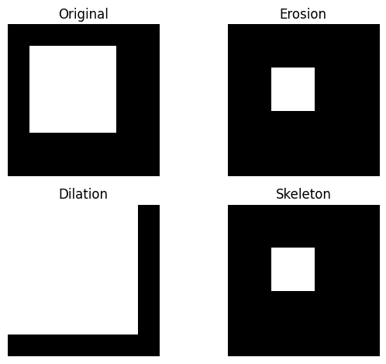

Program 14
Question: Apply adaptive filters to remove noise from the image.
Aim
To remove noise from an image using an adaptive (Wiener) filter.
Theory
Adaptive filters change their behaviour according to the local statistics (mean and variance) of the image under the filter window, unlike fixed filters.
The adaptive Wiener filter estimates the local mean μ and variance σ² in each window and computes: f(x,y) = μ + (σ² − ν²)/σ² · (g(x,y) − μ), where ν² is the noise variance. In flat regions (σ² ≈ ν²) it smooths strongly; near edges (σ² large) it leaves the pixel nearly unchanged, so edges are preserved.
Here Gaussian noise (mean 0, σ = 25) is added to the image and removed with scipy.signal.wiener using a 5×5 window.
Code
import cv2
import numpy as np
import matplotlib.pyplot as plt
from scipy.signal import wiener

# Read the image
img = cv2.imread("antman.jpg", 0)

# Add Gaussian noise
noise = np.random.normal(0, 25, img.shape)
noisy = np.clip(img + noise, 0, 255).astype(np.uint8)

# Apply adaptive Wiener filter
filtered = wiener(noisy.astype(float), (5, 5))
filtered = np.clip(filtered, 0, 255).astype(np.uint8)

# Display images
plt.figure(figsize=(12, 4))

plt.subplot(1, 3, 1)
plt.imshow(img, cmap='gray')
plt.title("Original Image")
plt.axis("off")

plt.subplot(1, 3, 2)
plt.imshow(noisy, cmap='gray')
plt.title("Noisy Image")
plt.axis("off")

plt.subplot(1, 3, 3)
plt.imshow(filtered, cmap='gray')
plt.title("Adaptive Filtered Image")
plt.axis("off")

plt.tight_layout()
plt.show()
Output
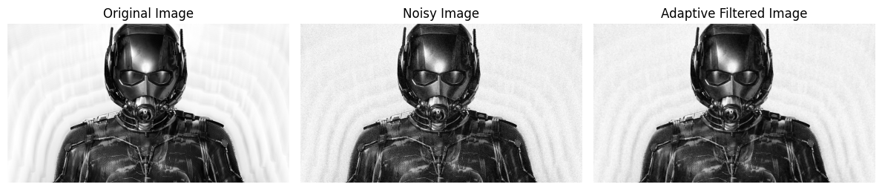

Program 15
Question: Write a python program to implement face detection using feature matching techniques.
Aim
To match features between a face image and a group image using ORB keypoints and a brute-force matcher.
Theory
Feature-based detection finds distinctive keypoints (corners, blobs) in images and describes them by descriptors; matching descriptors between two images locates the same object (here a face) in another image.
ORB (Oriented FAST and Rotated BRIEF) is a fast, rotation-invariant, free alternative to SIFT/SURF. It produces binary descriptors that are compared with the Hamming distance by the Brute-Force matcher (cv2.BFMatcher with NORM_HAMMING). Smaller distance means a better match.
The matches are sorted by distance and the 10 best are drawn between the two images with cv2.drawMatches().
Code
import cv2
import matplotlib.pyplot as plt

img1 = cv2.imread("trump-canada.webp", 0)
img2 = cv2.imread("trump2.png", 0)

orb = cv2.ORB_create()

# Detect keypoints and compute descriptors
kp1, des1 = orb.detectAndCompute(img1, None)
kp2, des2 = orb.detectAndCompute(img2, None)

bf = cv2.BFMatcher(cv2.NORM_HAMMING, crossCheck=True)

matches = bf.match(des1, des2)
print(matches)
matches = sorted(matches, key=lambda x: x.distance)

# Draw best 10 matches
result = cv2.drawMatches(
img1, kp1, img2, kp2, matches[:10], None
)

plt.figure(figsize=(12, 6))
plt.imshow(result, cmap="gray")
plt.title("Face Detection using Feature Matching")
plt.axis("off")
plt.show()
Output
[<cv2.DMatch object>, <cv2.DMatch object>, <cv2.DMatch object>, ... ] (list of all matched descriptors; long list truncated)

