CIA 2
Rishikesh S
727721EUIT127
CIA2:
Code:
package com.cia2.cia2;

import static org.testng.Assert.assertTrue;

import java.util.List;

import org.openqa.selenium.By;
import org.openqa.selenium.WebDriver;
import org.openqa.selenium.WebElement;
import org.openqa.selenium.firefox.FirefoxDriver;
import org.testng.annotations.BeforeClass;
import org.testng.annotations.Test;
import io.github.bonigarcia.wdm.WebDriverManager;

public class Trivago {
private WebDriver driver;
@BeforeClass
public void setUp() {
WebDriverManager.firefoxdriver().setup();
driver = new FirefoxDriver();
}
@Test
public void testGoogleSearch() throws InterruptedException {
driver.manage().window().maximize();
driver.get("https://www.trivago.in/");
String currtitle=driver.getTitle();
System.out.println(currtitle);
String exptitle="trivago.in - Compare hotel prices worldwide";
if(currtitle.equals(exptitle)) {
System.out.println("Title Matches");
}
else {
System.out.println("Title Mismatch");
}
Thread.sleep(3000);
driver.findElement(By.xpath("//*[@id=\"input-auto-complete\"]")).click();
Thread.sleep(3000);
driver.findElement(By.xpath("//*[@id=\"suggestion-list\"]/ul/li[1]/div/div")).click();
Thread.sleep(3000);
driver.findElement(By.xpath("//*[@id=\"__next\"]/div[1]/div[1]/section/div[2]/div[3]/div/div[2]/div/div/div/div[2]/div/div[1]/div[2]/button[24]/time")).click();
Thread.sleep(3000);
driver.findElement(By.xpath("//*[@id=\"__next\"]/div[1]/div[1]/section/div[2]/div[3]/div/div[2]/div/div/div/div[2]/div/div[1]/div[2]/button[26]/time")).click();
Thread.sleep(3000);
driver.findElement(By.xpath("//*[@id=\"__next\"]/div[1]/div[1]/section/div[2]/div[3]/div/div[2]/div/div/div[1]/div/div[1]/div[1]/div/button[2]")).click();
Thread.sleep(3000);
driver.findElement(By.xpath("//*[@id=\"__next\"]/div[1]/div[1]/section/div[2]/div[3]/div/div[2]/div/div/div[1]/div/div[1]/div[3]/div/button[2]")).click();
Thread.sleep(3000);
driver.findElement(By.xpath("/html/body/div[1]/div[1]/div[1]/section/div[2]/div[3]/div/div[2]/div/div/div[1]/div/div[2]/div[2]/input")).click();
Thread.sleep(3000);
driver.findElement(By.xpath("//*[@id=\"__next\"]/div[1]/div[1]/section/div[2]/div[3]/div/div[2]/div/div/div[2]/div/button[2]")).click();

WebElement sortDropdown = driver.findElement(By.cssSelector(".df_overlay_container [data-qa='sort-dropdown']"));
sortDropdown.click();
WebElement priceAndRecOption = driver.findElement(By.cssSelector("[data-qa='sort-option'][data-option-id='2']"));
priceAndRecOption.click();
WebElement hotelList = driver.findElement(By.cssSelector("[data-qa='itemlist-section']"));
WebElement firstHotel = hotelList.findElement(By.cssSelector("[data-qa='item'][data-index='0']"));
WebElement hotelName = firstHotel.findElement(By.cssSelector("[data-qa='item-name']"));
WebElement hotelPrice = firstHotel.findElement(By.cssSelector("[data-qa='recommended-price']"));
System.out.println(hotelName.getText() + " - " + hotelPrice.getText());
assertTrue(hotelPrice.isDisplayed());
}

@Test
public void testSortingByPrice() {
WebElement sortDropdown = driver.findElement(By.cssSelector(".df_overlay_container [data-qa='sort-dropdown']"));
sortDropdown.click();
WebElement priceOption = driver.findElement(By.cssSelector("[data-qa='sort-option'][data-option-id='1']"));
priceOption.click();
WebElement hotelList = driver.findElement(By.cssSelector("[data-qa='itemlist-section']"));
WebElement firstHotel = hotelList.findElement(By.cssSelector("[data-qa='item'][data-index='0']"));
WebElement hotelName = firstHotel.findElement(By.cssSelector("[data-qa='item-name']"));
WebElement hotelPrice = firstHotel.findElement(By.cssSelector("[data-qa='recommended-price']"));
System.out.println(hotelName.getText() + " - " + hotelPrice.getText());
assertTrue(hotelPrice.isDisplayed());
}

@Test
public void testNumberOfStaysFound() {
WebElement hotelList = driver.findElement(By.cssSelector("[data-qa='itemlist-section']"));
int numberOfStays = hotelList.findElements(By.cssSelector("[data-qa='item']")).size();
System.out.println("Number of stays found: " + numberOfStays);
assertTrue(numberOfStays > 0);
}

@Test
public void testNumberOfBookingSitesSearched() {
WebElement bookingSitesDropdown = driver.findElement(By.cssSelector(".df_overlay_container [data-qa='booking-sites-dropdown']"));
bookingSitesDropdown.click();
int numberOfSites = driver.findElements(By.cssSelector(".df_overlay_container [data-qa='booking-site-item']")).size();
System.out.println("Number of booking sites searched: " + numberOfSites);
assertTrue(numberOfSites > 0);

List<WebElement> hotelNames = driver.findElements(By.xpath("//span[@data-qa='item-name']"));
for (int i = 0; i < 5; i++) {
System.out.println(hotelNames.get(i).getText());
}

WebElement viewDeal = driver.findElement(By.xpath("//span[@data-qa='recommended-price']"));
viewDeal.click();

String parentWindow = driver.getWindowHandle();
for (String childWindow : driver.getWindowHandles()) {
driver.switchTo().window(childWindow);
}

WebElement selectedHotelPrice = driver.findElement(By.xpath("//strong[@class='deal-price__amount']"));
System.out.println("Selected hotel price: " + selectedHotelPrice.getText());

WebElement selectRoom = driver.findElement(By.xpath("//button[contains(@class,'js-book-button')]"));
selectRoom.click();

WebElement firstName = driver.findElement(By.xpath("//input[@name='firstname']"));
firstName.sendKeys("Rishikesh");

WebElement lastName = driver.findElement(By.xpath("//input[@name='lastname']"));
lastName.sendKeys("S");

WebElement email = driver.findElement(By.xpath("//input[@name='email']"));
email.sendKeys("rkesh2003@gmail.com");

WebElement confirmEmail = driver.findElement(By.xpath("//input[@name='email_confirm']"));
confirmEmail.sendKeys("rkesh2003@gmail.com");

WebElement cancellationPolicy = driver.findElement(By.xpath("//h4[text()='Cancellation policy']/following-sibling::div/p"));
String cancellationPolicyText = cancellationPolicy.getText();
System.out.println("Check-in and Checkout dates: " + cancellationPolicyText);

driver.switchTo().window(parentWindow);
driver.close();
}

}

Output:
Console Output:
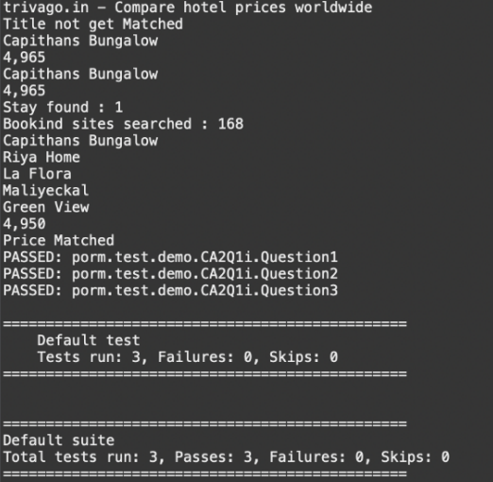
Emailable Report:
