CC1 727721euit127, RISHIKESH S

1.
package com.test.test;

import org.openqa.selenium.By;
import org.openqa.selenium.Keys;
import org.openqa.selenium.WebDriver;
import org.openqa.selenium.WebElement;
import org.openqa.selenium.firefox.FirefoxDriver;
import org.openqa.selenium.interactions.Actions;

import io.github.bonigarcia.wdm.WebDriverManager;

public class App {
public static void main( String[] args ) throws InterruptedException
{
WebDriverManager.firefoxdriver().setup();
WebDriver driver = new FirefoxDriver();
driver.manage().window().maximize();
driver.navigate().to("https://www.saucedemo.com/");
driver.manage().window().maximize();
driver.findElement(By.xpath("//*[@id=\"user-name\"]")).sendKeys("standard_user");
driver.findElement(By.xpath("//*[@id=\"password\"]")).sendKeys("secret_sauce");
driver.findElement(By.xpath("//*[@id=\"login-button\"]")).click();
driver.findElement(By.xpath("//*[@id=\"add-to-cart-sauce-labs-backpack\"]")).click();
String cartNum = driver.findElement(By.xpath("/html/body/div/div/div/div[1]/div[1]/div[3]/a/span")).getText();
if (cartNum.equals("1")) {
System.out.println("Added to cart successfully");
}
driver.findElement(By.xpath("/html/body/div/div/div/div[1]/div[1]/div[3]/a")).click();
String prodStr = "Sauce Labs Backpack";
if(driver.findElement(By.xpath("/html/body/div/div/div/div[2]/div/div[1]/div[3]/div[2]/a/div")).getText().equals(prodStr));
{
System.out.println("User can view the contents of the cart");
}
driver.findElement(By.xpath("//*[@id=\"checkout\"]")).click();
if(driver.findElement(By.xpath("/html/body/div/div/div/div[1]/div[2]/span")).getText().equals("Checkout: Your Information")) {
System.out.println("Your information form is displayed");
}
driver.findElement(By.xpath("//*[@id=\"first-name\"]")).sendKeys("Rishikesh");
driver.findElement(By.xpath("//*[@id=\"last-name\"]")).sendKeys("S");
driver.findElement(By.xpath("//*[@id=\"postal-code\"]")).sendKeys("641008");
driver.findElement(By.xpath("//*[@id=\"continue\"]")).click();
if(driver.findElement(By.xpath("/html/body/div/div/div/div[1]/div[2]/span")).getText().equals("Checkout: Overview")) {
System.out.println("Product overview page is displayed");
}
System.out.println("Name of the product: " + driver.findElement(By.xpath("/html/body/div/div/div/div[2]/div/div[1]/div[3]/div[2]/a/div")).getText());
System.out.println("Price of the product: " + driver.findElement(By.xpath("/html/body/div/div/div/div[2]/div/div[1]/div[3]/div[2]/div[2]/div")).getText());
if(driver.getTitle().equals("Swag Labs")) {
System.out.println("Title is matched");
}
if(driver.getCurrentUrl().equals("https://www.saucedemo.com/checkout-step-two.html")) {
System.out.println("URL is matched");
}
}
}

OUTPUT:
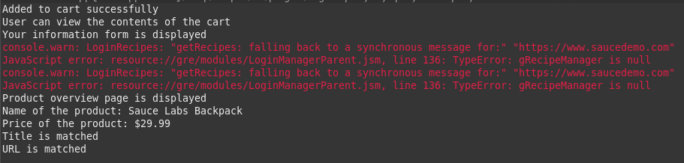

2.

package com.test.test;

import org.openqa.selenium.By;
import org.openqa.selenium.WebDriver;
import org.openqa.selenium.WebElement;

import org.openqa.selenium.firefox.FirefoxDriver;

import io.github.bonigarcia.wdm.WebDriverManager;

public class App1 {

public static void main(String[] args) throws InterruptedException {
// TODO Auto-generated method stub
WebDriverManager.firefoxdriver().setup();
WebDriver driver = new FirefoxDriver();
driver.get ("https://www.saucedemo.com/");
driver.manage().window().maximize() ;
WebElement txtBoxl=driver.findElement(By.xpath("//*[@id=\"user-name\"]"));
txtBoxl.sendKeys("standard_user");
WebElement txtBox2=driver.findElement(By.xpath("//*[@id=\"password\"]"));
txtBox2.sendKeys("secret_sauce");

driver.findElement(By.xpath("//*[@id=\"login-button\"]")).click();

String txt1=driver.findElement(By.xpath("//*[@id=\"item_4_title_link\"]/div")).getText();
System.out.println(txt1);

driver.findElement(By.xpath("//*[@id=\"header_container\"]/div[2]/div/span/select")).click();
driver.findElement(By.xpath("//*[@id=\"header_container\"]/div[2]/div/span/select/option[2]")).click();
String txt2=driver.findElement(By.xpath("//*[@id=\"item_3_title_link\"]/div")).getText();
System.out.println(txt2);

driver.findElement(By.xpath("//*[@id=\"header_container\"]/div[2]/div/span/select")).click();
driver.findElement(By.xpath("//*[@id=\"header_container\"]/div[2]/div/span/select/option[3]")).click();
String txt3=driver.findElement(By.xpath("//*[@id=\"item_2_title_link\"]/div")).getText();
System.out.println(txt3);

driver.findElement(By.xpath("//*[@id=\"header_container\"]/div[2]/div/span/select")).click();
driver.findElement(By.xpath("//*[@id=\"header_container\"]/div[2]/div/span/select/option[4]")).click();
String txt4=driver.findElement(By.xpath("//*[@id=\"item_5_title_link\"]/div")).getText();
System.out.println(txt4);

Thread.sleep(5000);

}

}

Output:
