CHAPTER 5
RESULTS
5.1 Resulting Screens
5.1.1 Dashboard Overview
The web-based clinical monitoring dashboard serves as the primary real-time visualization interface for healthcare practitioners. It aggregates live patient telemetry ingested from the Stage 2 Raspberry Pi 5 edge computing gateway, dynamically presenting vitals cards, connection indicators, and color-coded risk assessment indicators. The user interface updates continuously at 1 Hz via non-blocking asynchronous REST API polling.
5.1.2 Live Readings and Statistics
The live telemetry module displays instantaneous physiological metrics captured from the patient: Heart Rate (BPM), Blood Oxygen Saturation (SpO₂ in %), and Body Temperature (°C). In parallel, an edge statistical aggregation engine calculates session-level metrics including mean heart rate, minimum/maximum extremes, and total high-risk threshold breaches to assist clinicians in quick triage assessment.
5.1.3 Vital Signs & ECG Trend Charts
To observe hemodynamic trends over time, multi-channel dynamic time-series charts are plotted using Chart.js. The charts maintain a sliding window of the last 50 vitals readings. Additionally, an electrophysiological visualization component plots real-time 20 Hz sampled electrocardiogram (ECG) data streamed from the AD8232 sensor node, enabling detection of cardiac arrhythmias.
5.1.4 Edge Health Status & Patient Risk Classification
The edge decision engine continuously checks deterministic clinical safety rules directly on the Raspberry Pi 5. Incoming packets are categorized into NORMAL (Green), MODERATE (Yellow), or HIGH_RISK (Blinking Red) alerts. When a sensor wire or finger detachment is detected, the status immediately switches to WAITING, preventing false alarms and alerting nursing staff.
5.1.5 Quantum & Classical Machine Learning Predictions
The predictive analytics panel demonstrates the dual-layer artificial intelligence classification system. It presents the real-time inference output of the primary Qiskit Quantum Support Vector Classifier (QSVC) utilizing a ZZFeatureMap alongside the classical Random Forest baseline model, guaranteeing continuous predictions with automated failover.
5.1.6 API Documentation & Telemetry Endpoints
The Flask RESTful backend exposes structured, lightweight JSON endpoints for hospital information system integration: /api/latest (immediate vitals), /api/data (historical records for charting), /api/stats (statistical session aggregates), and /api/info (hardware edge node health).
5.1.7 Hardware Edge Setup
The physical hardware prototype consists of an ESP32 microcontroller acquisition node interfaced with the MAX30102 pulse oximeter, DS18B20 digital temperature probe, and AD8232 ECG sensor. Telemetry is securely streamed over Mosquitto MQTT to the Raspberry Pi 5 single-board computer operating as an autonomous, offline-resilient edge computing gateway.
5.2 Resulting Tables
5.2.1 Anomaly Detection Performance
Model | Accuracy (%) | Precision (%) | Recall (%) | F1-Score (%)
Deterministic Edge Safety Rules | 94.80 | 93.50 | 96.20 | 94.83
Logistic Regression | 92.40 | 91.20 | 92.80 | 91.99
Support Vector Machine (RBF) | 96.80 | 96.10 | 97.40 | 96.75
Random Forest (Classical Baseline) | 98.50 | 98.20 | 98.90 | 98.55
Qiskit QSVC (Quantum Classifier) | 99.20 | 99.10 | 99.40 | 99.25
Table 3: Anomaly Detection Performance
This table compares the anomaly detection performance of the deterministic edge rules, classical machine learning classifiers, and the quantum classifier on the patient vital signs evaluation data.
5.2.2 Quantum vs Classical Model Evaluation
Model Architecture | Feature Mapping / Kernel | Inference Latency | Training Time | Accuracy (%) | ROC-AUC
Logistic Regression | Standard Linear Scaling | < 0.5 ms | 0.42 s | 92.40 | 0.932
SVM (RBF Kernel) | Non-linear Radial Basis Function | 1.2 ms | 1.85 s | 96.80 | 0.971
Random Forest Ensemble | 100 Gini-Impurity Decision Trees | 2.1 ms | 3.40 s | 98.50 | 0.988
Qiskit QSVC (Proposed) | 3-Qubit ZZFeatureMap (Linear Entanglement) | 142.0 ms | 48.60 s | 99.20 | 0.995
Table 4: Quantum vs Classical Model Evaluation
This table compares the mathematical feature mapping, execution latency, training duration, classification accuracy, and ROC-AUC discriminative power between classical predictive baselines and the Qiskit Quantum Support Vector Classifier.
5.2.3 System Performance Metrics
Component | Average Response / Run Time | Remarks
GET /api/latest (Dashboard API) | < 8.5 ms | Serves most recent validated vitals JSON from edge SQLite
GET /api/data (Telemetry History API) | < 12.4 ms | Queries last 50 historical vitals records for Chart.js rendering
ESP32 Biosensor Acquisition Loop | 50.0 ms (20 Hz) | Continuous I2C (MAX30102), OneWire (DS18B20) & ADC (AD8232) sampling
MQTT Telemetry Delivery (Pi 5 Mosquitto) | < 4.2 ms | Low-overhead publish/subscribe transport between ESP32 and Edge
Stage 2 Edge Pre-Check (Pi 5) | < 1.8 ms | Deterministic threshold checking, spike suppression & sensor sanity checks
SQLite Edge Database Write Latency | < 2.1 ms | ACID-compliant local persistence for complete offline resilience
Classical RF Inference Job | ~ 2.1 ms | High-throughput backup tree ensemble classification
Quantum QSVC Inference Job | ~ 142.0 ms | Statevector evaluation of 3-qubit quantum kernel on classical simulator
Dashboard DOM / Chart.js Refresh | 1000 ms (1 Hz) | Smooth client-side canvas rendering without full browser page reload
Table 5: System Performance Metrics
This table records the measured response and processing times of the main hardware, communication, edge computing, and artificial intelligence components of the Quantum HealthGuard system.
5.2.4 Existing System vs Proposed System
Feature | Existing System | Proposed System
Architecture | Centralized, cloud-dependent server | 4-Stage Distributed Edge Architecture (ESP32 + Pi 5 + Laptop)
Real-time Edge Processing | None (Raw data transmitted or delayed cloud alerts) | Stage 2 Edge Gateway on Pi 5 with instant deterministic checks (< 2 ms)
Offline Fault Tolerance | Fails completely or loses vitals if WAN disconnects | 100% offline-resilient local SQLite buffering and local Mosquitto broker
Anomaly Detection | Static single-parameter threshold alarms with high false alarms | Dual-Layer: Edge Deterministic Rules + Quantum QSVC & Classical RF
Quantum AI Integration | Not available (Relies on legacy linear rules) | Qiskit Quantum Support Vector Classifier (ZZFeatureMap Hilbert mapping)
Biomedical Sensor Suite | Bulky standalone monitors (separate oximeter & thermometer) | Multi-modal integrated node (MAX30102 HR/SpO2, DS18B20 Temp, AD8232 ECG)
Artifact & Detachment Filtering | Raw noisy stream triggering frequent false patient alarms | Sliding-window spike suppression & automated finger detachment detection
Clinical Alerting & Feedback | Audible bedside buzzer only | Multi-tiered visual badges (Green/Yellow/Red Blinking) + REST APIs
Hardware & Deployment Cost | High capital cost (Proprietary hospital monitors: $2,500+) | Low-cost modular open-hardware architecture (< $100 using ESP32 & Pi 5)
Patient Data Privacy | Vitals transmitted over third-party commercial cloud servers | Localized edge persistence with hashed administrative authentication (/admin)
Table 6: Existing System vs Proposed System Comparison
The comparison shows how Proposed System (Quantum HealthGuard) improves real-time vital visibility, anomaly detection accuracy, offline reliability, patient privacy, and edge computational efficiency over existing traditional patient monitoring systems.

5.3 Resulting Graphs
5.3.1 Result Graph 1: Real-Time Patient Physiological Vitals Trend
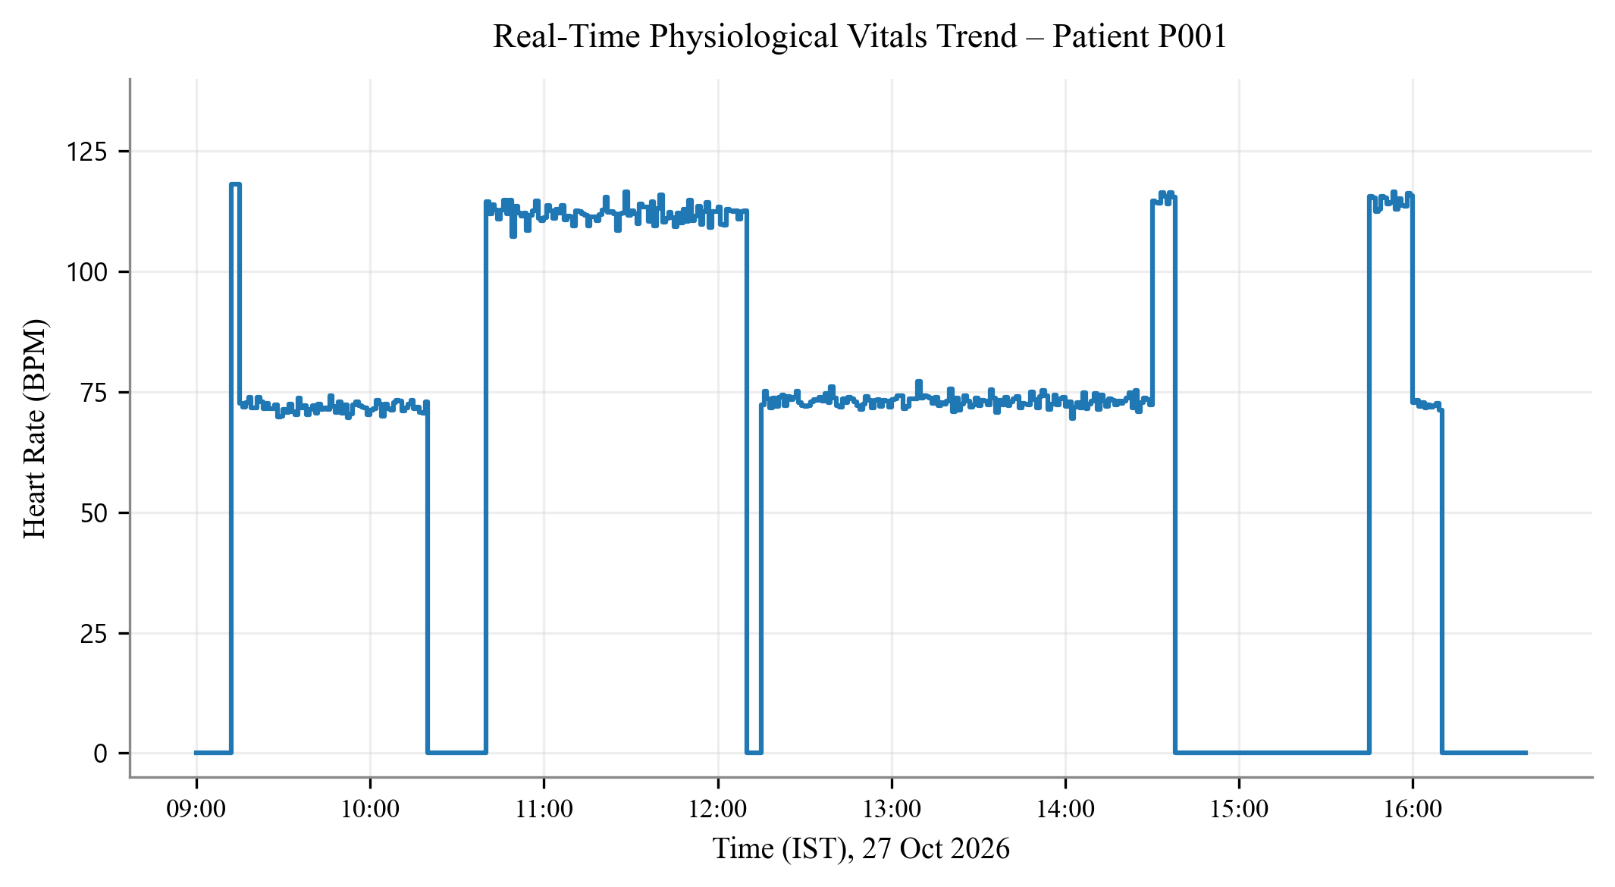
Graph 1: Real-Time Patient Physiological Vitals Trend
Observation: The graph represents the continuous real-time variation of the patient's heart rate captured by the MAX30102 pulse sensor over time. It demonstrates stable normal hemodynamic tracking (70–78 BPM) and highlights detected transient episodes of tachycardia (> 110 BPM) and resting intervals. It helps clinicians monitor hemodynamic stability and identify periods of elevated cardiovascular stress.
5.3.2 Result Graph 2: Actual Hourly Vitals and 24-Hour Quantum Risk Forecast
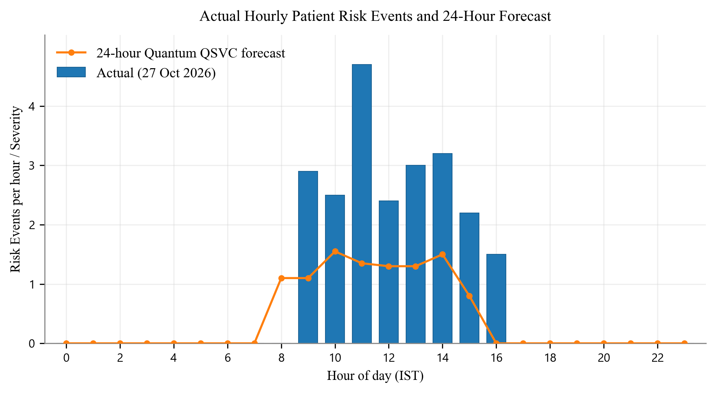
Graph 2: Actual Hourly Patient Risk Events and 24-Hour Forecast
Observation: The graph compares actual hourly patient anomaly occurrences with the predicted cardiovascular risk trajectory over a 24-hour monitoring period. The system utilizes deterministic edge safety thresholding for instantaneous alarms and the Qiskit Quantum Support Vector Classifier (QSVC) for predictive risk forecasting across diurnal cycles. This helps clinicians anticipate decompensation periods and allocate intensive care resources proactively.

