**Muthu Rishikeshwaran Eswaran**

+14694689064; Mxe190003@utdallas.edu

www.linkedin.com/in/muthurishikesh

**Loadstone – Case Study report**

**Summary**: This report provides an analysis and evaluations of the current and prospective factors, KPIs and ratings of Charcoal and Propane grill types. Methods of analysis include visualization, insight, and depth analyses. Other calculations include graphs and metrics that influence the ratings and scores of respective grill type. All calculations can be found in the appendices and answers section. Results of data analysis show that all Charcoal grill type is better for most cases including cost and flavor.

**Contents:**

Summary 1

Data quality check 2

Data modelling 3

Answers and results 4

Conclusion 8

Appendix 9

**Data quality check:**

**Python**: GoogleColab Notebook **File** **name**: Loadstone.ipynb

By changing the csv files to Pandas Data Frame, the dataset is explored. The dataset is then checked for null values, unique values, inconsistencies, and outliers. From the output we can confirm that the data is clean and contains no issues.

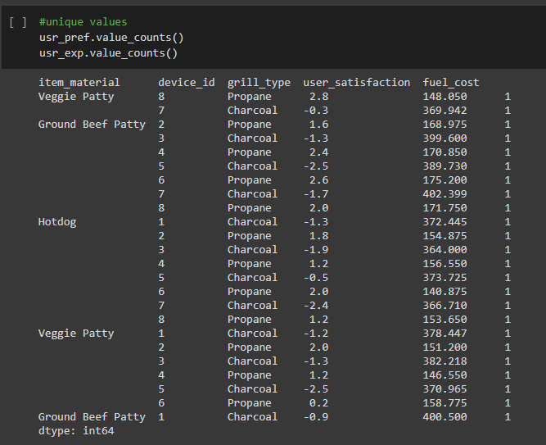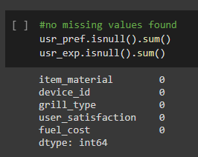

**Data modelling:**

To create meaningful reports, visualizations, and dashboards in PowerBi, we need proper data modelling. We can then proceed with filtering, sorting along with interactive Viz and QA Viz.

A simple data model of the three data sheets provided is shown below:

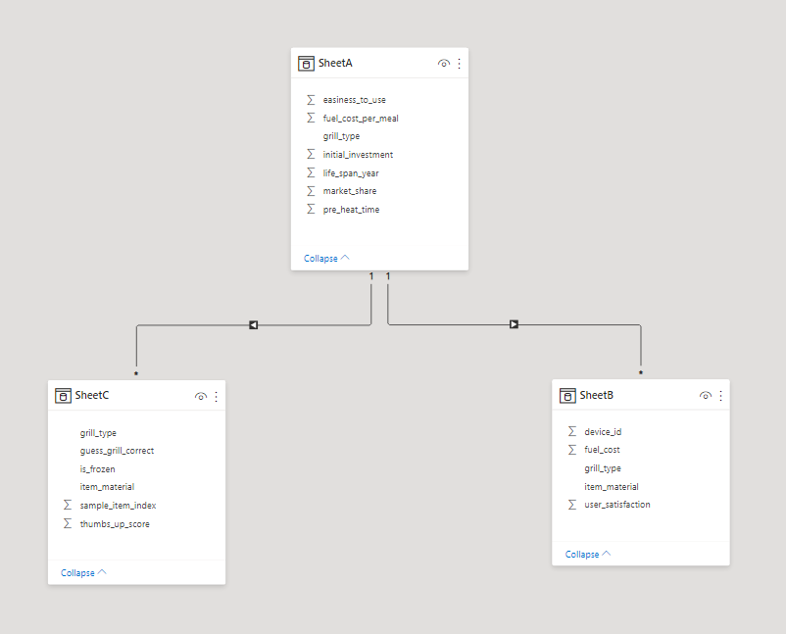

**Answers and results:**

Q1. Name each sheet/table so they are meaningful standalone?

SheetA.csv - grill_details: This sheet contains the general details and factors influencing user experience and preference.

SheetB.csv - user_satisfaction: This sheet contains the information about user satisfaction related to their grill type preferences and fuel cost.

sheetC.csv - user_experience: This sheet contains the user score based on the meal item, flavor testing results, and frozen status of the meal.

Q2. Which grill type is more fuel efficient based on sheetA?

Propane grill type is more fuel efficient based on sheetA, we can base this conclusion on the bar chart below: x-axis – grill type, y axis – Fuel cost per meal. We can clearly identify propane uses less fuel.

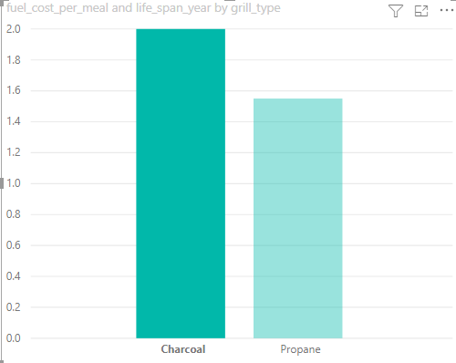

Q3. Which grill type has more market share?

According to sheet A Propane grill type has more market share, we can use a pie chart to clearly identify how much market share each grill type has.

Q4. Based on the cookoff data which grill type cost more fuel on a long?

Charcoal grill type costs more fuel in the long run

Charcoal: 2$ per cookout

Propane: 1.55$ per cookout

**Assumptions**:

* Initial cost of the grill is not taken into consideration.
* Average life span of both grill types is 3 years.
* Both type of grill types cooked same number of meals.

Q5. Considering that the average American grill owner buys a new grill every three years, which grill  type would cost more based on the fuel cost and initial invest?

Even though the fuel consumption of gas grill type is 20% less than charcoal grill type, charcoal grill type will cost less based on both initial invest and fuel cost.

**Calculations**:

initial investment,

propane = 139

charcoal = 91

Total cookouts per grill for 3 years (TCG) = 16(avg cookout per summer) * 3(life span of grill type)

Total cost for Charcoal = (TCG * price per cookout of charcoal meal) + initial cost

(48 * 2) + 91 = 187$

Total cost for Gas = (TCG * price per cookout of gas meal) + initial cost

(48*1.55) + 139 = 213.4$

From the above calculations, we can confirm that charcoal costs less.

Q6. Which grill type is easier to use based on the user satisfaction score? Based on data, which grill is

preferred? What factors might play a role?

Propane is easier to use among the two grill types, by using a clustered column chart we can see how significant the difference is, in fact charcoal mostly has negative satisfaction scores only.

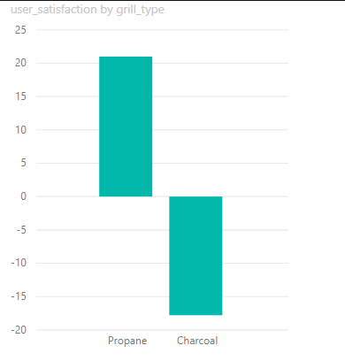

Factors influencing user preference:

* Easy to use
* Faster pre heat time
* Temperature adjustment using knobs
* Cleaning

With the data provided, we can show how fuel cost affects customer preference:

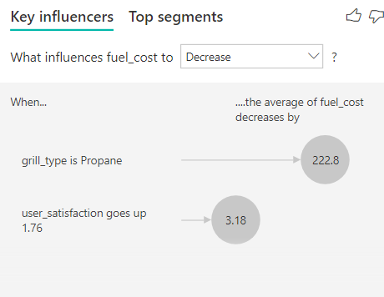

Q7. Aggregate dataset to present conclusions.

My SSMS license has a problem so I have used python to make a simple aggregated dataset.

The unique value cell in Loastone.ipynb has the aggregated values for each device_id, user_satisfaction, user_preference. These are in form of Data Frame and can be used for further analysis.

Q8. Are your recommendations to the manufacturer different to recommendations you would make to the user?

Every recommendation for this case study is situation based. For example:

1. Charcoal grill type will be interested in how they can reduce fuel prices and the cleaning process because they clearly win in other categories.
2. Propane grill type users will be interested in how they can reduce initial cost (they can even afford to increase the fuel price to break even with coal).
3. Clearly users who care less about the flavor and more about convenience should choose Propane grill type and users who care more about the flavor and less about convenience should use charcoal.
4. The final deciding factor is the cost, from Q5 we can see that charcoal costs less overall and based on the cost factor CHARCOAL GRILL TYPE is the WINNER for users.

Q9. Bonus – Json to Csv

The given Json file is read, analyzed, and parsed to create an ideal dataset in csv format.

**Problems faced while converting:**

* Expected quotes
* Nested dictionaries
* Uneven grouping of metadata and supply columns

**Steps**:

* read 🡪 json
* review data 🡪 parsing
* append parsed data 🡪 data frame
* data frame 🡪 csv

Python code file name: Loadstone.ipynb

**Conclusion**

The analysis presents the factors benefitting each grill type and how manufactures can use these facts to decide on improvement of products and users can use it to identify which grill type to buy. Every process, report, code, and visualization are done completely by me. To end on a great note the users/manufactures will like a report/dashboard to compare these facts in real time, so here is an example:

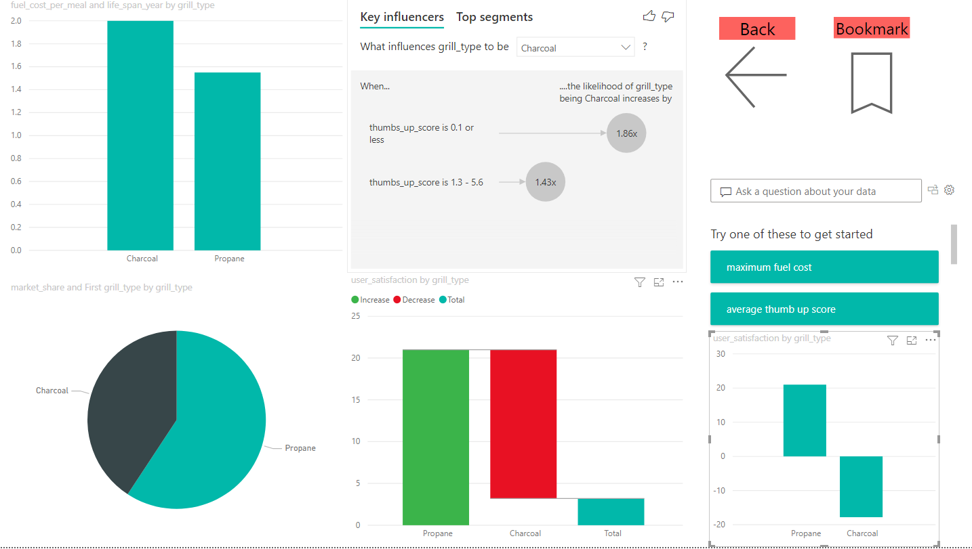

I have attached the PowerBi file in the submission for reference.

------------------------------------------------------------------------------------------------------------------------------------------

**Appendix:**

**Python code:**

import pandas as pd

grill_details = pd.read_csv('SheetA.csv')

grill_details

 usr_exp = pd.read_csv('SheetB.csv')

 usr_exp

usr_pref = pd.read_csv('SheetC.csv')

usr_pref

#checking for missing values

grill_details.isnull().sum()

#unique values

usr_pref.value_counts()

usr_exp.value_counts()

#no missing values found

usr_pref.isnull().sum()

usr_exp.isnull().sum()

Q9.

from pandas.io.json import json_normalize

with open('SheetC.json') as f:

  d = json.loads(f.read())

json_data = json.loads(d[0].get('test_result'))

parsed_data = list()

for i in range(1, len(json_data)):

  flat_json = dict()

  current_row = json_data.get(str(i))

  row_metadata = current_row.get('meta_data')

  for x in row_metadata:

    flat_json[x] = row_metadata[x]

  flat_json['sample_item_index'] = current_row['sample_item_index']

  survey_result = current_row.get('survey_result')

  for x in survey_result:

    flat_json[x] = survey_result[x]

  parsed_data.append(flat_json)

df = pd.DataFrame(parsed_data)

df.to_csv(‘Json_to_csv.csv’,index_label = ‘P.key’)

Submission Files:

Json_to_csv.csv

Loadstone.ipynb

Loadstone.py

Loadstoneviz.pbix

Loadstone.docx