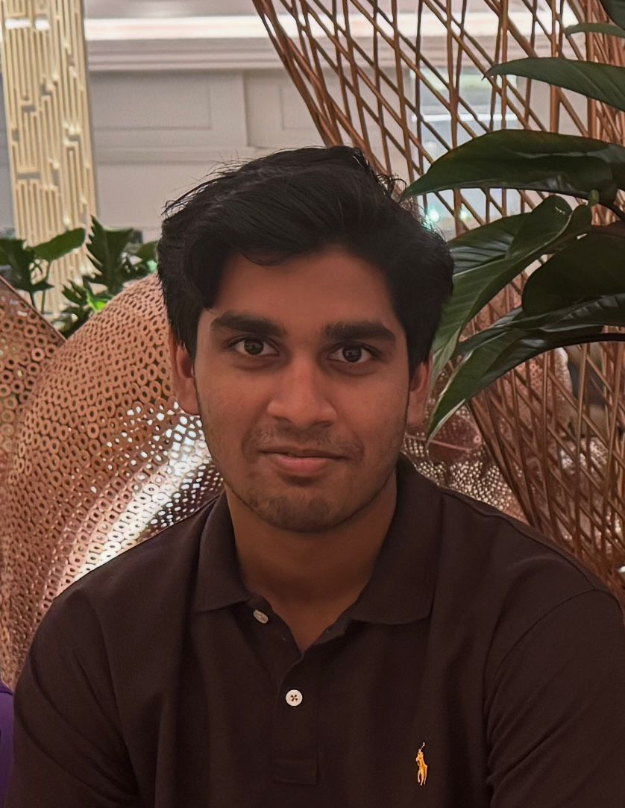

|  |  |  |  |  |  |  |
| --- | --- | --- | --- | --- | --- | --- |
| Rishikesh Aditya  Brahman | | | | | | |
|  | | | | | | |
| Summery  Motivated student with strong skills in mathematical analysis, data interpretation, and problem solving. Adept at applying analytical thinking to academic projects and personal learning activities. Eager to develop expertise further and contribute effectively in data-driven roles, while gaining practical experience and supporting organizational success.  REFERENCES  Available upon request.  ADDRESS  Muscat, Oman  PHONE  0096894554248  EMAIL  Rishikeshbrahman@gmail.com |  | EXPERIENCE | |  | |
|  | |
| As a high school student,   * Collaborated with peers on group presentations and class discussions. * Managed time effectively to balance coursework and extracurricular activities. * Gave presentations on current topics relevant to the curriculum. | | | |
| EDUCATION |  | | |
|  | | |
| Pearson Edexcel AS/AL (Mathematics) - 2025  Pearson Edexcel IGCSE - 2023  Sri Lankan School Muscat – High School Diploma - 2025 | | | |
| Extra-Curricular Activities | | |  |
|  |
| Playing tennis, golf and swimming | | | |
| achivements | |  | |
|  | |
| Tennis - U18 boys highest rank player 2023 (Muscat, Oman) | | | |