SMART URBAN MOBILITY & TRAFFIC INTELLIGENCE DASHBOARD

1. Student Details
Name: Rishikesh Dhapate
Project Title: Smart Urban Mobility & Traffic Intelligence Dashboard
Mentor Name: Kalaiyarasi
Batch: 3

2. Introduction
The Smart Urban Mobility and Traffic Intelligence Dashboard is a Power BI-based analytics project that brings together traffic movement, passenger activity, weather, and demographic data into a single, structured analytical model. The purpose of the project is to help understand urban mobility patterns and support data-driven decision-making around traffic, transit, and demand planning.
The project was carried out in four milestones. Milestone 1 focused on building the data foundation - acquiring and consolidating raw data, cleaning and transforming it through an ETL workflow in Power Query, and organising it into a star schema. Milestone 2 extended this foundation into geospatial and transit analytics, adding location-based demand analysis, route performance evaluation, and a mobility heatmap and flow-map. Milestone 3 built on the same cleaned dataset and star schema to deliver Demand Intelligence & Mobility Analytics, covering ride-hailing demand, supply-demand balance, hourly demand behaviour, weather sensitivity, and a demand trend and forecast view. Milestone 4 completed the solution with Advanced Analytics, adding a Mobility Access & Equity view, an Executive Intelligence dashboard, and a Forecasting & Mobility Intelligence page.
Together, the milestones form a complete, interactive mobility intelligence solution that allows a user to move from a high-level summary of traffic and passenger activity down to detailed, location- and route-specific insights.

3. Tools Used
- Power BI - data modelling, DAX measures, and dashboard/report design.
- Power Query (M language) - data extraction, cleaning, transformation, and shaping.
- DAX (Data Analysis Expressions) - KPI and measure calculations.
- Data Visualization - column, bar, combo, line, scatter, donut charts, and map visuals.
- Data Modelling - star schema design with fact and dimension tables.

4. Milestone 1 – Data Cleaning and Basic Analysis

4.1 Data Cleaning
The source dataset originally contained 2,000 records and 28 attributes. During transformation in Power Query, redundant or non-essential fields were removed, reducing the working dataset to 500 records and 11 fields: Date, RouteID, Location, Passenger Count, Average Speed, Vehicle Count, Weather Condition, Rainfall, Temperature, Population, and Area km². Date values were standardised, numeric fields were validated, and weather categories were kept consistent (Clear, Rain, Snow, Fog).
ETL Step | Action | Result
Extract | Import source mobility and related data | Raw 2,000 × 28 dataset
Transform | Select required fields and clean data | 11 relevant fields
Transform | Standardise types and date attributes | Analysis-ready values
Transform | Remove duplicate/invalid records | Cleaner model
Load | Import into Power BI and build relationships | Star-schema model
[Insert Power Query cleaning-steps / Applied Steps pane screenshot here]

4.2 Data Modelling
The cleaned dataset was organised into a star schema, with FactTraffic storing measurable traffic observations and four dimension tables - DimDate, DimRoute, DimLocation, and DimWeather - providing descriptive context. Relationships are one-to-many from each dimension to FactTraffic, which reduces repeated descriptive data and allows consistent analysis by date, route, location, and weather.
Table | Main Fields / Role
FactTraffic | Date, RouteID, Location, Weather Condition, Passenger Count, Vehicle Count, Average Speed, Rainfall, Temperature, Population, Area km²
DimDate | Date, Day Name, Month, Month Number, Year
DimRoute | Route ID
DimLocation | Location
DimWeather | Weather
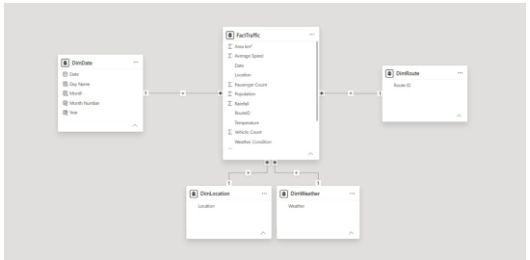
Figure 1: Star schema showing FactTraffic connected to DimDate, DimRoute, DimLocation, and DimWeather.

4.3 KPI Cards
Four core KPI measures were created using DAX to summarise the dataset at a glance:
Measure | DAX Function | Dashboard Use
Total Passengers | SUM | Total recorded passenger volume
Average Speed | AVERAGE | Overall traffic speed in km/h
Total Population | SUM | Combined population represented in the data
Average Rainfall | AVERAGE | Average recorded rainfall in mm
Displayed KPI values: Total Passengers 64K, Average Speed 42.37 km/h, Total Population 285M, Average Rainfall 3 mm.

4.4 Milestone 1 Dashboard Explanation
Visual | Purpose
Passenger Traffic Trend | Shows passenger traffic over time.
Average Traffic Speed by Weather | Compares average speed across Snow, Rain, Fog, and Clear.
Passenger Count by Route | Ranks routes by total passenger count.
Route Performance Analysis | Compares route area and population density context.
The dashboard also includes RouteID, Weather Condition, and Date slicers, allowing the user to move from an overall view to a specific route, weather condition, or time period.
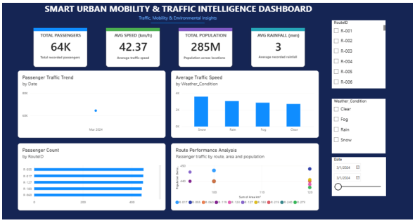
Figure 2: Smart Urban Mobility & Traffic Intelligence Dashboard — Milestone 1 Power BI report view.

5. Milestone 2 – Geospatial and Transit Analytics
Milestone 2 extends the dashboard from basic traffic reporting into interactive geospatial and transit analytics, using the same 500-record cleaned dataset from Milestone 1, enriched with geographic coordinates and time information.

5.1 Location-Based Analysis
The Location field was prepared for geographic grouping, and latitude/longitude values were used for map positioning. The geographic information was merged with the existing traffic records so that passenger demand could be compared across major locations. This supports the Passenger Demand by Location visual, and the Mobility Demand Heatmap, which gives a geographic view of demand concentration filterable by date, route, location, and weather.

5.2 Transit Reliability Analysis
A Reliability % measure was created as a route/service reliability indicator, alongside a Disruptions count of identified disruption records. Displayed values: Reliability 66.6%, Disruptions 98. These measures let the dashboard highlight how consistently the transit network performed across the selected filters.

5.3 Route/Trip Analysis
A Total Trips measure (76K) summarises the total number of mobility records/trips represented in the analysis. The Top Routes by Passenger visual highlights the routes with the highest passenger demand, making it possible to prioritise high-demand routes for service and capacity analysis, while the Route Performance & Demand visual combines passenger count with average speed at route level.

5.4 Conditional Formatting
Conditional formatting was applied to the KPI cards and category visuals (for example, Reliability % and Disruptions) to visually flag values that fall outside expected ranges, and colour scales were used on the Passenger Demand by Location bars and the geographic heatmap to distinguish high-demand areas from low-demand ones at a glance.

5.5 Milestone 2 Dashboard Explanation
The Milestone 2 dashboard brings together Passenger Demand by Location, Top Routes by Passenger, Passenger Demand Over Time, Passenger Demand by Weather, Route Performance & Demand, the Mobility Demand Heatmap, and a Geographic Drill-down Analysis panel. A Mobility Flow Map represents movement between origin and destination, using origin/destination name and latitude/longitude fields, with passenger count or trip volume driving line width. Interactive slicers for Date, Time, Route ID, Location, and Weather allow the dashboard to be filtered from an overall view down to specific segments.
- Passenger demand is concentrated in a smaller number of locations and routes, making them important areas for mobility planning.
- Demand varies across weather categories, allowing the effect of weather conditions to be investigated.
- The geographic heatmap makes spatial concentration visible and supports identification of mobility hotspots.
- The drill-down section provides a location-level comparison for more detailed geographic analysis.
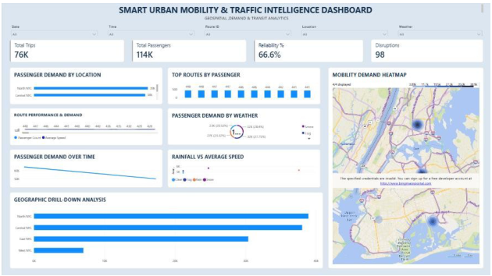
Figure: Smart Urban Mobility & Traffic Intelligence Dashboard — Milestone 2 Geospatial & Transit Analytics view.

6. Milestone 3 – Demand Intelligence and Mobility Analytics
Milestone 3 extends the dashboard into Demand Intelligence & Mobility Analytics, using the same 500-record cleaned dataset and star schema from Milestones 1 and 2 to analyse ride-hailing demand, vehicle supply, weather sensitivity, and demand trends.

6.1 Demand Trend Analysis
The Passenger Demand Trend & Forecast visual shows the demand trend across the date axis with a forecast line for the direction of demand. Over the early March 2024 period covered by the dataset, demand moves downward. Because the period is short, the forecast should be read as an indication of direction rather than a precise prediction.

6.2 Transportation Mode Analysis
The dataset does not contain a dedicated travel-mode field, so a direct mode-by-mode comparison was not possible. Instead, transportation-mode behaviour was assessed indirectly by comparing passenger demand against vehicle supply across locations, weather conditions, and hours of the day, using the Passenger Demand vs Vehicle Supply visual and the Passengers per Vehicle measure (1.50) to highlight where supply does or does not keep pace with demand.

6.3 Mobility Analysis
Cycling, micromobility, and modal-substitution behaviour were also addressed indirectly, since the dataset has no cycling-specific field. The Passenger Demand vs Vehicle Supply and Passengers per Vehicle measures provide the supply-and-utilisation view used for micromobility-style planning, while demand shifts across weather, hour, and location were compared against vehicle supply to indicate where demand is not matched by supply and where another mode could substitute.

6.4 Forecasting
Power BI's built-in forecasting was applied to the demand trend line to project the likely direction of passenger demand beyond the observed dates. This is shown alongside the historical trend in the Passenger Demand Trend & Forecast visual, giving an early indication of whether demand is rising or falling.

6.5 Milestone 3 Dashboard Explanation
Measure | Calculation | Dashboard Use
Total Demand | SUM of Passenger Count | Total passenger demand across the selected filters.
Total Vehicles | SUM of Vehicle Count | Vehicle supply available to serve the demand.
Average Speed | AVERAGE of Average Speed | Overall traffic speed used as a performance indicator.
Passengers per Vehicle | Total Demand ÷ Total Vehicles | Average vehicle load; a utilisation and supply-demand indicator.
Displayed KPI values: Total Demand 114K, Total Vehicles 76K, Average Speed 42.08, Passengers per Vehicle 1.50.
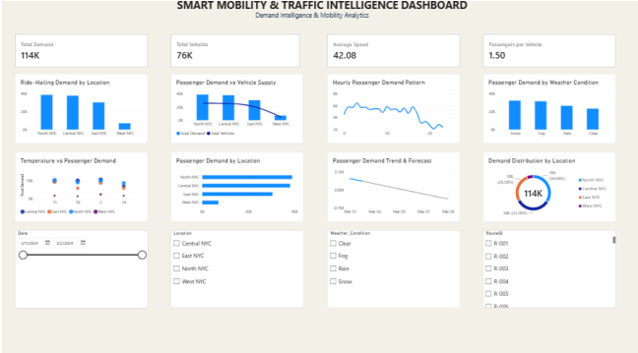
Figure: Smart Mobility & Traffic Intelligence Dashboard — Milestone 3 Demand Intelligence & Mobility Analytics view.

7. Milestone 4 – Advanced Analytics
Milestone 4 completes the project with three advanced analytics pages built on the same 500-record cleaned dataset and FactTraffic star schema used in Milestones 1 to 3: Mobility Access & Equity, the Executive Intelligence Dashboard, and Forecasting & Mobility Intelligence. Together with the earlier pages, the report now has six pages linked by a navigation bar.

7.1 Mobility Access Index
The Mobility Access Index was created to compare how accessible and reliable mobility service is across locations and routes. The overall value on the dashboard is 31.35, shown alongside Reliability % (66.6%), Average Speed Score (42.08), Total Demand (114K) and Total Trips (76K). The index is shown by location, by route, and in a location-by-route matrix, so gaps in coverage can be found quickly.
Sample DAX:
[Paste the DAX formula used for the Mobility Access Index here]

7.2 Executive Intelligence Analysis
The Executive Intelligence Dashboard gives decision-makers a one-screen summary. It repeats the five headline KPIs (Total Demand, Total Trips, Mobility Access Index, Reliability %, Average of Average Speed) and adds four supporting visuals: Total Passengers by Location, Sum of Average Speed by Date, Total Trips by Location, and Total Trips by Weather. Date, Location, RouteID and Weather slicers filter every visual on the page.

7.3 Forecasting and Geographic Analysis
The Forecasting & Mobility Intelligence page places a Forecast line next to the Actual Demand Trend, so the projected direction of demand can be compared with the recorded demand. A Mobility Demand by Location map with weather-coloured markers shows where demand occurs across the New York area. Recorded demand falls across the early March 2024 period and the forecast continues that downward direction. Because the period is short, the forecast should be read as an indication of direction rather than a precise prediction.

7.4 Milestone 4 Dashboard Explanation
Measure | Calculation | Dashboard Use
Mobility Access Index | Composite access index | Compares accessibility across locations and routes. Overall value: 31.35.
Reliability % | Reliability indicator | Service reliability across the selected filters. Overall value: 66.6%.
Average Speed Score | AVERAGE of Average Speed | Traffic speed used as a performance indicator. Overall value: 42.08.
Total Demand | SUM of Passenger Count | Total passenger demand. Overall value: 114K.
Total Trips | Count of trip records | Total mobility trips in the analysis. Overall value: 76K.
Displayed KPI values: Mobility Access Index 31.35, Reliability 66.6%, Average Speed 42.08, Total Demand 114K, Total Trips 76K.
Visual | Purpose
Mobility Access by Location | Compares the Mobility Access Index across East, North, Central and West NYC.
Mobility Access by Route | Ranks routes by their Mobility Access Index.
Demand vs Mobility Access | Scatter plot relating total demand to mobility access for each location.
Trips by Weather Condition | Donut chart of the share of trips under Snow, Fog, Rain and Clear conditions.
Mobility Access by Location & Route | Matrix of the index for each location and route combination.
Total Passengers / Total Trips by Location | Bar and column charts comparing passenger volume and trip counts by location.
Sum of Average Speed by Date | Line chart showing how speed changes over the period.
Forecast and Actual Demand Trend | Line charts showing projected and recorded demand over time.
Mobility Demand by Location | Map showing where demand occurs, with markers coloured by weather.

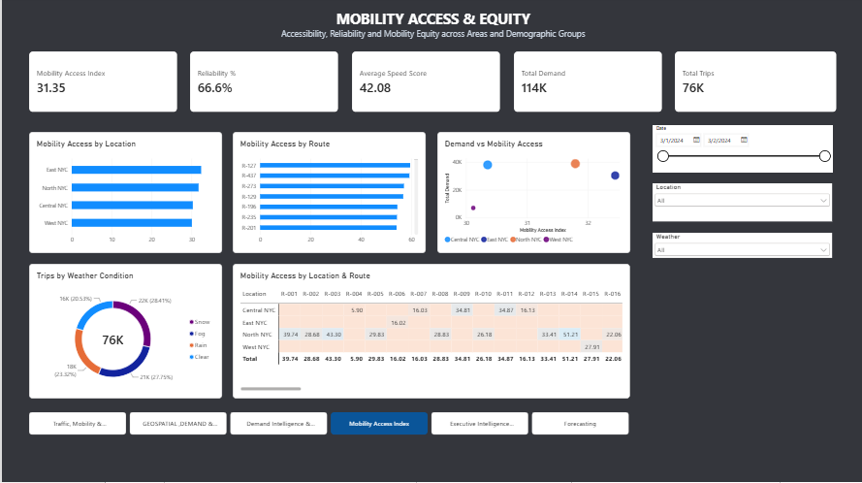
Figure: Smart Urban Mobility & Traffic Intelligence Dashboard — Milestone 4 Mobility Access & Equity view.
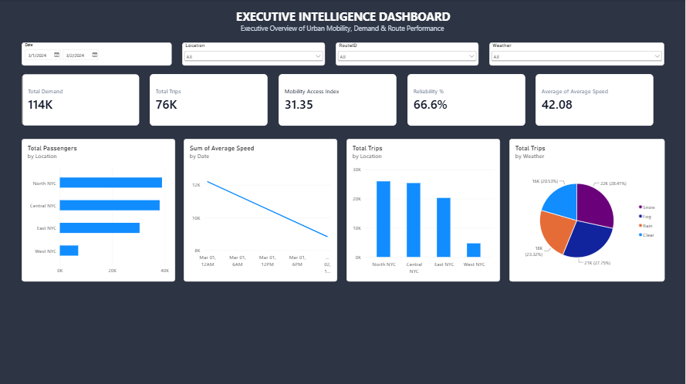
Figure: Smart Urban Mobility & Traffic Intelligence Dashboard — Milestone 4 Executive Intelligence Dashboard view.
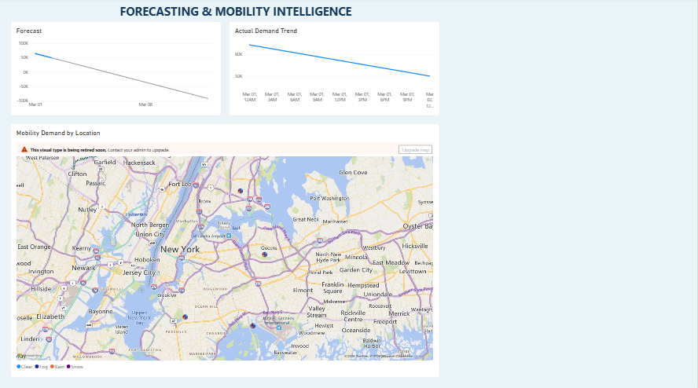
Figure: Smart Urban Mobility & Traffic Intelligence Dashboard — Milestone 4 Forecasting & Mobility Intelligence view.

8. Key Insights
- Mobility access is fairly even across the four locations, at roughly 30 to 32 on the index, even though demand is very uneven. West NYC has the lowest access score and by far the lowest demand.
- North NYC and Central NYC carry most of the volume (about 39K and 38K passengers). West NYC has only about 7K passengers, so it is the least-served area.
- Reliability is 66.6%, so about one in three records falls short of the reliability standard. This is a clear area for service improvement.
- The location-by-route matrix shows North NYC has the widest route coverage, while the other locations are served by only a few routes each.
- Snow (28.41%) and Fog (27.75%) have the highest share of trips, followed by Rain (23.32%) and Clear (20.5%). Adverse weather does not reduce trip activity.
- Average speed and demand both trend downward across the early March 2024 period, and the forecast continues that direction. The forecast line drops below zero, which real demand cannot do, so it should be read as direction only.
- The map visual is flagged by Power BI as being retired soon, so it should be upgraded to the newer map visual in future.

9. Conclusion
The Smart Urban Mobility and Traffic Intelligence Dashboard provides useful insights into transportation demand, mobility patterns, accessibility, reliability, and travel performance. Power BI was used for data cleaning, modelling, visualization, advanced analytics, forecasting, and dashboard development. The project helps users understand mobility trends and make data-driven decisions.

10. References
Resources used for completing the project:
- Microsoft Power BI Documentation
- Microsoft Excel
- Power BI Learning Resources
- Dataset Source: Smart urban mobility dataset (2,000 records, 28 attributes) provided for the project

