**Cloud Computing 3:**Creating an Application in SalesForce.com using Apex programming Language.

**Create variables**

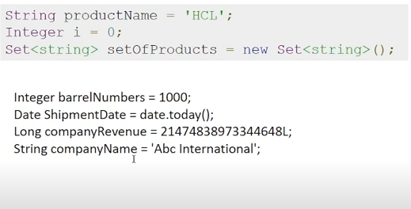

**Concatenation**

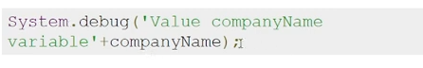

Output display : System.debug

* It is same as Java .
* Instead of string we can put integer also
* ArrayofProducts will go on adding values

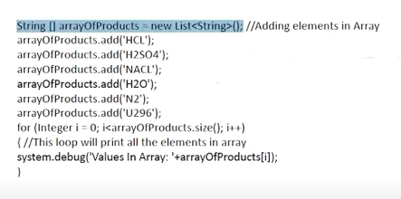

**Sorting program in Apex**

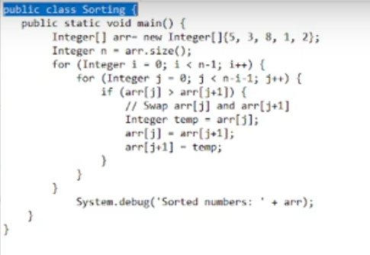

**Go to**

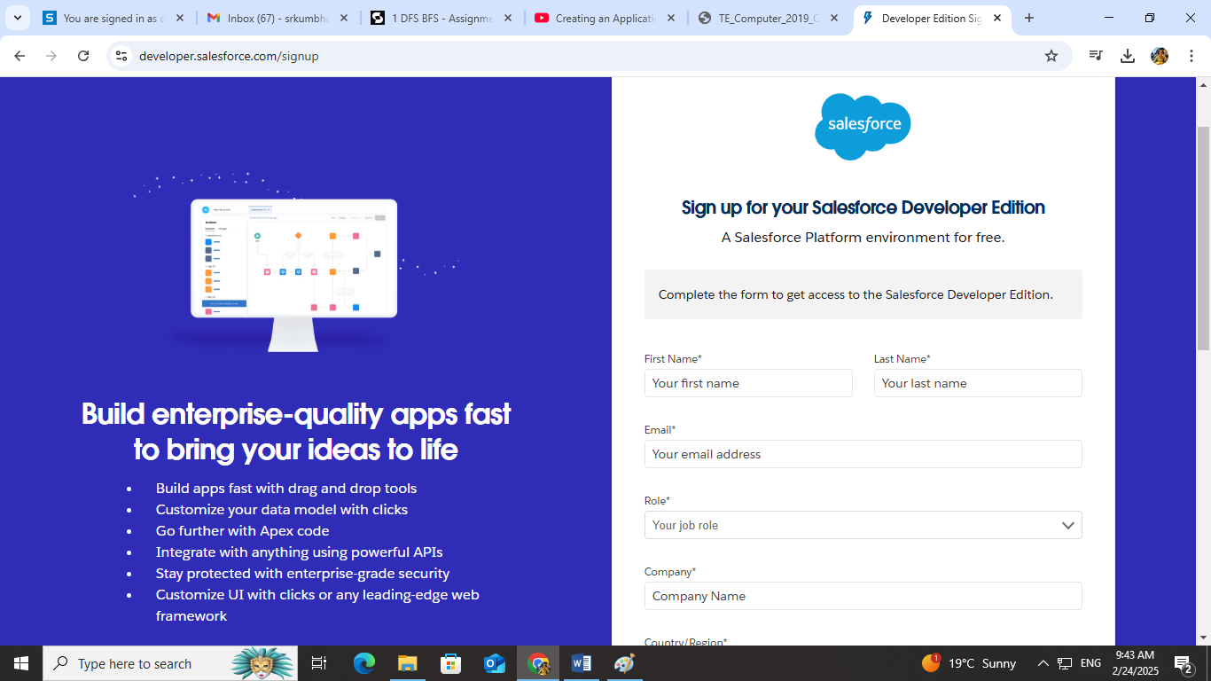

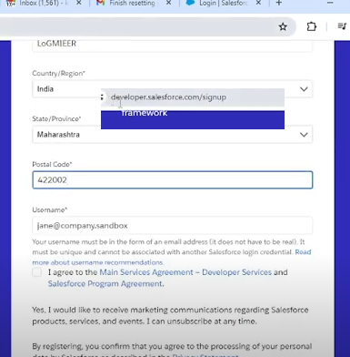

**GUI: called as Lightning GUI**

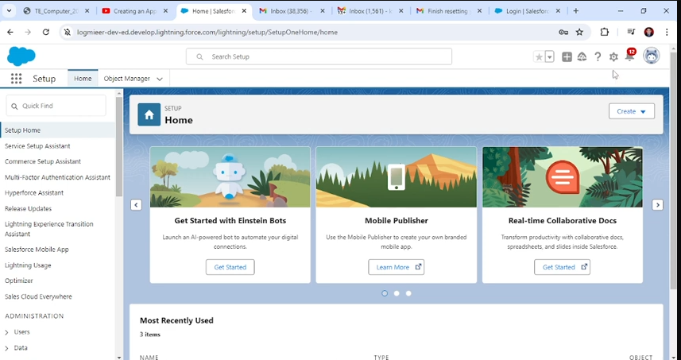

**Consol**

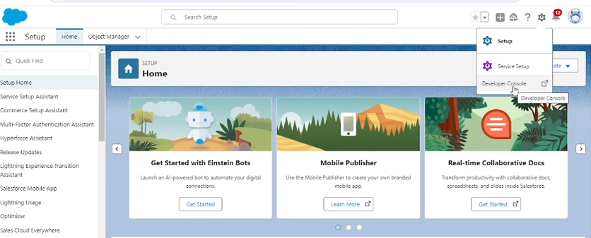

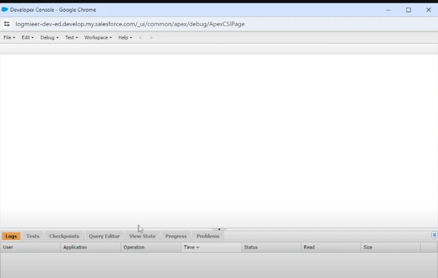

**File -> New -> apex class-> enter name (sorting)-> ok**

**Paste the code here**

**Save :ctrl+s**

**Run: debug ->open executive window**

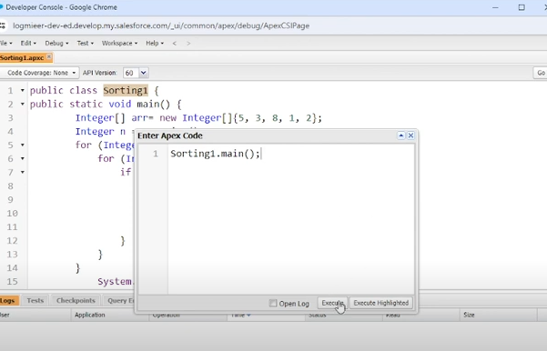

**Click on open log and then execute**

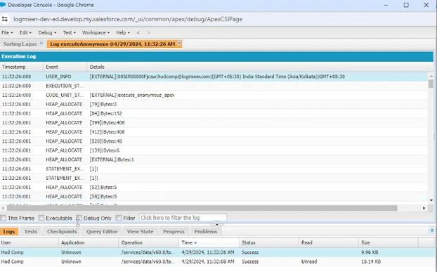

**To see output click on debug only**