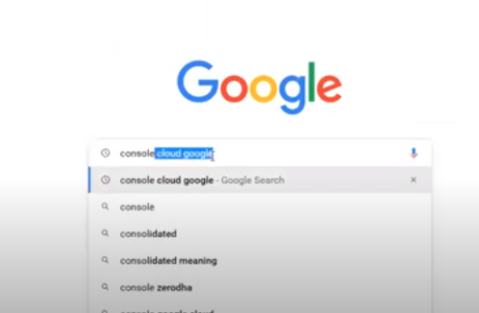

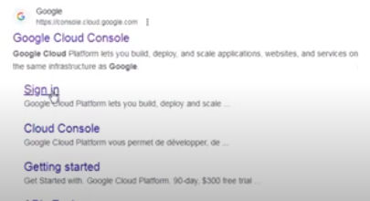

Sig in 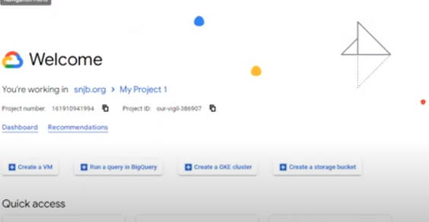

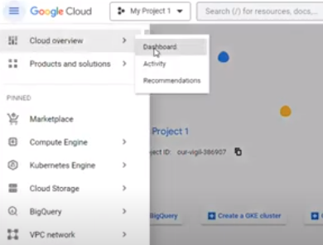

Create a project

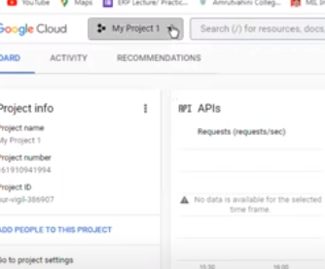

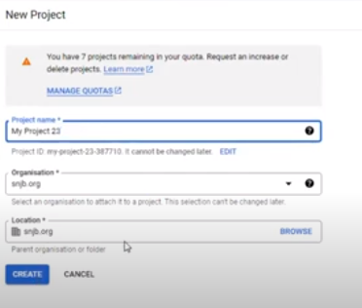 enter only the name of project rest remains the same . -> create

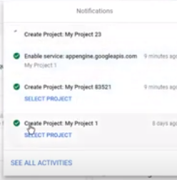 disable rest project and enable new created project

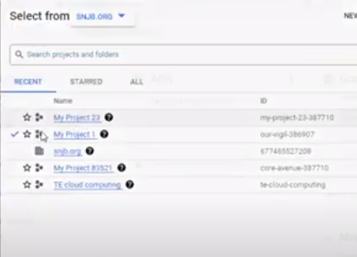

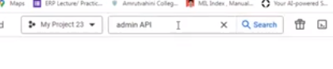Enter admin API

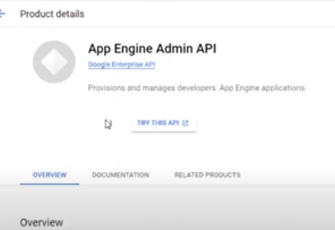 select the Admin API

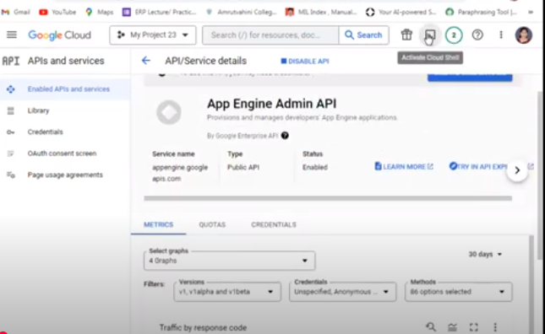

Go to **Active Cloud Shell**

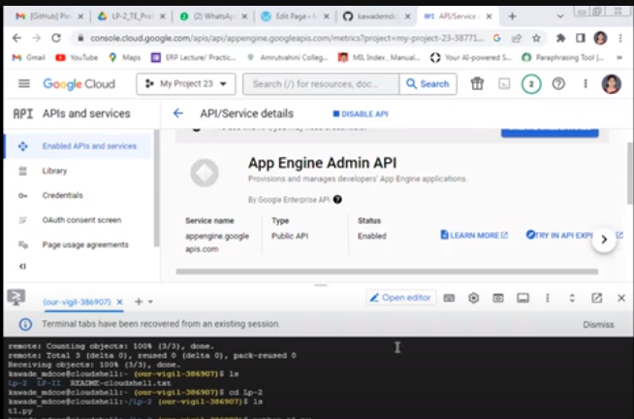

Shell will open

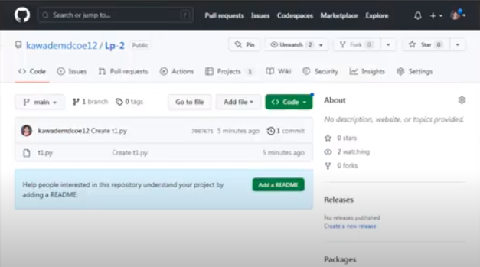

Then go to GIT HUB

Do login

Create a python program

T1.py is program

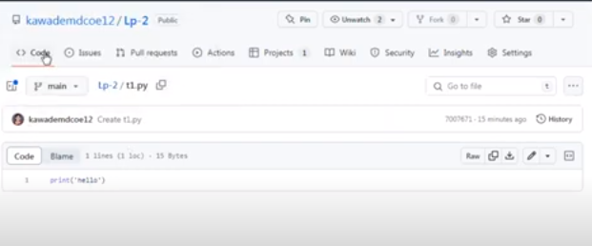

After creating the program go to main page

Click in code -> HTTP-> copy the link -> go to API shell

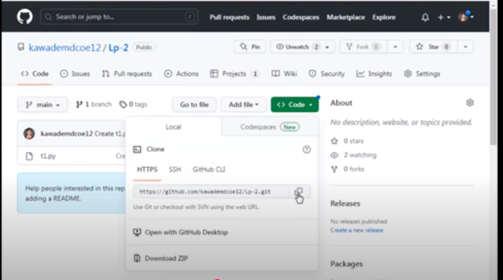

If already directory is cloned

Remove clone = rm –rf LP-2

Ls to see if file is tere to check

Cloning processes

Git clone {paste the http link}

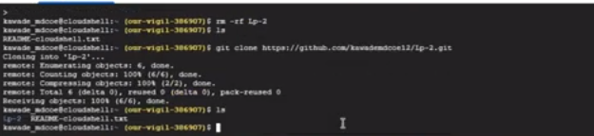

Ls -> to see files in that link

Cd LP2-> enter the directory

Ls

T1.py [program name ] u will see the program here

Python t1.py

If u want to edit the file go back to github

Edit the file . do changes u want to

Copy the link

