**1]Fibonacci**

fib(1,1).

fib(2,1).

fib(N,R):- N >= 3,N1 is N-1,N2 is N-2,

fib(N1,R1),fib(N2,R2),R is R1+R2.

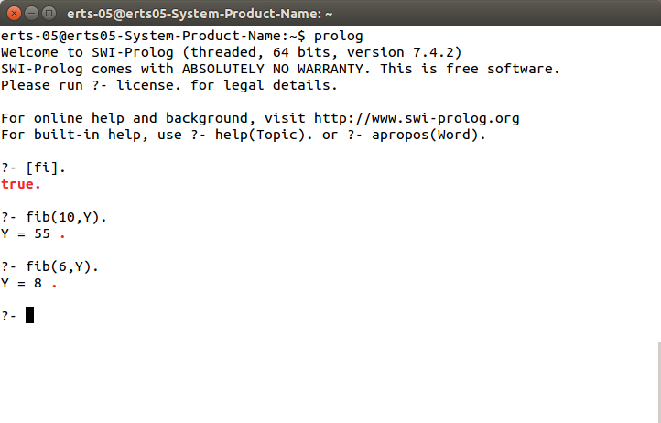

**2] Factorial**

factorial(0,1).

factorial(N,F) :-

N>0,

N1 is N-1,

factorial(N1,F1),

F is N * F1.

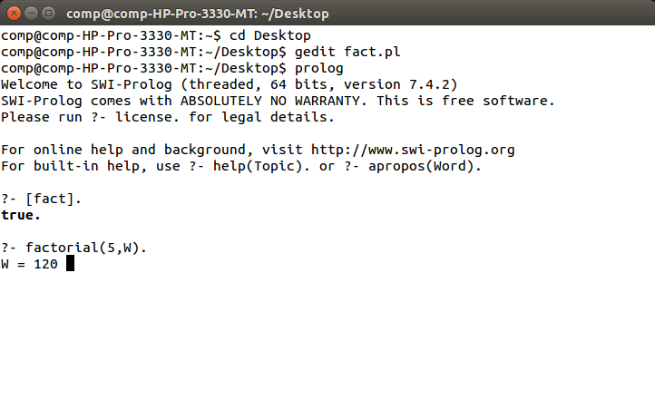

**3] TOWER OF HANOI**

move(1,X,Y,_) :-

write('Move top disk from '),

write(X),

write(' to '),

write(Y),

nl.

move(N,X,Y,Z) :-

N>1,

M is N-1,

move(M,X,Z,Y),

move(1,X,Y,_),

move(M,Z,Y,X).

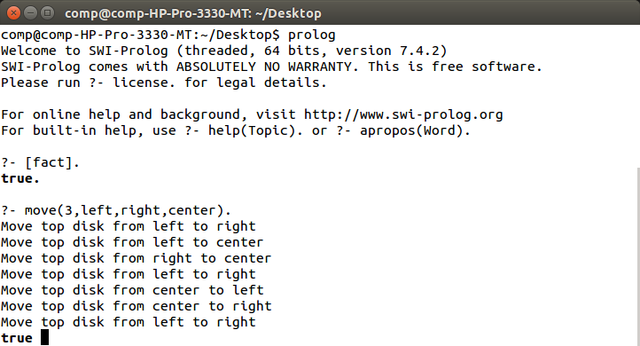

**4] family Tree**

discontiguous male/1, female/1, parent/2.

male(dicky).

male(randy).

male(mike).

male(don).

male(elmer).

female(anne).

female(rosie).

female(esther).

female(mildred).

female(greatgramma).

male(blair).

male(god).

female(god).

parent(don,randy).

parent(don,mike).

parent(don,anne).

parent(rosie,randy).

parent(rosie,mike).

parent(rosie,anne).

parent(elmer,don).

parent(mildred,don).

parent(esther,rosie).

parent(esther,dicky).

parent(greatgramma,esther).

parent(randy,blair).

male(mel).

male(teo).

parent(melsr,mel).

parent(melsr,teo).

american(anne).

american(X) :- ancestor(X,anne).

american(X) :- ancestor(anne,X).

relation(X,Y) :- ancestor(A,X), ancestor(A,Y).

father(X,Y) :- male(X),parent(X,Y).

father(god, _) :- male(god).

mother(X,Y) :- female(X),parent(X,Y).

son(X,Y) :- male(X),parent(Y,X).

daughter(X,Y) :- female(X),parent(Y,X).

grandfather(X,Y) :- male(X),parent(X,Somebody),parent(Somebody,Y).

aunt(X,Y) :- female(X),sister(X,Mom),mother(Mom,Y).

aunt(X,Y) :- female(X),sister(X,Dad),father(Dad,Y).

sister(X,Y) :- female(X),parent(Par,X),parent(Par,Y), X \= Y.

uncle(X,Y) :- brother(X,Par),parent(Par,Y).

cousin(X,Y) :- uncle(Unc , X),father(Unc,Y).

ancestor(X,Y) :- parent(X,Y).

ancestor(X,Y) :- parent(X,Somebody),ancestor(Somebody,Y).

brother(X,Y) :- male(X),parent(Somebody,X),parent(Somebody,Y), X \= Y.

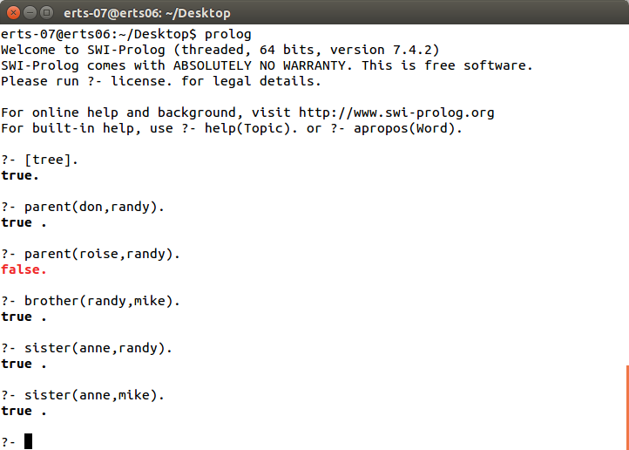

**5] Area of circle**

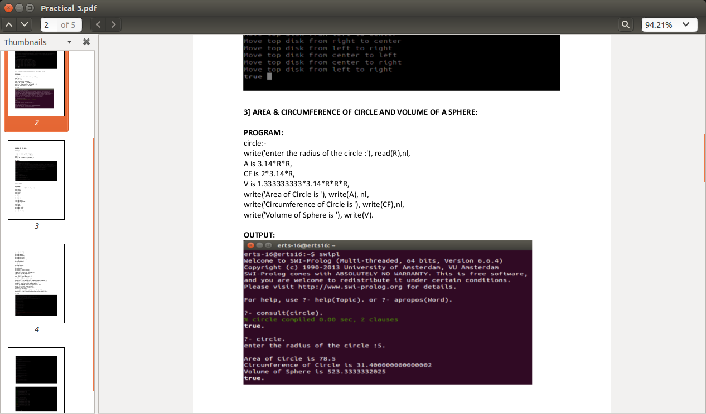

***Conclusion:*** Thus, various program using prolog has implemented.