Experiment No: 2

***Aim:*** *Virtualization in cloud*

***Theory:***

In computing, virtualization means to create a virtual version of a device or resource, such as a server, storage device, network or even an operating system where the framework divides the resource into one or more execution environments. Even something as simple as partitioning a hard drive is considered virtualization because you take one drive and partition it to create two separate hard drives. Devices, applications and human users are able to interact with the virtual resource as if it were a real single logical resource. The term virtualization has become somewhat of a buzzword, and as a result the term is now associated with a number of computing technologies including the following:

* **Storage Virtualization:** the amalgamation of multiple network storage devices into what appears to be a single storage unit.
* **Server Virtualization:** the partitioning a physical server into smaller virtual servers.
* **Operating system-level virtualization:** a type of server virtualization technology which works at the operating system (kernel) layer.
* **Network Virtualization:** using network resources through a logical segmentation of a single physical network.
* **Application Virtualization**

**Installation Of VMware Player:**

**Step 1:** Install packages and dependencies

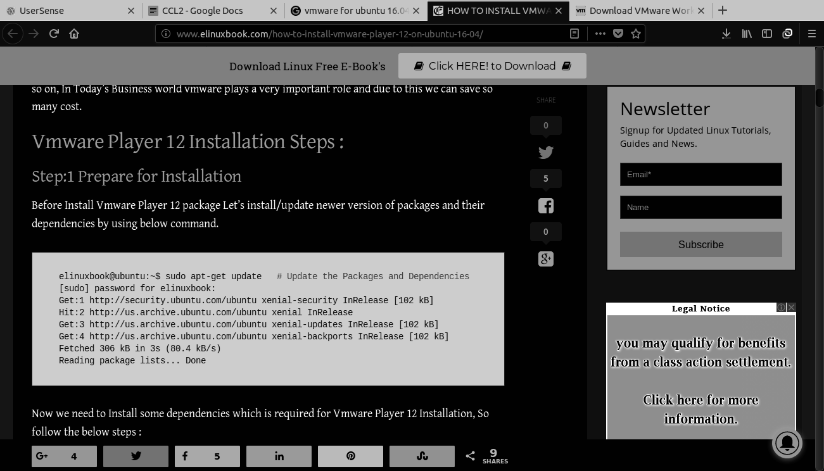

Install **build-essential** and **gcc**

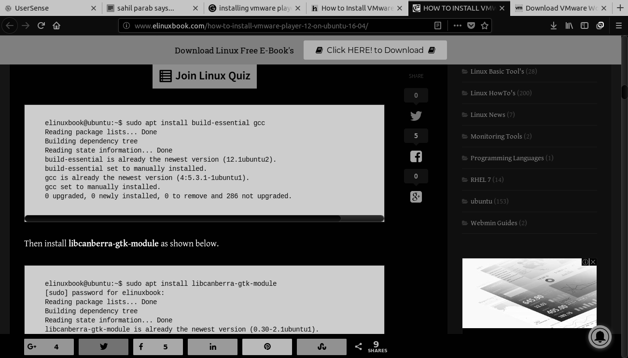

Install **libcanberra-gtk-module**

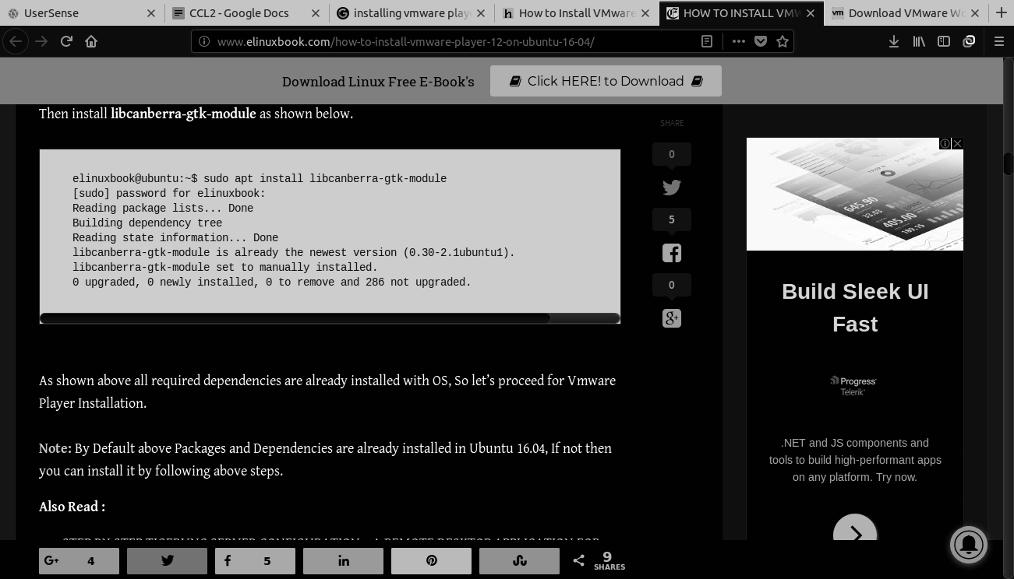

**Step 2:** Download VMware Workstation 14 from its Official Site

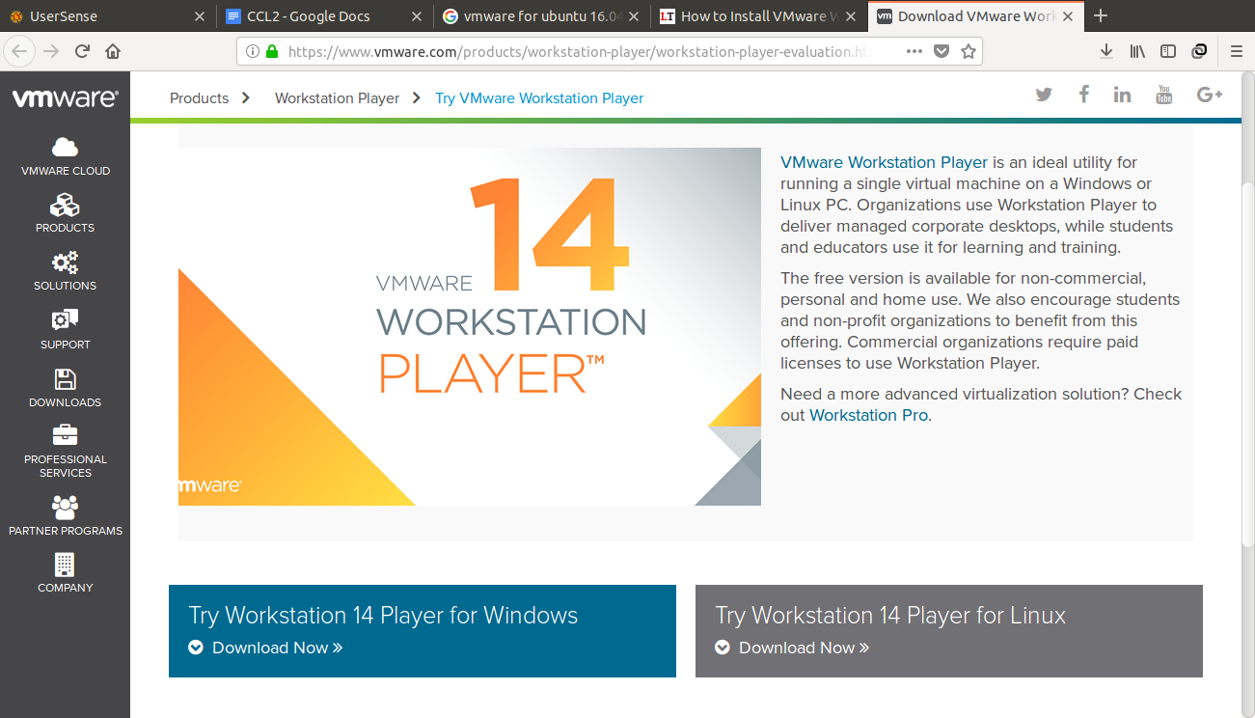

**Step 3:** Start VMware Workstation 14 installation from the terminal

Before starting the installation, let’s us set the executable permissions on the downloaded bundle file.

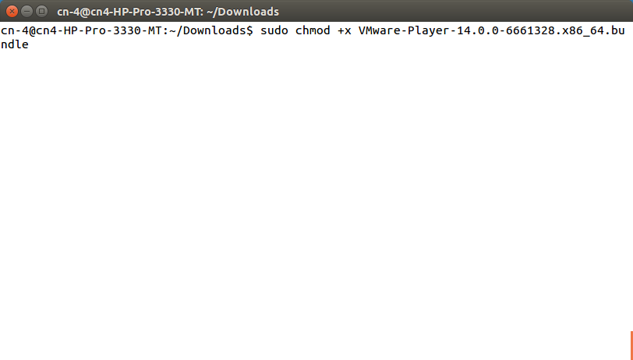

Now Start the VMware Workstation installer by executing the downloaded bundle file.

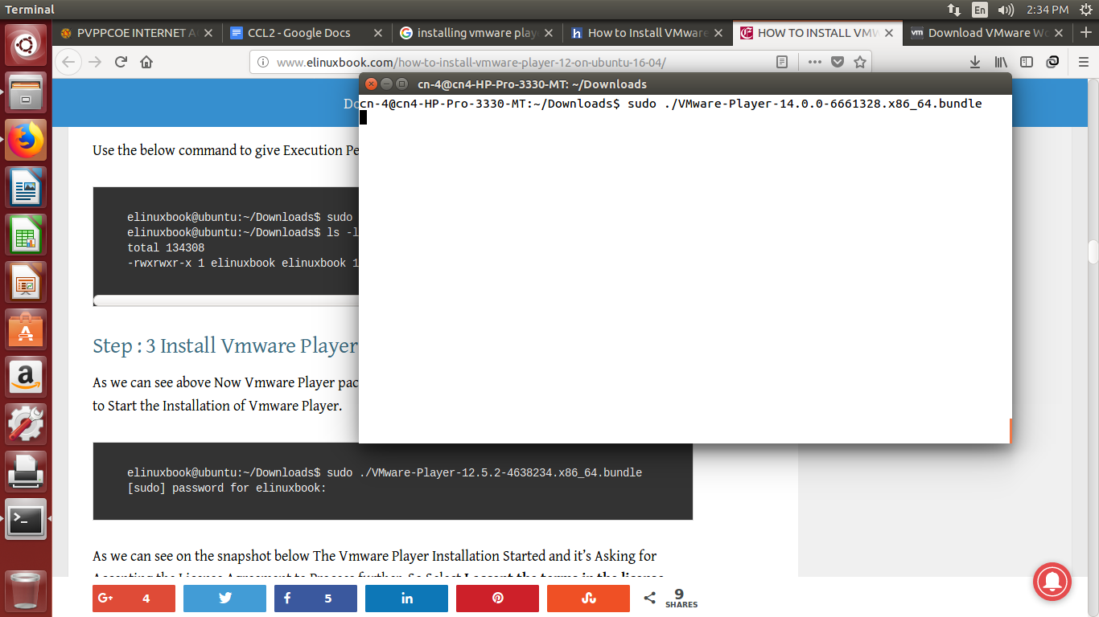

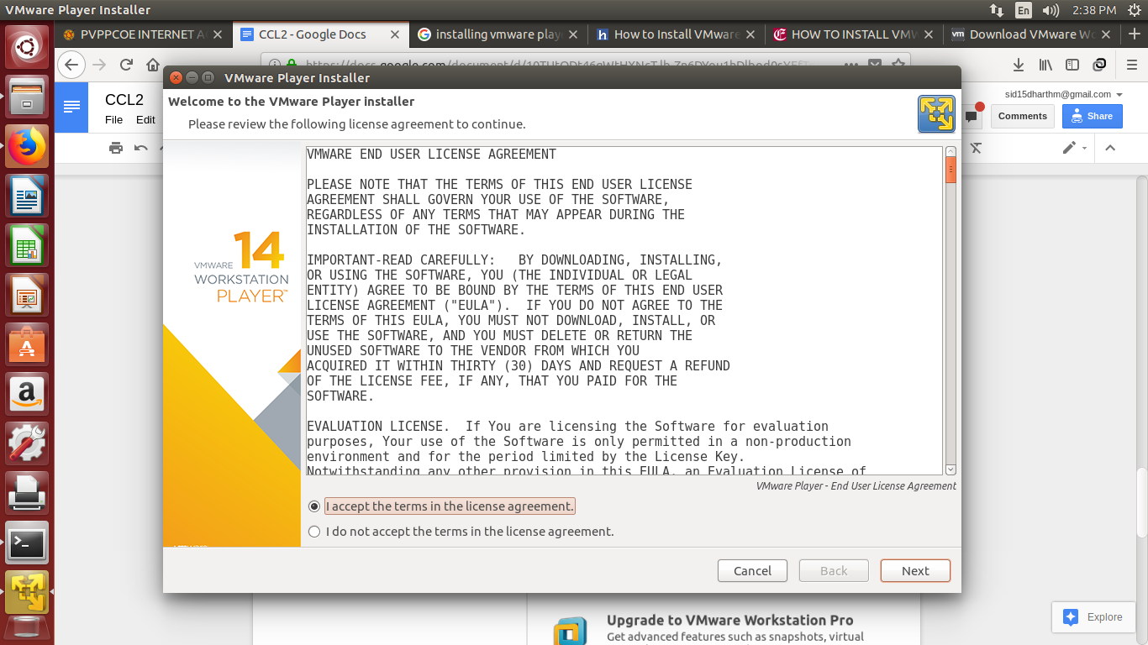

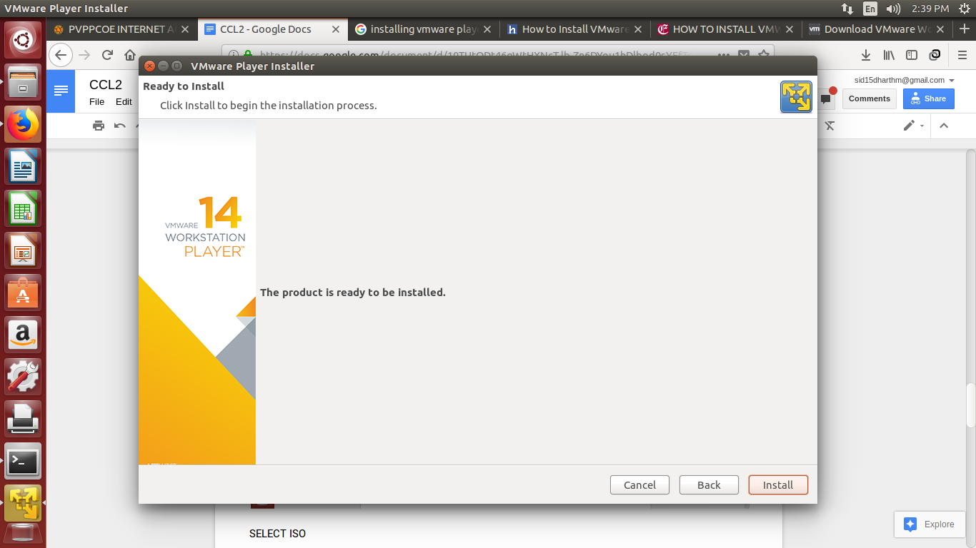

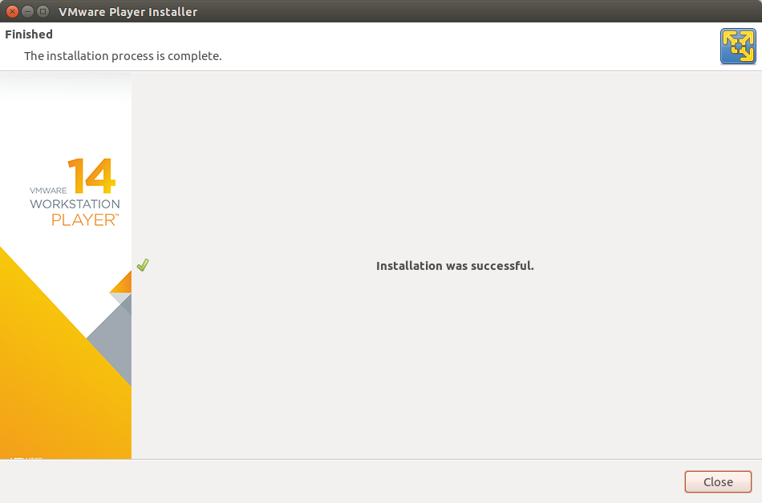

**Creating a virtual machine:**

**Step 1:** Open VMware Workstation Player.

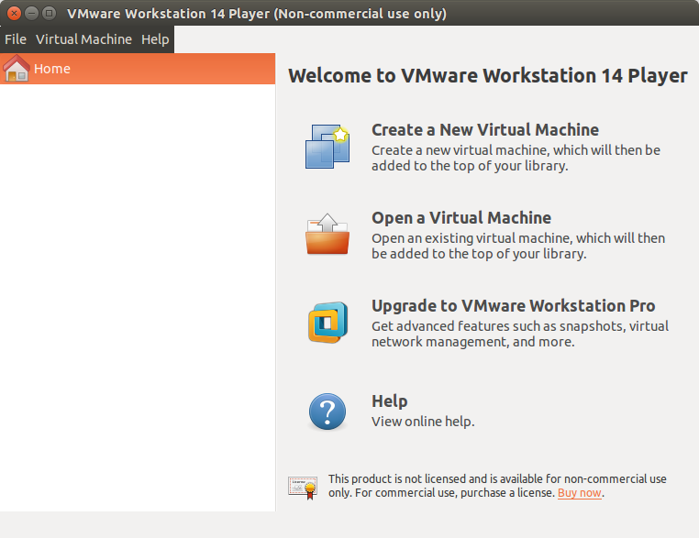

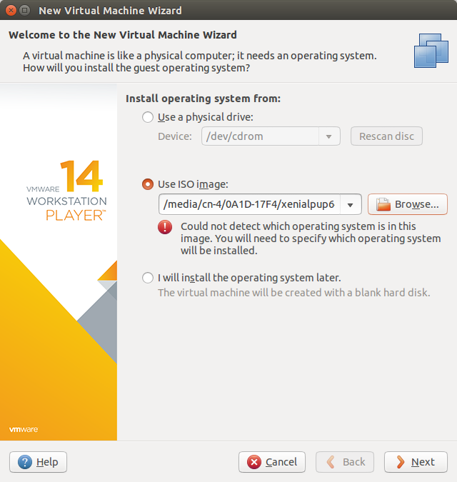

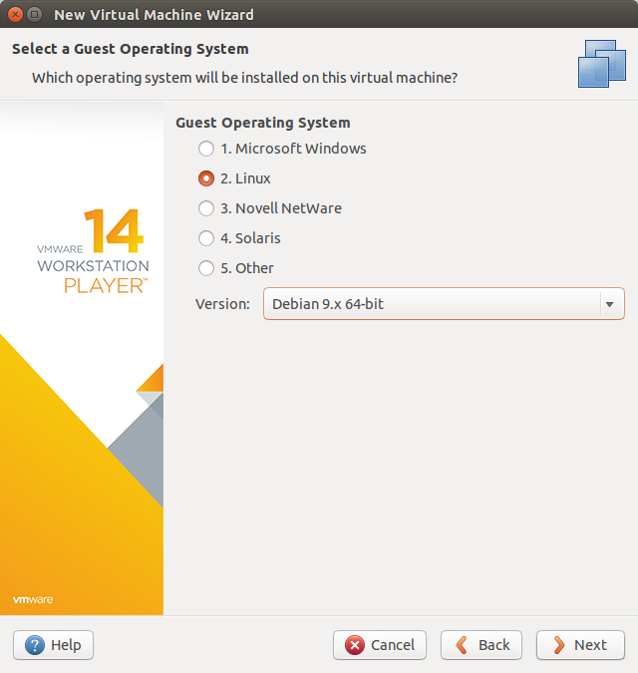

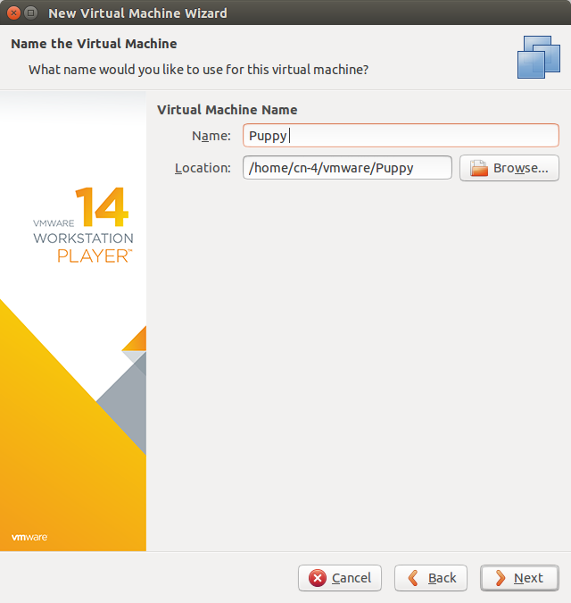

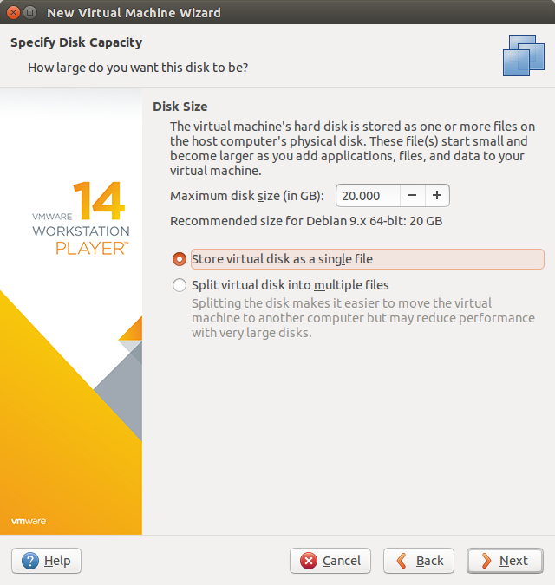

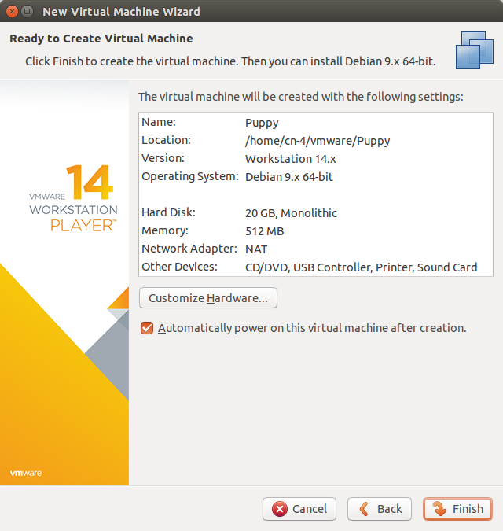

***Conclusion:*** VMWare installed and configured properly alongside with an OS of choice.