Experiment No.5

**Aim:** Study and installation of Storage As Service using ownCloud.

**Theory:**

ownCloud is a file sharing server that permits you to store your personal content, like documents and pictures, in a centralized location, much like Dropbox. The difference with ownCloud is that it is free and open-source, which allows anyone to use and examine it. It also returns the control and security of your sensitive data back to you, thus eliminating the utilization of a third-party cloud hosting service.

In this tutorial, we will install and configure an ownCloud instance on an Ubuntu 16.04 server.

**Prerequisites**

* **A sudo user on your server**: You can create a user with sudo privileges by following the Ubuntu 16.04 initial server setup guide.
* **A LAMP stack**: ownCloud requires a web server, a database, and PHP to function properly.

**Step 1 - ownCloud Installation**

The ownCloud server package does not exist within the default repositories for Ubuntu. However, ownCloud maintains a dedicated repository for the distro.

To begin, download their release key using the curl command and import it with the apt-key utility with the add command:

*sudo curl https://download.owncloud.org/download/repositories/stable/Ubuntu_16.04/Release.key | sudo apt-key add -*

The 'Release.key' file contains a PGP (Pretty Good Privacy) public key which apt will use to verify that the ownCloud package is authentic.

In addition to importing the key, create a file called owncloud.list in the sources.list.d directory for apt. The file will contain the address to the ownCloud repository.

*echo 'deb https://download.owncloud.org/download/repositories/stable/Ubuntu_16.04/ /' | sudo tee /etc/apt/sources.list.d/owncloud.list*

After adding a new source, use the apt-get utility and the update command to make apt aware of the change:

*sudo apt-get update*

Finally, perform the installation of ownCloud using the apt-get utility and the install command:

*sudo apt-get install owncloud*  
 Use the systemctl utility with the reload command to make the Apache daemon aware of the change:

*sudo systemctl reload apache2*

**Step 2 – MySQL Database Configuration**

To get started, log into MySQL with the administrative account:

*mysql -u root -p*

Enter the password you set for the MySQL root user when you installed the database server. ownCloud requires a separate database for storing administrative data. While you can call this database whatever you prefer, we decided on the name owncloud to keep things simple.

*CREATE DATABASE owncloud;*

Next, create a separate MySQL user account that will interact with the newly created database.

*GRANT ALL ON owncloud.* to 'owncloud'@'localhost' IDENTIFIED BY 'set_database_password';*

## 

**Step 3 – ownCloud Configuration**

To access the ownCloud web interface, open a web browser and navigate to the following address:

*https://server_domain_or_IP/owncloud*

You should see something like this:

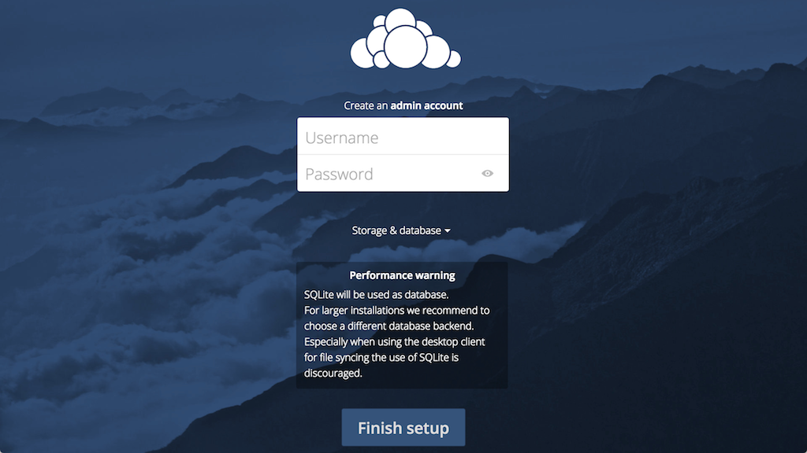

Create an admin account by choosing a username and a password. For security purposes it is not recommended to use something like "admin" for the username.

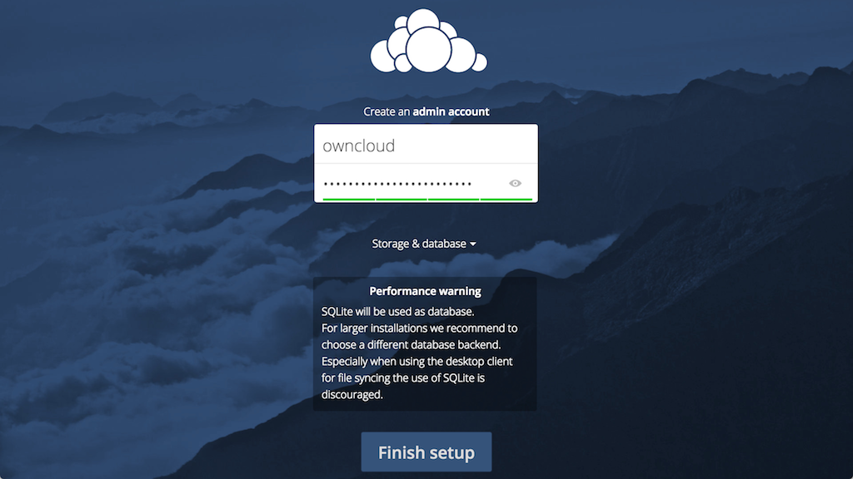

Before clicking the **Finish setup** button, click on the **Storage & database** link:

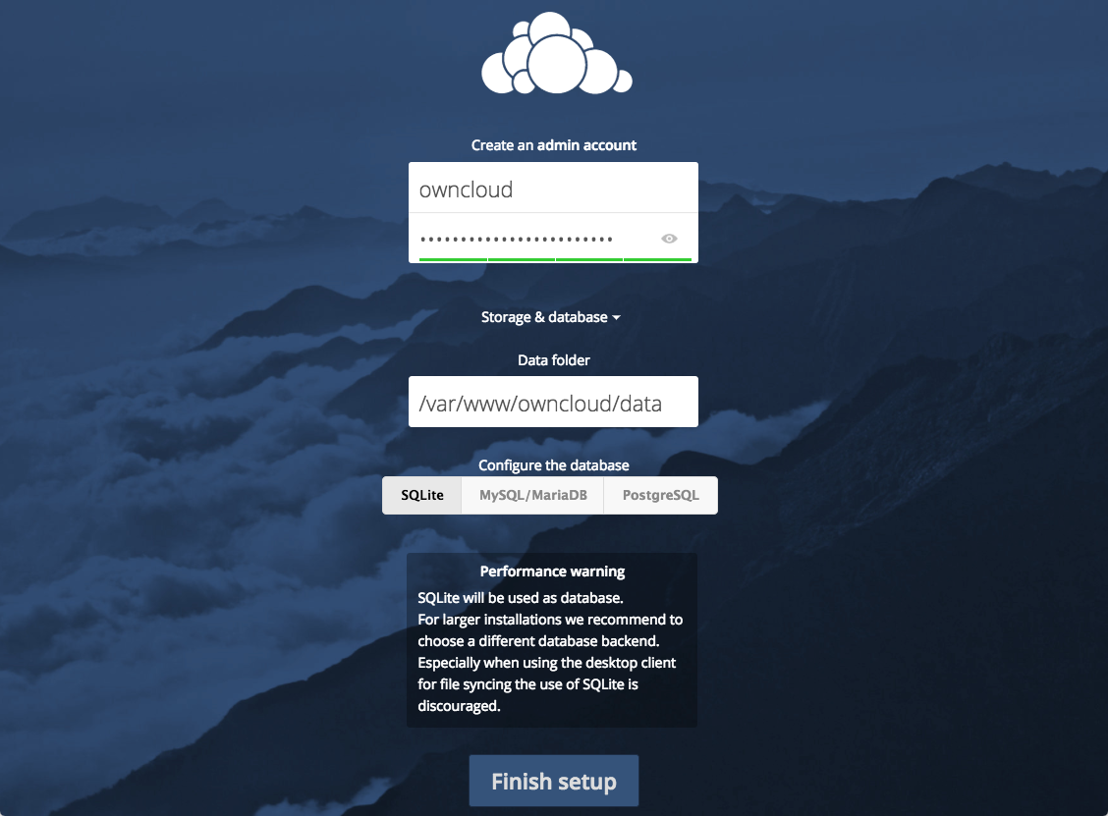

Leave the **Data folder** setting as-is and click the **MySQL/MariaDB** button in the **Configure the database** section.

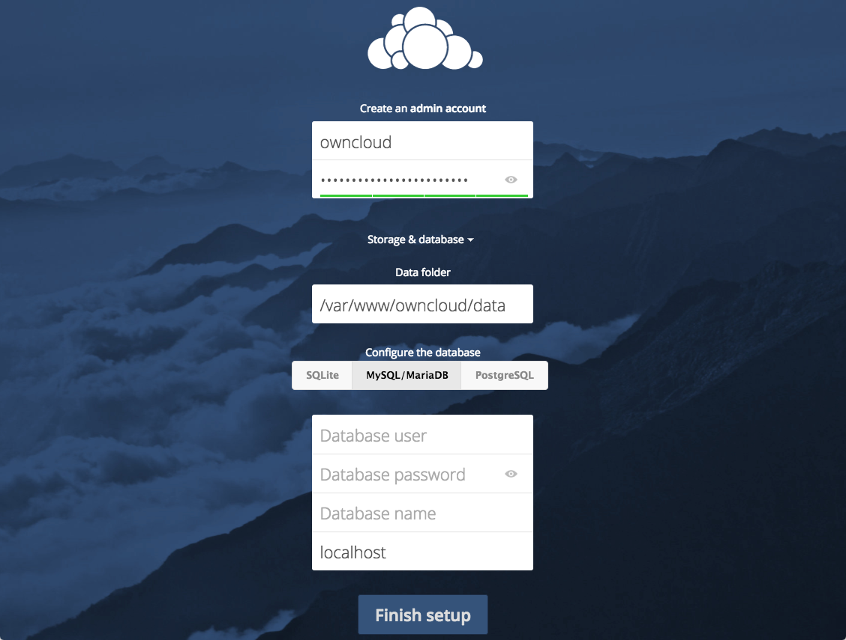

Enter the database information that you configured in the previous step. Below is an example, which matches the database credentials that we used in this guide:

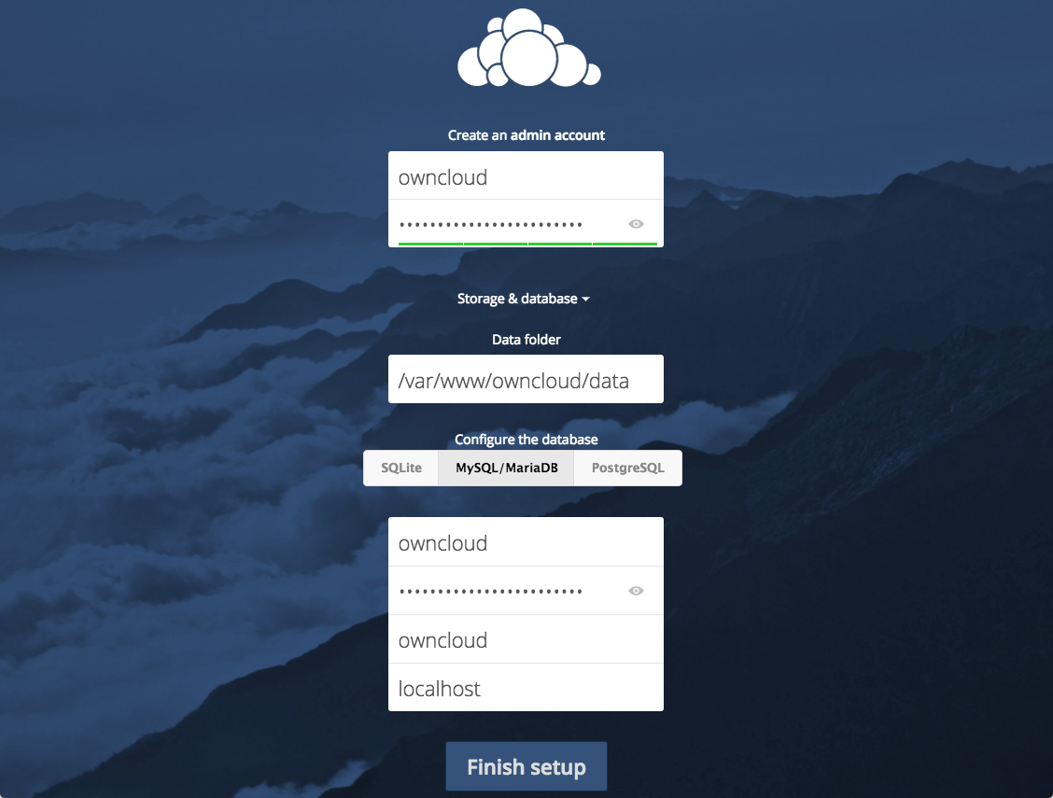

Click the **Finish setup** button to sign into ownCloud. **A safe home for all your data** splash screen should appear. Click the **x** in the top-right corner of the splash screen to access the main interface:

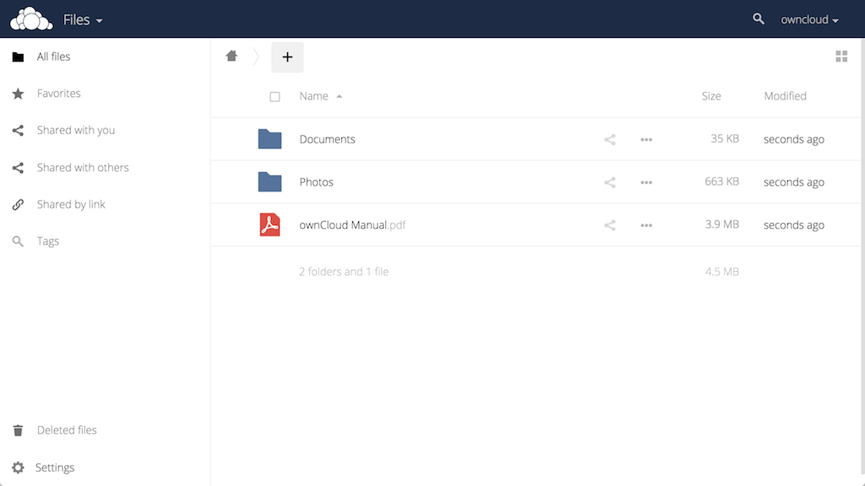

**Conclusion:**

ownCloud can replicate the capabilities of popular third-party cloud storage services. Content can be shared between users or externally with public URLs. The advantage of ownCloud is that the information is stored securely in a place that you control.