Experiment No.6

**Aim:** Implementation of identity management using ownCloud.

**Theory:**

**Identity Management:**

Every enterprise will have its own identity management system to control access to information and computing resources. Cloud providers either integrate the customer’s identity management system into their own infrastructure, using federation or SSO technology, or a biometric-based identification system, or provide an identity management solution of their own. CloudID, for instance, provides a privacy-preserving cloud-based and cross-enterprise biometric identification solutions for this problem. It links the confidential information of the users to their biometrics and stores it in an encrypted fashion. Making use of a searchable encryption technique, biometric identification is performed in encrypted domain to make sure that the cloud provider or potential attackers do not gain access to any sensitive data or even the contents of the individual queries.

**Procedure:**

1. Deploying the own storage cloud our own cloud(SaaS)
2. reboot pc and enable vtx in bios
3. install virtualbox
4. virtualbox is type 2 hypervisor
5. cloud is install on virtualbox
6. note down the IP address of system
7. we have our own cloud system ready so we will open in virtualbox
8. my system 192.168.44.169
9. continuing
10. need to change the setting in the storage cloud
11. note down the ip address of server is 10.0.2.15/owncloud
12. id and password are shown below
13. in browser enter localhost:8888
14. local.conf specify the detail
15. owncloud client
16. open owncloud in browser
17. now open client
18. select the folder you want to upload
19. create the folder in cloud
20. now sync
21. if you check in browser you will see the paper is uploaded
22. let modify the content of folder already on cloud
23. if you add any content to folder that is sync then you can see change in cloud in browser

**Creating a New User:**

To create a user account:

* Enter the new user’s Login Name and their initial Password
* Optionally, assign Groups memberships
* Click the Create button

**Reset a User’s Password:**

You cannot recover a user’s password, but you can set a new one:

* Hover your cursor over the user’s Password field
* Click on the pencil icon
* Enter the user’s new password in the password field, and remember to provide the user with their password

**Renaming a User:**

Each ownCloud user has two names: a unique Login Name used for authentication, and a Full Name, which is their display name. You can edit the display name of a user, but you cannot change the login name of any user.

To set or change a user’s display name:

* Hover your cursor over the user’s Full Name field
* Click on the Pencil icon
* Enter the user’s new display name

**Granting Administrator Privileges to a User:**

ownCloud has two types of administrators: Super Administrators and Group Administrators. Group administrators have the rights to create, edit and delete users in their assigned groups. Group administrators cannot access system settings, or add or modify users in the groups that they are not Group Administrators for. Use the dropdown menus in the Group Admin column to assign group admin privileges

**Managing Groups:**

You can assign new users to groups when you create them, and create new groups when you create new users. You may also use the Add Group button at the top of the left pane to create new groups. New group members will immediately have access to file shares that belong to their new groups.

**Setting Storage Quotas:**

Click the gear on the lower left pane to set a default storage quota. This is automatically applied to new users. You may assign a different quota to any user by selecting from the Quota dropdown, selecting either a preset value or entering a custom value. When you create custom quotas, use the normal abbreviations for your storage values such as 500 MB, 5 GB, 5 TB, and so on.

**Deleting users:**

Deleting a user is easy: hover your cursor over their name on the Users page until a trashcan icon appears at the far right. Click the trashcan, and they’re gone. You’ll see an undo button at the top of the page, which remains until you refresh the page. When the undo button is gone you cannot recover the deleted user.

**File Sharing:**

ownCloud users can share files with their ownCloud groups and other users on the same ownCloud server, and create public shares for people who are not ownCloud users. You have control of a number of user permissions on file shares:

* Allowing users to share files
* Allowing users to create public shares
* Requiring a password on public shares
* Allowing public uploads to public shares
* Requiring an expiration date on public share links
* Allowing resharing
* Restricting sharing to group members only
* Allowing email notifications of new public shares
* Excluding groups from creating shares

**Result:**

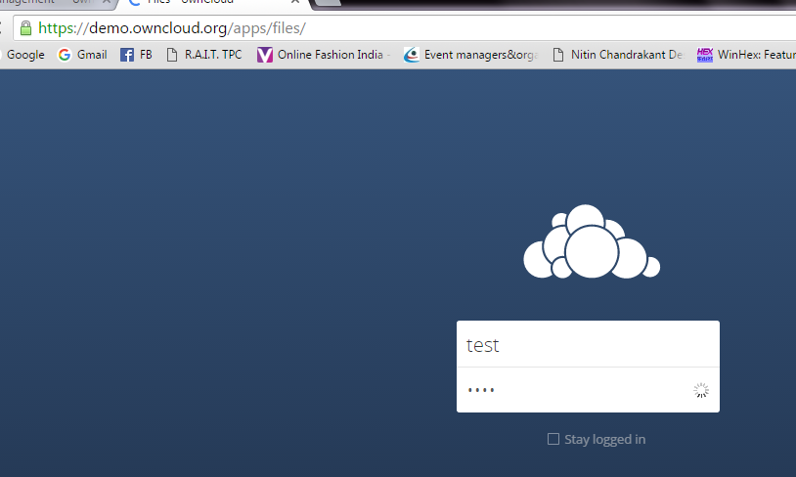

By default, the ownCloud Web interface opens to your Files page. You can add, remove, and share files, and make changes based on the access privileges set by you (if you are administering the server) or by your server administrator. You can access your ownCloud files with the ownCloud web interface and create, preview, edit, delete, share, and re-share files. Your ownCloud administrator has the option to disable these features, so if any of them are missing on your system ask your server administrator.

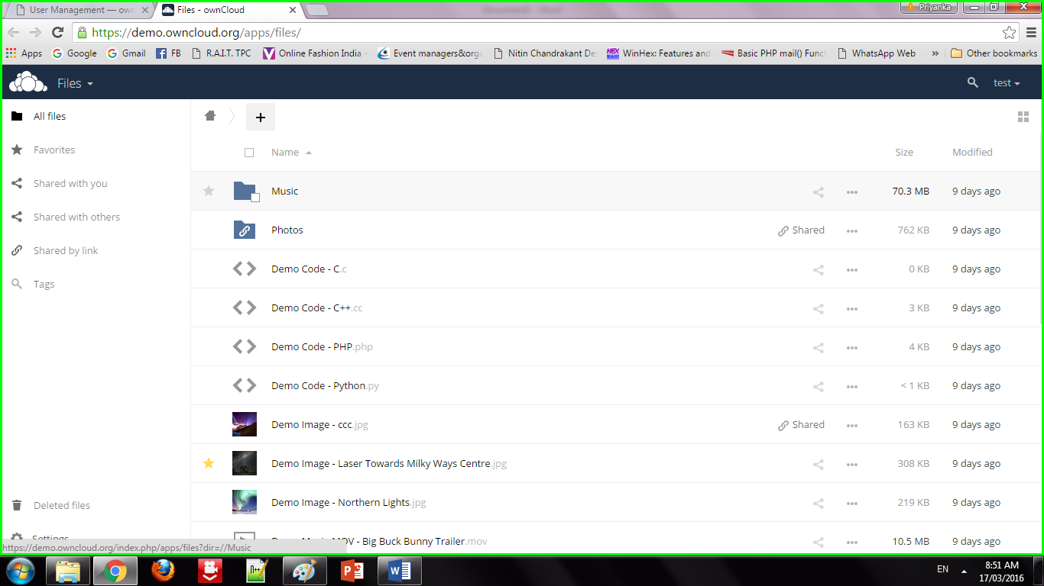

**Apps Selection Menu:** Located in the upper left corner, click the arrow to open a dropdown menu to navigate to your various available apps. **Apps Information field:** Located in the left sidebar, this provides filters and tasks associated with your selected app. **Application View:** The main central field in the ownCloud user interface. This field displays the contents or user features of your selected app.

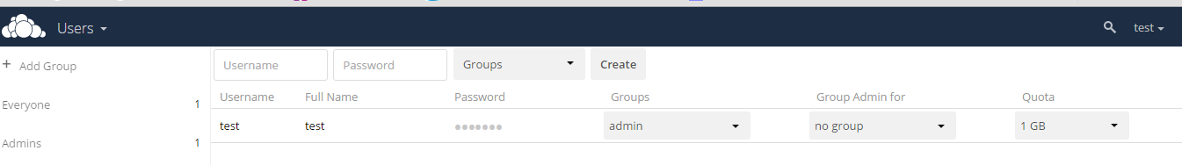

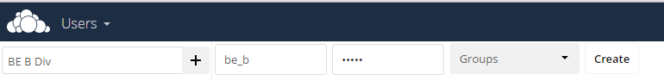

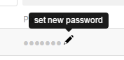 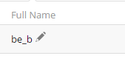

Share the file or folder with a group or other users, and create public shares with hyperlinks. You can also see who you have shared with already, and revoke shares by clicking the trash can icon. If username auto-completion is enabled, when you start typing the user or group name ownCloud will automatically complete it for you. If your administrator has enabled email notifications, you can send an email notification of the new share from the sharing screen.

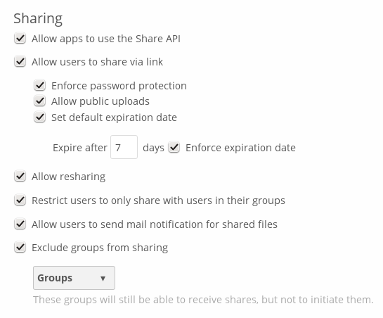

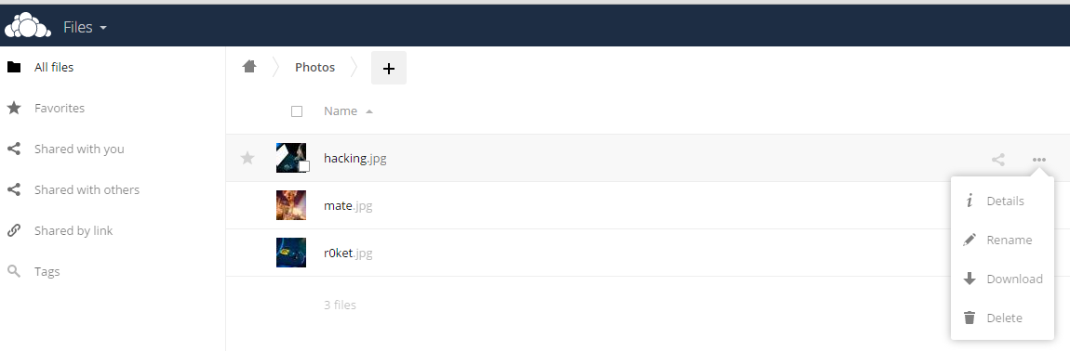

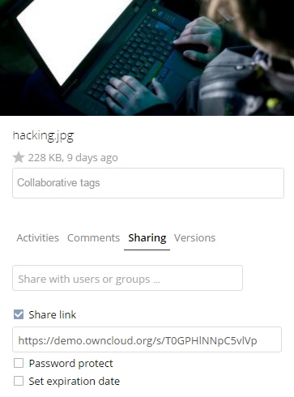

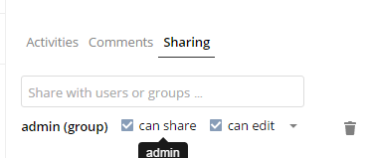

Five Share permissions are :

* Can share; allows the users you share with to re-share.
* Can edit; allows the users you share with to edit your shared files, and to collaborate using the Documents app.
* Create; allows the users you share with to create new files and add them to the share.
* Change; allows uploading a new version of a shared file and replacing it.
* Delete; allows the users you share with to delete shared files.

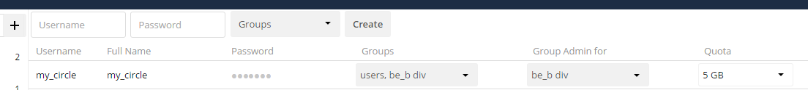



**Conclusion:**

We have studied how to use ownCloud for ensuring identity management of the users. We can create multiple groups and provide privileges to view or modify data as per defined permissions. It also enables simplified look and feel to be used by anyone.