Experiment No:9

**Aim:** Case study on Microsoft azure.

**Theory:**

Microsoft Azure (formerly Windows Azure) is a cloud computing service created by Microsoft for building, testing, deploying, and managing applications and services through a global network of Microsoft-manageddatacenters. It provides software as a service (SaaS), platform as a service (PaaS) and infrastructure as a service (IaaS) and supports many different programming languages, tools and frameworks, including both Microsoft-specific and third-party software and systems.

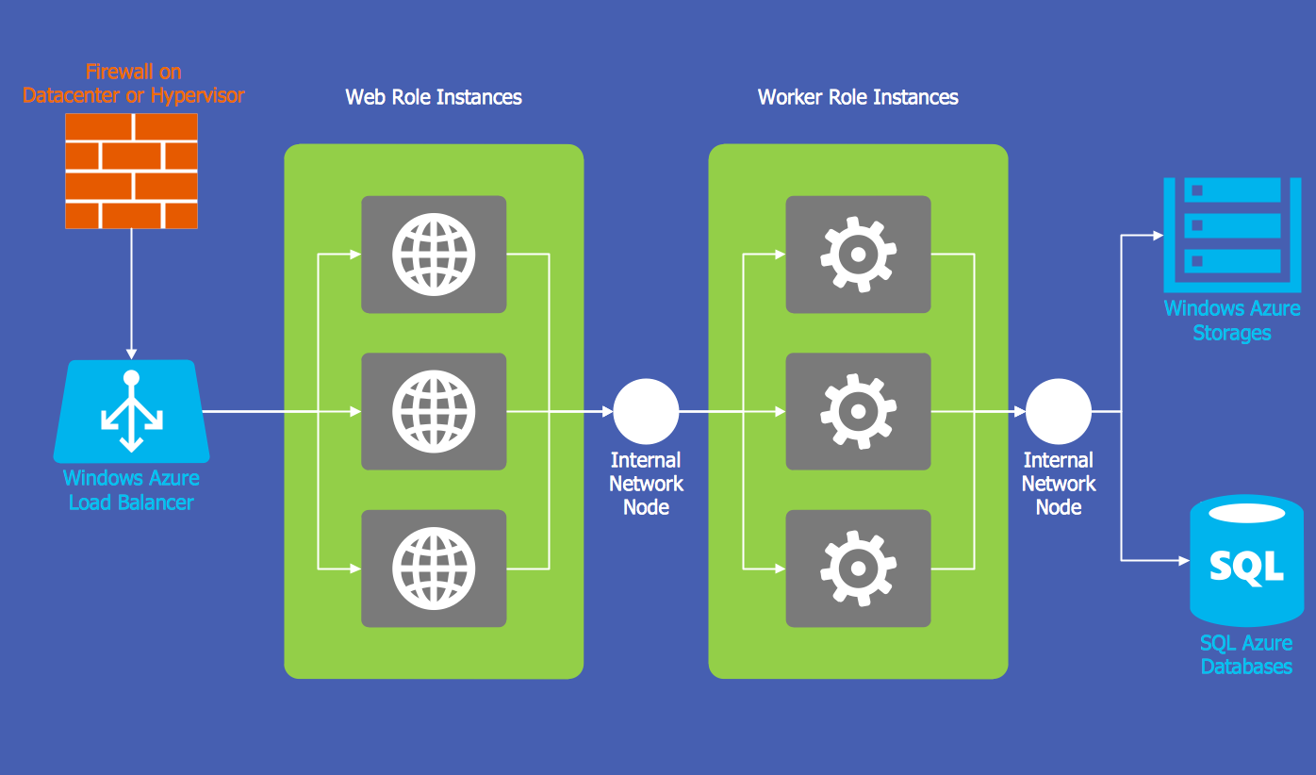

**Fig- *Windows Azure Network and Compute Architecture***

**Microsoft lists over 600 Azure services, of which some are covered below:**

**Compute**

* Virtual machines, infrastructure as a service (IaaS) allowing users to launch general-purpose Microsoft Windows and Linux virtual machines, as well as preconfigured machine images for popular software packages.
* App services, platform as a service (PaaS) environment letting developers easily publish and manage websites.
* Websites, high density hosting of websites allows developers to build sites usingASP.NET, PHP, Node.js, orPython and can be deployed using FTP, Git, Mercurial, Team Foundation Server or uploaded through the user portal. This feature was announced in preview form in June 2012 at the Meet Microsoft Azure event. Customers can create websites in PHP, ASP.NET, Node.js, or Python, or select from several open source applications from a gallery to deploy. This comprises one aspect of the platform as a service (PaaS) offerings for the Microsoft Azure Platform. It was renamed to Web Apps in April 2015.WebJobs, applications that can be deployed to a WebApp to implement background processing that can be invoked on a schedule, on demand, or run continuously. The Blob, Table and Queue services can be used to communicate between WebApps and WebJobs and to provide state.

**Mobile services**

* Mobile Engagement collects real-time analytics that highlight users’ behavior. It also provides push notifications to mobile devices.
* HockeyApp can be used to develop, distribute, and beta-test mobile apps.

### **Storage services**

* Storage Services provides REST and SDK APIs for storing and accessing data on the cloud.
* Table Service lets programs store structured text in partitioned collections of entities that are accessed by partition key and primary key. It's a NoSQL non-relational database.
* Blob Service allows programs to store unstructured text and binary data as blobs that can be accessed by a HTTP(S) path. Blob service also provides security mechanisms to control access to data.
* Queue Service lets programs communicate asynchronously by message using queues.
* File Service allows storing and access of data on the cloud using theREST APIs or the SMB protocol.

### **Data management**

* Azure Search provides text search and a subset of Data structured filters using REST or SDK APIs.
* Cosmos DB is a NoSQL database service that implements a subset of the SQL SELECT statement on JSON documents.
* Redis Cache is a managed implementation of Redis.
* StorSimple manages storage tasks between on-premises devices and cloud storage.SQL Database, formerly known as SQL Azure Database, works to create, scale and extend applications into the cloud using Microsoft SQL Server technology. It also integrates with Active Directory andMicrosoft System Center and Hadoop.
* SQL Data Warehouse is a data warehousing service designed to handle computational and data intensive queries on datasets exceeding 1TB.
* Azure Data Lake is a scalable data storage and analytic service for big-data analytics workloads that require developers to run massively parallel queries.
* Azure HDInsight is a big data relevant service, that deploys Hortonworks Hadoop on Microsoft Azure, and supports the creation of Hadoop clusters using Linux with Ubuntu.
* Azure Stream Analytics is a serverless scalable event processing engine that enables users to develop and run real-time analytics on multiple streams of data from sources such as devices, sensors, websites, social media, and other applications.

### **Messaging**

The Microsoft Azure Service Bus allows applications running on Azure premises or off premises devices to communicate with Azure. This helps to build scalable and reliable applications in aservice-oriented architecture (SOA). The Azure service bus supports four different types of communication mechanisms:

* **Event Hubs**, which provide event and telemetry ingress to the cloud at massive scale, with low latency and high reliability. For example an event hub can be used to track data from cell phones such as a GPS location coordinate in real time.
* **Queues**, which allow one-directional communication. A sender application would send the message to the service bus queue, and a receiver would read from the queue. Though there can be multiple readers for the queue only one would process a single message.
* **Topics**, which provide one-directional communication using a subscriber pattern. It is similar to a queue, however each subscriber will receive a copy of the message sent to a Topic. Optionally the subscriber can filter out messages based on specific criteria defined by the subscriber.
* **Relays**, which provide bi-directional communication. Unlike queues and topics, a relay doesn't store in-flight messages in its own memory. Instead, it just passes them on to the destination application.

### 

### **Media services**

A Paas offering that can be used for encoding, content protection, streaming, oranalytics.

### **CDN**

A global content delivery network (CDN) for audio, video, applications, images, and other static files. It can be used to cache static assets of websites geographically closer to users to increase performance. The network can be managed by a REST based HTTP API.

Azure has 30 point of presence locations worldwide (also known as Edge locations) as of December 2016.

### **Developer**

* Application Insights
* Visual Studio Team Services

**Management**

* Azure Automation, provides a way for users to automate the manual, long-running, error-prone, and frequently repeated tasks that are commonly performed in a cloud and enterprise environment. It saves time and increases the reliability of regular administrative tasks and even schedules them to be automatically performed at regular intervals. You can automate processes using runbooks or automate configuration management using Desired State Configuration.
* Microsoft SMA (software)

### **Machine learning**

* Microsoft Azure Machine Learning (Azure ML) service is part of Cortana Intelligence Suite that enables predictive analytics and interaction with data using natural language and speech through Cortana.

**Azure as PaaS (Platform as a Service)**  
 As the name suggests, a platform is provided to clients to develop and deploy software. The clients can focus on the application development rather than having to worry about hardware and infrastructure. It also takes care of most of the operating systems, servers and networking issues.

* **Pros**
  + The overall cost is low as the resources are allocated on demand and servers are automatically updated.
  + It is less vulnerable as servers are automatically updated and being checked for all known security issues. The whole process is not visible to developer and thus does not pose a risk of data breach.
  + Since new versions of development tools are tested by the Azure team, it becomes easy for developers to move on to new tools. This also helps the developers to meet the customer’s demand by quickly adapting to new versions.
* **Cons**
  + There are portability issues with using PaaS. There can be a different environment at Azure, thus the application might have to be adapted accordingly.

**Azure as IaaS (Infrastructure as a Service)**  
 It is a managed compute service that gives complete control of the operating systems and the application platform stack to the application developers. It lets the user to access, manage and monitor the data centers by themselves.

* **Pros**
  + This is ideal for the application where complete control is required. The virtual machine can be completely adapted to the requirements of the organization or business.
  + IaaS facilitates very efficient design time portability. This means application can be migrated to Windows Azure without rework. All the application dependencies such as database can also be migrated to Azure.
  + IaaS allows quick transition of services to clouds, which helps the vendors to offer services to their clients easily. This also helps the vendors to expand their business by selling the existing software or services in new markets.
* **Cons**
  + Since users are given complete control they are tempted to stick to a particular version for the dependencies of applications. It might become difficult for them to migrate the application to future versions.
  + There are many factors which increases the cost of its operation. For example, higher server maintenance for patching and upgrading software.
  + There are lots of security risks from unpatched servers. Some companies have well defined processes for testing and updating on-premise servers for security vulnerabilities. These processes need to be extended to the cloud-hosted IaaS VMs to mitigate hacking risks.
  + The unpatched servers pose a great security risk. Unlike PaaS, there is no provision of automatic server patching in IaaS. An unpatched server with sensitive information can be very vulnerable affecting the entire business of an organization.
  + It is difficult to maintain legacy apps in Iaas. It can be stuck with the older version of the operating systems and application stacks. Thus, resulting in applications that are difficult to maintain and add new functionality over the period of time.

**Let us see how the management portal for azure looks like:**

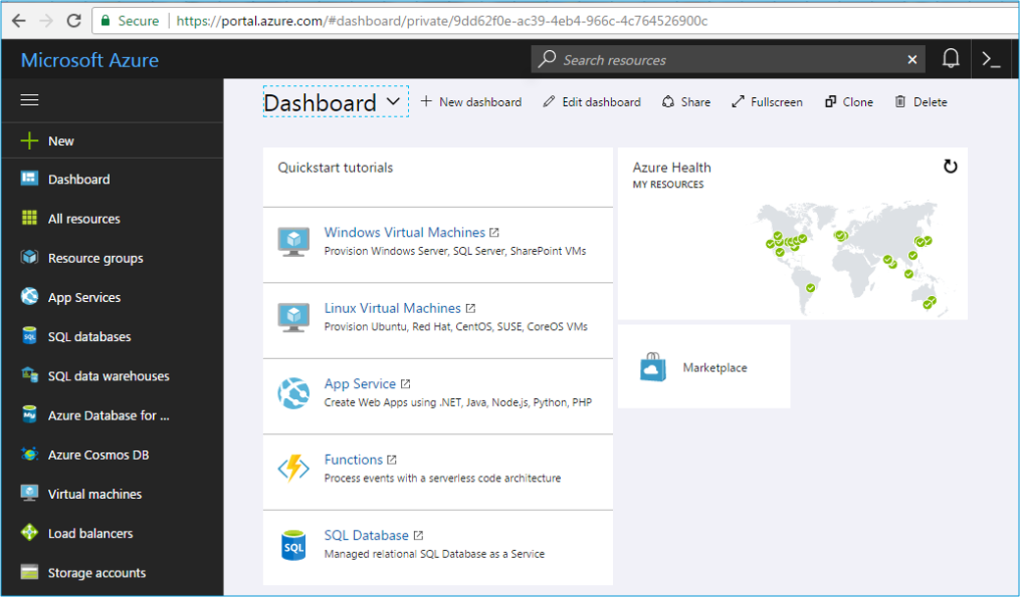

On the left side, all the resources are listed. These resources can broadly be divided into the following categories:

* **Compute**

It is used to process data on the cloud by making use of powerful processors which serve multiple instances at a time.

* **Storage Services**

The storage as the name suggests, is used to store data in the cloud with the ability to scale as and when required. This data can be stored anywhere.

* **Database**

The database domain is used to provide reliable relational and non relational database instances managed by Azure.

* **Networking**

It includes services which provide a variety of networking features such as security, faster access etc.

* **Developer Tools**

It includes services which provides services that ease the ability to code for an organization. For example: it eases the teams to share code, track work and ship software.

* **Management and Monitoring Tools**

It includes services which can be used to manage and monitor your Azure instances.

* **Enterprise Integration**

Services that bring functionalities like seamlessly integrating the enterprise and the cloud.

* **Security and Identity**

It includes services for user authentication or limiting access to a certain set of audience on your Azure resources.

* **Web and Mobile Apps**

These are mainly used to create web apps or mobile apps for any platform and any device.

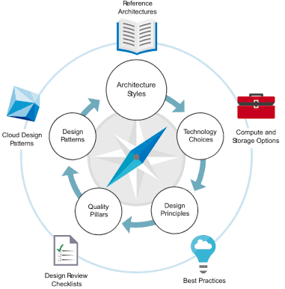

***Fig- Azure Application Architecture***

**Advantages**

* **High Availability**

Unlike other vendors, the Microsoft Azure cloud offers high availability and redundancy in data centers on a global scale. Because of this, Azure can offer a service level agreement, or SLA, of 99.95% (approximately 4.38 hours of downtime per year), something that most businesses cannot achieve.

* **Security**

Microsoft Azure has a strong focus on security, following the standard security model of Detect, Assess, Diagnose, Stabilize and Close. Paired with strong cyber security controls, this model has allowed Azure to achieve multiple compliance certifications, all of which establish Azure as a leader in IaaS security. Not only is the platform protected, the end user is also covered with Azure. This multi-level of protection is essential as security threats continue to multiply daily across the globe, targeting end users and putting your business’ data at risk. Azure provides simple, user-friendly services for increased protection, such as multi-factor authentication and application password requirements.

* **Scalability**

Scalability is the backbone of any good cloud provider, and Azure is no different. For example, consider the following: a firm runs SQL reports daily for 28 out of 30 days of the month, using minimal compute power. On the last two days of the month, there is an increase in report activity, requiring more compute power. Microsoft Azure makes it easy to scale compute power up or down with nothing more than the click of a button. With this scalability structure, businesses have the flexibility to pay for only what they use.

* **Cost-Effectiveness**

It’s imperative to keep IT budgets in mind when choosing a cloud provider, which is why the Microsoft Azure platform is so attractive to many organizations. Azure’s pay-as-you-go pricing allows SMBs to better manage their IT budgets, purchasing only as much as they need. Additionally, the cloud environment allows businesses to launch both customer applications and internal apps in the cloud, which saves on infrastructure costs while reducing the hardware and maintenance burdens on in-house IT management.

**Disadvantages:**

* **Requires Management:**

As with anything, there are a couple of potential cons with Microsoft Azure. Unlike SaaS platforms where the end-user is consuming information (for example, Office 365), IaaS (Azure) moves your business’ compute power from your data center or office to the cloud. As with most cloud service providers, Azure needs to be expertly managed and maintained, which includes patching and server monitoring.

* **Requires Platform Expertise:**

Unlike local servers, Azure requires expertise to ensure all moving parts work together efficiently. A common mistake by business administrators that are not fully engaged in how well (or poorly) their cloud servers are operating is to over-provision cloud services. While a common mistake, on premise servers’ compute power does not translate unequivocally in the cloud, potentially costing businesses thousands of dollars per year.

As more and more businesses continue to move their data to the cloud, it can be difficult to track which provider is best for your business. As an IT company serving small and mid-size businesses, iCorps had to conduct its own proof of concept, migrating core business applications to Azure to ensure maximum efficiency. With a seamless migration and continued usage, iCorps hasn’t looked back, saving nearly $4,000 per month on licensing, hardware, and support.

**Conclusion :**

Microsoft Azure has been successfully studied.