Experiment No:8

**Aim:** Write a program to demonstrate working of virus.

**Theory:**

**Computer Virus:**

A computer virus is a program, script, or macro designed to cause damage, steal personal information, modify data, send e-mail, display messages, or some combination of these actions.

When the virus is executed, it spreads by copying itself into or over data files, programs, or boot sector of a computer's hard drive, or potentially anything else writable. To help spread an infection the virus writers use detailed knowledge of security vulnerabilities, zero days, or social engineering to gain access to a host's computer.

**Which operating systems are susceptible to viruses?**

All of the major operating systems can contract a computer virus. Whether you use Microsoft Windows, macOS, or a Linux variant, your computer can be at risk.

**How to protect your computer from a virus?**

You can protect your computer from viruses by installing an antivirus protection program. Once installed on a computer an antivirus monitors, detects, and cleans any computer viruses by looking for virus signatures.

**What can a virus do to a computer?**

What a virus does to a computer once it has infected the computer depends on the type of virus. Typically most computer viruses will delete data, overwrite information, display messages, and add itself to other files on the computer. Almost all computer viruses only damage the data contained on the computer and do not physically harm the computer or its hardware. More sophisticated viruses like Stuxnet can cause physical damage.

**Examples of computer viruses:**

Below is a list of the different types of computer viruses.

* Appending virus
* Boot sector virus
* Spacefiller virus, a.k.a. the Cavity Virus
* CMOS virus
* Companion virus
* Encrypted virus
* Executable virus
* MBR virus
* Macro virus
* Multipart virus
* Non-resident virus
* Overwrite virus
* Polymorphic virus
* Rabbit virus
* Resident virus
* Spacefiller virus
* Stealth virus

**When was the term "Virus" first coined?**

The concept of a computer program capable of reproducing itself was first mentioned by John von Neumann in his 1949 "Theory of self-reproducing automata" essay. Later, Fred Cohen in 1983 coined the term virus in a 1984 research paper as "a computer program that can affect other computer programs by modifying them in such a way as to include a (possibly evolved) copy of itself."

What was the first computer virus ever created?

The first computer virus known as the Elk Cloner was written by Rich Skrenta in 1982 who was a 15-year old high school student at the time. The Elk Cloner virus spread to other computers by monitoring the floppy drive and copying itself to any floppy diskette that was inserted into the computer. Once a floppy was infected it would infect all other computers that used the disk was. A computer that was infected would display a short poem on every 50th boot.

**Implementation:**

**Step 1: Creating the Virus - BloatWare**

Create your target folder - this is the folder you want your virus to attack. For demonstration purposes, I have created a folder called Test under the C Drive.

This virus would create an endless number of text files which contains a different number in the text document each time.The code of virus is as follows:

@echo off

color 0a

msg *You have just launched BloatWarez %random%

:Reckon

echo This is bloatware #%random% >C:\Test\%random%%random%.virus.txt

goto Reckon

Save the file as virus.bat and run it.

**Step 2: Creating the Anti-Virus**

So now we have identified the effect of the virus, let's now create the antivirus. An antivirus, identifies and removes (quarantines) the infection. We start by writing the following code:

@echo off

color 0a

msg *Removing BloatWarez Virus

del /s *virus.txt

echo Virus Successfully Removed

Pause

Save the file as antivirus.bat and run it.

**Output:**

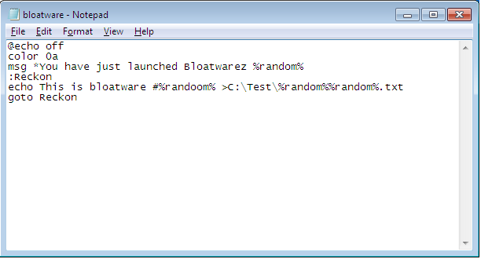

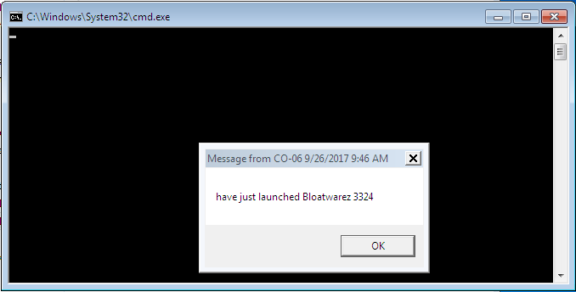

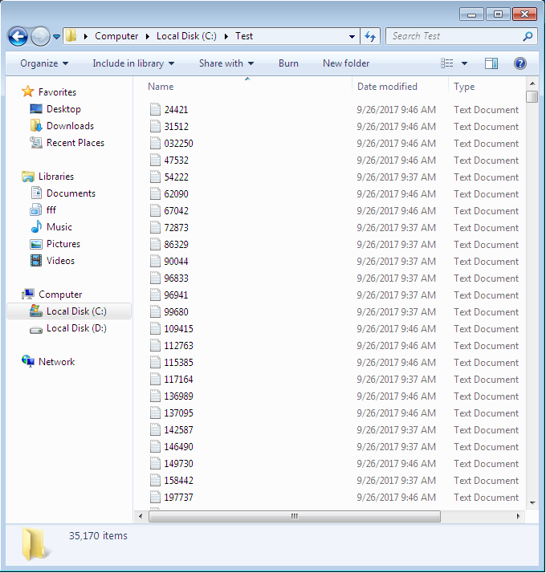

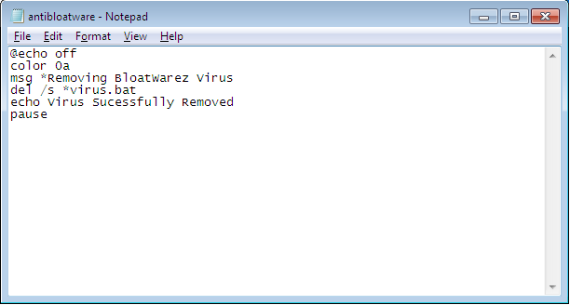

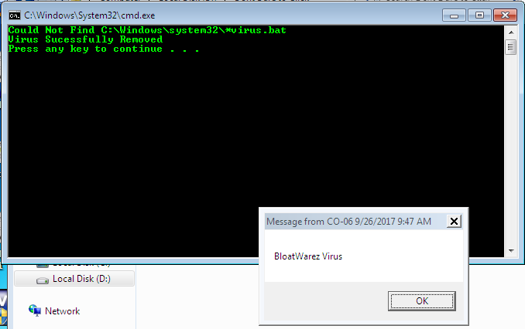

**Conclusion:**

Viruses are programs that replicate, evolve, and/or infect. They spread from program to program, user to user, computer to computer, and network to network. Their unique properties are generality, persistence and extent. They are an integrity problem, not a secrecy problem. Therefore, improving computer security to keep secrets better does not eliminate the virus problem.