Experiment No.12

**Aim:** Tostudy and monitor the performance of USBDeview application.

**Theory:**

**USBDeview:**

USBDeview is a small tool that allows you to manage the USB devices connected to your computer.

* Launch the program and you'll get a lengthy list of every device that's even been plugged in to your system, including its description, the device type (storage, webcam, audio and so on), driver name and more.
* Right-click a USB drive, say, and you'll find an option to disconnect it, allowing you to unplug the drive safely. You're able to disable a device, just temporarily, if it's conflicting with other software or hardware. And if you no longer use a device, then right-click its entry, select Uninstall and Windows will remove its driver.
* There's a Speed Test option that will benchmark the performance of your USB drives. This could be very handy if you're planning to use Windows ReadyBoost, for instance - it's important to pick the fastest drive you have.
* And Windows experts will appreciate the right-click "Open in RegEdit" option, that launches the Registry Editor at the device entry you've specified, ready for manual editing. If you're not a Windows expert, though, be careful with this one - playing around with low-level Registry settings can seriously harm your PC.

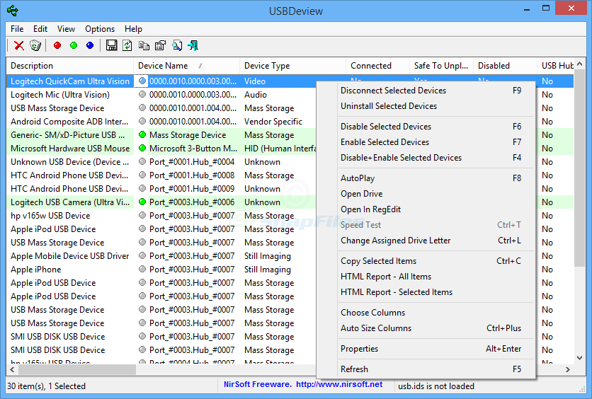

**Conclusion:**

Thus Successfully studied and monitor USBDeview application.