Experiment No: 14

**Aim:** To perform Email Spoofing.

**Theory:**

E-mail spoofing is the forgery of an e-mail header so that the message appears to have originated from someone or somewhere other than the actual source. Distributors of spam often use spoofing in an attempt to get recipients to open, and possibly even respond to, their solicitations. Spoofing can be used legitimately. Classic examples of senders who might prefer to disguise the source of the e-mail include a sender reporting mistreatment by a spouse to a welfare agency or a "whistle-blower" who fears retaliation. However, spoofing anyone other than you is illegal in some jurisdictions’-mail spoofing is possible because Simple Mail Transfer Protocol (SMTP), the main protocol used in sending e-mail, does not include an authentication mechanism.

Telnet is a user command and an underlying TCP/IP protocol for else's computer remotely. On the Web, HTTP and FTP accessing remote computers. Through Telnet, an administrator or another user can access someone protocols allow you to request specific files from remote computers, but not to actually be logged on as a user of that computer. With Telnet, you log on as a regular user with whatever privileges you may have been granted to the specific application and data on that computer.

**Step 1:- Finding an SMTP Server**

An SMTP (simple mail transfer protocol) server is a mail server that transfers mail between users. Mail often bounces through several SMTP servers on its way to its destination. You will need to find a SMTP server that allows for "open relaying". This is next to impossible these days, but you may be able to find one or two out there.

**Step 2:-Find a list of SMTP servers**

There are several places online that you can find lists of popular SMTP servers. Finding an Open relay one will be more difficult, and will require a lot of trial and error. Try small businesses and local companies, as they are less likely to have configured their SMTP server properly.

**Step 3:-Test the SMTP server**

You need to find out if the SMTP server is open before you can connect to it. Open the Command Prompt or Terminal. Type *telnetsmpt.server25* and press enter. Replace SMTP server with the address of the server you are trying to connect to.

For example :-Google's SMTP server is smtp.gmail.com (it's not an open relay server, so don't bother trying).

**Step 4:-Start communication with the server**

If you are able to connect to the server, start off with the H E L O (Hello) com.

**Step 5:-Create the mail using your fake address**

Type *MAIL FROM:fakemail@hotmail.com*. This will start the message creation process using the email address that you provide.

**Step 6:-Enter in the recipient's address**

Type *RCPT TO:recipientaddress@server.com*. Make sure that your recipient's address is entered correctly.

**Step7:-Start entering the email information.**

Type DATA and press ↵ Enter to start entering the actual data of the email. This will let the SMTP server know that you are entering the data of the email.

**⦁ Create the header:**  The first thing you will need to do when you start entering data is to create your fake header. This will appear at the top of the email that your recipient receives. Enter the following information, replacing the data with your desired content:

**⦁ Type Date:** DD Mon YY XX:XX:XX and press ↵ Enter. Replace DD Mon YY XX:XX:XX with the date you want to use. For example Date: 17 Jun 07 12:24:13

**⦁ Type From:** fakemail@hotmail.com and press ↵ Enter. Make sure you enter the same address you entered when you opened the connection.

**⦁ Type To:**  recipientaddress@server.com and press ↵ Enter. Ensure that you enter the same address that you entered above.

**Step 8:-Type Subject**

Your subject and press Enter. Try to keep your subject short.Type the body of your email. After typing the subject and pressing ↵ Enter, everything you type will be the body of the email. Type in whatever you'd like. You can press ↵ Enter to move to a new line and start a new paragraph. After finishing your email, press ↵ Enter to move to a new line.

**Step 9:-Send the email**

Type .on a new line and press ↵ Enter. This will send the email to the address. You will receive a Mail accepted message when the email is sent.

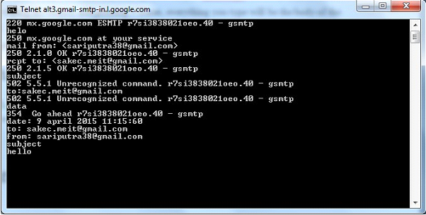

**Conclusion:**

Email spoofing is referred to activity of sending emails using someone else’s identity. The attackers may vary from innocent mischievous users seeking fun , to malicious attackers who seek more serious damages to the users. These attacks may be used to launch phishing attacks so as to get information from users. Administrators need to take a variety of measures to prevent, detect and provide remedial measures to email spoofing attacks. The causes of email spoofing have been described in the preceding sections. Implementation of security also takes on importance when there is commerce that is involved in the email communication.