**EXPERIMENT NO: 1**

### **Aim:**

Study of analog signal waveform generation for the following: (C/C++ & Scilab)

1. Sine Waveform
2. Cosine Waveform
3. Exponential Function

### **Theory:**

An analog signal is any continuous signal for which the time varying feature (variable) of the signal is a representation of some other time varying quantity, i.e., analogous to another time varying signal. For example, in an analog audio signal, the instantaneous voltage of the signal varies continuously with the pressure of the sound waves. It differs from a digital signal, in which the continuous quantity is a representation of a sequence of discrete values which can only take on one of a finite number of values.The term analog signal usually refers to electrical signals; however, mechanical, pneumatic, hydraulic, human speech, and other systems may also convey or be considered analog signals.

An analog signal uses some property of the medium to convey the signal's information. For example, an aneroid barometer uses rotary position as the signal to convey pressure information. In an electrical signal, the voltage, current, or frequency of the signal may be varied to represent the information.

#### **Steps:**

1. Take time period 1 to 20 seconds.
2. Take fundamental frequency .
3. Take value for amplitude .
4. For time t = 0 to 20 seconds apply formula for sine & cosine wave
   1. sine wave: (0 to 20)
   2. cosine wave: (0 to 20)
5. Print value for sine & cosine waves.
6. To display waveform use scilab
   1. Take output in Excel sheet
   2. Read this file in Scilab
   3. Use subplot function to plot waveform.

#### **Sine Wave:**

A sine wave or sinusoid is a mathematical curve that describes a smooth repetitive oscillation. A sine wave is a continuous wave. It is named after the function sine, of which it is the graph. It occurs often in pure and applied mathematics, as well as physics, engineering, signal processing and many other fields. Its most basic form as a function of time (t) is:

where:

* = the amplitude, the peak deviation of the function from zero.
* = the ordinary frequency, the number of oscillations (cycles) that occur each second of time.
* =, the angular frequency, the rate of change of the function argument in units of radians per second
* = the phase, specifies (in radians) where in its cycle the oscillation is at
* When is non-zero, the entire waveform appears to be shifted in time by the amount seconds. A negative value represents a delay, and a positive value represents an advance.

#### **Cosine Wave:**

A cosine wave is a signal waveform with a shape identical to that of a sine wave , except each point on the cosine wave occurs exactly 1/4 cycle earlier than the corresponding point on the sine wave. A cosine wave and its corresponding sine wave have the same frequency, but the cosine wave leads the sine wave by 90 degrees of phase.

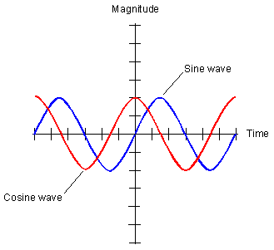

#### **Exponential Function:**

Exponential functions are uniquely characterized by the fact that the growth rate of such a function is directly proportional to the value of the function.The exponential function models a relationship in which a constant change in the independent variable gives the same proportional change (i.e. percentage increase or decrease) in the dependent variable. The function is often written as , especially when it is impractical to write the independent variable as a superscript. The exponential function is widely used in physics, chemistry, engineering, mathematical biology, economics and mathematics.

The graph of is upward-sloping, and increases faster as increases. The graph always lies above the x-axis but can get arbitrarily close to it for negative x; thus, the x-axis is a horizontal asymptote. The slope of the tangent to the graph at each point is equal to its y-coordinate at that point. The inverse function is the natural logarithm ; because of this, some old texts refer to the exponential function as the antilogarithm.

In general, the variable can be any real or complex number or even an entirely different kind of mathematical object; see the formal definition below. A nonrepetitive waveform that rises or falls exponentially from some initial value at some initial time, according to the law For the waveform rises without bound with increasing time; for the waveform decays to zero.

#### **Program:**

#include <math.h>

#include <graphics.h>

void main() {

int gd = DETECT, gm;

int angle = 0, ch;

double x, y;

printf("Enter choice:\n1.Sin\n2.Cos\n3.Expo\n4.Exit:\t");

scanf("%d", &ch);

initgraph(&gd, &gm, NULL);

setbkcolor(WHITE);

line(0, getmaxy() / 2, getmaxx(), getmaxy() / 2);

switch (ch) {

case 1:

/* generate a sine wave */

for (x = 0; x < getmaxx(); x += 3) {

/* calculate y value given x */

y = 50 * sin(angle * 3.141 / 180);

y = getmaxy() / 2 - y;

/* color a pixel at the given position */

putpixel(x, y, 0);

delay(100);

/* increment angle */

angle += 5;

}

main();

break;

case 2:

/* generate a cosine wave */

for (x = 0; x < getmaxx(); x += 3) {

/* calculate y value given x */

y = 50 * cos(angle * 3.141 / 180);

y = getmaxy() / 2 - y;

/* color a pixel at the given position */

putpixel(x, y, 0);

delay(100);

/* increment angle */

angle+=5;

}

main();

break;

case 3:

/* generate a exp^n wave */

for (x = 0; x < getmaxx(); x += 3) {

/* calculate y value given x */

y = 50 * exp(angle * 3.141 / 180);

y = getmaxy() / 2 - y;

/* color a pixel at the given position */

putpixel(x, y, 0);

delay(100);

/* increment angle */

angle+=2;

}

main();

break;

case 4:

exit(0);

break;

default:

printf("Invalid choice!");

}

getch();

/* deallocate memory allocated for graphics screen */

closegraph();

}

#### **Output:**

1. *Sine*

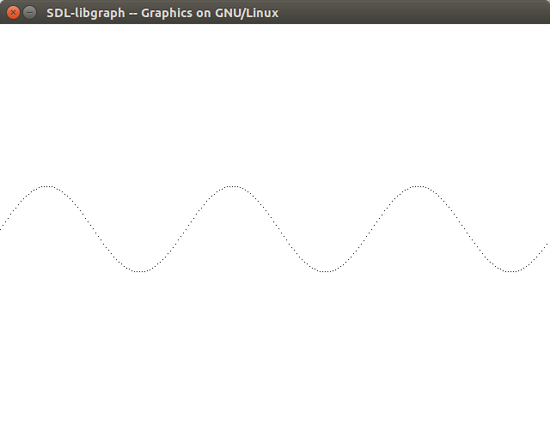

1. *Cosine*

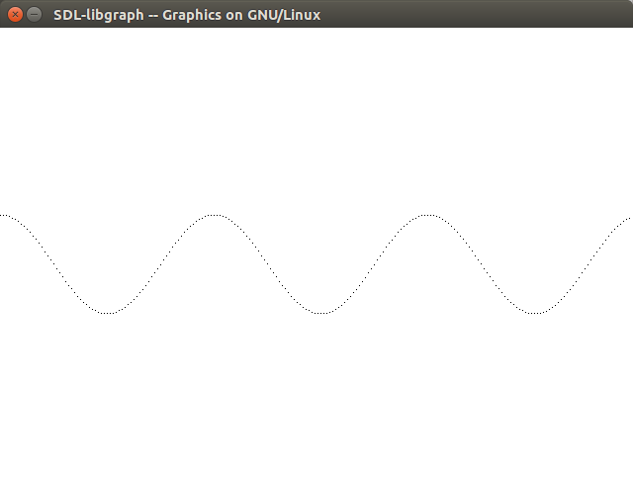

1. *Exponential*

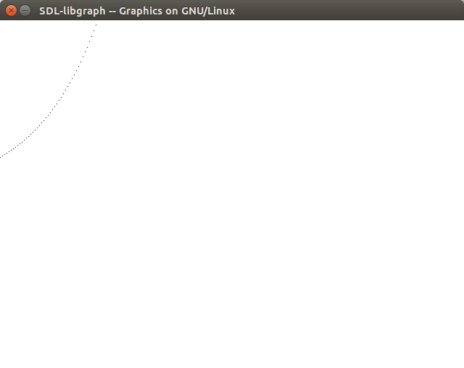

#### **Conclusion:**

Thus, Analog Signal Processing has performed and the Sine, cosine, exponential wave result is displayed.