Experiment No. 10

**Aim:** Study of Latex Tool.

**Theory:**

Latex is a document preparation system. When writing, the writer uses plain text as opposed to the formatted text found in WYSIWYG word processors like Microsoft Word, LibreOffice Writer and Apple Pages. The writer uses markup tagging conventions to define the general structure of a document (such as article, book, and letter), to stylise text throughout a document (such as bold and italics), and to add citations and cross-references. A TeX distribution such as TeX Live or MikTeX is used to produce an output file (such as PDF or DVI) suitable for printing or digital distribution. LaTeX is widely used in academia for the communication and publication of scientific documents in many fields, including mathematics, statistics, computer science, engineering, chemistry, physics, economics, quantitative psychology, philosophy, and political science. It also has a prominent role in the preparation and publication of books and articles that contain complex multilingual materials, such as Tamil, Sanskrit and Greek. LaTeX uses the TeX typesetting program for formatting its output, and is itself written in the TeX macro language.

LaTeX can be used as a standalone document preparation system or as an intermediate format. In the latter role, for example, it is sometimes used as part of a pipeline for translating DocBook and other XML-based formats to PDF. The typesetting system offers programmable desktop publishing features and extensive facilities for automating most aspects of typesetting and desktop publishing, including numbering and cross-referencing of tables and figures, chapter and section headings, the inclusion of graphics, page layout, indexing and bibliographies. Like TeX, LaTeX started as a writing tool for mathematicians and computer scientists, but from early in its development it has also been taken up by scholars who needed to write documents that include complex math expressions or non-Latin scripts, such as Arabic, Sanskrit and Chinese.

***Typesetting System***

LaTeX follows the design philosophy of separating presentation from content, so that authors can focus on the content of what they are writing without attending simultaneously to its visual appearance. In preparing a LaTeX document, the author specifies the logical structure using simple, familiar concepts such as chapter, section, table, figure, etc., and lets the LaTeX system worry about the formatting and layout of these structures. It therefore encourages the separation of layout from content while still allowing manual typesetting adjustments where needed. This concept is similar to the mechanism by which many word processors allow styles to be defined globally for an entire document or the use of Cascading Style Sheets to style HTML. The LaTeX system is a markup language that also handles typesetting and rendering.

***Example:***

\documentclass{article} \usepackage{amsmath} \title{\LaTeX}  
 \begin{document}  
 \maketitle  
 \LaTeX{} is a document preparation system for the \TeX{} typesetting program. It offers programmable desktop publishing features and extensive facilities for automating most aspects of typesetting and desktop publishing, including numbering and cross-referencing, tables and figures, page layout, bibliographies, and much more. \LaTeX{} was originally written in 1984 by Leslie Lamport and has become the dominant method for using \TeX; few people write in plain \TeX{} anymore. The current version is \LaTeXe.  
  
 % The following shows typesetting power of LaTeX:  
 \begin{align}  
 E_0 &= mc^2 \\  
 E &= \frac{mc^2}{\sqrt{1-\frac{v^2}{c^2}}}  
 \end{align}   
\end{document}

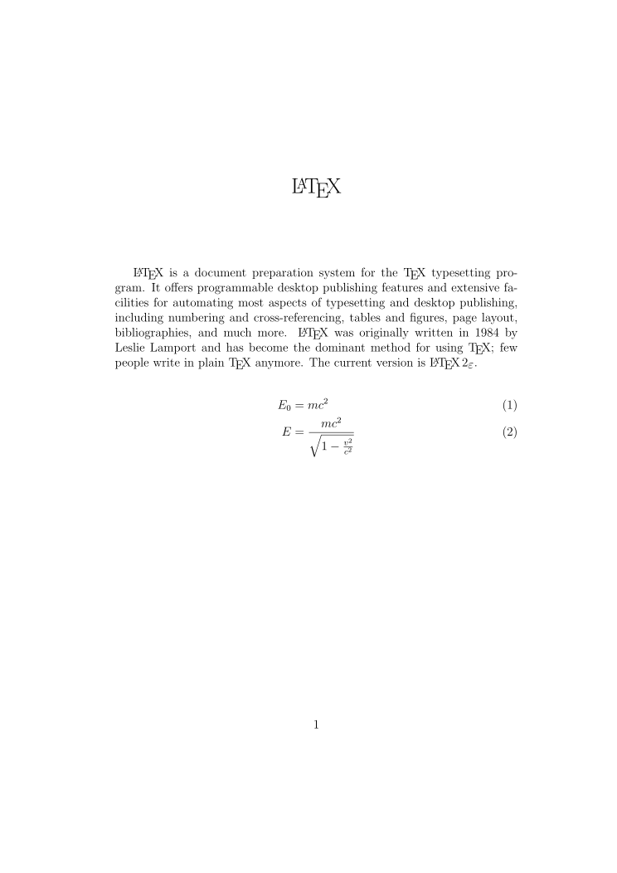

***Pronouncing and writing "LaTeX"***

The final consonant of TeX (on which LaTeX is based) is intended by its developer to be pronounced similar to 'loch' or 'Bach'. However, English speakers often pronounce it /ˈtɛk/, like the first syllable of technical.

The characters T, E, X in the name come from the Greek capital letters tau, epsilon, and chi, as the name of TeX derives from the Greek: τέχνη (skill, art, technique); for this reason, TeX's creator Donald Knuth promotes a pronunciation of /tɛx/ (tekh) (that is, with a voiceless velar fricative as in Modern Greek, similar to the ch in loch). Lamport writes "TeX is usually pronounced tech, making lah-teck, lah-teck, and lay-teck the logical choices; but language is not always logical, so lay-tecks is also possible."

***Licensing***

LaTeX is typically distributed along with plain TeX. It is distributed under a free software license, the LaTeX Project Public License (LPPL). The LPPL is not compatible with the GNU General Public License, as it requires that modified files must be clearly differentiable from their originals (usually by changing the filename); this was done to ensure that files that depend on other files will produce the expected behavior and avoid dependency hell. The LPPL is DFSG compliant as of version 1.3. As free software, LaTeX is available on most operating systems including UNIX (Solaris, HP-UX, AIX), BSD (FreeBSD, macOS, NetBSD, OpenBSD), Linux (Red Hat, Debian, Arch, Gentoo), Windows, DOS, RISC OS, AmigaOS and Plan9.

**Conclusion:**

Thus we studied the Latex tool.