Experiment No. 4

**Aim:** To study mathematical operation such as Linear convolution, Circular convolution, Circular convolution using linear convolution.

**Theory:**

**Linear Convolution**

Convolution is a formal mathematical operation, just as multiplication, addition, and integration. Addition takes two numbers and produces a third number, while convolution takes two signals and produces a third signal. Convolution is used in the mathematics of many fields, such as probability and statistics. In linear systems, convolution is used to describe the relationship between three signals of interest: the input signal, the impulse response, and the output signal. If the input and impulse response of a system are x[n] and h[n] respectively, the convolution is given by the expression, x[n] * h[n] = ε x[k] h[n-k] Where k ranges between -∞ and ∞ If, x(n) is a M- point sequence h(n) is a N – point sequence then, y(n) is a (M+N-1) – point sequence. In this equation, x(k), h(n-k) and y(n) represent the input to and output from the system at time n. Here we could see that one of the inputs is shifted in time by a value every time it is multiplied with the other input signal. Linear Convolution is quite often used as a method of implementing filters of various types.

**Circular Convolution**

The circular convolution, also known as cyclic convolution. A convolution operation that contains a circular shift is called circular convolution. Circular convolution of two sequences x1[n] and x2[n] is given by x1[n]*x2[n] = εk x1[k] x2((n-k))N, 0≤ n ≤N-1 where k ranges between 0 and N-1. In circular convolution the length of the output sequence will be equal to length of the input sequence ie. length(y)=length(x) So first perform linear convolution using any of the methods u find easier. If m is the length of 'x' and n is the length of the 'h' then length of 'yl' from linear conv is m+n-1. Since length of output from circular conv is m, we will uted bring the last n-1 terms from 'yl' and add them to first n-1 terms. So the obtained output is circularly convoluted output.

**Objective:**

* Develop a function to find Linear Convolution and Circular Convolution.
* Calculate Linear Convolution, Circular Convolution, Linear Convolution using Circular Convolution and verify the results using mathematical formulation.
* Conclude on aliasing effect in Circular convolution.

**Input Specifications:**

1. Length of first Signal L and signal values.
2. Length of second Signal M and signal values

**Problem Definition:**

1. Find Linear Convolution and Circular Convolution of L point sequence x[n] and M point sequence h[n].
2. Find Linear Convolution of L point sequence x[n] and M point sequence h[n] using Circular convolution.
3. Give your conclusion about No of values in linearly convolved signal, and Aliasing effect in Circular Convolution.

**Program:**

**Linear Convolution:**

#include<stdio.h>

int x[15], h[15], y[15];

main()

{

int i, j, m, n;

printf("Enter value for m: ");

scanf("%d", &m);

printf("Enter value for n: ");

scanf("%d", &n);

printf("Enter values for i/p x(n): ");

for (i = 0; i < m; i++)

scanf("%d", &x[i]);

printf("Enter Values for i/p h(n): ");

for (i = 0; i < n; i++)

scanf("%d", &h[i]);

// padding of zeors

for (i = m; i <= m + n - 1; i++)

x[i] = 0;

for (i = n; i <= m + n - 1; i++)

h[i] = 0;

/* convolution operation */

for (i = 0; i < m + n - 1; i++)

{

y[i] = 0;

for (j = 0; j <= i; j++)

{

y[i] = y[i] + (x[j] * h[i - j]);

}

}

//displaying the o/p

for (i = 0; i < m + n - 1; i++)

printf("The Value of output y[%d]=%d\n", i, y[i]);

}

**Circular Convolution:**

#include<stdio.h>

int m, n, x[30], h[30], y[30], i, j, k, x2[30], a[30];

void main()

{

printf("Enter the length of the first sequence: ");

scanf("%d", &m);

printf("Enter the length of the second sequence: ");

scanf("%d", &n);

printf("Enter the first sequence: ");

for (i = 0; i < m; i++)

scanf("%d", &x[i]);

printf("Enter the second sequence: ");

for (j = 0; j < n; j++)

scanf("%d", &h[j]);

if (m - n != 0) /*If length of both sequences are not equal*/

{

if (m > n) /* Pad the smaller sequence with zero*/

{

for (i = n; i < m; i++)

h[i] = 0;

n = m;

}

for (i = m; i < n; i++)

x[i] = 0;

m = n;

}

y[0] = 0;

a[0] = h[0];

for (j = 1; j < n; j++) /*folding h(n) to h(-n)*/

a[j] = h[n - j];

/*Circular convolution*/

for (i = 0; i < n; i++)

y[0] += x[i] * a[i];

for (k = 1; k < n; k++)

{

y[k] = 0;

/*circular shift*/

for (j = 1; j < n; j++)

x2[j] = a[j - 1];

x2[0] = a[n - 1];

for (i = 0; i < n; i++)

{

a[i] = x2[i];

y[k] += x[i] * x2[i];

}

}

/*displaying the result*/

printf("The circular convolution is: ");

for (i = 0; i < n; i++)

printf("%d \t", y[i]);

printf("\n");

}

**Circular using linear convolution:**

#include<stdio.h>

int m, n, x[30], h[30], y[30], i, j, k, l, x2[30], a[30];

void main()

{

printf("Enter the length of the first sequence: ");

scanf("%d", &m);

printf("Enter the length of the second sequence: ");

scanf("%d", &n);

printf("Enter the first sequence: ");

for (i = 0; i < m; i++)

scanf("%d", &x[i]);

printf("Enter the second sequence: ");

for (j = 0; j < n; j++)

scanf("%d", &h[j]);

if (m - n != 0) /*If length of both sequences are not equal*/

{

l = m + n - 1;

if (m > n || m < n) /* Pad the smaller sequence with zero*/

{

for (i = l; i < m; i++)

for (i = l; i < n; i++)

h[i] = 0;

n = l;

m = l;

}

}

y[0] = 0;

a[0] = h[0];

for (j = 1; j < n; j++) /*folding h(n) to h(-n)*/

a[j] = h[n - j];

/*Circular convolution*/

for (i = 0; i < n; i++)

y[0] += x[i] * a[i];

for (k = 1; k < n; k++)

{

y[k] = 0;

/*circular shift*/

for (j = 1; j < n; j++)

x2[j] = a[j - 1];

x2[0] = a[n - 1];

for (i = 0; i < n; i++)

{

a[i] = x2[i];

y[k] += x[i] * x2[i];

}

}

/*displaying the result*/

printf("The circular convolution is: ");

for (i = 0; i < n; i++)

printf("%d \t", y[i]);

printf("\n");

}

**Output:**

**Linear Convolution:**

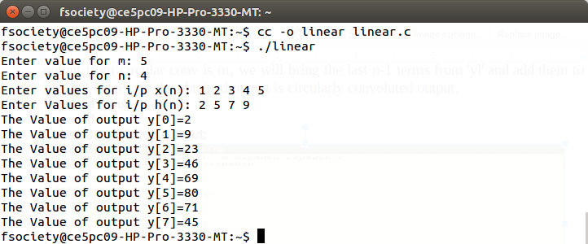

**Circular Convolution:**

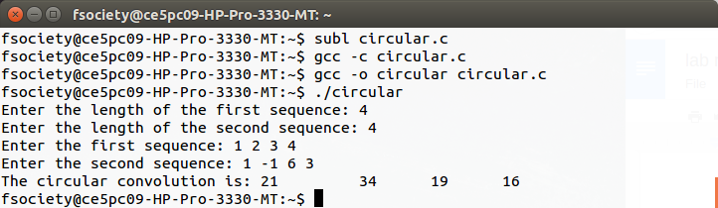

**Circular Convolution using Linear Convolution:**

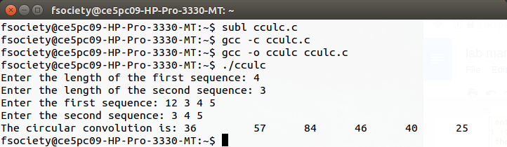

**Conclusion:**

Thus, the Linear convolution, Circular convolution, Linear convolution using circular convolution of two given discrete sequence has performed and the result is displayed.