Experiment No.7

**Aim:** To perform filtering of Long Data Sequence using Overlap Add Method and Overlap Save Method.

**Theory:**

Overlap–save is the traditional name for an efficient way to evaluate the discrete convolution between a very long signal x[n] and a finite impulse response (FIR) filter h[n]

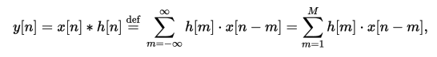

where h[m]=0 for m outside the region [1, M]

The concept is to compute short segments of y[n] of an arbitrary length L, and concatenate the segments together. Consider a segment that begins at n = kL + M, for any integer k, and define:

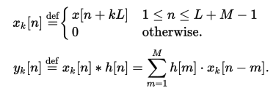

The task is thereby reduced to computing yk[n], for M ≤ n ≤ L + M − 1.

**Objective:**

Develop a function to implement Fast Overlap Add and Fast Overlap Save Algorithm using FFT.

**Input Specifications:**

1. Length of long data sequence and signal values.
2. Length of impulse response M and coefficient values of h[n].

**Problem Definition:**

Find the output of a Discrete Time system using Fast Overlap Add Method OR Fast Overlap Save Method.

**Program:**

#include<stdio.h>

int main(){

int x[12],h[4];

int c[4][4];

int i,j,k,n,m;

int xs[6][4],xa[6][4];

int y[14];

for(i=0;i<12;i++){

x[i]=0;

}

for(i=0;i<4;i++){

h[i]=0;

}

for(i=0;i<6;i++){

for(j=0;j<4;j++){

xs[i][j]=0;

}

}

printf("Enter the number of elements in x(n) (max 12):");

scanf("%d",&n);

printf("Enter x(n):\n");

for(i=0;i<n;i++)

scanf("%d",&x[i]);

/*for(i=0;i<16;i++)

printf("%d ",x1[i]);*/

printf("\nEnter the number of elements in h(n) (max 4):");

scanf("%d",&m);

printf("Enter h(n):\n");

for(i=0;i<m;i++)

scanf("%d",&h[i]);

printf("\nThe block size is 4\n\n");

k=0;

for(i=0;i<6;i++){

for(j=0;j<2;j++){

xs[i][j]=x[k++];

}

}

for(i=0;i<6;i++){

printf("x%d(n)={ ",i+1);

for(j=0;j<4;j++){

printf("%d ",xs[i][j]);

}

printf("}\n");

}

printf("\nh(n)={ ");

for(i=0;i<4;i++){

printf("%d ",h[i]);

}

printf("}\n");

for(i=0;i<4;i++){

for(j=0;j<4;j++){

c[j][i]=h[(j+4-i)%4];}

}

for(i=0;i<6;i++){

for(j=0;j<4;j++){

xa[i][j]=0;

for(k=0;k<4;k++){

xa[i][j]+=c[j][k]*xs[i][k];

}}}

printf("\nAfter circular convolutions:\n");

for(i=0;i<6;i++){

printf("y%d(n)={ ",i+1);

for(j=0;j<4;j++){

printf("%d ",xa[i][j]);

}printf("}\n");

}i=0;

y[0]=xa[0][0];

y[1]=xa[0][1];

for(k=2;k<12;k++){

y[k++]=xa[i][2]+xa[i+1][0];

y[k]=xa[i][3]+xa[i+1][1];

i++;

}y[12]=xa[5][2];

y[13]=xa[5][3];printf("\ny(n)={ ");

for(i=0;i<14;i++){

printf("%d ",y[i]);

}

printf("}\n");

return 0;

}

**Output:**

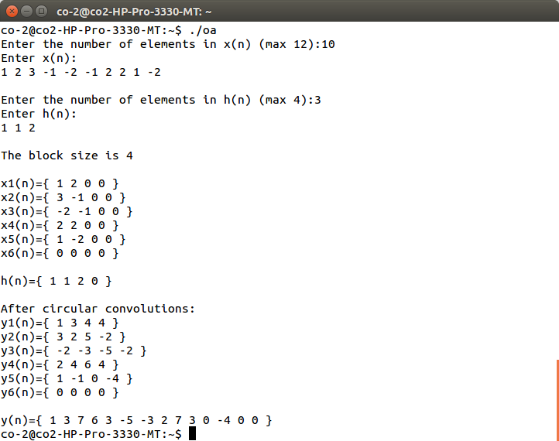

**Conclusion:**

Thus, performed filtering of Long Data Sequence using Overlap Add Method and Overlap Save Method.