Experiment No.1

**Aim:** Case study on Data Mart / Data Warehouse.

**Theory:**

**Data Mart:**

The data mart is a subset of the data warehouse and is usually oriented to a specific business line or team. Whereas data warehouses have an enterprise-wide depth, the information in data marts pertains to a single department. Each data mart is dedicated to a specific business function or region.

**Data Warehouse:**

A data warehouse is a subject-oriented, integrated, time-variant and non-volatile collection of data in support of management's decision making process. Subject-Oriented: A data warehouse can be used to analyze a particular subject area. For example, "sales" can be a particular subject.

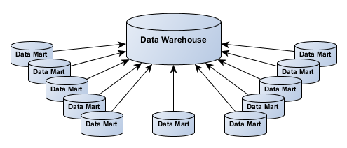

**Data Cube**:

It is a multi-dimensional array of values, commonly used to describe a time series of image data. The data cube is used to represent data along some measure of interest.

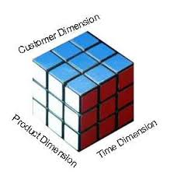

**Dimension table:**

A dimension table is a table in a star schema of a data warehouse. A dimension table stores attributes, or dimensions, that describe the objects in a fact table.

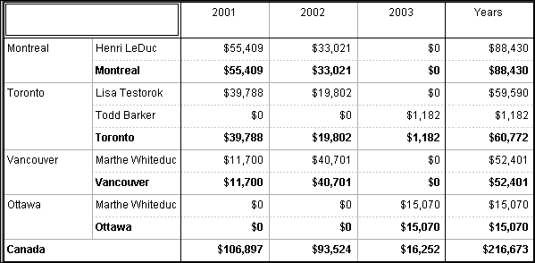

**Fact table:**

A fact table is the central table in a star schema of a data warehouse. A fact table stores quantitative information for analysis and is often denormalized.

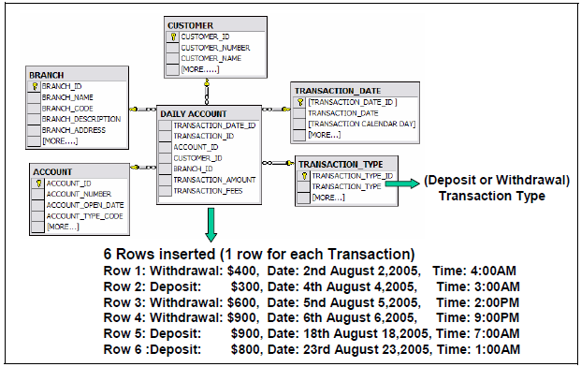

**Star Schema:**

In data warehousing and business intelligence , a star schema is the simplest form of a dimensional model, in which data is organized into facts and dimensions. A fact is an event that is counted or measured, such as a sale or login. A dimension contains reference information about the fact, such as date, product, or customer. A star schema is diagrammed by surrounding each fact with its associated dimensions. The resulting diagram resembles a star.

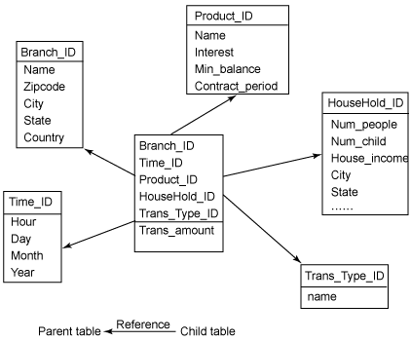

**Snowflake schema:**

A snowflake schema is a logical arrangement of tables in a multidimensional database such that the entity relationship diagram resembles a snowflake shape. The snowflake schema is represented by centralized fact tables which are connected to multiple dimensions.

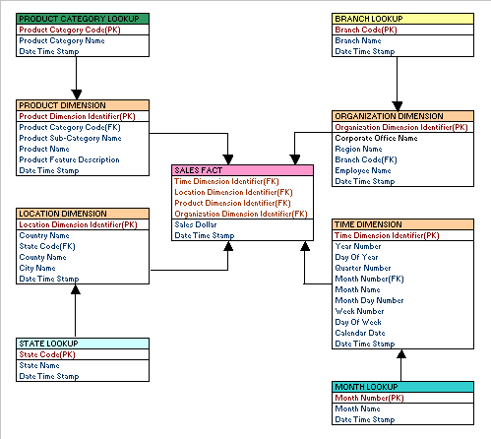

**Conclusion:**

Hence we have studied about the Data Mart and Data Warehousing problem statement, design, Implementation, dimentio and fact table and its schemas.