Experiment No:10

**Aim:** To study SPSS Business Intelligence Tool.

**Overview:**

IBM® SPSS® Modeler is a powerful, versatile data and text analytics workbench that helps you build accurate predictive models quickly and intuitively, without programming. Discover patterns and trends in structured or unstructured data more easily, using a unique visual interface supported by advanced analytics. Model outcomes and understand what factors influence them so you can take advantage of opportunities and mitigate risks.

* Easily visualize the data mining process, using IBM SPSS Modeler intuitive graphical interface. From this interface, you can easily access both structured (numbers and dates) and unstructured (text) from a variety of sources, such as operational databases, survey data, files, and your IBM Cognos 8 Business Intelligence framework, and use modeling to improve business outcomes in areas as diverse as customer relationship management, marketing, resource planning, fraud and risk mitigation, medical research, law enforcement and national security.
* Produce deeper insight and more accurate predictions by utilizing all of your data assets to create a complete view of your customers or constituents. IBM SPSS Modeler integrates with IBM Cognos 8 Business Intelligence software, as well as with a wide range of databases, spreadsheets and flat files – including IBM® SPSS® Statistics, SAS® and Microsoft® Excel® files – and on a wide range of platforms.
* Choose from a complete range of advanced analytical functions, including state-of-the-art algorithms, automated data preparation and rich, interactive visualization capabilities.
* Deploy models, predictions and insight to decision makers and operational systems, including call center staff, customer-facing staff and websites.
* Access all of IBM SPSS Modeler predictive capabilities, as well as IBM SPSS Statistics' data transformation, hypothesis testing and reporting capabilities, from a single interface.
* Integration with Cognos and InfoSphere Warehouse helps you realize more value from your investment in information systems because you can use your wealth of data not only to understand the current state of your business better but also to get a view into the future through predictive analytics.

IBM® SPSS® Modeler is available as two editions to support your data mining projects. Both editions are available for desktop-based and client-server deployment.

* IBM SPSS Modeler Professional includes all of the tools you need to leverage your structured data – such as behaviors and interactions tracked in your CRM systems, demographics, purchasing behavior and sales data
* IBM SPSS Modeler Premium extends the functionality of Modeler Professional by including a powerful text mining workbench for extracting key concepts, sentiments and relationships from textual or "unstructured" data and converting them to a structured format that can be used to make predictive models more accurate
* IBM SPSS Modeler Server​ , available for both IBM SPSS Modeler Professional and IBM SPSS Modeler Premium, delivers high-performance capabilities and improved performance and scalability through client/server architecture, in-database mining, SQL pushback and batch processing.

**Editions:**

1] IBM SPSS Modeler Professional :

* Make better predictions with predictive intelligence
* Create and evaluate sophisticated models easily and visually
* Choose from an unparalleled breadth of techniques
* Extend predictive analytics to new users and new environments
* Support for enterprise standards and technologies

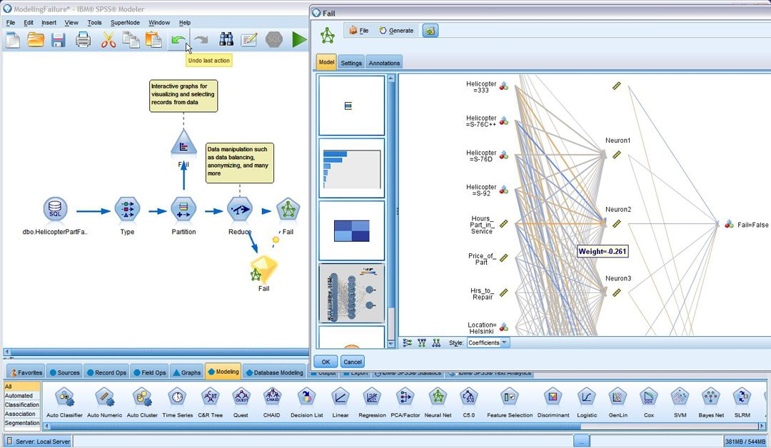

**IBM SPSS Modeler includes advanced, interactive visualization for models that use a single technique, or ensemble models that combine techniques making modeling results easy to understand and communicate.**

**New Features in IBM SPSS Modeler Professional**

* Additional in-database algorithms for InfoSphere Warehouse: Logistic Regression, Naïve Bayes, Time- Series and RBF (Radial Basis Function) (Requires IBM SPSS Modeler Server) Read to and write from IBM Cognos 8 Business Intelligence to enable users to leverage IBM SPSS Modeler's powerful analytics against their enterprise data views.
* Support for IBM Classic Federation and zDB2® provides the ability to use Modeler's data validation, data transformation and data aggregation techniques and algorithms to build predictive models with data stored in mainframe systems
* Extended InfoSphere / DB2 integration - features such as access to the full range of InfoSphere data mining algorithms, DB2 compression and partitioning. This ensures that InfoSphere and IBM SPSS Modeler are a best-in-class, single-vendor solution for data storage, data management and advanced analytics
* Integration into IBM Smart Analytics Systems, an integrated platform that provides broad analytics capabilities on a powerful warehouse foundation with IBM server and storage
* Linux on System z support will enable enterprise customers to quickly and cost effectively deploy advanced analytics on System z® machines running a Linux operating system
* IBM SPSS Modeler introduces the ability to read from and write to a IBM Cognos 8 Business Intelligence environment directly, ensuring that business analysts can leverage the same view of the data across their analytical work and can easily integrate predictive intelligence into their Business Intelligence dashboards directly from the IBM SPSS Modeler interface.

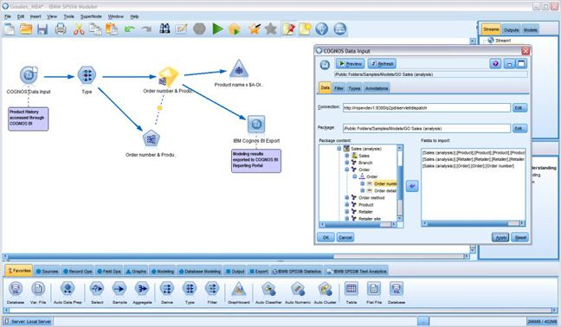

**2] IBM SPSS Modeler Premium**

* Make more accurate predictions by integrating unstructured text
* Explore a broader range of data
* Get insights in any language
* Customize for your needs and industry
* Improve decision-making across the enterprise

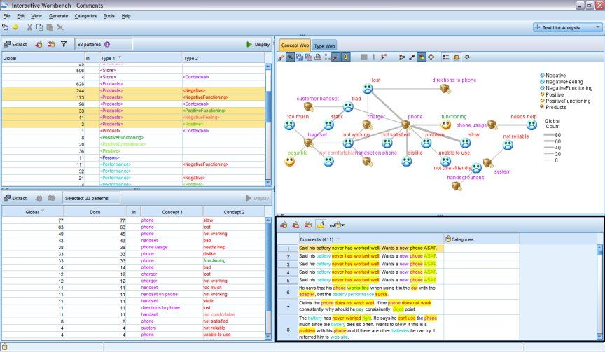

**New features in IBM SPSS Modeler Premium**

* Additional in-database algorithms for InfoSphere Warehouse: Logistic Regression, Naïve Bayes, Time- Series and RBF (Radial Basis Function)
* Read to and write from Cognos® Business Intelligence to enable users to leverage IBM SPSS Modeler's powerful analytics against their enterprise data views
* Support for IBM Classic Federation provides the ability to use IBM SPSS Modeler data validation, data transformation and data aggregation techniques and algorithms to build predictive models with data stored in mainframe systems
* Extended InfoSphere / DB2® in-database mining capabilities enables InfoSphere customers to take advantage of in-database mining's superior performance, IBM SPSS Modeler's intuitive interface and additional functionality from a single workbench
* Integration into IBM Smart Analytics Systems, an integrated platform that provides broad analytics capabilities on a powerful warehouse foundation with IBM server and storage
* Linux on System z support for IBM SPSS Modeler Server will enable enterprise customers to quickly and cost effectively deploy advanced analytics on System z® machines running a Linux operating system

**3] IBM SPSS Modeler Server**

Improve performance and scalability in high-volume environments Sometimes you need to go beyond the desktop to analyze millions of records or deploy data mining as a part of enterprise architecture. By choosing a high-performance data mining tool, you can mine your data more efficiently and gain a significant return on investment.

IBM® SPSS® Modeler Server enables you to extract key insight from vast amounts of data in very short time with enterprise-level technologies. It offers all the features of IBM SPSS Modeler, plus specialized capabilities that deliver faster performance, more efficient administration and greater security in enterprise deployments.

**IBM SPSS Modeler Server Features**

* Optimized performance by leveraging proven parallel processing technology
* Increased flexibility with IBM SPSS Modeler Server Batch Mode to automate production tasks
* High efficiency with Incremental Model Refresh technology
* Extensive in-database modeling capabilities making the most of the existing IT infrastructure
* Unlimited number of CPUs and scoring capability
* SSL Encryption and password protection ensures all sensitive data is fully protected



**Features And Benefits:**

**Uncover key insights and use them to solve real business problems**

Many FORTUNE® 500 corporations, academic institutions and national and local government agencies worldwide rely on IBM SPSS Modeler to unlock the value of their enterprise data, improve business processes and make more informed decisions in areas such as:

* Customer intimacy/customer experience management
* Fraud and risk mitigation
* Human capital management/resource planning
* Inventory management
* Marketing effectiveness
* Operational excellence

**Who uses IBM SPSS Modeler?**

* Banking and financial services firms make their marketing campaigns more effective, evaluate credit risk more reliably and spot potentially fraudulent activities more efficiently
* Insurance companies fine-tune marketing efforts and streamline claim processing while identifying fraudulent claims more reliably
* Telecommunications companies develop more intimate customer relationships in order to build loyalty and reduce customer defection or "churn"
* Retailers improve their assortment planning and fine-tune their marketing and customer loyalty efforts
* Utilities and energy suppliers offer more personalized service to customers. Analytics also plays a role in preventive maintenance, which results in greater reliability at less cost.

**System Requirements :**

Client

* Operating system
  + Microsoft® Windows® 7 (Professional and Enterprise) x32 and x64
  + Editions
  + Microsoft Windows Vista (Business and Enterprise) with Service Pack 1
  + x32 and x64 Editions
  + Microsoft Windows XP Professional with Service Pack 3 x32 and x64
  + Editions.
* Hardware
  + Intel® Pentium® or Pentium-class processor or higher (for 32-bit
  + Windows);
  + x64 (AMD64 and EM64T) processor family (for 64-bit Windows).
  + A monitor with 1024x768 resolution or higher.
  + A DVD-ROM drive is also required if you are installing from the installation disk.
  + Free disk space - 2 GB of available hard-disk space.
  + RAM - 2 GB or more recommended.
* Software - Microsoft® Internet Explorer® 6.0 or higher for online help.
* Virtual environment - The following virtual environments are supported
  + Windows 2008® Terminal Services and R2
  + Windows 2003® Terminal Services and R2
  + Citrix Presentation Server 4.5 – Standard, Advanced and Enterprise

Server

* Operating system
  + Windows Server 2008 R2 (Enterprise) x64
  + Windows Server 2008 (Standard and Enterprise) x32 and x64 Editions;
  + Windows Server 2003® (Standard and Enterprise) x32 and x64 Editions○ Windows Server 2003 R2 (Standard and Enterprise) x32 and x64
  + Editions
  + Red Hat Enterprise Linux Advanced Platform 5.x (x32, EM64T and
  + AMD64 processors)
  + Red Hat Enterprise Linux Advanced Server 4.x (EM64T and AMD64)
  + Red Hat Enterprise Linux Enterprise 4.x (x32, EM64T and AMD64)
  + Sun Solaris 9 or 10 (for SPARC 64-bit machines)
  + HP-UX 11i V3 for Itanium 64-bit machines
  + IBM AIX® 5L 64-bit, version 5.3 and 6.1
  + SuSE Linux Enterprise Server 10 (IBM z) x64
* Hardware
  + Pentium® or Pentium-class processor or higher (for 32-bit Windows)
  + x64 (AMD64 and EM64T) processor family (for 64-bit Windows),
  + running at 1GHz or faster.
  + Pentium or Pentium-class processor or higher for 32-bit Linux
  + x64 (AMD64 and EM64T) processor family for 64-bit Linux
  + UltraSPARC II or better (for SolarisTM)
  + Itanium processor for HP-UX
  + PowerPC processor, 233MHz or faster and IBM RS/6000® for AIX®.
  + A DVD-ROM drive if installing from media
  + A network adaptor running the TCP/IP network protocol.
  + Free disk space - 1 gigabyte (GB) or more recommended, 2GB or more
  + recommended if running on HP-UX.
  + RAM - 4 GB or more is recommended.
* Client software - The client software must be at the same release level as the

server software

* Virtual environment - The following virtual environments are supported
  + VMWare ESX Server 3.5
  + VMWare ESX Server 3.0

**Conclusion:**​

Thus SPSS Business Intelligence Tool has been successfully studied.