Experiment No. 2

**Aim:** To Study & implement OLAP Operations (Slice, Dice, Roll-Up, Drill-Down, Pivot)

**Theory:**

Here is the list of OLAP operations −

* Roll-up
* Drill-down
* Slice and dice
* Pivot (rotate)

**Roll-up:**

Roll-up performs aggregation on a data cube in any of the following ways −

* By climbing up a concept hierarchy for a dimension
* By dimension reduction

The following diagram illustrates how roll-up works.

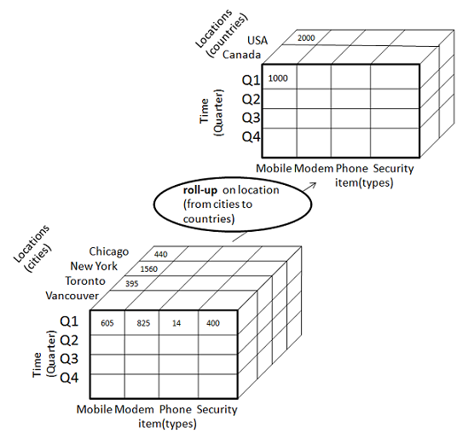

Roll-up is performed by climbing up a concept hierarchy for the dimension location. Initially the concept hierarchy was "street < city < province < country". On rolling up, the data is aggregated by ascending the location hierarchy from the level of city to the level of country. The data is grouped into cities rather than countries. When roll-up is performed, one or more dimensions from the data cube are removed.

**Drill-down:**

Drill-down is the reverse operation of roll-up. It is performed by either of the following ways −

* By stepping down a concept hierarchy for a dimension
* By introducing a new dimension.

The following diagram illustrates how drill-down works

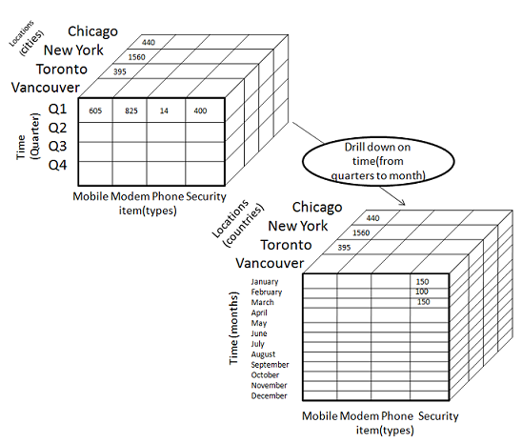

Drill-down is performed by stepping down a concept hierarchy for the dimension time. Initially the concept hierarchy was "day < month < quarter < year." On drilling down, the time dimension is descended from the level of quarter to the level of month. When drill-down is performed, one or more dimensions from the data cube are added. It navigates the data from less detailed data to highly detailed data.

**Slice:**

The slice operation selects one particular dimension from a given cube and provides a new sub-cube. Consider the following diagram that shows how slice works.

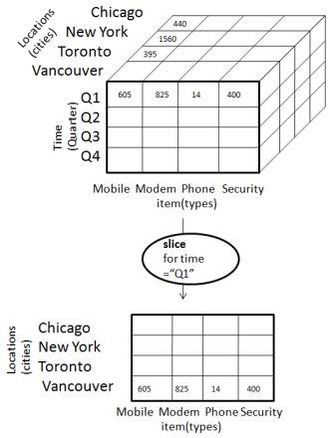

Here Slice is performed for the dimension "time" using the criterion time = "Q1". It will form a new sub-cube by selecting one or more dimensions.

**Dice:**

Dice selects two or more dimensions from a given cube and provides a new sub-cube. Consider the following diagram that shows the dice operation.

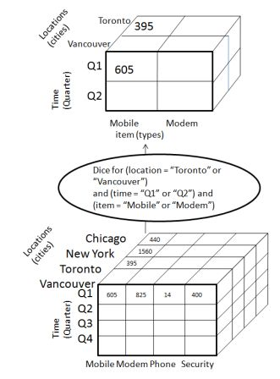

The dice operation on the cube based on the following selection criteria involves three dimensions.

* (location = "Toronto" or "Vancouver")
* (time = "Q1" or "Q2")
* (item =" Mobile" or "Modem")

**Pivot:**

The pivot operation is also known as rotation. It rotates the data axes in view in order to provide an alternative presentation of data. Consider the following diagram that shows the pivot operation.

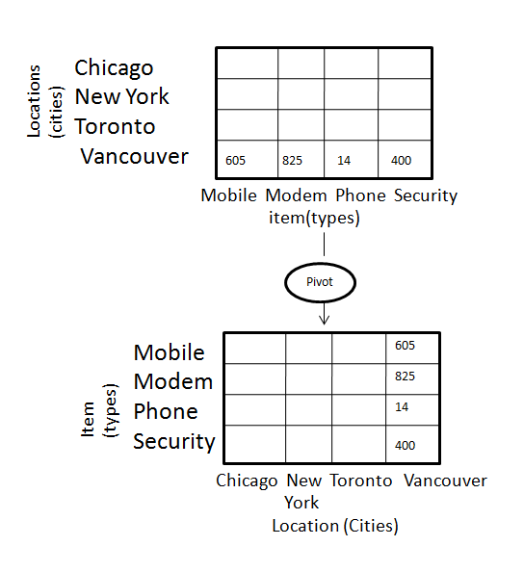

**Operation performed: -**

This operations are OLAP operation using mysql where,select clause.

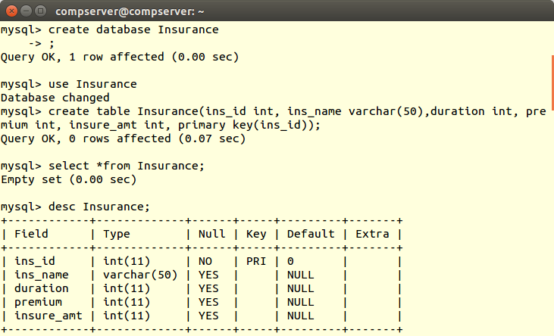

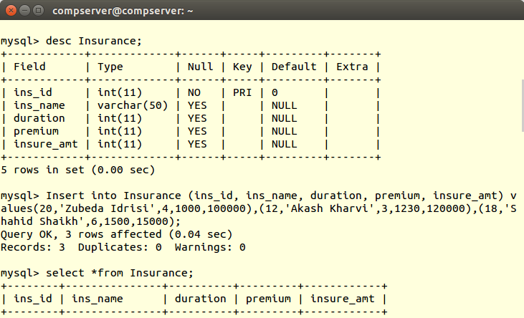

**Inserting data into database:**

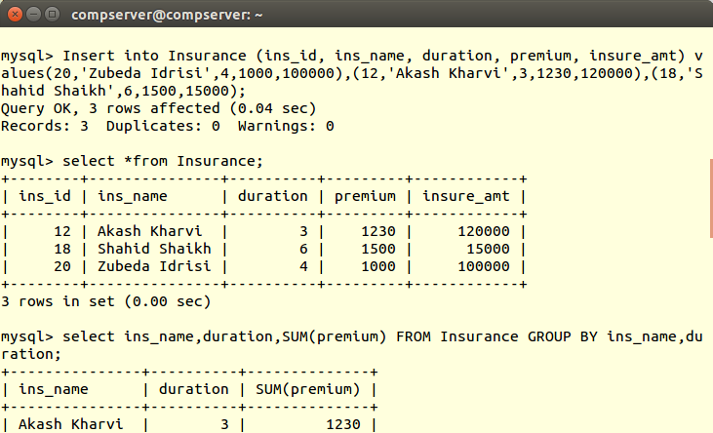

**ROLL UP**

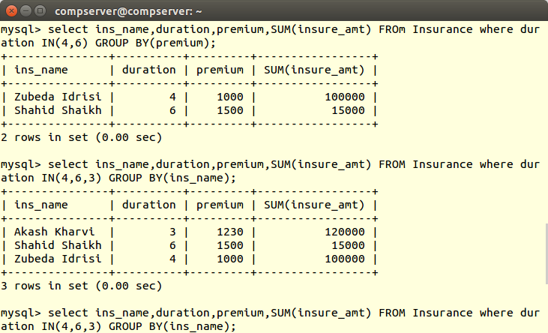

**ROLL DOWN**

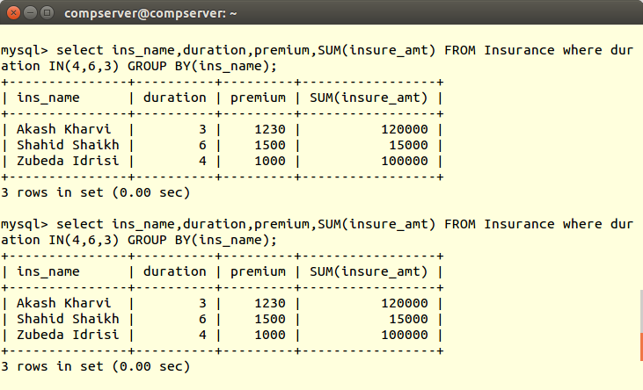

**SLICING**

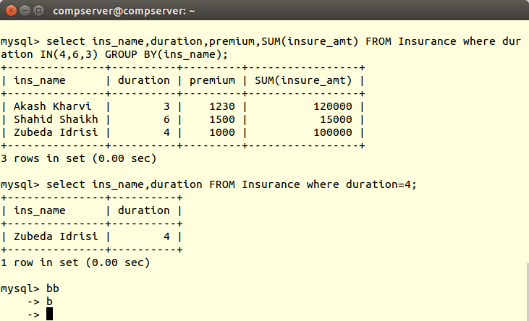

**DICING**

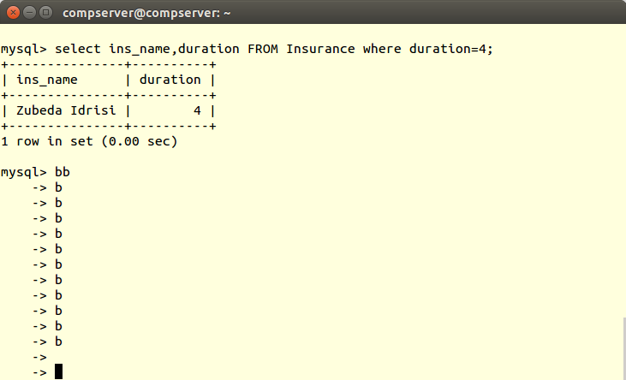

**Conclusion:**

Thus, OLAP Operations (Slice, Dice, Roll-Up, Drill-Down, Pivot) are Studied & implemented successfully .