Experiment No-8

**Aim:** Implementation of Apriori Association Rule Mining Algorithm Using Weka Tool.

**Theory:**

This experiment illustrate some of the basic elements of association rule mining using WEKA.the sample dataset use for this example is test.arff.

**Steps involved in this experiment:**

1. Open the data file in Weka explore. it is the presume that the required data field have been discretized. In this example it is age attribute.
2. Clicking on the associate tab will bring up interface for association rule algorithm.
3. We will use apriori algorithm. This is the default algorithm.
4. Inorder to change parameters for the run (example support, confidence etc.) we click on the next text box immediately to the right of the choose button.

***Dataset test.arff***

@relation test

@attribute admissionyear {2005,2006,2007,2008,2009,2010}

@attribute course {cse,mech,it,ece}

@data

%

2005, cse

2005, it

2005, cse

2006, mech

2006, it

2006, ece

2007, it

2007, cse

2008, it

2008, cse

2009, it

2009, ece

%

**Output:**

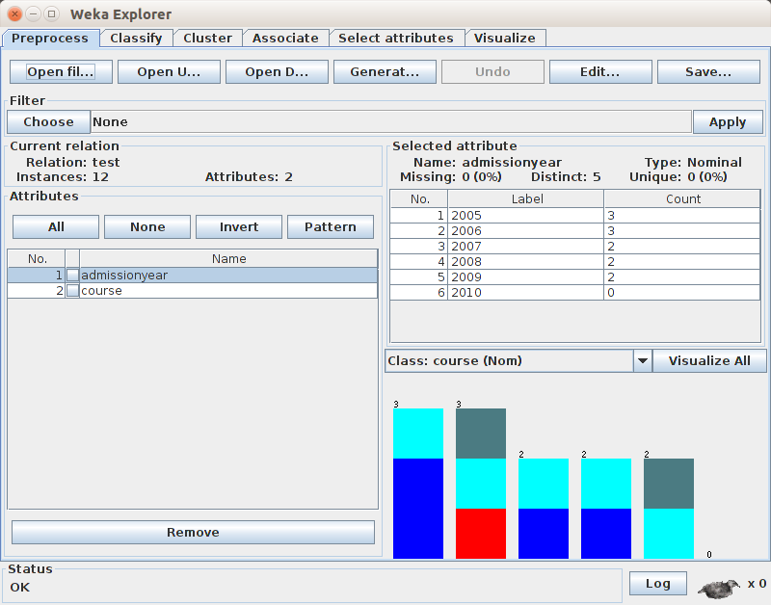

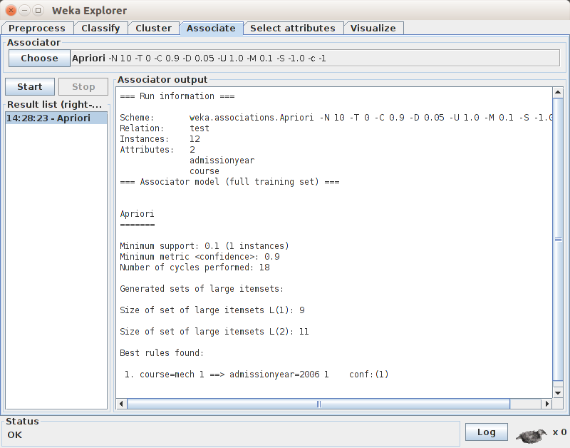

**Conclusion:**

Hence, We have Implemented Apriori Association Rule Mining Algorithm Using Weka Tool.